HW-3

Mohammad Azimi

402123100

Table of Contents

HW-3   
Mohammad Azimi   
402123100   
 Q01   
 Q02   
 Hands-on-Paper:   
 Hands-on-Keyboard:   
 Q03   
 Q04   
 Q05

# Q01

Navigate to the /Q01 directory and find the main.m file. Open it just hit the Run button. The simulation results are shown as the runtime moves forward. Note that all the necessary functions to run the script are placed within the same directory.

Init:

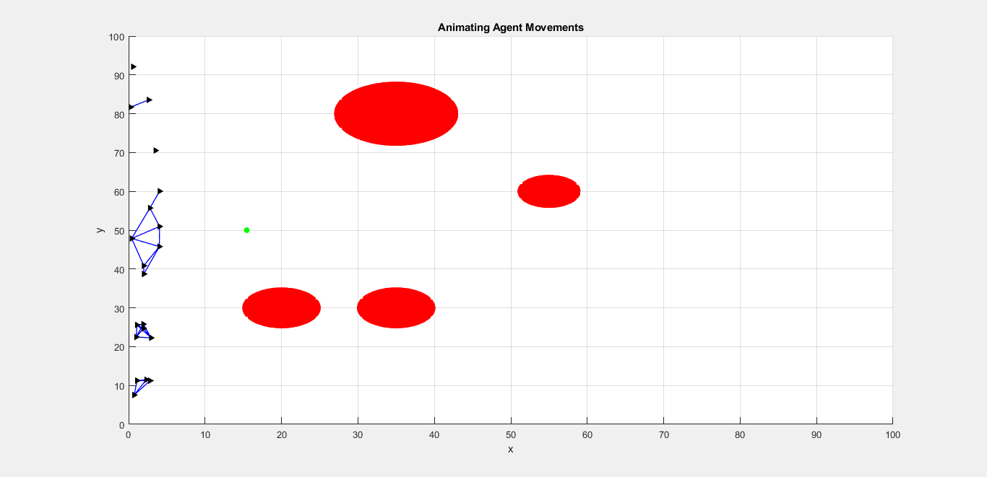

where the red circles, black triangles and the green dot are the obtacles, agents and the virual leader respectively.

In this runtime, there are 20 agents spreaded randomly in 100m along the y-axis.

A subtle grasp of the agents movents is depicted in the following sequence of figures.

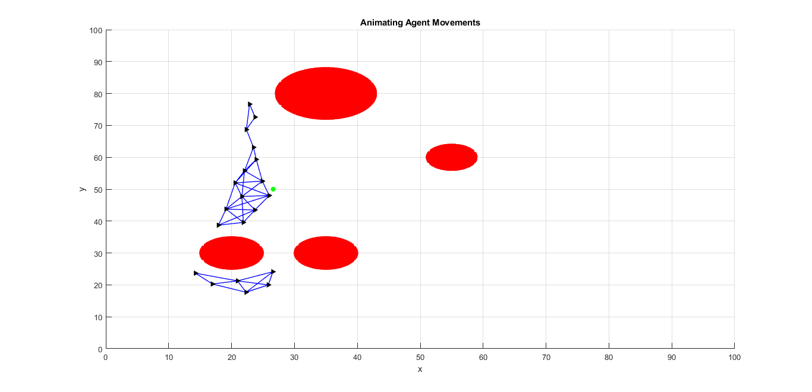

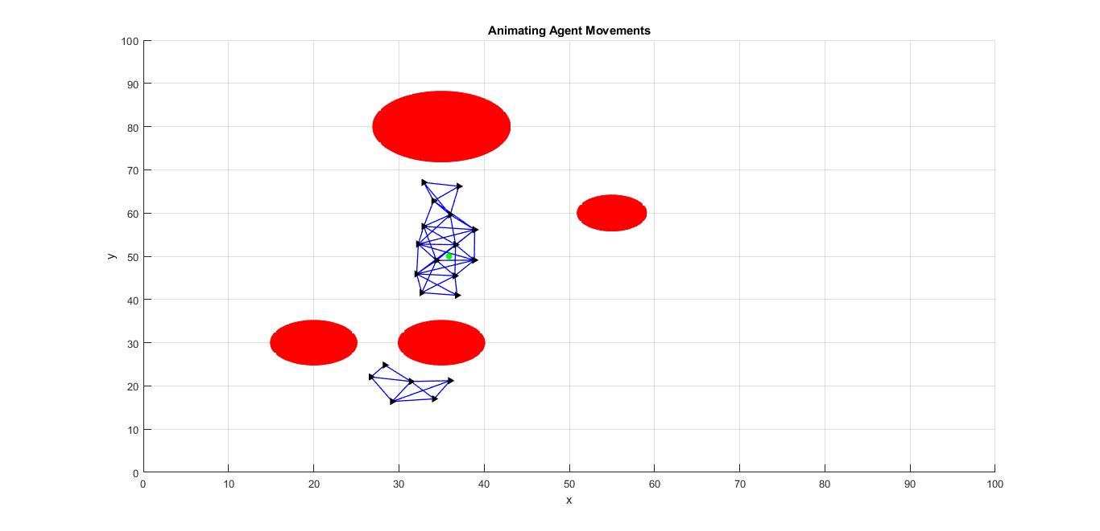

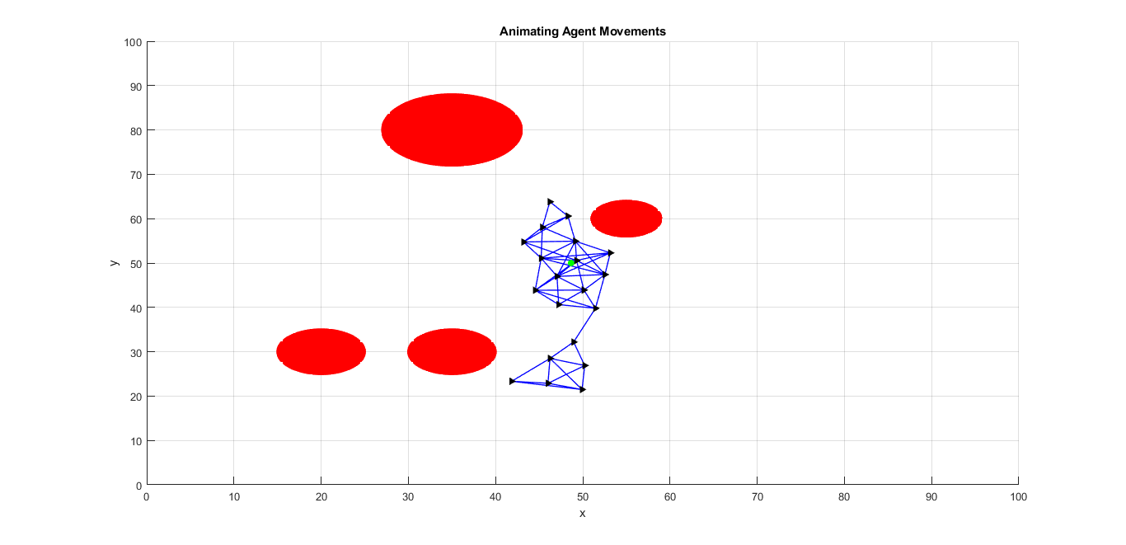

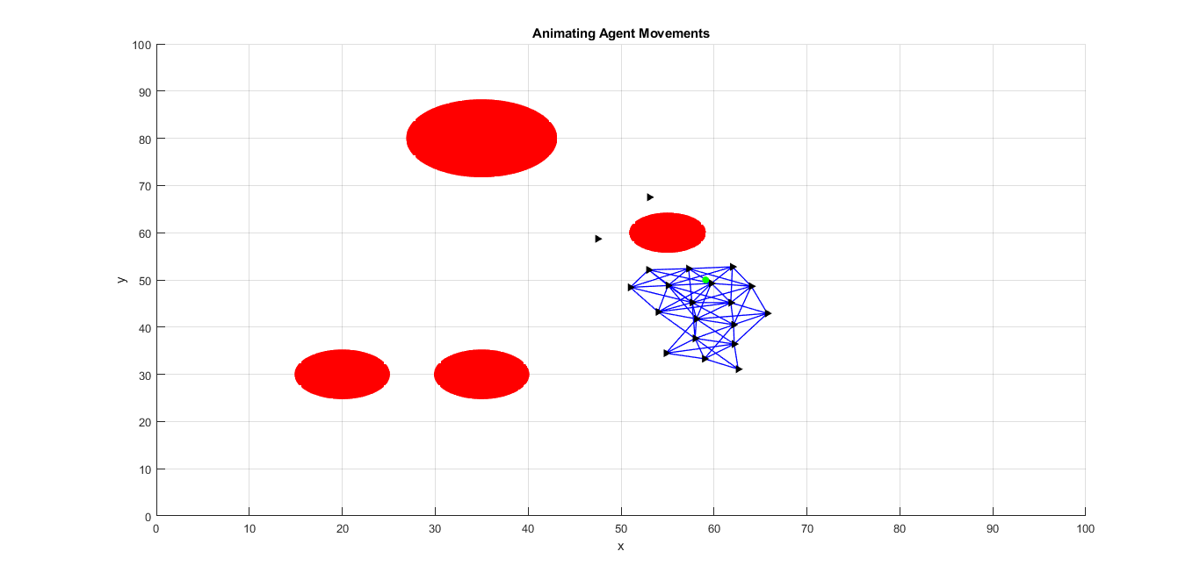

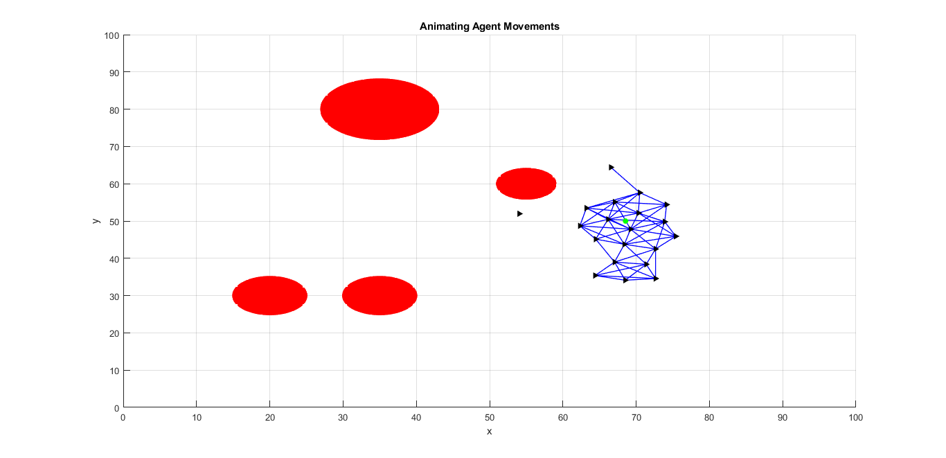

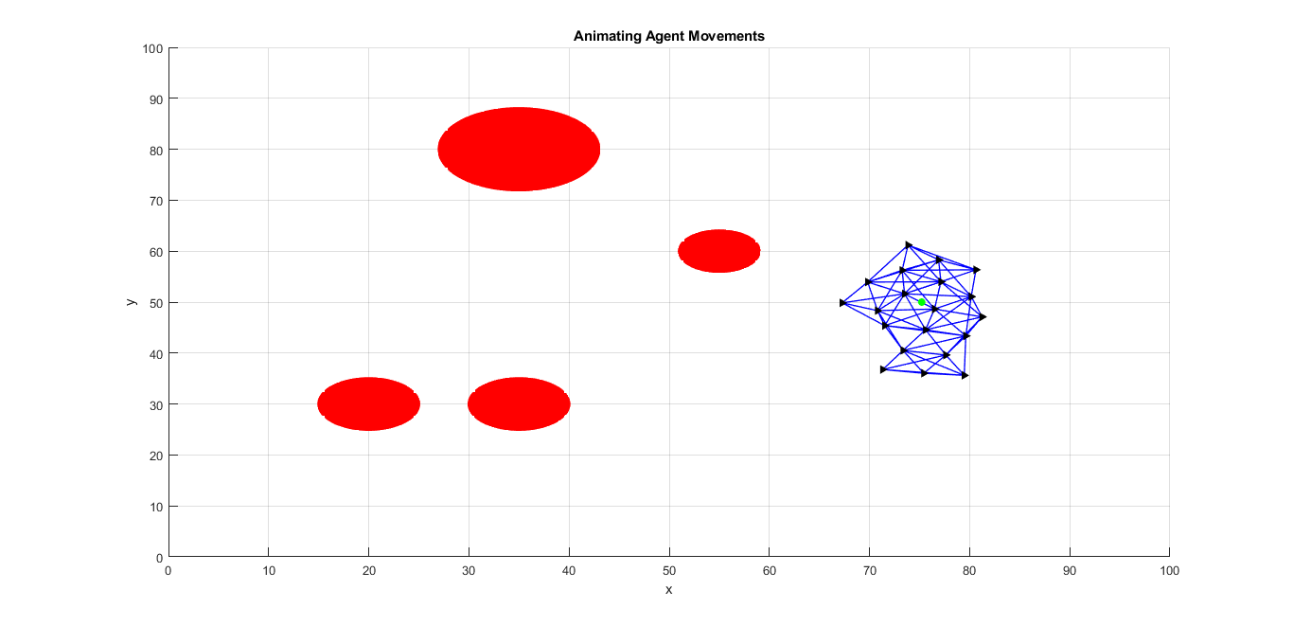

# Q02

## Hands-on-Paper:

Since  is symmetric:

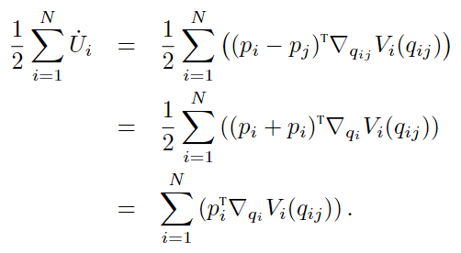

Hence,  along agents’ trajectories:

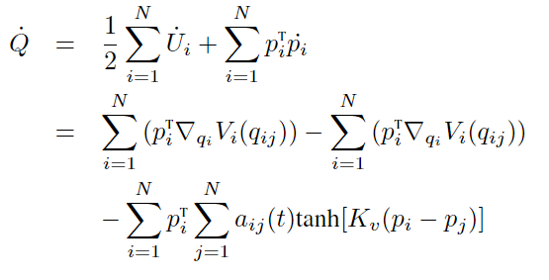

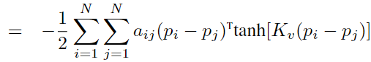

Also, since ,  for all . Note that . Assuming that the network is connected,  and that we have  for any agent . Therefore,  for all . Then the following set is a connect invariant set.

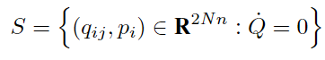

It then follows from LaSalle Invariance Principle that all trajectories of the agents that start from  converge to the largest invariant set inside the region

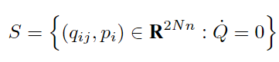

Since

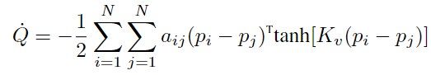

therefore



and this proves the first part.

In steady state:



whish implies that . Also:

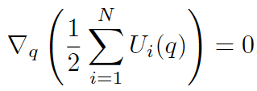

Thus, the configuration converges asyptotically to a fixed configuration that is an extremum of 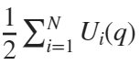.

Accordingly, almost every configuration the system approaches is a local extremum of the total artificial potencial energy 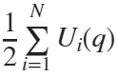

Finally,  is nonincreasing function of time t and thus  for all .

## Hands-on-Keyboard:

Navigate to the /Q02 directory and find the main.m file. Open it just hit the Run button. The simulation results are shown as the runtime moves forward. Note that all the necessary functions to run the script are placed within the same directory.

At the very beginning of the simulation, agents are as in the following image. Note the agents’ movements are on the 3d view on the left-side plot and the velocities along each axis is demonstrated on the right-side plots.

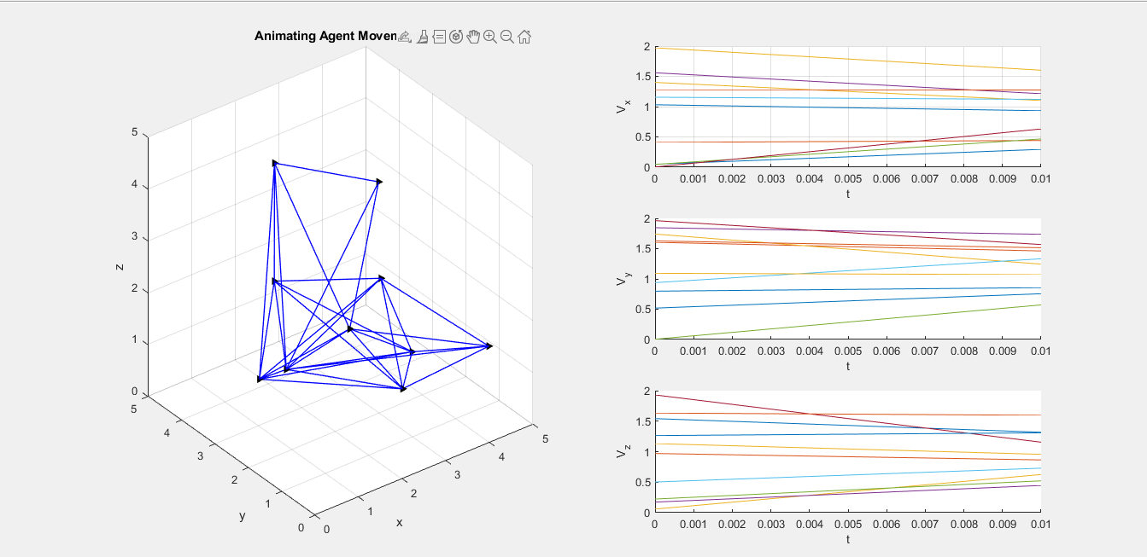

The next figure illustrates the results at almost 

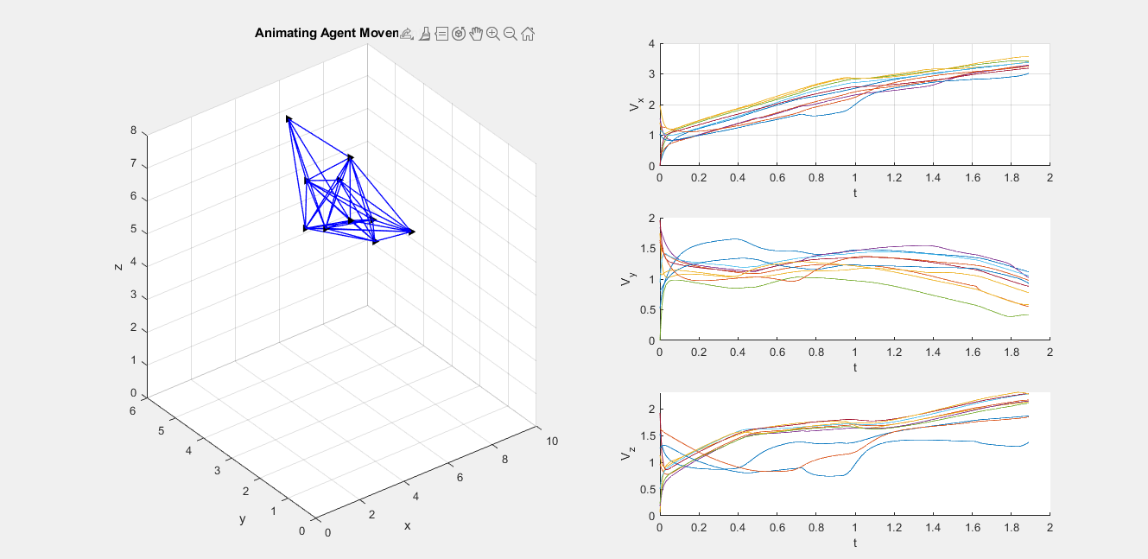

At :

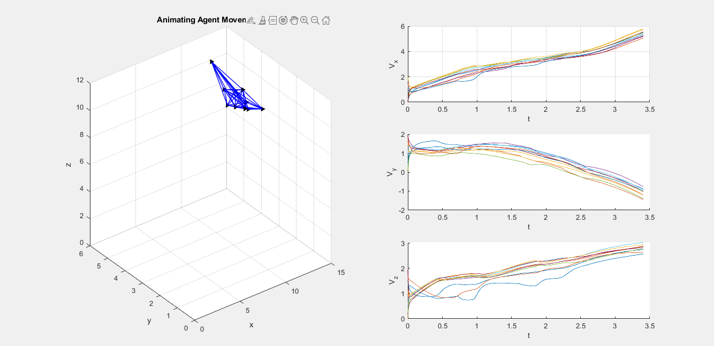

and even further, at 

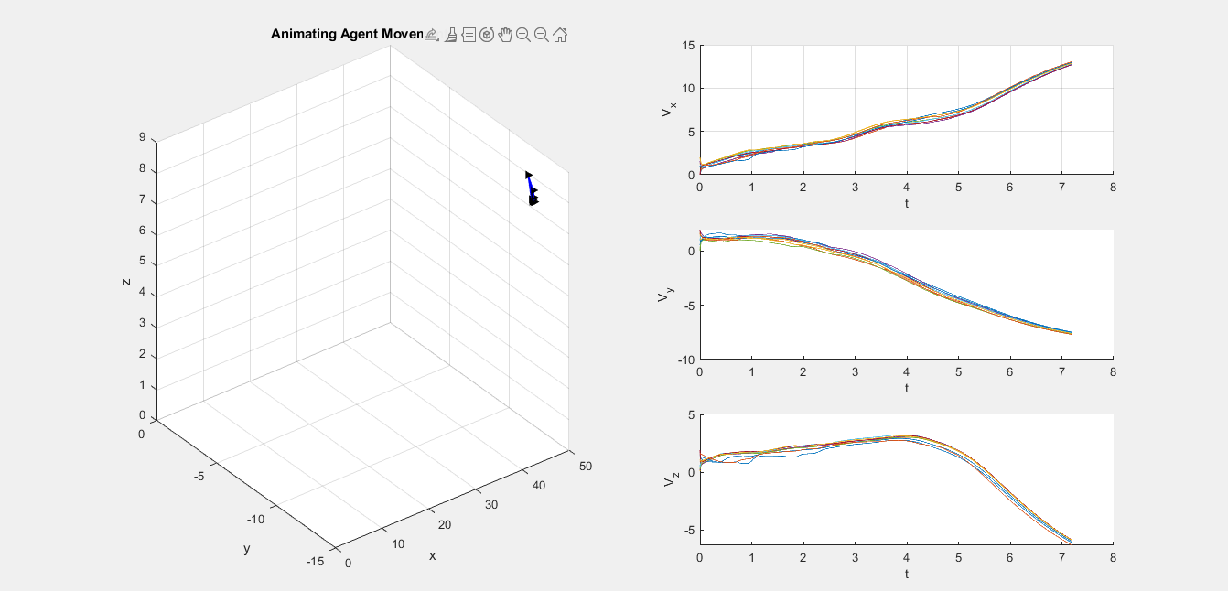

It is shown that the agents’ velocities have converged to a common value and the flock has reached consensus.

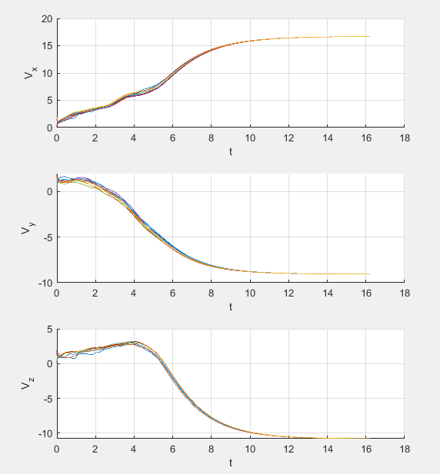

# 

# Q03

Question 3 is not well-represented and the dynamics and structures are not correctly hence it is not implemented.

# Q04

Navigate to the /Q04 directory and find the main.m file. Open it just hit the Run button. The simulation results are shown as the runtime moves forward. Note that all the necessary functions to run the script are placed within the same directory.

:

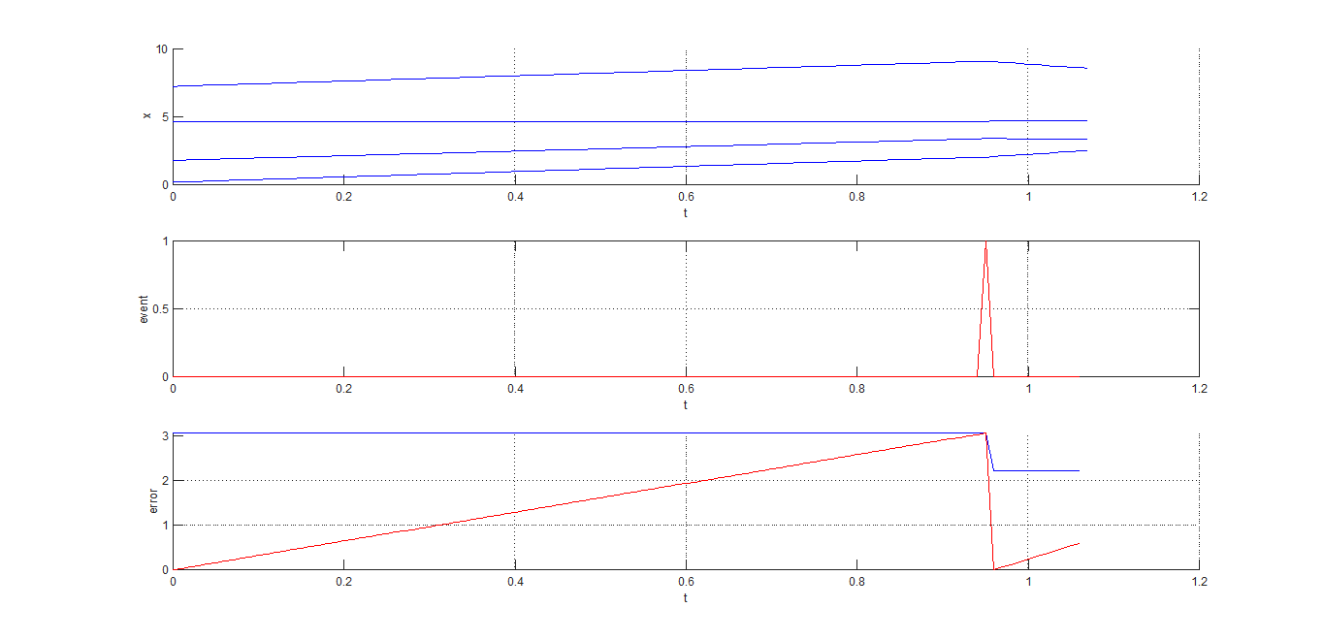

at :

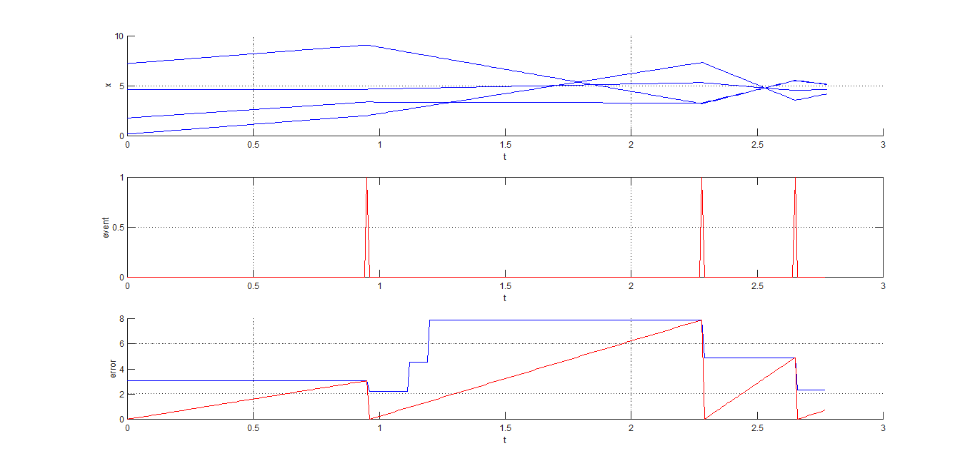

and finally, at 

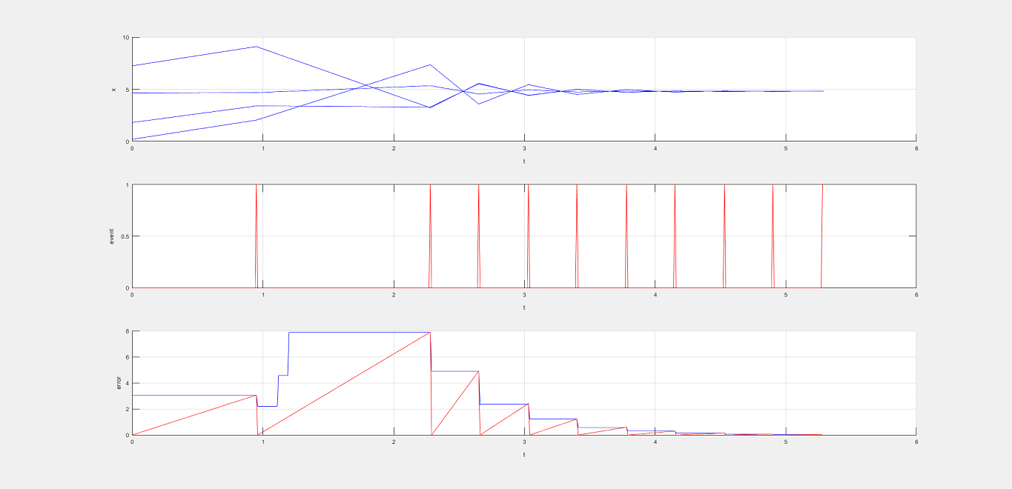

The sequence of events is shown and the consensus is reached.

# Q05