Bat Activity Analysis

Site Name: NA

Author: NA

05/11/2019

# Summary

Bats were detected on **133** nights between **2017-06-08** and **2019-10-16**, using **10** static bat detectors. Throughout this period **10** species were recorded. Detectors were placed at the following locations:

|  |  |  |
| --- | --- | --- |
| Detector ID | Latitude | Longitude |
| MS2 | 51.77727 | -1.212748 |
| MS1 | 51.77756 | -1.218425 |
| MS3 | 51.77281 | -1.214768 |
| MS4 | 51.77463 | -1.222331 |
| MS5 | 51.77470 | -1.205923 |
| MS6 | 51.76976 | -1.194546 |
| MS10 | 51.77335 | -1.200483 |
| MS7 | 51.77230 | -1.197922 |
| MS8 | 51.77179 | -1.207018 |
| MS9 | 51.77182 | -1.203466 |

##### Page Break

# Survey Nights

The number of nights that bats were detected on each recorder. This is not the same as the number of nights that detectors were active if there were nights when no bats were detected.

|  |  |
| --- | --- |
| Detector ID | No. of nights |
| MS1 | 17 |
| MS10 | 30 |
| MS2 | 40 |
| MS3 | 36 |
| MS4 | 26 |
| MS5 | 37 |
| MS6 | 65 |
| MS7 | 51 |
| MS8 | 44 |
| MS9 | 47 |

##### Page Break

# Survey Nights

Horizontal bars show nights when acoustic detectors recorded bats.

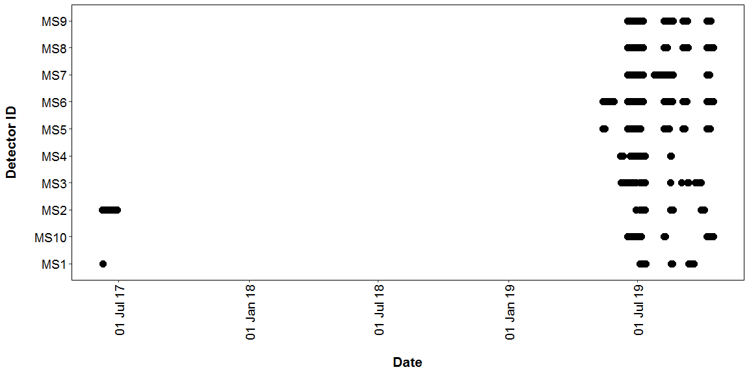

##### Page Break

## PART 1: Percentiles Analysis

The reference range dataset was stratified to include:

* Only records from within 30 days of the survey date.
* Only records from within 100km2 of the survey location.

## PER DETECTOR

#### Table 1

Summary table showing the number of nights recorded bat activity fell into each activity band for each species.

|  |  |  |  |  |  |  |
| --- | --- | --- | --- | --- | --- | --- |
| Detector ID | Species/Species Group | Nights of High Activity | Nights of Moderate/ High Activity | Nights of Moderate Activity | Nights of Low/ Moderate Activity | Nights of Low Activity |
| MS1 | *Myotis* | 0 | 0 | 0 | 0 | 1 |
| MS1 | *Pipistrellus* | 0 | 0 | 0 | 1 | 0 |
| MS1 | *Pipistrellus pipistrellus* | 2 | 2 | 2 | 4 | 6 |
| MS1 | *Pipistrellus pygmaeus* | 0 | 1 | 0 | 1 | 4 |
| MS10 | *Barbastella barbastellus* | 0 | 5 | 1 | 3 | 8 |
| MS10 | *Eptesicus serotinus* | 0 | 0 | 0 | 0 | 2 |
| MS10 | *Myotis* | 6 | 10 | 3 | 6 | 3 |
| MS10 | *Nyctalus leisleri* | 0 | 0 | 0 | 0 | 5 |
| MS10 | *Nyctalus noctula* | 1 | 0 | 5 | 7 | 7 |
| MS10 | *Pipistrellus* | 1 | 0 | 0 | 0 | 0 |
| MS10 | *Pipistrellus nathusii* | 0 | 0 | 1 | 5 | 1 |
| MS10 | *Pipistrellus pipistrellus* | 26 | 4 | 0 | 0 | 0 |
| MS10 | *Pipistrellus pygmaeus* | 1 | 7 | 5 | 4 | 8 |
| MS10 | *Plecotus auritus* | 0 | 2 | 2 | 3 | 4 |
| MS2 | *Myotis* | 0 | 2 | 6 | 9 | 6 |
| MS2 | *Nyctalus leisleri* | 0 | 0 | 0 | 0 | 1 |
| MS2 | *Nyctalus noctula* | 0 | 0 | 2 | 6 | 12 |
| MS2 | *Pipistrellus* | 0 | 0 | 0 | 0 | 1 |
| MS2 | *Pipistrellus pipistrellus* | 34 | 4 | 0 | 0 | 0 |
| MS2 | *Pipistrellus pygmaeus* | 16 | 17 | 1 | 2 | 4 |
| MS2 | *Plecotus auritus* | 0 | 0 | 0 | 1 | 1 |
| MS3 | *Myotis* | 0 | 3 | 5 | 9 | 8 |
| MS3 | *Nyctalus leisleri* | 0 | 0 | 2 | 7 | 6 |
| MS3 | *Nyctalus noctula* | 0 | 9 | 8 | 4 | 3 |
| MS3 | *Pipistrellus* | 0 | 0 | 0 | 0 | 4 |
| MS3 | *Pipistrellus pipistrellus* | 24 | 6 | 2 | 4 | 0 |
| MS3 | *Pipistrellus pygmaeus* | 17 | 14 | 1 | 2 | 0 |
| MS3 | *Plecotus auritus* | 0 | 0 | 0 | 1 | 8 |
| MS4 | *Pipistrellus pipistrellus* | 16 | 7 | 1 | 2 | 0 |
| MS4 | *Pipistrellus pygmaeus* | 4 | 14 | 3 | 0 | 3 |
| MS5 | *Barbastella barbastellus* | 0 | 4 | 1 | 2 | 1 |
| MS5 | *Eptesicus serotinus* | 0 | 0 | 0 | 1 | 3 |
| MS5 | *Myotis* | 5 | 5 | 6 | 6 | 5 |
| MS5 | *Nyctalus leisleri* | 0 | 0 | 1 | 3 | 2 |
| MS5 | *Nyctalus noctula* | 0 | 4 | 9 | 8 | 11 |
| MS5 | *Pipistrellus* | 1 | 0 | 0 | 0 | 0 |
| MS5 | *Pipistrellus nathusii* | 0 | 1 | 1 | 3 | 1 |
| MS5 | *Pipistrellus pipistrellus* | 32 | 5 | 0 | 0 | 0 |
| MS5 | *Pipistrellus pygmaeus* | 14 | 19 | 3 | 1 | 0 |
| MS5 | *Plecotus auritus* | 0 | 0 | 0 | 0 | 2 |
| MS6 | *Barbastella barbastellus* | 0 | 0 | 5 | 10 | 15 |
| MS6 | *Eptesicus serotinus* | 0 | 0 | 1 | 2 | 8 |
| MS6 | *Myotis* | 0 | 12 | 19 | 14 | 10 |
| MS6 | *Nyctalus leisleri* | 0 | 0 | 0 | 4 | 8 |
| MS6 | *Nyctalus noctula* | 11 | 18 | 15 | 9 | 6 |
| MS6 | *Pipistrellus* | 4 | 1 | 0 | 0 | 0 |
| MS6 | *Pipistrellus nathusii* | 0 | 0 | 0 | 3 | 5 |
| MS6 | *Pipistrellus pipistrellus* | 45 | 16 | 2 | 0 | 0 |
| MS6 | *Pipistrellus pygmaeus* | 18 | 24 | 11 | 5 | 3 |
| MS6 | *Plecotus auritus* | 0 | 0 | 1 | 4 | 2 |
| MS7 | *Barbastella barbastellus* | 0 | 0 | 0 | 1 | 3 |
| MS7 | *Myotis* | 0 | 4 | 7 | 8 | 16 |
| MS7 | *Nyctalus leisleri* | 0 | 0 | 0 | 7 | 6 |
| MS7 | *Nyctalus noctula* | 1 | 5 | 7 | 8 | 10 |
| MS7 | *Pipistrellus* | 5 | 1 | 0 | 0 | 0 |
| MS7 | *Pipistrellus nathusii* | 0 | 0 | 3 | 4 | 4 |
| MS7 | *Pipistrellus pipistrellus* | 8 | 28 | 5 | 6 | 1 |
| MS7 | *Pipistrellus pygmaeus* | 22 | 13 | 1 | 6 | 3 |
| MS7 | *Plecotus auritus* | 0 | 1 | 0 | 1 | 1 |
| MS8 | *Barbastella barbastellus* | 0 | 0 | 0 | 3 | 6 |
| MS8 | *Eptesicus serotinus* | 0 | 0 | 0 | 1 | 2 |
| MS8 | *Myotis* | 0 | 6 | 8 | 6 | 10 |
| MS8 | *Nyctalus leisleri* | 0 | 0 | 1 | 4 | 4 |
| MS8 | *Nyctalus noctula* | 0 | 6 | 6 | 17 | 5 |
| MS8 | *Pipistrellus* | 1 | 3 | 0 | 0 | 0 |
| MS8 | *Pipistrellus nathusii* | 0 | 5 | 3 | 3 | 7 |
| MS8 | *Pipistrellus pipistrellus* | 10 | 15 | 8 | 6 | 2 |
| MS8 | *Pipistrellus pygmaeus* | 2 | 8 | 8 | 6 | 7 |
| MS9 | *Barbastella barbastellus* | 0 | 0 | 0 | 2 | 4 |
| MS9 | *Eptesicus serotinus* | 0 | 0 | 0 | 0 | 4 |
| MS9 | *Myotis* | 0 | 2 | 4 | 6 | 11 |
| MS9 | *Nyctalus leisleri* | 0 | 0 | 0 | 1 | 6 |
| MS9 | *Nyctalus noctula* | 0 | 4 | 9 | 7 | 7 |
| MS9 | *Pipistrellus* | 3 | 0 | 0 | 0 | 0 |
| MS9 | *Pipistrellus nathusii* | 0 | 0 | 3 | 7 | 5 |
| MS9 | *Pipistrellus pipistrellus* | 30 | 5 | 6 | 1 | 5 |
| MS9 | *Pipistrellus pygmaeus* | 4 | 10 | 10 | 7 | 3 |
| MS9 | *Plecotus auritus* | 0 | 0 | 0 | 3 | 6 |

#### Table 2

Summary table showing key metrics for each species recorded.

|  |  |  |  |  |  |  |
| --- | --- | --- | --- | --- | --- | --- |
| Detector ID | Species/Species Group | Median Percentile | 95% CIs | Max Percentile | Nights Recorded | Reference Range |
| MS1 | *Myotis* | 0 | 0 | 0 | 1 | 1967 |
| MS1 | *Pipistrellus* | 38 | 0 | 38 | 1 | 4447 |
| MS1 | *Pipistrellus pipistrellus* | 26 | 32 - 72 | 86 | 16 | 4017 |
| MS1 | *Pipistrellus pygmaeus* | 0 | 52 - 52 | 66 | 6 | 2306 |
| MS10 | *Barbastella barbastellus* | 25 | 37 - 68 | 72 | 17 | 245.3 |
| MS10 | *Eptesicus serotinus* | 0 | 0 - 0 | 0 | 2 | 1251 |
| MS10 | *Myotis* | 61 | 51 - 69.5 | 91 | 28 | 1384 |
| MS10 | *Nyctalus leisleri* | 0 | 0 - 0 | 0 | 5 | 305.6 |
| MS10 | *Nyctalus noctula* | 25 | 31.5 - 51 | 89 | 20 | 1338 |
| MS10 | *Pipistrellus* | 81 | 0 | 81 | 1 | 2364 |
| MS10 | *Pipistrellus nathusii* | 26 | 26 - 38 | 58 | 7 | 429 |
| MS10 | *Pipistrellus pipistrellus* | 93 | 87.5 - 94 | 99 | 30 | 2850 |
| MS10 | *Pipistrellus pygmaeus* | 46 | 43.5 - 62 | 87 | 25 | 1713 |
| MS10 | *Plecotus auritus* | 25 | 31.5 - 57.5 | 65 | 11 | 446.8 |
| MS2 | *Myotis* | 26 | 32 - 49 | 62 | 23 | 1537 |
| MS2 | *Nyctalus leisleri* | 0 | 0 | 0 | 1 | 239 |
| MS2 | *Nyctalus noctula* | 0 | 26 - 42.5 | 57 | 20 | 1361 |
| MS2 | *Pipistrellus* | 0 | 0 | 0 | 1 | 2347 |
| MS2 | *Pipistrellus pipistrellus* | 97 | 91 - 97.5 | 100 | 38 | 3168 |
| MS2 | *Pipistrellus pygmaeus* | 78 | 74.5 - 83 | 99 | 40 | 1845 |
| MS2 | *Plecotus auritus* | 13 | 13 - 13 | 26 | 2 | 582 |
| MS3 | *Myotis* | 38 | 36.5 - 50 | 68 | 25 | 1848 |
| MS3 | *Nyctalus leisleri* | 26 | 26 - 41 | 56 | 15 | 266 |
| MS3 | *Nyctalus noctula* | 56 | 50 - 61.5 | 72 | 24 | 1774 |
| MS3 | *Pipistrellus* | 0 | 0 - 0 | 0 | 4 | 3999 |
| MS3 | *Pipistrellus pipistrellus* | 88 | 76 - 90.5 | 99 | 36 | 3692 |
| MS3 | *Pipistrellus pygmaeus* | 82 | 75.5 - 86 | 98 | 34 | 2261 |
| MS3 | *Plecotus auritus* | 0 | 0 - 0 | 26 | 9 | 581 |
| MS4 | *Pipistrellus pipistrellus* | 83 | 76.5 - 84.5 | 95 | 26 | 3692 |
| MS4 | *Pipistrellus pygmaeus* | 71 | 66.5 - 76 | 88 | 24 | 2261 |
| MS5 | *Barbastella barbastellus* | 58 | 31.5 - 69 | 71 | 8 | 255 |
| MS5 | *Eptesicus serotinus* | 0 | 0 - 0 | 25 | 4 | 930 |
| MS5 | *Myotis* | 51 | 46.5 - 67.5 | 85 | 27 | 1306 |
| MS5 | *Nyctalus leisleri* | 26 | 26 - 26 | 51 | 6 | 276 |
| MS5 | *Nyctalus noctula* | 37 | 41 - 54 | 80 | 32 | 1408 |
| MS5 | *Pipistrellus* | 92 | 0 | 92 | 1 | 3578 |
| MS5 | *Pipistrellus nathusii* | 38 | 26 - 63 | 63 | 6 | 429 |
| MS5 | *Pipistrellus pipistrellus* | 95 | 91.5 - 96 | 99 | 37 | 2785 |
| MS5 | *Pipistrellus pygmaeus* | 77 | 72.5 - 82 | 100 | 37 | 1692 |
| MS5 | *Plecotus auritus* | 0 | 0 - 0 | 0 | 2 | 409 |
| MS6 | *Barbastella barbastellus* | 13 | 31 - 44 | 56 | 30 | 259.4 |
| MS6 | *Eptesicus serotinus* | 0 | 25 - 25 | 47 | 11 | 1095 |
| MS6 | *Myotis* | 46 | 45 - 55 | 77 | 55 | 1358 |
| MS6 | *Nyctalus leisleri* | 0 | 0 - 0 | 26 | 12 | 303.8 |
| MS6 | *Nyctalus noctula* | 59 | 56 - 67 | 94 | 59 | 1437 |
| MS6 | *Pipistrellus* | 89 | 83.5 - 93 | 97 | 5 | 3092 |
| MS6 | *Pipistrellus nathusii* | 0 | 26 - 26 | 38 | 8 | 429 |
| MS6 | *Pipistrellus pipistrellus* | 87 | 82.5 - 87.5 | 99 | 63 | 2875 |
| MS6 | *Pipistrellus pygmaeus* | 67 | 64 - 73 | 92 | 61 | 1734 |
| MS6 | *Plecotus auritus* | 25 | 25 - 44 | 51 | 7 | 453.6 |
| MS7 | *Barbastella barbastellus* | 0 | 0 - 0 | 25 | 4 | 271.5 |
| MS7 | *Myotis* | 25 | 37.5 - 54.5 | 74 | 35 | 1372 |
| MS7 | *Nyctalus leisleri* | 26 | 26 - 26 | 39 | 13 | 324.4 |
| MS7 | *Nyctalus noctula* | 25 | 37.5 - 56 | 83 | 31 | 1518 |
| MS7 | *Pipistrellus* | 87 | 81 - 97 | 99 | 6 | 2971 |
| MS7 | *Pipistrellus nathusii* | 26 | 26 - 40.5 | 55 | 11 | 429 |
| MS7 | *Pipistrellus pipistrellus* | 71 | 64 - 73 | 88 | 48 | 2870 |
| MS7 | *Pipistrellus pygmaeus* | 80 | 72 - 84.5 | 98 | 45 | 1711 |
| MS7 | *Plecotus auritus* | 25 | 48 - 48 | 71 | 3 | 409 |
| MS8 | *Barbastella barbastellus* | 0 | 25 - 25 | 38 | 9 | 244 |
| MS8 | *Eptesicus serotinus* | 0 | 0 - 0 | 25 | 3 | 1108 |
| MS8 | *Myotis* | 38 | 42 - 57 | 73 | 30 | 1271 |
| MS8 | *Nyctalus leisleri* | 26 | 26 - 26 | 52 | 9 | 313 |
| MS8 | *Nyctalus noctula* | 38 | 36 - 49 | 73 | 34 | 1405 |
| MS8 | *Pipistrellus* | 70 | 62 - 83 | 83 | 4 | 3578 |
| MS8 | *Pipistrellus nathusii* | 26 | 40.5 - 66 | 74 | 18 | 429 |
| MS8 | *Pipistrellus pipistrellus* | 69 | 59 - 73.5 | 95 | 41 | 2753 |
| MS8 | *Pipistrellus pygmaeus* | 47 | 45.5 - 63 | 89 | 31 | 1707 |
| MS9 | *Barbastella barbastellus* | 0 | 0 - 0 | 25 | 6 | 255 |
| MS9 | *Eptesicus serotinus* | 0 | 0 - 0 | 0 | 4 | 930 |
| MS9 | *Myotis* | 25 | 36 - 53.5 | 69 | 23 | 1284 |
| MS9 | *Nyctalus leisleri* | 0 | 0 - 0 | 26 | 7 | 334.1 |
| MS9 | *Nyctalus noctula* | 38 | 39.5 - 54 | 76 | 27 | 1472 |
| MS9 | *Pipistrellus* | 86 | 86 - 86 | 93 | 3 | 3578 |
| MS9 | *Pipistrellus nathusii* | 26 | 26 - 42 | 58 | 15 | 429 |
| MS9 | *Pipistrellus pipistrellus* | 86 | 78 - 88.5 | 98 | 47 | 2677 |
| MS9 | *Pipistrellus pygmaeus* | 56 | 51 - 66.5 | 88 | 34 | 1725 |
| MS9 | *Plecotus auritus* | 0 | 25 - 25 | 38 | 9 | 455.2 |

### Figures

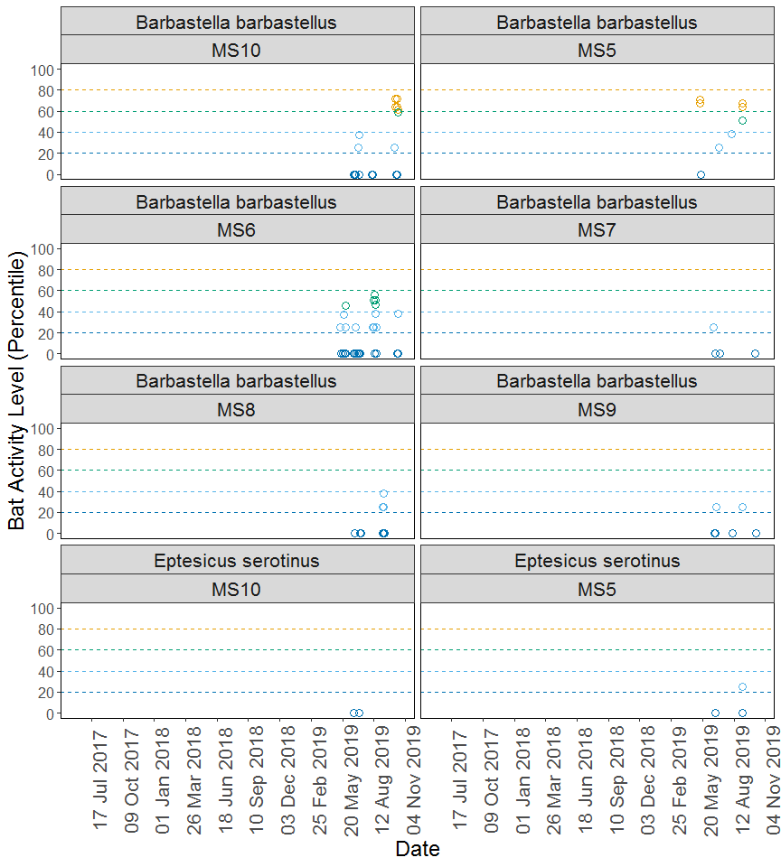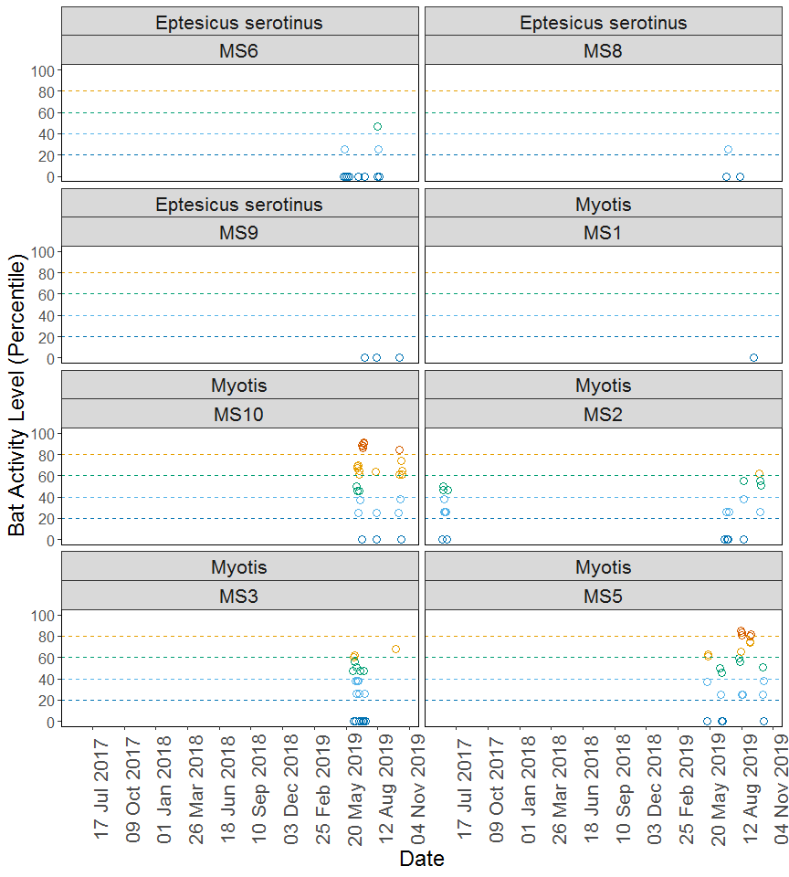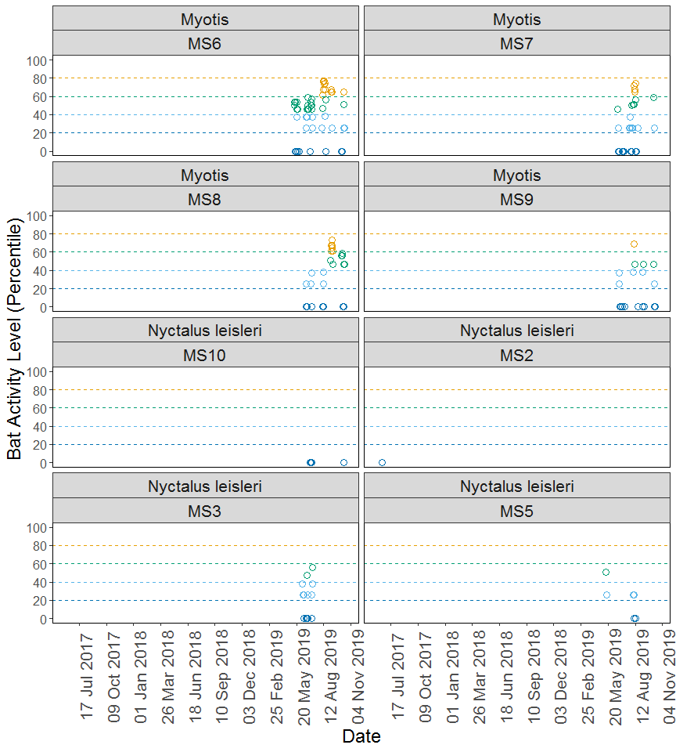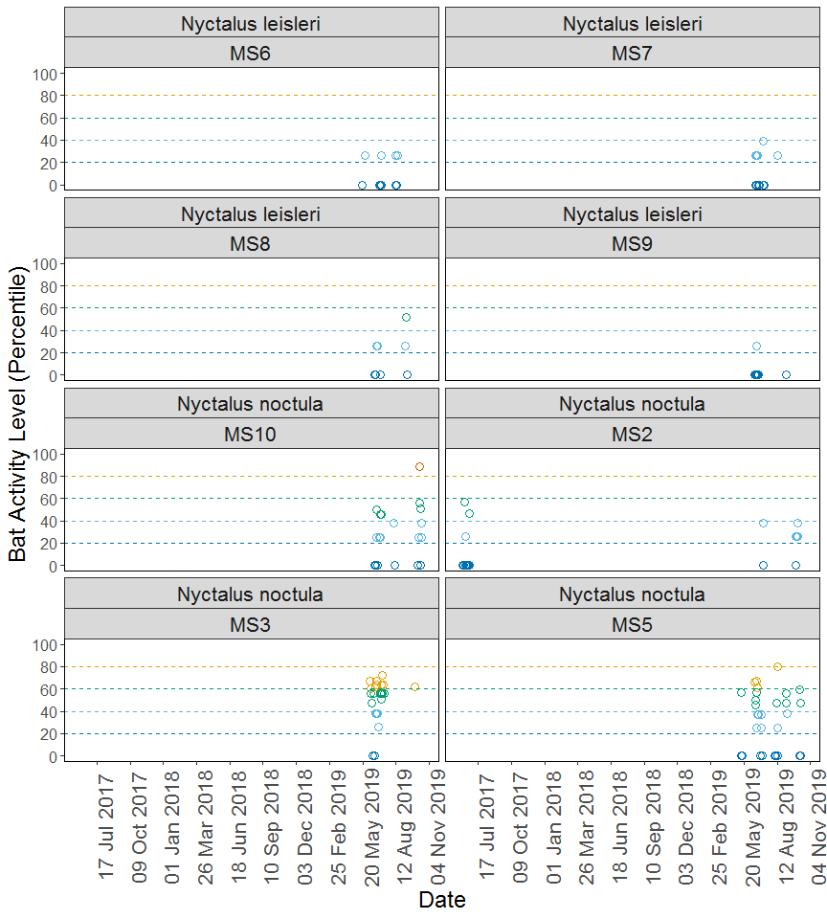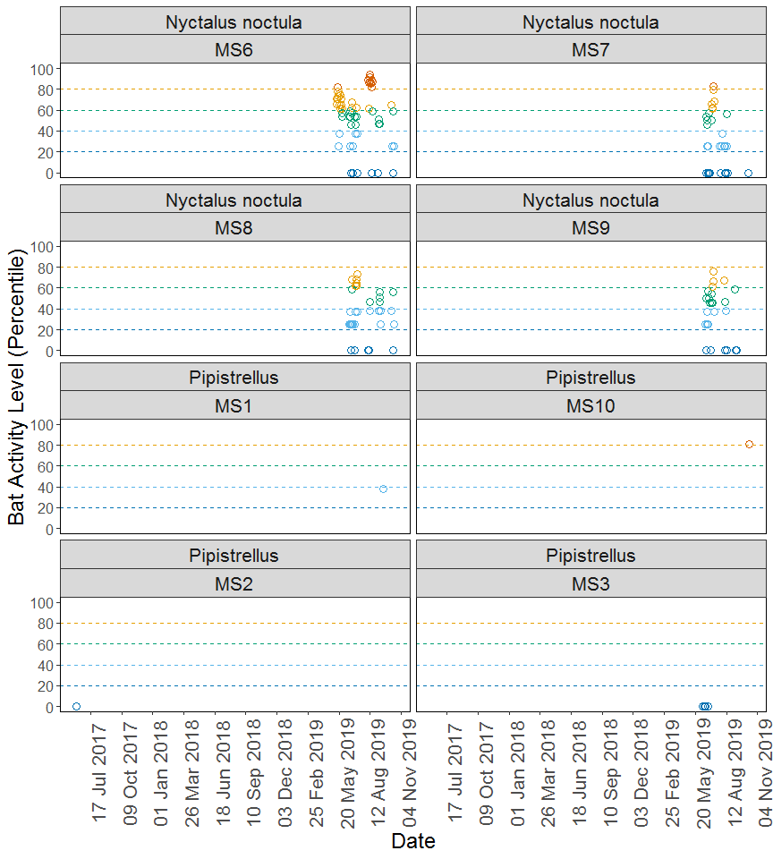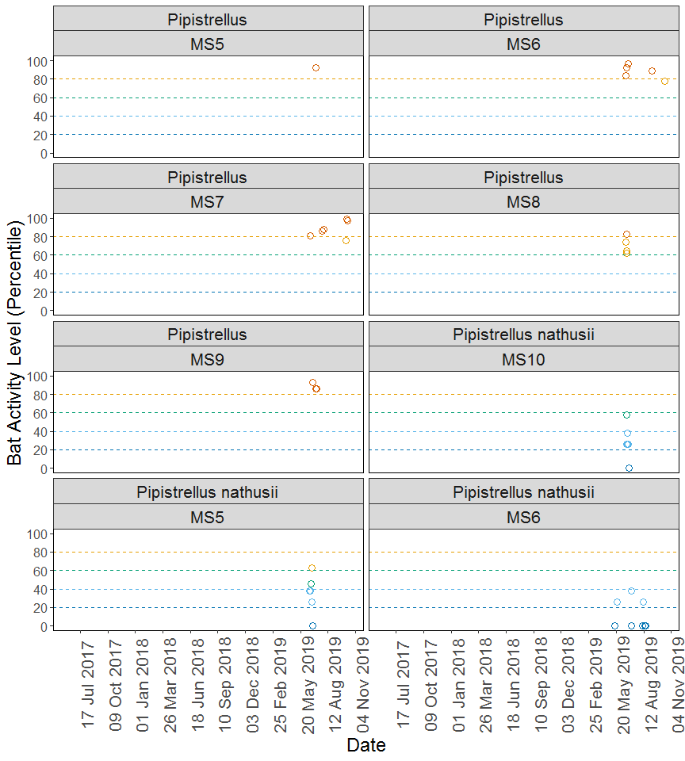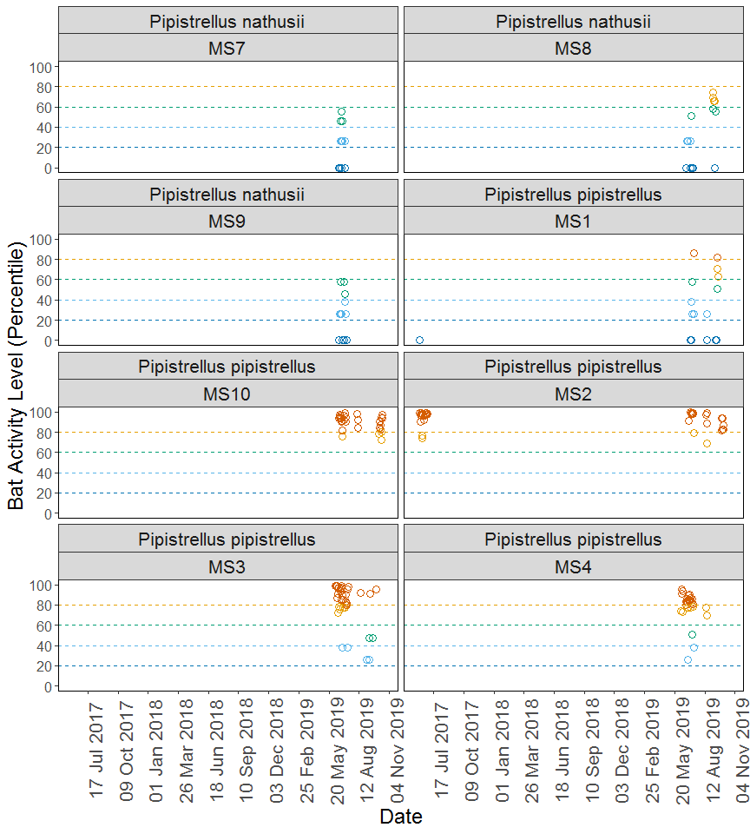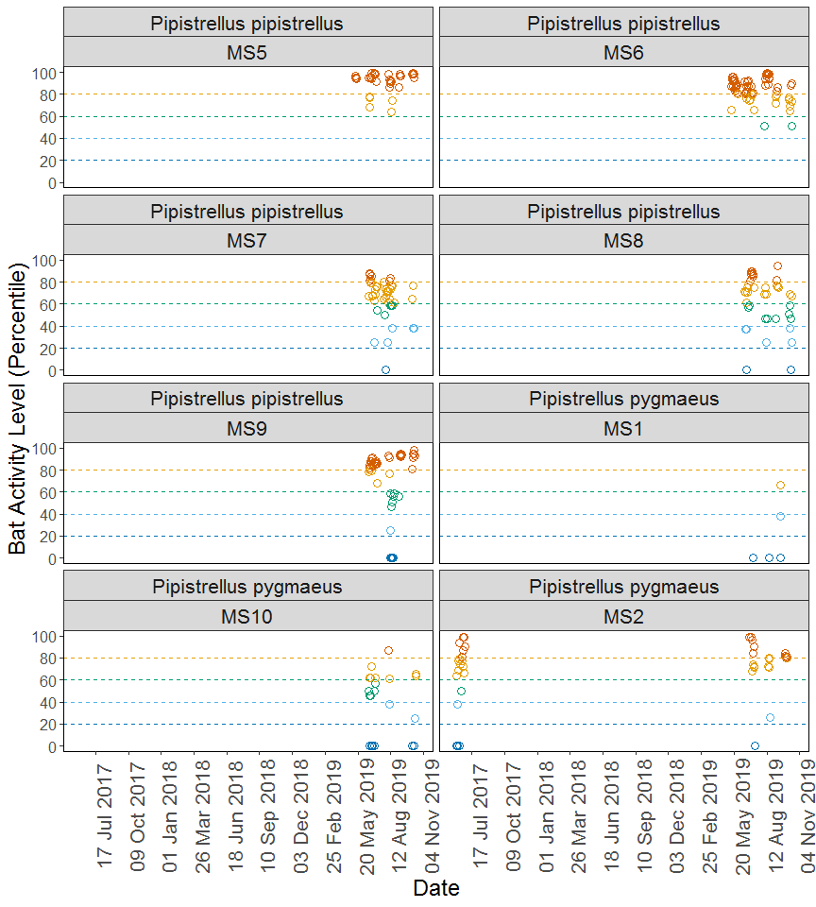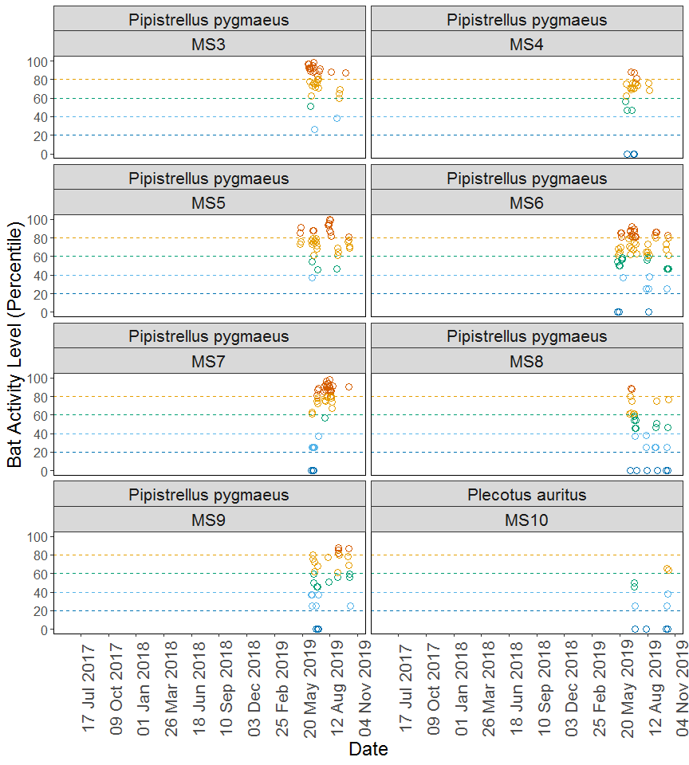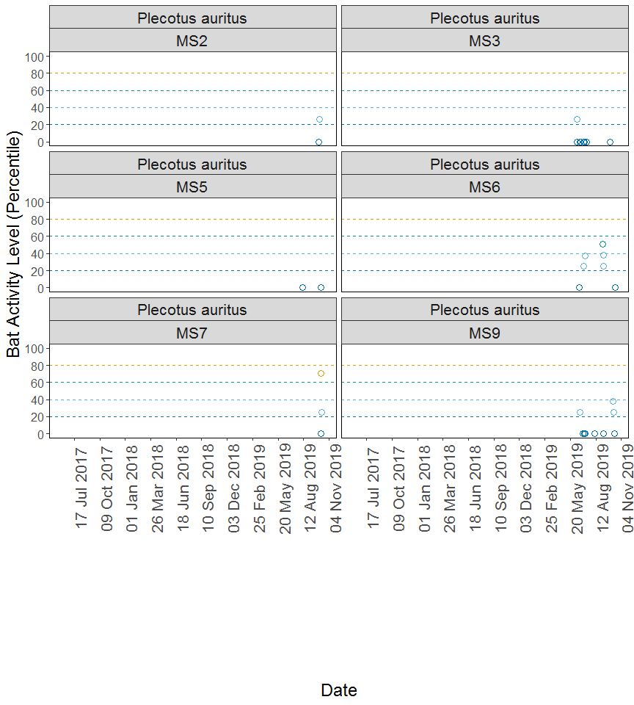

## PER DETECTOR, PER MONTH

#### Table 1

Summary table showing the number of nights recorded bat activity fell into each activity band for each species at each detector during each month.

|  |  |  |  |  |  |  |  |
| --- | --- | --- | --- | --- | --- | --- | --- |
| Detector ID | Species/Species Group | Month | Nights of High Activity | Nights of Moderate/ High Activity | Nights of Moderate Activity | Nights of Low/ Moderate Activity | Nights of Low Activity |
| MS1 | *Myotis* | Sep | 0 | 0 | 0 | 0 | 1 |
| MS1 | *Pipistrellus* | Sep | 0 | 0 | 0 | 1 | 0 |
| MS1 | *Pipistrellus pipistrellus* | Jun | 0 | 0 | 0 | 0 | 1 |
| MS1 | *Pipistrellus pipistrellus* | Jul | 1 | 0 | 1 | 3 | 2 |
| MS1 | *Pipistrellus pipistrellus* | Aug | 0 | 0 | 0 | 1 | 1 |
| MS1 | *Pipistrellus pipistrellus* | Sep | 1 | 2 | 1 | 0 | 2 |
| MS1 | *Pipistrellus pygmaeus* | Jul | 0 | 0 | 0 | 0 | 1 |
| MS1 | *Pipistrellus pygmaeus* | Aug | 0 | 0 | 0 | 0 | 2 |
| MS1 | *Pipistrellus pygmaeus* | Sep | 0 | 1 | 0 | 1 | 1 |
| MS10 | *Barbastella barbastellus* | Jun | 0 | 0 | 0 | 0 | 3 |
| MS10 | *Barbastella barbastellus* | Jul | 0 | 0 | 0 | 2 | 1 |
| MS10 | *Barbastella barbastellus* | Aug | 0 | 0 | 0 | 0 | 2 |
| MS10 | *Barbastella barbastellus* | Oct | 0 | 5 | 1 | 1 | 2 |
| MS10 | *Eptesicus serotinus* | Jun | 0 | 0 | 0 | 0 | 1 |
| MS10 | *Eptesicus serotinus* | Jul | 0 | 0 | 0 | 0 | 1 |
| MS10 | *Myotis* | Jun | 0 | 5 | 3 | 3 | 0 |
| MS10 | *Myotis* | Jul | 5 | 0 | 0 | 0 | 1 |
| MS10 | *Myotis* | Aug | 0 | 1 | 0 | 1 | 1 |
| MS10 | *Myotis* | Oct | 1 | 4 | 0 | 2 | 1 |
| MS10 | *Nyctalus leisleri* | Jul | 0 | 0 | 0 | 0 | 3 |
| MS10 | *Nyctalus leisleri* | Oct | 0 | 0 | 0 | 0 | 2 |
| MS10 | *Nyctalus noctula* | Jun | 0 | 0 | 1 | 1 | 3 |
| MS10 | *Nyctalus noctula* | Jul | 0 | 0 | 2 | 2 | 0 |
| MS10 | *Nyctalus noctula* | Aug | 0 | 0 | 0 | 1 | 2 |
| MS10 | *Nyctalus noctula* | Oct | 1 | 0 | 2 | 3 | 2 |
| MS10 | *Pipistrellus* | Oct | 1 | 0 | 0 | 0 | 0 |
| MS10 | *Pipistrellus nathusii* | Jun | 0 | 0 | 1 | 5 | 1 |
| MS10 | *Pipistrellus pipistrellus* | Jun | 10 | 1 | 0 | 0 | 0 |
| MS10 | *Pipistrellus pipistrellus* | Jul | 6 | 0 | 0 | 0 | 0 |
| MS10 | *Pipistrellus pipistrellus* | Aug | 3 | 0 | 0 | 0 | 0 |
| MS10 | *Pipistrellus pipistrellus* | Oct | 7 | 3 | 0 | 0 | 0 |
| MS10 | *Pipistrellus pygmaeus* | Jun | 0 | 3 | 3 | 0 | 4 |
| MS10 | *Pipistrellus pygmaeus* | Jul | 0 | 1 | 2 | 0 | 1 |
| MS10 | *Pipistrellus pygmaeus* | Aug | 1 | 1 | 0 | 1 | 0 |
| MS10 | *Pipistrellus pygmaeus* | Oct | 0 | 2 | 0 | 3 | 3 |
| MS10 | *Plecotus auritus* | Jul | 0 | 0 | 2 | 1 | 1 |
| MS10 | *Plecotus auritus* | Aug | 0 | 0 | 0 | 0 | 1 |
| MS10 | *Plecotus auritus* | Oct | 0 | 2 | 0 | 2 | 2 |
| MS2 | *Myotis* | Jun | 0 | 0 | 3 | 5 | 3 |
| MS2 | *Myotis* | Jul | 0 | 0 | 0 | 2 | 2 |
| MS2 | *Myotis* | Aug | 0 | 0 | 1 | 1 | 1 |
| MS2 | *Myotis* | Sep | 0 | 2 | 1 | 0 | 0 |
| MS2 | *Myotis* | Oct | 0 | 0 | 1 | 1 | 0 |
| MS2 | *Nyctalus leisleri* | Jun | 0 | 0 | 0 | 0 | 1 |
| MS2 | *Nyctalus noctula* | Jun | 0 | 0 | 2 | 1 | 10 |
| MS2 | *Nyctalus noctula* | Jul | 0 | 0 | 0 | 1 | 1 |
| MS2 | *Nyctalus noctula* | Sep | 0 | 0 | 0 | 1 | 1 |
| MS2 | *Nyctalus noctula* | Oct | 0 | 0 | 0 | 3 | 0 |
| MS2 | *Pipistrellus* | Jun | 0 | 0 | 0 | 0 | 1 |
| MS2 | *Pipistrellus pipistrellus* | Jun | 18 | 2 | 0 | 0 | 0 |
| MS2 | *Pipistrellus pipistrellus* | Jul | 7 | 1 | 0 | 0 | 0 |
| MS2 | *Pipistrellus pipistrellus* | Aug | 3 | 1 | 0 | 0 | 0 |
| MS2 | *Pipistrellus pipistrellus* | Sep | 3 | 0 | 0 | 0 | 0 |
| MS2 | *Pipistrellus pipistrellus* | Oct | 3 | 0 | 0 | 0 | 0 |
| MS2 | *Pipistrellus pygmaeus* | Jun | 7 | 8 | 1 | 1 | 3 |
| MS2 | *Pipistrellus pygmaeus* | Jul | 4 | 4 | 0 | 0 | 1 |
| MS2 | *Pipistrellus pygmaeus* | Aug | 0 | 4 | 0 | 1 | 0 |
| MS2 | *Pipistrellus pygmaeus* | Sep | 3 | 0 | 0 | 0 | 0 |
| MS2 | *Pipistrellus pygmaeus* | Oct | 2 | 1 | 0 | 0 | 0 |
| MS2 | *Plecotus auritus* | Oct | 0 | 0 | 0 | 1 | 1 |
| MS3 | *Myotis* | Jun | 0 | 2 | 4 | 8 | 5 |
| MS3 | *Myotis* | Jul | 0 | 0 | 1 | 1 | 3 |
| MS3 | *Myotis* | Sep | 0 | 1 | 0 | 0 | 0 |
| MS3 | *Nyctalus leisleri* | Jun | 0 | 0 | 1 | 5 | 4 |
| MS3 | *Nyctalus leisleri* | Jul | 0 | 0 | 1 | 2 | 2 |
| MS3 | *Nyctalus noctula* | Jun | 0 | 5 | 3 | 4 | 3 |
| MS3 | *Nyctalus noctula* | Jul | 0 | 3 | 5 | 0 | 0 |
| MS3 | *Nyctalus noctula* | Sep | 0 | 1 | 0 | 0 | 0 |
| MS3 | *Pipistrellus* | Jun | 0 | 0 | 0 | 0 | 4 |
| MS3 | *Pipistrellus pipistrellus* | Jun | 15 | 4 | 0 | 1 | 0 |
| MS3 | *Pipistrellus pipistrellus* | Jul | 6 | 2 | 0 | 1 | 0 |
| MS3 | *Pipistrellus pipistrellus* | Aug | 1 | 0 | 0 | 0 | 0 |
| MS3 | *Pipistrellus pipistrellus* | Sep | 2 | 0 | 2 | 2 | 0 |
| MS3 | *Pipistrellus pygmaeus* | Jun | 12 | 6 | 1 | 1 | 0 |
| MS3 | *Pipistrellus pygmaeus* | Jul | 3 | 5 | 0 | 0 | 0 |
| MS3 | *Pipistrellus pygmaeus* | Aug | 1 | 0 | 0 | 0 | 0 |
| MS3 | *Pipistrellus pygmaeus* | Sep | 1 | 3 | 0 | 1 | 0 |
| MS3 | *Plecotus auritus* | Jun | 0 | 0 | 0 | 1 | 4 |
| MS3 | *Plecotus auritus* | Jul | 0 | 0 | 0 | 0 | 3 |
| MS3 | *Plecotus auritus* | Sep | 0 | 0 | 0 | 0 | 1 |
| MS4 | *Pipistrellus pipistrellus* | Jun | 10 | 3 | 0 | 1 | 0 |
| MS4 | *Pipistrellus pipistrellus* | Jul | 6 | 2 | 1 | 1 | 0 |
| MS4 | *Pipistrellus pipistrellus* | Aug | 0 | 2 | 0 | 0 | 0 |
| MS4 | *Pipistrellus pygmaeus* | Jun | 1 | 7 | 3 | 0 | 2 |
| MS4 | *Pipistrellus pygmaeus* | Jul | 3 | 5 | 0 | 0 | 1 |
| MS4 | *Pipistrellus pygmaeus* | Aug | 0 | 2 | 0 | 0 | 0 |
| MS5 | *Barbastella barbastellus* | May | 0 | 2 | 0 | 0 | 1 |
| MS5 | *Barbastella barbastellus* | Jul | 0 | 0 | 0 | 1 | 0 |
| MS5 | *Barbastella barbastellus* | Aug | 0 | 0 | 0 | 1 | 0 |
| MS5 | *Barbastella barbastellus* | Sep | 0 | 2 | 1 | 0 | 0 |
| MS5 | *Eptesicus serotinus* | Jun | 0 | 0 | 0 | 0 | 1 |
| MS5 | *Eptesicus serotinus* | Sep | 0 | 0 | 0 | 1 | 2 |
| MS5 | *Myotis* | May | 0 | 2 | 0 | 1 | 1 |
| MS5 | *Myotis* | Jun | 0 | 0 | 2 | 1 | 3 |
| MS5 | *Myotis* | Aug | 3 | 1 | 3 | 2 | 0 |
| MS5 | *Myotis* | Sep | 2 | 2 | 0 | 0 | 0 |
| MS5 | *Myotis* | Oct | 0 | 0 | 1 | 2 | 1 |
| MS5 | *Nyctalus leisleri* | May | 0 | 0 | 1 | 1 | 0 |
| MS5 | *Nyctalus leisleri* | Aug | 0 | 0 | 0 | 2 | 2 |
| MS5 | *Nyctalus noctula* | May | 0 | 0 | 1 | 0 | 3 |
| MS5 | *Nyctalus noctula* | Jun | 0 | 3 | 3 | 3 | 0 |
| MS5 | *Nyctalus noctula* | Jul | 0 | 0 | 0 | 3 | 2 |
| MS5 | *Nyctalus noctula* | Aug | 0 | 1 | 1 | 1 | 4 |
| MS5 | *Nyctalus noctula* | Sep | 0 | 0 | 2 | 1 | 0 |
| MS5 | *Nyctalus noctula* | Oct | 0 | 0 | 2 | 0 | 2 |
| MS5 | *Pipistrellus* | Jul | 1 | 0 | 0 | 0 | 0 |
| MS5 | *Pipistrellus nathusii* | Jun | 0 | 1 | 1 | 3 | 1 |
| MS5 | *Pipistrellus pipistrellus* | May | 4 | 0 | 0 | 0 | 0 |
| MS5 | *Pipistrellus pipistrellus* | Jun | 7 | 3 | 0 | 0 | 0 |
| MS5 | *Pipistrellus pipistrellus* | Jul | 5 | 0 | 0 | 0 | 0 |
| MS5 | *Pipistrellus pipistrellus* | Aug | 7 | 2 | 0 | 0 | 0 |
| MS5 | *Pipistrellus pipistrellus* | Sep | 4 | 0 | 0 | 0 | 0 |
| MS5 | *Pipistrellus pipistrellus* | Oct | 5 | 0 | 0 | 0 | 0 |
| MS5 | *Pipistrellus pygmaeus* | May | 2 | 2 | 0 | 0 | 0 |
| MS5 | *Pipistrellus pygmaeus* | Jun | 2 | 6 | 1 | 1 | 0 |
| MS5 | *Pipistrellus pygmaeus* | Jul | 0 | 4 | 1 | 0 | 0 |
| MS5 | *Pipistrellus pygmaeus* | Aug | 9 | 0 | 0 | 0 | 0 |
| MS5 | *Pipistrellus pygmaeus* | Sep | 0 | 3 | 1 | 0 | 0 |
| MS5 | *Pipistrellus pygmaeus* | Oct | 1 | 4 | 0 | 0 | 0 |
| MS5 | *Plecotus auritus* | Aug | 0 | 0 | 0 | 0 | 1 |
| MS5 | *Plecotus auritus* | Oct | 0 | 0 | 0 | 0 | 1 |
| MS6 | *Barbastella barbastellus* | May | 0 | 0 | 1 | 4 | 5 |
| MS6 | *Barbastella barbastellus* | Jun | 0 | 0 | 0 | 1 | 3 |
| MS6 | *Barbastella barbastellus* | Jul | 0 | 0 | 0 | 0 | 3 |
| MS6 | *Barbastella barbastellus* | Aug | 0 | 0 | 4 | 4 | 2 |
| MS6 | *Barbastella barbastellus* | Oct | 0 | 0 | 0 | 1 | 2 |
| MS6 | *Eptesicus serotinus* | May | 0 | 0 | 0 | 1 | 4 |
| MS6 | *Eptesicus serotinus* | Jun | 0 | 0 | 0 | 0 | 1 |
| MS6 | *Eptesicus serotinus* | Jul | 0 | 0 | 0 | 0 | 1 |
| MS6 | *Eptesicus serotinus* | Aug | 0 | 0 | 1 | 1 | 2 |
| MS6 | *Myotis* | May | 0 | 0 | 6 | 1 | 4 |
| MS6 | *Myotis* | Jun | 0 | 0 | 5 | 4 | 0 |
| MS6 | *Myotis* | Jul | 0 | 0 | 5 | 2 | 2 |
| MS6 | *Myotis* | Aug | 0 | 8 | 2 | 2 | 1 |
| MS6 | *Myotis* | Sep | 0 | 3 | 0 | 2 | 0 |
| MS6 | *Myotis* | Oct | 0 | 1 | 1 | 3 | 3 |
| MS6 | *Nyctalus leisleri* | May | 0 | 0 | 0 | 1 | 1 |
| MS6 | *Nyctalus leisleri* | Jul | 0 | 0 | 0 | 1 | 4 |
| MS6 | *Nyctalus leisleri* | Aug | 0 | 0 | 0 | 2 | 3 |
| MS6 | *Nyctalus noctula* | May | 1 | 12 | 2 | 2 | 0 |
| MS6 | *Nyctalus noctula* | Jun | 0 | 2 | 5 | 2 | 2 |
| MS6 | *Nyctalus noctula* | Jul | 0 | 2 | 3 | 2 | 1 |
| MS6 | *Nyctalus noctula* | Aug | 10 | 1 | 1 | 0 | 1 |
| MS6 | *Nyctalus noctula* | Sep | 0 | 0 | 3 | 0 | 1 |
| MS6 | *Nyctalus noctula* | Oct | 0 | 1 | 1 | 3 | 1 |
| MS6 | *Pipistrellus* | Jun | 3 | 0 | 0 | 0 | 0 |
| MS6 | *Pipistrellus* | Sep | 1 | 0 | 0 | 0 | 0 |
| MS6 | *Pipistrellus* | Oct | 0 | 1 | 0 | 0 | 0 |
| MS6 | *Pipistrellus nathusii* | May | 0 | 0 | 0 | 1 | 1 |
| MS6 | *Pipistrellus nathusii* | Jul | 0 | 0 | 0 | 1 | 1 |
| MS6 | *Pipistrellus nathusii* | Aug | 0 | 0 | 0 | 1 | 3 |
| MS6 | *Pipistrellus pipistrellus* | May | 15 | 2 | 0 | 0 | 0 |
| MS6 | *Pipistrellus pipistrellus* | Jun | 9 | 2 | 0 | 0 | 0 |
| MS6 | *Pipistrellus pipistrellus* | Jul | 5 | 4 | 0 | 0 | 0 |
| MS6 | *Pipistrellus pipistrellus* | Aug | 12 | 0 | 1 | 0 | 0 |
| MS6 | *Pipistrellus pipistrellus* | Sep | 2 | 3 | 0 | 0 | 0 |
| MS6 | *Pipistrellus pipistrellus* | Oct | 2 | 5 | 1 | 0 | 0 |
| MS6 | *Pipistrellus pygmaeus* | May | 3 | 5 | 6 | 1 | 2 |
| MS6 | *Pipistrellus pygmaeus* | Jun | 6 | 5 | 0 | 0 | 0 |
| MS6 | *Pipistrellus pygmaeus* | Jul | 5 | 4 | 0 | 0 | 0 |
| MS6 | *Pipistrellus pygmaeus* | Aug | 0 | 5 | 2 | 3 | 1 |
| MS6 | *Pipistrellus pygmaeus* | Sep | 3 | 1 | 0 | 0 | 0 |
| MS6 | *Pipistrellus pygmaeus* | Oct | 1 | 4 | 3 | 1 | 0 |
| MS6 | *Plecotus auritus* | Jun | 0 | 0 | 0 | 0 | 1 |
| MS6 | *Plecotus auritus* | Jul | 0 | 0 | 0 | 2 | 0 |
| MS6 | *Plecotus auritus* | Sep | 0 | 0 | 1 | 2 | 0 |
| MS6 | *Plecotus auritus* | Oct | 0 | 0 | 0 | 0 | 1 |
| MS7 | *Barbastella barbastellus* | Jun | 0 | 0 | 0 | 1 | 1 |
| MS7 | *Barbastella barbastellus* | Jul | 0 | 0 | 0 | 0 | 1 |
| MS7 | *Barbastella barbastellus* | Oct | 0 | 0 | 0 | 0 | 1 |
| MS7 | *Myotis* | Jun | 0 | 0 | 1 | 1 | 4 |
| MS7 | *Myotis* | Jul | 0 | 0 | 0 | 3 | 9 |
| MS7 | *Myotis* | Aug | 0 | 4 | 5 | 3 | 3 |
| MS7 | *Myotis* | Oct | 0 | 0 | 1 | 1 | 0 |
| MS7 | *Nyctalus leisleri* | Jun | 0 | 0 | 0 | 5 | 4 |
| MS7 | *Nyctalus leisleri* | Jul | 0 | 0 | 0 | 1 | 2 |
| MS7 | *Nyctalus leisleri* | Aug | 0 | 0 | 0 | 1 | 0 |
| MS7 | *Nyctalus noctula* | Jun | 0 | 0 | 4 | 2 | 4 |
| MS7 | *Nyctalus noctula* | Jul | 1 | 5 | 2 | 3 | 2 |
| MS7 | *Nyctalus noctula* | Aug | 0 | 0 | 1 | 3 | 3 |
| MS7 | *Nyctalus noctula* | Oct | 0 | 0 | 0 | 0 | 1 |
| MS7 | *Pipistrellus* | Jun | 1 | 0 | 0 | 0 | 0 |
| MS7 | *Pipistrellus* | Jul | 2 | 0 | 0 | 0 | 0 |
| MS7 | *Pipistrellus* | Oct | 2 | 1 | 0 | 0 | 0 |
| MS7 | *Pipistrellus nathusii* | Jun | 0 | 0 | 3 | 3 | 3 |
| MS7 | *Pipistrellus nathusii* | Jul | 0 | 0 | 0 | 1 | 1 |
| MS7 | *Pipistrellus pipistrellus* | Jun | 6 | 5 | 0 | 0 | 0 |
| MS7 | *Pipistrellus pipistrellus* | Jul | 0 | 11 | 2 | 1 | 1 |
| MS7 | *Pipistrellus pipistrellus* | Aug | 2 | 10 | 3 | 3 | 0 |
| MS7 | *Pipistrellus pipistrellus* | Oct | 0 | 2 | 0 | 2 | 0 |
| MS7 | *Pipistrellus pygmaeus* | Jun | 0 | 2 | 0 | 5 | 3 |
| MS7 | *Pipistrellus pygmaeus* | Jul | 7 | 5 | 1 | 1 | 0 |
| MS7 | *Pipistrellus pygmaeus* | Aug | 14 | 6 | 0 | 0 | 0 |
| MS7 | *Pipistrellus pygmaeus* | Oct | 1 | 0 | 0 | 0 | 0 |
| MS7 | *Plecotus auritus* | Oct | 0 | 1 | 0 | 1 | 1 |
| MS8 | *Barbastella barbastellus* | Jun | 0 | 0 | 0 | 0 | 1 |
| MS8 | *Barbastella barbastellus* | Jul | 0 | 0 | 0 | 0 | 2 |
| MS8 | *Barbastella barbastellus* | Sep | 0 | 0 | 0 | 3 | 3 |
| MS8 | *Eptesicus serotinus* | Jul | 0 | 0 | 0 | 1 | 1 |
| MS8 | *Eptesicus serotinus* | Aug | 0 | 0 | 0 | 0 | 1 |
| MS8 | *Myotis* | Jun | 0 | 0 | 0 | 1 | 2 |
| MS8 | *Myotis* | Jul | 0 | 0 | 0 | 3 | 2 |
| MS8 | *Myotis* | Aug | 0 | 0 | 0 | 2 | 3 |
| MS8 | *Myotis* | Sep | 0 | 6 | 2 | 0 | 0 |
| MS8 | *Myotis* | Oct | 0 | 0 | 6 | 0 | 3 |
| MS8 | *Nyctalus leisleri* | Jun | 0 | 0 | 0 | 3 | 2 |
| MS8 | *Nyctalus leisleri* | Jul | 0 | 0 | 0 | 0 | 1 |
| MS8 | *Nyctalus leisleri* | Sep | 0 | 0 | 1 | 1 | 1 |
| MS8 | *Nyctalus noctula* | Jun | 0 | 1 | 1 | 7 | 1 |
| MS8 | *Nyctalus noctula* | Jul | 0 | 5 | 0 | 3 | 1 |
| MS8 | *Nyctalus noctula* | Aug | 0 | 0 | 1 | 1 | 2 |
| MS8 | *Nyctalus noctula* | Sep | 0 | 0 | 3 | 3 | 0 |
| MS8 | *Nyctalus noctula* | Oct | 0 | 0 | 1 | 3 | 1 |
| MS8 | *Pipistrellus* | Jun | 1 | 3 | 0 | 0 | 0 |
| MS8 | *Pipistrellus nathusii* | Jun | 0 | 0 | 0 | 2 | 2 |
| MS8 | *Pipistrellus nathusii* | Jul | 0 | 0 | 1 | 1 | 4 |
| MS8 | *Pipistrellus nathusii* | Sep | 0 | 5 | 2 | 0 | 1 |
| MS8 | *Pipistrellus pipistrellus* | Jun | 0 | 6 | 2 | 2 | 1 |
| MS8 | *Pipistrellus pipistrellus* | Jul | 8 | 1 | 0 | 0 | 0 |
| MS8 | *Pipistrellus pipistrellus* | Aug | 0 | 3 | 2 | 1 | 0 |
| MS8 | *Pipistrellus pipistrellus* | Sep | 2 | 3 | 1 | 0 | 0 |
| MS8 | *Pipistrellus pipistrellus* | Oct | 0 | 2 | 3 | 3 | 1 |
| MS8 | *Pipistrellus pygmaeus* | Jun | 2 | 4 | 0 | 0 | 2 |
| MS8 | *Pipistrellus pygmaeus* | Jul | 0 | 2 | 5 | 1 | 1 |
| MS8 | *Pipistrellus pygmaeus* | Aug | 0 | 0 | 0 | 2 | 1 |
| MS8 | *Pipistrellus pygmaeus* | Sep | 0 | 1 | 2 | 2 | 1 |
| MS8 | *Pipistrellus pygmaeus* | Oct | 0 | 1 | 1 | 1 | 2 |
| MS9 | *Barbastella barbastellus* | Jun | 0 | 0 | 0 | 1 | 2 |
| MS9 | *Barbastella barbastellus* | Aug | 0 | 0 | 0 | 0 | 1 |
| MS9 | *Barbastella barbastellus* | Sep | 0 | 0 | 0 | 1 | 0 |
| MS9 | *Barbastella barbastellus* | Oct | 0 | 0 | 0 | 0 | 1 |
| MS9 | *Eptesicus serotinus* | Jul | 0 | 0 | 0 | 0 | 1 |
| MS9 | *Eptesicus serotinus* | Aug | 0 | 0 | 0 | 0 | 1 |
| MS9 | *Eptesicus serotinus* | Oct | 0 | 0 | 0 | 0 | 2 |
| MS9 | *Myotis* | Jun | 0 | 0 | 0 | 2 | 3 |
| MS9 | *Myotis* | Jul | 0 | 0 | 0 | 0 | 2 |
| MS9 | *Myotis* | Aug | 0 | 2 | 1 | 1 | 1 |
| MS9 | *Myotis* | Sep | 0 | 0 | 2 | 2 | 3 |
| MS9 | *Myotis* | Oct | 0 | 0 | 1 | 1 | 2 |
| MS9 | *Nyctalus leisleri* | Jun | 0 | 0 | 0 | 1 | 5 |
| MS9 | *Nyctalus leisleri* | Sep | 0 | 0 | 0 | 0 | 1 |
| MS9 | *Nyctalus noctula* | Jun | 0 | 0 | 4 | 5 | 1 |
| MS9 | *Nyctalus noctula* | Jul | 0 | 3 | 3 | 1 | 1 |
| MS9 | *Nyctalus noctula* | Aug | 0 | 1 | 1 | 1 | 2 |
| MS9 | *Nyctalus noctula* | Sep | 0 | 0 | 1 | 0 | 3 |
| MS9 | *Pipistrellus* | Jun | 1 | 0 | 0 | 0 | 0 |
| MS9 | *Pipistrellus* | Jul | 2 | 0 | 0 | 0 | 0 |
| MS9 | *Pipistrellus nathusii* | Jun | 0 | 0 | 1 | 4 | 3 |
| MS9 | *Pipistrellus nathusii* | Jul | 0 | 0 | 2 | 3 | 2 |
| MS9 | *Pipistrellus pipistrellus* | Jun | 8 | 3 | 0 | 0 | 0 |
| MS9 | *Pipistrellus pipistrellus* | Jul | 8 | 1 | 0 | 0 | 0 |
| MS9 | *Pipistrellus pipistrellus* | Aug | 2 | 1 | 5 | 1 | 5 |
| MS9 | *Pipistrellus pipistrellus* | Sep | 6 | 0 | 1 | 0 | 0 |
| MS9 | *Pipistrellus pipistrellus* | Oct | 6 | 0 | 0 | 0 | 0 |
| MS9 | *Pipistrellus pygmaeus* | Jun | 0 | 4 | 3 | 4 | 0 |
| MS9 | *Pipistrellus pygmaeus* | Jul | 0 | 1 | 3 | 2 | 3 |
| MS9 | *Pipistrellus pygmaeus* | Aug | 0 | 1 | 1 | 0 | 0 |
| MS9 | *Pipistrellus pygmaeus* | Sep | 3 | 2 | 1 | 0 | 0 |
| MS9 | *Pipistrellus pygmaeus* | Oct | 1 | 2 | 2 | 1 | 0 |
| MS9 | *Plecotus auritus* | Jun | 0 | 0 | 0 | 1 | 0 |
| MS9 | *Plecotus auritus* | Jul | 0 | 0 | 0 | 0 | 3 |
| MS9 | *Plecotus auritus* | Aug | 0 | 0 | 0 | 0 | 1 |
| MS9 | *Plecotus auritus* | Sep | 0 | 0 | 0 | 0 | 1 |
| MS9 | *Plecotus auritus* | Oct | 0 | 0 | 0 | 2 | 1 |

#### Table 2

Summary table showing key metrics for each species recorded per month. Please note that the reference range is not split by month.

|  |  |  |  |  |  |  |  |
| --- | --- | --- | --- | --- | --- | --- | --- |
| Detector ID | Species/Species Group | Month | Median Percentile | 95% CIs | Max Percentile | Nights Recorded | Reference Range |
| MS1 | *Myotis* | Sep | 0 | 0 | 0 | 1 | 1967 |
| MS1 | *Pipistrellus* | Sep | 38 | 0 | 38 | 1 | 4447 |
| MS1 | *Pipistrellus pipistrellus* | Jun | 0 | 32 - 72 | 0 | 1 | 2198 |
| MS1 | *Pipistrellus pipistrellus* | Jul | 26 | 32 - 72 | 86 | 7 | 4138 |
| MS1 | *Pipistrellus pipistrellus* | Aug | 13 | 32 - 72 | 26 | 2 | 4138 |
| MS1 | *Pipistrellus pipistrellus* | Sep | 57 | 32 - 72 | 82 | 6 | 4138 |
| MS1 | *Pipistrellus pygmaeus* | Jul | 0 | 52 - 52 | 0 | 1 | 2306 |
| MS1 | *Pipistrellus pygmaeus* | Aug | 0 | 52 - 52 | 0 | 2 | 2306 |
| MS1 | *Pipistrellus pygmaeus* | Sep | 38 | 52 - 52 | 66 | 3 | 2306 |
| MS10 | *Barbastella barbastellus* | Jun | 0 | 37 - 68 | 0 | 3 | 288 |
| MS10 | *Barbastella barbastellus* | Jul | 25 | 37 - 68 | 37 | 3 | 288 |
| MS10 | *Barbastella barbastellus* | Aug | 0 | 37 - 68 | 0 | 2 | 222 |
| MS10 | *Barbastella barbastellus* | Oct | 61 | 37 - 68 | 72 | 9 | 222 |
| MS10 | *Eptesicus serotinus* | Jun | 0 | 0 - 0 | 0 | 1 | 1251 |
| MS10 | *Eptesicus serotinus* | Jul | 0 | 0 - 0 | 0 | 1 | 1251 |
| MS10 | *Myotis* | Jun | 50 | 51 - 69.5 | 70 | 11 | 1514 |
| MS10 | *Myotis* | Jul | 89 | 51 - 69.5 | 91 | 6 | 1514 |
| MS10 | *Myotis* | Aug | 25 | 51 - 69.5 | 64 | 3 | 1183 |
| MS10 | *Myotis* | Oct | 61 | 51 - 69.5 | 84 | 8 | 1183 |
| MS10 | *Nyctalus leisleri* | Jul | 0 | 0 - 0 | 0 | 3 | 350 |
| MS10 | *Nyctalus leisleri* | Oct | 0 | 0 - 0 | 0 | 2 | 239 |
| MS10 | *Nyctalus noctula* | Jun | 0 | 31.5 - 51 | 50 | 5 | 1677 |
| MS10 | *Nyctalus noctula* | Jul | 36 | 31.5 - 51 | 46 | 4 | 1677 |
| MS10 | *Nyctalus noctula* | Aug | 0 | 31.5 - 51 | 38 | 3 | 1061 |
| MS10 | *Nyctalus noctula* | Oct | 32 | 31.5 - 51 | 89 | 8 | 1061 |
| MS10 | *Pipistrellus* | Oct | 81 | 0 | 81 | 1 | 2364 |
| MS10 | *Pipistrellus nathusii* | Jun | 26 | 26 - 38 | 58 | 7 | 429 |
| MS10 | *Pipistrellus pipistrellus* | Jun | 94 | 87.5 - 94 | 97 | 11 | 3382 |
| MS10 | *Pipistrellus pipistrellus* | Jul | 96 | 87.5 - 94 | 99 | 6 | 3382 |
| MS10 | *Pipistrellus pipistrellus* | Aug | 92 | 87.5 - 94 | 98 | 3 | 2154 |
| MS10 | *Pipistrellus pipistrellus* | Oct | 86 | 87.5 - 94 | 97 | 10 | 2154 |
| MS10 | *Pipistrellus pygmaeus* | Jun | 46 | 43.5 - 62 | 72 | 10 | 1911 |
| MS10 | *Pipistrellus pygmaeus* | Jul | 54 | 43.5 - 62 | 62 | 4 | 1911 |
| MS10 | *Pipistrellus pygmaeus* | Aug | 61 | 43.5 - 62 | 87 | 3 | 1460 |
| MS10 | *Pipistrellus pygmaeus* | Oct | 25 | 43.5 - 62 | 65 | 8 | 1460 |
| MS10 | *Plecotus auritus* | Jul | 36 | 31.5 - 57.5 | 50 | 4 | 513 |
| MS10 | *Plecotus auritus* | Aug | 0 | 31.5 - 57.5 | 0 | 1 | 409 |
| MS10 | *Plecotus auritus* | Oct | 32 | 31.5 - 57.5 | 65 | 6 | 409 |
| MS2 | *Myotis* | Jun | 26 | 32 - 49 | 50 | 11 | 1068 |
| MS2 | *Myotis* | Jul | 13 | 32 - 49 | 26 | 4 | 1967 |
| MS2 | *Myotis* | Aug | 38 | 32 - 49 | 55 | 3 | 1967 |
| MS2 | *Myotis* | Sep | 62 | 32 - 49 | 62 | 3 | 1967 |
| MS2 | *Myotis* | Oct | 39 | 32 - 49 | 51 | 2 | 1967 |
| MS2 | *Nyctalus leisleri* | Jun | 0 | 0 | 0 | 1 | 239 |
| MS2 | *Nyctalus noctula* | Jun | 0 | 26 - 42.5 | 57 | 13 | 1004 |
| MS2 | *Nyctalus noctula* | Jul | 19 | 26 - 42.5 | 38 | 2 | 2023 |
| MS2 | *Nyctalus noctula* | Sep | 13 | 26 - 42.5 | 26 | 2 | 2023 |
| MS2 | *Nyctalus noctula* | Oct | 26 | 26 - 42.5 | 38 | 3 | 2023 |
| MS2 | *Pipistrellus* | Jun | 0 | 0 | 0 | 1 | 2347 |
| MS2 | *Pipistrellus pipistrellus* | Jun | 97 | 91 - 97.5 | 99 | 20 | 2295 |
| MS2 | *Pipistrellus pipistrellus* | Jul | 99 | 91 - 97.5 | 100 | 8 | 4138 |
| MS2 | *Pipistrellus pipistrellus* | Aug | 93 | 91 - 97.5 | 99 | 4 | 4138 |
| MS2 | *Pipistrellus pipistrellus* | Sep | 83 | 91 - 97.5 | 94 | 3 | 4138 |
| MS2 | *Pipistrellus pipistrellus* | Oct | 87 | 91 - 97.5 | 94 | 3 | 4138 |
| MS2 | *Pipistrellus pygmaeus* | Jun | 76 | 74.5 - 83 | 99 | 20 | 1384 |
| MS2 | *Pipistrellus pygmaeus* | Jul | 74 | 74.5 - 83 | 99 | 9 | 2306 |
| MS2 | *Pipistrellus pygmaeus* | Aug | 72 | 74.5 - 83 | 80 | 5 | 2306 |
| MS2 | *Pipistrellus pygmaeus* | Sep | 82 | 74.5 - 83 | 84 | 3 | 2306 |
| MS2 | *Pipistrellus pygmaeus* | Oct | 80 | 74.5 - 83 | 81 | 3 | 2306 |
| MS2 | *Plecotus auritus* | Oct | 13 | 13 - 13 | 26 | 2 | 582 |
| MS3 | *Myotis* | Jun | 38 | 36.5 - 50 | 62 | 19 | 1848 |
| MS3 | *Myotis* | Jul | 0 | 36.5 - 50 | 47 | 5 | 1848 |
| MS3 | *Myotis* | Sep | 68 | 36.5 - 50 | 68 | 1 | 1848 |
| MS3 | *Nyctalus leisleri* | Jun | 26 | 26 - 41 | 47 | 10 | 266 |
| MS3 | *Nyctalus leisleri* | Jul | 26 | 26 - 41 | 56 | 5 | 266 |
| MS3 | *Nyctalus noctula* | Jun | 47 | 50 - 61.5 | 67 | 15 | 1774 |
| MS3 | *Nyctalus noctula* | Jul | 56 | 50 - 61.5 | 72 | 8 | 1774 |
| MS3 | *Nyctalus noctula* | Sep | 62 | 50 - 61.5 | 62 | 1 | 1774 |
| MS3 | *Pipistrellus* | Jun | 0 | 0 - 0 | 0 | 4 | 3999 |
| MS3 | *Pipistrellus pipistrellus* | Jun | 93 | 76 - 90.5 | 99 | 20 | 3692 |
| MS3 | *Pipistrellus pipistrellus* | Jul | 82 | 76 - 90.5 | 98 | 9 | 3692 |
| MS3 | *Pipistrellus pipistrellus* | Aug | 92 | 76 - 90.5 | 92 | 1 | 3692 |
| MS3 | *Pipistrellus pipistrellus* | Sep | 47 | 76 - 90.5 | 95 | 6 | 3692 |
| MS3 | *Pipistrellus pygmaeus* | Jun | 89 | 75.5 - 86 | 98 | 20 | 2261 |
| MS3 | *Pipistrellus pygmaeus* | Jul | 80 | 75.5 - 86 | 91 | 8 | 2261 |
| MS3 | *Pipistrellus pygmaeus* | Aug | 88 | 75.5 - 86 | 88 | 1 | 2261 |
| MS3 | *Pipistrellus pygmaeus* | Sep | 65 | 75.5 - 86 | 87 | 5 | 2261 |
| MS3 | *Plecotus auritus* | Jun | 0 | 0 - 0 | 26 | 5 | 581 |
| MS3 | *Plecotus auritus* | Jul | 0 | 0 - 0 | 0 | 3 | 581 |
| MS3 | *Plecotus auritus* | Sep | 0 | 0 - 0 | 0 | 1 | 581 |
| MS4 | *Pipistrellus pipistrellus* | Jun | 84 | 76.5 - 84.5 | 95 | 14 | 3692 |
| MS4 | *Pipistrellus pipistrellus* | Jul | 82 | 76.5 - 84.5 | 90 | 10 | 3692 |
| MS4 | *Pipistrellus pipistrellus* | Aug | 74 | 76.5 - 84.5 | 77 | 2 | 3692 |
| MS4 | *Pipistrellus pygmaeus* | Jun | 69 | 66.5 - 76 | 88 | 13 | 2261 |
| MS4 | *Pipistrellus pygmaeus* | Jul | 76 | 66.5 - 76 | 87 | 9 | 2261 |
| MS4 | *Pipistrellus pygmaeus* | Aug | 72 | 66.5 - 76 | 76 | 2 | 2261 |
| MS5 | *Barbastella barbastellus* | May | 67 | 31.5 - 69 | 71 | 3 | 288 |
| MS5 | *Barbastella barbastellus* | Jul | 25 | 31.5 - 69 | 25 | 1 | 288 |
| MS5 | *Barbastella barbastellus* | Aug | 38 | 31.5 - 69 | 38 | 1 | 222 |
| MS5 | *Barbastella barbastellus* | Sep | 64 | 31.5 - 69 | 67 | 3 | 222 |
| MS5 | *Eptesicus serotinus* | Jun | 0 | 0 - 0 | 0 | 1 | 1251 |
| MS5 | *Eptesicus serotinus* | Sep | 0 | 0 - 0 | 25 | 3 | 823 |
| MS5 | *Myotis* | May | 49 | 46.5 - 67.5 | 63 | 4 | 1514 |
| MS5 | *Myotis* | Jun | 13 | 46.5 - 67.5 | 50 | 6 | 1514 |
| MS5 | *Myotis* | Aug | 59 | 46.5 - 67.5 | 85 | 9 | 1183 |
| MS5 | *Myotis* | Sep | 78 | 46.5 - 67.5 | 82 | 4 | 1183 |
| MS5 | *Myotis* | Oct | 32 | 46.5 - 67.5 | 51 | 4 | 1183 |
| MS5 | *Nyctalus leisleri* | May | 39 | 26 - 26 | 51 | 2 | 350 |
| MS5 | *Nyctalus leisleri* | Aug | 13 | 26 - 26 | 26 | 4 | 239 |
| MS5 | *Nyctalus noctula* | May | 0 | 41 - 54 | 57 | 4 | 1677 |
| MS5 | *Nyctalus noctula* | Jun | 50 | 41 - 54 | 67 | 9 | 1677 |
| MS5 | *Nyctalus noctula* | Jul | 25 | 41 - 54 | 37 | 5 | 1677 |
| MS5 | *Nyctalus noctula* | Aug | 0 | 41 - 54 | 80 | 7 | 1061 |
| MS5 | *Nyctalus noctula* | Sep | 47 | 41 - 54 | 56 | 3 | 1061 |
| MS5 | *Nyctalus noctula* | Oct | 24 | 41 - 54 | 59 | 4 | 1061 |
| MS5 | *Pipistrellus* | Jul | 92 | 0 | 92 | 1 | 3578 |
| MS5 | *Pipistrellus nathusii* | Jun | 38 | 26 - 63 | 63 | 6 | 429 |
| MS5 | *Pipistrellus pipistrellus* | May | 95 | 91.5 - 96 | 97 | 4 | 3382 |
| MS5 | *Pipistrellus pipistrellus* | Jun | 95 | 91.5 - 96 | 99 | 10 | 3382 |
| MS5 | *Pipistrellus pipistrellus* | Jul | 98 | 91.5 - 96 | 99 | 5 | 3382 |
| MS5 | *Pipistrellus pipistrellus* | Aug | 91 | 91.5 - 96 | 98 | 9 | 2154 |
| MS5 | *Pipistrellus pipistrellus* | Sep | 97 | 91.5 - 96 | 98 | 4 | 2154 |
| MS5 | *Pipistrellus pipistrellus* | Oct | 98 | 91.5 - 96 | 99 | 5 | 2154 |
| MS5 | *Pipistrellus pygmaeus* | May | 81 | 72.5 - 82 | 91 | 4 | 1911 |
| MS5 | *Pipistrellus pygmaeus* | Jun | 76 | 72.5 - 82 | 88 | 10 | 1911 |
| MS5 | *Pipistrellus pygmaeus* | Jul | 72 | 72.5 - 82 | 79 | 5 | 1911 |
| MS5 | *Pipistrellus pygmaeus* | Aug | 94 | 72.5 - 82 | 100 | 9 | 1460 |
| MS5 | *Pipistrellus pygmaeus* | Sep | 63 | 72.5 - 82 | 69 | 4 | 1460 |
| MS5 | *Pipistrellus pygmaeus* | Oct | 76 | 72.5 - 82 | 81 | 5 | 1460 |
| MS5 | *Plecotus auritus* | Aug | 0 | 0 - 0 | 0 | 1 | 409 |
| MS5 | *Plecotus auritus* | Oct | 0 | 0 - 0 | 0 | 1 | 409 |
| MS6 | *Barbastella barbastellus* | May | 13 | 31 - 44 | 46 | 10 | 288 |
| MS6 | *Barbastella barbastellus* | Jun | 0 | 31 - 44 | 25 | 4 | 288 |
| MS6 | *Barbastella barbastellus* | Jul | 0 | 31 - 44 | 0 | 3 | 288 |
| MS6 | *Barbastella barbastellus* | Aug | 32 | 31 - 44 | 56 | 10 | 222 |
| MS6 | *Barbastella barbastellus* | Oct | 0 | 31 - 44 | 38 | 3 | 222 |
| MS6 | *Eptesicus serotinus* | May | 0 | 25 - 25 | 25 | 5 | 1251 |
| MS6 | *Eptesicus serotinus* | Jun | 0 | 25 - 25 | 0 | 1 | 1251 |
| MS6 | *Eptesicus serotinus* | Jul | 0 | 25 - 25 | 0 | 1 | 1251 |
| MS6 | *Eptesicus serotinus* | Aug | 13 | 25 - 25 | 47 | 4 | 823 |
| MS6 | *Myotis* | May | 46 | 45 - 55 | 54 | 11 | 1514 |
| MS6 | *Myotis* | Jun | 46 | 45 - 55 | 59 | 9 | 1514 |
| MS6 | *Myotis* | Jul | 46 | 45 - 55 | 57 | 9 | 1514 |
| MS6 | *Myotis* | Aug | 67 | 45 - 55 | 77 | 13 | 1183 |
| MS6 | *Myotis* | Sep | 65 | 45 - 55 | 67 | 5 | 1183 |
| MS6 | *Myotis* | Oct | 25 | 45 - 55 | 65 | 8 | 1183 |
| MS6 | *Nyctalus leisleri* | May | 13 | 0 - 0 | 26 | 2 | 350 |
| MS6 | *Nyctalus leisleri* | Jul | 0 | 0 - 0 | 26 | 5 | 350 |
| MS6 | *Nyctalus leisleri* | Aug | 0 | 0 - 0 | 26 | 5 | 239 |
| MS6 | *Nyctalus noctula* | May | 66 | 56 - 67 | 82 | 17 | 1677 |
| MS6 | *Nyctalus noctula* | Jun | 54 | 56 - 67 | 67 | 11 | 1677 |
| MS6 | *Nyctalus noctula* | Jul | 50 | 56 - 67 | 62 | 8 | 1677 |
| MS6 | *Nyctalus noctula* | Aug | 86 | 56 - 67 | 94 | 13 | 1061 |
| MS6 | *Nyctalus noctula* | Sep | 47 | 56 - 67 | 51 | 4 | 1061 |
| MS6 | *Nyctalus noctula* | Oct | 25 | 56 - 67 | 65 | 6 | 1061 |
| MS6 | *Pipistrellus* | Jun | 92 | 83.5 - 93 | 97 | 3 | 3578 |
| MS6 | *Pipistrellus* | Sep | 89 | 83.5 - 93 | 89 | 1 | 2364 |
| MS6 | *Pipistrellus* | Oct | 78 | 83.5 - 93 | 78 | 1 | 2364 |
| MS6 | *Pipistrellus nathusii* | May | 13 | 26 - 26 | 26 | 2 | 429 |
| MS6 | *Pipistrellus nathusii* | Jul | 19 | 26 - 26 | 38 | 2 | 429 |
| MS6 | *Pipistrellus nathusii* | Aug | 0 | 26 - 26 | 26 | 4 | 429 |
| MS6 | *Pipistrellus pipistrellus* | May | 88 | 82.5 - 87.5 | 96 | 17 | 3382 |
| MS6 | *Pipistrellus pipistrellus* | Jun | 84 | 82.5 - 87.5 | 92 | 11 | 3382 |
| MS6 | *Pipistrellus pipistrellus* | Jul | 81 | 82.5 - 87.5 | 87 | 9 | 3382 |
| MS6 | *Pipistrellus pipistrellus* | Aug | 97 | 82.5 - 87.5 | 99 | 13 | 2154 |
| MS6 | *Pipistrellus pipistrellus* | Sep | 79 | 82.5 - 87.5 | 86 | 5 | 2154 |
| MS6 | *Pipistrellus pipistrellus* | Oct | 74 | 82.5 - 87.5 | 90 | 8 | 2154 |
| MS6 | *Pipistrellus pygmaeus* | May | 59 | 64 - 73 | 85 | 17 | 1911 |
| MS6 | *Pipistrellus pygmaeus* | Jun | 81 | 64 - 73 | 92 | 11 | 1911 |
| MS6 | *Pipistrellus pygmaeus* | Jul | 81 | 64 - 73 | 90 | 9 | 1911 |
| MS6 | *Pipistrellus pygmaeus* | Aug | 59 | 64 - 73 | 73 | 11 | 1460 |
| MS6 | *Pipistrellus pygmaeus* | Sep | 85 | 64 - 73 | 86 | 4 | 1460 |
| MS6 | *Pipistrellus pygmaeus* | Oct | 61 | 64 - 73 | 83 | 9 | 1460 |
| MS6 | *Plecotus auritus* | Jun | 0 | 25 - 44 | 0 | 1 | 513 |
| MS6 | *Plecotus auritus* | Jul | 31 | 25 - 44 | 37 | 2 | 513 |
| MS6 | *Plecotus auritus* | Sep | 38 | 25 - 44 | 51 | 3 | 409 |
| MS6 | *Plecotus auritus* | Oct | 0 | 25 - 44 | 0 | 1 | 409 |
| MS7 | *Barbastella barbastellus* | Jun | 13 | 0 - 0 | 25 | 2 | 288 |
| MS7 | *Barbastella barbastellus* | Jul | 0 | 0 - 0 | 0 | 1 | 288 |
| MS7 | *Barbastella barbastellus* | Oct | 0 | 0 - 0 | 0 | 1 | 222 |
| MS7 | *Myotis* | Jun | 0 | 37.5 - 54.5 | 46 | 6 | 1514 |
| MS7 | *Myotis* | Jul | 0 | 37.5 - 54.5 | 37 | 12 | 1514 |
| MS7 | *Myotis* | Aug | 51 | 37.5 - 54.5 | 74 | 15 | 1227 |
| MS7 | *Myotis* | Oct | 42 | 37.5 - 54.5 | 59 | 2 | 1183 |
| MS7 | *Nyctalus leisleri* | Jun | 26 | 26 - 26 | 26 | 9 | 350 |
| MS7 | *Nyctalus leisleri* | Jul | 0 | 26 - 26 | 39 | 3 | 276 |
| MS7 | *Nyctalus leisleri* | Aug | 26 | 26 - 26 | 26 | 1 | 239 |
| MS7 | *Nyctalus noctula* | Jun | 25 | 37.5 - 56 | 57 | 10 | 1677 |
| MS7 | *Nyctalus noctula* | Jul | 50 | 37.5 - 56 | 83 | 13 | 1677 |
| MS7 | *Nyctalus noctula* | Aug | 25 | 37.5 - 56 | 56 | 7 | 1061 |
| MS7 | *Nyctalus noctula* | Oct | 0 | 37.5 - 56 | 0 | 1 | 1061 |
| MS7 | *Pipistrellus* | Jun | 81 | 81 - 97 | 81 | 1 | 3578 |
| MS7 | *Pipistrellus* | Jul | 87 | 81 - 97 | 88 | 2 | 3578 |
| MS7 | *Pipistrellus* | Oct | 97 | 81 - 97 | 99 | 3 | 2364 |
| MS7 | *Pipistrellus nathusii* | Jun | 26 | 26 - 40.5 | 55 | 9 | 429 |
| MS7 | *Pipistrellus nathusii* | Jul | 13 | 26 - 40.5 | 26 | 2 | 429 |
| MS7 | *Pipistrellus pipistrellus* | Jun | 81 | 64 - 73 | 88 | 11 | 3382 |
| MS7 | *Pipistrellus pipistrellus* | Jul | 69 | 64 - 73 | 80 | 15 | 3382 |
| MS7 | *Pipistrellus pipistrellus* | Aug | 67 | 64 - 73 | 84 | 18 | 2290 |
| MS7 | *Pipistrellus pipistrellus* | Oct | 52 | 64 - 73 | 77 | 4 | 2154 |
| MS7 | *Pipistrellus pygmaeus* | Jun | 25 | 72 - 84.5 | 63 | 10 | 1911 |
| MS7 | *Pipistrellus pygmaeus* | Jul | 80 | 72 - 84.5 | 93 | 14 | 1911 |
| MS7 | *Pipistrellus pygmaeus* | Aug | 87 | 72 - 84.5 | 98 | 20 | 1483 |
| MS7 | *Pipistrellus pygmaeus* | Oct | 90 | 72 - 84.5 | 90 | 1 | 1460 |
| MS7 | *Plecotus auritus* | Oct | 25 | 48 - 48 | 71 | 3 | 409 |
| MS8 | *Barbastella barbastellus* | Jun | 0 | 25 - 25 | 0 | 1 | 288 |
| MS8 | *Barbastella barbastellus* | Jul | 0 | 25 - 25 | 0 | 2 | 288 |
| MS8 | *Barbastella barbastellus* | Sep | 13 | 25 - 25 | 38 | 6 | 222 |
| MS8 | *Eptesicus serotinus* | Jul | 13 | 0 - 0 | 25 | 2 | 1251 |
| MS8 | *Eptesicus serotinus* | Aug | 0 | 0 - 0 | 0 | 1 | 823 |
| MS8 | *Myotis* | Jun | 0 | 42 - 57 | 25 | 3 | 1514 |
| MS8 | *Myotis* | Jul | 25 | 42 - 57 | 37 | 5 | 1514 |
| MS8 | *Myotis* | Aug | 0 | 42 - 57 | 38 | 5 | 1183 |
| MS8 | *Myotis* | Sep | 63 | 42 - 57 | 73 | 8 | 1183 |
| MS8 | *Myotis* | Oct | 47 | 42 - 57 | 59 | 9 | 1183 |
| MS8 | *Nyctalus leisleri* | Jun | 26 | 26 - 26 | 26 | 5 | 350 |
| MS8 | *Nyctalus leisleri* | Jul | 0 | 26 - 26 | 0 | 1 | 350 |
| MS8 | *Nyctalus leisleri* | Sep | 26 | 26 - 26 | 52 | 3 | 239 |
| MS8 | *Nyctalus noctula* | Jun | 25 | 36 - 49 | 68 | 10 | 1677 |
| MS8 | *Nyctalus noctula* | Jul | 62 | 36 - 49 | 73 | 9 | 1677 |
| MS8 | *Nyctalus noctula* | Aug | 19 | 36 - 49 | 47 | 4 | 1061 |
| MS8 | *Nyctalus noctula* | Sep | 43 | 36 - 49 | 56 | 6 | 1061 |
| MS8 | *Nyctalus noctula* | Oct | 38 | 36 - 49 | 56 | 5 | 1061 |
| MS8 | *Pipistrellus* | Jun | 70 | 62 - 83 | 83 | 4 | 3578 |
| MS8 | *Pipistrellus nathusii* | Jun | 13 | 40.5 - 66 | 26 | 4 | 429 |
| MS8 | *Pipistrellus nathusii* | Jul | 0 | 40.5 - 66 | 51 | 6 | 429 |
| MS8 | *Pipistrellus nathusii* | Sep | 66 | 40.5 - 66 | 74 | 8 | 429 |
| MS8 | *Pipistrellus pipistrellus* | Jun | 61 | 59 - 73.5 | 78 | 11 | 3382 |
| MS8 | *Pipistrellus pipistrellus* | Jul | 87 | 59 - 73.5 | 90 | 9 | 3382 |
| MS8 | *Pipistrellus pipistrellus* | Aug | 58 | 59 - 73.5 | 75 | 6 | 2154 |
| MS8 | *Pipistrellus pipistrellus* | Sep | 77 | 59 - 73.5 | 95 | 6 | 2154 |
| MS8 | *Pipistrellus pipistrellus* | Oct | 47 | 59 - 73.5 | 69 | 9 | 2154 |
| MS8 | *Pipistrellus pygmaeus* | Jun | 69 | 45.5 - 63 | 89 | 8 | 1911 |
| MS8 | *Pipistrellus pygmaeus* | Jul | 54 | 45.5 - 63 | 61 | 9 | 1911 |
| MS8 | *Pipistrellus pygmaeus* | Aug | 25 | 45.5 - 63 | 38 | 3 | 1460 |
| MS8 | *Pipistrellus pygmaeus* | Sep | 36 | 45.5 - 63 | 75 | 6 | 1460 |
| MS8 | *Pipistrellus pygmaeus* | Oct | 25 | 45.5 - 63 | 77 | 5 | 1460 |
| MS9 | *Barbastella barbastellus* | Jun | 0 | 0 - 0 | 25 | 3 | 288 |
| MS9 | *Barbastella barbastellus* | Aug | 0 | 0 - 0 | 0 | 1 | 222 |
| MS9 | *Barbastella barbastellus* | Sep | 25 | 0 - 0 | 25 | 1 | 222 |
| MS9 | *Barbastella barbastellus* | Oct | 0 | 0 - 0 | 0 | 1 | 222 |
| MS9 | *Eptesicus serotinus* | Jul | 0 | 0 - 0 | 0 | 1 | 1251 |
| MS9 | *Eptesicus serotinus* | Aug | 0 | 0 - 0 | 0 | 1 | 823 |
| MS9 | *Eptesicus serotinus* | Oct | 0 | 0 - 0 | 0 | 2 | 823 |
| MS9 | *Myotis* | Jun | 0 | 36 - 53.5 | 37 | 5 | 1514 |
| MS9 | *Myotis* | Jul | 0 | 36 - 53.5 | 0 | 2 | 1514 |
| MS9 | *Myotis* | Aug | 47 | 36 - 53.5 | 69 | 5 | 1183 |
| MS9 | *Myotis* | Sep | 38 | 36 - 53.5 | 47 | 7 | 1183 |
| MS9 | *Myotis* | Oct | 13 | 36 - 53.5 | 47 | 4 | 1183 |
| MS9 | *Nyctalus leisleri* | Jun | 0 | 0 - 0 | 26 | 6 | 350 |
| MS9 | *Nyctalus leisleri* | Sep | 0 | 0 - 0 | 0 | 1 | 239 |
| MS9 | *Nyctalus noctula* | Jun | 31 | 39.5 - 54 | 57 | 10 | 1677 |
| MS9 | *Nyctalus noctula* | Jul | 50 | 39.5 - 54 | 76 | 8 | 1677 |
| MS9 | *Nyctalus noctula* | Aug | 38 | 39.5 - 54 | 67 | 5 | 1061 |
| MS9 | *Nyctalus noctula* | Sep | 0 | 39.5 - 54 | 59 | 4 | 1061 |
| MS9 | *Pipistrellus* | Jun | 93 | 86 - 86 | 93 | 1 | 3578 |
| MS9 | *Pipistrellus* | Jul | 86 | 86 - 86 | 86 | 2 | 3578 |
| MS9 | *Pipistrellus nathusii* | Jun | 26 | 26 - 42 | 58 | 8 | 429 |
| MS9 | *Pipistrellus nathusii* | Jul | 26 | 26 - 42 | 58 | 7 | 429 |
| MS9 | *Pipistrellus pipistrellus* | Jun | 84 | 78 - 88.5 | 91 | 11 | 3382 |
| MS9 | *Pipistrellus pipistrellus* | Jul | 86 | 78 - 88.5 | 88 | 9 | 3382 |
| MS9 | *Pipistrellus pipistrellus* | Aug | 49 | 78 - 88.5 | 93 | 14 | 2154 |
| MS9 | *Pipistrellus pipistrellus* | Sep | 93 | 78 - 88.5 | 95 | 7 | 2154 |
| MS9 | *Pipistrellus pipistrellus* | Oct | 94 | 78 - 88.5 | 98 | 6 | 2154 |
| MS9 | *Pipistrellus pygmaeus* | Jun | 50 | 51 - 66.5 | 80 | 11 | 1911 |
| MS9 | *Pipistrellus pygmaeus* | Jul | 37 | 51 - 66.5 | 68 | 9 | 1911 |
| MS9 | *Pipistrellus pygmaeus* | Aug | 64 | 51 - 66.5 | 77 | 2 | 1460 |
| MS9 | *Pipistrellus pygmaeus* | Sep | 81 | 51 - 66.5 | 88 | 6 | 1460 |
| MS9 | *Pipistrellus pygmaeus* | Oct | 64 | 51 - 66.5 | 87 | 6 | 1460 |
| MS9 | *Plecotus auritus* | Jun | 25 | 25 - 25 | 25 | 1 | 513 |
| MS9 | *Plecotus auritus* | Jul | 0 | 25 - 25 | 0 | 3 | 513 |
| MS9 | *Plecotus auritus* | Aug | 0 | 25 - 25 | 0 | 1 | 409 |
| MS9 | *Plecotus auritus* | Sep | 0 | 25 - 25 | 0 | 1 | 409 |
| MS9 | *Plecotus auritus* | Oct | 25 | 25 - 25 | 38 | 3 | 409 |

## PER SITE

#### Table 1

Summary table showing the number of nights recorded bat activity fell into each activity band for each species.

|  |  |  |  |  |  |
| --- | --- | --- | --- | --- | --- |
| Species/Species Group | Nights of High Activity | Nights of Moderate/ High Activity | Nights of Moderate Activity | Nights of Low/ Moderate Activity | Nights of Low Activity |
| Barbastella barbastellus | *0* | 9 | 7 | 21 | 37 |
| Eptesicus serotinus | *0* | 0 | 1 | 4 | 19 |
| Myotis | *11* | 44 | 58 | 64 | 70 |
| Nyctalus leisleri | *0* | 0 | 4 | 26 | 38 |
| Nyctalus noctula | *13* | 46 | 61 | 66 | 61 |
| Pipistrellus | *15* | 5 | 0 | 1 | 5 |
| Pipistrellus nathusii | *0* | 6 | 11 | 25 | 23 |
| Pipistrellus pipistrellus | *227* | 92 | 26 | 23 | 14 |
| Pipistrellus pygmaeus | *98* | 127 | 43 | 34 | 35 |
| Plecotus auritus | *0* | 3 | 3 | 13 | 24 |

#### Table 2

Summary table showing key metrics for each species recorded.

|  |  |  |  |  |  |
| --- | --- | --- | --- | --- | --- |
| Species/Species Group | Median Percentile | 95% CIs | Max Percentile | Nights Recorded | Reference Range |
| *Barbastella barbastellus* | 13 | 37 - 68 | 72 | 74 | 254.1 |
| *Eptesicus serotinus* | 0 | 25 - 25 | 47 | 24 | 1055 |
| *Myotis* | 38 | 51 - 69.5 | 91 | 247 | 1408 |
| *Nyctalus leisleri* | 0 | 26 - 41 | 56 | 68 | 300.5 |
| *Nyctalus noctula* | 38 | 56 - 67 | 94 | 247 | 1461 |
| *Pipistrellus* | 82 | 86 - 86 | 99 | 26 | 3349 |
| *Pipistrellus nathusii* | 26 | 40.5 - 66 | 74 | 65 | 429 |
| *Pipistrellus pipistrellus* | 84 | 91.5 - 96 | 100 | 382 | 3036 |
| *Pipistrellus pygmaeus* | 71 | 75.5 - 86 | 100 | 337 | 1835 |
| *Plecotus auritus* | 0 | 48 - 48 | 71 | 43 | 479.7 |

### Figures

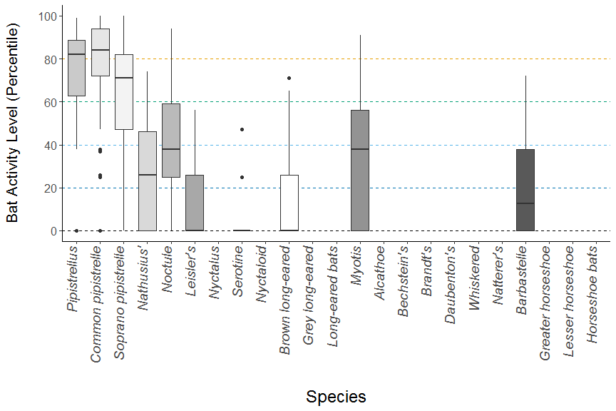

**Figure 1.** The activity level (percentile) of bats recorded across each night of the bat survey for the entire site.

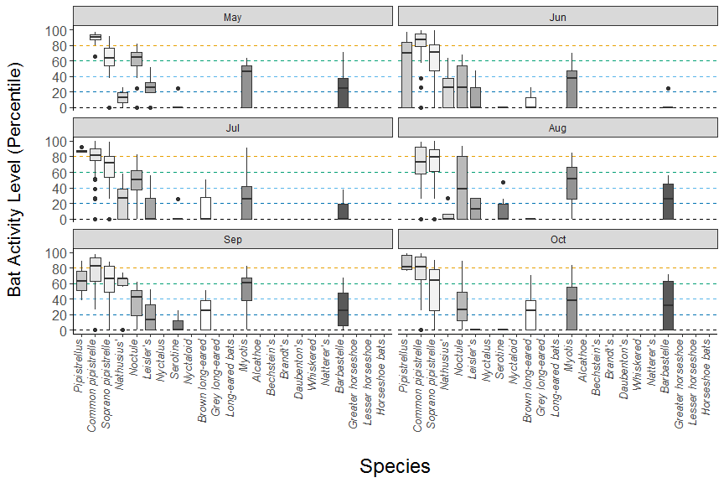

**Figure 2.** The activity level (percentile) of bats recorded across each night of the bat survey for the entire site, but split between months.

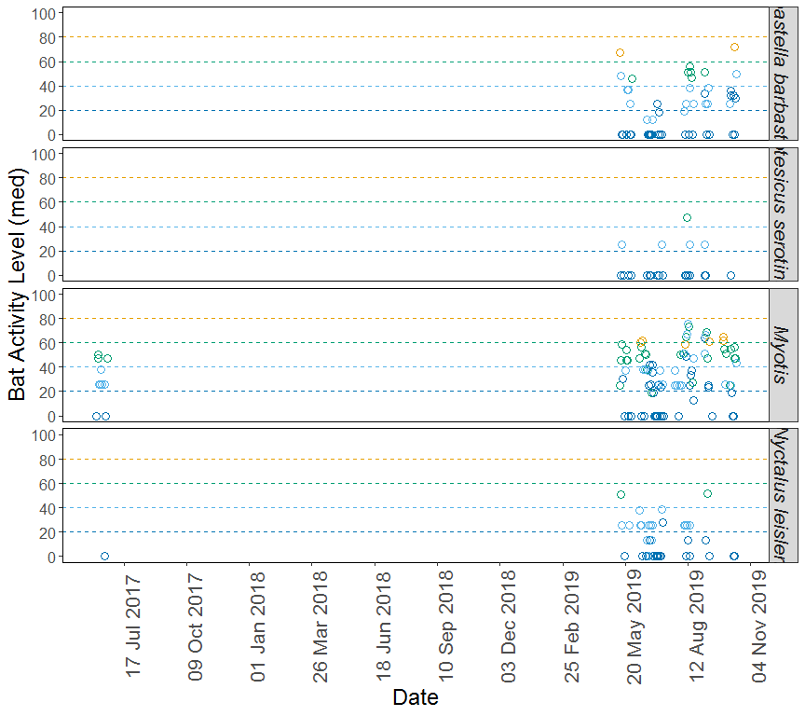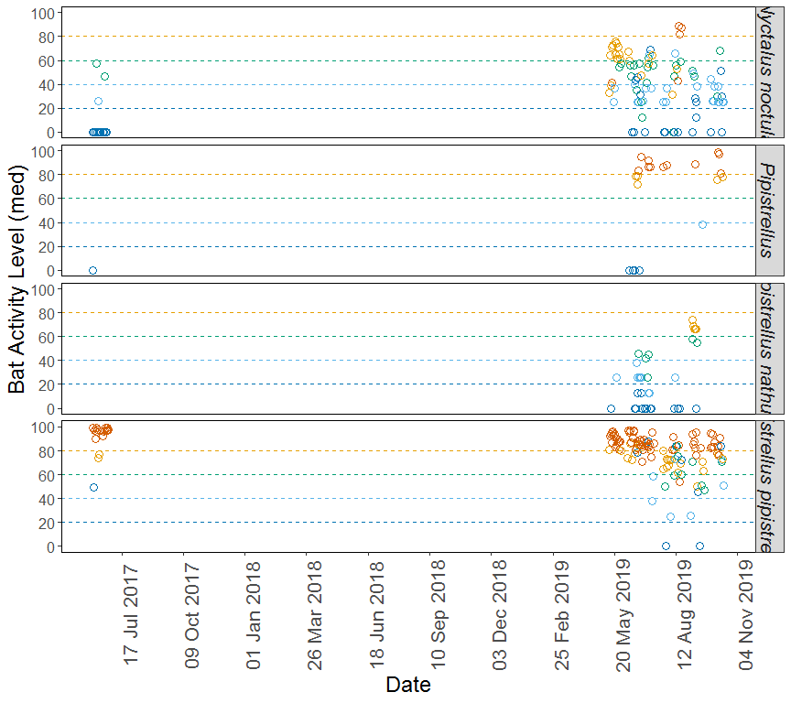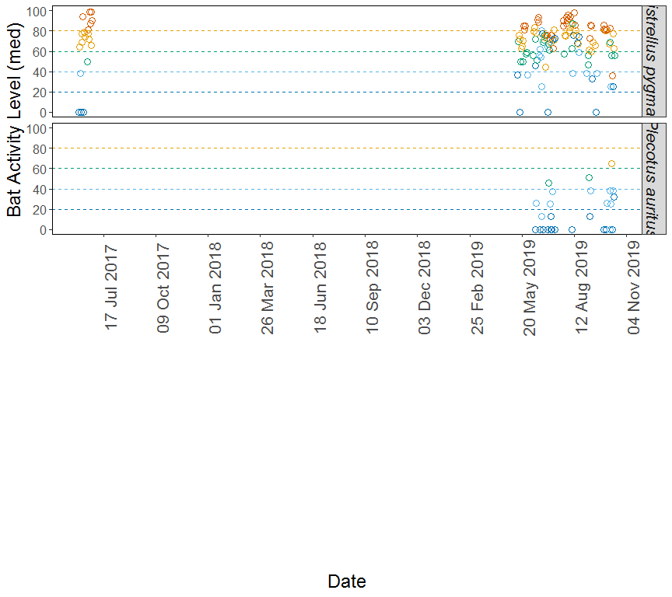

**Figure 3.** The activity level (percentile) of bats recorded across each night of the bat survey, split by species.

## PER SITE, PER MONTH

#### Table 1

Summary table showing the number of nights recorded bat activity fell into each activity band for each species during each month.

|  |  |  |  |  |  |  |
| --- | --- | --- | --- | --- | --- | --- |
| Species/Species Group | Month | Nights of High Activity | Nights of Moderate/ High Activity | Nights of Moderate Activity | Nights of Low/ Moderate Activity | Nights of Low Activity |
| *Barbastella barbastellus* | May | 0 | 2 | 1 | 4 | 6 |
| *Barbastella barbastellus* | Jun | 0 | 0 | 0 | 3 | 10 |
| *Barbastella barbastellus* | Jul | 0 | 0 | 0 | 3 | 7 |
| *Barbastella barbastellus* | Aug | 0 | 0 | 4 | 5 | 5 |
| *Barbastella barbastellus* | Sep | 0 | 2 | 1 | 4 | 3 |
| *Barbastella barbastellus* | Oct | 0 | 5 | 1 | 2 | 6 |
| *Eptesicus serotinus* | May | 0 | 0 | 0 | 1 | 4 |
| *Eptesicus serotinus* | Jun | 0 | 0 | 0 | 0 | 3 |
| *Eptesicus serotinus* | Jul | 0 | 0 | 0 | 1 | 4 |
| *Eptesicus serotinus* | Aug | 0 | 0 | 1 | 1 | 4 |
| *Eptesicus serotinus* | Sep | 0 | 0 | 0 | 1 | 2 |
| *Eptesicus serotinus* | Oct | 0 | 0 | 0 | 0 | 2 |
| *Myotis* | May | 0 | 2 | 6 | 2 | 5 |
| *Myotis* | Jun | 0 | 7 | 18 | 25 | 20 |
| *Myotis* | Jul | 5 | 0 | 6 | 11 | 21 |
| *Myotis* | Aug | 3 | 16 | 12 | 12 | 10 |
| *Myotis* | Sep | 2 | 14 | 5 | 4 | 4 |
| *Myotis* | Oct | 1 | 5 | 11 | 10 | 10 |
| *Nyctalus leisleri* | May | 0 | 0 | 1 | 2 | 1 |
| *Nyctalus leisleri* | Jun | 0 | 0 | 1 | 14 | 16 |
| *Nyctalus leisleri* | Jul | 0 | 0 | 1 | 4 | 12 |
| *Nyctalus leisleri* | Aug | 0 | 0 | 0 | 5 | 5 |
| *Nyctalus leisleri* | Sep | 0 | 0 | 1 | 1 | 2 |
| *Nyctalus leisleri* | Oct | 0 | 0 | 0 | 0 | 2 |
| *Nyctalus noctula* | May | 1 | 12 | 3 | 2 | 3 |
| *Nyctalus noctula* | Jun | 0 | 11 | 23 | 25 | 24 |
| *Nyctalus noctula* | Jul | 1 | 18 | 15 | 15 | 8 |
| *Nyctalus noctula* | Aug | 10 | 3 | 5 | 7 | 14 |
| *Nyctalus noctula* | Sep | 0 | 1 | 9 | 5 | 5 |
| *Nyctalus noctula* | Oct | 1 | 1 | 6 | 12 | 7 |
| *Pipistrellus* | Jun | 6 | 3 | 0 | 0 | 5 |
| *Pipistrellus* | Jul | 5 | 0 | 0 | 0 | 0 |
| *Pipistrellus* | Sep | 1 | 0 | 0 | 1 | 0 |
| *Pipistrellus* | Oct | 3 | 2 | 0 | 0 | 0 |
| *Pipistrellus nathusii* | May | 0 | 0 | 0 | 1 | 1 |
| *Pipistrellus nathusii* | Jun | 0 | 1 | 6 | 17 | 10 |
| *Pipistrellus nathusii* | Jul | 0 | 0 | 3 | 6 | 8 |
| *Pipistrellus nathusii* | Aug | 0 | 0 | 0 | 1 | 3 |
| *Pipistrellus nathusii* | Sep | 0 | 5 | 2 | 0 | 1 |
| *Pipistrellus pipistrellus* | May | 19 | 2 | 0 | 0 | 0 |
| *Pipistrellus pipistrellus* | Jun | 83 | 29 | 2 | 4 | 2 |
| *Pipistrellus pipistrellus* | Jul | 52 | 22 | 4 | 6 | 3 |
| *Pipistrellus pipistrellus* | Aug | 30 | 19 | 11 | 6 | 6 |
| *Pipistrellus pipistrellus* | Sep | 20 | 8 | 5 | 2 | 2 |
| *Pipistrellus pipistrellus* | Oct | 23 | 12 | 4 | 5 | 1 |
| *Pipistrellus pygmaeus* | May | 5 | 7 | 6 | 1 | 2 |
| *Pipistrellus pygmaeus* | Jun | 30 | 45 | 12 | 12 | 14 |
| *Pipistrellus pygmaeus* | Jul | 22 | 31 | 12 | 4 | 8 |
| *Pipistrellus pygmaeus* | Aug | 25 | 19 | 3 | 7 | 4 |
| *Pipistrellus pygmaeus* | Sep | 10 | 11 | 4 | 4 | 2 |
| *Pipistrellus pygmaeus* | Oct | 6 | 14 | 6 | 6 | 5 |
| *Plecotus auritus* | Jun | 0 | 0 | 0 | 2 | 5 |
| *Plecotus auritus* | Jul | 0 | 0 | 2 | 3 | 7 |
| *Plecotus auritus* | Aug | 0 | 0 | 0 | 0 | 3 |
| *Plecotus auritus* | Sep | 0 | 0 | 1 | 2 | 2 |
| *Plecotus auritus* | Oct | 0 | 3 | 0 | 6 | 7 |

#### Table 2

Summary table showing key metrics for each species recorded per month. Please note that the reference range is not split by month.

|  |  |  |  |  |  |  |
| --- | --- | --- | --- | --- | --- | --- |
| Species/Species Group | Month | Median Percentile | 95% CIs | Max Percentile | Nights Recorded | Reference Range |
| *Barbastella barbastellus* | May | 25 | 31.5 - 69 | 71 | 13 | 288 |
| *Barbastella barbastellus* | Jun | 0 | 37 - 68 | 25 | 13 | 288 |
| *Barbastella barbastellus* | Jul | 0 | 37 - 68 | 37 | 10 | 288 |
| *Barbastella barbastellus* | Aug | 25 | 37 - 68 | 56 | 14 | 222 |
| *Barbastella barbastellus* | Sep | 25 | 31.5 - 69 | 67 | 10 | 222 |
| *Barbastella barbastellus* | Oct | 32 | 37 - 68 | 72 | 14 | 222 |
| *Eptesicus serotinus* | May | 0 | 25 - 25 | 25 | 5 | 1251 |
| *Eptesicus serotinus* | Jun | 0 | 25 - 25 | 0 | 3 | 1251 |
| *Eptesicus serotinus* | Jul | 0 | 25 - 25 | 25 | 5 | 1251 |
| *Eptesicus serotinus* | Aug | 0 | 25 - 25 | 47 | 6 | 823 |
| *Eptesicus serotinus* | Sep | 0 | 0 - 0 | 25 | 3 | 823 |
| *Eptesicus serotinus* | Oct | 0 | 0 - 0 | 0 | 2 | 823 |
| *Myotis* | May | 46 | 46.5 - 67.5 | 63 | 15 | 1514 |
| *Myotis* | Jun | 37 | 51 - 69.5 | 70 | 70 | 1535 |
| *Myotis* | Jul | 25 | 51 - 69.5 | 91 | 43 | 1595 |
| *Myotis* | Aug | 51 | 51 - 69.5 | 85 | 53 | 1240 |
| *Myotis* | Sep | 61 | 46.5 - 67.5 | 82 | 29 | 1314 |
| *Myotis* | Oct | 38 | 51 - 69.5 | 84 | 37 | 1225 |
| *Nyctalus leisleri* | May | 26 | 26 - 26 | 51 | 4 | 350 |
| *Nyctalus leisleri* | Jun | 0 | 26 - 41 | 47 | 31 | 319.3 |
| *Nyctalus leisleri* | Jul | 0 | 26 - 41 | 56 | 17 | 312.2 |
| *Nyctalus leisleri* | Aug | 13 | 26 - 26 | 26 | 10 | 239 |
| *Nyctalus leisleri* | Sep | 13 | 26 - 26 | 52 | 4 | 239 |
| *Nyctalus leisleri* | Oct | 0 | 0 - 0 | 0 | 2 | 239 |
| *Nyctalus noctula* | May | 65 | 56 - 67 | 82 | 21 | 1677 |
| *Nyctalus noctula* | Jun | 26 | 56 - 67 | 68 | 83 | 1589 |
| *Nyctalus noctula* | Jul | 50 | 56 - 67 | 83 | 57 | 1703 |
| *Nyctalus noctula* | Aug | 38 | 56 - 67 | 94 | 39 | 1061 |
| *Nyctalus noctula* | Sep | 43 | 56 - 67 | 62 | 20 | 1193 |
| *Nyctalus noctula* | Oct | 26 | 56 - 67 | 89 | 27 | 1168 |
| *Pipistrellus* | Jun | 70 | 86 - 86 | 97 | 14 | 3610 |
| *Pipistrellus* | Jul | 86 | 86 - 86 | 92 | 5 | 3578 |
| *Pipistrellus* | Sep | 64 | 83.5 - 93 | 89 | 2 | 3406 |
| *Pipistrellus* | Oct | 81 | 83.5 - 93 | 99 | 5 | 2364 |
| *Pipistrellus nathusii* | May | 13 | 26 - 26 | 26 | 2 | 429 |
| *Pipistrellus nathusii* | Jun | 26 | 40.5 - 66 | 63 | 34 | 429 |
| *Pipistrellus nathusii* | Jul | 26 | 40.5 - 66 | 58 | 17 | 429 |
| *Pipistrellus nathusii* | Aug | 0 | 26 - 26 | 26 | 4 | 429 |
| *Pipistrellus nathusii* | Sep | 66 | 40.5 - 66 | 74 | 8 | 429 |
| *Pipistrellus pipistrellus* | May | 90 | 91.5 - 96 | 97 | 21 | 3382 |
| *Pipistrellus pipistrellus* | Jun | 87 | 91.5 - 96 | 99 | 120 | 3279 |
| *Pipistrellus pipistrellus* | Jul | 82 | 91.5 - 96 | 100 | 87 | 3580 |
| *Pipistrellus pipistrellus* | Aug | 74 | 91.5 - 96 | 99 | 72 | 2418 |
| *Pipistrellus pipistrellus* | Sep | 82 | 91.5 - 96 | 98 | 37 | 2886 |
| *Pipistrellus pipistrellus* | Oct | 81 | 91.5 - 96 | 99 | 45 | 2286 |
| *Pipistrellus pygmaeus* | May | 63 | 72.5 - 82 | 91 | 21 | 1911 |
| *Pipistrellus pygmaeus* | Jun | 71 | 75.5 - 86 | 99 | 113 | 1920 |
| *Pipistrellus pygmaeus* | Jul | 72 | 75.5 - 86 | 99 | 77 | 2040 |
| *Pipistrellus pygmaeus* | Aug | 79 | 75.5 - 86 | 100 | 58 | 1611 |
| *Pipistrellus pygmaeus* | Sep | 66 | 75.5 - 86 | 88 | 31 | 1753 |
| *Pipistrellus pygmaeus* | Oct | 64 | 74.5 - 83 | 90 | 37 | 1529 |
| *Plecotus auritus* | Jun | 0 | 25 - 44 | 26 | 7 | 561.6 |
| *Plecotus auritus* | Jul | 0 | 31.5 - 57.5 | 50 | 12 | 530 |
| *Plecotus auritus* | Aug | 0 | 31.5 - 57.5 | 0 | 3 | 409 |
| *Plecotus auritus* | Sep | 25 | 25 - 44 | 51 | 5 | 443.4 |
| *Plecotus auritus* | Oct | 25 | 48 - 48 | 71 | 16 | 430.6 |

### Figures

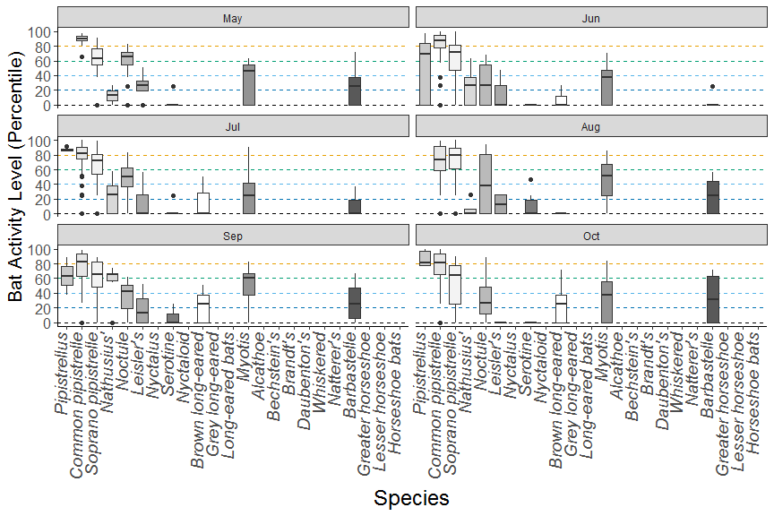

**Figure 1.** The activity level (percentile) of bats recorded across each night of the bat survey for the entire site, but split between months.

##### Page Break

## PART 2: Nightly Analysis

# ENTIRE SURVEY PERIOD

# Sunrise and Sunset Times

**The times of sunset and sunrise the following morning for surveys beginning on the date shown.**

|  |  |  |  |
| --- | --- | --- | --- |
| Night (y-m-d) | Sunset (hh:mm) | Sunrise (hh:mm) | Night Length (hours) |
| 2017-06-08 | 21:21 | 04:48 | 7.4 |
| 2017-06-09 | 21:22 | 04:48 | 7.4 |
| 2017-06-10 | 21:23 | 04:47 | 7.4 |
| 2017-06-11 | 21:24 | 04:47 | 7.4 |
| 2017-06-12 | 21:24 | 04:47 | 7.4 |
| 2017-06-13 | 21:25 | 04:47 | 7.4 |
| 2017-06-14 | 21:25 | 04:46 | 7.3 |
| 2017-06-15 | 21:26 | 04:46 | 7.3 |
| 2017-06-16 | 21:26 | 04:46 | 7.3 |
| 2017-06-17 | 21:27 | 04:46 | 7.3 |
| 2017-06-21 | 21:28 | 04:47 | 7.3 |
| 2017-06-22 | 21:28 | 04:47 | 7.3 |
| 2017-06-23 | 21:28 | 04:48 | 7.3 |
| 2017-06-24 | 21:28 | 04:48 | 7.3 |
| 2017-06-25 | 21:28 | 04:48 | 7.3 |
| 2017-06-26 | 21:28 | 04:49 | 7.3 |
| 2017-06-27 | 21:28 | 04:49 | 7.3 |
| 2017-06-28 | 21:28 | 04:50 | 7.4 |
| 2017-06-29 | 21:28 | 04:51 | 7.4 |
| 2019-05-13 | 20:48 | 05:15 | 8.5 |
| 2019-05-14 | 20:49 | 05:13 | 8.4 |
| 2019-05-15 | 20:51 | 05:12 | 8.4 |
| 2019-05-16 | 20:52 | 05:10 | 8.3 |
| 2019-05-17 | 20:54 | 05:09 | 8.3 |
| 2019-05-18 | 20:55 | 05:08 | 8.2 |
| 2019-05-19 | 20:57 | 05:06 | 8.2 |
| 2019-05-20 | 20:58 | 05:05 | 8.1 |
| 2019-05-21 | 21:00 | 05:04 | 8.1 |
| 2019-05-22 | 21:01 | 05:02 | 8.0 |
| 2019-05-23 | 21:03 | 05:01 | 8.0 |
| 2019-05-24 | 21:04 | 05:00 | 7.9 |
| 2019-05-25 | 21:05 | 04:59 | 7.9 |
| 2019-05-26 | 21:07 | 04:58 | 7.9 |
| 2019-05-27 | 21:08 | 04:57 | 7.8 |
| 2019-05-28 | 21:09 | 04:56 | 7.8 |
| 2019-05-29 | 21:10 | 04:55 | 7.7 |
| 2019-06-07 | 21:20 | 04:49 | 7.5 |
| 2019-06-08 | 21:21 | 04:48 | 7.5 |
| 2019-06-09 | 21:22 | 04:48 | 7.4 |
| 2019-06-10 | 21:22 | 04:47 | 7.4 |
| 2019-06-11 | 21:23 | 04:47 | 7.4 |
| 2019-06-12 | 21:24 | 04:47 | 7.4 |
| 2019-06-13 | 21:25 | 04:47 | 7.4 |
| 2019-06-14 | 21:25 | 04:46 | 7.4 |
| 2019-06-15 | 21:26 | 04:46 | 7.3 |
| 2019-06-16 | 21:26 | 04:46 | 7.3 |
| 2019-06-17 | 21:27 | 04:46 | 7.3 |
| 2019-06-18 | 21:27 | 04:46 | 7.3 |
| 2019-06-19 | 21:27 | 04:46 | 7.3 |
| 2019-06-20 | 21:28 | 04:47 | 7.3 |
| 2019-06-21 | 21:28 | 04:47 | 7.3 |
| 2019-06-22 | 21:28 | 04:47 | 7.3 |
| 2019-06-23 | 21:28 | 04:47 | 7.3 |
| 2019-06-24 | 21:28 | 04:48 | 7.3 |
| 2019-06-25 | 21:28 | 04:48 | 7.3 |
| 2019-06-26 | 21:28 | 04:49 | 7.3 |
| 2019-06-27 | 21:28 | 04:49 | 7.3 |
| 2019-06-28 | 21:28 | 04:50 | 7.4 |
| 2019-06-29 | 21:28 | 04:50 | 7.4 |
| 2019-06-30 | 21:28 | 04:51 | 7.4 |
| 2019-07-01 | 21:28 | 04:52 | 7.4 |
| 2019-07-02 | 21:27 | 04:52 | 7.4 |
| 2019-07-03 | 21:27 | 04:53 | 7.4 |
| 2019-07-04 | 21:27 | 04:54 | 7.5 |
| 2019-07-05 | 21:26 | 04:55 | 7.5 |
| 2019-07-06 | 21:26 | 04:56 | 7.5 |
| 2019-07-07 | 21:25 | 04:57 | 7.5 |
| 2019-07-08 | 21:24 | 04:57 | 7.6 |
| 2019-07-09 | 21:24 | 04:58 | 7.6 |
| 2019-07-10 | 21:23 | 05:00 | 7.6 |
| 2019-07-11 | 21:22 | 05:01 | 7.6 |
| 2019-07-12 | 21:21 | 05:02 | 7.7 |
| 2019-07-13 | 21:20 | 05:03 | 7.7 |
| 2019-07-25 | 21:07 | 05:19 | 8.2 |
| 2019-07-26 | 21:05 | 05:20 | 8.2 |
| 2019-07-27 | 21:04 | 05:22 | 8.3 |
| 2019-07-28 | 21:02 | 05:23 | 8.3 |
| 2019-07-29 | 21:01 | 05:25 | 8.4 |
| 2019-07-30 | 20:59 | 05:26 | 8.4 |
| 2019-07-31 | 20:58 | 05:28 | 8.5 |
| 2019-08-01 | 20:56 | 05:29 | 8.5 |
| 2019-08-02 | 20:55 | 05:31 | 8.6 |
| 2019-08-03 | 20:53 | 05:32 | 8.7 |
| 2019-08-04 | 20:51 | 05:34 | 8.7 |
| 2019-08-05 | 20:50 | 05:35 | 8.8 |
| 2019-08-06 | 20:48 | 05:37 | 8.8 |
| 2019-08-07 | 20:46 | 05:38 | 8.9 |
| 2019-08-08 | 20:44 | 05:40 | 8.9 |
| 2019-08-09 | 20:42 | 05:42 | 9.0 |
| 2019-08-10 | 20:41 | 05:43 | 9.0 |
| 2019-08-11 | 20:39 | 05:45 | 9.1 |
| 2019-08-12 | 20:37 | 05:46 | 9.2 |
| 2019-08-13 | 20:35 | 05:48 | 9.2 |
| 2019-08-14 | 20:33 | 05:50 | 9.3 |
| 2019-08-15 | 20:31 | 05:51 | 9.3 |
| 2019-08-16 | 20:29 | 05:53 | 9.4 |
| 2019-08-17 | 20:27 | 05:55 | 9.5 |
| 2019-08-18 | 20:25 | 05:56 | 9.5 |
| 2019-08-19 | 20:23 | 05:58 | 9.6 |
| 2019-08-20 | 20:21 | 05:59 | 9.6 |
| 2019-09-01 | 19:55 | 06:19 | 10.4 |
| 2019-09-03 | 19:50 | 06:22 | 10.5 |
| 2019-09-04 | 19:48 | 06:24 | 10.6 |
| 2019-09-05 | 19:46 | 06:25 | 10.7 |
| 2019-09-06 | 19:43 | 06:27 | 10.7 |
| 2019-09-07 | 19:41 | 06:28 | 10.8 |
| 2019-09-08 | 19:39 | 06:30 | 10.9 |
| 2019-09-09 | 19:37 | 06:32 | 10.9 |
| 2019-09-10 | 19:34 | 06:33 | 11.0 |
| 2019-09-11 | 19:32 | 06:35 | 11.0 |
| 2019-09-13 | 19:27 | 06:38 | 11.2 |
| 2019-09-14 | 19:25 | 06:40 | 11.2 |
| 2019-09-15 | 19:23 | 06:41 | 11.3 |
| 2019-09-16 | 19:20 | 06:43 | 11.4 |
| 2019-09-17 | 19:18 | 06:44 | 11.4 |
| 2019-09-18 | 19:16 | 06:46 | 11.5 |
| 2019-09-20 | 19:11 | 06:49 | 11.6 |
| 2019-09-28 | 18:52 | 07:02 | 12.2 |
| 2019-09-29 | 18:50 | 07:04 | 12.2 |
| 2019-09-30 | 18:48 | 07:05 | 12.3 |
| 2019-10-01 | 18:45 | 07:07 | 12.4 |
| 2019-10-02 | 18:43 | 07:09 | 12.4 |
| 2019-10-03 | 18:41 | 07:10 | 12.5 |
| 2019-10-07 | 18:31 | 07:17 | 12.8 |
| 2019-10-08 | 18:29 | 07:19 | 12.8 |
| 2019-10-09 | 18:27 | 07:20 | 12.9 |
| 2019-10-10 | 18:25 | 07:22 | 13.0 |
| 2019-10-11 | 18:22 | 07:24 | 13.0 |
| 2019-10-12 | 18:20 | 07:26 | 13.1 |
| 2019-10-13 | 18:18 | 07:27 | 13.2 |
| 2019-10-14 | 18:16 | 07:29 | 13.2 |
| 2019-10-15 | 18:14 | 07:31 | 13.3 |
| 2019-10-16 | 18:12 | 07:32 | 13.3 |

##### Page Break

# Distribution of Bat Activity Across the Night through Time

## Per Detector

**Timing of bat calls plotted as minutes before/after sunset, whereby 0 on the y axis represents sunset. Sunrise throughout the survey period is depicted as the red dashed line. Colours indicate kernel densities, with darkest colours showing peaks of activity. These colours are comparative only within each plot, and do not account for overall activity.**

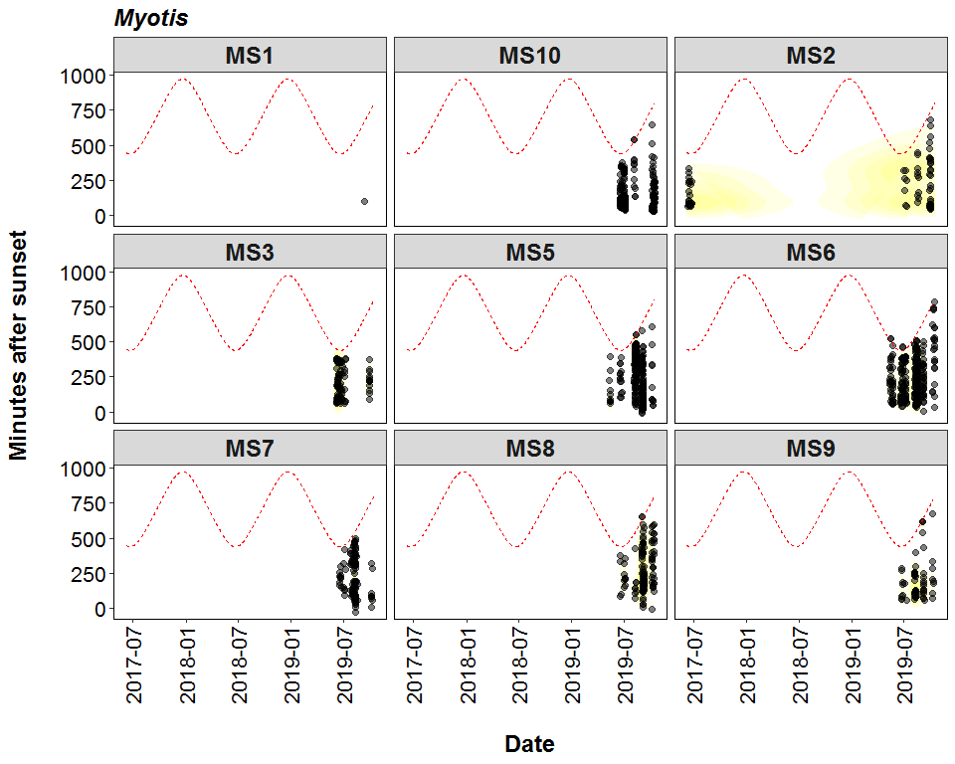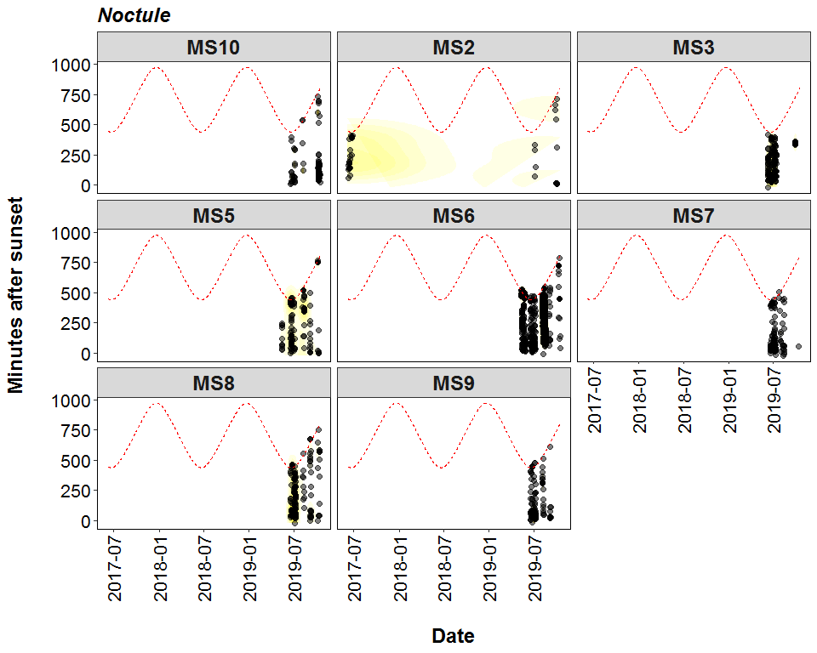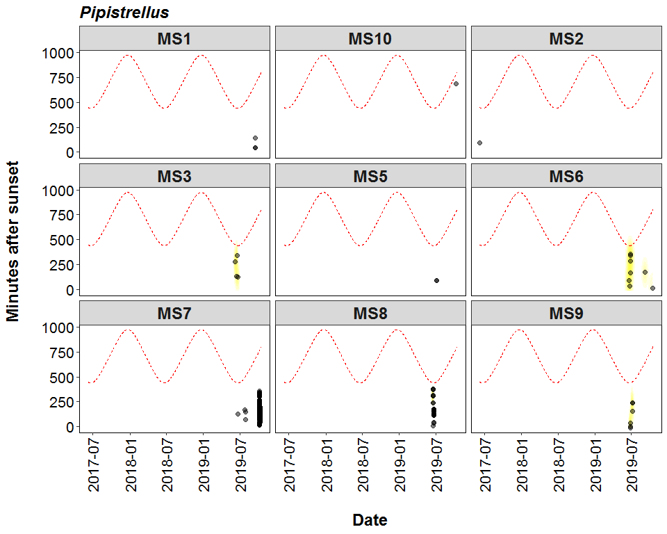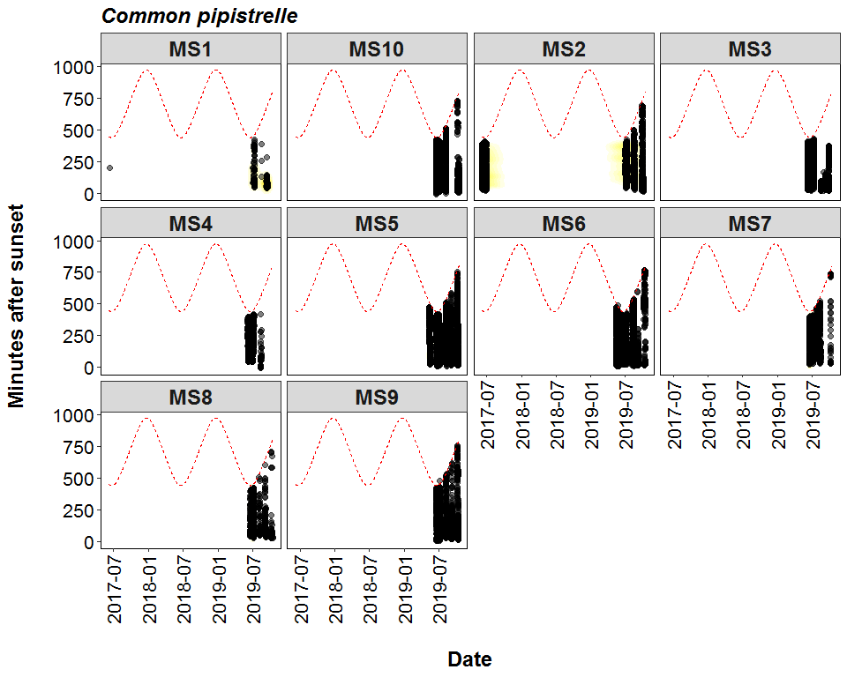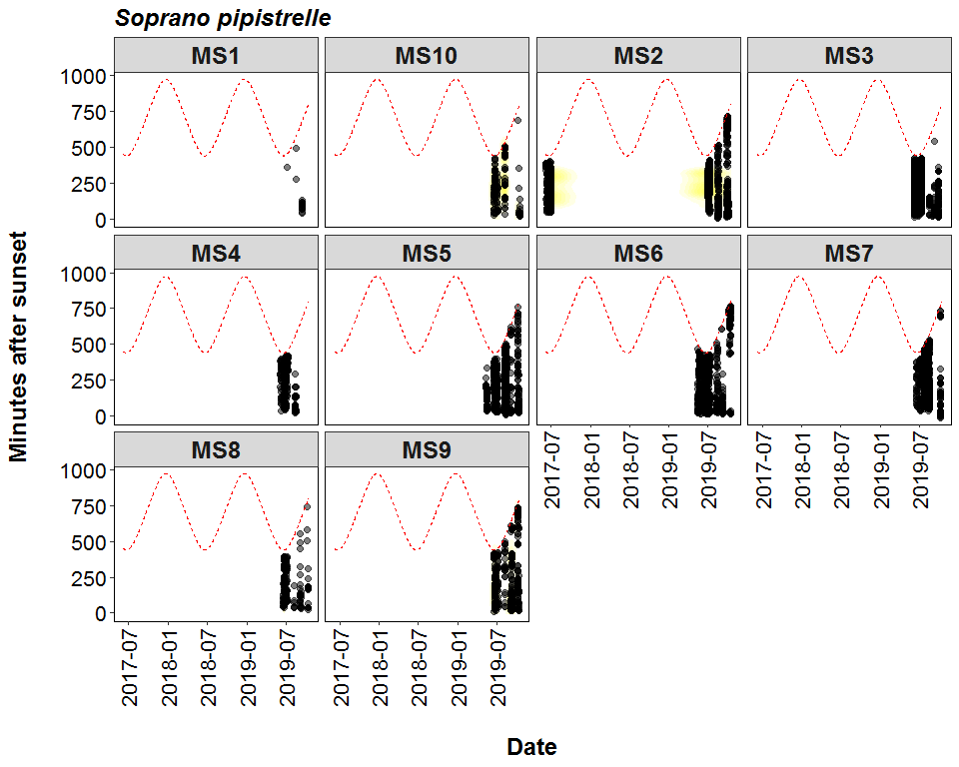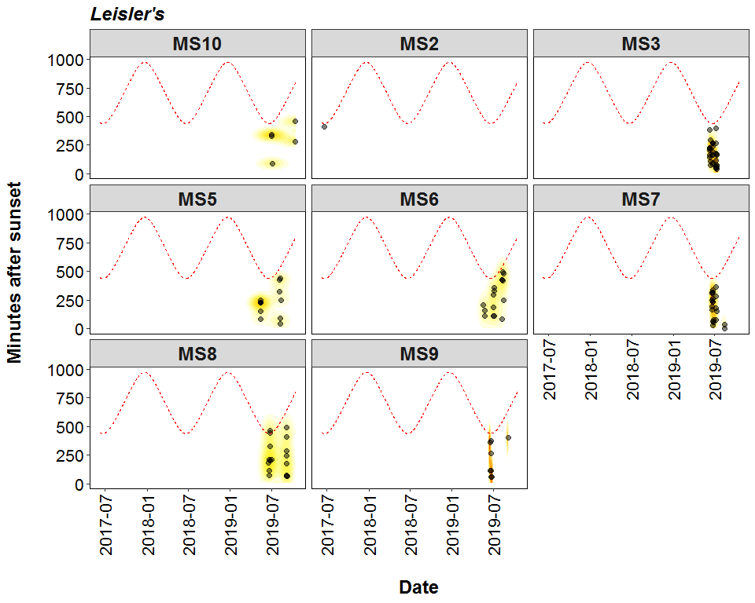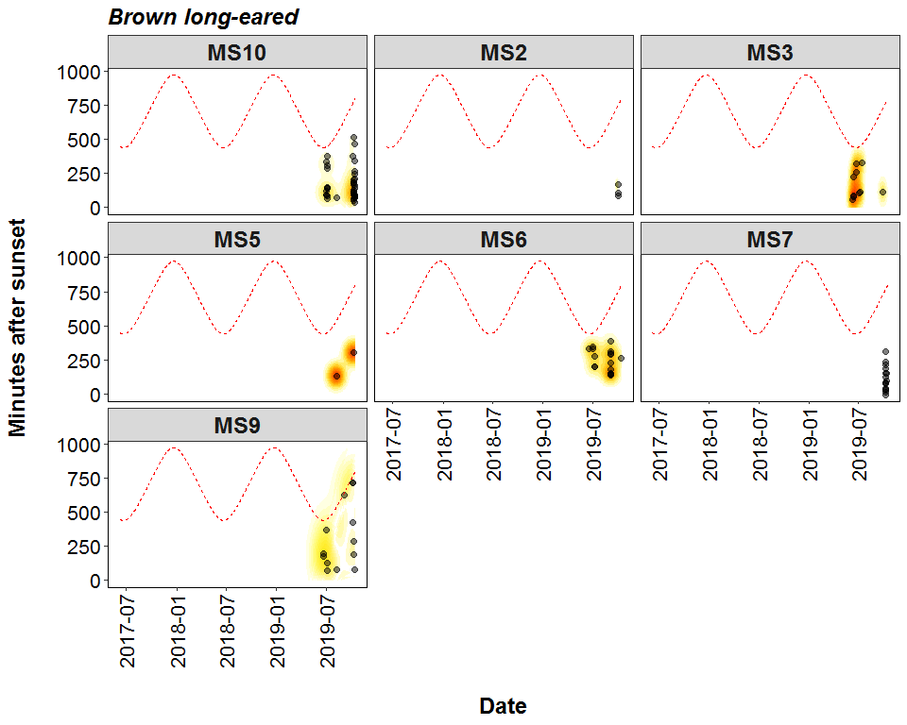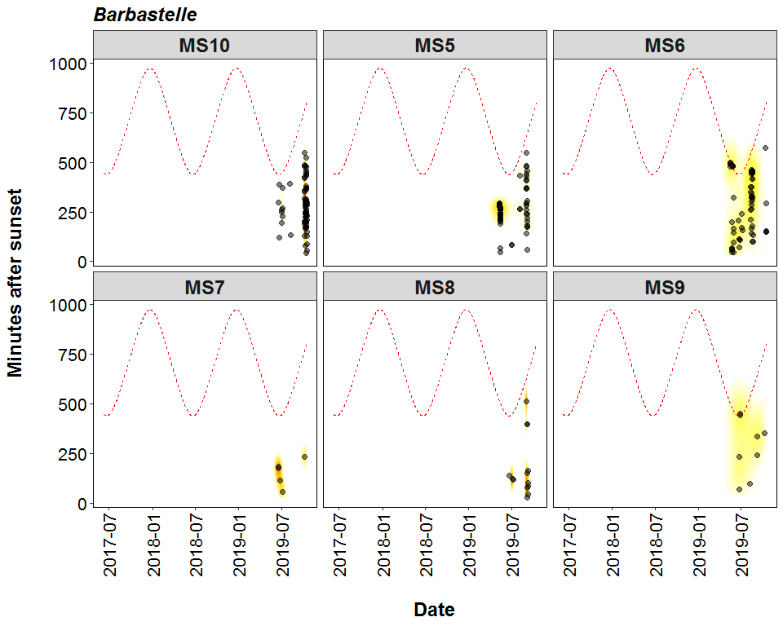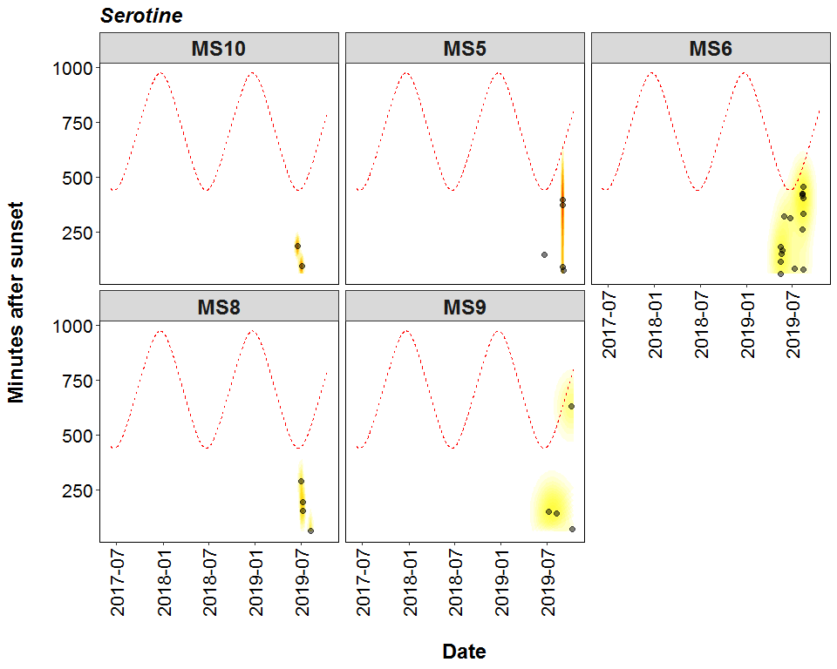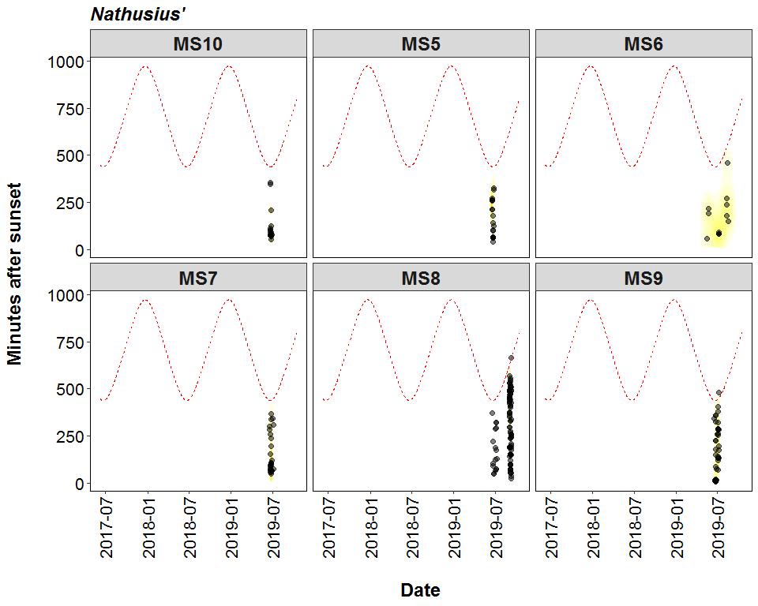

##### Page Break

# Roost Emergence Time and Bat Observation

Based on: *Russ, Jon. 2012. British Bat Calls a Guide to species Identification.* *Pelagic Publishing.*

For more information see <https://rbats-blog.updog.co/2018/05/29/bat-emergence/>

## Bat Passes Potentially Indicating Close Proximity to a Roost (Russ 2012) - Table

**Number of bat calls recorded before the upper time of the species-specific emergence time range, and which therefore may potentially indicate the presence of a nearby roost.**

Table continues below

|  |  |  |  |  |  |  |
| --- | --- | --- | --- | --- | --- | --- |
| Species | Detector ID | 2017-06-09 | 2017-06-10 | 2017-06-13 | 2017-06-22 | 2017-06-25 |
| Pipistrellus | MS6 | 0 | 0 | 0 | 0 | 0 |
| Pipistrellus | MS7 | 0 | 0 | 0 | 0 | 0 |
| Pipistrellus | MS8 | 0 | 0 | 0 | 0 | 0 |
| Pipistrellus | MS9 | 0 | 0 | 0 | 0 | 0 |
| Common pipistrelle | MS10 | 0 | 0 | 0 | 0 | 0 |
| Common pipistrelle | MS2 | 1 | 1 | 1 | 0 | 1 |
| Common pipistrelle | MS3 | 0 | 0 | 0 | 0 | 0 |
| Common pipistrelle | MS4 | 0 | 0 | 0 | 0 | 0 |
| Common pipistrelle | MS5 | 0 | 0 | 0 | 0 | 0 |
| Common pipistrelle | MS6 | 0 | 0 | 0 | 0 | 0 |
| Common pipistrelle | MS7 | 0 | 0 | 0 | 0 | 0 |
| Common pipistrelle | MS8 | 0 | 0 | 0 | 0 | 0 |
| Common pipistrelle | MS9 | 0 | 0 | 0 | 0 | 0 |
| Soprano pipistrelle | MS10 | 0 | 0 | 0 | 0 | 0 |
| Soprano pipistrelle | MS2 | 0 | 0 | 0 | 0 | 0 |
| Soprano pipistrelle | MS3 | 0 | 0 | 0 | 0 | 0 |
| Soprano pipistrelle | MS4 | 0 | 0 | 0 | 0 | 0 |
| Soprano pipistrelle | MS5 | 0 | 0 | 0 | 0 | 0 |
| Soprano pipistrelle | MS6 | 0 | 0 | 0 | 0 | 0 |
| Soprano pipistrelle | MS7 | 0 | 0 | 0 | 0 | 0 |
| Soprano pipistrelle | MS8 | 0 | 0 | 0 | 0 | 0 |
| Soprano pipistrelle | MS9 | 0 | 0 | 0 | 0 | 0 |
| Nathusius’ | MS8 | 0 | 0 | 0 | 0 | 0 |
| Nathusius’ | MS9 | 0 | 0 | 0 | 0 | 0 |
| Noctule | MS2 | 0 | 0 | 0 | 0 | 0 |
| Noctule | MS3 | 0 | 0 | 0 | 0 | 0 |
| Noctule | MS5 | 0 | 0 | 0 | 0 | 0 |
| Noctule | MS6 | 0 | 0 | 0 | 0 | 0 |
| Noctule | MS7 | 0 | 0 | 0 | 0 | 0 |
| Noctule | MS8 | 0 | 0 | 0 | 0 | 0 |
| Noctule | MS9 | 0 | 0 | 0 | 0 | 0 |
| Leisler’s | MS7 | 0 | 0 | 0 | 0 | 0 |
| Brown long-eared | MS10 | 0 | 0 | 0 | 0 | 0 |
| Brown long-eared | MS7 | 0 | 0 | 0 | 0 | 0 |
| Myotis | MS10 | 0 | 0 | 0 | 0 | 0 |
| Myotis | MS2 | 0 | 1 | 0 | 1 | 0 |
| Myotis | MS3 | 0 | 0 | 0 | 0 | 0 |
| Myotis | MS5 | 0 | 0 | 0 | 0 | 0 |
| Myotis | MS6 | 0 | 0 | 0 | 0 | 0 |
| Myotis | MS7 | 0 | 0 | 0 | 0 | 0 |
| Myotis | MS8 | 0 | 0 | 0 | 0 | 0 |
| Myotis | MS9 | 0 | 0 | 0 | 0 | 0 |
| Barbastelle | MS10 | 0 | 0 | 0 | 0 | 0 |
| Barbastelle | MS5 | 0 | 0 | 0 | 0 | 0 |
| Barbastelle | MS6 | 0 | 0 | 0 | 0 | 0 |
| Barbastelle | MS7 | 0 | 0 | 0 | 0 | 0 |
| Barbastelle | MS8 | 0 | 0 | 0 | 0 | 0 |

Table continues below

|  |  |  |  |  |  |  |
| --- | --- | --- | --- | --- | --- | --- |
| 2017-06-26 | 2017-06-29 | 2019-05-14 | 2019-05-15 | 2019-05-16 | 2019-05-17 | 2019-05-20 |
| 0 | 0 | 0 | 0 | 0 | 0 | 0 |
| 0 | 0 | 0 | 0 | 0 | 0 | 0 |
| 0 | 0 | 0 | 0 | 0 | 0 | 0 |
| 0 | 0 | 0 | 0 | 0 | 0 | 0 |
| 0 | 0 | 0 | 0 | 0 | 0 | 0 |
| 3 | 1 | 0 | 0 | 0 | 0 | 0 |
| 0 | 0 | 0 | 0 | 0 | 0 | 0 |
| 0 | 0 | 0 | 0 | 0 | 0 | 0 |
| 0 | 0 | 13 | 27 | 40 | 0 | 0 |
| 0 | 0 | 9 | 12 | 18 | 6 | 2 |
| 0 | 0 | 0 | 0 | 0 | 0 | 0 |
| 0 | 0 | 0 | 0 | 0 | 0 | 0 |
| 0 | 0 | 0 | 0 | 0 | 0 | 0 |
| 0 | 0 | 0 | 0 | 0 | 0 | 0 |
| 0 | 0 | 0 | 0 | 0 | 0 | 0 |
| 0 | 0 | 0 | 0 | 0 | 0 | 0 |
| 0 | 0 | 0 | 0 | 0 | 0 | 0 |
| 0 | 0 | 0 | 0 | 0 | 0 | 0 |
| 0 | 0 | 1 | 1 | 0 | 0 | 1 |
| 0 | 0 | 0 | 0 | 0 | 0 | 0 |
| 0 | 0 | 0 | 0 | 0 | 0 | 0 |
| 0 | 0 | 0 | 0 | 0 | 0 | 0 |
| 0 | 0 | 0 | 0 | 0 | 0 | 0 |
| 0 | 0 | 0 | 0 | 0 | 0 | 0 |
| 0 | 0 | 0 | 0 | 0 | 0 | 0 |
| 0 | 0 | 0 | 0 | 0 | 0 | 0 |
| 0 | 0 | 0 | 0 | 0 | 0 | 0 |
| 0 | 0 | 0 | 0 | 0 | 0 | 0 |
| 0 | 0 | 0 | 0 | 0 | 0 | 0 |
| 0 | 0 | 0 | 0 | 0 | 0 | 0 |
| 0 | 0 | 0 | 0 | 0 | 0 | 0 |
| 0 | 0 | 0 | 0 | 0 | 0 | 0 |
| 0 | 0 | 0 | 0 | 0 | 0 | 0 |
| 0 | 0 | 0 | 0 | 0 | 0 | 0 |
| 0 | 0 | 0 | 0 | 0 | 0 | 0 |
| 0 | 0 | 0 | 0 | 0 | 0 | 0 |
| 0 | 0 | 0 | 0 | 0 | 0 | 0 |
| 0 | 0 | 1 | 0 | 0 | 0 | 0 |
| 0 | 0 | 0 | 0 | 0 | 0 | 1 |
| 0 | 0 | 0 | 0 | 0 | 0 | 0 |
| 0 | 0 | 0 | 0 | 0 | 0 | 0 |
| 0 | 0 | 0 | 0 | 0 | 0 | 0 |
| 0 | 0 | 0 | 0 | 0 | 0 | 0 |
| 0 | 0 | 1 | 0 | 0 | 0 | 0 |
| 0 | 0 | 0 | 0 | 0 | 0 | 0 |
| 0 | 0 | 0 | 0 | 0 | 0 | 0 |
| 0 | 0 | 0 | 0 | 0 | 0 | 0 |

Table continues below

|  |  |  |  |  |  |  |
| --- | --- | --- | --- | --- | --- | --- |
| 2019-05-21 | 2019-05-22 | 2019-05-23 | 2019-05-24 | 2019-05-25 | 2019-05-26 | 2019-05-27 |
| 0 | 0 | 0 | 0 | 0 | 0 | 0 |
| 0 | 0 | 0 | 0 | 0 | 0 | 0 |
| 0 | 0 | 0 | 0 | 0 | 0 | 0 |
| 0 | 0 | 0 | 0 | 0 | 0 | 0 |
| 0 | 0 | 0 | 0 | 0 | 0 | 0 |
| 0 | 0 | 0 | 0 | 0 | 0 | 0 |
| 0 | 0 | 0 | 0 | 0 | 0 | 0 |
| 0 | 0 | 0 | 0 | 0 | 0 | 0 |
| 0 | 0 | 0 | 0 | 0 | 0 | 0 |
| 3 | 6 | 2 | 1 | 6 | 2 | 1 |
| 0 | 0 | 0 | 0 | 0 | 0 | 0 |
| 0 | 0 | 0 | 0 | 0 | 0 | 0 |
| 0 | 0 | 0 | 0 | 0 | 0 | 0 |
| 0 | 0 | 0 | 0 | 0 | 0 | 0 |
| 0 | 0 | 0 | 0 | 0 | 0 | 0 |
| 0 | 0 | 0 | 0 | 0 | 0 | 0 |
| 0 | 0 | 0 | 0 | 0 | 0 | 0 |
| 0 | 0 | 0 | 0 | 0 | 0 | 0 |
| 1 | 0 | 0 | 1 | 3 | 0 | 0 |
| 0 | 0 | 0 | 0 | 0 | 0 | 0 |
| 0 | 0 | 0 | 0 | 0 | 0 | 0 |
| 0 | 0 | 0 | 0 | 0 | 0 | 0 |
| 0 | 0 | 0 | 0 | 0 | 0 | 0 |
| 0 | 0 | 0 | 0 | 0 | 0 | 0 |
| 0 | 0 | 0 | 0 | 0 | 0 | 0 |
| 0 | 0 | 0 | 0 | 0 | 0 | 0 |
| 0 | 0 | 0 | 0 | 0 | 0 | 0 |
| 0 | 0 | 0 | 0 | 0 | 0 | 0 |
| 0 | 0 | 0 | 0 | 0 | 0 | 0 |
| 0 | 0 | 0 | 0 | 0 | 0 | 0 |
| 0 | 0 | 0 | 0 | 0 | 0 | 0 |
| 0 | 0 | 0 | 0 | 0 | 0 | 0 |
| 0 | 0 | 0 | 0 | 0 | 0 | 0 |
| 0 | 0 | 0 | 0 | 0 | 0 | 0 |
| 0 | 0 | 0 | 0 | 0 | 0 | 0 |
| 0 | 0 | 0 | 0 | 0 | 0 | 0 |
| 0 | 0 | 0 | 0 | 0 | 0 | 0 |
| 0 | 0 | 0 | 0 | 0 | 0 | 0 |
| 1 | 2 | 0 | 0 | 0 | 0 | 0 |
| 0 | 0 | 0 | 0 | 0 | 0 | 0 |
| 0 | 0 | 0 | 0 | 0 | 0 | 0 |
| 0 | 0 | 0 | 0 | 0 | 0 | 0 |
| 0 | 0 | 0 | 0 | 0 | 0 | 0 |
| 0 | 0 | 0 | 0 | 0 | 0 | 0 |
| 0 | 0 | 0 | 2 | 0 | 0 | 0 |
| 0 | 0 | 0 | 0 | 0 | 0 | 0 |
| 0 | 0 | 0 | 0 | 0 | 0 | 0 |

Table continues below

|  |  |  |  |  |  |  |
| --- | --- | --- | --- | --- | --- | --- |
| 2019-05-28 | 2019-05-29 | 2019-06-09 | 2019-06-10 | 2019-06-11 | 2019-06-18 | 2019-06-19 |
| 0 | 0 | 0 | 0 | 0 | 0 | 0 |
| 0 | 0 | 0 | 0 | 0 | 0 | 0 |
| 0 | 0 | 0 | 0 | 0 | 0 | 0 |
| 0 | 0 | 0 | 0 | 0 | 0 | 0 |
| 0 | 0 | 0 | 0 | 0 | 122 | 69 |
| 0 | 0 | 0 | 0 | 0 | 0 | 0 |
| 0 | 0 | 4 | 2 | 0 | 0 | 0 |
| 0 | 0 | 0 | 0 | 0 | 0 | 0 |
| 0 | 0 | 0 | 0 | 0 | 9 | 0 |
| 6 | 16 | 0 | 0 | 0 | 0 | 0 |
| 0 | 0 | 0 | 0 | 0 | 0 | 4 |
| 0 | 0 | 0 | 0 | 0 | 0 | 0 |
| 0 | 0 | 0 | 0 | 0 | 1 | 5 |
| 0 | 0 | 0 | 0 | 0 | 1 | 0 |
| 0 | 0 | 0 | 0 | 0 | 0 | 0 |
| 0 | 0 | 2 | 0 | 1 | 0 | 0 |
| 0 | 0 | 0 | 0 | 0 | 0 | 0 |
| 0 | 0 | 0 | 0 | 0 | 0 | 0 |
| 0 | 2 | 0 | 0 | 0 | 3 | 0 |
| 0 | 0 | 0 | 0 | 0 | 0 | 0 |
| 0 | 0 | 0 | 0 | 0 | 0 | 0 |
| 0 | 0 | 0 | 0 | 0 | 0 | 1 |
| 0 | 0 | 0 | 0 | 0 | 0 | 0 |
| 0 | 0 | 0 | 0 | 0 | 0 | 0 |
| 0 | 0 | 0 | 0 | 0 | 0 | 0 |
| 0 | 0 | 0 | 1 | 0 | 0 | 0 |
| 0 | 0 | 0 | 0 | 0 | 1 | 0 |
| 0 | 0 | 0 | 0 | 0 | 0 | 0 |
| 0 | 0 | 0 | 0 | 0 | 0 | 0 |
| 0 | 0 | 0 | 0 | 0 | 0 | 0 |
| 0 | 0 | 0 | 0 | 0 | 0 | 3 |
| 0 | 0 | 0 | 0 | 0 | 0 | 0 |
| 0 | 0 | 0 | 0 | 0 | 0 | 0 |
| 0 | 0 | 0 | 0 | 0 | 0 | 0 |
| 0 | 0 | 0 | 0 | 0 | 0 | 2 |
| 0 | 0 | 0 | 0 | 0 | 0 | 0 |
| 0 | 0 | 2 | 0 | 0 | 0 | 0 |
| 0 | 0 | 0 | 0 | 0 | 0 | 0 |
| 0 | 0 | 0 | 0 | 0 | 1 | 0 |
| 0 | 0 | 0 | 0 | 0 | 0 | 0 |
| 0 | 0 | 0 | 0 | 0 | 0 | 0 |
| 0 | 0 | 0 | 0 | 0 | 0 | 0 |
| 0 | 0 | 0 | 0 | 0 | 0 | 0 |
| 0 | 0 | 0 | 0 | 0 | 0 | 0 |
| 0 | 1 | 0 | 0 | 0 | 0 | 0 |
| 0 | 0 | 0 | 0 | 0 | 0 | 0 |
| 0 | 0 | 0 | 0 | 0 | 0 | 0 |

Table continues below

|  |  |  |  |  |  |  |
| --- | --- | --- | --- | --- | --- | --- |
| 2019-06-20 | 2019-06-21 | 2019-06-22 | 2019-06-23 | 2019-06-24 | 2019-06-25 | 2019-06-26 |
| 0 | 1 | 0 | 0 | 0 | 0 | 0 |
| 0 | 0 | 0 | 0 | 0 | 0 | 0 |
| 1 | 0 | 0 | 0 | 0 | 0 | 0 |
| 0 | 0 | 0 | 0 | 0 | 0 | 2 |
| 41 | 32 | 45 | 72 | 39 | 92 | 12 |
| 0 | 0 | 0 | 0 | 0 | 0 | 0 |
| 0 | 0 | 0 | 1 | 0 | 0 | 3 |
| 0 | 0 | 0 | 0 | 0 | 0 | 0 |
| 0 | 0 | 15 | 42 | 4 | 28 | 62 |
| 0 | 0 | 2 | 1 | 0 | 3 | 2 |
| 1 | 1 | 6 | 0 | 0 | 1 | 0 |
| 0 | 0 | 0 | 0 | 0 | 0 | 0 |
| 1 | 11 | 8 | 17 | 3 | 14 | 17 |
| 0 | 0 | 0 | 0 | 0 | 0 | 0 |
| 0 | 0 | 0 | 0 | 0 | 0 | 0 |
| 0 | 0 | 0 | 0 | 0 | 0 | 1 |
| 0 | 0 | 0 | 0 | 0 | 0 | 0 |
| 0 | 0 | 0 | 0 | 0 | 0 | 0 |
| 0 | 0 | 0 | 1 | 1 | 2 | 2 |
| 0 | 0 | 0 | 0 | 0 | 0 | 0 |
| 0 | 0 | 0 | 0 | 0 | 0 | 0 |
| 0 | 0 | 1 | 3 | 0 | 0 | 1 |
| 0 | 0 | 0 | 0 | 0 | 0 | 0 |
| 2 | 2 | 2 | 1 | 0 | 0 | 1 |
| 0 | 0 | 0 | 0 | 0 | 0 | 0 |
| 0 | 0 | 0 | 0 | 0 | 0 | 0 |
| 0 | 0 | 0 | 0 | 0 | 0 | 0 |
| 0 | 0 | 0 | 0 | 0 | 5 | 0 |
| 1 | 0 | 0 | 0 | 0 | 0 | 0 |
| 0 | 0 | 0 | 0 | 0 | 0 | 0 |
| 0 | 0 | 0 | 0 | 1 | 0 | 0 |
| 0 | 0 | 0 | 0 | 0 | 0 | 0 |
| 0 | 0 | 0 | 0 | 0 | 0 | 0 |
| 0 | 0 | 0 | 0 | 0 | 0 | 0 |
| 0 | 0 | 0 | 4 | 4 | 1 | 2 |
| 0 | 0 | 0 | 0 | 0 | 0 | 0 |
| 0 | 0 | 1 | 0 | 0 | 0 | 0 |
| 0 | 0 | 0 | 0 | 0 | 0 | 0 |
| 0 | 0 | 0 | 2 | 0 | 1 | 0 |
| 0 | 0 | 0 | 0 | 0 | 0 | 0 |
| 0 | 0 | 0 | 0 | 0 | 0 | 0 |
| 0 | 0 | 0 | 2 | 0 | 0 | 0 |
| 0 | 0 | 0 | 0 | 0 | 0 | 0 |
| 0 | 0 | 0 | 0 | 0 | 0 | 0 |
| 0 | 0 | 0 | 0 | 0 | 0 | 0 |
| 0 | 0 | 0 | 0 | 0 | 0 | 0 |
| 0 | 0 | 0 | 0 | 0 | 0 | 0 |

Table continues below

|  |  |  |  |  |  |  |
| --- | --- | --- | --- | --- | --- | --- |
| 2019-06-27 | 2019-06-28 | 2019-06-29 | 2019-07-02 | 2019-07-03 | 2019-07-04 | 2019-07-05 |
| 0 | 0 | 0 | 0 | 0 | 0 | 0 |
| 0 | 0 | 0 | 0 | 0 | 0 | 0 |
| 0 | 0 | 0 | 0 | 0 | 0 | 0 |
| 0 | 0 | 0 | 0 | 0 | 0 | 0 |
| 2 | 0 | 0 | 60 | 28 | 28 | 31 |
| 0 | 0 | 0 | 0 | 0 | 0 | 0 |
| 0 | 1 | 2 | 0 | 0 | 0 | 0 |
| 0 | 0 | 0 | 0 | 0 | 0 | 0 |
| 0 | 0 | 0 | 16 | 40 | 18 | 18 |
| 0 | 0 | 0 | 1 | 1 | 0 | 0 |
| 0 | 0 | 0 | 0 | 0 | 0 | 0 |
| 0 | 0 | 0 | 0 | 0 | 0 | 0 |
| 13 | 0 | 0 | 11 | 6 | 3 | 3 |
| 0 | 0 | 0 | 0 | 0 | 0 | 0 |
| 0 | 0 | 0 | 0 | 0 | 0 | 0 |
| 0 | 1 | 0 | 0 | 0 | 0 | 0 |
| 0 | 0 | 0 | 0 | 0 | 0 | 0 |
| 0 | 0 | 0 | 0 | 0 | 1 | 0 |
| 0 | 0 | 0 | 2 | 1 | 0 | 0 |
| 0 | 0 | 0 | 0 | 0 | 0 | 0 |
| 0 | 0 | 0 | 0 | 0 | 0 | 0 |
| 0 | 0 | 0 | 0 | 0 | 0 | 0 |
| 0 | 0 | 0 | 0 | 0 | 0 | 0 |
| 0 | 0 | 0 | 0 | 0 | 0 | 0 |
| 0 | 0 | 0 | 0 | 0 | 0 | 0 |
| 0 | 0 | 0 | 0 | 0 | 0 | 0 |
| 0 | 0 | 0 | 0 | 0 | 0 | 0 |
| 0 | 0 | 0 | 0 | 0 | 0 | 0 |
| 0 | 0 | 0 | 0 | 0 | 0 | 0 |
| 0 | 0 | 0 | 0 | 0 | 1 | 0 |
| 0 | 0 | 0 | 0 | 0 | 0 | 0 |
| 0 | 0 | 0 | 0 | 0 | 0 | 0 |
| 0 | 0 | 0 | 0 | 0 | 0 | 0 |
| 0 | 0 | 0 | 0 | 0 | 0 | 0 |
| 1 | 0 | 0 | 12 | 6 | 11 | 19 |
| 0 | 0 | 0 | 0 | 0 | 0 | 0 |
| 0 | 0 | 0 | 0 | 0 | 0 | 0 |
| 0 | 0 | 0 | 0 | 0 | 0 | 0 |
| 0 | 0 | 0 | 0 | 2 | 0 | 0 |
| 0 | 0 | 0 | 0 | 0 | 0 | 0 |
| 0 | 0 | 0 | 0 | 0 | 0 | 0 |
| 0 | 0 | 0 | 0 | 0 | 0 | 0 |
| 0 | 0 | 0 | 0 | 0 | 0 | 0 |
| 0 | 0 | 0 | 0 | 0 | 0 | 0 |
| 0 | 0 | 0 | 0 | 0 | 0 | 0 |
| 0 | 0 | 0 | 0 | 0 | 0 | 0 |
| 0 | 0 | 0 | 0 | 0 | 0 | 0 |

Table continues below

|  |  |  |  |  |  |  |
| --- | --- | --- | --- | --- | --- | --- |
| 2019-07-06 | 2019-07-07 | 2019-07-08 | 2019-07-09 | 2019-08-08 | 2019-08-09 | 2019-08-10 |
| 0 | 0 | 0 | 0 | 0 | 0 | 0 |
| 0 | 0 | 0 | 0 | 0 | 0 | 0 |
| 0 | 0 | 0 | 0 | 0 | 0 | 0 |
| 0 | 0 | 0 | 0 | 0 | 0 | 0 |
| 86 | 0 | 0 | 0 | 11 | 3 | 0 |
| 0 | 0 | 0 | 0 | 0 | 0 | 0 |
| 0 | 0 | 0 | 0 | 0 | 0 | 0 |
| 0 | 0 | 0 | 0 | 0 | 0 | 0 |
| 0 | 0 | 0 | 0 | 3 | 0 | 0 |
| 0 | 1 | 1 | 0 | 4 | 1 | 1 |
| 2 | 0 | 0 | 0 | 0 | 0 | 0 |
| 4 | 0 | 0 | 0 | 0 | 0 | 0 |
| 10 | 3 | 3 | 5 | 1 | 1 | 0 |
| 0 | 0 | 0 | 0 | 0 | 0 | 0 |
| 0 | 0 | 0 | 0 | 0 | 0 | 0 |
| 0 | 0 | 0 | 0 | 0 | 0 | 0 |
| 0 | 0 | 0 | 0 | 0 | 0 | 0 |
| 0 | 0 | 0 | 0 | 9 | 0 | 0 |
| 21 | 0 | 3 | 0 | 0 | 0 | 0 |
| 0 | 0 | 0 | 0 | 0 | 0 | 0 |
| 0 | 0 | 0 | 0 | 0 | 0 | 0 |
| 0 | 0 | 0 | 0 | 0 | 0 | 0 |
| 0 | 0 | 0 | 0 | 0 | 0 | 0 |
| 0 | 0 | 0 | 0 | 0 | 0 | 0 |
| 0 | 0 | 0 | 0 | 0 | 0 | 0 |
| 0 | 0 | 0 | 0 | 0 | 0 | 0 |
| 0 | 0 | 0 | 0 | 0 | 0 | 0 |
| 0 | 0 | 0 | 0 | 0 | 0 | 1 |
| 0 | 0 | 0 | 1 | 0 | 1 | 0 |
| 0 | 0 | 0 | 0 | 0 | 0 | 0 |
| 0 | 0 | 0 | 0 | 0 | 0 | 0 |
| 0 | 0 | 0 | 0 | 0 | 0 | 0 |
| 0 | 0 | 0 | 0 | 0 | 0 | 0 |
| 0 | 0 | 0 | 0 | 0 | 0 | 0 |
| 72 | 0 | 0 | 0 | 0 | 0 | 0 |
| 0 | 0 | 0 | 1 | 0 | 0 | 0 |
| 0 | 1 | 0 | 0 | 0 | 0 | 0 |
| 0 | 0 | 0 | 0 | 3 | 0 | 0 |
| 0 | 0 | 0 | 2 | 0 | 3 | 2 |
| 0 | 0 | 0 | 0 | 0 | 0 | 2 |
| 0 | 0 | 0 | 0 | 0 | 0 | 0 |
| 0 | 0 | 0 | 1 | 1 | 0 | 0 |
| 0 | 0 | 0 | 0 | 0 | 0 | 0 |
| 0 | 0 | 0 | 0 | 0 | 0 | 0 |
| 0 | 0 | 0 | 0 | 0 | 0 | 0 |
| 1 | 0 | 0 | 0 | 0 | 0 | 0 |
| 0 | 0 | 0 | 0 | 0 | 0 | 0 |

Table continues below

|  |  |  |  |  |  |  |
| --- | --- | --- | --- | --- | --- | --- |
| 2019-08-11 | 2019-08-12 | 2019-08-13 | 2019-08-14 | 2019-08-15 | 2019-08-16 | 2019-08-17 |
| 0 | 0 | 0 | 0 | 0 | 0 | 0 |
| 0 | 0 | 0 | 0 | 0 | 0 | 0 |
| 0 | 0 | 0 | 0 | 0 | 0 | 0 |
| 0 | 0 | 0 | 0 | 0 | 0 | 0 |
| 0 | 0 | 0 | 0 | 0 | 0 | 0 |
| 0 | 0 | 0 | 0 | 0 | 0 | 0 |
| 0 | 0 | 0 | 0 | 0 | 99 | 0 |
| 0 | 0 | 0 | 0 | 0 | 8 | 0 |
| 0 | 3 | 8 | 0 | 0 | 0 | 0 |
| 29 | 6 | 13 | 10 | 10 | 1 | 13 |
| 0 | 0 | 0 | 1 | 0 | 0 | 0 |
| 0 | 0 | 0 | 0 | 0 | 0 | 0 |
| 0 | 0 | 0 | 0 | 0 | 0 | 0 |
| 0 | 0 | 0 | 0 | 0 | 0 | 0 |
| 0 | 0 | 0 | 0 | 0 | 3 | 2 |
| 0 | 0 | 0 | 0 | 0 | 3 | 0 |
| 0 | 0 | 0 | 0 | 0 | 2 | 1 |
| 0 | 18 | 19 | 0 | 1 | 0 | 0 |
| 0 | 0 | 0 | 0 | 0 | 0 | 2 |
| 0 | 0 | 0 | 0 | 0 | 0 | 0 |
| 0 | 0 | 0 | 0 | 0 | 0 | 0 |
| 0 | 0 | 0 | 0 | 0 | 0 | 0 |
| 0 | 0 | 0 | 0 | 0 | 0 | 0 |
| 0 | 0 | 0 | 0 | 0 | 0 | 0 |
| 0 | 0 | 0 | 0 | 0 | 0 | 0 |
| 0 | 0 | 0 | 0 | 0 | 0 | 0 |
| 0 | 0 | 0 | 0 | 0 | 0 | 0 |
| 0 | 0 | 0 | 0 | 0 | 0 | 0 |
| 0 | 0 | 1 | 0 | 1 | 0 | 0 |
| 0 | 0 | 0 | 0 | 0 | 0 | 0 |
| 0 | 0 | 0 | 0 | 0 | 0 | 0 |
| 0 | 1 | 0 | 0 | 0 | 0 | 0 |
| 0 | 0 | 0 | 0 | 0 | 0 | 0 |
| 0 | 0 | 0 | 0 | 0 | 0 | 0 |
| 0 | 0 | 0 | 0 | 0 | 0 | 0 |
| 0 | 0 | 0 | 0 | 0 | 0 | 0 |
| 0 | 0 | 0 | 0 | 0 | 0 | 0 |
| 0 | 0 | 2 | 0 | 1 | 0 | 0 |
| 0 | 2 | 1 | 1 | 4 | 1 | 1 |
| 0 | 8 | 1 | 0 | 0 | 0 | 0 |
| 0 | 0 | 0 | 0 | 0 | 0 | 0 |
| 0 | 0 | 0 | 0 | 0 | 0 | 0 |
| 0 | 0 | 0 | 0 | 0 | 0 | 0 |
| 0 | 0 | 0 | 0 | 0 | 0 | 0 |
| 0 | 0 | 0 | 0 | 0 | 0 | 0 |
| 0 | 0 | 0 | 0 | 0 | 0 | 0 |
| 0 | 0 | 0 | 0 | 0 | 0 | 0 |

Table continues below

|  |  |  |  |  |  |  |
| --- | --- | --- | --- | --- | --- | --- |
| 2019-08-18 | 2019-08-19 | 2019-08-20 | 2019-09-01 | 2019-09-04 | 2019-09-05 | 2019-09-06 |
| 0 | 0 | 0 | 0 | 0 | 0 | 0 |
| 0 | 0 | 0 | 0 | 0 | 0 | 0 |
| 0 | 0 | 0 | 0 | 0 | 0 | 0 |
| 0 | 0 | 0 | 0 | 0 | 0 | 0 |
| 0 | 0 | 0 | 0 | 0 | 0 | 0 |
| 0 | 1 | 0 | 0 | 0 | 0 | 0 |
| 0 | 0 | 0 | 1 | 0 | 0 | 0 |
| 0 | 0 | 0 | 0 | 0 | 0 | 0 |
| 0 | 0 | 0 | 0 | 8 | 3 | 12 |
| 5 | 5 | 0 | 0 | 5 | 7 | 9 |
| 0 | 0 | 0 | 0 | 0 | 0 | 0 |
| 0 | 0 | 0 | 0 | 0 | 0 | 0 |
| 0 | 0 | 0 | 0 | 2 | 24 | 5 |
| 0 | 0 | 0 | 0 | 0 | 0 | 0 |
| 3 | 1 | 0 | 0 | 0 | 0 | 0 |
| 0 | 0 | 0 | 3 | 0 | 0 | 0 |
| 0 | 0 | 0 | 0 | 0 | 0 | 0 |
| 0 | 0 | 0 | 0 | 1 | 2 | 1 |
| 0 | 0 | 0 | 0 | 0 | 1 | 2 |
| 0 | 0 | 0 | 0 | 0 | 0 | 0 |
| 0 | 0 | 0 | 0 | 0 | 0 | 0 |
| 0 | 0 | 0 | 0 | 1 | 3 | 14 |
| 0 | 0 | 0 | 0 | 0 | 0 | 0 |
| 0 | 0 | 0 | 0 | 0 | 0 | 0 |
| 0 | 0 | 0 | 0 | 0 | 0 | 0 |
| 0 | 0 | 0 | 0 | 0 | 0 | 0 |
| 0 | 0 | 0 | 0 | 4 | 0 | 0 |
| 0 | 0 | 0 | 0 | 0 | 0 | 0 |
| 0 | 0 | 0 | 0 | 0 | 0 | 0 |
| 0 | 0 | 0 | 0 | 0 | 0 | 0 |
| 0 | 0 | 0 | 0 | 0 | 0 | 0 |
| 0 | 0 | 0 | 0 | 0 | 0 | 0 |
| 0 | 0 | 0 | 0 | 0 | 0 | 0 |
| 0 | 0 | 0 | 0 | 0 | 0 | 0 |
| 0 | 0 | 0 | 0 | 0 | 0 | 0 |
| 0 | 0 | 0 | 0 | 0 | 0 | 0 |
| 0 | 0 | 0 | 0 | 0 | 0 | 0 |
| 0 | 0 | 0 | 0 | 8 | 2 | 12 |
| 0 | 1 | 0 | 0 | 0 | 1 | 0 |
| 0 | 0 | 1 | 0 | 0 | 0 | 0 |
| 0 | 0 | 0 | 0 | 0 | 1 | 3 |
| 0 | 0 | 0 | 0 | 0 | 0 | 0 |
| 0 | 0 | 0 | 0 | 0 | 0 | 0 |
| 0 | 0 | 0 | 0 | 0 | 0 | 0 |
| 0 | 0 | 0 | 0 | 0 | 0 | 0 |
| 0 | 0 | 0 | 0 | 0 | 0 | 0 |
| 0 | 0 | 0 | 0 | 0 | 0 | 1 |

Table continues below

|  |  |  |  |  |  |  |
| --- | --- | --- | --- | --- | --- | --- |
| 2019-09-07 | 2019-09-08 | 2019-09-09 | 2019-09-10 | 2019-09-11 | 2019-09-28 | 2019-09-29 |
| 0 | 0 | 0 | 0 | 0 | 0 | 0 |
| 0 | 0 | 0 | 0 | 0 | 0 | 0 |
| 0 | 0 | 0 | 0 | 0 | 0 | 0 |
| 0 | 0 | 0 | 0 | 0 | 0 | 0 |
| 0 | 0 | 0 | 0 | 0 | 0 | 0 |
| 0 | 0 | 0 | 0 | 0 | 3 | 8 |
| 0 | 0 | 2 | 0 | 5 | 13 | 0 |
| 0 | 0 | 0 | 0 | 0 | 0 | 0 |
| 0 | 0 | 0 | 0 | 0 | 0 | 0 |
| 1 | 6 | 0 | 0 | 0 | 0 | 0 |
| 0 | 0 | 0 | 0 | 0 | 0 | 0 |
| 0 | 0 | 2 | 0 | 0 | 0 | 0 |
| 27 | 8 | 17 | 0 | 0 | 0 | 0 |
| 0 | 0 | 0 | 0 | 0 | 0 | 0 |
| 0 | 0 | 0 | 0 | 0 | 7 | 10 |
| 0 | 0 | 2 | 0 | 0 | 22 | 0 |
| 0 | 0 | 0 | 0 | 0 | 0 | 0 |
| 0 | 0 | 0 | 0 | 0 | 0 | 0 |
| 37 | 21 | 0 | 0 | 0 | 0 | 0 |
| 0 | 0 | 0 | 0 | 0 | 0 | 0 |
| 0 | 0 | 0 | 0 | 0 | 0 | 0 |
| 2 | 8 | 5 | 0 | 0 | 0 | 0 |
| 0 | 0 | 0 | 1 | 0 | 0 | 0 |
| 0 | 0 | 0 | 0 | 0 | 0 | 0 |
| 0 | 0 | 0 | 0 | 0 | 0 | 0 |
| 0 | 0 | 0 | 0 | 0 | 0 | 0 |
| 0 | 0 | 0 | 0 | 0 | 0 | 0 |
| 0 | 0 | 0 | 0 | 0 | 0 | 0 |
| 0 | 0 | 0 | 0 | 0 | 0 | 0 |
| 1 | 0 | 0 | 0 | 0 | 0 | 0 |
| 0 | 0 | 0 | 0 | 0 | 0 | 0 |
| 0 | 0 | 0 | 0 | 0 | 0 | 0 |
| 0 | 0 | 0 | 0 | 0 | 0 | 0 |
| 0 | 0 | 0 | 0 | 0 | 0 | 0 |
| 0 | 0 | 0 | 0 | 0 | 0 | 0 |
| 0 | 0 | 0 | 0 | 0 | 2 | 2 |
| 0 | 0 | 0 | 0 | 0 | 0 | 0 |
| 0 | 0 | 0 | 0 | 0 | 0 | 0 |
| 0 | 1 | 0 | 0 | 0 | 0 | 0 |
| 0 | 0 | 0 | 0 | 0 | 0 | 0 |
| 1 | 0 | 0 | 0 | 0 | 0 | 0 |
| 0 | 0 | 1 | 0 | 0 | 0 | 0 |
| 0 | 0 | 0 | 0 | 0 | 0 | 0 |
| 0 | 0 | 0 | 0 | 0 | 0 | 0 |
| 0 | 0 | 0 | 0 | 0 | 0 | 0 |
| 0 | 0 | 0 | 0 | 0 | 0 | 0 |
| 0 | 1 | 0 | 0 | 0 | 0 | 0 |

Table continues below

|  |  |  |  |  |  |  |
| --- | --- | --- | --- | --- | --- | --- |
| 2019-09-30 | 2019-10-01 | 2019-10-02 | 2019-10-03 | 2019-10-08 | 2019-10-09 | 2019-10-10 |
| 0 | 0 | 0 | 0 | 0 | 0 | 0 |
| 0 | 0 | 0 | 0 | 12 | 0 | 0 |
| 0 | 0 | 0 | 0 | 0 | 0 | 0 |
| 0 | 0 | 0 | 0 | 0 | 0 | 0 |
| 0 | 0 | 0 | 0 | 1 | 8 | 9 |
| 2 | 11 | 24 | 11 | 0 | 0 | 0 |
| 0 | 0 | 0 | 0 | 0 | 0 | 0 |
| 0 | 0 | 0 | 0 | 0 | 0 | 0 |
| 0 | 0 | 0 | 0 | 13 | 56 | 37 |
| 0 | 0 | 0 | 0 | 4 | 0 | 1 |
| 0 | 0 | 0 | 0 | 2 | 0 | 2 |
| 0 | 0 | 0 | 0 | 1 | 0 | 5 |
| 0 | 0 | 0 | 0 | 34 | 7 | 24 |
| 0 | 0 | 0 | 0 | 0 | 0 | 0 |
| 1 | 2 | 7 | 9 | 0 | 0 | 0 |
| 0 | 0 | 0 | 0 | 0 | 0 | 0 |
| 0 | 0 | 0 | 0 | 0 | 0 | 0 |
| 0 | 0 | 0 | 0 | 1 | 4 | 1 |
| 0 | 0 | 0 | 0 | 8 | 0 | 0 |
| 0 | 0 | 0 | 0 | 36 | 0 | 0 |
| 0 | 0 | 0 | 0 | 0 | 0 | 0 |
| 0 | 0 | 0 | 0 | 6 | 1 | 2 |
| 0 | 0 | 0 | 0 | 0 | 0 | 0 |
| 0 | 0 | 0 | 0 | 0 | 0 | 0 |
| 0 | 0 | 0 | 2 | 0 | 0 | 0 |
| 0 | 0 | 0 | 0 | 0 | 0 | 0 |
| 0 | 0 | 0 | 0 | 0 | 0 | 0 |
| 0 | 0 | 0 | 0 | 0 | 0 | 0 |
| 0 | 0 | 0 | 0 | 0 | 0 | 0 |
| 0 | 0 | 0 | 0 | 1 | 0 | 0 |
| 0 | 0 | 0 | 0 | 0 | 0 | 0 |
| 0 | 0 | 0 | 0 | 0 | 0 | 0 |
| 0 | 0 | 0 | 0 | 0 | 0 | 1 |
| 0 | 0 | 0 | 0 | 5 | 0 | 0 |
| 0 | 0 | 0 | 0 | 5 | 29 | 3 |
| 3 | 1 | 0 | 0 | 0 | 0 | 0 |
| 0 | 0 | 0 | 0 | 0 | 0 | 0 |
| 0 | 0 | 0 | 0 | 0 | 0 | 2 |
| 0 | 0 | 0 | 0 | 0 | 0 | 0 |
| 0 | 0 | 0 | 0 | 1 | 1 | 0 |
| 0 | 0 | 0 | 0 | 1 | 0 | 0 |
| 0 | 0 | 0 | 0 | 0 | 0 | 0 |
| 0 | 0 | 0 | 0 | 0 | 0 | 0 |
| 0 | 0 | 0 | 0 | 0 | 0 | 0 |
| 0 | 0 | 0 | 0 | 0 | 0 | 0 |
| 0 | 0 | 0 | 0 | 0 | 0 | 0 |
| 0 | 0 | 0 | 0 | 0 | 0 | 0 |

|  |  |  |  |  |  |
| --- | --- | --- | --- | --- | --- |
| 2019-10-11 | 2019-10-12 | 2019-10-13 | 2019-10-14 | 2019-10-15 | 2019-10-16 |
| 0 | 0 | 0 | 0 | 1 | 0 |
| 0 | 0 | 0 | 0 | 0 | 0 |
| 0 | 0 | 0 | 0 | 0 | 0 |
| 0 | 0 | 0 | 0 | 0 | 0 |
| 5 | 16 | 7 | 0 | 33 | 46 |
| 0 | 0 | 0 | 0 | 0 | 0 |
| 0 | 0 | 0 | 0 | 0 | 0 |
| 0 | 0 | 0 | 0 | 0 | 0 |
| 49 | 0 | 0 | 0 | 0 | 0 |
| 0 | 10 | 0 | 0 | 6 | 4 |
| 0 | 0 | 0 | 0 | 0 | 0 |
| 0 | 0 | 0 | 1 | 0 | 2 |
| 24 | 75 | 0 | 0 | 0 | 0 |
| 0 | 0 | 0 | 0 | 1 | 9 |
| 0 | 0 | 0 | 0 | 0 | 0 |
| 0 | 0 | 0 | 0 | 0 | 0 |
| 0 | 0 | 0 | 0 | 0 | 0 |
| 0 | 0 | 0 | 0 | 0 | 0 |
| 0 | 0 | 4 | 0 | 1 | 4 |
| 0 | 0 | 0 | 0 | 0 | 0 |
| 0 | 0 | 0 | 1 | 0 | 0 |
| 0 | 1 | 0 | 0 | 0 | 0 |
| 0 | 0 | 0 | 0 | 0 | 0 |
| 0 | 0 | 0 | 0 | 0 | 0 |
| 0 | 0 | 0 | 0 | 0 | 0 |
| 0 | 0 | 0 | 0 | 0 | 0 |
| 3 | 0 | 0 | 0 | 0 | 0 |
| 0 | 0 | 0 | 0 | 0 | 0 |
| 0 | 0 | 0 | 0 | 0 | 0 |
| 0 | 0 | 0 | 0 | 0 | 0 |
| 0 | 0 | 0 | 0 | 0 | 0 |
| 0 | 0 | 0 | 0 | 0 | 0 |
| 0 | 0 | 0 | 0 | 1 | 0 |
| 0 | 0 | 0 | 0 | 0 | 0 |
| 0 | 0 | 2 | 0 | 3 | 0 |
| 0 | 0 | 0 | 0 | 0 | 0 |
| 0 | 0 | 0 | 0 | 0 | 0 |
| 0 | 0 | 0 | 0 | 0 | 0 |
| 0 | 0 | 0 | 0 | 0 | 1 |
| 0 | 0 | 0 | 0 | 0 | 0 |
| 0 | 0 | 0 | 0 | 0 | 0 |
| 0 | 0 | 0 | 0 | 0 | 0 |
| 0 | 1 | 0 | 0 | 0 | 1 |
| 0 | 0 | 0 | 0 | 0 | 0 |
| 0 | 0 | 0 | 0 | 0 | 0 |
| 0 | 0 | 0 | 0 | 0 | 0 |
| 0 | 0 | 0 | 0 | 0 | 0 |

##### Page Break

### Bat Passes Potentially Indicating Close Proximity to a Roost (Russ 2012) - Figures

**Figures show time from 15 minutes before to 90 minutes after sunset. species-specific emergence time ranges are shown as grey bars. Bat passes overlapping species-specific grey bars, or occuring earlier than this time range, may potentially indicate the presence of a nearby roost.**

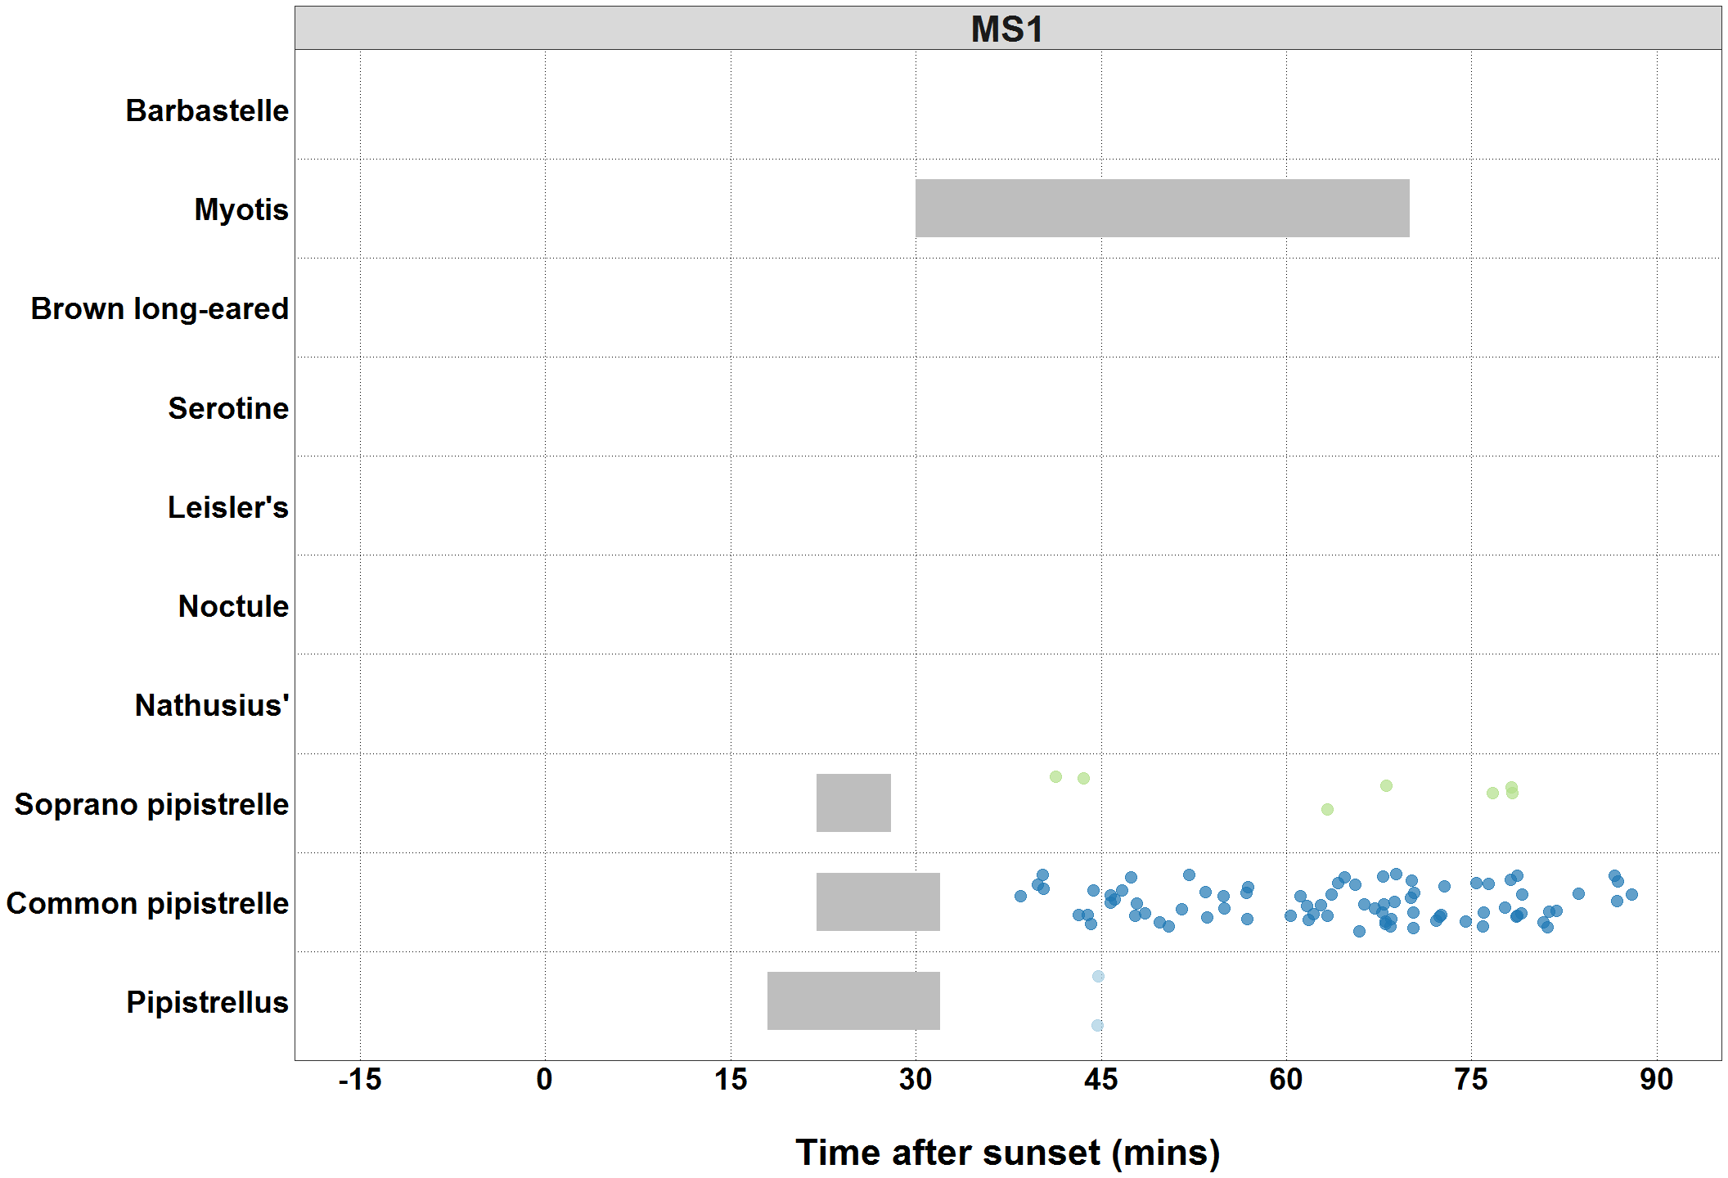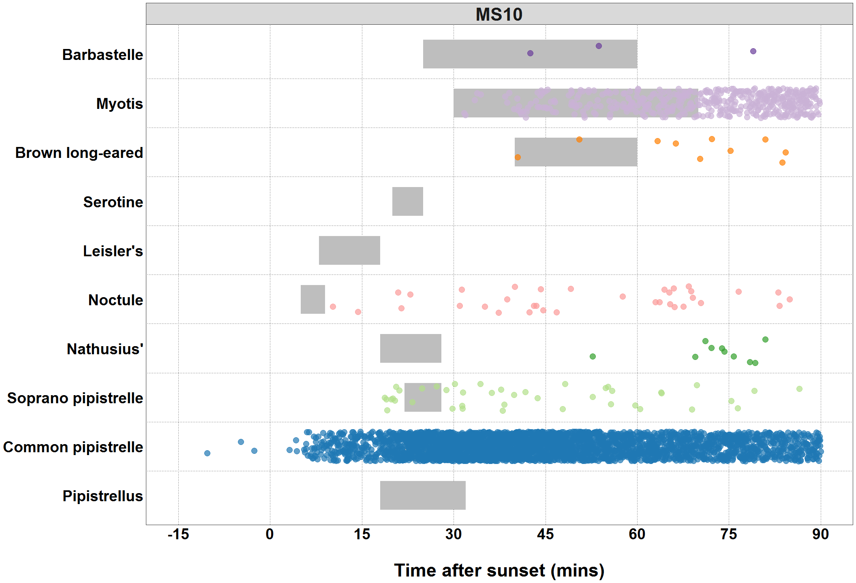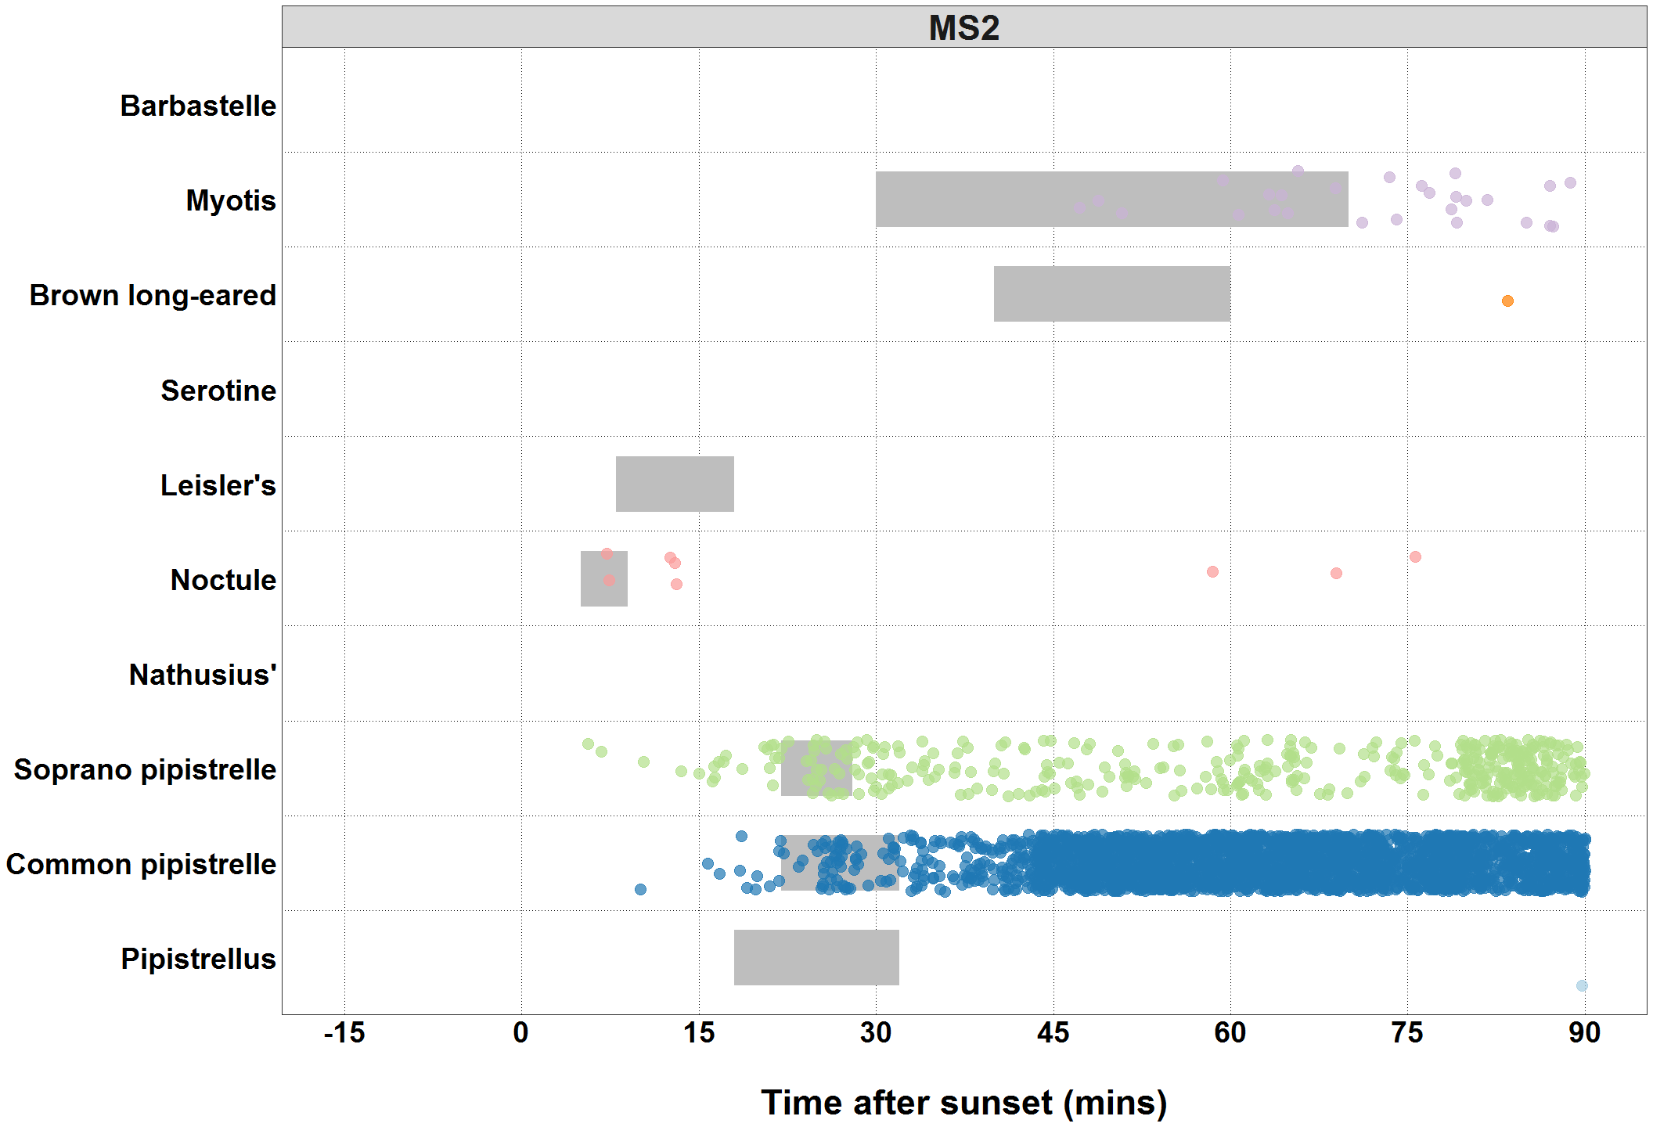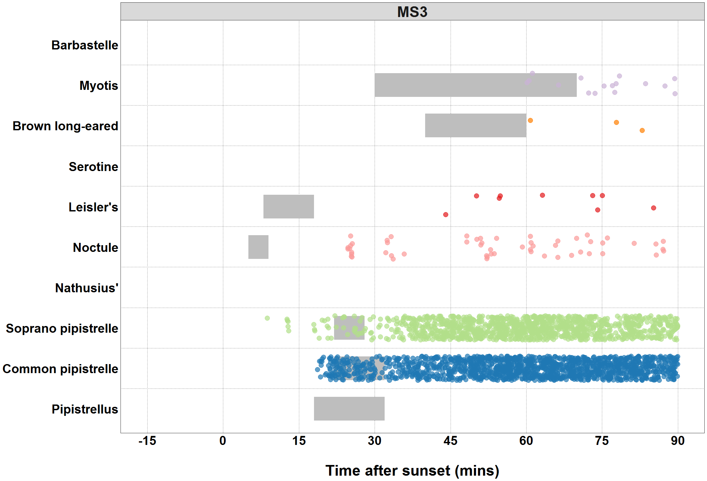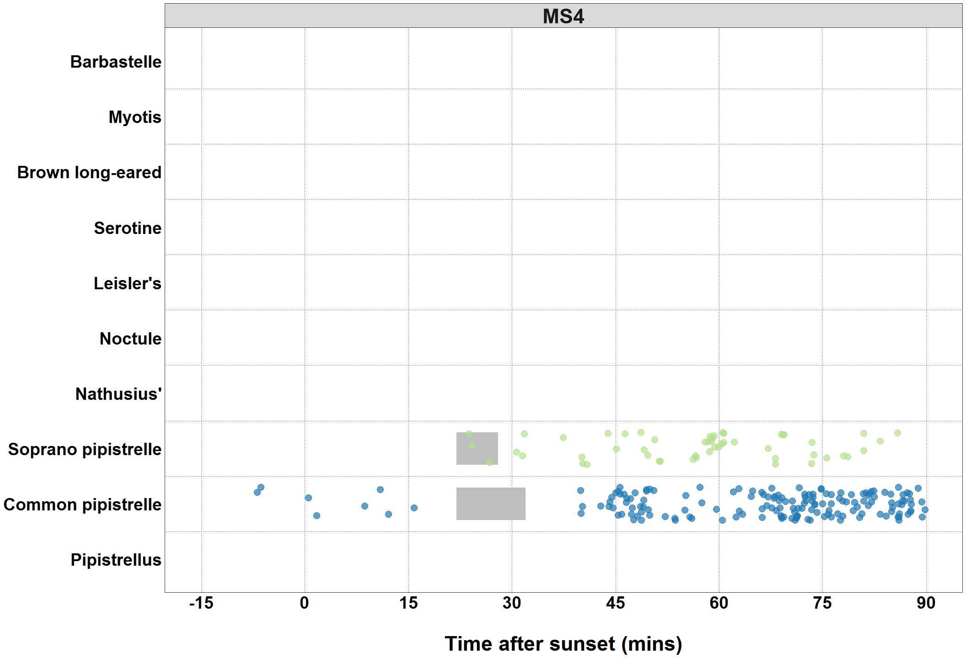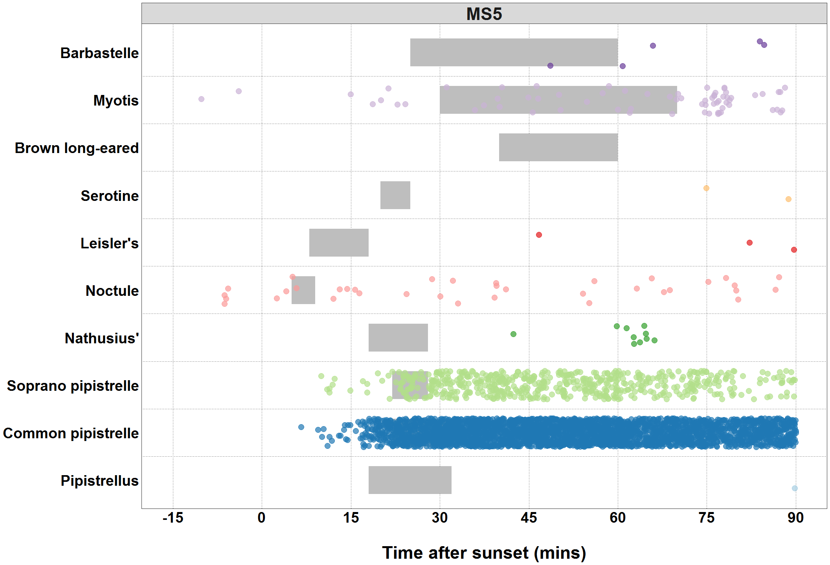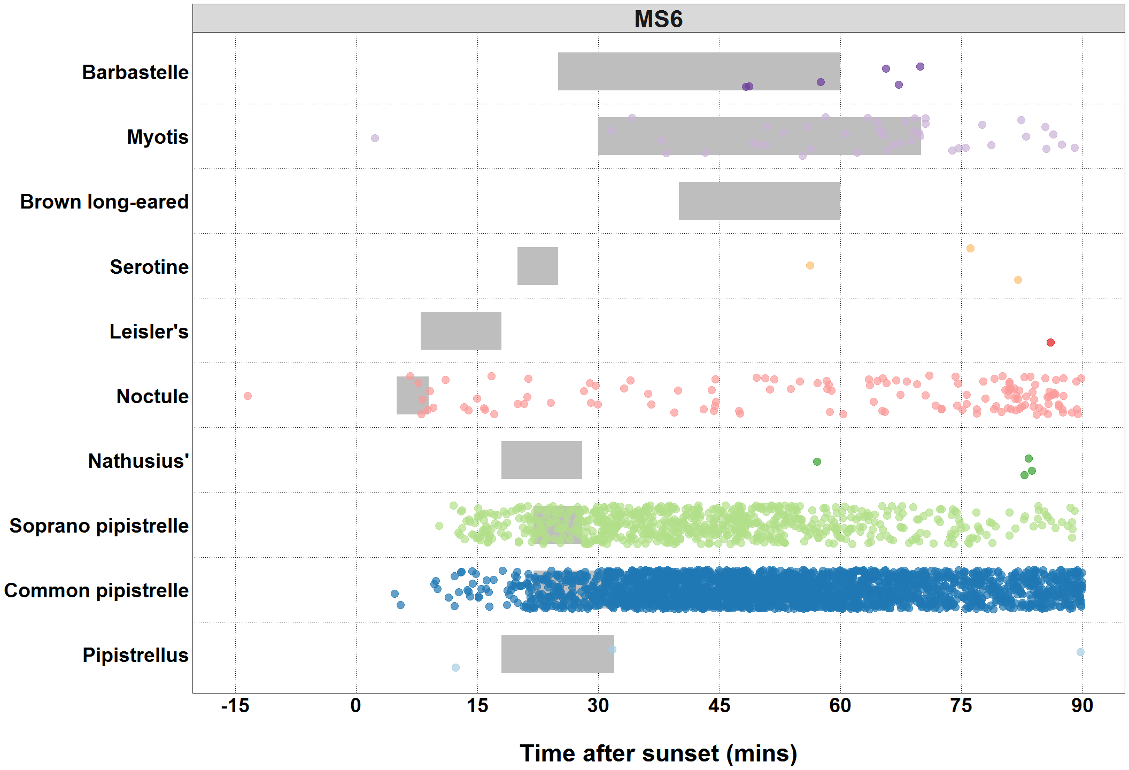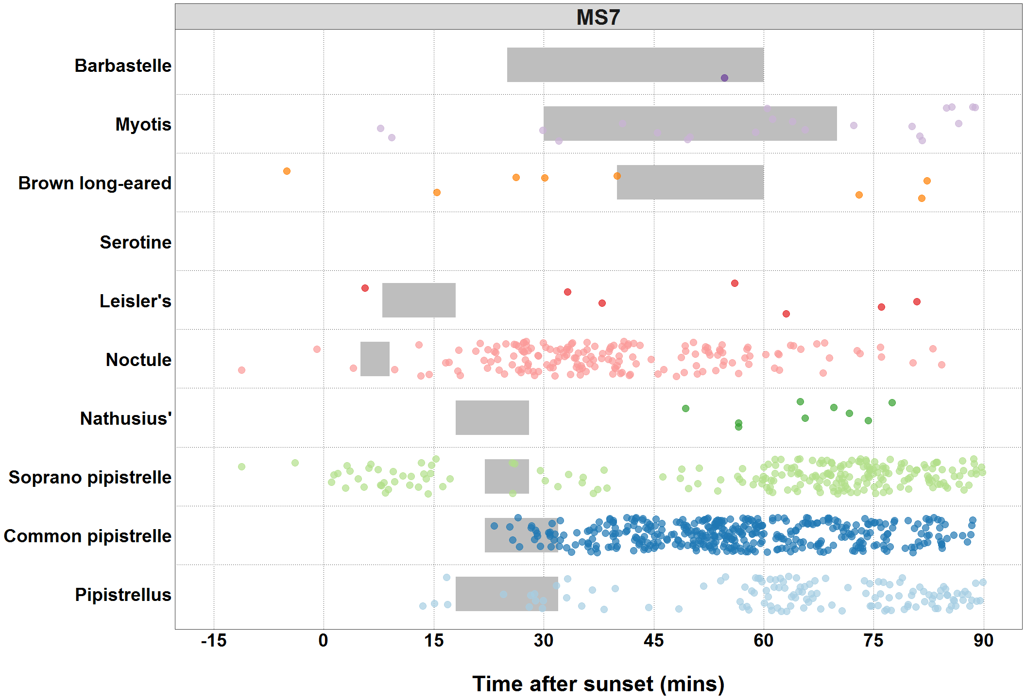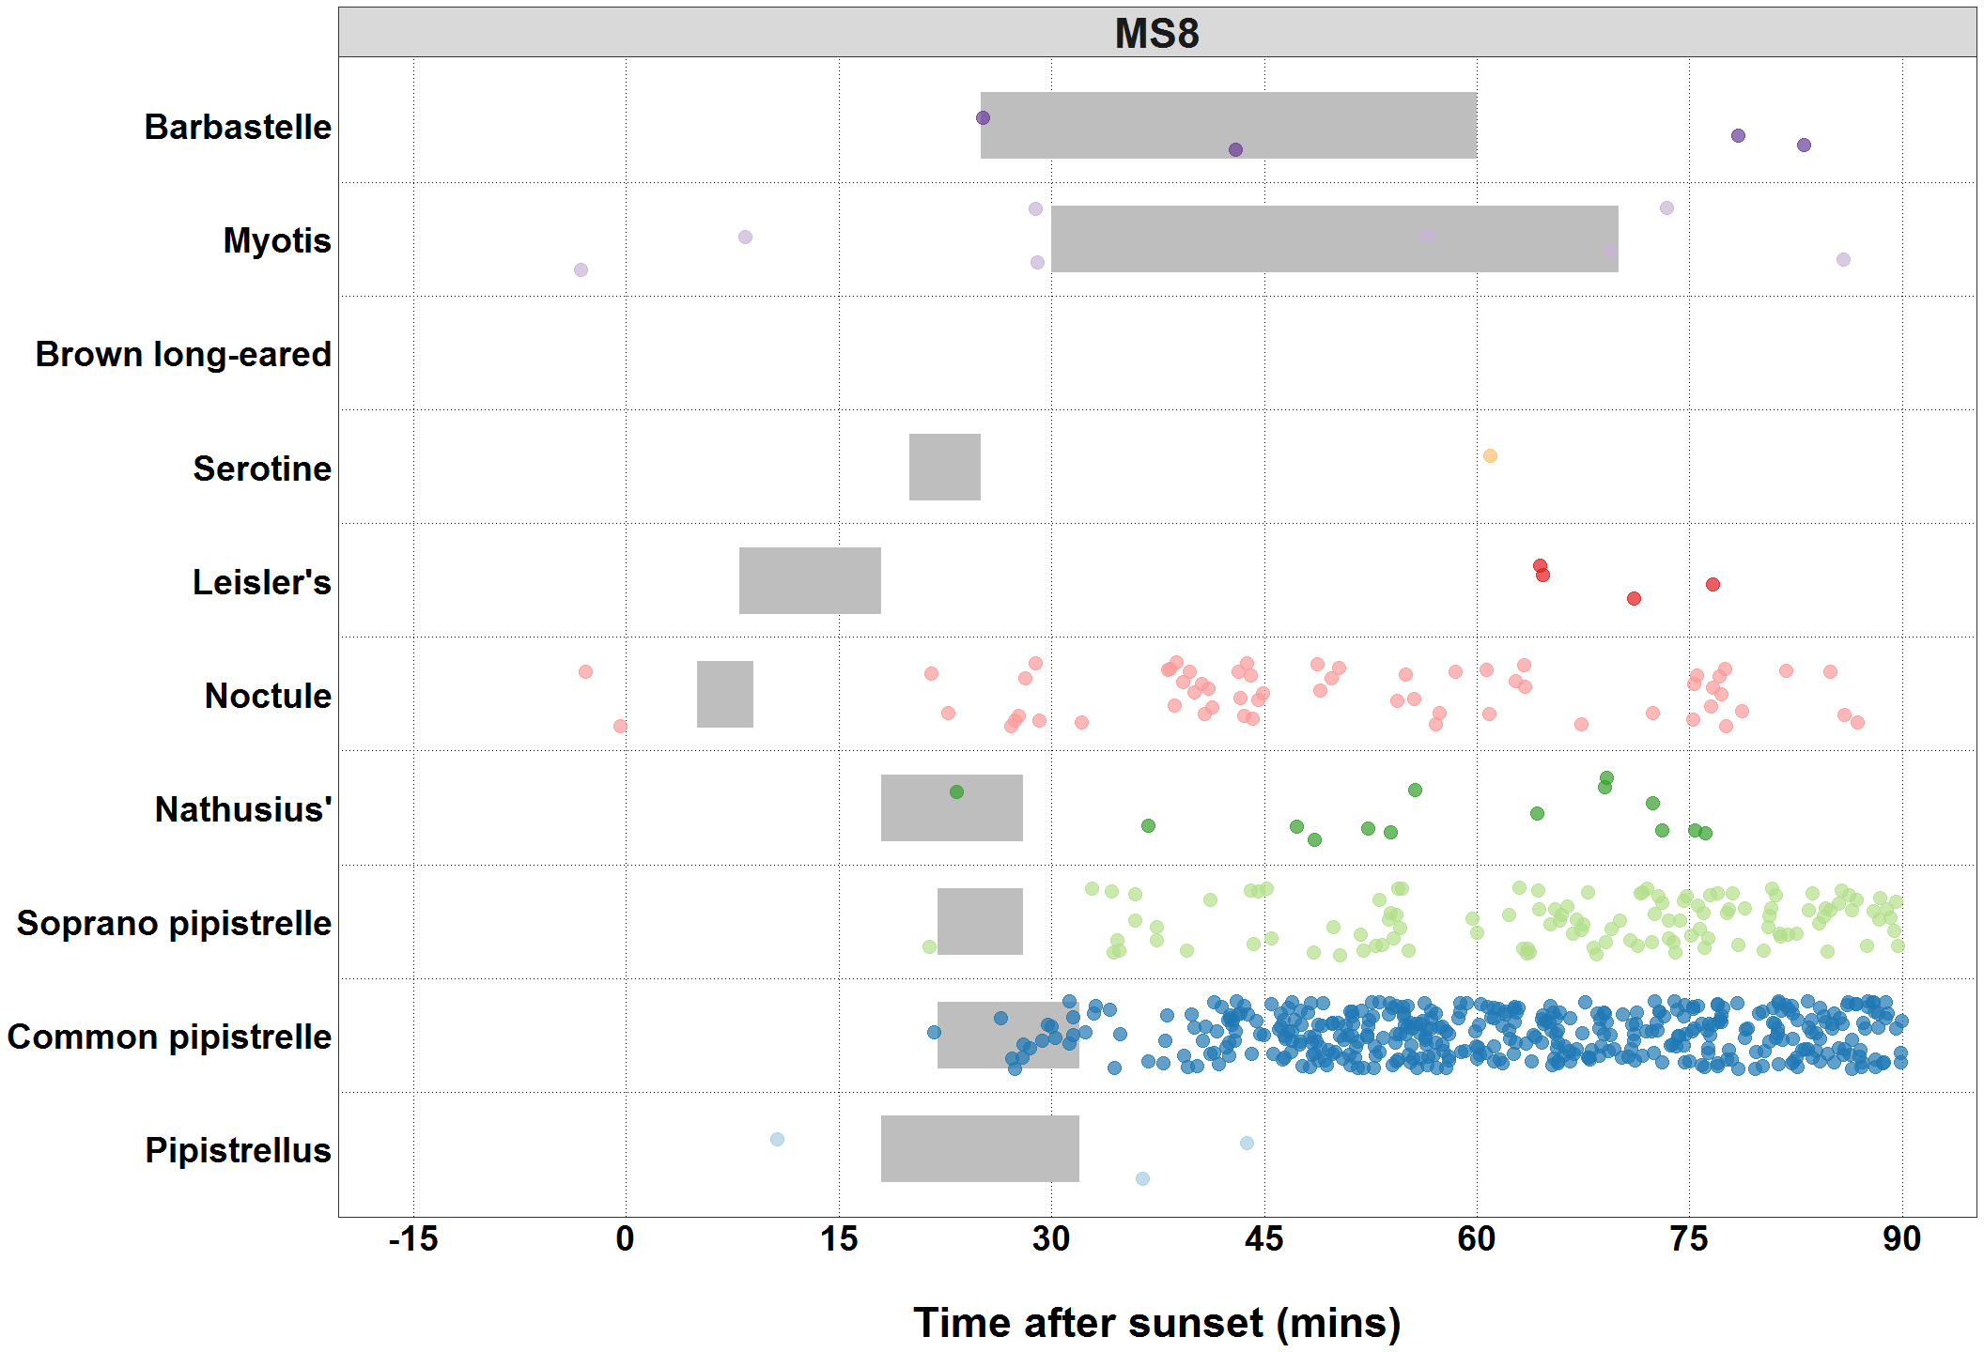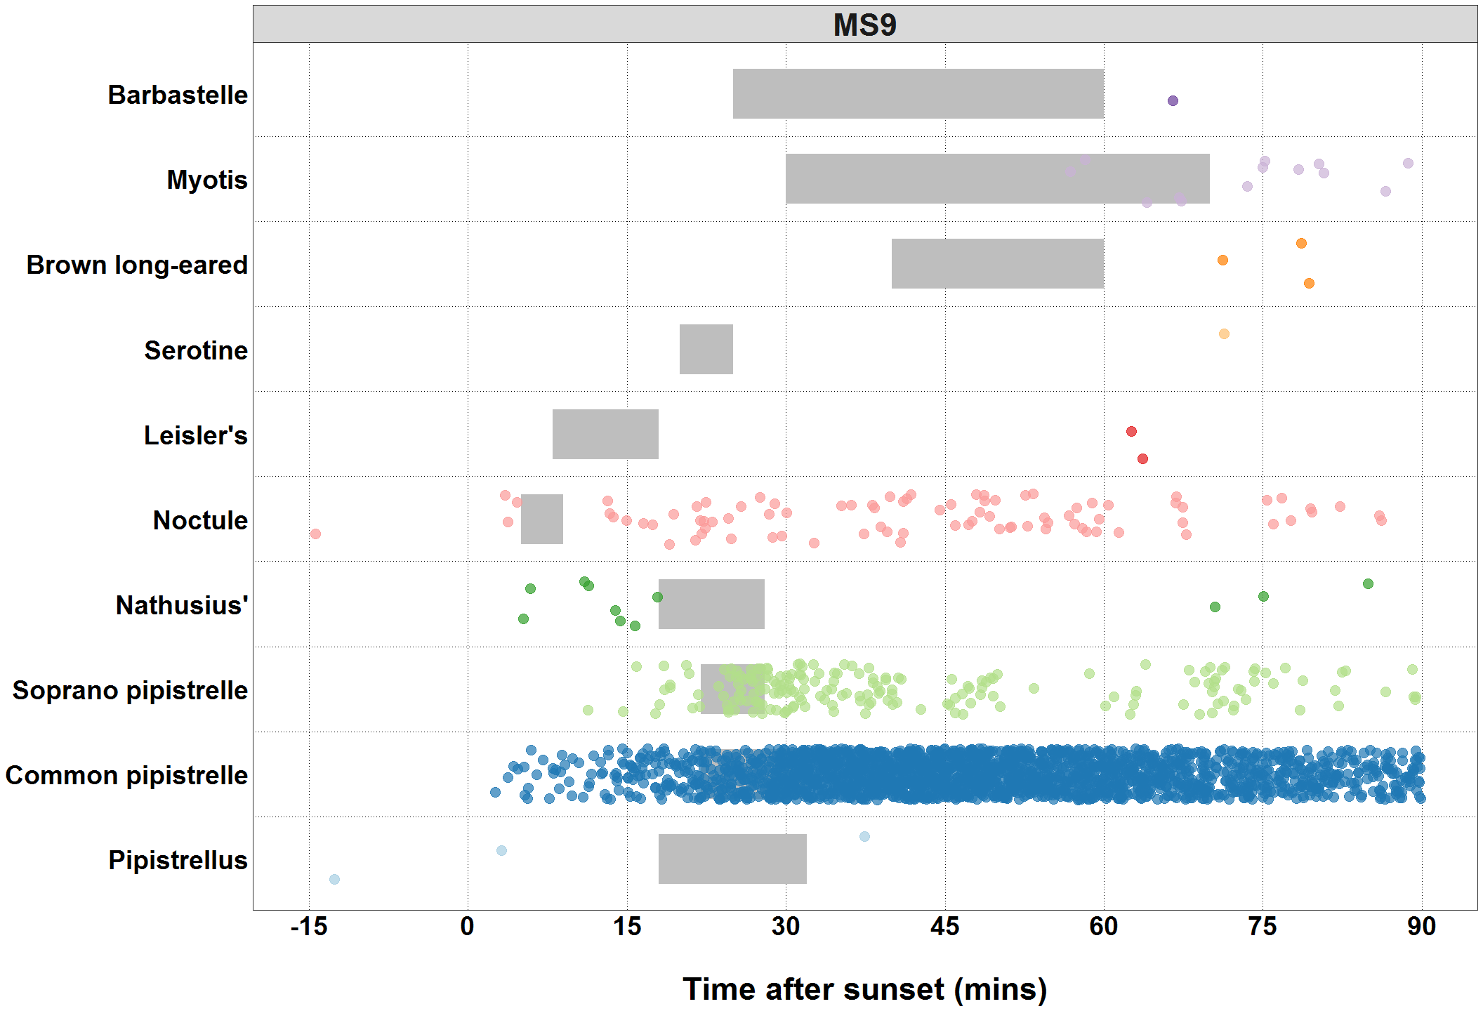

##### Page Break

### Bat Passes Potentially Indicating Close Proximity to a Roost (Maternity Period Only)

**Table:** *Maternity period defined as 15th June - 30th July.*

Table continues below

|  |  |  |  |  |  |  |
| --- | --- | --- | --- | --- | --- | --- |
| Species | Detector ID | 2017-06-22 | 2017-06-25 | 2017-06-26 | 2017-06-29 | 2019-06-18 |
| Pipistrellus | MS6 | 0 | 0 | 0 | 0 | 0 |
| Pipistrellus | MS8 | 0 | 0 | 0 | 0 | 0 |
| Pipistrellus | MS9 | 0 | 0 | 0 | 0 | 0 |
| Common pipistrelle | MS10 | 0 | 0 | 0 | 0 | 122 |
| Common pipistrelle | MS2 | 0 | 1 | 3 | 1 | 0 |
| Common pipistrelle | MS3 | 0 | 0 | 0 | 0 | 0 |
| Common pipistrelle | MS5 | 0 | 0 | 0 | 0 | 9 |
| Common pipistrelle | MS6 | 0 | 0 | 0 | 0 | 0 |
| Common pipistrelle | MS7 | 0 | 0 | 0 | 0 | 0 |
| Common pipistrelle | MS8 | 0 | 0 | 0 | 0 | 0 |
| Common pipistrelle | MS9 | 0 | 0 | 0 | 0 | 1 |
| Soprano pipistrelle | MS10 | 0 | 0 | 0 | 0 | 1 |
| Soprano pipistrelle | MS3 | 0 | 0 | 0 | 0 | 0 |
| Soprano pipistrelle | MS5 | 0 | 0 | 0 | 0 | 0 |
| Soprano pipistrelle | MS6 | 0 | 0 | 0 | 0 | 3 |
| Soprano pipistrelle | MS9 | 0 | 0 | 0 | 0 | 0 |
| Nathusius’ | MS9 | 0 | 0 | 0 | 0 | 0 |
| Noctule | MS5 | 0 | 0 | 0 | 0 | 1 |
| Noctule | MS6 | 0 | 0 | 0 | 0 | 0 |
| Noctule | MS7 | 0 | 0 | 0 | 0 | 0 |
| Noctule | MS8 | 0 | 0 | 0 | 0 | 0 |
| Noctule | MS9 | 0 | 0 | 0 | 0 | 0 |
| Myotis | MS10 | 0 | 0 | 0 | 0 | 0 |
| Myotis | MS2 | 1 | 0 | 0 | 0 | 0 |
| Myotis | MS3 | 0 | 0 | 0 | 0 | 0 |
| Myotis | MS6 | 0 | 0 | 0 | 0 | 1 |
| Myotis | MS9 | 0 | 0 | 0 | 0 | 0 |
| Barbastelle | MS7 | 0 | 0 | 0 | 0 | 0 |

Table continues below

|  |  |  |  |  |  |  |
| --- | --- | --- | --- | --- | --- | --- |
| 2019-06-19 | 2019-06-20 | 2019-06-21 | 2019-06-22 | 2019-06-23 | 2019-06-24 | 2019-06-25 |
| 0 | 0 | 1 | 0 | 0 | 0 | 0 |
| 0 | 1 | 0 | 0 | 0 | 0 | 0 |
| 0 | 0 | 0 | 0 | 0 | 0 | 0 |
| 69 | 41 | 32 | 45 | 72 | 39 | 92 |
| 0 | 0 | 0 | 0 | 0 | 0 | 0 |
| 0 | 0 | 0 | 0 | 1 | 0 | 0 |
| 0 | 0 | 0 | 15 | 42 | 4 | 28 |
| 0 | 0 | 0 | 2 | 1 | 0 | 3 |
| 4 | 1 | 1 | 6 | 0 | 0 | 1 |
| 0 | 0 | 0 | 0 | 0 | 0 | 0 |
| 5 | 1 | 11 | 8 | 17 | 3 | 14 |
| 0 | 0 | 0 | 0 | 0 | 0 | 0 |
| 0 | 0 | 0 | 0 | 0 | 0 | 0 |
| 0 | 0 | 0 | 0 | 0 | 0 | 0 |
| 0 | 0 | 0 | 0 | 1 | 1 | 2 |
| 1 | 0 | 0 | 1 | 3 | 0 | 0 |
| 0 | 2 | 2 | 2 | 1 | 0 | 0 |
| 0 | 0 | 0 | 0 | 0 | 0 | 0 |
| 0 | 0 | 0 | 0 | 0 | 0 | 5 |
| 0 | 1 | 0 | 0 | 0 | 0 | 0 |
| 0 | 0 | 0 | 0 | 0 | 0 | 0 |
| 3 | 0 | 0 | 0 | 0 | 1 | 0 |
| 2 | 0 | 0 | 0 | 4 | 4 | 1 |
| 0 | 0 | 0 | 0 | 0 | 0 | 0 |
| 0 | 0 | 0 | 1 | 0 | 0 | 0 |
| 0 | 0 | 0 | 0 | 2 | 0 | 1 |
| 0 | 0 | 0 | 0 | 2 | 0 | 0 |
| 0 | 0 | 0 | 0 | 0 | 0 | 0 |

Table continues below

|  |  |  |  |  |  |  |
| --- | --- | --- | --- | --- | --- | --- |
| 2019-06-26 | 2019-06-27 | 2019-06-28 | 2019-06-29 | 2019-07-02 | 2019-07-03 | 2019-07-04 |
| 0 | 0 | 0 | 0 | 0 | 0 | 0 |
| 0 | 0 | 0 | 0 | 0 | 0 | 0 |
| 2 | 0 | 0 | 0 | 0 | 0 | 0 |
| 12 | 2 | 0 | 0 | 60 | 28 | 28 |
| 0 | 0 | 0 | 0 | 0 | 0 | 0 |
| 3 | 0 | 1 | 2 | 0 | 0 | 0 |
| 62 | 0 | 0 | 0 | 16 | 40 | 18 |
| 2 | 0 | 0 | 0 | 1 | 1 | 0 |
| 0 | 0 | 0 | 0 | 0 | 0 | 0 |
| 0 | 0 | 0 | 0 | 0 | 0 | 0 |
| 17 | 13 | 0 | 0 | 11 | 6 | 3 |
| 0 | 0 | 0 | 0 | 0 | 0 | 0 |
| 1 | 0 | 1 | 0 | 0 | 0 | 0 |
| 0 | 0 | 0 | 0 | 0 | 0 | 1 |
| 2 | 0 | 0 | 0 | 2 | 1 | 0 |
| 1 | 0 | 0 | 0 | 0 | 0 | 0 |
| 1 | 0 | 0 | 0 | 0 | 0 | 0 |
| 0 | 0 | 0 | 0 | 0 | 0 | 0 |
| 0 | 0 | 0 | 0 | 0 | 0 | 0 |
| 0 | 0 | 0 | 0 | 0 | 0 | 0 |
| 0 | 0 | 0 | 0 | 0 | 0 | 1 |
| 0 | 0 | 0 | 0 | 0 | 0 | 0 |
| 2 | 1 | 0 | 0 | 12 | 6 | 11 |
| 0 | 0 | 0 | 0 | 0 | 0 | 0 |
| 0 | 0 | 0 | 0 | 0 | 0 | 0 |
| 0 | 0 | 0 | 0 | 0 | 2 | 0 |
| 0 | 0 | 0 | 0 | 0 | 0 | 0 |
| 0 | 0 | 0 | 0 | 0 | 0 | 0 |

|  |  |  |  |  |
| --- | --- | --- | --- | --- |
| 2019-07-05 | 2019-07-06 | 2019-07-07 | 2019-07-08 | 2019-07-09 |
| 0 | 0 | 0 | 0 | 0 |
| 0 | 0 | 0 | 0 | 0 |
| 0 | 0 | 0 | 0 | 0 |
| 31 | 86 | 0 | 0 | 0 |
| 0 | 0 | 0 | 0 | 0 |
| 0 | 0 | 0 | 0 | 0 |
| 18 | 0 | 0 | 0 | 0 |
| 0 | 0 | 1 | 1 | 0 |
| 0 | 2 | 0 | 0 | 0 |
| 0 | 4 | 0 | 0 | 0 |
| 3 | 10 | 3 | 3 | 5 |
| 0 | 0 | 0 | 0 | 0 |
| 0 | 0 | 0 | 0 | 0 |
| 0 | 0 | 0 | 0 | 0 |
| 0 | 21 | 0 | 3 | 0 |
| 0 | 0 | 0 | 0 | 0 |
| 0 | 0 | 0 | 0 | 0 |
| 0 | 0 | 0 | 0 | 0 |
| 0 | 0 | 0 | 0 | 0 |
| 0 | 0 | 0 | 0 | 1 |
| 0 | 0 | 0 | 0 | 0 |
| 0 | 0 | 0 | 0 | 0 |
| 19 | 72 | 0 | 0 | 0 |
| 0 | 0 | 0 | 0 | 1 |
| 0 | 0 | 1 | 0 | 0 |
| 0 | 0 | 0 | 0 | 2 |
| 0 | 0 | 0 | 0 | 1 |
| 0 | 1 | 0 | 0 | 0 |

##### Page Break

### Bat Passes Potentially Indicating Close Proximity to a Roost (Maternity Period Only)

**Figures:** *Maternity period defined as 15th June - 30th July.*

##### Page Break

# Counts of Bat Passes

## All detectors

**The total number of passes recorded for each species across all of the detectors.** The ‘Total’ percentage may be slightly above 100% due to rounding of the percentages per species.

|  |  |  |
| --- | --- | --- |
| Species | Count (No) | Percentage of total (%) |
| Pipistrellus | 3123 | 3.0 |
| Common pipistrelle | 72447 | 69.4 |
| Soprano pipistrelle | 23828 | 22.8 |
| Nathusius’ | 223 | 0.2 |
| Noctule | 2276 | 2.2 |
| Leisler’s | 113 | 0.1 |
| Serotine | 31 | 0.0 |
| Brown long-eared | 100 | 0.1 |
| Myotis | 2013 | 1.9 |
| Barbastelle | 231 | 0.2 |
| Total | 104385 | 99.9 |

##### Page Break

# Counts of Bat Passes

## Per Detector

**The number of passes recorded for each species at each detector.**

|  |  |  |  |
| --- | --- | --- | --- |
| Species | Detector ID | Count (No) | Percentage by Detector (%) |
| Pipistrellus | MS1 | 3 | 1.5 |
| Pipistrellus | MS10 | 34 | 0.4 |
| Pipistrellus | MS2 | 1 | 0.0 |
| Pipistrellus | MS3 | 4 | 0.0 |
| Pipistrellus | MS5 | 207 | 1.1 |
| Pipistrellus | MS6 | 853 | 6.0 |
| Pipistrellus | MS7 | 1453 | 22.5 |
| Pipistrellus | MS8 | 120 | 4.7 |
| Pipistrellus | MS9 | 448 | 7.6 |
| Common pipistrelle | MS1 | 183 | 88.8 |
| Common pipistrelle | MS10 | 7317 | 83.9 |
| Common pipistrelle | MS2 | 21828 | 72.8 |
| Common pipistrelle | MS3 | 10470 | 71.9 |
| Common pipistrelle | MS4 | 1909 | 76.3 |
| Common pipistrelle | MS5 | 13642 | 70.7 |
| Common pipistrelle | MS6 | 9699 | 68.2 |
| Common pipistrelle | MS7 | 1256 | 19.4 |
| Common pipistrelle | MS8 | 1536 | 59.9 |
| Common pipistrelle | MS9 | 4607 | 78.5 |
| Soprano pipistrelle | MS1 | 19 | 9.2 |
| Soprano pipistrelle | MS10 | 189 | 2.2 |
| Soprano pipistrelle | MS2 | 8032 | 26.8 |
| Soprano pipistrelle | MS3 | 3807 | 26.1 |
| Soprano pipistrelle | MS4 | 592 | 23.7 |
| Soprano pipistrelle | MS5 | 4860 | 25.2 |
| Soprano pipistrelle | MS6 | 1968 | 13.8 |
| Soprano pipistrelle | MS7 | 3345 | 51.7 |
| Soprano pipistrelle | MS8 | 475 | 18.5 |
| Soprano pipistrelle | MS9 | 541 | 9.2 |
| Nathusius’ | MS10 | 19 | 0.2 |
| Nathusius’ | MS5 | 23 | 0.1 |
| Nathusius’ | MS6 | 12 | 0.1 |
| Nathusius’ | MS7 | 26 | 0.4 |
| Nathusius’ | MS8 | 105 | 4.1 |
| Nathusius’ | MS9 | 38 | 0.6 |
| Noctule | MS10 | 133 | 1.5 |
| Noctule | MS2 | 37 | 0.1 |
| Noctule | MS3 | 157 | 1.1 |
| Noctule | MS5 | 147 | 0.8 |
| Noctule | MS6 | 1271 | 8.9 |
| Noctule | MS7 | 226 | 3.5 |
| Noctule | MS8 | 168 | 6.5 |
| Noctule | MS9 | 137 | 2.3 |
| Leisler’s | MS10 | 5 | 0.1 |
| Leisler’s | MS2 | 1 | 0.0 |
| Leisler’s | MS3 | 32 | 0.2 |
| Leisler’s | MS5 | 13 | 0.1 |
| Leisler’s | MS6 | 16 | 0.1 |
| Leisler’s | MS7 | 21 | 0.3 |
| Leisler’s | MS8 | 17 | 0.7 |
| Leisler’s | MS9 | 8 | 0.1 |
| Serotine | MS10 | 2 | 0.0 |
| Serotine | MS5 | 5 | 0.0 |
| Serotine | MS6 | 16 | 0.1 |
| Serotine | MS8 | 4 | 0.2 |
| Serotine | MS9 | 4 | 0.1 |
| Brown long-eared | MS10 | 39 | 0.4 |
| Brown long-eared | MS2 | 3 | 0.0 |
| Brown long-eared | MS3 | 10 | 0.1 |
| Brown long-eared | MS5 | 2 | 0.0 |
| Brown long-eared | MS6 | 17 | 0.1 |
| Brown long-eared | MS7 | 16 | 0.2 |
| Brown long-eared | MS9 | 13 | 0.2 |
| Myotis | MS1 | 1 | 0.5 |
| Myotis | MS10 | 909 | 10.4 |
| Myotis | MS2 | 74 | 0.2 |
| Myotis | MS3 | 84 | 0.6 |
| Myotis | MS5 | 321 | 1.7 |
| Myotis | MS6 | 307 | 2.2 |
| Myotis | MS7 | 122 | 1.9 |
| Myotis | MS8 | 128 | 5.0 |
| Myotis | MS9 | 67 | 1.1 |
| Barbastelle | MS10 | 77 | 0.9 |
| Barbastelle | MS5 | 65 | 0.3 |
| Barbastelle | MS6 | 63 | 0.4 |
| Barbastelle | MS7 | 5 | 0.1 |
| Barbastelle | MS8 | 13 | 0.5 |
| Barbastelle | MS9 | 8 | 0.1 |

##### Page Break

# Species Composition of Passes at each Detector

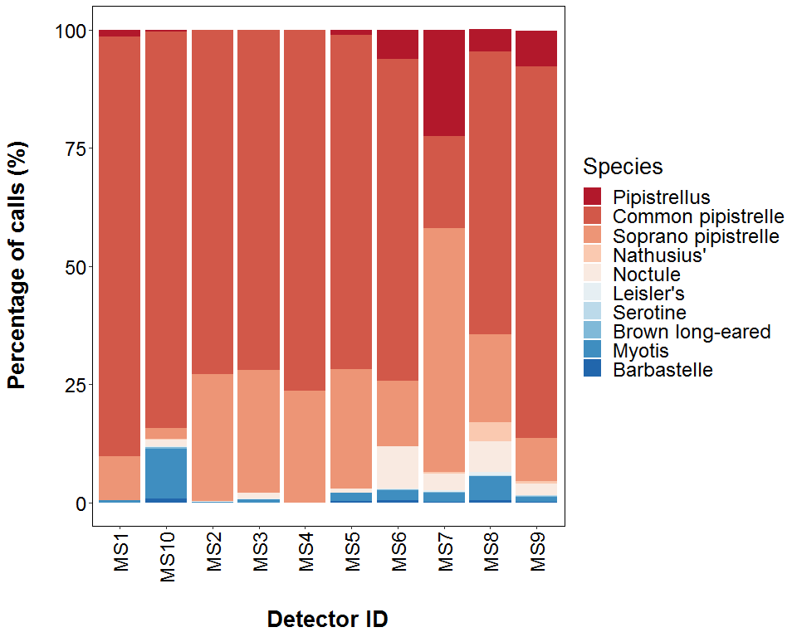

##### Page Break

## **PART 2a: Presence Only**

**THE NEXT SECTION OF THE REPORT FEATURES THE RAW DATA SUPPLIED TO ECOBAT AND ONLY TAKES INTO ACCOUNT THE PRESENCE, AND NOT THE ABSENCE, OF EACH BAT SPECIES. FOR EACH NIGHT, THERE IS NO ‘ZERO DATA’ FOR WHEN SPECIES WERE NOT DETECTED.**

##### Page Break

## Nightly Bat Pass Rate (Bat passes per hour)

# Median Per Detector

**The median Nightly Pass Rate (bat passes per hour, per night) of each species. If NA, then no bat passes.**

Bat pass rates are often highly variable between nights, with some nights having few or no passes and other nights having high activity. In these circumstances, the median is likely to be a more useful summary of the ‘average’ activity than is the mean. For further information see: *Lintott, P. R., & Mathews, F. (2018). Basic mathematical errors may make ecological assessments unreliable. Biodiversity and Conservation, 27(1), 265-267.* <https://doi.org/10.1007/s10531-017-1418-5>

|  |  |  |
| --- | --- | --- |
| Species | Detector ID | Median Pass Rate |
| Pipistrellus | MS1 | 0.3 |
| Pipistrellus | MS10 | 2.6 |
| Pipistrellus | MS2 | 0.1 |
| Pipistrellus | MS3 | 0.1 |
| Pipistrellus | MS5 | 27.7 |
| Pipistrellus | MS6 | 10.4 |
| Pipistrellus | MS7 | 12.9 |
| Pipistrellus | MS8 | 2.8 |
| Pipistrellus | MS9 | 12.8 |
| Common pipistrelle | MS1 | 0.3 |
| Common pipistrelle | MS10 | 23.5 |
| Common pipistrelle | MS2 | 56.5 |
| Common pipistrelle | MS3 | 13.4 |
| Common pipistrelle | MS4 | 7.2 |
| Common pipistrelle | MS5 | 37.5 |
| Common pipistrelle | MS6 | 8.8 |
| Common pipistrelle | MS7 | 1.8 |
| Common pipistrelle | MS8 | 1.4 |
| Common pipistrelle | MS9 | 11.3 |
| Soprano pipistrelle | MS1 | 0.1 |
| Soprano pipistrelle | MS10 | 0.6 |
| Soprano pipistrelle | MS2 | 3.8 |
| Soprano pipistrelle | MS3 | 6.5 |
| Soprano pipistrelle | MS4 | 2.2 |
| Soprano pipistrelle | MS5 | 4.3 |
| Soprano pipistrelle | MS6 | 1.5 |
| Soprano pipistrelle | MS7 | 4.4 |
| Soprano pipistrelle | MS8 | 0.5 |
| Soprano pipistrelle | MS9 | 0.6 |
| Nathusius’ | MS10 | 0.3 |
| Nathusius’ | MS5 | 0.4 |
| Nathusius’ | MS6 | 0.1 |
| Nathusius’ | MS7 | 0.3 |
| Nathusius’ | MS8 | 0.3 |
| Nathusius’ | MS9 | 0.3 |
| Noctule | MS10 | 0.2 |
| Noctule | MS2 | 0.1 |
| Noctule | MS3 | 0.8 |
| Noctule | MS5 | 0.3 |
| Noctule | MS6 | 0.9 |
| Noctule | MS7 | 0.3 |
| Noctule | MS8 | 0.3 |
| Noctule | MS9 | 0.4 |
| Leisler’s | MS10 | 0.1 |
| Leisler’s | MS2 | 0.1 |
| Leisler’s | MS3 | 0.3 |
| Leisler’s | MS5 | 0.2 |
| Leisler’s | MS6 | 0.1 |
| Leisler’s | MS7 | 0.2 |
| Leisler’s | MS8 | 0.2 |
| Leisler’s | MS9 | 0.1 |
| Serotine | MS10 | 0.1 |
| Serotine | MS5 | 0.1 |
| Serotine | MS6 | 0.1 |
| Serotine | MS8 | 0.1 |
| Serotine | MS9 | 0.1 |
| Brown long-eared | MS10 | 0.2 |
| Brown long-eared | MS2 | 0.1 |
| Brown long-eared | MS3 | 0.1 |
| Brown long-eared | MS5 | 0.1 |
| Brown long-eared | MS6 | 0.3 |
| Brown long-eared | MS7 | 0.2 |
| Brown long-eared | MS9 | 0.1 |
| Myotis | MS1 | 0.1 |
| Myotis | MS10 | 0.7 |
| Myotis | MS2 | 0.3 |
| Myotis | MS3 | 0.4 |
| Myotis | MS5 | 0.7 |
| Myotis | MS6 | 0.5 |
| Myotis | MS7 | 0.2 |
| Myotis | MS8 | 0.3 |
| Myotis | MS9 | 0.2 |
| Barbastelle | MS10 | 0.2 |
| Barbastelle | MS5 | 0.7 |
| Barbastelle | MS6 | 0.2 |
| Barbastelle | MS7 | 0.1 |
| Barbastelle | MS8 | 0.1 |
| Barbastelle | MS9 | 0.1 |

##### Page Break

## Nightly Bat Pass Rate (Bat passes per hour)

# Mean per Detector

**The mean Nightly Pass Rate (bat passes per hour, per night) of each species at each detector. Values are given to 1 decimal place.**

We recommend using the median values given above, for the reasons stated above, but provide the mean values in the table below.

|  |  |  |
| --- | --- | --- |
| Species | Detector ID | Mean Pass Rate |
| Pipistrellus | MS1 | 0.3 |
| Pipistrellus | MS10 | 2.6 |
| Pipistrellus | MS2 | 0.1 |
| Pipistrellus | MS3 | 0.1 |
| Pipistrellus | MS5 | 27.7 |
| Pipistrellus | MS6 | 22.3 |
| Pipistrellus | MS7 | 20.9 |
| Pipistrellus | MS8 | 4.1 |
| Pipistrellus | MS9 | 20.1 |
| Common pipistrelle | MS1 | 1.3 |
| Common pipistrelle | MS10 | 30.5 |
| Common pipistrelle | MS2 | 75.1 |
| Common pipistrelle | MS3 | 38.4 |
| Common pipistrelle | MS4 | 9.8 |
| Common pipistrelle | MS5 | 43.2 |
| Common pipistrelle | MS6 | 17.8 |
| Common pipistrelle | MS7 | 3.3 |
| Common pipistrelle | MS8 | 4.6 |
| Common pipistrelle | MS9 | 10.5 |
| Soprano pipistrelle | MS1 | 0.3 |
| Soprano pipistrelle | MS10 | 0.9 |
| Soprano pipistrelle | MS2 | 26.7 |
| Soprano pipistrelle | MS3 | 14.9 |
| Soprano pipistrelle | MS4 | 3.3 |
| Soprano pipistrelle | MS5 | 14.8 |
| Soprano pipistrelle | MS6 | 4.0 |
| Soprano pipistrelle | MS7 | 8.6 |
| Soprano pipistrelle | MS8 | 2.0 |
| Soprano pipistrelle | MS9 | 1.7 |
| Nathusius’ | MS10 | 0.4 |
| Nathusius’ | MS5 | 0.5 |
| Nathusius’ | MS6 | 0.2 |
| Nathusius’ | MS7 | 0.3 |
| Nathusius’ | MS8 | 0.6 |
| Nathusius’ | MS9 | 0.3 |
| Noctule | MS10 | 0.6 |
| Noctule | MS2 | 0.2 |
| Noctule | MS3 | 0.9 |
| Noctule | MS5 | 0.5 |
| Noctule | MS6 | 2.5 |
| Noctule | MS7 | 1.0 |
| Noctule | MS8 | 0.6 |
| Noctule | MS9 | 0.6 |
| Leisler’s | MS10 | 0.1 |
| Leisler’s | MS2 | 0.1 |
| Leisler’s | MS3 | 0.3 |
| Leisler’s | MS5 | 0.3 |
| Leisler’s | MS6 | 0.2 |
| Leisler’s | MS7 | 0.2 |
| Leisler’s | MS8 | 0.2 |
| Leisler’s | MS9 | 0.2 |
| Serotine | MS10 | 0.1 |
| Serotine | MS5 | 0.1 |
| Serotine | MS6 | 0.2 |
| Serotine | MS8 | 0.2 |
| Serotine | MS9 | 0.1 |
| Brown long-eared | MS10 | 0.3 |
| Brown long-eared | MS2 | 0.1 |
| Brown long-eared | MS3 | 0.1 |
| Brown long-eared | MS5 | 0.1 |
| Brown long-eared | MS6 | 0.3 |
| Brown long-eared | MS7 | 0.4 |
| Brown long-eared | MS9 | 0.1 |
| Myotis | MS1 | 0.1 |
| Myotis | MS10 | 4.2 |
| Myotis | MS2 | 0.4 |
| Myotis | MS3 | 0.4 |
| Myotis | MS5 | 1.3 |
| Myotis | MS6 | 0.6 |
| Myotis | MS7 | 0.4 |
| Myotis | MS8 | 0.4 |
| Myotis | MS9 | 0.3 |
| Barbastelle | MS10 | 0.4 |
| Barbastelle | MS5 | 0.9 |
| Barbastelle | MS6 | 0.2 |
| Barbastelle | MS7 | 0.2 |
| Barbastelle | MS8 | 0.1 |
| Barbastelle | MS9 | 0.2 |

##### Page Break

# Nightly Bat Passes (Bat passes per hour)

## Per Detector - Figures

Figures show boxplots for the number of bat passes per hour each night, for each detector. The ‘box’ shows the interquartile range, which is where the middle 50% of the data lie. The line dividing the box is the median, the mid-point of the data. The ‘whiskers’ extend from the box and represent the ranges for the bottom 25% and the top 25% of the data values, excluding outliers. An outlier is any extreme value that lies further away from the box than 1.5 times the interquartile range. Outliers are shown as dots. Where very few passes are recorded it is not possible to produce the box, so the data are shown as a line.

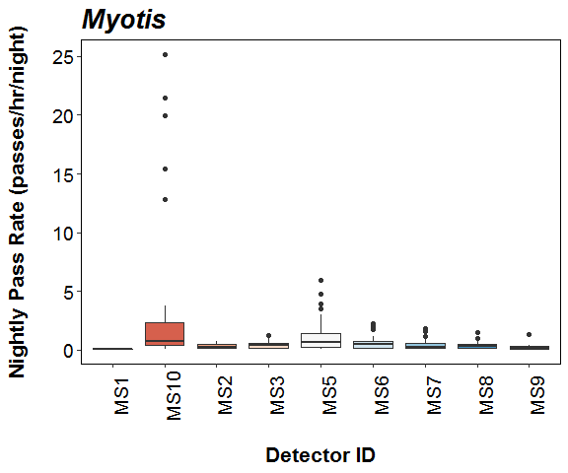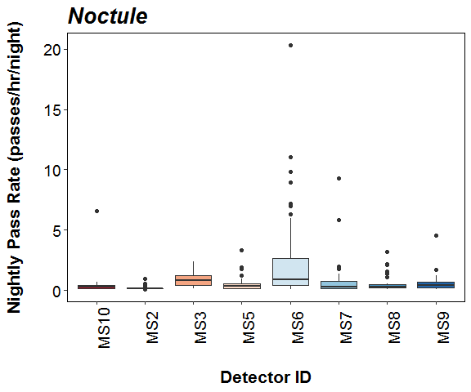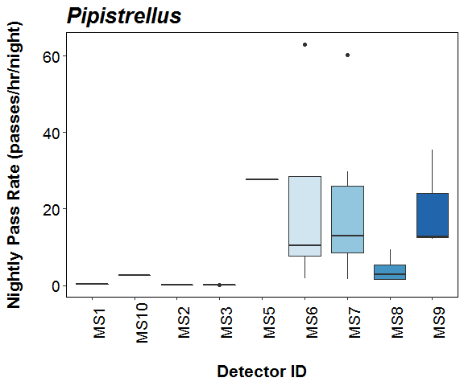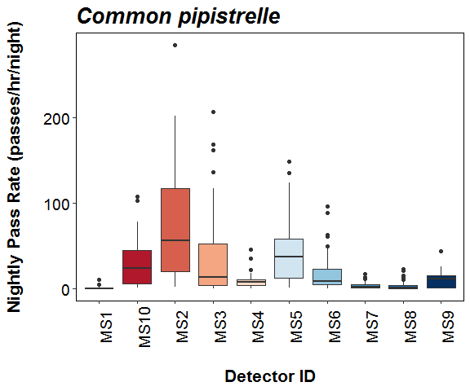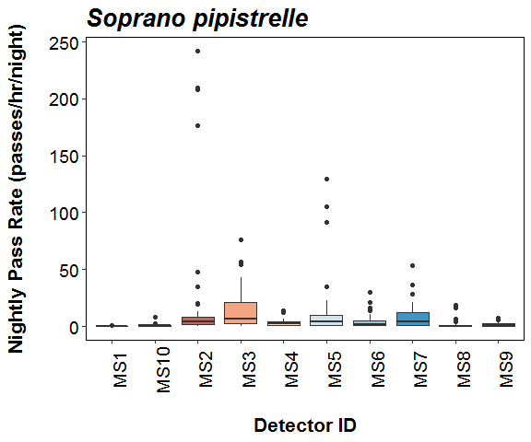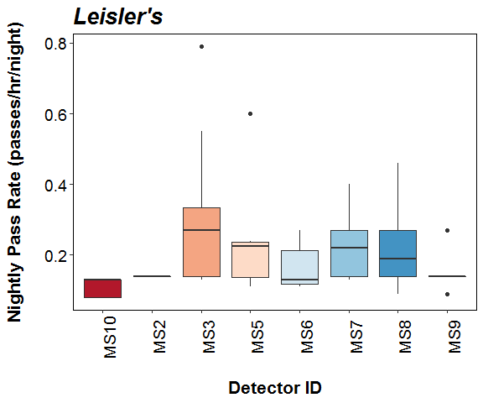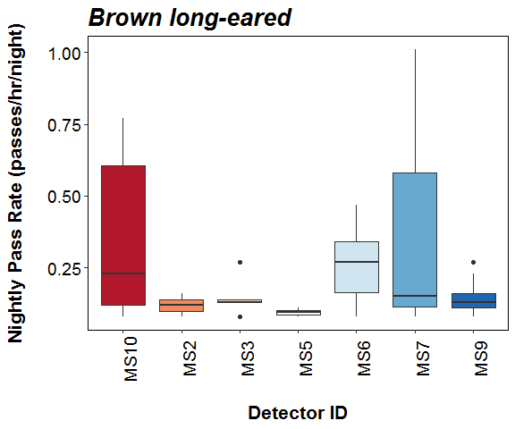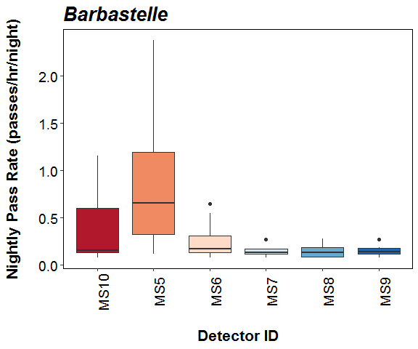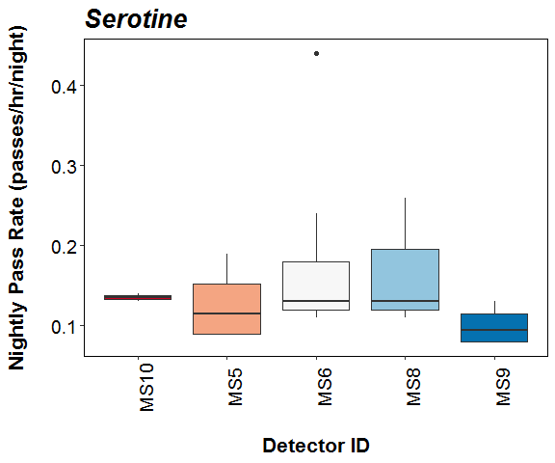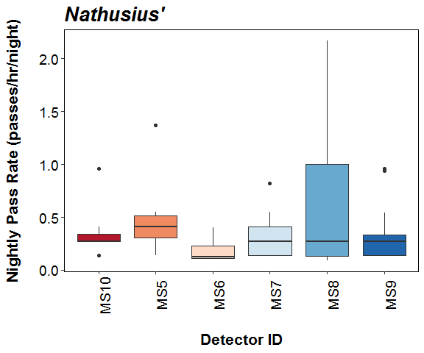

##### Page Break

# SPLIT BY MONTH

# Total Bat Passes per Detector, each Month

## Per Detector

**The total number of bat passes of each species in each month at each detector.** This table simply tells you how many bats of each species were recorded passing each detector during each month. These numbers are not standardised by the night length, or how many nights each detector was active for during each month.

|  |  |  |  |  |  |  |  |
| --- | --- | --- | --- | --- | --- | --- | --- |
| Species | Detector ID | May | Jun | Jul | Aug | Sep | Oct |
| Pipistrellus | MS1 | 0 | 0 | 0 | 0 | 3 | 0 |
| Pipistrellus | MS10 | 0 | 0 | 0 | 0 | 0 | 34 |
| Pipistrellus | MS2 | 0 | 1 | 0 | 0 | 0 | 0 |
| Pipistrellus | MS3 | 0 | 4 | 0 | 0 | 0 | 0 |
| Pipistrellus | MS5 | 0 | 0 | 207 | 0 | 0 | 0 |
| Pipistrellus | MS6 | 0 | 746 | 0 | 0 | 82 | 25 |
| Pipistrellus | MS7 | 0 | 55 | 217 | 0 | 0 | 1181 |
| Pipistrellus | MS8 | 0 | 120 | 0 | 0 | 0 | 0 |
| Pipistrellus | MS9 | 0 | 260 | 188 | 0 | 0 | 0 |
| Common pipistrelle | MS1 | 0 | 1 | 94 | 3 | 85 | 0 |
| Common pipistrelle | MS10 | 0 | 2962 | 2671 | 621 | 0 | 1063 |
| Common pipistrelle | MS2 | 0 | 11082 | 8457 | 1487 | 375 | 427 |
| Common pipistrelle | MS3 | 0 | 8503 | 1290 | 200 | 477 | 0 |
| Common pipistrelle | MS4 | 0 | 1326 | 537 | 46 | 0 | 0 |
| Common pipistrelle | MS5 | 1549 | 4021 | 3070 | 1274 | 1218 | 2510 |
| Common pipistrelle | MS6 | 2702 | 1101 | 458 | 5019 | 167 | 252 |
| Common pipistrelle | MS7 | 0 | 650 | 307 | 261 | 0 | 38 |
| Common pipistrelle | MS8 | 0 | 165 | 920 | 52 | 352 | 47 |
| Common pipistrelle | MS9 | 0 | 1072 | 786 | 342 | 1053 | 1354 |
| Soprano pipistrelle | MS1 | 0 | 0 | 1 | 2 | 16 | 0 |
| Soprano pipistrelle | MS10 | 0 | 58 | 23 | 80 | 0 | 28 |
| Soprano pipistrelle | MS2 | 0 | 5412 | 2201 | 120 | 167 | 132 |
| Soprano pipistrelle | MS3 | 0 | 3060 | 513 | 106 | 128 | 0 |
| Soprano pipistrelle | MS4 | 0 | 257 | 296 | 39 | 0 | 0 |
| Soprano pipistrelle | MS5 | 334 | 445 | 121 | 3819 | 34 | 107 |
| Soprano pipistrelle | MS6 | 329 | 741 | 520 | 73 | 182 | 123 |
| Soprano pipistrelle | MS7 | 0 | 33 | 1071 | 2142 | 0 | 99 |
| Soprano pipistrelle | MS8 | 0 | 358 | 50 | 6 | 32 | 29 |
| Soprano pipistrelle | MS9 | 0 | 144 | 35 | 26 | 214 | 122 |
| Nathusius’ | MS10 | 0 | 19 | 0 | 0 | 0 | 0 |
| Nathusius’ | MS5 | 0 | 23 | 0 | 0 | 0 | 0 |
| Nathusius’ | MS6 | 3 | 0 | 4 | 5 | 0 | 0 |
| Nathusius’ | MS7 | 0 | 23 | 3 | 0 | 0 | 0 |
| Nathusius’ | MS8 | 0 | 6 | 11 | 0 | 88 | 0 |
| Nathusius’ | MS9 | 0 | 18 | 20 | 0 | 0 | 0 |
| Noctule | MS10 | 0 | 10 | 12 | 5 | 0 | 106 |
| Noctule | MS2 | 0 | 23 | 4 | 0 | 3 | 7 |
| Noctule | MS3 | 0 | 81 | 67 | 0 | 9 | 0 |
| Noctule | MS5 | 10 | 60 | 10 | 41 | 13 | 13 |
| Noctule | MS6 | 319 | 61 | 43 | 810 | 14 | 24 |
| Noctule | MS7 | 0 | 30 | 180 | 15 | 0 | 1 |
| Noctule | MS8 | 0 | 40 | 81 | 9 | 23 | 15 |
| Noctule | MS9 | 0 | 33 | 74 | 20 | 10 | 0 |
| Leisler’s | MS10 | 0 | 0 | 3 | 0 | 0 | 2 |
| Leisler’s | MS2 | 0 | 1 | 0 | 0 | 0 | 0 |
| Leisler’s | MS3 | 0 | 19 | 13 | 0 | 0 | 0 |
| Leisler’s | MS5 | 7 | 0 | 0 | 6 | 0 | 0 |
| Leisler’s | MS6 | 3 | 0 | 6 | 7 | 0 | 0 |
| Leisler’s | MS7 | 0 | 14 | 5 | 2 | 0 | 0 |
| Leisler’s | MS8 | 0 | 8 | 1 | 0 | 8 | 0 |
| Leisler’s | MS9 | 0 | 7 | 0 | 0 | 1 | 0 |
| Serotine | MS10 | 0 | 1 | 1 | 0 | 0 | 0 |
| Serotine | MS5 | 0 | 1 | 0 | 0 | 4 | 0 |
| Serotine | MS6 | 6 | 1 | 1 | 8 | 0 | 0 |
| Serotine | MS8 | 0 | 0 | 3 | 1 | 0 | 0 |
| Serotine | MS9 | 0 | 0 | 1 | 1 | 0 | 2 |
| Brown long-eared | MS10 | 0 | 0 | 12 | 1 | 0 | 26 |
| Brown long-eared | MS2 | 0 | 0 | 0 | 0 | 0 | 3 |
| Brown long-eared | MS3 | 0 | 6 | 3 | 0 | 1 | 0 |
| Brown long-eared | MS5 | 0 | 0 | 0 | 1 | 0 | 1 |
| Brown long-eared | MS6 | 0 | 1 | 5 | 0 | 10 | 1 |
| Brown long-eared | MS7 | 0 | 0 | 0 | 0 | 0 | 16 |
| Brown long-eared | MS9 | 0 | 2 | 3 | 1 | 1 | 6 |
| Myotis | MS1 | 0 | 0 | 0 | 0 | 1 | 0 |
| Myotis | MS10 | 0 | 91 | 708 | 12 | 0 | 98 |
| Myotis | MS2 | 0 | 27 | 6 | 10 | 24 | 7 |
| Myotis | MS3 | 0 | 62 | 9 | 0 | 13 | 0 |
| Myotis | MS5 | 24 | 14 | 0 | 167 | 105 | 11 |
| Myotis | MS6 | 38 | 36 | 34 | 140 | 35 | 24 |
| Myotis | MS7 | 0 | 10 | 16 | 87 | 0 | 9 |
| Myotis | MS8 | 0 | 4 | 9 | 8 | 73 | 34 |
| Myotis | MS9 | 0 | 8 | 2 | 32 | 17 | 8 |
| Barbastelle | MS10 | 0 | 3 | 6 | 2 | 0 | 66 |
| Barbastelle | MS5 | 35 | 0 | 2 | 3 | 25 | 0 |
| Barbastelle | MS6 | 19 | 5 | 3 | 31 | 0 | 5 |
| Barbastelle | MS7 | 0 | 3 | 1 | 0 | 0 | 1 |
| Barbastelle | MS8 | 0 | 1 | 2 | 0 | 10 | 0 |
| Barbastelle | MS9 | 0 | 4 | 0 | 1 | 2 | 1 |

##### Page Break

# Survey Effort

**The number of survey nights per month per detector.**

|  |  |  |
| --- | --- | --- |
| Month | Detector ID | No of Survey Nights |
| May | MS5 | 4 |
| May | MS6 | 17 |
| Jun | MS1 | 1 |
| Jun | MS10 | 11 |
| Jun | MS2 | 20 |
| Jun | MS3 | 20 |
| Jun | MS4 | 14 |
| Jun | MS5 | 10 |
| Jun | MS6 | 11 |
| Jun | MS7 | 11 |
| Jun | MS8 | 11 |
| Jun | MS9 | 11 |
| Jul | MS1 | 7 |
| Jul | MS10 | 6 |
| Jul | MS2 | 9 |
| Jul | MS3 | 9 |
| Jul | MS4 | 10 |
| Jul | MS5 | 5 |
| Jul | MS6 | 9 |
| Jul | MS7 | 16 |
| Jul | MS8 | 9 |
| Jul | MS9 | 9 |
| Aug | MS1 | 2 |
| Aug | MS10 | 3 |
| Aug | MS2 | 5 |
| Aug | MS3 | 1 |
| Aug | MS4 | 2 |
| Aug | MS5 | 9 |
| Aug | MS6 | 13 |
| Aug | MS7 | 20 |
| Aug | MS8 | 6 |
| Aug | MS9 | 14 |
| Sep | MS1 | 7 |
| Sep | MS2 | 3 |
| Sep | MS3 | 6 |
| Sep | MS5 | 4 |
| Sep | MS6 | 6 |
| Sep | MS8 | 8 |
| Sep | MS9 | 7 |
| Oct | MS10 | 10 |
| Oct | MS2 | 3 |
| Oct | MS5 | 5 |
| Oct | MS6 | 9 |
| Oct | MS7 | 4 |
| Oct | MS8 | 10 |
| Oct | MS9 | 6 |

##### Page Break

## Nightly Bat Pass Rate for each Month

# Median Per Detector

**The median Nightly Pass Rate (bat passes per hour, per night) of each species throughout each month. If NA, then no bat passes.**

Bat pass rates are often highly variable between nights, with some nights having few or no passes and other nights having high activity. In these circumstances, the median is likely to be a more useful summary of the ‘average’ activity than is the mean. For further information see: *Lintott, P. R., & Mathews, F. (2018). Basic mathematical errors may make ecological assessments unreliable. Biodiversity and Conservation, 27(1), 265-267.* <https://doi.org/10.1007/s10531-017-1418-5>

|  |  |  |  |  |  |  |  |
| --- | --- | --- | --- | --- | --- | --- | --- |
| Species | Detector ID | May | Jun | Jul | Aug | Sep | Oct |
| Pipistrellus | MS1 | NA | NA | NA | NA | 0.3 | NA |
| Pipistrellus | MS10 | NA | NA | NA | NA | NA | 2.6 |
| Pipistrellus | MS2 | NA | 0.1 | NA | NA | NA | NA |
| Pipistrellus | MS3 | NA | 0.1 | NA | NA | NA | NA |
| Pipistrellus | MS5 | NA | NA | 27.7 | NA | NA | NA |
| Pipistrellus | MS6 | NA | 28.4 | NA | NA | 7.6 | 1.9 |
| Pipistrellus | MS7 | NA | 7.5 | 12.9 | NA | NA | 29.9 |
| Pipistrellus | MS8 | NA | 2.8 | NA | NA | NA | NA |
| Pipistrellus | MS9 | NA | 35.5 | 12.5 | NA | NA | NA |
| Common pipistrelle | MS1 | NA | 0.1 | 0.3 | 0.2 | 0.7 | NA |
| Common pipistrelle | MS10 | NA | 40.3 | 48.7 | 16.4 | NA | 4.2 |
| Common pipistrelle | MS2 | NA | 62.1 | 140.2 | 29.6 | 4.8 | 7.6 |
| Common pipistrelle | MS3 | NA | 29.1 | 6.6 | 21.3 | 0.4 | NA |
| Common pipistrelle | MS4 | NA | 8.4 | 6.3 | 2.4 | NA | NA |
| Common pipistrelle | MS5 | 40.7 | 45.3 | 88.0 | 11.1 | 31.0 | 37.5 |
| Common pipistrelle | MS6 | 15.8 | 10.2 | 6.9 | 38.1 | 2.4 | 1.3 |
| Common pipistrelle | MS7 | NA | 7.1 | 2.3 | 1.4 | NA | 0.5 |
| Common pipistrelle | MS8 | NA | 1.2 | 13.8 | 0.9 | 1.8 | 0.3 |
| Common pipistrelle | MS9 | NA | 10.3 | 12.4 | 0.5 | 14.7 | 15.3 |
| Soprano pipistrelle | MS1 | NA | NA | 0.1 | 0.1 | 0.3 | NA |
| Soprano pipistrelle | MS10 | NA | 0.6 | 0.8 | 0.9 | NA | 0.2 |
| Soprano pipistrelle | MS2 | NA | 4.8 | 3.0 | 2.0 | 4.5 | 3.6 |
| Soprano pipistrelle | MS3 | NA | 15.8 | 5.4 | 11.3 | 1.0 | NA |
| Soprano pipistrelle | MS4 | NA | 1.9 | 3.6 | 2.1 | NA | NA |
| Soprano pipistrelle | MS5 | 7.2 | 4.9 | 2.8 | 19.4 | 0.8 | 1.6 |
| Soprano pipistrelle | MS6 | 1.0 | 7.1 | 7.3 | 0.8 | 4.5 | 0.6 |
| Soprano pipistrelle | MS7 | NA | 0.3 | 6.5 | 7.6 | NA | 7.7 |
| Soprano pipistrelle | MS8 | NA | 2.7 | 0.8 | 0.2 | 0.3 | 0.2 |
| Soprano pipistrelle | MS9 | NA | 0.7 | 0.4 | 1.5 | 3.2 | 0.7 |
| Nathusius’ | MS10 | NA | 0.3 | NA | NA | NA | NA |
| Nathusius’ | MS5 | NA | 0.4 | NA | NA | NA | NA |
| Nathusius’ | MS6 | 0.2 | NA | 0.3 | 0.1 | NA | NA |
| Nathusius’ | MS7 | NA | 0.3 | 0.2 | NA | NA | NA |
| Nathusius’ | MS8 | NA | 0.2 | 0.1 | NA | 1.1 | NA |
| Nathusius’ | MS9 | NA | 0.3 | 0.3 | NA | NA | NA |
| Noctule | MS10 | NA | 0.1 | 0.4 | 0.1 | NA | 0.2 |
| Noctule | MS2 | NA | 0.1 | 0.3 | NA | 0.1 | 0.2 |
| Noctule | MS3 | NA | 0.5 | 0.8 | NA | 0.7 | NA |
| Noctule | MS5 | 0.1 | 0.7 | 0.3 | 0.1 | 0.4 | 0.2 |
| Noctule | MS6 | 1.5 | 0.8 | 0.7 | 6.3 | 0.4 | 0.2 |
| Noctule | MS7 | NA | 0.3 | 0.7 | 0.2 | NA | 0.1 |
| Noctule | MS8 | NA | 0.3 | 1.3 | 0.2 | 0.3 | 0.2 |
| Noctule | MS9 | NA | 0.3 | 0.7 | 0.3 | 0.1 | NA |
| Leisler’s | MS10 | NA | NA | 0.1 | NA | NA | 0.1 |
| Leisler’s | MS2 | NA | 0.1 | NA | NA | NA | NA |
| Leisler’s | MS3 | NA | 0.3 | 0.3 | NA | NA | NA |
| Leisler’s | MS5 | 0.4 | NA | NA | 0.2 | NA | NA |
| Leisler’s | MS6 | 0.2 | NA | 0.1 | 0.1 | NA | NA |
| Leisler’s | MS7 | NA | 0.3 | 0.1 | 0.2 | NA | NA |
| Leisler’s | MS8 | NA | 0.3 | 0.1 | NA | 0.2 | NA |
| Leisler’s | MS9 | NA | 0.1 | NA | NA | 0.1 | NA |
| Serotine | MS10 | NA | 0.1 | 0.1 | NA | NA | NA |
| Serotine | MS5 | NA | 0.1 | NA | NA | 0.1 | NA |
| Serotine | MS6 | 0.1 | 0.1 | 0.1 | 0.2 | NA | NA |
| Serotine | MS8 | NA | NA | 0.2 | 0.1 | NA | NA |
| Serotine | MS9 | NA | NA | 0.1 | 0.1 | NA | 0.1 |
| Brown long-eared | MS10 | NA | NA | 0.4 | 0.1 | NA | 0.2 |
| Brown long-eared | MS2 | NA | NA | NA | NA | NA | 0.1 |
| Brown long-eared | MS3 | NA | 0.1 | 0.1 | NA | 0.1 | NA |
| Brown long-eared | MS5 | NA | NA | NA | 0.1 | NA | 0.1 |
| Brown long-eared | MS6 | NA | 0.1 | 0.3 | NA | 0.3 | 0.1 |
| Brown long-eared | MS7 | NA | NA | NA | NA | NA | 0.2 |
| Brown long-eared | MS9 | NA | 0.3 | 0.1 | 0.1 | 0.1 | 0.2 |
| Myotis | MS1 | NA | NA | NA | NA | 0.1 | NA |
| Myotis | MS10 | NA | 0.7 | 17.7 | 0.2 | NA | 0.6 |
| Myotis | MS2 | NA | 0.3 | 0.2 | 0.3 | 0.7 | 0.3 |
| Myotis | MS3 | NA | 0.4 | 0.1 | NA | 1.1 | NA |
| Myotis | MS5 | 0.7 | 0.2 | NA | 0.8 | 2.4 | 0.2 |
| Myotis | MS6 | 0.5 | 0.6 | 0.5 | 1.2 | 0.9 | 0.2 |
| Myotis | MS7 | NA | 0.1 | 0.1 | 0.6 | NA | 0.4 |
| Myotis | MS8 | NA | 0.1 | 0.3 | 0.1 | 0.8 | 0.3 |
| Myotis | MS9 | NA | 0.1 | 0.1 | 0.4 | 0.3 | 0.1 |
| Barbastelle | MS10 | NA | 0.1 | 0.3 | 0.1 | NA | 0.6 |
| Barbastelle | MS5 | 1.7 | NA | 0.3 | 0.3 | 0.8 | NA |
| Barbastelle | MS6 | 0.2 | 0.1 | 0.1 | 0.3 | NA | 0.1 |
| Barbastelle | MS7 | NA | 0.2 | 0.1 | NA | NA | 0.1 |
| Barbastelle | MS8 | NA | 0.1 | 0.1 | NA | 0.1 | NA |
| Barbastelle | MS9 | NA | 0.1 | NA | 0.1 | 0.2 | 0.1 |

##### Page Break

## Nightly Bat Pass Rate for each Month

# Mean per Detector

**The mean Nightly Pass Rate (bat passes per hour, per night) of each species throughout each month. Values are given to 1 decimal place.**

We recommend using the median values given above, for the reasons stated above, but provide the mean values in the table below.

|  |  |  |  |  |  |  |  |
| --- | --- | --- | --- | --- | --- | --- | --- |
| Species | Detector ID | May | Jun | Jul | Aug | Sep | Oct |
| Pipistrellus | MS1 | NA | NA | NA | NA | 0.3 | NA |
| Pipistrellus | MS10 | NA | NA | NA | NA | NA | 2.6 |
| Pipistrellus | MS2 | NA | 0.1 | NA | NA | NA | NA |
| Pipistrellus | MS3 | NA | 0.1 | NA | NA | NA | NA |
| Pipistrellus | MS5 | NA | NA | 27.7 | NA | NA | NA |
| Pipistrellus | MS6 | NA | 33.9 | NA | NA | 7.6 | 1.9 |
| Pipistrellus | MS7 | NA | 7.5 | 12.9 | NA | NA | 30.6 |
| Pipistrellus | MS8 | NA | 4.1 | NA | NA | NA | NA |
| Pipistrellus | MS9 | NA | 35.5 | 12.5 | NA | NA | NA |
| Common pipistrelle | MS1 | NA | 0.1 | 1.7 | 0.2 | 1.2 | NA |
| Common pipistrelle | MS10 | NA | 36.8 | 59.8 | 23.3 | NA | 8.1 |
| Common pipistrelle | MS2 | NA | 75.2 | 140.6 | 39.3 | 10.2 | 11.5 |
| Common pipistrelle | MS3 | NA | 57.6 | 18.8 | 21.3 | 6.8 | NA |
| Common pipistrelle | MS4 | NA | 12.8 | 7.2 | 2.4 | NA | NA |
| Common pipistrelle | MS5 | 46.2 | 54.9 | 82.7 | 15.8 | 28.6 | 39.0 |
| Common pipistrelle | MS6 | 19.6 | 13.7 | 6.8 | 41.7 | 3.1 | 2.4 |
| Common pipistrelle | MS7 | NA | 8.1 | 2.6 | 1.6 | NA | 0.7 |
| Common pipistrelle | MS8 | NA | 2.0 | 13.7 | 1.0 | 5.4 | 0.4 |
| Common pipistrelle | MS9 | NA | 13.3 | 11.7 | 2.7 | 14.0 | 17.4 |
| Soprano pipistrelle | MS1 | NA | NA | 0.1 | 0.1 | 0.5 | NA |
| Soprano pipistrelle | MS10 | NA | 0.8 | 0.8 | 3.0 | NA | 0.3 |
| Soprano pipistrelle | MS2 | NA | 36.8 | 32.7 | 2.5 | 4.6 | 3.5 |
| Soprano pipistrelle | MS3 | NA | 20.8 | 8.5 | 11.3 | 2.2 | NA |
| Soprano pipistrelle | MS4 | NA | 2.7 | 4.4 | 2.1 | NA | NA |
| Soprano pipistrelle | MS5 | 10.0 | 6.1 | 3.3 | 46.5 | 0.8 | 1.7 |
| Soprano pipistrelle | MS6 | 2.4 | 9.2 | 7.7 | 0.7 | 4.2 | 1.0 |
| Soprano pipistrelle | MS7 | NA | 0.4 | 9.5 | 12.0 | NA | 7.7 |
| Soprano pipistrelle | MS8 | NA | 6.1 | 0.7 | 0.2 | 0.5 | 0.4 |
| Soprano pipistrelle | MS9 | NA | 1.8 | 0.5 | 1.5 | 3.3 | 1.6 |
| Nathusius’ | MS10 | NA | 0.4 | NA | NA | NA | NA |
| Nathusius’ | MS5 | NA | 0.5 | NA | NA | NA | NA |
| Nathusius’ | MS6 | 0.2 | NA | 0.3 | 0.1 | NA | NA |
| Nathusius’ | MS7 | NA | 0.4 | 0.2 | NA | NA | NA |
| Nathusius’ | MS8 | NA | 0.2 | 0.2 | NA | 1.0 | NA |
| Nathusius’ | MS9 | NA | 0.3 | 0.4 | NA | NA | NA |
| Noctule | MS10 | NA | 0.3 | 0.4 | 0.2 | NA | 1.0 |
| Noctule | MS2 | NA | 0.2 | 0.3 | NA | 0.1 | 0.2 |
| Noctule | MS3 | NA | 0.7 | 1.1 | NA | 0.7 | NA |
| Noctule | MS5 | 0.3 | 0.9 | 0.3 | 0.6 | 0.4 | 0.3 |
| Noctule | MS6 | 2.3 | 0.8 | 0.7 | 6.8 | 0.3 | 0.3 |
| Noctule | MS7 | NA | 0.4 | 1.8 | 0.2 | NA | 0.1 |
| Noctule | MS8 | NA | 0.5 | 1.2 | 0.2 | 0.4 | 0.2 |
| Noctule | MS9 | NA | 0.4 | 1.2 | 0.4 | 0.2 | NA |
| Leisler’s | MS10 | NA | NA | 0.1 | NA | NA | 0.1 |
| Leisler’s | MS2 | NA | 0.1 | NA | NA | NA | NA |
| Leisler’s | MS3 | NA | 0.3 | 0.3 | NA | NA | NA |
| Leisler’s | MS5 | 0.4 | NA | NA | 0.2 | NA | NA |
| Leisler’s | MS6 | 0.2 | NA | 0.2 | 0.2 | NA | NA |
| Leisler’s | MS7 | NA | 0.2 | 0.2 | 0.2 | NA | NA |
| Leisler’s | MS8 | NA | 0.2 | 0.1 | NA | 0.2 | NA |
| Leisler’s | MS9 | NA | 0.2 | NA | NA | 0.1 | NA |
| Serotine | MS10 | NA | 0.1 | 0.1 | NA | NA | NA |
| Serotine | MS5 | NA | 0.1 | NA | NA | 0.1 | NA |
| Serotine | MS6 | 0.1 | 0.1 | 0.1 | 0.2 | NA | NA |
| Serotine | MS8 | NA | NA | 0.2 | 0.1 | NA | NA |
| Serotine | MS9 | NA | NA | 0.1 | 0.1 | NA | 0.1 |
| Brown long-eared | MS10 | NA | NA | 0.4 | 0.1 | NA | 0.3 |
| Brown long-eared | MS2 | NA | NA | NA | NA | NA | 0.1 |
| Brown long-eared | MS3 | NA | 0.2 | 0.1 | NA | 0.1 | NA |
| Brown long-eared | MS5 | NA | NA | NA | 0.1 | NA | 0.1 |
| Brown long-eared | MS6 | NA | 0.1 | 0.3 | NA | 0.3 | 0.1 |
| Brown long-eared | MS7 | NA | NA | NA | NA | NA | 0.4 |
| Brown long-eared | MS9 | NA | 0.3 | 0.1 | 0.1 | 0.1 | 0.2 |
| Myotis | MS1 | NA | NA | NA | NA | 0.1 | NA |
| Myotis | MS10 | NA | 1.1 | 15.8 | 0.4 | NA | 0.9 |
| Myotis | MS2 | NA | 0.3 | 0.2 | 0.4 | 0.7 | 0.3 |
| Myotis | MS3 | NA | 0.4 | 0.2 | NA | 1.1 | NA |
| Myotis | MS5 | 0.7 | 0.3 | NA | 2.0 | 2.5 | 0.2 |
| Myotis | MS6 | 0.4 | 0.5 | 0.5 | 1.2 | 0.7 | 0.2 |
| Myotis | MS7 | NA | 0.2 | 0.2 | 0.6 | NA | 0.4 |
| Myotis | MS8 | NA | 0.2 | 0.2 | 0.2 | 0.8 | 0.3 |
| Myotis | MS9 | NA | 0.2 | 0.1 | 0.7 | 0.2 | 0.2 |
| Barbastelle | MS10 | NA | 0.1 | 0.3 | 0.1 | NA | 0.6 |
| Barbastelle | MS5 | 1.4 | NA | 0.3 | 0.3 | 0.8 | NA |
| Barbastelle | MS6 | 0.2 | 0.2 | 0.1 | 0.3 | NA | 0.1 |
| Barbastelle | MS7 | NA | 0.2 | 0.1 | NA | NA | 0.1 |
| Barbastelle | MS8 | NA | 0.1 | 0.1 | NA | 0.2 | NA |
| Barbastelle | MS9 | NA | 0.2 | NA | 0.1 | 0.2 | 0.1 |

##### Page Break

## Nightly Bat Pass Rate for each Month

## Per Detector - Figures

Figures show boxplots for the number of bat passes per hour by detector, for each month. The ‘box’ shows the interquartile range, which is where the middle 50% of the data lie. The line dividing the box is the median, the mid-point of the data. The ‘whiskers’ extend from the box and represent the ranges for the bottom 25% and the top 25% of the data values, excluding outliers. An outlier is any extreme value that lies further away from the box than 1.5 times the interquartile range. Outliers are shown as dots. Where very few passes are recorded it is not possible to produce the box, so the data are shown as a line.

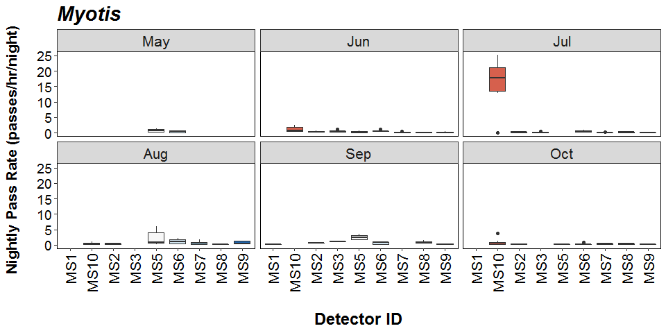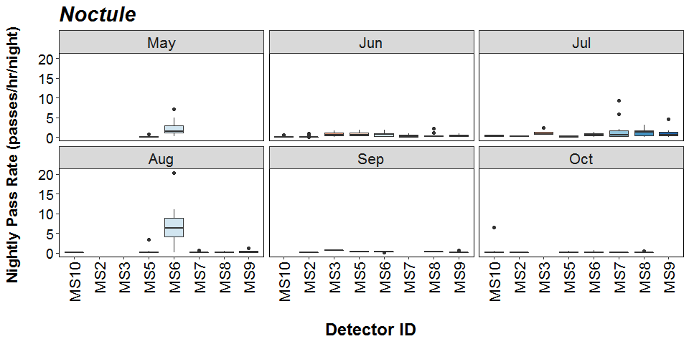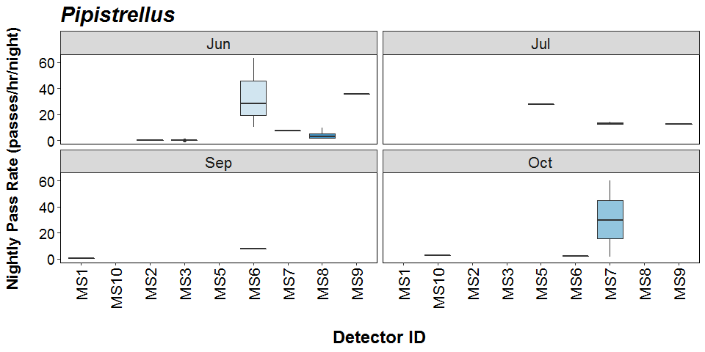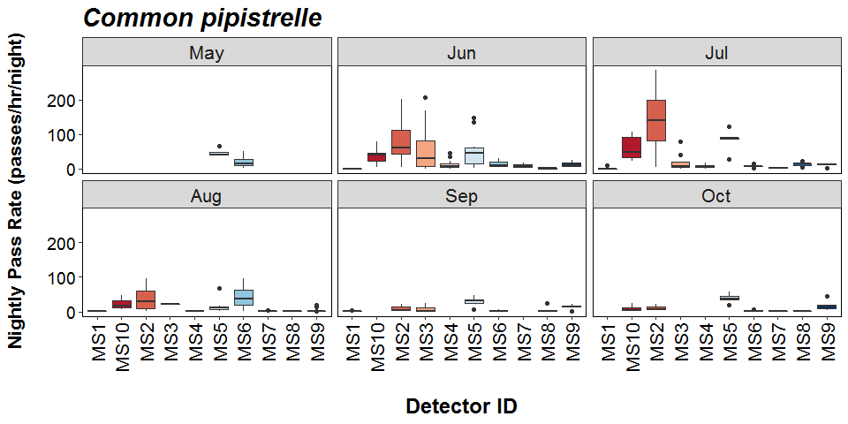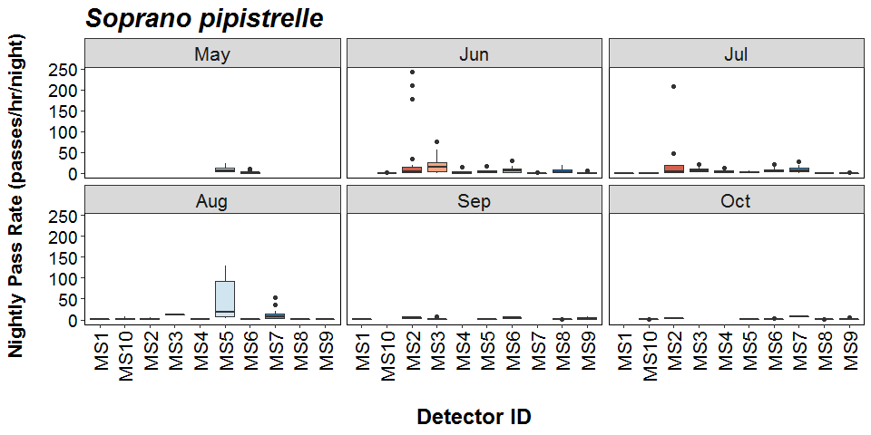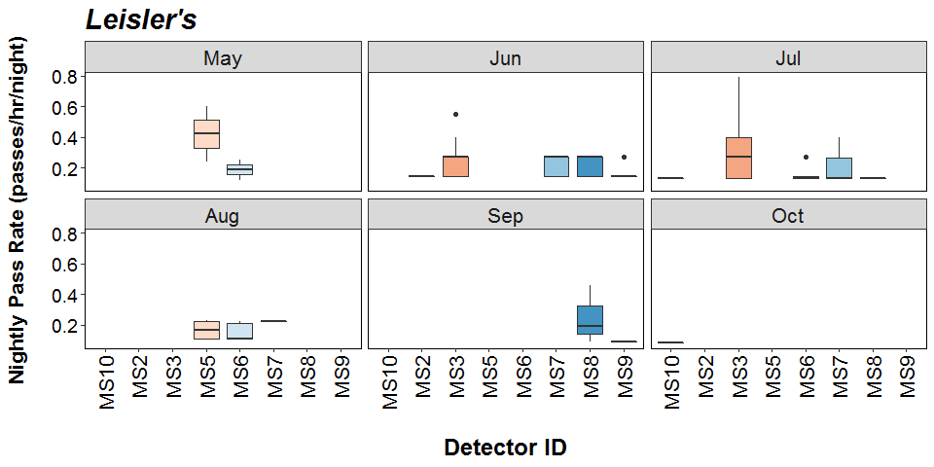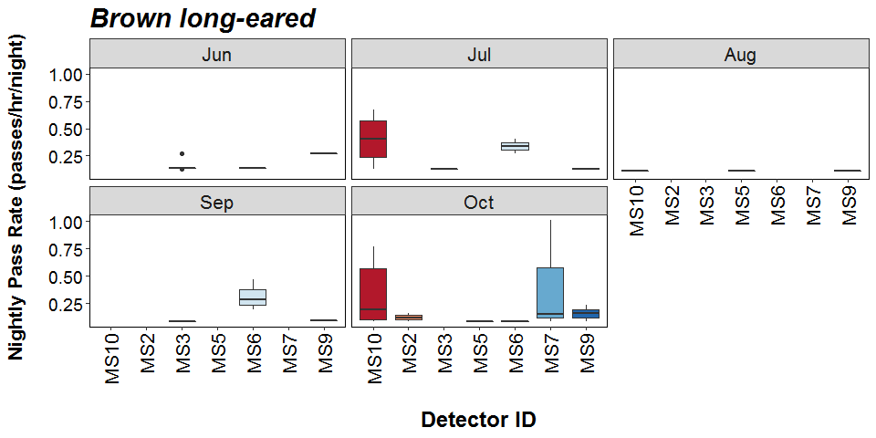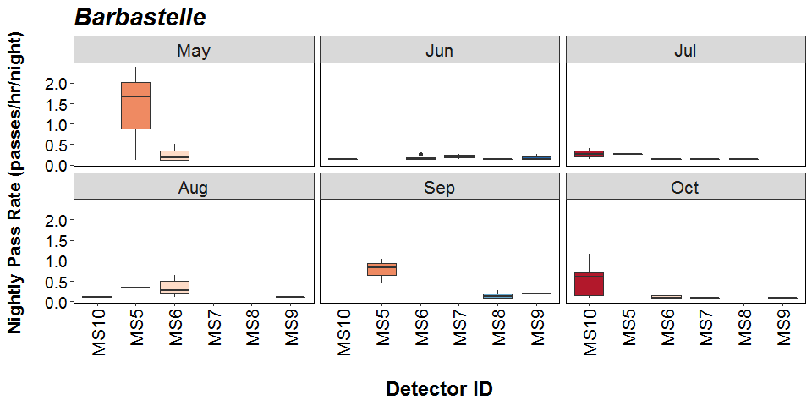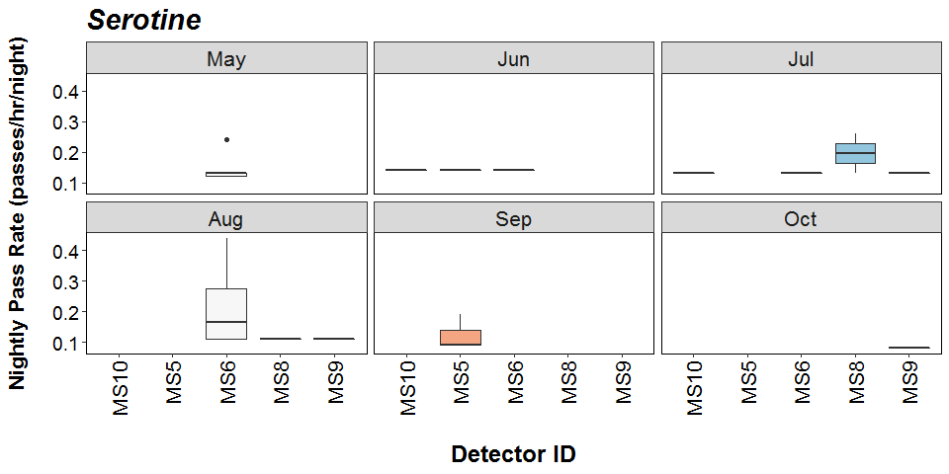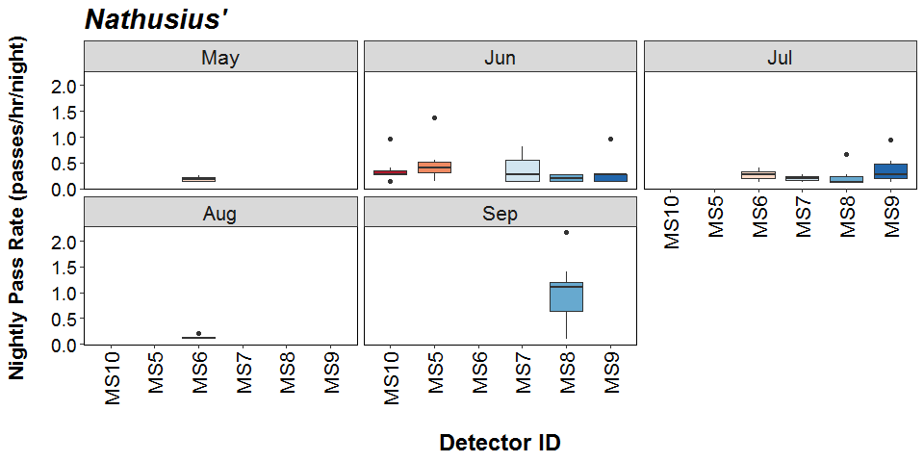

##### Page Break

# Bat Activity per Detector Location

**Detector ID reference:**

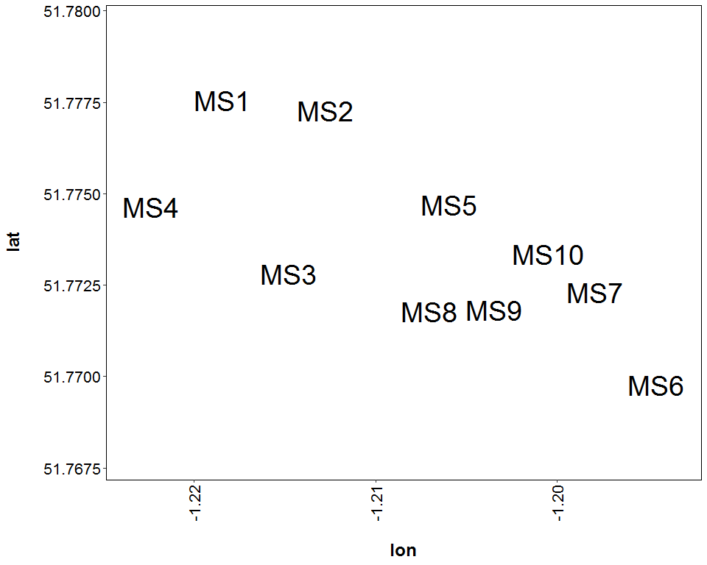

##### Page Break

**Median Nightly Pass Rate (bat passes/hr/night) throughout the survey period - represented by the size and colour of the point at each detector location.**

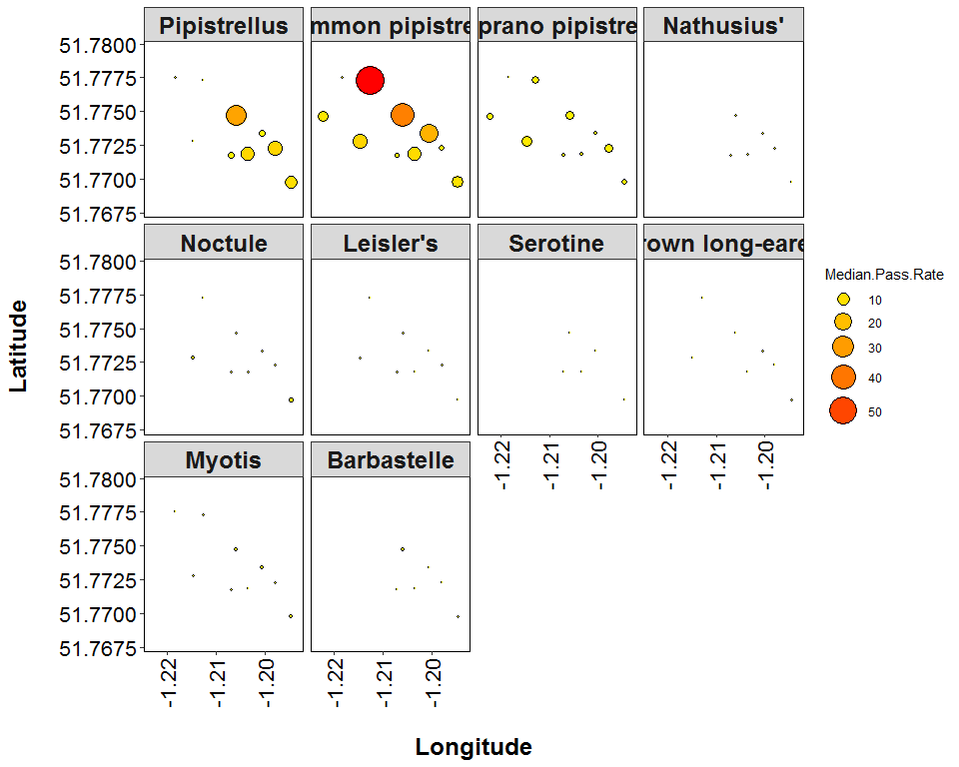

##### Page Break

**Maximum Nightly Pass Rate (bat passes/hr/night) recorded in a single night throughout the survey period - represented by the size and colour of the point at each detector location.**

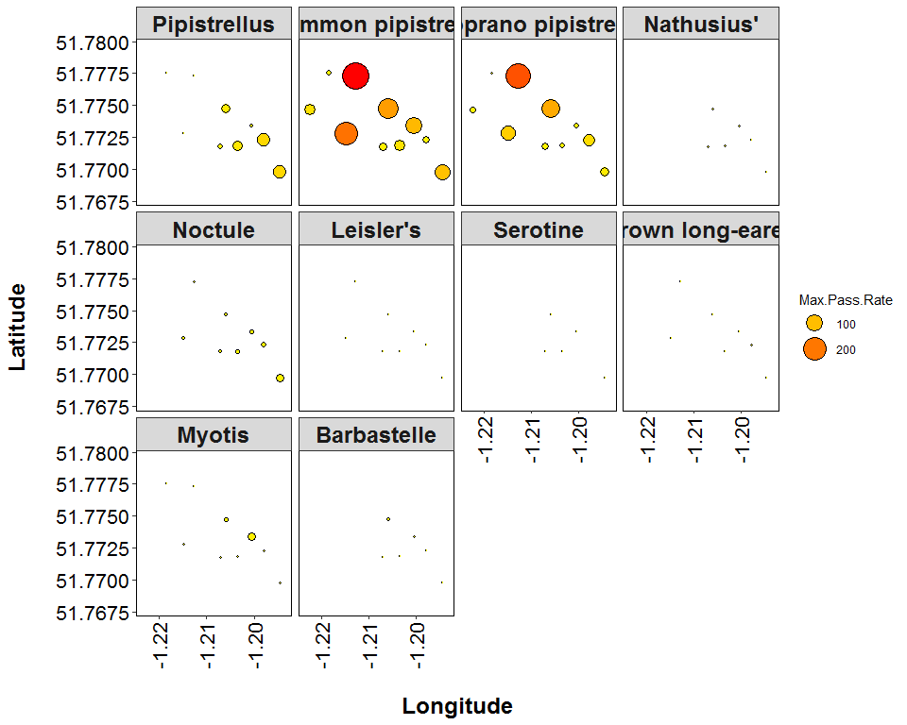

##### Page Break

## **PART 2B: Includes absences**

**THE NEXT SECTION OF THE REPORT FEATURES THE DATA SUPPLIED TO ECOBAT BUT TAKES INTO ACCOUNT SPECIES ABSENCES, AND THEREFORE INCLUDES ‘ZERO DATA’ FOR WHEN SPECIES WERE NOT DETECTED AT EACH DETECTOR ON A NIGHT. THIS DRAMATICALLY LOWERS THE MEANS AND MEDIANS OF THE DATA PRESENTED.**

##### Page Break

## Nightly Bat Pass Rate (Bat passes per hour)

# Median Per Detector

**The median Nightly Pass Rate (bat passes per hour, per night) of each species. If NA, then no bat passes.**

Bat pass rates are often highly variable between nights, with some nights having few or no passes and other nights having high activity. In these circumstances, the median is likely to be a more useful summary of the ‘average’ activity than is the mean. For further information see: *Lintott, P. R., & Mathews, F. (2018). Basic mathematical errors may make ecological assessments unreliable. Biodiversity and Conservation, 27(1), 265-267.* <https://doi.org/10.1007/s10531-017-1418-5>

|  |  |  |
| --- | --- | --- |
| Species | Detector ID | Median Pass Rate |
| Barbastelle | MS1 | 0.0 |
| Barbastelle | MS10 | 0.1 |
| Barbastelle | MS2 | 0.0 |
| Barbastelle | MS3 | 0.0 |
| Barbastelle | MS4 | 0.0 |
| Barbastelle | MS5 | 0.0 |
| Barbastelle | MS6 | 0.0 |
| Barbastelle | MS7 | 0.0 |
| Barbastelle | MS8 | 0.0 |
| Barbastelle | MS9 | 0.0 |
| Brown long-eared | MS1 | 0.0 |
| Brown long-eared | MS10 | 0.0 |
| Brown long-eared | MS2 | 0.0 |
| Brown long-eared | MS3 | 0.0 |
| Brown long-eared | MS4 | 0.0 |
| Brown long-eared | MS5 | 0.0 |
| Brown long-eared | MS6 | 0.0 |
| Brown long-eared | MS7 | 0.0 |
| Brown long-eared | MS8 | 0.0 |
| Brown long-eared | MS9 | 0.0 |
| Common pipistrelle | MS1 | 0.3 |
| Common pipistrelle | MS10 | 23.5 |
| Common pipistrelle | MS2 | 53.3 |
| Common pipistrelle | MS3 | 13.4 |
| Common pipistrelle | MS4 | 7.2 |
| Common pipistrelle | MS5 | 37.5 |
| Common pipistrelle | MS6 | 8.7 |
| Common pipistrelle | MS7 | 1.7 |
| Common pipistrelle | MS8 | 1.3 |
| Common pipistrelle | MS9 | 11.3 |
| Leisler’s | MS1 | 0.0 |
| Leisler’s | MS10 | 0.0 |
| Leisler’s | MS2 | 0.0 |
| Leisler’s | MS3 | 0.0 |
| Leisler’s | MS4 | 0.0 |
| Leisler’s | MS5 | 0.0 |
| Leisler’s | MS6 | 0.0 |
| Leisler’s | MS7 | 0.0 |
| Leisler’s | MS8 | 0.0 |
| Leisler’s | MS9 | 0.0 |
| Myotis | MS1 | 0.0 |
| Myotis | MS10 | 0.6 |
| Myotis | MS2 | 0.1 |
| Myotis | MS3 | 0.1 |
| Myotis | MS4 | 0.0 |
| Myotis | MS5 | 0.2 |
| Myotis | MS6 | 0.4 |
| Myotis | MS7 | 0.1 |
| Myotis | MS8 | 0.1 |
| Myotis | MS9 | 0.0 |
| Nathusius’ | MS1 | 0.0 |
| Nathusius’ | MS10 | 0.0 |
| Nathusius’ | MS2 | 0.0 |
| Nathusius’ | MS3 | 0.0 |
| Nathusius’ | MS4 | 0.0 |
| Nathusius’ | MS5 | 0.0 |
| Nathusius’ | MS6 | 0.0 |
| Nathusius’ | MS7 | 0.0 |
| Nathusius’ | MS8 | 0.0 |
| Nathusius’ | MS9 | 0.0 |
| Noctule | MS1 | 0.0 |
| Noctule | MS10 | 0.1 |
| Noctule | MS2 | 0.0 |
| Noctule | MS3 | 0.4 |
| Noctule | MS4 | 0.0 |
| Noctule | MS5 | 0.3 |
| Noctule | MS6 | 0.8 |
| Noctule | MS7 | 0.1 |
| Noctule | MS8 | 0.3 |
| Noctule | MS9 | 0.1 |
| Pipistrellus | MS1 | 0.0 |
| Pipistrellus | MS10 | 0.0 |
| Pipistrellus | MS2 | 0.0 |
| Pipistrellus | MS3 | 0.0 |
| Pipistrellus | MS4 | 0.0 |
| Pipistrellus | MS5 | 0.0 |
| Pipistrellus | MS6 | 0.0 |
| Pipistrellus | MS7 | 0.0 |
| Pipistrellus | MS8 | 0.0 |
| Pipistrellus | MS9 | 0.0 |
| Serotine | MS1 | 0.0 |
| Serotine | MS10 | 0.0 |
| Serotine | MS2 | 0.0 |
| Serotine | MS3 | 0.0 |
| Serotine | MS4 | 0.0 |
| Serotine | MS5 | 0.0 |
| Serotine | MS6 | 0.0 |
| Serotine | MS7 | 0.0 |
| Serotine | MS8 | 0.0 |
| Serotine | MS9 | 0.0 |
| Soprano pipistrelle | MS1 | 0.0 |
| Soprano pipistrelle | MS10 | 0.2 |
| Soprano pipistrelle | MS2 | 3.8 |
| Soprano pipistrelle | MS3 | 5.4 |
| Soprano pipistrelle | MS4 | 2.2 |
| Soprano pipistrelle | MS5 | 4.3 |
| Soprano pipistrelle | MS6 | 1.4 |
| Soprano pipistrelle | MS7 | 3.5 |
| Soprano pipistrelle | MS8 | 0.2 |
| Soprano pipistrelle | MS9 | 0.5 |

##### Page Break

## Nightly Bat Pass Rate (Bat passes per hour)

# Mean per Detector

**The mean Nightly Pass Rate (bat passes per hour, per night) of each species at each detector. Values are given to 1 decimal place.**

We recommend using the median values given above, for the reasons stated above, but provide the mean values in the table below.

|  |  |  |
| --- | --- | --- |
| Species | Detector ID | Mean Pass Rate |
| Barbastelle | MS1 | 0.0 |
| Barbastelle | MS10 | 0.2 |
| Barbastelle | MS2 | 0.0 |
| Barbastelle | MS3 | 0.0 |
| Barbastelle | MS4 | 0.0 |
| Barbastelle | MS5 | 0.2 |
| Barbastelle | MS6 | 0.1 |
| Barbastelle | MS7 | 0.0 |
| Barbastelle | MS8 | 0.0 |
| Barbastelle | MS9 | 0.0 |
| Brown long-eared | MS1 | 0.0 |
| Brown long-eared | MS10 | 0.1 |
| Brown long-eared | MS2 | 0.0 |
| Brown long-eared | MS3 | 0.0 |
| Brown long-eared | MS4 | 0.0 |
| Brown long-eared | MS5 | 0.0 |
| Brown long-eared | MS6 | 0.0 |
| Brown long-eared | MS7 | 0.0 |
| Brown long-eared | MS8 | 0.0 |
| Brown long-eared | MS9 | 0.0 |
| Common pipistrelle | MS1 | 1.2 |
| Common pipistrelle | MS10 | 30.5 |
| Common pipistrelle | MS2 | 71.3 |
| Common pipistrelle | MS3 | 38.4 |
| Common pipistrelle | MS4 | 9.8 |
| Common pipistrelle | MS5 | 43.2 |
| Common pipistrelle | MS6 | 17.3 |
| Common pipistrelle | MS7 | 3.1 |
| Common pipistrelle | MS8 | 4.3 |
| Common pipistrelle | MS9 | 10.5 |
| Leisler’s | MS1 | 0.0 |
| Leisler’s | MS10 | 0.0 |
| Leisler’s | MS2 | 0.0 |
| Leisler’s | MS3 | 0.1 |
| Leisler’s | MS4 | 0.0 |
| Leisler’s | MS5 | 0.0 |
| Leisler’s | MS6 | 0.0 |
| Leisler’s | MS7 | 0.1 |
| Leisler’s | MS8 | 0.0 |
| Leisler’s | MS9 | 0.0 |
| Myotis | MS1 | 0.0 |
| Myotis | MS10 | 3.9 |
| Myotis | MS2 | 0.2 |
| Myotis | MS3 | 0.3 |
| Myotis | MS4 | 0.0 |
| Myotis | MS5 | 0.9 |
| Myotis | MS6 | 0.5 |
| Myotis | MS7 | 0.3 |
| Myotis | MS8 | 0.3 |
| Myotis | MS9 | 0.2 |
| Nathusius’ | MS1 | 0.0 |
| Nathusius’ | MS10 | 0.1 |
| Nathusius’ | MS2 | 0.0 |
| Nathusius’ | MS3 | 0.0 |
| Nathusius’ | MS4 | 0.0 |
| Nathusius’ | MS5 | 0.1 |
| Nathusius’ | MS6 | 0.0 |
| Nathusius’ | MS7 | 0.1 |
| Nathusius’ | MS8 | 0.2 |
| Nathusius’ | MS9 | 0.1 |
| Noctule | MS1 | 0.0 |
| Noctule | MS10 | 0.4 |
| Noctule | MS2 | 0.1 |
| Noctule | MS3 | 0.6 |
| Noctule | MS4 | 0.0 |
| Noctule | MS5 | 0.5 |
| Noctule | MS6 | 2.2 |
| Noctule | MS7 | 0.6 |
| Noctule | MS8 | 0.5 |
| Noctule | MS9 | 0.4 |
| Pipistrellus | MS1 | 0.0 |
| Pipistrellus | MS10 | 0.1 |
| Pipistrellus | MS2 | 0.0 |
| Pipistrellus | MS3 | 0.0 |
| Pipistrellus | MS4 | 0.0 |
| Pipistrellus | MS5 | 0.7 |
| Pipistrellus | MS6 | 1.7 |
| Pipistrellus | MS7 | 2.5 |
| Pipistrellus | MS8 | 0.4 |
| Pipistrellus | MS9 | 1.3 |
| Serotine | MS1 | 0.0 |
| Serotine | MS10 | 0.0 |
| Serotine | MS2 | 0.0 |
| Serotine | MS3 | 0.0 |
| Serotine | MS4 | 0.0 |
| Serotine | MS5 | 0.0 |
| Serotine | MS6 | 0.0 |
| Serotine | MS7 | 0.0 |
| Serotine | MS8 | 0.0 |
| Serotine | MS9 | 0.0 |
| Soprano pipistrelle | MS1 | 0.1 |
| Soprano pipistrelle | MS10 | 0.7 |
| Soprano pipistrelle | MS2 | 26.7 |
| Soprano pipistrelle | MS3 | 14.0 |
| Soprano pipistrelle | MS4 | 3.0 |
| Soprano pipistrelle | MS5 | 14.8 |
| Soprano pipistrelle | MS6 | 3.8 |
| Soprano pipistrelle | MS7 | 7.5 |
| Soprano pipistrelle | MS8 | 1.4 |
| Soprano pipistrelle | MS9 | 1.2 |

##### Page Break

# Nightly Bat Passes (Bat passes per hour)

## Per Detector - Figures

Figures show boxplots for the number of bat passes per hour each night, for each detector. The ‘box’ shows the interquartile range, which is where the middle 50% of the data lie. The line dividing the box is the median, the mid-point of the data. The ‘whiskers’ extend from the box and represent the ranges for the bottom 25% and the top 25% of the data values, excluding outliers. An outlier is any extreme value that lies further away from the box than 1.5 times the interquartile range. Outliers are shown as dots. Where very few passes are recorded it is not possible to produce the box, so the data are shown as a line.

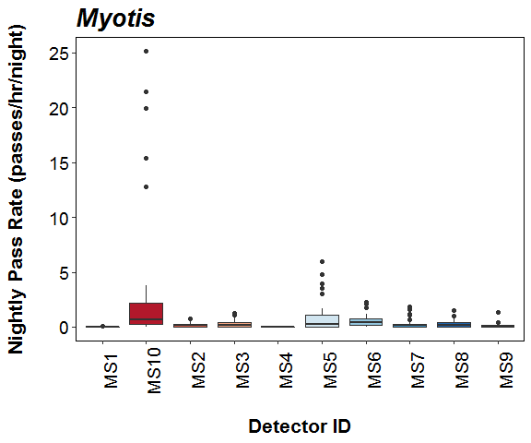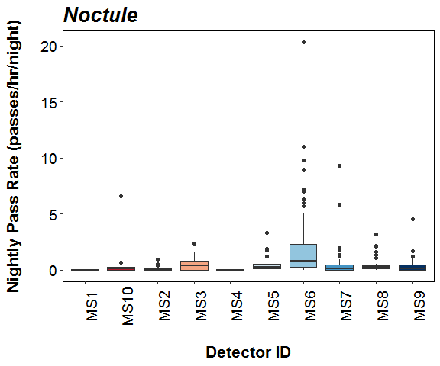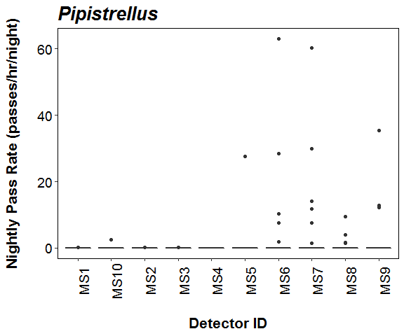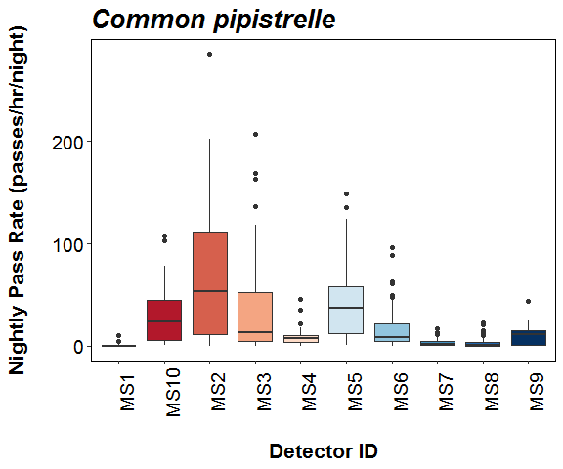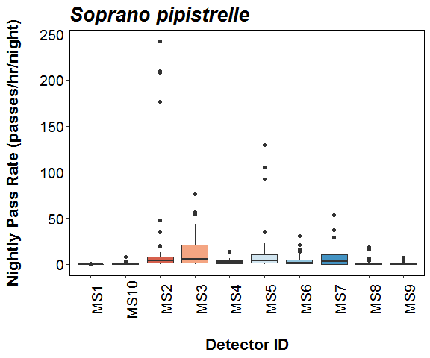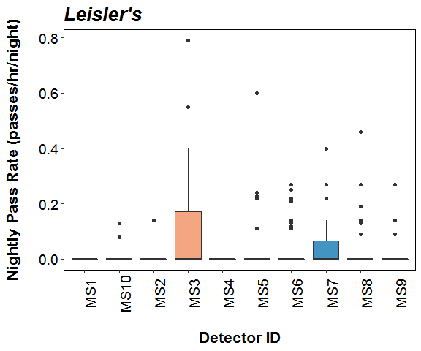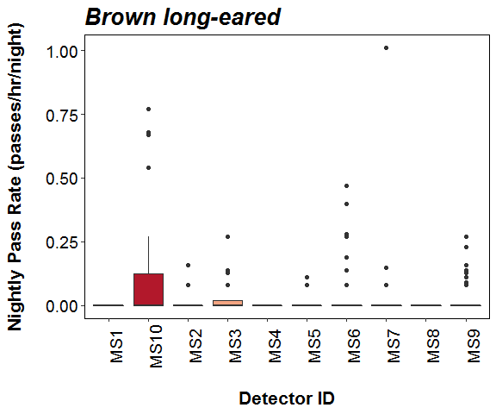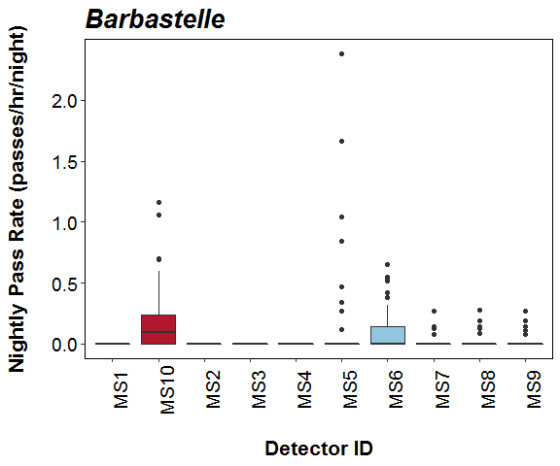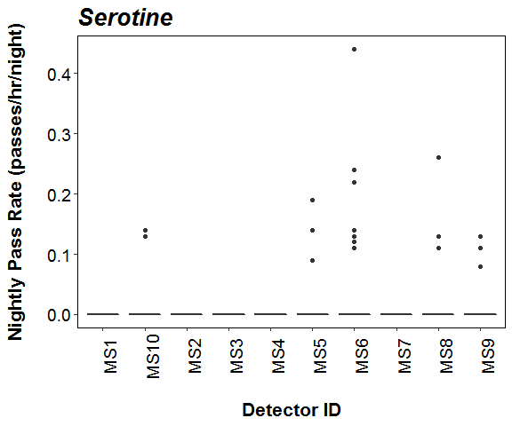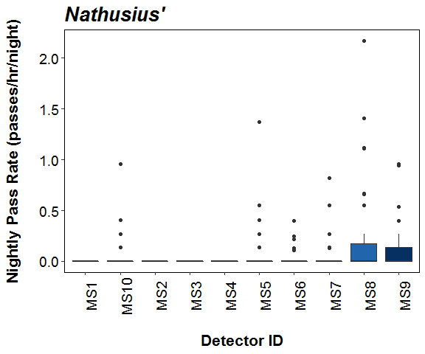

##### Page Break

# Survey Effort

**The number of survey nights per month per detector.**

|  |  |  |
| --- | --- | --- |
| Month | Detector ID | No of Survey Nights |
| May | MS5 | 4 |
| May | MS6 | 17 |
| Jun | MS1 | 1 |
| Jun | MS10 | 11 |
| Jun | MS2 | 20 |
| Jun | MS3 | 20 |
| Jun | MS4 | 14 |
| Jun | MS5 | 10 |
| Jun | MS6 | 11 |
| Jun | MS7 | 11 |
| Jun | MS8 | 11 |
| Jun | MS9 | 11 |
| Jul | MS1 | 7 |
| Jul | MS10 | 6 |
| Jul | MS2 | 9 |
| Jul | MS3 | 9 |
| Jul | MS4 | 10 |
| Jul | MS5 | 5 |
| Jul | MS6 | 9 |
| Jul | MS7 | 16 |
| Jul | MS8 | 9 |
| Jul | MS9 | 9 |
| Aug | MS1 | 2 |
| Aug | MS10 | 3 |
| Aug | MS2 | 5 |
| Aug | MS3 | 1 |
| Aug | MS4 | 2 |
| Aug | MS5 | 9 |
| Aug | MS6 | 13 |
| Aug | MS7 | 20 |
| Aug | MS8 | 6 |
| Aug | MS9 | 14 |
| Sep | MS1 | 7 |
| Sep | MS2 | 3 |
| Sep | MS3 | 6 |
| Sep | MS5 | 4 |
| Sep | MS6 | 6 |
| Sep | MS8 | 8 |
| Sep | MS9 | 7 |
| Oct | MS10 | 10 |
| Oct | MS2 | 3 |
| Oct | MS5 | 5 |
| Oct | MS6 | 9 |
| Oct | MS7 | 4 |
| Oct | MS8 | 10 |
| Oct | MS9 | 6 |

##### Page Break

## Nightly Bat Pass Rate for each Month

# Median Per Detector

**The median Nightly Pass Rate (bat passes per hour, per night) of each species throughout each month. If NA, then no bat passes.**

Bat pass rates are often highly variable between nights, with some nights having few or no passes and other nights having high activity. In these circumstances, the median is likely to be a more useful summary of the ‘average’ activity than is the mean. For further information see: *Lintott, P. R., & Mathews, F. (2018). Basic mathematical errors may make ecological assessments unreliable. Biodiversity and Conservation, 27(1), 265-267.* <https://doi.org/10.1007/s10531-017-1418-5>

|  |  |  |  |  |  |  |  |
| --- | --- | --- | --- | --- | --- | --- | --- |
| Species | Detector ID | Aug | Jul | Jun | May | Oct | Sep |
| Barbastelle | MS1 | 0.0 | 0.0 | 0.0 | NA | NA | 0.0 |
| Barbastelle | MS10 | 0.1 | 0.1 | 0.0 | NA | 0.6 | NA |
| Barbastelle | MS2 | 0.0 | 0.0 | 0.0 | NA | 0.0 | 0.0 |
| Barbastelle | MS3 | 0.0 | 0.0 | 0.0 | NA | NA | 0.0 |
| Barbastelle | MS4 | 0.0 | 0.0 | 0.0 | NA | NA | NA |
| Barbastelle | MS5 | 0.0 | 0.0 | 0.0 | 0.9 | 0.0 | 0.7 |
| Barbastelle | MS6 | 0.2 | 0.0 | 0.0 | 0.1 | 0.0 | 0.0 |
| Barbastelle | MS7 | 0.0 | 0.0 | 0.0 | NA | 0.0 | NA |
| Barbastelle | MS8 | 0.0 | 0.0 | 0.0 | NA | 0.0 | 0.1 |
| Barbastelle | MS9 | 0.0 | 0.0 | 0.0 | NA | 0.0 | 0.0 |
| Brown long-eared | MS1 | 0.0 | 0.0 | 0.0 | NA | NA | 0.0 |
| Brown long-eared | MS10 | 0.0 | 0.2 | 0.0 | NA | 0.1 | NA |
| Brown long-eared | MS2 | 0.0 | 0.0 | 0.0 | NA | 0.1 | 0.0 |
| Brown long-eared | MS3 | 0.0 | 0.0 | 0.0 | NA | NA | 0.0 |
| Brown long-eared | MS4 | 0.0 | 0.0 | 0.0 | NA | NA | NA |
| Brown long-eared | MS5 | 0.0 | 0.0 | 0.0 | 0.0 | 0.0 | 0.0 |
| Brown long-eared | MS6 | 0.0 | 0.0 | 0.0 | 0.0 | 0.0 | 0.1 |
| Brown long-eared | MS7 | 0.0 | 0.0 | 0.0 | NA | 0.1 | NA |
| Brown long-eared | MS8 | 0.0 | 0.0 | 0.0 | NA | 0.0 | 0.0 |
| Brown long-eared | MS9 | 0.0 | 0.0 | 0.0 | NA | 0.0 | 0.0 |
| Common pipistrelle | MS1 | 0.2 | 0.3 | 0.1 | NA | NA | 0.4 |
| Common pipistrelle | MS10 | 16.4 | 48.7 | 40.3 | NA | 4.2 | NA |
| Common pipistrelle | MS2 | 12.6 | 119.9 | 62.1 | NA | 7.6 | 4.8 |
| Common pipistrelle | MS3 | 21.3 | 6.6 | 29.1 | NA | NA | 0.4 |
| Common pipistrelle | MS4 | 2.4 | 6.3 | 8.4 | NA | NA | NA |
| Common pipistrelle | MS5 | 11.1 | 88.0 | 45.3 | 40.7 | 37.5 | 31.0 |
| Common pipistrelle | MS6 | 38.1 | 6.9 | 10.2 | 15.8 | 1.2 | 2.4 |
| Common pipistrelle | MS7 | 1.0 | 1.9 | 7.1 | NA | 0.5 | NA |
| Common pipistrelle | MS8 | 0.9 | 13.8 | 1.2 | NA | 0.3 | 1.7 |
| Common pipistrelle | MS9 | 0.5 | 12.4 | 10.3 | NA | 15.3 | 14.7 |
| Leisler’s | MS1 | 0.0 | 0.0 | 0.0 | NA | NA | 0.0 |
| Leisler’s | MS10 | 0.0 | 0.1 | 0.0 | NA | 0.0 | NA |
| Leisler’s | MS2 | 0.0 | 0.0 | 0.0 | NA | 0.0 | 0.0 |
| Leisler’s | MS3 | 0.0 | 0.1 | 0.1 | NA | NA | 0.0 |
| Leisler’s | MS4 | 0.0 | 0.0 | 0.0 | NA | NA | NA |
| Leisler’s | MS5 | 0.0 | 0.0 | 0.0 | 0.1 | 0.0 | 0.0 |
| Leisler’s | MS6 | 0.0 | 0.1 | 0.0 | 0.0 | 0.0 | 0.0 |
| Leisler’s | MS7 | 0.0 | 0.0 | 0.1 | NA | 0.0 | NA |
| Leisler’s | MS8 | 0.0 | 0.0 | 0.0 | NA | 0.0 | 0.0 |
| Leisler’s | MS9 | 0.0 | 0.0 | 0.1 | NA | 0.0 | 0.0 |
| Myotis | MS1 | 0.0 | 0.0 | 0.0 | NA | NA | 0.0 |
| Myotis | MS10 | 0.2 | 17.7 | 0.7 | NA | 0.4 | NA |
| Myotis | MS2 | 0.1 | 0.0 | 0.1 | NA | 0.2 | 0.7 |
| Myotis | MS3 | 0.0 | 0.1 | 0.4 | NA | NA | 0.0 |
| Myotis | MS4 | 0.0 | 0.0 | 0.0 | NA | NA | NA |
| Myotis | MS5 | 0.8 | 0.0 | 0.1 | 0.7 | 0.2 | 2.4 |
| Myotis | MS6 | 1.2 | 0.5 | 0.4 | 0.1 | 0.2 | 0.6 |
| Myotis | MS7 | 0.2 | 0.1 | 0.1 | NA | 0.1 | NA |
| Myotis | MS8 | 0.1 | 0.1 | 0.0 | NA | 0.3 | 0.8 |
| Myotis | MS9 | 0.0 | 0.0 | 0.0 | NA | 0.1 | 0.3 |
| Nathusius’ | MS1 | 0.0 | 0.0 | 0.0 | NA | NA | 0.0 |
| Nathusius’ | MS10 | 0.0 | 0.0 | 0.3 | NA | 0.0 | NA |
| Nathusius’ | MS2 | 0.0 | 0.0 | 0.0 | NA | 0.0 | 0.0 |
| Nathusius’ | MS3 | 0.0 | 0.0 | 0.0 | NA | NA | 0.0 |
| Nathusius’ | MS4 | 0.0 | 0.0 | 0.0 | NA | NA | NA |
| Nathusius’ | MS5 | 0.0 | 0.0 | 0.2 | 0.0 | 0.0 | 0.0 |
| Nathusius’ | MS6 | 0.0 | 0.0 | 0.0 | 0.0 | 0.0 | 0.0 |
| Nathusius’ | MS7 | 0.0 | 0.0 | 0.3 | NA | 0.0 | NA |
| Nathusius’ | MS8 | 0.0 | 0.1 | 0.0 | NA | 0.0 | 1.1 |
| Nathusius’ | MS9 | 0.0 | 0.3 | 0.1 | NA | 0.0 | 0.0 |
| Noctule | MS1 | 0.0 | 0.0 | 0.0 | NA | NA | 0.0 |
| Noctule | MS10 | 0.1 | 0.3 | 0.0 | NA | 0.2 | NA |
| Noctule | MS2 | 0.0 | 0.0 | 0.1 | NA | 0.2 | 0.1 |
| Noctule | MS3 | 0.0 | 0.8 | 0.4 | NA | NA | 0.0 |
| Noctule | MS4 | 0.0 | 0.0 | 0.0 | NA | NA | NA |
| Noctule | MS5 | 0.1 | 0.3 | 0.6 | 0.1 | 0.1 | 0.3 |
| Noctule | MS6 | 6.3 | 0.5 | 0.8 | 1.5 | 0.2 | 0.2 |
| Noctule | MS7 | 0.0 | 0.5 | 0.3 | NA | 0.0 | NA |
| Noctule | MS8 | 0.1 | 1.3 | 0.3 | NA | 0.0 | 0.3 |
| Noctule | MS9 | 0.0 | 0.5 | 0.3 | NA | 0.0 | 0.1 |
| Pipistrellus | MS1 | 0.0 | 0.0 | 0.0 | NA | NA | 0.0 |
| Pipistrellus | MS10 | 0.0 | 0.0 | 0.0 | NA | 0.0 | NA |
| Pipistrellus | MS2 | 0.0 | 0.0 | 0.0 | NA | 0.0 | 0.0 |
| Pipistrellus | MS3 | 0.0 | 0.0 | 0.0 | NA | NA | 0.0 |
| Pipistrellus | MS4 | 0.0 | 0.0 | 0.0 | NA | NA | NA |
| Pipistrellus | MS5 | 0.0 | 0.0 | 0.0 | 0.0 | 0.0 | 0.0 |
| Pipistrellus | MS6 | 0.0 | 0.0 | 0.0 | 0.0 | 0.0 | 0.0 |
| Pipistrellus | MS7 | 0.0 | 0.0 | 0.0 | NA | 15.7 | NA |
| Pipistrellus | MS8 | 0.0 | 0.0 | 0.0 | NA | 0.0 | 0.0 |
| Pipistrellus | MS9 | 0.0 | 0.0 | 0.0 | NA | 0.0 | 0.0 |
| Serotine | MS1 | 0.0 | 0.0 | 0.0 | NA | NA | 0.0 |
| Serotine | MS10 | 0.0 | 0.0 | 0.0 | NA | 0.0 | NA |
| Serotine | MS2 | 0.0 | 0.0 | 0.0 | NA | 0.0 | 0.0 |
| Serotine | MS3 | 0.0 | 0.0 | 0.0 | NA | NA | 0.0 |
| Serotine | MS4 | 0.0 | 0.0 | 0.0 | NA | NA | NA |
| Serotine | MS5 | 0.0 | 0.0 | 0.0 | 0.0 | 0.0 | 0.1 |
| Serotine | MS6 | 0.0 | 0.0 | 0.0 | 0.0 | 0.0 | 0.0 |
| Serotine | MS7 | 0.0 | 0.0 | 0.0 | NA | 0.0 | NA |
| Serotine | MS8 | 0.0 | 0.0 | 0.0 | NA | 0.0 | 0.0 |
| Serotine | MS9 | 0.0 | 0.0 | 0.0 | NA | 0.0 | 0.0 |
| Soprano pipistrelle | MS1 | 0.1 | 0.0 | 0.0 | NA | NA | 0.0 |
| Soprano pipistrelle | MS10 | 0.9 | 0.4 | 0.6 | NA | 0.1 | NA |
| Soprano pipistrelle | MS2 | 2.0 | 3.0 | 4.8 | NA | 3.6 | 4.5 |
| Soprano pipistrelle | MS3 | 11.3 | 5.4 | 15.8 | NA | NA | 0.9 |
| Soprano pipistrelle | MS4 | 2.1 | 3.1 | 1.6 | NA | NA | NA |
| Soprano pipistrelle | MS5 | 19.4 | 2.8 | 4.9 | 7.2 | 1.6 | 0.8 |
| Soprano pipistrelle | MS6 | 0.7 | 7.3 | 7.1 | 1.0 | 0.6 | 3.4 |
| Soprano pipistrelle | MS7 | 7.6 | 5.0 | 0.3 | NA | 0.0 | NA |
| Soprano pipistrelle | MS8 | 0.1 | 0.8 | 1.2 | NA | 0.0 | 0.2 |
| Soprano pipistrelle | MS9 | 0.0 | 0.4 | 0.7 | NA | 0.7 | 2.8 |

##### Page Break

## Nightly Bat Pass Rate for each Month

# Mean per Detector

**The mean Nightly Pass Rate (bat passes per hour, per night) of each species throughout each month. Values are given to 1 decimal place.**

We recommend using the median values given above, for the reasons stated above, but provide the mean values in the table below.

|  |  |  |  |  |  |  |  |
| --- | --- | --- | --- | --- | --- | --- | --- |
| Species | Detector ID | Aug | Jul | Jun | May | Oct | Sep |
| Barbastelle | MS1 | 0.0 | 0.0 | 0.0 | NA | NA | 0.0 |
| Barbastelle | MS10 | 0.1 | 0.1 | 0.0 | NA | 0.5 | NA |
| Barbastelle | MS2 | 0.0 | 0.0 | 0.0 | NA | 0.0 | 0.0 |
| Barbastelle | MS3 | 0.0 | 0.0 | 0.0 | NA | NA | 0.0 |
| Barbastelle | MS4 | 0.0 | 0.0 | 0.0 | NA | NA | NA |
| Barbastelle | MS5 | 0.0 | 0.1 | 0.0 | 1.0 | 0.0 | 0.6 |
| Barbastelle | MS6 | 0.3 | 0.0 | 0.1 | 0.1 | 0.0 | 0.0 |
| Barbastelle | MS7 | 0.0 | 0.0 | 0.0 | NA | 0.0 | NA |
| Barbastelle | MS8 | 0.0 | 0.0 | 0.0 | NA | 0.0 | 0.1 |
| Barbastelle | MS9 | 0.0 | 0.0 | 0.0 | NA | 0.0 | 0.0 |
| Brown long-eared | MS1 | 0.0 | 0.0 | 0.0 | NA | NA | 0.0 |
| Brown long-eared | MS10 | 0.0 | 0.3 | 0.0 | NA | 0.2 | NA |
| Brown long-eared | MS2 | 0.0 | 0.0 | 0.0 | NA | 0.1 | 0.0 |
| Brown long-eared | MS3 | 0.0 | 0.0 | 0.0 | NA | NA | 0.0 |
| Brown long-eared | MS4 | 0.0 | 0.0 | 0.0 | NA | NA | NA |
| Brown long-eared | MS5 | 0.0 | 0.0 | 0.0 | 0.0 | 0.0 | 0.0 |
| Brown long-eared | MS6 | 0.0 | 0.1 | 0.0 | 0.0 | 0.0 | 0.2 |
| Brown long-eared | MS7 | 0.0 | 0.0 | 0.0 | NA | 0.3 | NA |
| Brown long-eared | MS8 | 0.0 | 0.0 | 0.0 | NA | 0.0 | 0.0 |
| Brown long-eared | MS9 | 0.0 | 0.0 | 0.0 | NA | 0.1 | 0.0 |
| Common pipistrelle | MS1 | 0.2 | 1.7 | 0.1 | NA | NA | 1.1 |
| Common pipistrelle | MS10 | 23.3 | 59.8 | 36.8 | NA | 8.1 | NA |
| Common pipistrelle | MS2 | 31.5 | 125.0 | 75.2 | NA | 11.5 | 10.2 |
| Common pipistrelle | MS3 | 21.3 | 18.8 | 57.6 | NA | NA | 6.8 |
| Common pipistrelle | MS4 | 2.4 | 7.2 | 12.8 | NA | NA | NA |
| Common pipistrelle | MS5 | 15.8 | 82.7 | 54.9 | 46.2 | 39.0 | 28.6 |
| Common pipistrelle | MS6 | 41.7 | 6.8 | 13.7 | 19.6 | 2.1 | 2.6 |
| Common pipistrelle | MS7 | 1.4 | 2.5 | 8.1 | NA | 0.7 | NA |
| Common pipistrelle | MS8 | 1.0 | 13.7 | 2.0 | NA | 0.4 | 4.1 |
| Common pipistrelle | MS9 | 2.7 | 11.7 | 13.3 | NA | 17.4 | 14.0 |
| Leisler’s | MS1 | 0.0 | 0.0 | 0.0 | NA | NA | 0.0 |
| Leisler’s | MS10 | 0.0 | 0.1 | 0.0 | NA | 0.0 | NA |
| Leisler’s | MS2 | 0.0 | 0.0 | 0.0 | NA | 0.0 | 0.0 |
| Leisler’s | MS3 | 0.0 | 0.2 | 0.1 | NA | NA | 0.0 |
| Leisler’s | MS4 | 0.0 | 0.0 | 0.0 | NA | NA | NA |
| Leisler’s | MS5 | 0.1 | 0.0 | 0.0 | 0.2 | 0.0 | 0.0 |
| Leisler’s | MS6 | 0.1 | 0.1 | 0.0 | 0.0 | 0.0 | 0.0 |
| Leisler’s | MS7 | 0.0 | 0.0 | 0.2 | NA | 0.0 | NA |
| Leisler’s | MS8 | 0.0 | 0.0 | 0.1 | NA | 0.0 | 0.1 |
| Leisler’s | MS9 | 0.0 | 0.0 | 0.1 | NA | 0.0 | 0.0 |
| Myotis | MS1 | 0.0 | 0.0 | 0.0 | NA | NA | 0.0 |
| Myotis | MS10 | 0.4 | 15.8 | 1.1 | NA | 0.8 | NA |
| Myotis | MS2 | 0.2 | 0.1 | 0.2 | NA | 0.2 | 0.7 |
| Myotis | MS3 | 0.0 | 0.1 | 0.4 | NA | NA | 0.2 |
| Myotis | MS4 | 0.0 | 0.0 | 0.0 | NA | NA | NA |
| Myotis | MS5 | 2.0 | 0.0 | 0.2 | 0.7 | 0.2 | 2.5 |
| Myotis | MS6 | 1.2 | 0.5 | 0.4 | 0.3 | 0.2 | 0.5 |
| Myotis | MS7 | 0.5 | 0.1 | 0.1 | NA | 0.2 | NA |
| Myotis | MS8 | 0.1 | 0.1 | 0.0 | NA | 0.3 | 0.8 |
| Myotis | MS9 | 0.3 | 0.0 | 0.1 | NA | 0.1 | 0.2 |
| Nathusius’ | MS1 | 0.0 | 0.0 | 0.0 | NA | NA | 0.0 |
| Nathusius’ | MS10 | 0.0 | 0.0 | 0.2 | NA | 0.0 | NA |
| Nathusius’ | MS2 | 0.0 | 0.0 | 0.0 | NA | 0.0 | 0.0 |
| Nathusius’ | MS3 | 0.0 | 0.0 | 0.0 | NA | NA | 0.0 |
| Nathusius’ | MS4 | 0.0 | 0.0 | 0.0 | NA | NA | NA |
| Nathusius’ | MS5 | 0.0 | 0.0 | 0.3 | 0.0 | 0.0 | 0.0 |
| Nathusius’ | MS6 | 0.0 | 0.1 | 0.0 | 0.0 | 0.0 | 0.0 |
| Nathusius’ | MS7 | 0.0 | 0.0 | 0.3 | NA | 0.0 | NA |
| Nathusius’ | MS8 | 0.0 | 0.2 | 0.1 | NA | 0.0 | 1.0 |
| Nathusius’ | MS9 | 0.0 | 0.3 | 0.2 | NA | 0.0 | 0.0 |
| Noctule | MS1 | 0.0 | 0.0 | 0.0 | NA | NA | 0.0 |
| Noctule | MS10 | 0.2 | 0.3 | 0.1 | NA | 0.8 | NA |
| Noctule | MS2 | 0.0 | 0.1 | 0.2 | NA | 0.2 | 0.1 |
| Noctule | MS3 | 0.0 | 1.0 | 0.6 | NA | NA | 0.1 |
| Noctule | MS4 | 0.0 | 0.0 | 0.0 | NA | NA | NA |
| Noctule | MS5 | 0.5 | 0.3 | 0.8 | 0.3 | 0.2 | 0.3 |
| Noctule | MS6 | 6.8 | 0.6 | 0.8 | 2.3 | 0.2 | 0.2 |
| Noctule | MS7 | 0.1 | 1.5 | 0.4 | NA | 0.0 | NA |
| Noctule | MS8 | 0.2 | 1.2 | 0.5 | NA | 0.1 | 0.3 |
| Noctule | MS9 | 0.2 | 1.1 | 0.4 | NA | 0.0 | 0.1 |
| Pipistrellus | MS1 | 0.0 | 0.0 | 0.0 | NA | NA | 0.0 |
| Pipistrellus | MS10 | 0.0 | 0.0 | 0.0 | NA | 0.3 | NA |
| Pipistrellus | MS2 | 0.0 | 0.0 | 0.0 | NA | 0.0 | 0.0 |
| Pipistrellus | MS3 | 0.0 | 0.0 | 0.0 | NA | NA | 0.0 |
| Pipistrellus | MS4 | 0.0 | 0.0 | 0.0 | NA | NA | NA |
| Pipistrellus | MS5 | 0.0 | 5.5 | 0.0 | 0.0 | 0.0 | 0.0 |
| Pipistrellus | MS6 | 0.0 | 0.0 | 9.3 | 0.0 | 0.2 | 1.3 |
| Pipistrellus | MS7 | 0.0 | 1.6 | 0.7 | NA | 22.9 | NA |
| Pipistrellus | MS8 | 0.0 | 0.0 | 1.5 | NA | 0.0 | 0.0 |
| Pipistrellus | MS9 | 0.0 | 2.8 | 3.2 | NA | 0.0 | 0.0 |
| Serotine | MS1 | 0.0 | 0.0 | 0.0 | NA | NA | 0.0 |
| Serotine | MS10 | 0.0 | 0.0 | 0.0 | NA | 0.0 | NA |
| Serotine | MS2 | 0.0 | 0.0 | 0.0 | NA | 0.0 | 0.0 |
| Serotine | MS3 | 0.0 | 0.0 | 0.0 | NA | NA | 0.0 |
| Serotine | MS4 | 0.0 | 0.0 | 0.0 | NA | NA | NA |
| Serotine | MS5 | 0.0 | 0.0 | 0.0 | 0.0 | 0.0 | 0.1 |
| Serotine | MS6 | 0.1 | 0.0 | 0.0 | 0.0 | 0.0 | 0.0 |
| Serotine | MS7 | 0.0 | 0.0 | 0.0 | NA | 0.0 | NA |
| Serotine | MS8 | 0.0 | 0.0 | 0.0 | NA | 0.0 | 0.0 |
| Serotine | MS9 | 0.0 | 0.0 | 0.0 | NA | 0.0 | 0.0 |
| Soprano pipistrelle | MS1 | 0.1 | 0.0 | 0.0 | NA | NA | 0.2 |
| Soprano pipistrelle | MS10 | 3.0 | 0.5 | 0.7 | NA | 0.2 | NA |
| Soprano pipistrelle | MS2 | 2.5 | 32.7 | 36.8 | NA | 3.5 | 4.6 |
| Soprano pipistrelle | MS3 | 11.3 | 7.5 | 20.8 | NA | NA | 1.8 |
| Soprano pipistrelle | MS4 | 2.1 | 3.9 | 2.5 | NA | NA | NA |
| Soprano pipistrelle | MS5 | 46.5 | 3.3 | 6.1 | 10.0 | 1.7 | 0.8 |
| Soprano pipistrelle | MS6 | 0.6 | 7.7 | 9.2 | 2.4 | 1.0 | 2.8 |
| Soprano pipistrelle | MS7 | 12.0 | 8.3 | 0.4 | NA | 1.9 | NA |
| Soprano pipistrelle | MS8 | 0.1 | 0.7 | 4.4 | NA | 0.2 | 0.4 |
| Soprano pipistrelle | MS9 | 0.2 | 0.5 | 1.8 | NA | 1.6 | 2.8 |

##### Page Break

## Nightly Bat Pass Rate for each Month

## Per Detector - Figures

Figures show boxplots for the number of bat passes per hour by detector, for each month. The ‘box’ shows the interquartile range, which is where the middle 50% of the data lie. The line dividing the box is the median, the mid-point of the data. The ‘whiskers’ extend from the box and represent the ranges for the bottom 25% and the top 25% of the data values, excluding outliers. An outlier is any extreme value that lies further away from the box than 1.5 times the interquartile range. Outliers are shown as dots. Where very few passes are recorded it is not possible to produce the box, so the data are shown as a line.

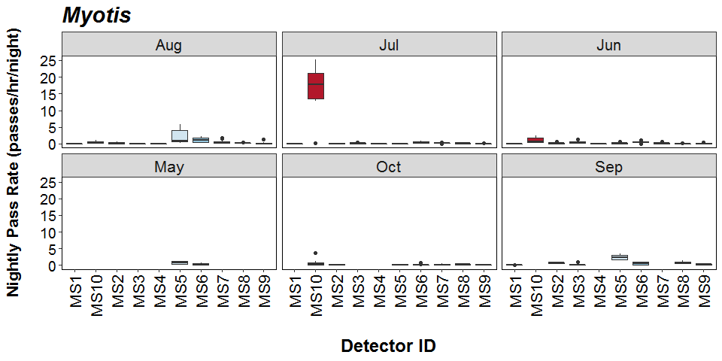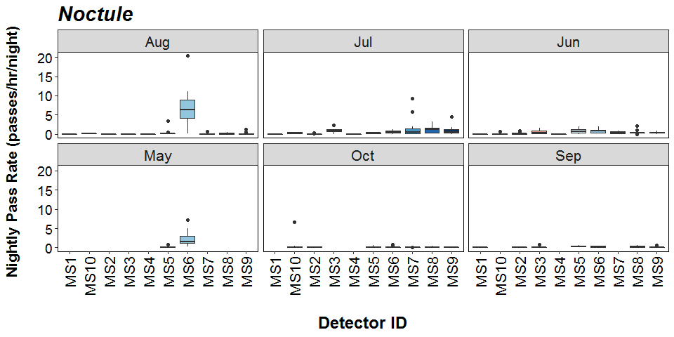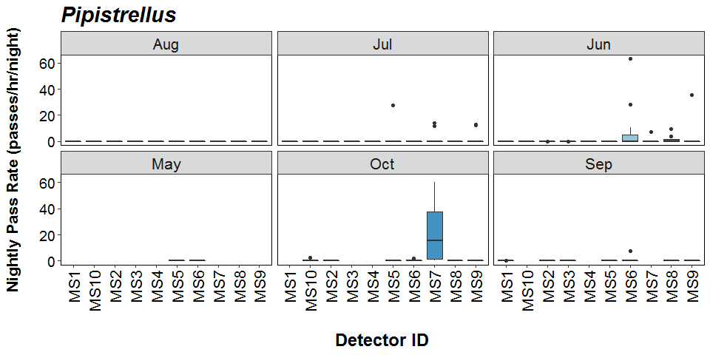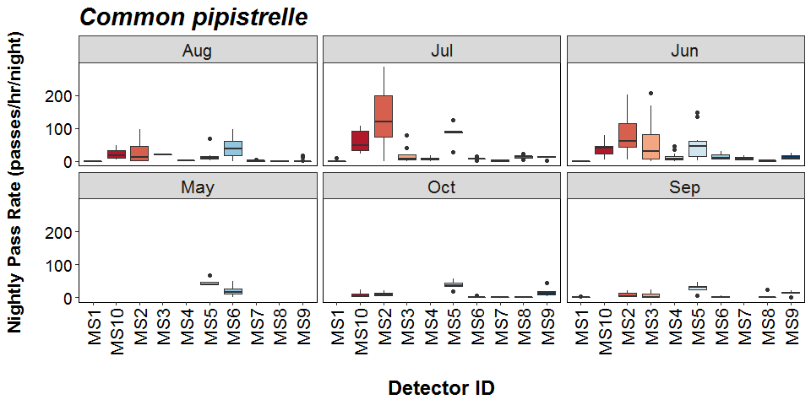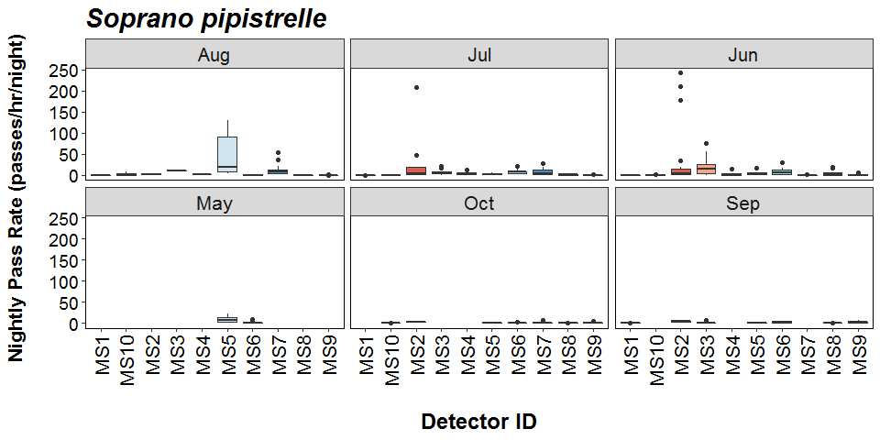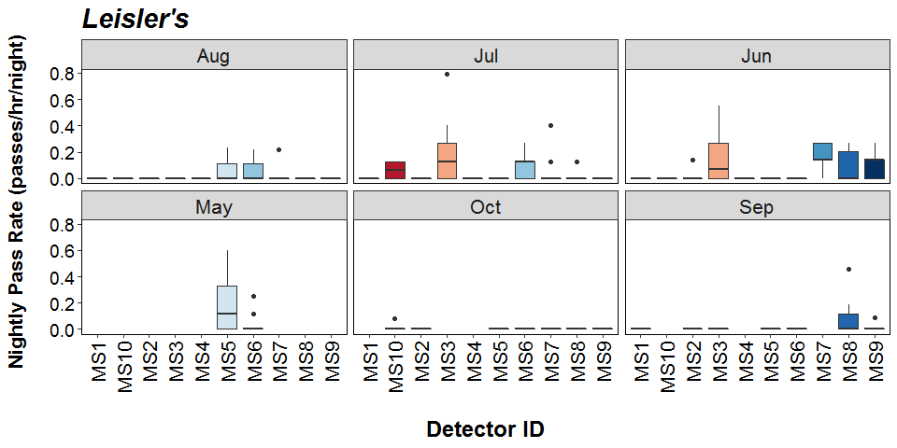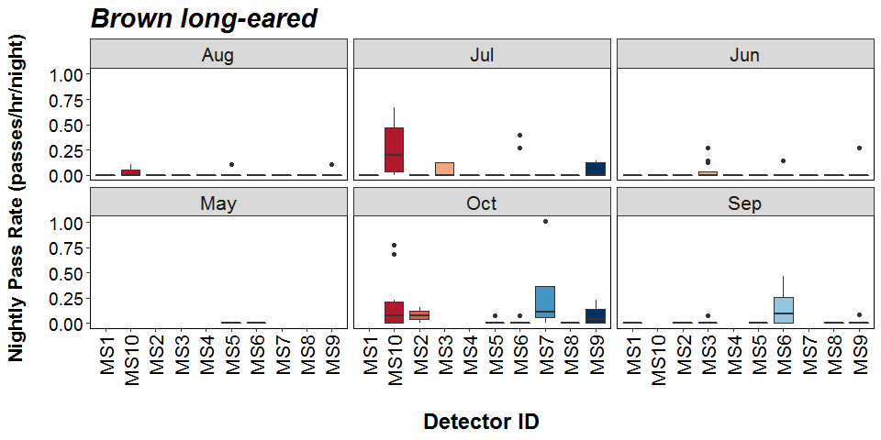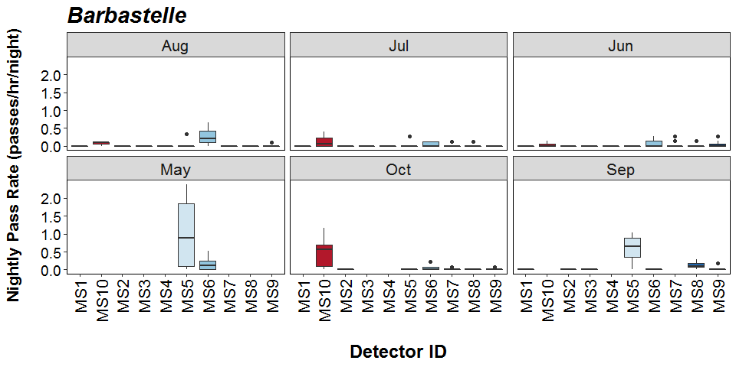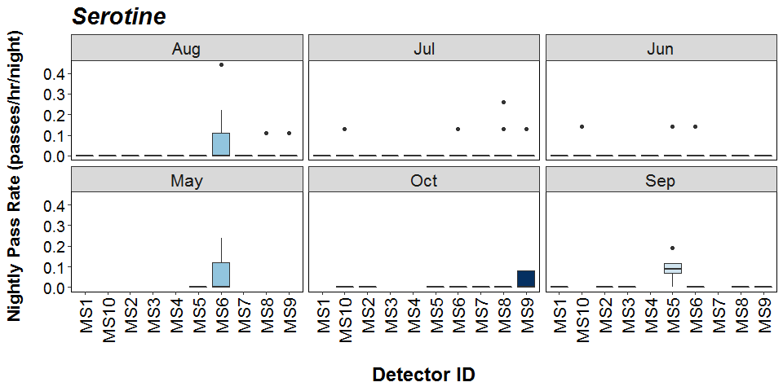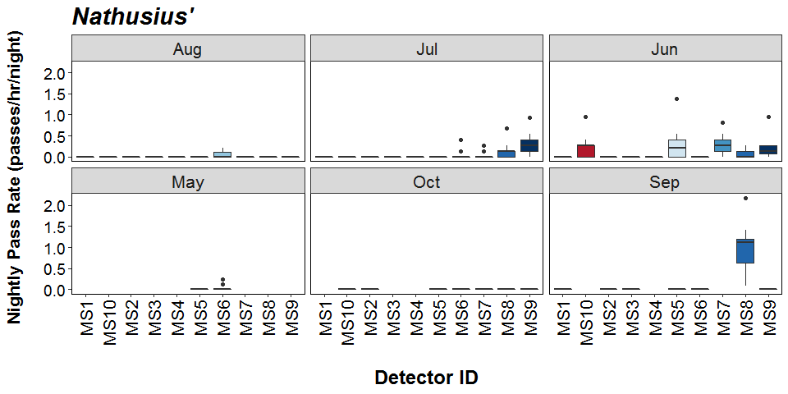

##### Page Break

# Bat Activity per Detector Location

**Detector ID reference:**



##### Page Break

**Median Nightly Pass Rate (bat passes/hr/night) throughout the survey period - represented by the size and colour of the point at each detector location.**

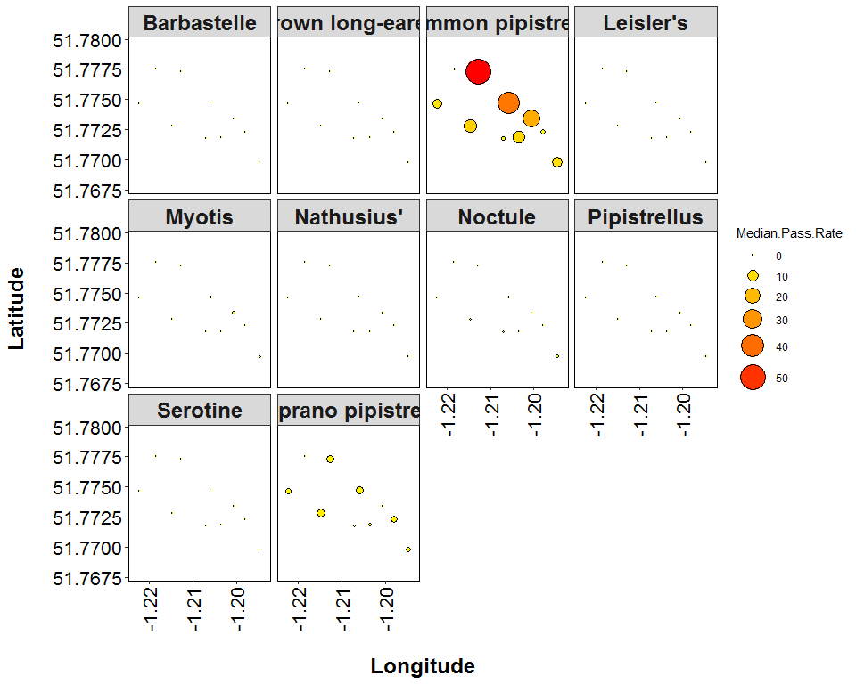

##### Page Break

**Maximum Nightly Pass Rate (bat passes/hr/night) recorded in a single night throughout the survey period - represented by the size and colour of the point at each detector location.**

