Bat Activity Analysis

Site Name: NA

Author: NA

25/04/2019

# Summary

Bats were detected on **49** nights between **2018-07-09** and **2018-09-09**, using **5** static bat detectors. Throughout this period **7** species were recorded. Detectors were placed at the following locations:

|  |  |  |
| --- | --- | --- |
| Detector ID | lat | lon |
| d8 | 55.02213 | -6.821350 |
| d7 | 55.02458 | -6.821733 |
| d10 | 55.01728 | -6.819750 |
| d9 | 55.01965 | -6.820650 |
| d6 | 55.02690 | -6.821783 |

##### Page Break

# Survey Nights

The number of nights that bats were detected on each recorder. This is not the same as the number of nights that detectors were active if there were nights when no bats were detected.

|  |  |
| --- | --- |
| Detector ID | No. of nights |
| d10 | 40 |
| d6 | 30 |
| d7 | 22 |
| d8 | 42 |
| d9 | 35 |

##### Page Break

# Survey Nights

Horizontal bars show nights when acoustic detectors recorded bats.

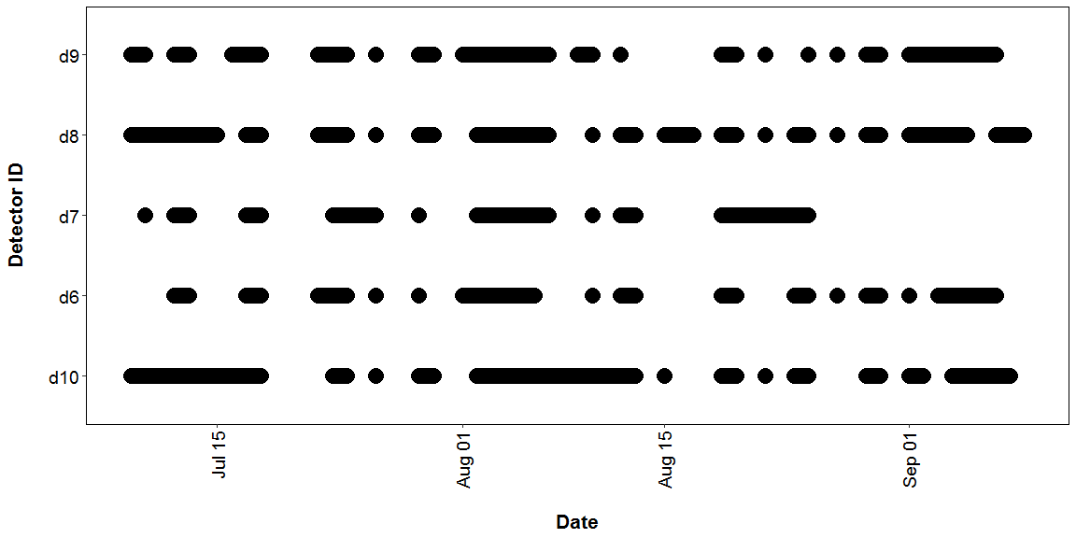

##### Page Break

## PART 1: Percentiles Analysis

The reference range dataset was stratified to include:

* Only records from within 30 days of the survey date.
* Only records from within 100km2 of the survey location.
* Records using any make of bat detector.

#### Table 1

Summary table showing the number of nights recorded bat activity fell into each activity band for each species.

|  |  |  |  |  |  |  |
| --- | --- | --- | --- | --- | --- | --- |
| Location | Species/Species Group | Nights of High Activity | Nights of Moderate/ High Activity | Nights of Moderate Activity | Nights of Low/ Moderate Activity | Nights of Low Activity |
| d10 | *Myotis* | 0 | 0 | 0 | 0 | 6 |
| d10 | *Nyctalus leisleri* | 12 | 12 | 3 | 4 | 5 |
| d10 | *Pipistrellus* | 0 | 0 | 0 | 0 | 3 |
| d10 | *Pipistrellus nathusii* | 0 | 0 | 0 | 3 | 4 |
| d10 | *Pipistrellus pipistrellus* | 3 | 2 | 3 | 2 | 3 |
| d10 | *Pipistrellus pygmaeus* | 2 | 1 | 2 | 1 | 7 |
| d10 | *Plecotus auritus* | 0 | 0 | 0 | 0 | 2 |
| d6 | *Nyctalus leisleri* | 6 | 3 | 2 | 7 | 4 |
| d6 | *Pipistrellus* | 0 | 0 | 0 | 0 | 2 |
| d6 | *Pipistrellus nathusii* | 0 | 0 | 0 | 2 | 5 |
| d6 | *Pipistrellus pipistrellus* | 4 | 2 | 1 | 1 | 6 |
| d6 | *Pipistrellus pygmaeus* | 1 | 2 | 0 | 2 | 5 |
| d7 | *Myotis* | 0 | 0 | 0 | 1 | 2 |
| d7 | *Nyctalus leisleri* | 6 | 3 | 2 | 5 | 4 |
| d7 | *Pipistrellus nathusii* | 0 | 1 | 0 | 1 | 2 |
| d7 | *Pipistrellus pipistrellus* | 1 | 2 | 1 | 0 | 4 |
| d7 | *Pipistrellus pygmaeus* | 2 | 0 | 1 | 1 | 5 |
| d7 | *Plecotus auritus* | 0 | 0 | 0 | 0 | 1 |
| d8 | *Myotis* | 0 | 0 | 1 | 0 | 5 |
| d8 | *Nyctalus leisleri* | 9 | 11 | 2 | 7 | 5 |
| d8 | *Pipistrellus* | 0 | 0 | 0 | 0 | 2 |
| d8 | *Pipistrellus nathusii* | 0 | 0 | 2 | 4 | 0 |
| d8 | *Pipistrellus pipistrellus* | 4 | 5 | 1 | 5 | 7 |
| d8 | *Pipistrellus pygmaeus* | 1 | 3 | 0 | 2 | 11 |
| d8 | *Plecotus auritus* | 0 | 0 | 0 | 0 | 1 |
| d9 | *Myotis* | 0 | 0 | 1 | 0 | 4 |
| d9 | *Nyctalus leisleri* | 4 | 9 | 5 | 5 | 6 |
| d9 | *Pipistrellus nathusii* | 0 | 0 | 0 | 2 | 3 |
| d9 | *Pipistrellus pipistrellus* | 3 | 0 | 3 | 1 | 7 |
| d9 | *Pipistrellus pygmaeus* | 0 | 1 | 0 | 3 | 6 |

#### Table 2

Summary table showing key metrics for each species recorded.

|  |  |  |  |  |  |  |
| --- | --- | --- | --- | --- | --- | --- |
| Location | Species/Species Group | Median Percentile | 95% CIs | Max Percentile | Nights Recorded | Reference Range |
| d10 | *Myotis* | 0 | 0 - 0 | 0 | 6 | 74 |
| d10 | *Nyctalus leisleri* | 67 | 62 - 79 | 96 | 36 | 306 |
| d10 | *Pipistrellus* | 0 | 0 - 0 | 0 | 3 | 371 |
| d10 | *Pipistrellus nathusii* | 0 | 0 - 0 | 31 | 7 | 56 |
| d10 | *Pipistrellus pipistrellus* | 51 | 41 - 80 | 94 | 13 | 275 |
| d10 | *Pipistrellus pygmaeus* | 0 | 41 - 83 | 83 | 13 | 213 |
| d10 | *Plecotus auritus* | 0 | 0 - 0 | 0 | 2 | 22 |
| d6 | *Nyctalus leisleri* | 41 | 41 - 73.5 | 97 | 22 | 306 |
| d6 | *Pipistrellus* | 0 | 0 - 0 | 0 | 2 | 371 |
| d6 | *Pipistrellus nathusii* | 0 | 0 - 0 | 31 | 7 | 56 |
| d6 | *Pipistrellus pipistrellus* | 41 | 51 - 95.5 | 98 | 14 | 275 |
| d6 | *Pipistrellus pygmaeus* | 16 | 31 - 79 | 86 | 10 | 213 |
| d7 | *Myotis* | 0 | 0 - 0 | 31 | 3 | 74 |
| d7 | *Nyctalus leisleri* | 51 | 45.5 - 76.5 | 96 | 20 | 306 |
| d7 | *Pipistrellus nathusii* | 16 | 45.5 - 45.5 | 60 | 4 | 56 |
| d7 | *Pipistrellus pipistrellus* | 26 | 51 - 94 | 94 | 8 | 275 |
| d7 | *Pipistrellus pygmaeus* | 0 | 31 - 86 | 86 | 9 | 213 |
| d7 | *Plecotus auritus* | 0 | 0 | 0 | 1 | 22 |
| d8 | *Myotis* | 0 | 0 - 0 | 51 | 6 | 74 |
| d8 | *Nyctalus leisleri* | 69 | 57 - 78 | 98 | 34 | 306 |
| d8 | *Pipistrellus* | 0 | 0 - 0 | 0 | 2 | 371 |
| d8 | *Pipistrellus nathusii* | 31 | 31 - 41 | 51 | 6 | 56 |
| d8 | *Pipistrellus pipistrellus* | 31 | 49 - 77 | 94 | 22 | 275 |
| d8 | *Pipistrellus pygmaeus* | 0 | 45.5 - 72 | 84 | 17 | 213 |
| d8 | *Plecotus auritus* | 0 | 0 | 0 | 1 | 22 |
| d9 | *Myotis* | 0 | 0 - 0 | 51 | 5 | 74 |
| d9 | *Nyctalus leisleri* | 51 | 51 - 67.5 | 96 | 29 | 306 |
| d9 | *Pipistrellus nathusii* | 0 | 0 - 0 | 31 | 5 | 56 |
| d9 | *Pipistrellus pipistrellus* | 16 | 41 - 88.5 | 89 | 14 | 275 |
| d9 | *Pipistrellus pygmaeus* | 0 | 31 - 31 | 77 | 10 | 213 |

### Figures

**Figure 1.** Differences in bat activity between static detector locations. The centre line indicates the median activity level whereas the box represents the interquartile range (the spread of the middle 50% of nights of activity)

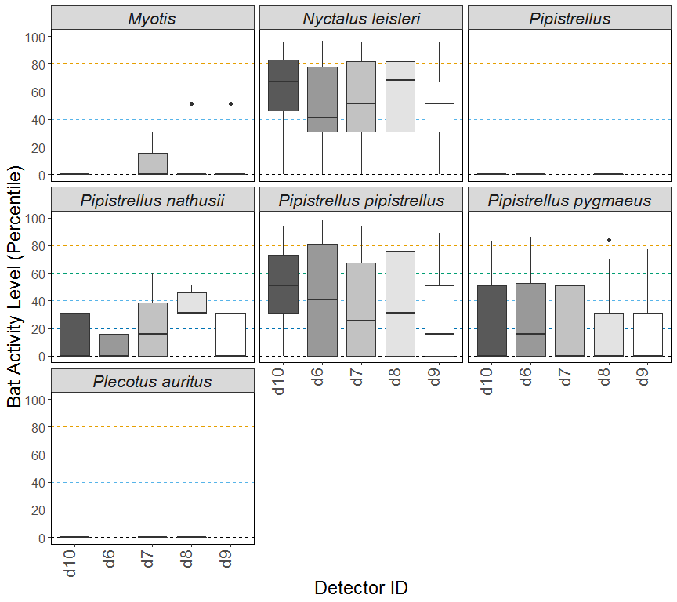

**Figure 1.** Differences in activity between static detector locations, split by species and location. The centre line indicates the median activity level whereas the box represents the interquartile range (the spread of the middle 50% of nights of activity)

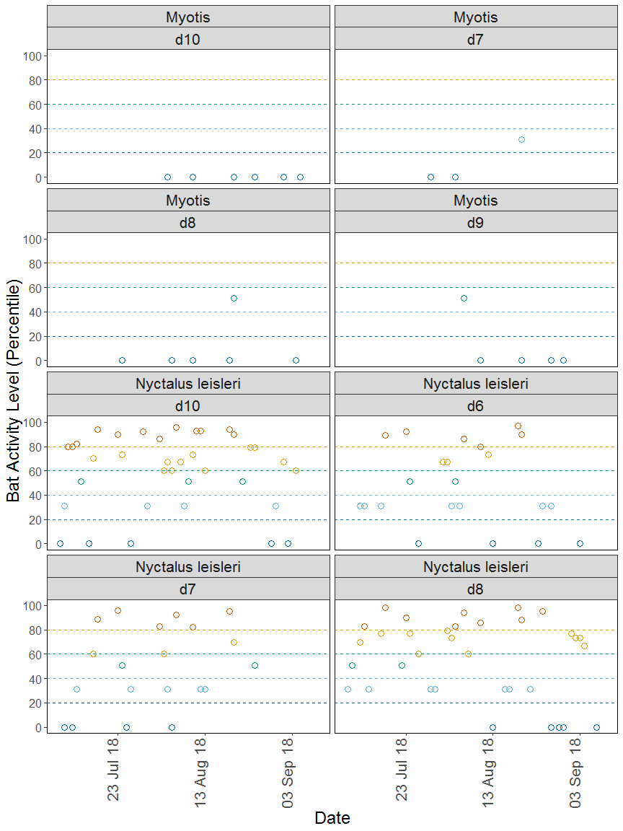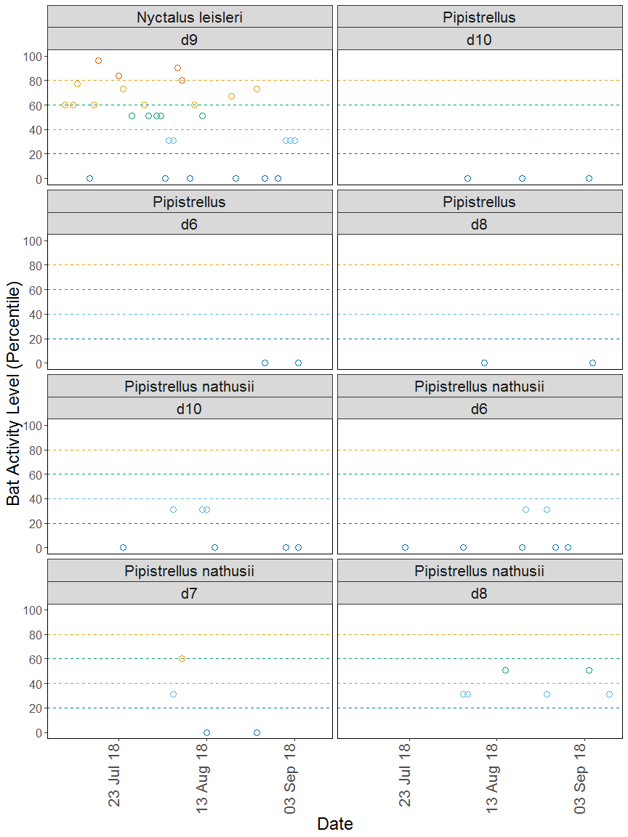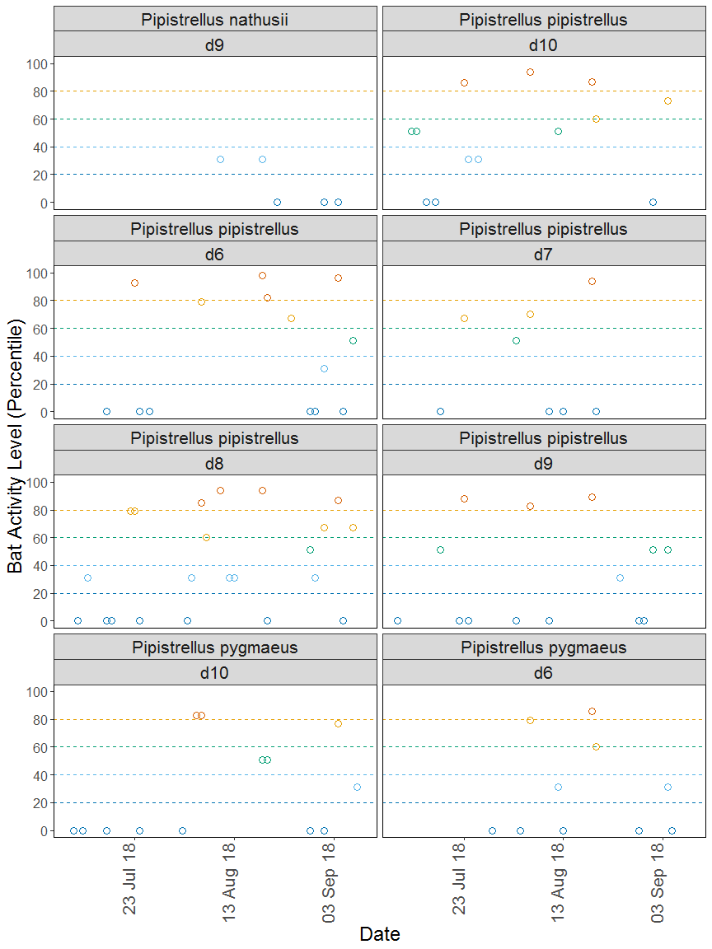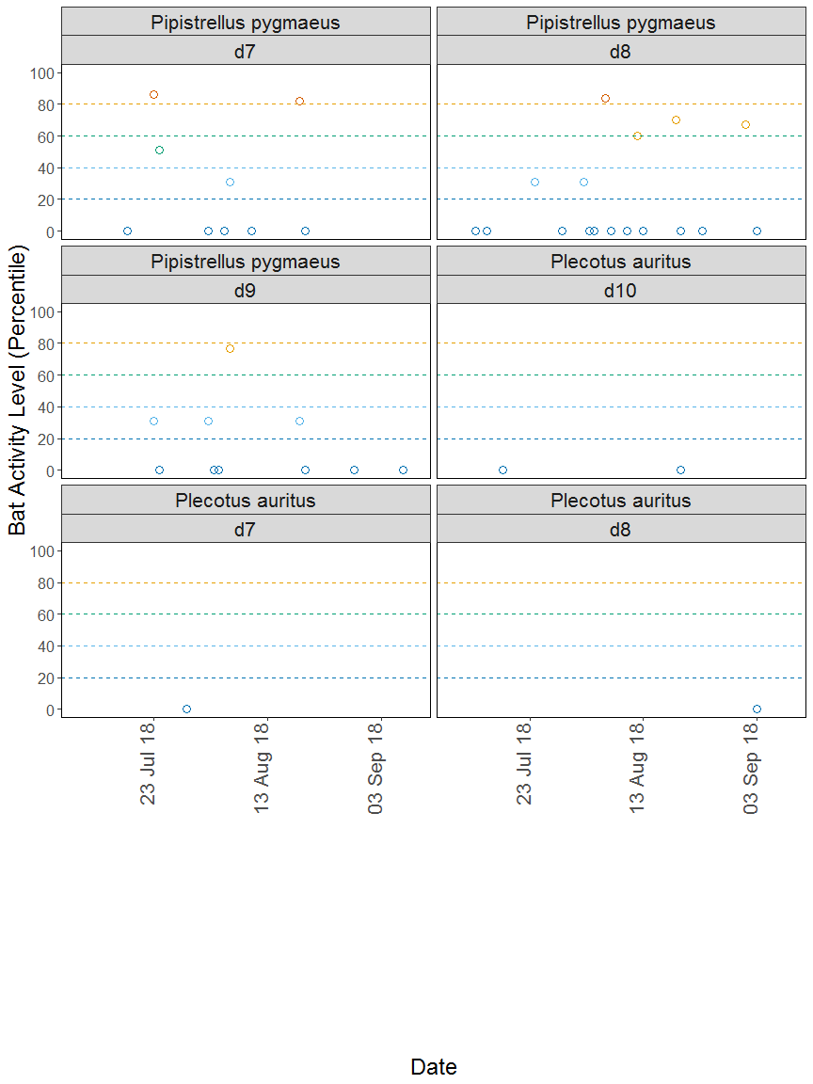

**Figure 2.** The activity level (percentile) of bats recorded across each night of the bat survey, split by location and species.

##### Page Break

## PART 2: Nightly Analysis

# Sunrise and Sunset Times

**The times of sunset and sunrise the following morning for surveys beginning on the date shown.**

|  |  |  |  |
| --- | --- | --- | --- |
| Night (y-m-d) | Sunset (hh:mm) | Sunrise (hh:mm) | Night Length (hours) |
| 2018-07-09 | 22:05 | 05:02 | 7.0 |
| 2018-07-10 | 22:04 | 05:04 | 7.0 |
| 2018-07-11 | 22:03 | 05:05 | 7.0 |
| 2018-07-12 | 22:02 | 05:06 | 7.1 |
| 2018-07-13 | 22:01 | 05:07 | 7.1 |
| 2018-07-14 | 22:00 | 05:09 | 7.1 |
| 2018-07-15 | 21:59 | 05:10 | 7.2 |
| 2018-07-16 | 21:58 | 05:12 | 7.2 |
| 2018-07-17 | 21:56 | 05:13 | 7.3 |
| 2018-07-18 | 21:55 | 05:15 | 7.3 |
| 2018-07-22 | 21:49 | 05:21 | 7.5 |
| 2018-07-23 | 21:48 | 05:23 | 7.6 |
| 2018-07-24 | 21:46 | 05:24 | 7.6 |
| 2018-07-25 | 21:45 | 05:26 | 7.7 |
| 2018-07-26 | 21:43 | 05:28 | 7.7 |
| 2018-07-29 | 21:38 | 05:33 | 7.9 |
| 2018-07-30 | 21:36 | 05:35 | 8.0 |
| 2018-08-01 | 21:32 | 05:38 | 8.1 |
| 2018-08-02 | 21:30 | 05:40 | 8.2 |
| 2018-08-03 | 21:28 | 05:42 | 8.2 |
| 2018-08-04 | 21:26 | 05:44 | 8.3 |
| 2018-08-05 | 21:24 | 05:46 | 8.4 |
| 2018-08-06 | 21:22 | 05:47 | 8.4 |
| 2018-08-07 | 21:20 | 05:49 | 8.5 |
| 2018-08-08 | 21:18 | 05:51 | 8.5 |
| 2018-08-09 | 21:16 | 05:53 | 8.6 |
| 2018-08-10 | 21:14 | 05:55 | 8.7 |
| 2018-08-11 | 21:12 | 05:57 | 8.7 |
| 2018-08-12 | 21:10 | 05:59 | 8.8 |
| 2018-08-13 | 21:08 | 06:00 | 8.9 |
| 2018-08-15 | 21:03 | 06:04 | 9.0 |
| 2018-08-16 | 21:01 | 06:06 | 9.1 |
| 2018-08-17 | 20:59 | 06:08 | 9.2 |
| 2018-08-19 | 20:54 | 06:12 | 9.3 |
| 2018-08-20 | 20:52 | 06:14 | 9.4 |
| 2018-08-22 | 20:47 | 06:17 | 9.5 |
| 2018-08-24 | 20:42 | 06:21 | 9.6 |
| 2018-08-25 | 20:40 | 06:23 | 9.7 |
| 2018-08-27 | 20:35 | 06:27 | 9.9 |
| 2018-08-29 | 20:30 | 06:30 | 10.0 |
| 2018-08-30 | 20:28 | 06:32 | 10.1 |
| 2018-09-01 | 20:23 | 06:36 | 10.2 |
| 2018-09-02 | 20:20 | 06:38 | 10.3 |
| 2018-09-03 | 20:18 | 06:40 | 10.4 |
| 2018-09-04 | 20:15 | 06:42 | 10.4 |
| 2018-09-05 | 20:12 | 06:43 | 10.5 |
| 2018-09-07 | 20:07 | 06:47 | 10.7 |
| 2018-09-08 | 20:05 | 06:49 | 10.7 |
| 2018-09-09 | 20:02 | 06:51 | 10.8 |

##### Page Break

# Counts of Bat Passes

## All detectors

**The total number of passes recorded for each species across all of the detectors.**

|  |  |  |
| --- | --- | --- |
| species | Count (No) | Percentage of total (%) |
| Pipistrellus | 7 | 0.3 |
| Common pipistrelle | 547 | 25.6 |
| Soprano pipistrelle | 185 | 8.7 |
| Nathusius’ | 48 | 2.2 |
| Leisler’s | 1318 | 61.8 |
| Brown long-eared | 4 | 0.2 |
| Myotis | 25 | 1.2 |
| Total | 2134 | 100.0 |

##### Page Break

# Counts of Bat Passes

## Per Detector

**The number of passes recorded for each species at each detector.**

|  |  |  |  |
| --- | --- | --- | --- |
| species | Detector ID | Count (No) | Percentage by Detector (%) |
| Pipistrellus | d10 | 3 | 0.6 |
| Pipistrellus | d6 | 2 | 0.5 |
| Pipistrellus | d8 | 2 | 0.3 |
| Common pipistrelle | d10 | 92 | 16.9 |
| Common pipistrelle | d6 | 183 | 43.3 |
| Common pipistrelle | d7 | 49 | 17.0 |
| Common pipistrelle | d8 | 152 | 25.2 |
| Common pipistrelle | d9 | 71 | 25.6 |
| Soprano pipistrelle | d10 | 47 | 8.6 |
| Soprano pipistrelle | d6 | 39 | 9.2 |
| Soprano pipistrelle | d7 | 36 | 12.5 |
| Soprano pipistrelle | d8 | 43 | 7.1 |
| Soprano pipistrelle | d9 | 20 | 7.2 |
| Nathusius’ | d10 | 10 | 1.8 |
| Nathusius’ | d6 | 9 | 2.1 |
| Nathusius’ | d7 | 8 | 2.8 |
| Nathusius’ | d8 | 14 | 2.3 |
| Nathusius’ | d9 | 7 | 2.5 |
| Leisler’s | d10 | 384 | 70.6 |
| Leisler’s | d6 | 190 | 44.9 |
| Leisler’s | d7 | 190 | 66.0 |
| Leisler’s | d8 | 382 | 63.5 |
| Leisler’s | d9 | 172 | 62.1 |
| Brown long-eared | d10 | 2 | 0.4 |
| Brown long-eared | d7 | 1 | 0.3 |
| Brown long-eared | d8 | 1 | 0.2 |
| Myotis | d10 | 6 | 1.1 |
| Myotis | d7 | 4 | 1.4 |
| Myotis | d8 | 8 | 1.3 |
| Myotis | d9 | 7 | 2.5 |

##### Page Break

# Species Composition of Passes at each Detector

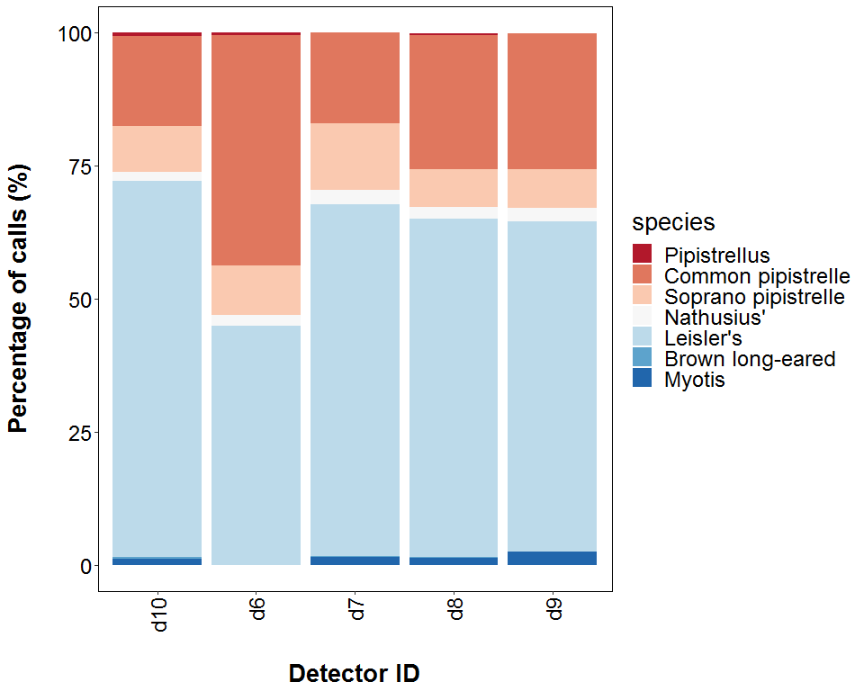

##### Page Break

# Bat Passes per Month

## Per Detector

**The total number of bat passes of each species in each month at each detector.**

|  |  |  |  |  |
| --- | --- | --- | --- | --- |
| species | Detector ID | Jul | Aug | Sep |
| Pipistrellus | d10 | 0 | 2 | 1 |
| Pipistrellus | d6 | 0 | 1 | 1 |
| Pipistrellus | d8 | 0 | 1 | 1 |
| Common pipistrelle | d10 | 28 | 56 | 8 |
| Common pipistrelle | d6 | 30 | 101 | 52 |
| Common pipistrelle | d7 | 6 | 43 | 0 |
| Common pipistrelle | d8 | 24 | 99 | 29 |
| Common pipistrelle | d9 | 25 | 40 | 6 |
| Soprano pipistrelle | d10 | 4 | 32 | 11 |
| Soprano pipistrelle | d6 | 1 | 35 | 3 |
| Soprano pipistrelle | d7 | 19 | 17 | 0 |
| Soprano pipistrelle | d8 | 5 | 32 | 6 |
| Soprano pipistrelle | d9 | 3 | 16 | 1 |
| Nathusius’ | d10 | 1 | 7 | 2 |
| Nathusius’ | d6 | 1 | 8 | 0 |
| Nathusius’ | d7 | 0 | 8 | 0 |
| Nathusius’ | d8 | 0 | 9 | 5 |
| Nathusius’ | d9 | 0 | 5 | 2 |
| Leisler’s | d10 | 139 | 235 | 10 |
| Leisler’s | d6 | 57 | 132 | 1 |
| Leisler’s | d7 | 83 | 107 | 0 |
| Leisler’s | d8 | 132 | 222 | 28 |
| Leisler’s | d9 | 98 | 68 | 6 |
| Brown long-eared | d10 | 1 | 1 | 0 |
| Brown long-eared | d7 | 1 | 0 | 0 |
| Brown long-eared | d8 | 0 | 0 | 1 |
| Myotis | d10 | 0 | 4 | 2 |
| Myotis | d7 | 1 | 3 | 0 |
| Myotis | d8 | 1 | 6 | 1 |
| Myotis | d9 | 0 | 7 | 0 |

##### Page Break

## Nightly Bat Passes for each Month

# Median Per Detector

**The median number of bat passes of each species throughout each month. If NA, then no bat passes.**

Bat pass rates are often highly variable between nights, with some nights having few or no passes and other nights having high activity. In these circumstances, the median is likely to be a more useful summary of the ‘average’ activity than is the mean. For further information see: *Lintott, P. R., & Mathews, F. (2018). Basic mathematical errors may make ecological assessments unreliable. Biodiversity and Conservation, 27(1), 265-267.* <https://doi.org/10.1007/s10531-017-1418-5>

|  |  |  |  |  |
| --- | --- | --- | --- | --- |
| species | Detector ID | Jul | Aug | Sep |
| Pipistrellus | d10 | NA | 1.0 | 1.0 |
| Pipistrellus | d6 | NA | 1.0 | 1.0 |
| Pipistrellus | d8 | NA | 1.0 | 1.0 |
| Common pipistrelle | d10 | 2.0 | 11.0 | 4.0 |
| Common pipistrelle | d6 | 1.0 | 7.0 | 2.5 |
| Common pipistrelle | d7 | 3.0 | 2.0 | NA |
| Common pipistrelle | d8 | 1.0 | 2.0 | 5.0 |
| Common pipistrelle | d9 | 1.0 | 1.0 | 3.0 |
| Soprano pipistrelle | d10 | 1.0 | 3.0 | 2.0 |
| Soprano pipistrelle | d6 | 1.0 | 2.0 | 1.5 |
| Soprano pipistrelle | d7 | 3.0 | 1.0 | NA |
| Soprano pipistrelle | d8 | 1.0 | 1.0 | 3.0 |
| Soprano pipistrelle | d9 | 1.5 | 1.0 | 1.0 |
| Nathusius’ | d10 | 1.0 | 2.0 | 1.0 |
| Nathusius’ | d6 | 1.0 | 1.0 | NA |
| Nathusius’ | d7 | NA | 1.5 | NA |
| Nathusius’ | d8 | NA | 2.0 | 2.5 |
| Nathusius’ | d9 | NA | 2.0 | 1.0 |
| Leisler’s | d10 | 6.5 | 5.0 | 4.0 |
| Leisler’s | d6 | 2.0 | 4.0 | 1.0 |
| Leisler’s | d7 | 2.0 | 4.0 | NA |
| Leisler’s | d8 | 4.0 | 5.5 | 7.0 |
| Leisler’s | d9 | 4.0 | 3.0 | 2.0 |
| Brown long-eared | d10 | 1.0 | 1.0 | NA |
| Brown long-eared | d7 | 1.0 | NA | NA |
| Brown long-eared | d8 | NA | NA | 1.0 |
| Myotis | d10 | NA | 1.0 | 1.0 |
| Myotis | d7 | 1.0 | 1.5 | NA |
| Myotis | d8 | 1.0 | 1.0 | 1.0 |
| Myotis | d9 | NA | 1.0 | NA |

##### Page Break

## Nightly Bat Passes for each Month

# Mean per Detector

**The mean number of bat passes of each species per night throughout each month. Calculated with (Number of passes each month) / (Number of survey nights each month) for each detector. Values are given to 1 decimal place.** *We recommend using the median values given above, for the reasons stated above, but provide the mean values in the table below.**

# Survey Effort

**The number of survey nights per month per detector.**

|  |  |  |
| --- | --- | --- |
| Month | Detector ID | No of Survey Nights |
| Jul | d10 | 15 |
| Jul | d6 | 9 |
| Jul | d7 | 10 |
| Jul | d8 | 15 |
| Jul | d9 | 13 |
| Aug | d10 | 20 |
| Aug | d6 | 16 |
| Aug | d7 | 12 |
| Aug | d8 | 20 |
| Aug | d9 | 17 |
| Sep | d10 | 5 |
| Sep | d6 | 5 |
| Sep | d8 | 7 |
| Sep | d9 | 5 |

##### Page Break

# Mean per Detector

|  |  |  |  |  |
| --- | --- | --- | --- | --- |
| Species | Detector ID | Jul | Aug | Sep |
| Pipistrellus | d10 | 0.0 | 0.1 | 0.2 |
| Pipistrellus | d6 | 0.0 | 0.1 | 0.2 |
| Pipistrellus | d8 | 0.0 | 0.0 | 0.1 |
| Common pipistrelle | d10 | 2.2 | 2.8 | 2.0 |
| Common pipistrelle | d6 | 4.1 | 6.5 | 10.8 |
| Common pipistrelle | d7 | 0.6 | 3.6 | 0.0 |
| Common pipistrelle | d8 | 1.1 | 5.2 | 3.4 |
| Common pipistrelle | d9 | 2.0 | 2.5 | 1.2 |
| Soprano pipistrelle | d10 | 0.3 | 1.4 | 2.2 |
| Soprano pipistrelle | d6 | 0.1 | 2.3 | 0.6 |
| Soprano pipistrelle | d7 | 2.0 | 1.8 | 0.0 |
| Soprano pipistrelle | d8 | 0.3 | 2.0 | 0.9 |
| Soprano pipistrelle | d9 | 0.2 | 1.1 | 0.4 |
| Nathusius’ | d10 | 0.1 | 0.3 | 0.4 |
| Nathusius’ | d6 | 0.1 | 0.5 | 0.0 |
| Nathusius’ | d7 | 0.0 | 0.7 | 0.0 |
| Nathusius’ | d8 | 0.0 | 0.4 | 0.6 |
| Nathusius’ | d9 | 0.0 | 0.3 | 0.4 |
| Leisler’s | d10 | 9.4 | 10.4 | 2.2 |
| Leisler’s | d6 | 6.4 | 8.4 | 0.2 |
| Leisler’s | d7 | 8.4 | 8.9 | 0.0 |
| Leisler’s | d8 | 8.8 | 11.3 | 3.0 |
| Leisler’s | d9 | 7.8 | 3.8 | 1.2 |
| Brown long-eared | d10 | 0.1 | 0.0 | 0.0 |
| Brown long-eared | d7 | 0.1 | 0.0 | 0.0 |
| Brown long-eared | d8 | 0.0 | 0.0 | 0.1 |
| Myotis | d10 | 0.0 | 0.2 | 0.4 |
| Myotis | d7 | 0.1 | 0.2 | 0.0 |
| Myotis | d8 | 0.1 | 0.3 | 0.1 |
| Myotis | d9 | 0.0 | 0.4 | 0.0 |

##### Page Break

# Bat Passes per Month

## Per Detector - Figures

Figures show boxplots for the number of bat passes by detector each month. The ‘box’ shows the interquartile range, which is where the middle 50% of the data lie. The line dividing the box is the median, the mid-point of the data. The ‘whiskers’ extend from the box and represent the ranges for the bottom 25% and the top 25% of the data values, excluding outliers. An outlier is any extreme value that lies further away from the box than 1.5 times the interquartile range. Outliers are shown as dots. Where very few passes are recorded it is not possible to produce the box, so the data are shown as a line.

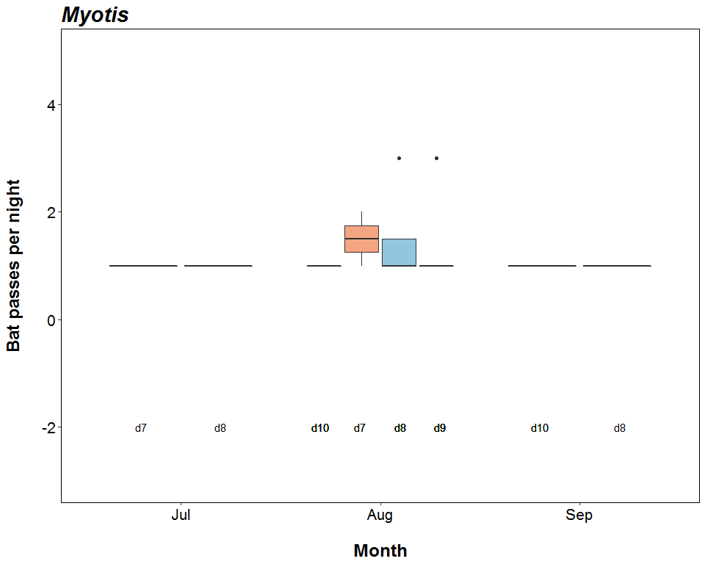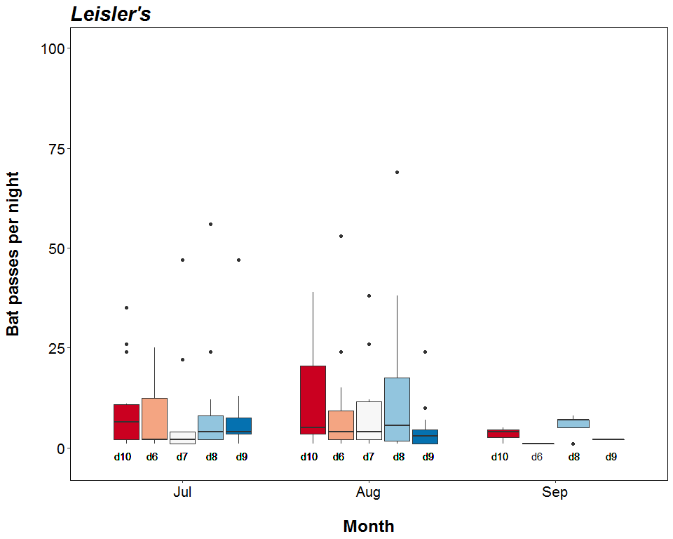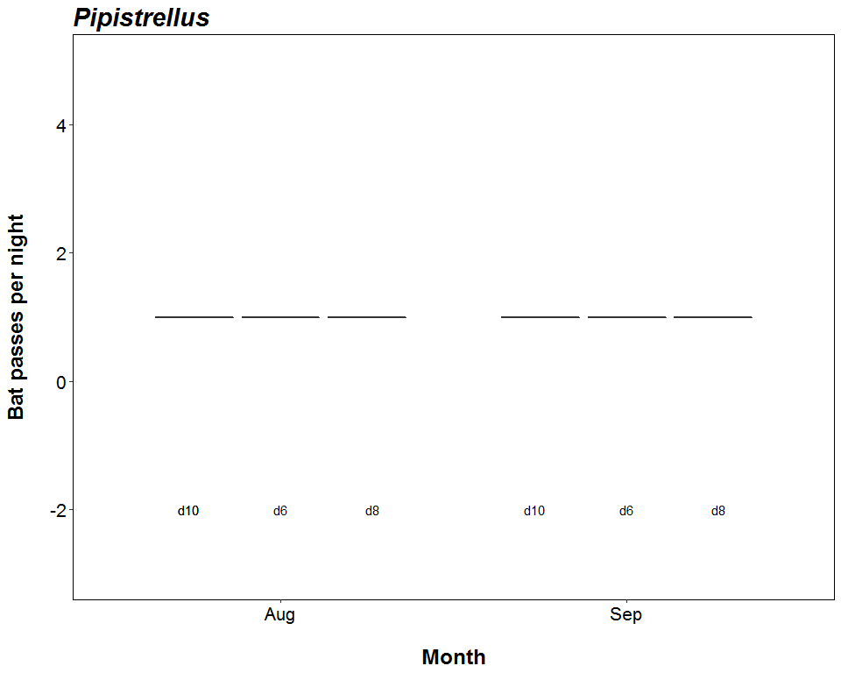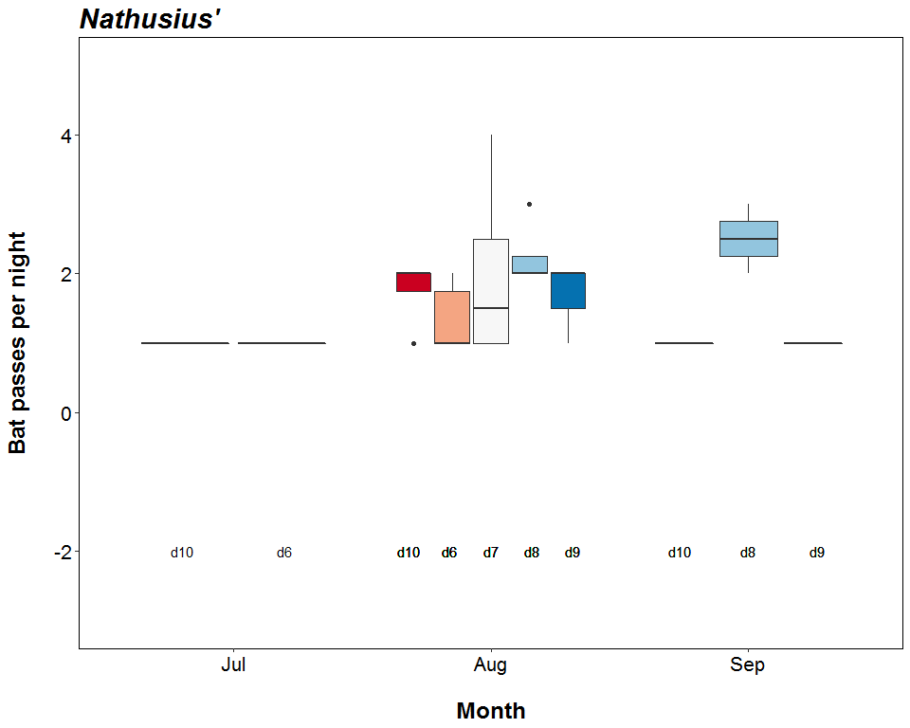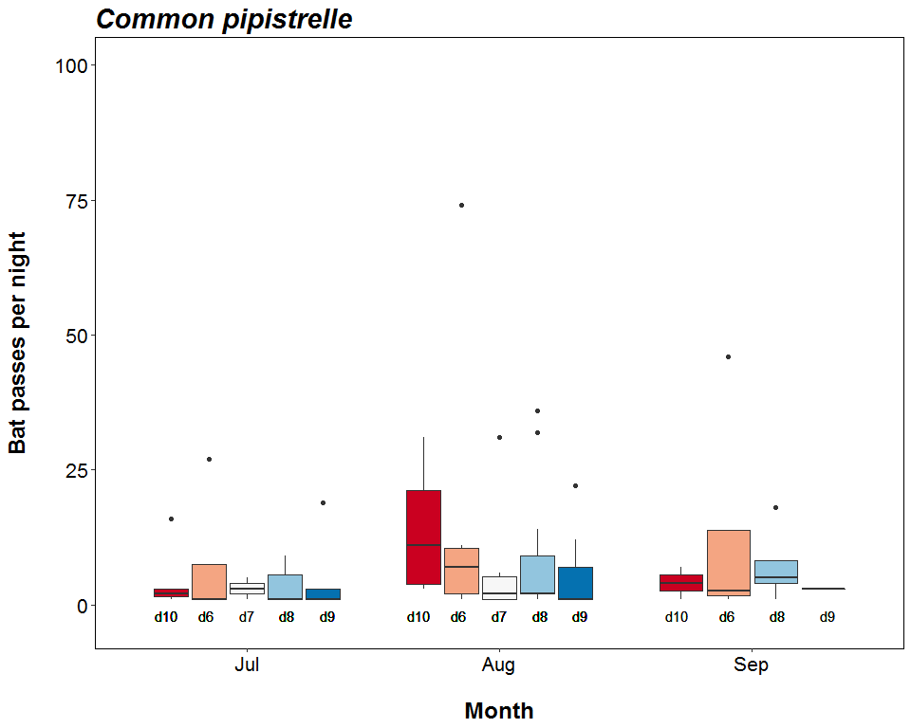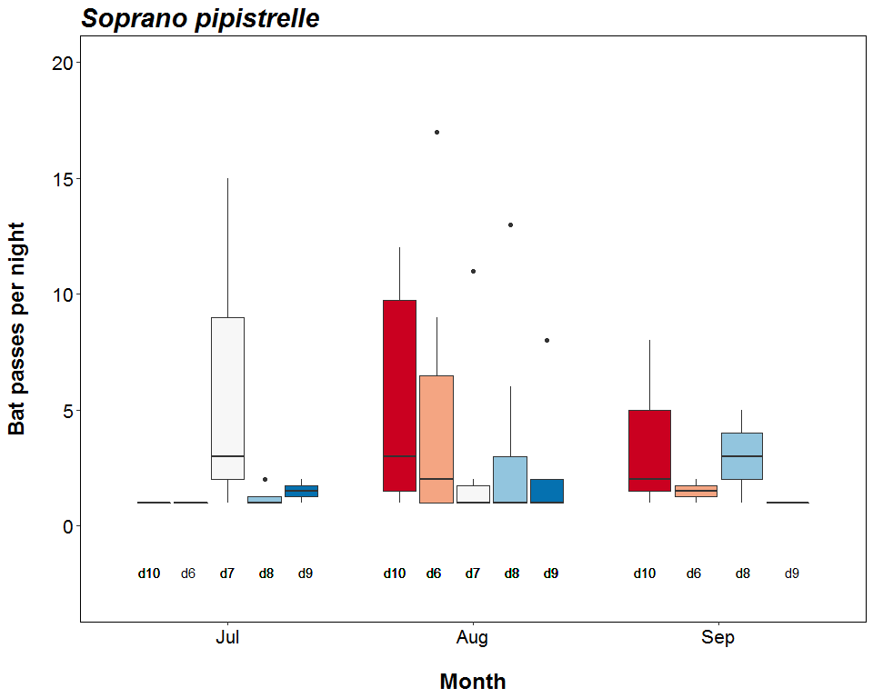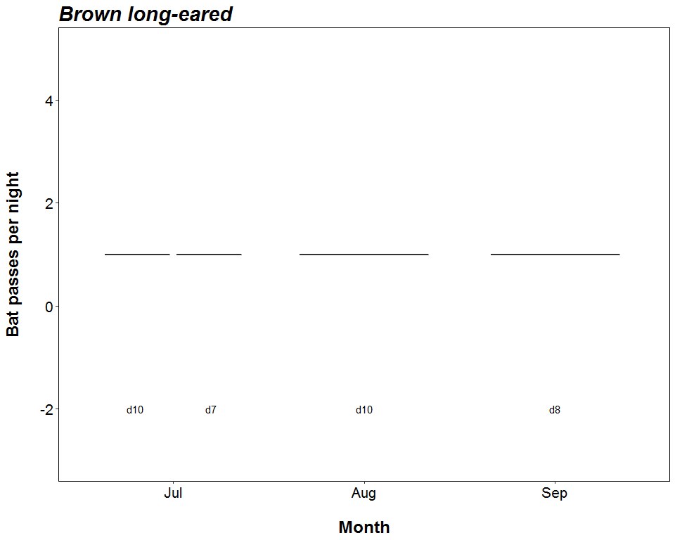

##### Page Break

# Distribution of Bat Passes Across Hours of the Night

## All Detectors

**The total number of bat passes occuring during each hour after sunset.**

###### Hours After Sunset

|  |  |  |  |  |  |  |  |  |  |  |  |
| --- | --- | --- | --- | --- | --- | --- | --- | --- | --- | --- | --- |
| Species | Detector ID | 0 | 1 | 2 | 3 | 4 | 5 | 6 | 7 | 8 | 9 |
| Pipistrellus | d10 | 0 | 2 | 0 | 1 | 0 | 0 | 0 | 0 | 0 | 0 |
| Pipistrellus | d6 | 0 | 2 | 0 | 0 | 0 | 0 | 0 | 0 | 0 | 0 |
| Pipistrellus | d8 | 0 | 1 | 0 | 1 | 0 | 0 | 0 | 0 | 0 | 0 |
| Common pipistrelle | d10 | 18 | 70 | 1 | 3 | 0 | 0 | 0 | 0 | 0 | 0 |
| Common pipistrelle | d6 | 0 | 175 | 6 | 1 | 1 | 0 | 0 | 0 | 0 | 0 |
| Common pipistrelle | d7 | 0 | 46 | 1 | 2 | 0 | 0 | 0 | 0 | 0 | 0 |
| Common pipistrelle | d8 | 36 | 99 | 3 | 13 | 0 | 1 | 0 | 0 | 0 | 0 |
| Common pipistrelle | d9 | 0 | 50 | 19 | 2 | 0 | 0 | 0 | 0 | 0 | 0 |
| Soprano pipistrelle | d10 | 0 | 15 | 15 | 0 | 0 | 2 | 13 | 2 | 0 | 0 |
| Soprano pipistrelle | d6 | 0 | 27 | 6 | 1 | 1 | 4 | 0 | 0 | 0 | 0 |
| Soprano pipistrelle | d7 | 0 | 28 | 2 | 5 | 1 | 0 | 0 | 0 | 0 | 0 |
| Soprano pipistrelle | d8 | 0 | 26 | 11 | 1 | 3 | 2 | 0 | 0 | 0 | 0 |
| Soprano pipistrelle | d9 | 0 | 15 | 3 | 1 | 0 | 0 | 1 | 0 | 0 | 0 |
| Nathusius’ | d10 | 0 | 1 | 2 | 5 | 2 | 0 | 0 | 0 | 0 | 0 |
| Nathusius’ | d6 | 0 | 0 | 1 | 2 | 6 | 0 | 0 | 0 | 0 | 0 |
| Nathusius’ | d7 | 0 | 0 | 0 | 8 | 0 | 0 | 0 | 0 | 0 | 0 |
| Nathusius’ | d8 | 0 | 2 | 5 | 2 | 3 | 2 | 0 | 0 | 0 | 0 |
| Nathusius’ | d9 | 0 | 3 | 0 | 3 | 1 | 0 | 0 | 0 | 0 | 0 |
| Leisler’s | d10 | 49 | 266 | 16 | 2 | 12 | 0 | 0 | 0 | 30 | 9 |
| Leisler’s | d6 | 54 | 125 | 5 | 6 | 0 | 0 | 0 | 0 | 0 | 0 |
| Leisler’s | d7 | 0 | 184 | 5 | 0 | 0 | 1 | 0 | 0 | 0 | 0 |
| Leisler’s | d8 | 69 | 295 | 8 | 0 | 7 | 0 | 2 | 1 | 0 | 0 |
| Leisler’s | d9 | 1 | 148 | 10 | 3 | 1 | 7 | 0 | 1 | 0 | 1 |
| Brown long-eared | d10 | 0 | 0 | 0 | 0 | 1 | 0 | 0 | 1 | 0 | 0 |
| Brown long-eared | d7 | 0 | 0 | 0 | 1 | 0 | 0 | 0 | 0 | 0 | 0 |
| Brown long-eared | d8 | 0 | 0 | 0 | 0 | 0 | 0 | 0 | 1 | 0 | 0 |
| Myotis | d10 | 0 | 0 | 0 | 1 | 3 | 1 | 0 | 1 | 0 | 0 |
| Myotis | d7 | 0 | 0 | 1 | 1 | 2 | 0 | 0 | 0 | 0 | 0 |
| Myotis | d8 | 0 | 0 | 0 | 2 | 4 | 0 | 2 | 0 | 0 | 0 |
| Myotis | d9 | 0 | 0 | 1 | 0 | 2 | 3 | 1 | 0 | 0 | 0 |

##### Page Break

# Distribution of Bat Activity Across the Night through Time

## Per Detector

**Timing of bat calls plotted as minutes before/after sunset, whereby 0 on the y axis represents sunset. Sunrise throughout the survey period is depicted as the red dashed line. Colours indicate kernel densities, with darkest colours showing peaks of activity. These colours are comparative only within each plot, and do not account for overall activity.**

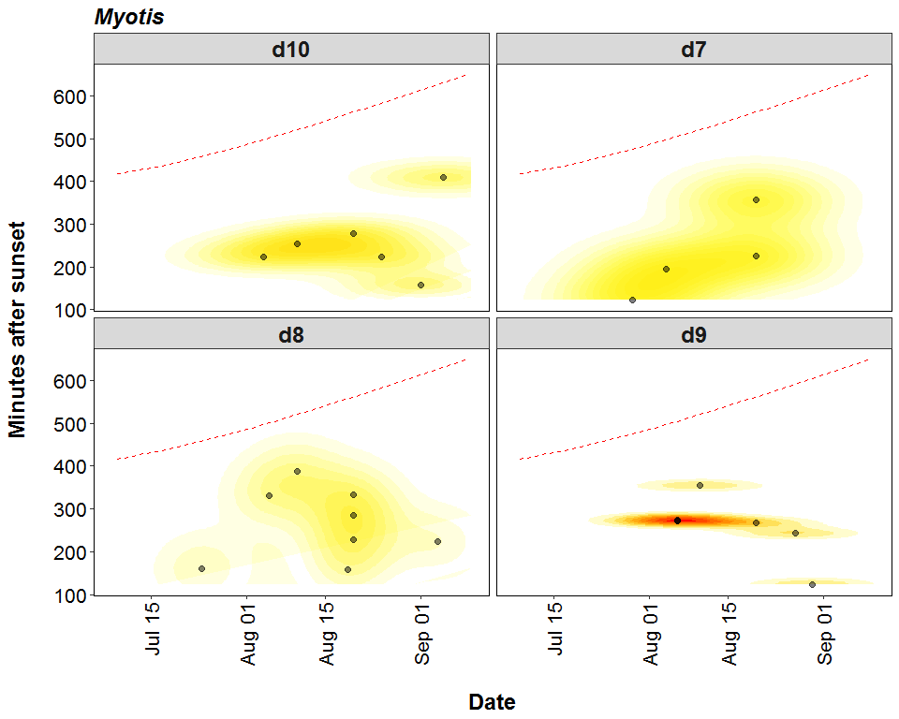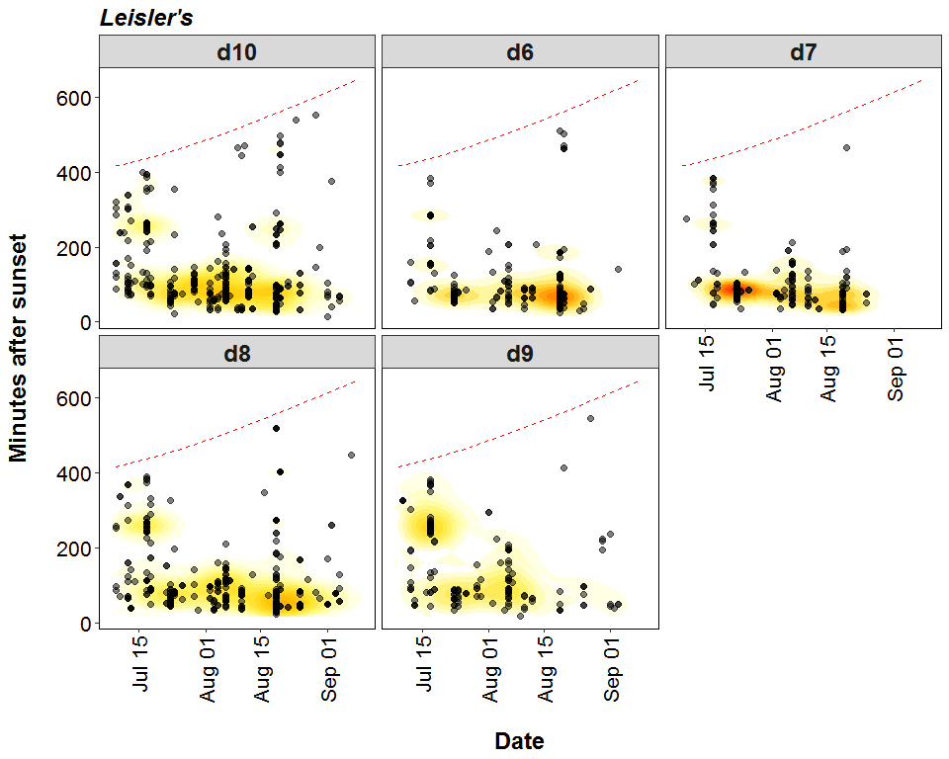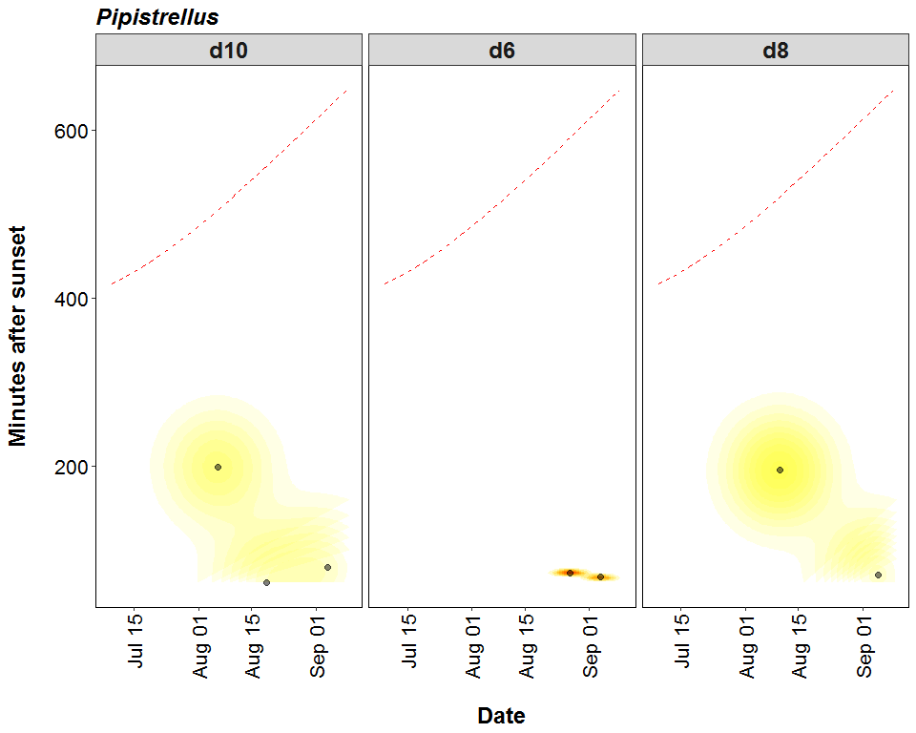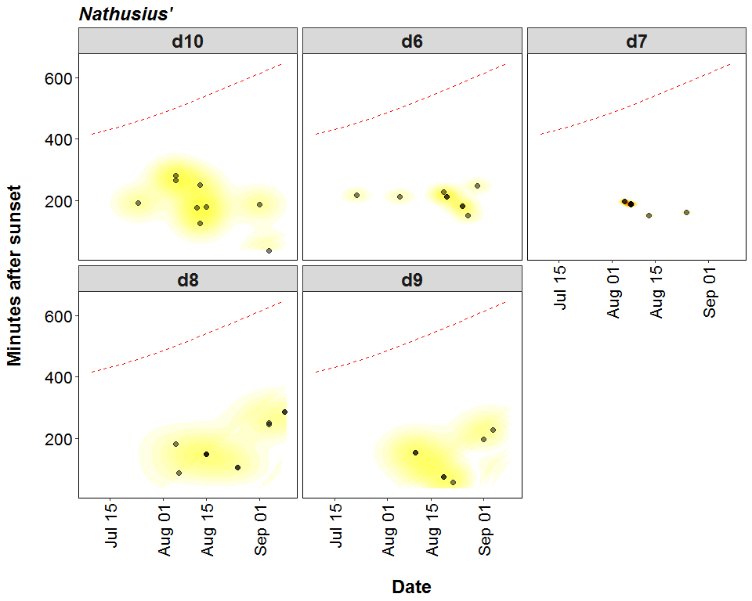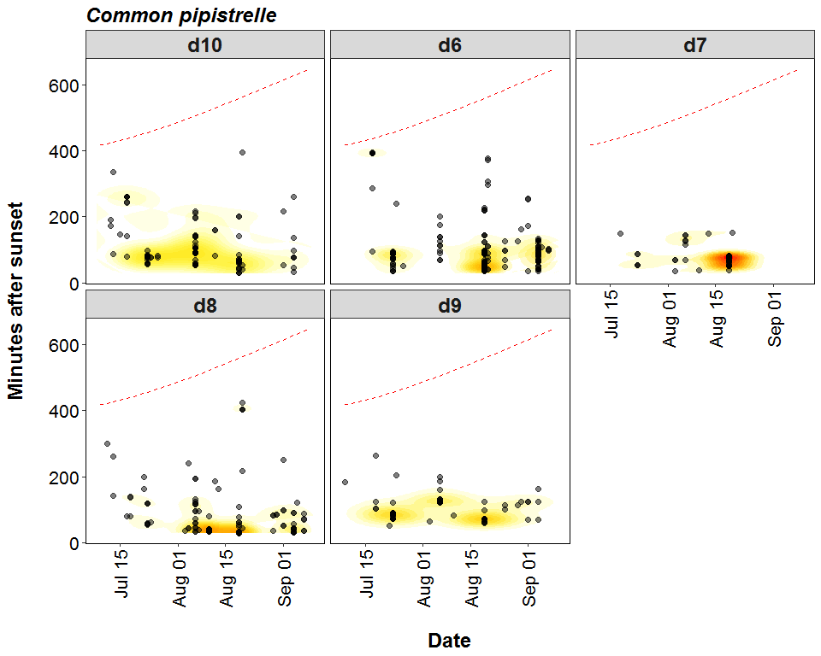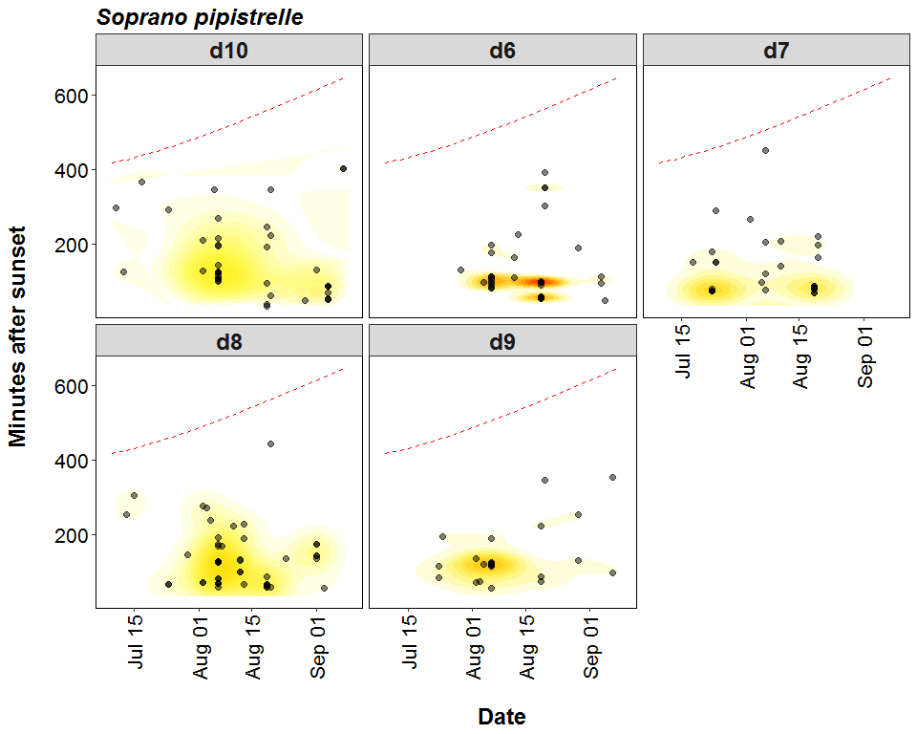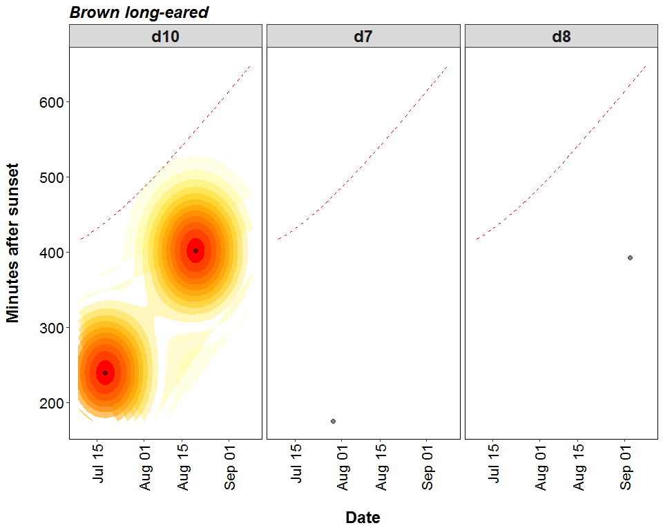

##### Page Break

# Distribution of Bat Passes Across Hours of the Night

## All Detectors

**Cumulative number of bat passes throughout the night.**

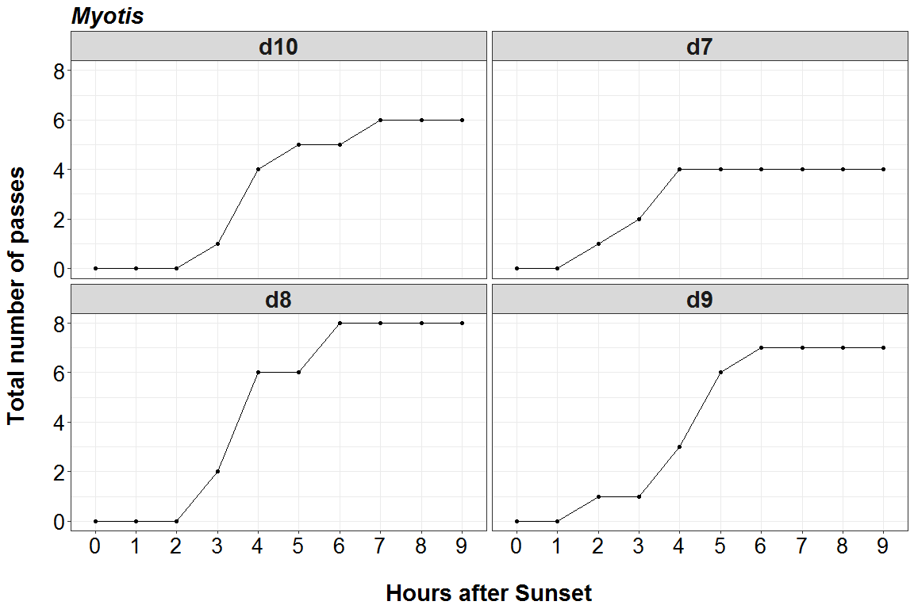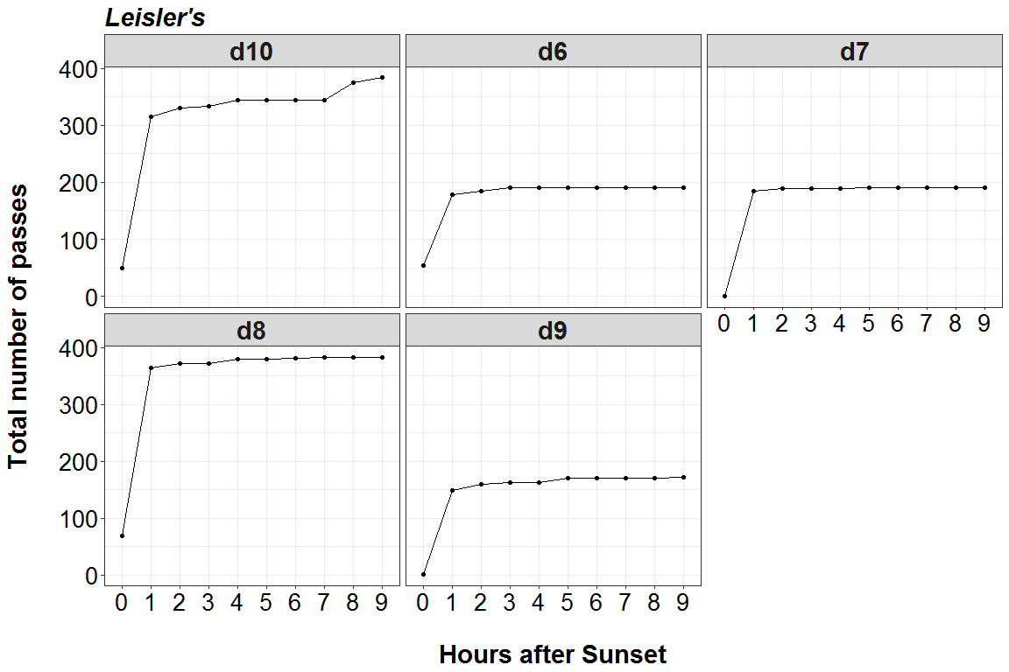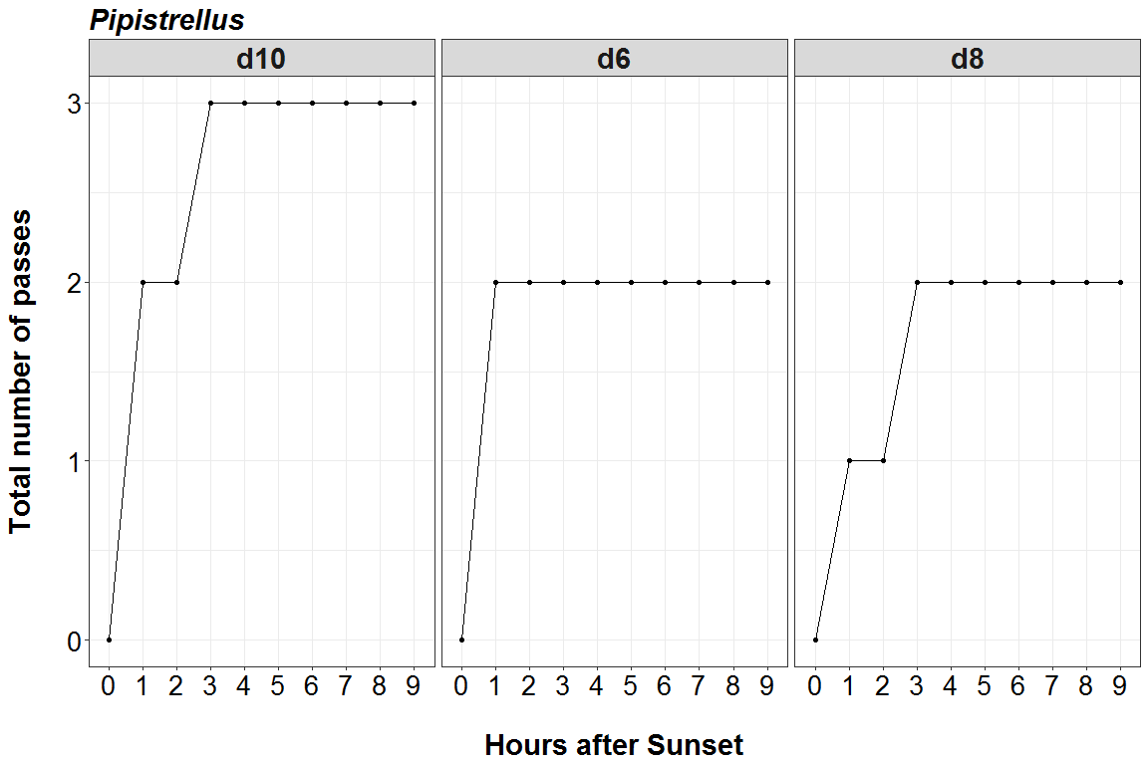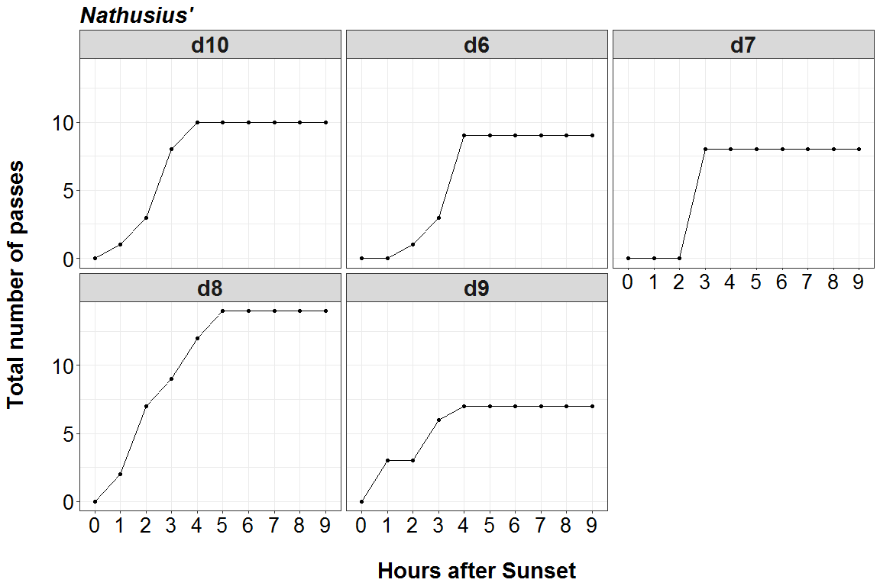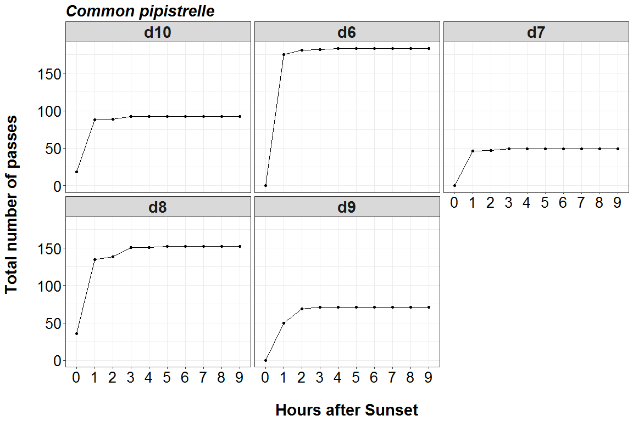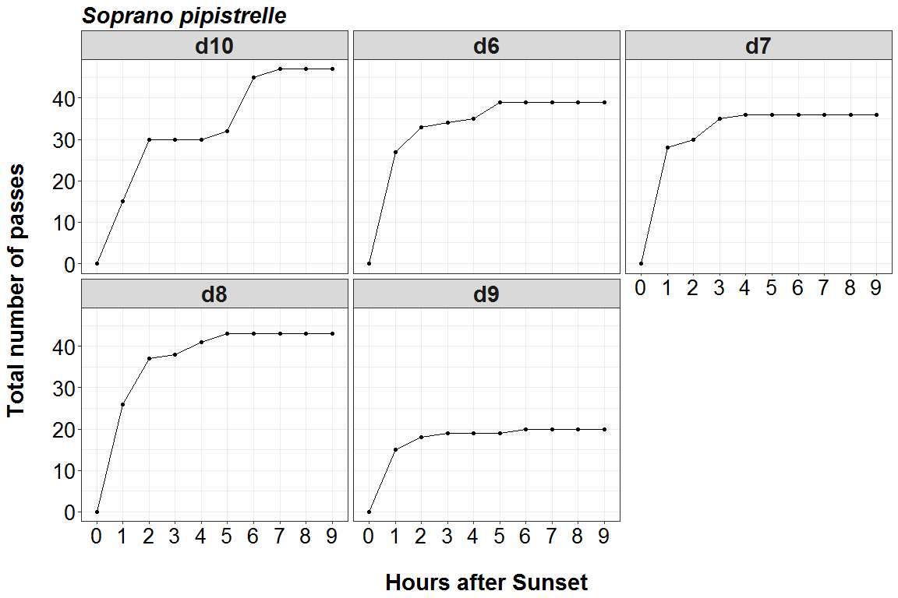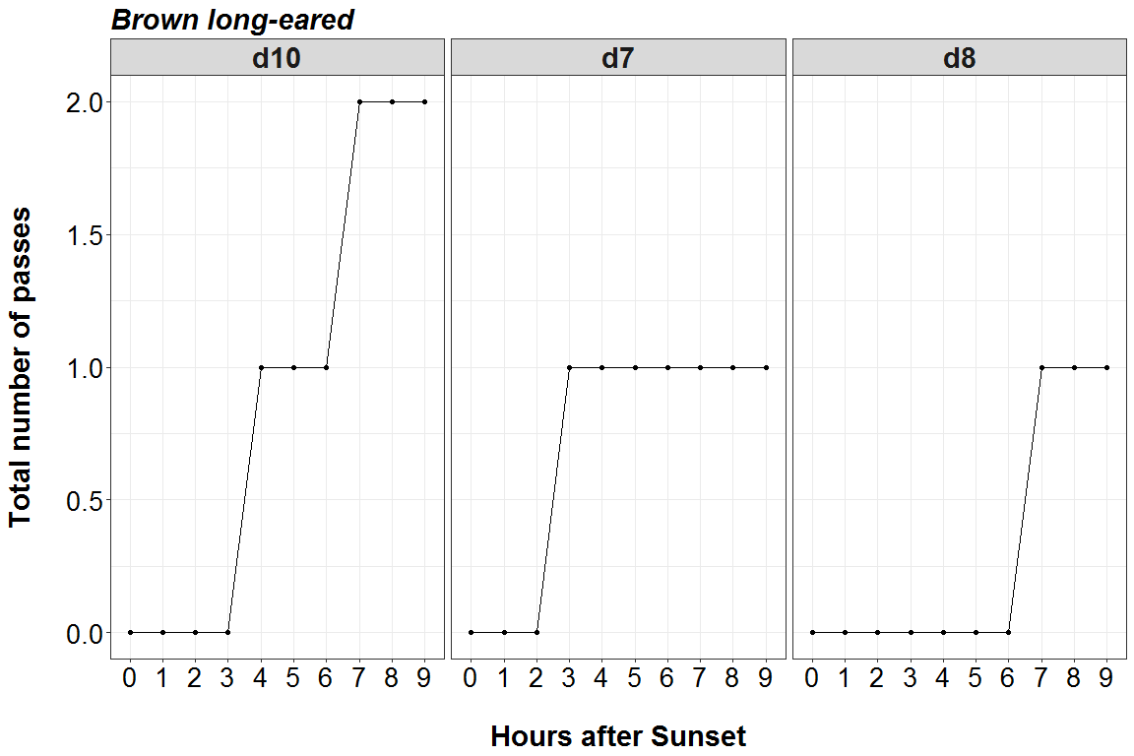

##### Page Break

# Bat Activity per Detector Location

**Detector ID reference:**

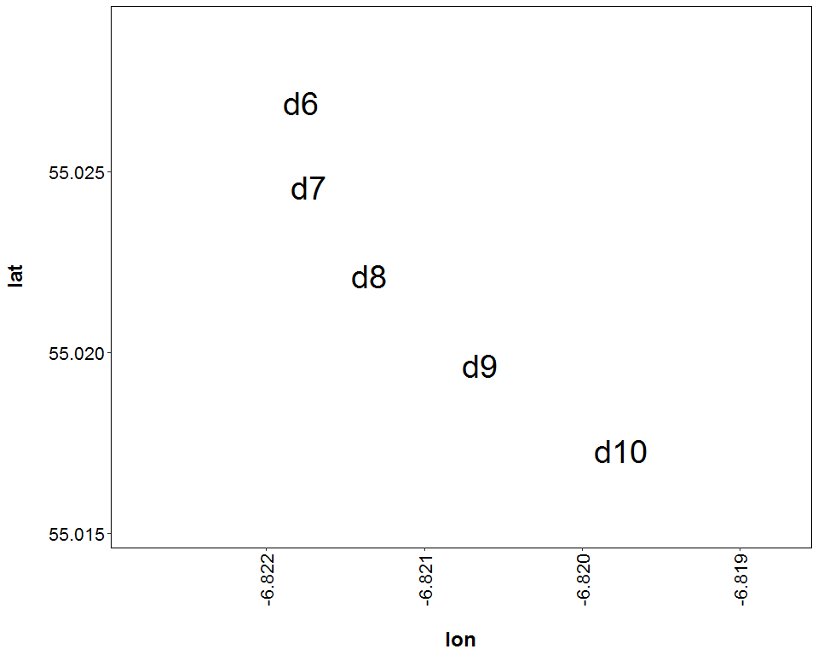

##### Page Break

**Median of the number of bat calls per night throughout the survey period - represented by the size and colour of the point at each detector location.**

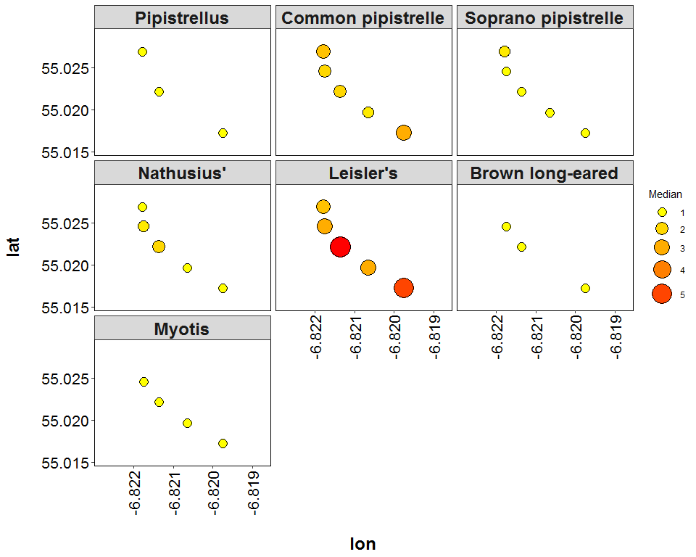

##### Page Break

**Maximum number of bat calls recorded in a single night throughout the survey period - represented by the size and colour of the point at each detector location.**

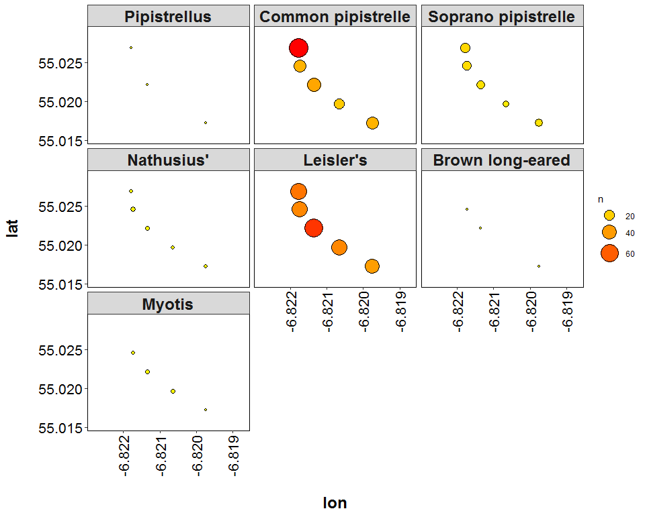

##### Page Break

# Roost Emergence Time and Bat Observation

Based on: *Russ, Jon. 2012. British Bat Calls a Guide to species Identification.* *Pelagic Publishing.*

For more information see <https://rbats-blog.updog.co/2018/05/29/bat-emergence/>

## Bat Passes Potentially Indicating Close Proximity to a Roost (Russ 2012) - Table

**Number of bat calls recorded within the species-specific emergence time range, and which therefore may potentially indicate the presence of a nearby roost.**

|  |  |  |  |  |
| --- | --- | --- | --- | --- |
| species | Detector ID | 2018-08-19 | 2018-09-01 | 2018-09-04 |
| Common pipistrelle | d10 | 18 | 0 | 0 |
| Common pipistrelle | d8 | 36 | 0 | 18 |
| Leisler’s | d10 | 0 | 5 | 0 |

##### Page Break

### Bat Passes Potentially Indicating Close Proximity to a Roost (Russ 2012) - Figures

**Figures show time from 15 minutes before to 90 minutes after sunset. species-specific emergence time ranges are shown as grey bars. Bat passes overlapping species-specific grey bars may potentially indicate the presence of a nearby roost.**

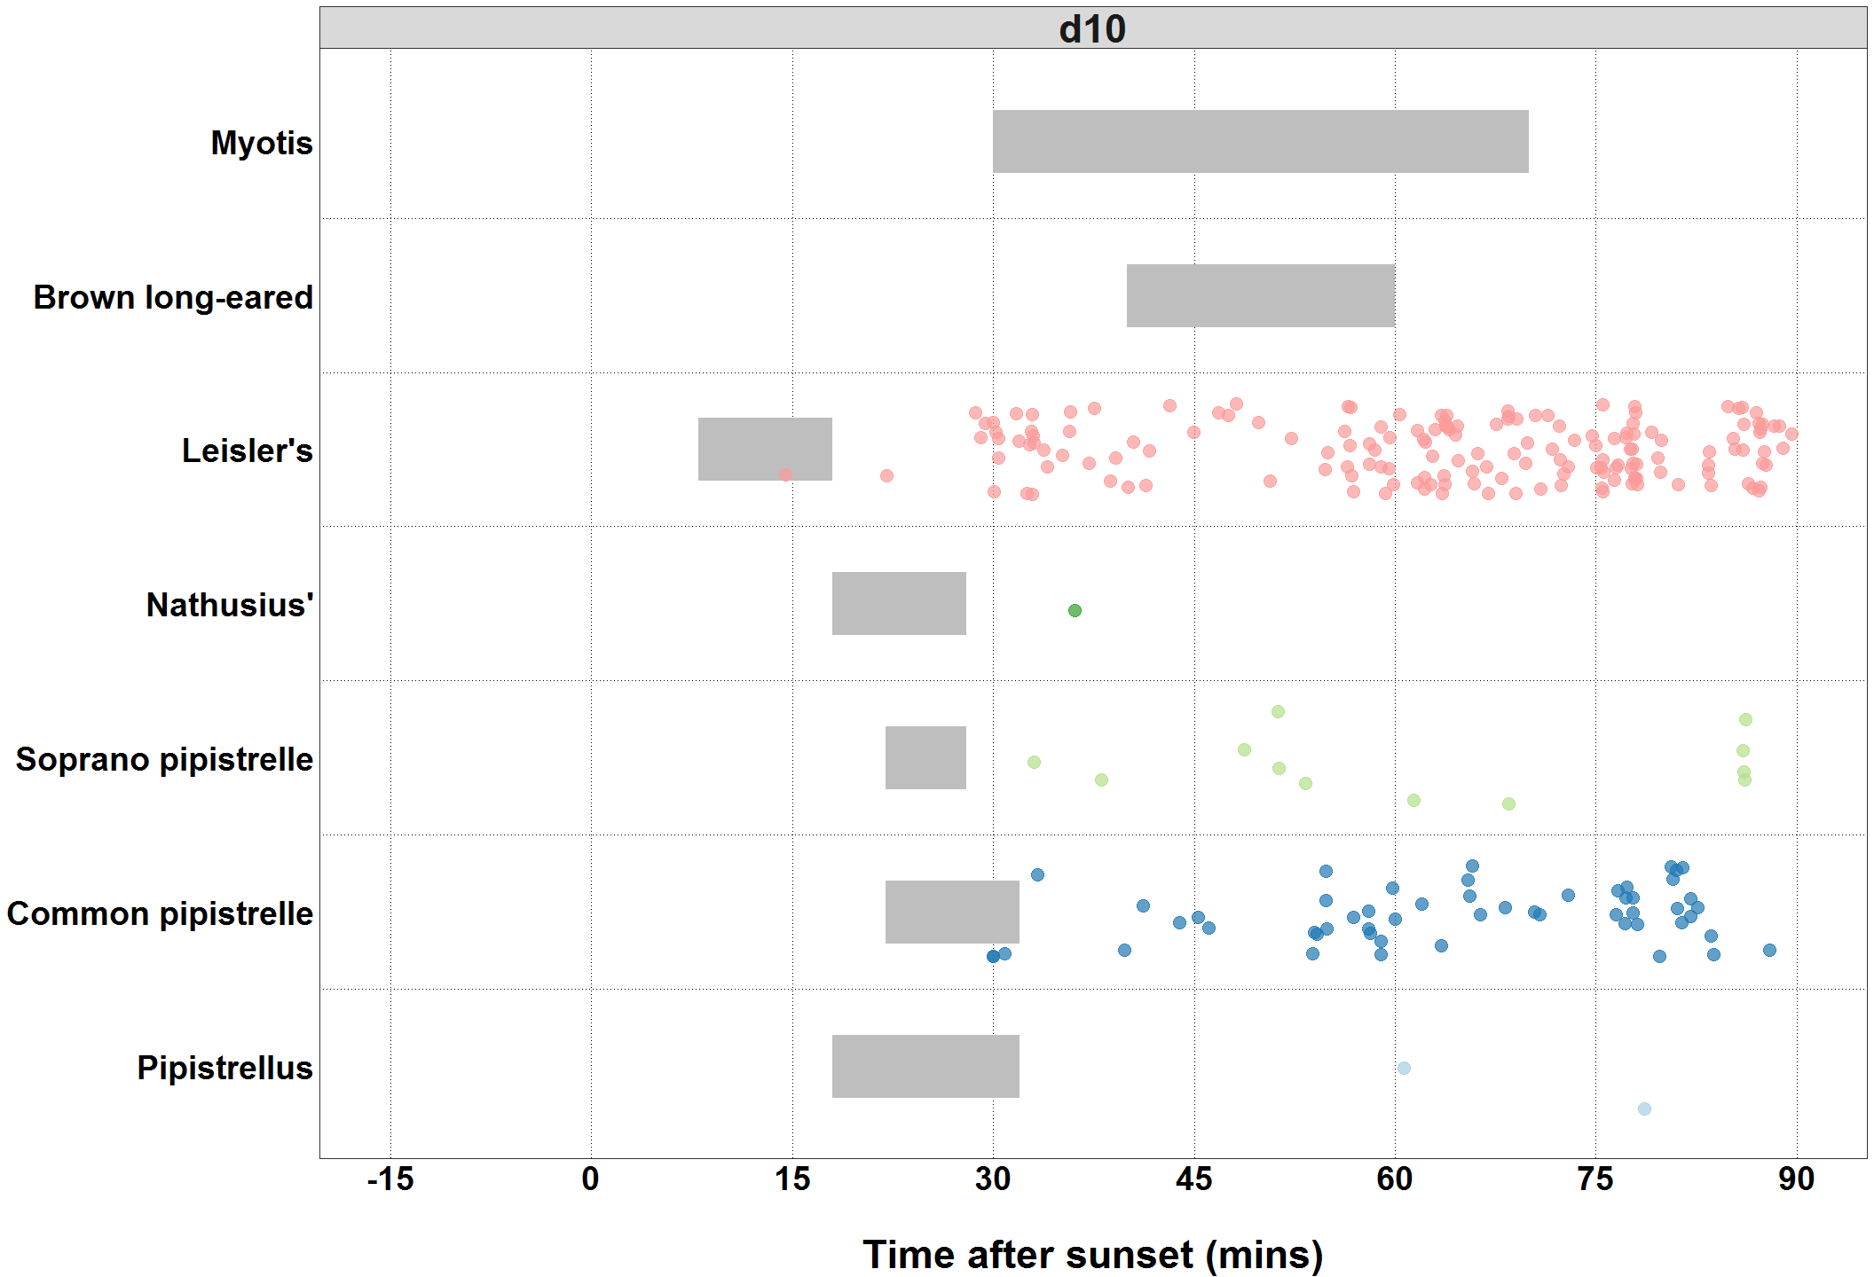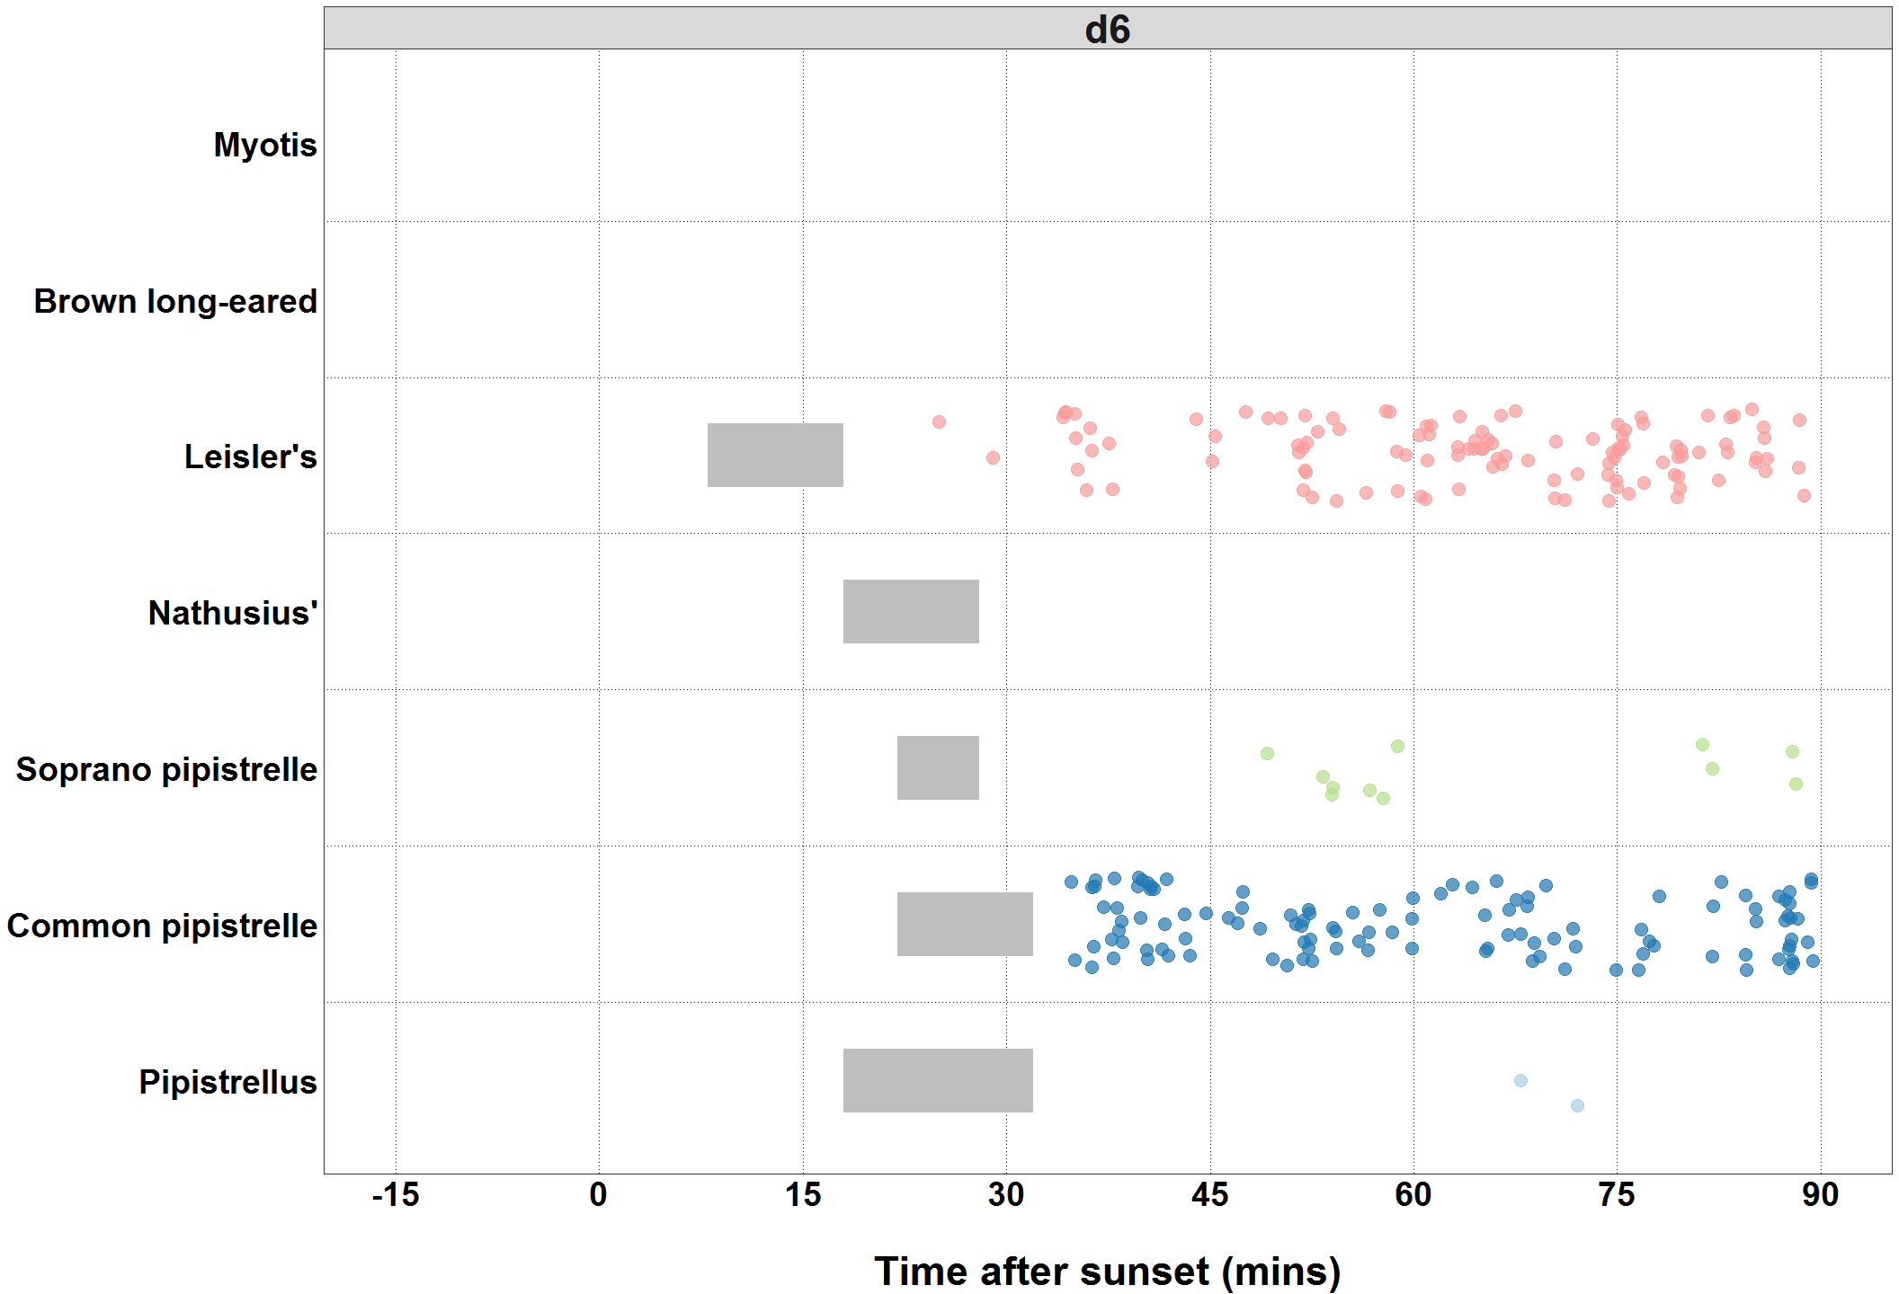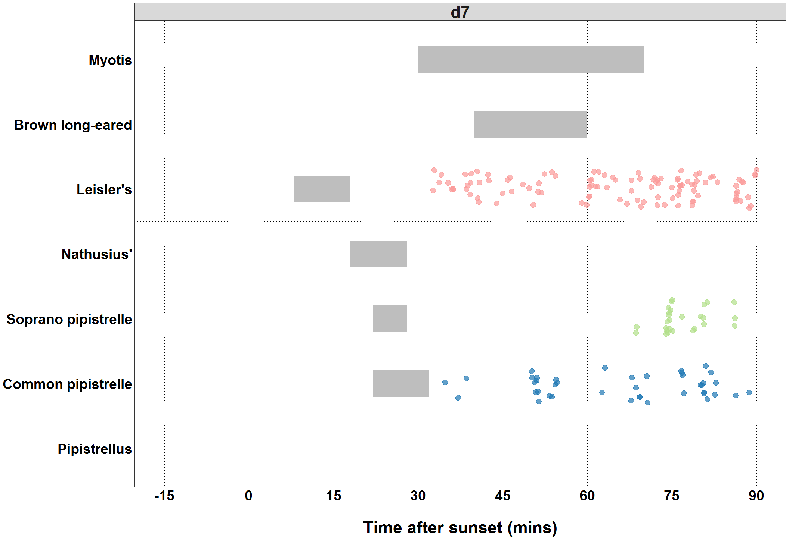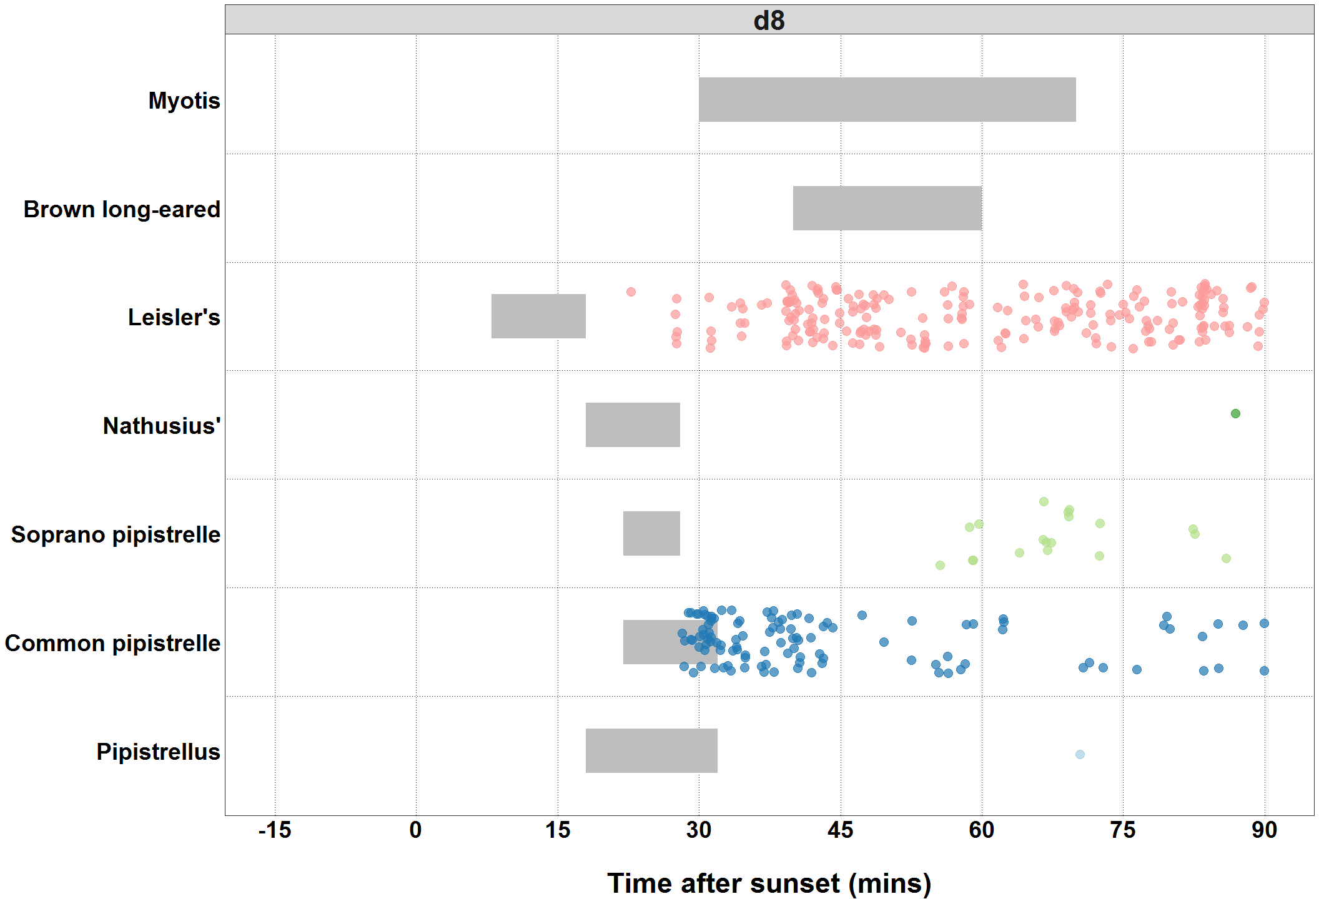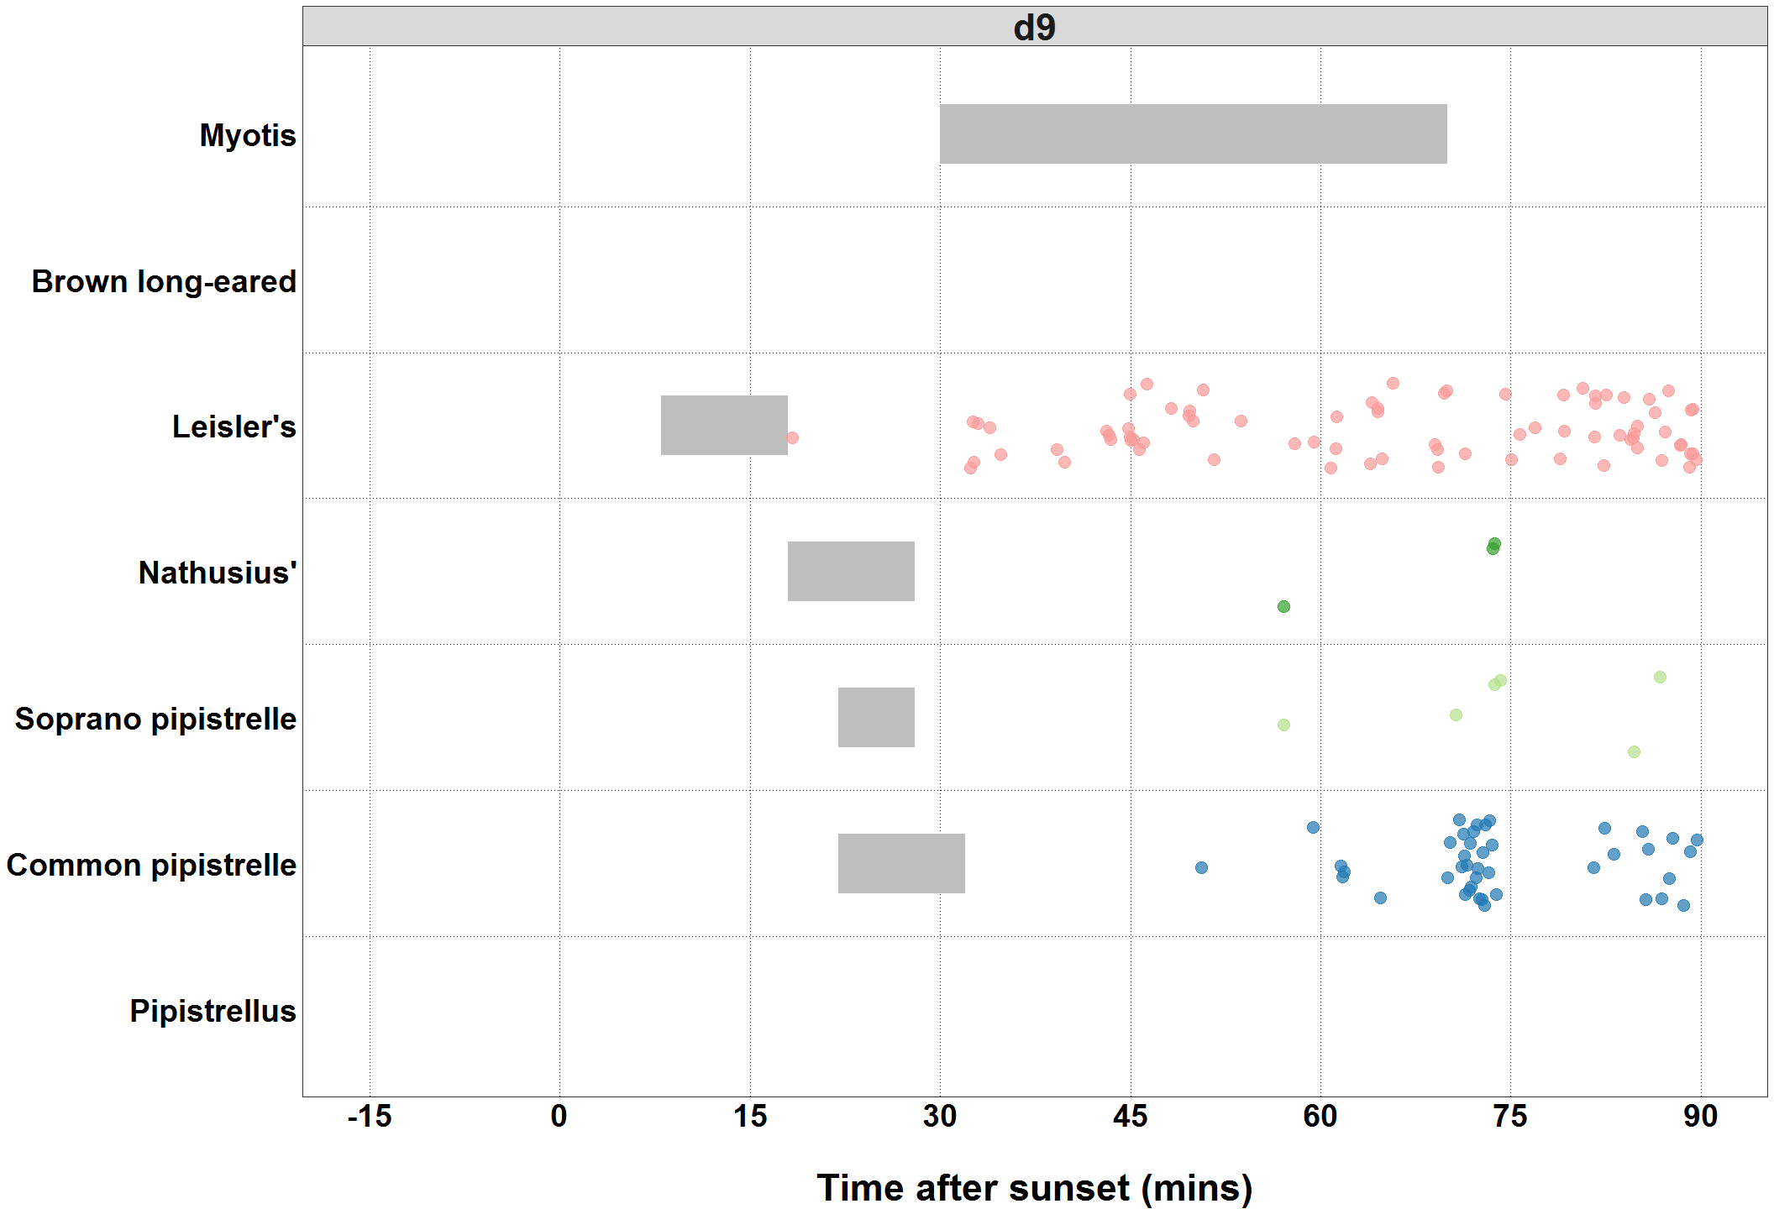

##### Page Break

### Bat Passes Potentially Indicating Close Proximity to a Roost (Maternity Period Only)

**Table:** *Maternity period defined as 15th June - 30th July.*

##### Page Break

### Bat Passes Potentially Indicating Close Proximity to a Roost (Maternity Period Only)

**Figures:** *Maternity period defined as 15th June - 30th July.*

