Bat Activity Analysis

Site Name: BBX

Author: Stacey Whiteley

06/12/2019

# Summary

Bats were detected on **31** nights between **2019-07-04** and **2019-09-28**, using **10** static bat detectors. Throughout this period **5** species were recorded. Detectors were placed at the following locations:

|  |  |  |
| --- | --- | --- |
| Detector ID | Latitude | Longitude |
| Loc.C | 57.48937 | -3.573912 |
| Loc.E | 57.50617 | -3.536297 |
| Loc.D | 57.50587 | -3.548051 |
| Loc.A | 57.49557 | -3.588229 |
| Loc.G | 57.48520 | -3.509310 |
| Loc.B | 57.49875 | -3.583661 |
| Loc.L | 57.48453 | -3.585564 |
| Loc.I | 57.47511 | -3.536944 |
| Loc.J | 57.46903 | -3.549177 |
| Loc.F | 57.49688 | -3.516400 |

##### Page Break

# Survey Nights

The number of nights that bats were detected on each recorder. This is not the same as the number of nights that detectors were active if there were nights when no bats were detected.

|  |  |
| --- | --- |
| Detector ID | No. of nights |
| Loc.A | 12 |
| Loc.B | 9 |
| Loc.C | 20 |
| Loc.D | 26 |
| Loc.E | 17 |
| Loc.F | 6 |
| Loc.G | 9 |
| Loc.I | 3 |
| Loc.J | 7 |
| Loc.L | 6 |

##### Page Break

# Survey Nights

**Figure 1.** Horizontal bars show nights when acoustic detectors recorded bats.

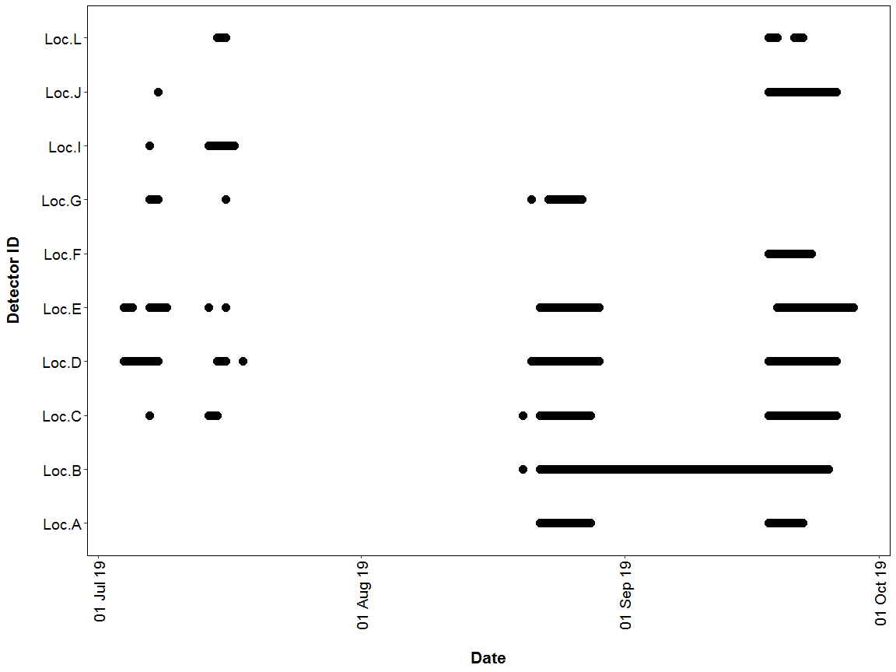

##### Page Break

## PART 1: Percentiles Analysis

This first part of the analysis looks at the relative activity levels of the bats you recorded. We take your value for the total bat passes each night for each species, and compare this to the values in our reference database. We tell you what percentile your data falls at, and therefore what the relative activity level is. For example, if the reference database has values of 5, 10, 15, 20 and you submit a value of 18, this will be the 80th percentile, and be classed as high activity.

The reference range dataset was stratified to include:

* Only records from within 30 days of the survey date.
* Only records from within 100km2 of the survey location.

##### Page Break

## PER DETECTOR

Summary table showing the number of nights recorded bat activity fell into each activity band for each species.

|  |  |  |  |  |  |  |
| --- | --- | --- | --- | --- | --- | --- |
| Detector ID | Species/Species Group | Nights of High Activity | Nights of Moderate/ High Activity | Nights of Moderate Activity | Nights of Low/ Moderate Activity | Nights of Low Activity |
| Loc.A | *Myotis* | 0 | 0 | 0 | 1 | 2 |
| Loc.A | *Pipistrellus* | 2 | 0 | 0 | 0 | 0 |
| Loc.A | *Pipistrellus pipistrellus* | 2 | 3 | 3 | 0 | 1 |
| Loc.A | *Pipistrellus pygmaeus* | 3 | 2 | 2 | 2 | 3 |
| Loc.B | *Myotis* | 0 | 0 | 0 | 0 | 1 |
| Loc.B | *Pipistrellus pipistrellus* | 4 | 1 | 3 | 0 | 0 |
| Loc.B | *Pipistrellus pygmaeus* | 1 | 4 | 1 | 1 | 0 |
| Loc.C | *Myotis* | 0 | 0 | 0 | 2 | 3 |
| Loc.C | *Pipistrellus pipistrellus* | 2 | 5 | 5 | 2 | 1 |
| Loc.C | *Pipistrellus pygmaeus* | 5 | 7 | 3 | 1 | 2 |
| Loc.D | *Myotis* | 0 | 0 | 0 | 1 | 3 |
| Loc.D | *Nyctaloid* | 0 | 0 | 0 | 0 | 2 |
| Loc.D | *Pipistrellus pipistrellus* | 6 | 5 | 7 | 6 | 2 |
| Loc.D | *Pipistrellus pygmaeus* | 9 | 6 | 2 | 3 | 3 |
| Loc.E | *Myotis* | 0 | 0 | 0 | 1 | 2 |
| Loc.E | *Pipistrellus pipistrellus* | 0 | 3 | 4 | 3 | 4 |
| Loc.E | *Pipistrellus pygmaeus* | 2 | 3 | 2 | 5 | 3 |
| Loc.F | *Pipistrellus pipistrellus* | 0 | 1 | 0 | 1 | 2 |
| Loc.F | *Pipistrellus pygmaeus* | 0 | 1 | 1 | 0 | 3 |
| Loc.G | *Pipistrellus pipistrellus* | 0 | 1 | 2 | 2 | 3 |
| Loc.G | *Pipistrellus pygmaeus* | 0 | 1 | 3 | 1 | 1 |
| Loc.I | *Pipistrellus pipistrellus* | 0 | 0 | 0 | 0 | 2 |
| Loc.I | *Pipistrellus pygmaeus* | 0 | 0 | 0 | 0 | 1 |
| Loc.J | *Myotis* | 0 | 0 | 0 | 0 | 1 |
| Loc.J | *Pipistrellus pipistrellus* | 0 | 0 | 0 | 1 | 3 |
| Loc.J | *Pipistrellus pygmaeus* | 0 | 0 | 0 | 2 | 2 |
| Loc.L | *Pipistrellus pipistrellus* | 0 | 0 | 1 | 2 | 3 |
| Loc.L | *Pipistrellus pygmaeus* | 0 | 0 | 0 | 0 | 1 |

##### Page Break

Summary table showing key metrics for each species recorded. The reference range is the number of nights for each species that your data were compared to. We recommend a Reference Range of 2000+ to be confident in the relative activity level.

|  |  |  |  |  |  |  |
| --- | --- | --- | --- | --- | --- | --- |
| Detector ID | Species/Species Group | Median Percentile | 95% CIs | Max Percentile | Nights Recorded | Reference Range |
| Loc.A | *Myotis* | 0 | 0 - 0 | 25 | 3 | 17 |
| Loc.A | *Pipistrellus* | 98 | 97.5 - 97.5 | 100 | 2 | 114 |
| Loc.A | *Pipistrellus pipistrellus* | 73 | 52 - 87 | 98 | 9 | 96 |
| Loc.A | *Pipistrellus pygmaeus* | 47 | 39 - 86 | 99 | 12 | 92 |
| Loc.B | *Myotis* | 0 | 0 | 0 | 1 | 17 |
| Loc.B | *Pipistrellus pipistrellus* | 82 | 50 - 93 | 98 | 8 | 96 |
| Loc.B | *Pipistrellus pygmaeus* | 63 | 44 - 81 | 94 | 7 | 92 |
| Loc.C | *Myotis* | 0 | 0 - 0 | 25 | 5 | 17 |
| Loc.C | *Pipistrellus pipistrellus* | 51 | 45 - 70 | 95 | 15 | 96 |
| Loc.C | *Pipistrellus pygmaeus* | 71 | 59.5 - 81 | 97 | 18 | 92 |
| Loc.D | *Myotis* | 0 | 0 - 0 | 35 | 4 | 17 |
| Loc.D | *Nyctaloid* | 0 | 0 - 0 | 0 | 2 | 2 |
| Loc.D | *Pipistrellus pipistrellus* | 48 | 46 - 66.5 | 92 | 26 | 96 |
| Loc.D | *Pipistrellus pygmaeus* | 69 | 58 - 82.5 | 98 | 23 | 92 |
| Loc.E | *Myotis* | 0 | 0 - 0 | 25 | 3 | 17 |
| Loc.E | *Pipistrellus pipistrellus* | 38 | 35 - 65.5 | 78 | 14 | 96 |
| Loc.E | *Pipistrellus pygmaeus* | 35 | 35 - 70 | 87 | 15 | 92 |
| Loc.F | *Pipistrellus pipistrellus* | 13 | 48 - 48 | 71 | 4 | 96 |
| Loc.F | *Pipistrellus pygmaeus* | 0 | 59 - 59 | 62 | 5 | 92 |
| Loc.G | *Pipistrellus pipistrellus* | 25 | 25 - 51.5 | 62 | 8 | 96 |
| Loc.G | *Pipistrellus pygmaeus* | 41 | 35 - 65 | 65 | 6 | 92 |
| Loc.I | *Pipistrellus pipistrellus* | 0 | 0 - 0 | 0 | 2 | 96 |
| Loc.I | *Pipistrellus pygmaeus* | 0 | 0 | 0 | 1 | 92 |
| Loc.J | *Myotis* | 0 | 0 | 0 | 1 | 17 |
| Loc.J | *Pipistrellus pipistrellus* | 0 | 0 - 0 | 25 | 4 | 96 |
| Loc.J | *Pipistrellus pygmaeus* | 13 | 30 - 30 | 35 | 4 | 92 |
| Loc.L | *Pipistrellus pipistrellus* | 13 | 25 - 45 | 45 | 6 | 96 |
| Loc.L | *Pipistrellus pygmaeus* | 0 | 0 | 0 | 1 | 92 |

##### Page Break

### Figures

**Figure 2.** The recorded activity of bats during the survey. The centre line indicates the median activity level whereas the box represents the interquartile range (the spread of the middle 50% of nights of activity)

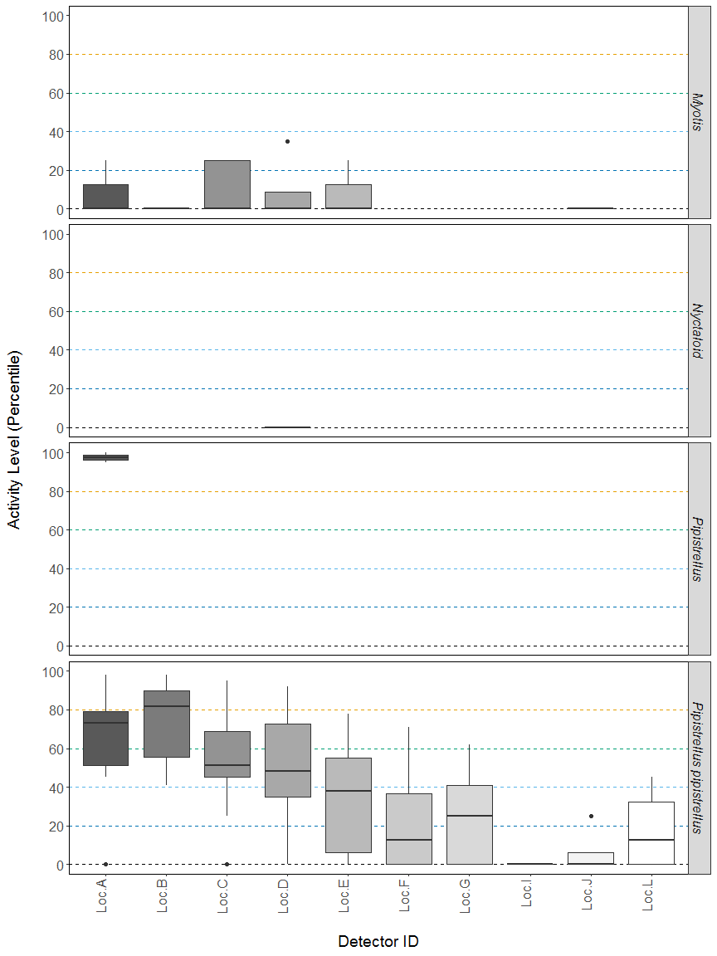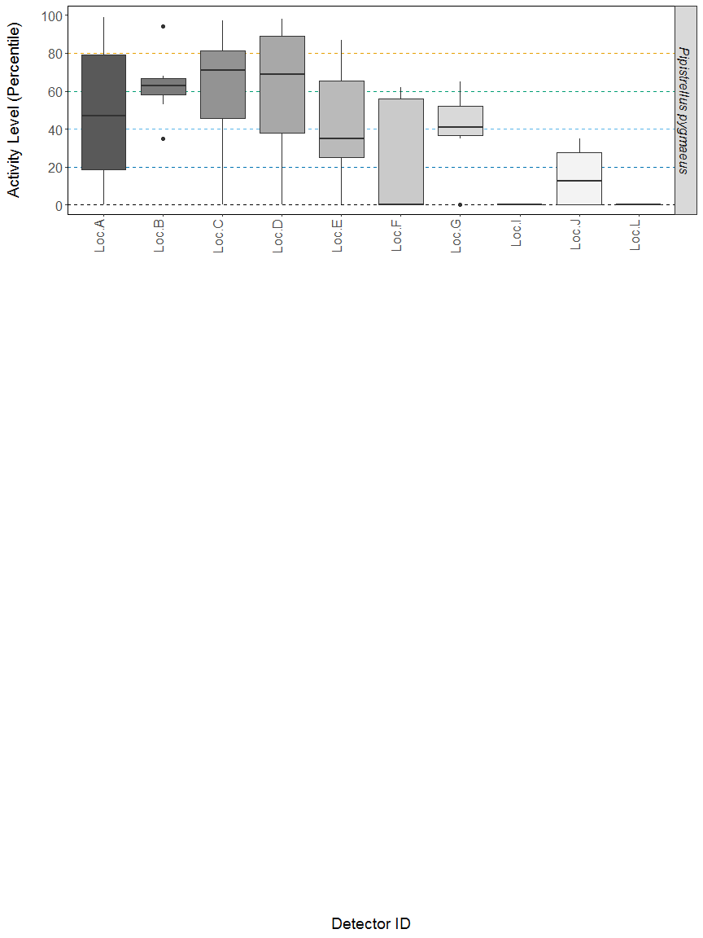

**Figure 3.** The activity level (percentile) of bats recorded across each night of the bat survey.

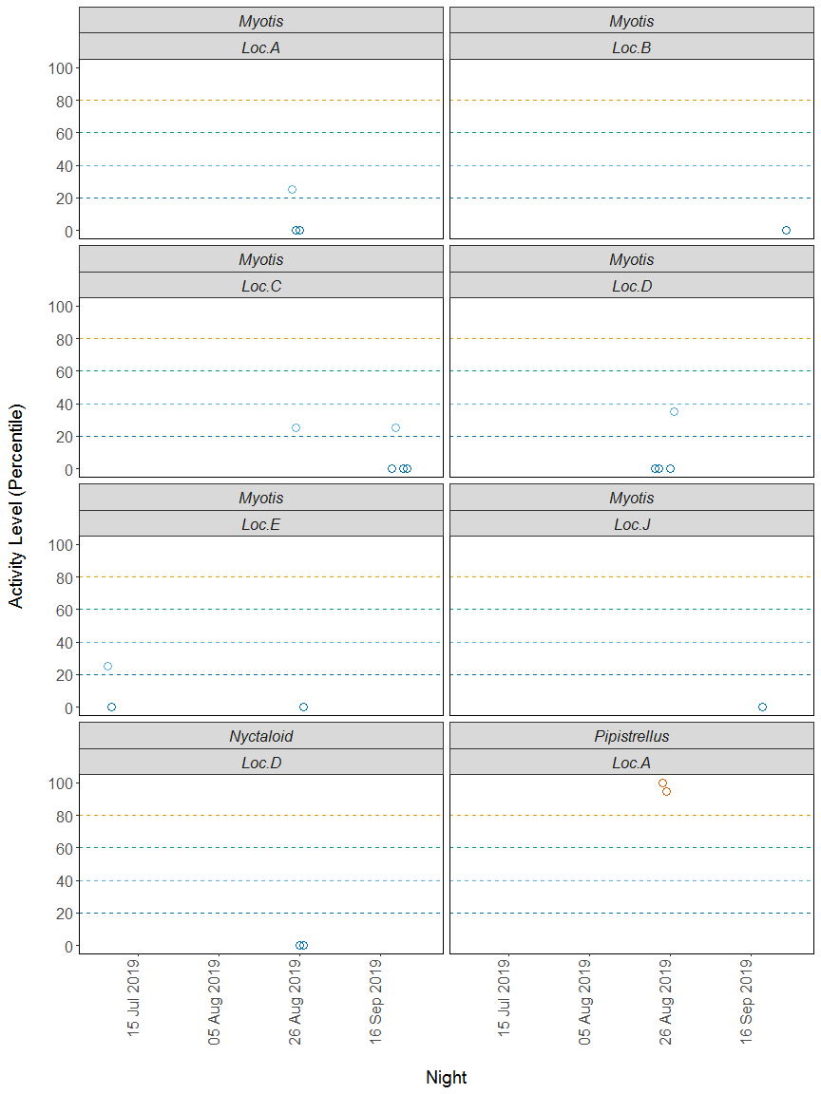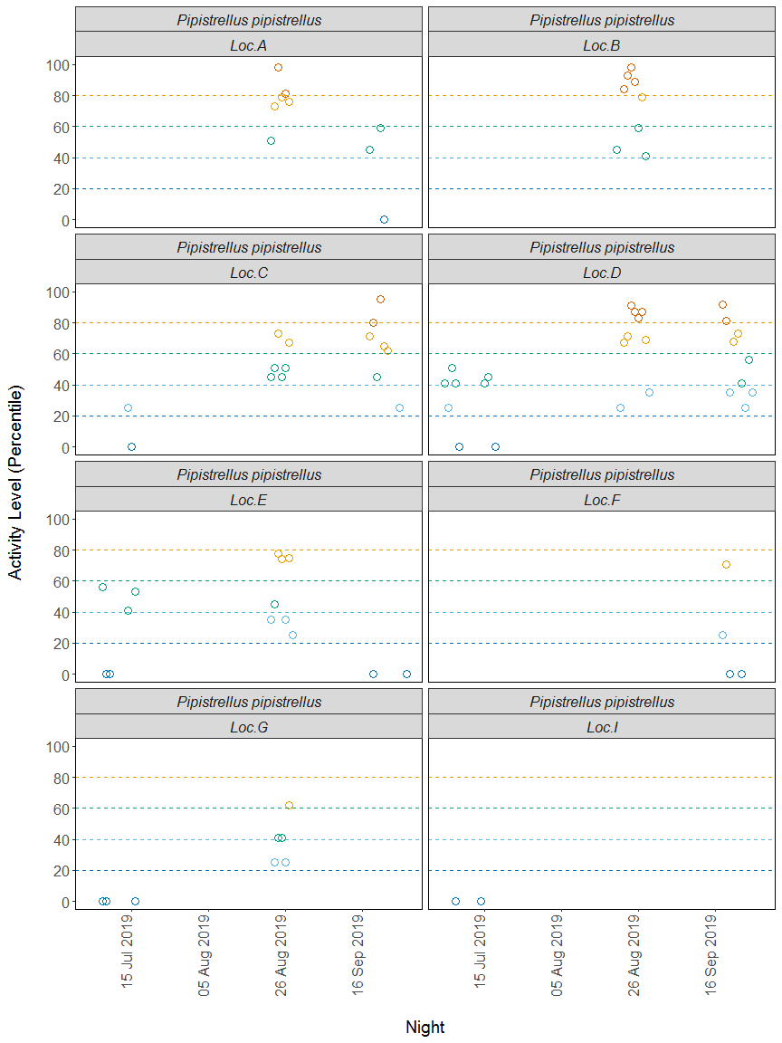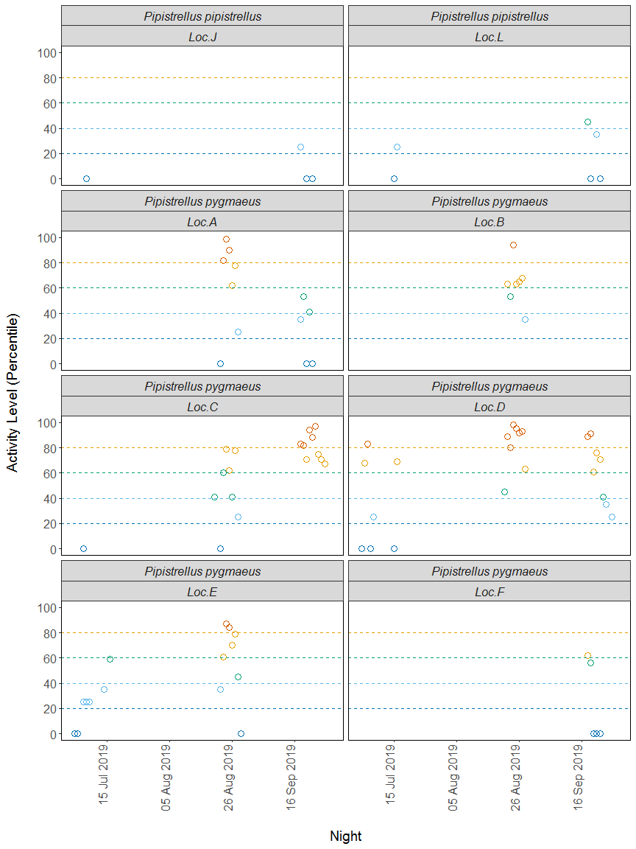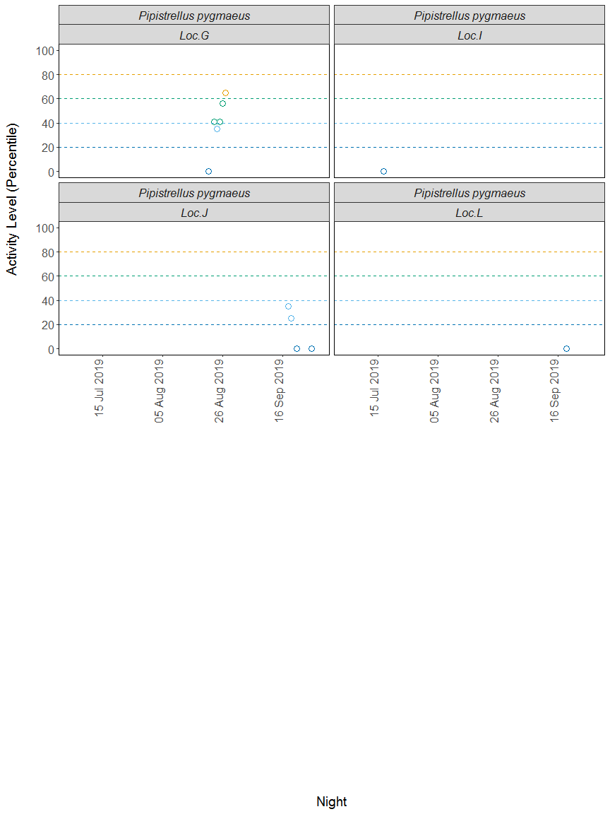

##### Page Break

## PER DETECTOR, PER MONTH

Summary table showing the number of nights recorded bat activity fell into each activity band for each species at each detector during each month.

|  |  |  |  |  |  |  |  |
| --- | --- | --- | --- | --- | --- | --- | --- |
| Detector ID | Species/Species Group | Month | Nights of High Activity | Nights of Moderate/ High Activity | Nights of Moderate Activity | Nights of Low/ Moderate Activity | Nights of Low Activity |
| Loc.A | *Myotis* | Aug | 0 | 0 | 0 | 1 | 2 |
| Loc.A | *Pipistrellus* | Aug | 2 | 0 | 0 | 0 | 0 |
| Loc.A | *Pipistrellus pipistrellus* | Aug | 2 | 3 | 1 | 0 | 0 |
| Loc.A | *Pipistrellus pipistrellus* | Sep | 0 | 0 | 2 | 0 | 1 |
| Loc.A | *Pipistrellus pygmaeus* | Aug | 3 | 2 | 0 | 1 | 1 |
| Loc.A | *Pipistrellus pygmaeus* | Sep | 0 | 0 | 2 | 1 | 2 |
| Loc.B | *Myotis* | Sep | 0 | 0 | 0 | 0 | 1 |
| Loc.B | *Pipistrellus pipistrellus* | Aug | 4 | 1 | 3 | 0 | 0 |
| Loc.B | *Pipistrellus pygmaeus* | Aug | 1 | 4 | 1 | 1 | 0 |
| Loc.C | *Myotis* | Aug | 0 | 0 | 0 | 1 | 0 |
| Loc.C | *Myotis* | Sep | 0 | 0 | 0 | 1 | 3 |
| Loc.C | *Pipistrellus pipistrellus* | Jul | 0 | 0 | 0 | 1 | 1 |
| Loc.C | *Pipistrellus pipistrellus* | Aug | 0 | 2 | 4 | 0 | 0 |
| Loc.C | *Pipistrellus pipistrellus* | Sep | 2 | 3 | 1 | 1 | 0 |
| Loc.C | *Pipistrellus pygmaeus* | Jul | 0 | 0 | 0 | 0 | 1 |
| Loc.C | *Pipistrellus pygmaeus* | Aug | 0 | 3 | 3 | 1 | 1 |
| Loc.C | *Pipistrellus pygmaeus* | Sep | 5 | 4 | 0 | 0 | 0 |
| Loc.D | *Myotis* | Aug | 0 | 0 | 0 | 1 | 3 |
| Loc.D | *Nyctaloid* | Aug | 0 | 0 | 0 | 0 | 2 |
| Loc.D | *Pipistrellus pipistrellus* | Jul | 0 | 0 | 5 | 1 | 2 |
| Loc.D | *Pipistrellus pipistrellus* | Aug | 4 | 3 | 0 | 2 | 0 |
| Loc.D | *Pipistrellus pipistrellus* | Sep | 2 | 2 | 2 | 3 | 0 |
| Loc.D | *Pipistrellus pygmaeus* | Jul | 1 | 2 | 0 | 1 | 3 |
| Loc.D | *Pipistrellus pygmaeus* | Aug | 6 | 1 | 1 | 0 | 0 |
| Loc.D | *Pipistrellus pygmaeus* | Sep | 2 | 3 | 1 | 2 | 0 |
| Loc.E | *Myotis* | Jul | 0 | 0 | 0 | 1 | 1 |
| Loc.E | *Myotis* | Aug | 0 | 0 | 0 | 0 | 1 |
| Loc.E | *Pipistrellus pipistrellus* | Jul | 0 | 0 | 3 | 0 | 2 |
| Loc.E | *Pipistrellus pipistrellus* | Aug | 0 | 3 | 1 | 3 | 0 |
| Loc.E | *Pipistrellus pipistrellus* | Sep | 0 | 0 | 0 | 0 | 2 |
| Loc.E | *Pipistrellus pygmaeus* | Jul | 0 | 0 | 1 | 4 | 2 |
| Loc.E | *Pipistrellus pygmaeus* | Aug | 2 | 3 | 1 | 1 | 1 |
| Loc.F | *Pipistrellus pipistrellus* | Sep | 0 | 1 | 0 | 1 | 2 |
| Loc.F | *Pipistrellus pygmaeus* | Sep | 0 | 1 | 1 | 0 | 3 |
| Loc.G | *Pipistrellus pipistrellus* | Jul | 0 | 0 | 0 | 0 | 3 |
| Loc.G | *Pipistrellus pipistrellus* | Aug | 0 | 1 | 2 | 2 | 0 |
| Loc.G | *Pipistrellus pygmaeus* | Aug | 0 | 1 | 3 | 1 | 1 |
| Loc.I | *Pipistrellus pipistrellus* | Jul | 0 | 0 | 0 | 0 | 2 |
| Loc.I | *Pipistrellus pygmaeus* | Jul | 0 | 0 | 0 | 0 | 1 |
| Loc.J | *Myotis* | Sep | 0 | 0 | 0 | 0 | 1 |
| Loc.J | *Pipistrellus pipistrellus* | Jul | 0 | 0 | 0 | 0 | 1 |
| Loc.J | *Pipistrellus pipistrellus* | Sep | 0 | 0 | 0 | 1 | 2 |
| Loc.J | *Pipistrellus pygmaeus* | Sep | 0 | 0 | 0 | 2 | 2 |
| Loc.L | *Pipistrellus pipistrellus* | Jul | 0 | 0 | 0 | 1 | 1 |
| Loc.L | *Pipistrellus pipistrellus* | Sep | 0 | 0 | 1 | 1 | 2 |
| Loc.L | *Pipistrellus pygmaeus* | Sep | 0 | 0 | 0 | 0 | 1 |

##### Page Break

Summary table showing key metrics for each species recorded per month. Please note that we cannot split the reference range by month, hence this column is not shown in this table.

|  |  |  |  |  |  |  |
| --- | --- | --- | --- | --- | --- | --- |
| Detector ID | Species/Species Group | Month | Median Percentile | 95% CIs | Max Percentile | Nights Recorded |
| Loc.A | *Myotis* | Aug | 0 | 0 - 0 | 25 | 3 |
| Loc.A | *Pipistrellus* | Aug | 98 | 97.5 - 97.5 | 100 | 2 |
| Loc.A | *Pipistrellus pipistrellus* | Aug | 78 | 52 - 87 | 98 | 6 |
| Loc.A | *Pipistrellus pipistrellus* | Sep | 45 | 52 - 87 | 59 | 3 |
| Loc.A | *Pipistrellus pygmaeus* | Aug | 78 | 39 - 86 | 99 | 7 |
| Loc.A | *Pipistrellus pygmaeus* | Sep | 35 | 39 - 86 | 53 | 5 |
| Loc.B | *Myotis* | Sep | 0 | 0 | 0 | 1 |
| Loc.B | *Pipistrellus pipistrellus* | Aug | 82 | 50 - 93 | 98 | 8 |
| Loc.B | *Pipistrellus pygmaeus* | Aug | 63 | 44 - 81 | 94 | 7 |
| Loc.C | *Myotis* | Aug | 25 | 0 - 0 | 25 | 1 |
| Loc.C | *Myotis* | Sep | 0 | 0 - 0 | 25 | 4 |
| Loc.C | *Pipistrellus pipistrellus* | Jul | 13 | 45 - 70 | 25 | 2 |
| Loc.C | *Pipistrellus pipistrellus* | Aug | 51 | 45 - 70 | 73 | 6 |
| Loc.C | *Pipistrellus pipistrellus* | Sep | 65 | 45 - 70 | 95 | 7 |
| Loc.C | *Pipistrellus pygmaeus* | Jul | 0 | 59.5 - 81 | 0 | 1 |
| Loc.C | *Pipistrellus pygmaeus* | Aug | 51 | 59.5 - 81 | 79 | 8 |
| Loc.C | *Pipistrellus pygmaeus* | Sep | 82 | 59.5 - 81 | 97 | 9 |
| Loc.D | *Myotis* | Aug | 0 | 0 - 0 | 35 | 4 |
| Loc.D | *Nyctaloid* | Aug | 0 | 0 - 0 | 0 | 2 |
| Loc.D | *Pipistrellus pipistrellus* | Jul | 41 | 46 - 66.5 | 51 | 8 |
| Loc.D | *Pipistrellus pipistrellus* | Aug | 71 | 46 - 66.5 | 91 | 9 |
| Loc.D | *Pipistrellus pipistrellus* | Sep | 56 | 46 - 66.5 | 92 | 9 |
| Loc.D | *Pipistrellus pygmaeus* | Jul | 25 | 58 - 82.5 | 83 | 7 |
| Loc.D | *Pipistrellus pygmaeus* | Aug | 91 | 58 - 82.5 | 98 | 8 |
| Loc.D | *Pipistrellus pygmaeus* | Sep | 66 | 58 - 82.5 | 91 | 8 |
| Loc.E | *Myotis* | Jul | 13 | 0 - 0 | 25 | 2 |
| Loc.E | *Myotis* | Aug | 0 | 0 - 0 | 0 | 1 |
| Loc.E | *Pipistrellus pipistrellus* | Jul | 41 | 35 - 65.5 | 56 | 5 |
| Loc.E | *Pipistrellus pipistrellus* | Aug | 45 | 35 - 65.5 | 78 | 7 |
| Loc.E | *Pipistrellus pipistrellus* | Sep | 0 | 35 - 65.5 | 0 | 2 |
| Loc.E | *Pipistrellus pygmaeus* | Jul | 25 | 35 - 70 | 59 | 7 |
| Loc.E | *Pipistrellus pygmaeus* | Aug | 66 | 35 - 70 | 87 | 8 |
| Loc.F | *Pipistrellus pipistrellus* | Sep | 13 | 48 - 48 | 71 | 4 |
| Loc.F | *Pipistrellus pygmaeus* | Sep | 0 | 59 - 59 | 62 | 5 |
| Loc.G | *Pipistrellus pipistrellus* | Jul | 0 | 25 - 51.5 | 0 | 3 |
| Loc.G | *Pipistrellus pipistrellus* | Aug | 41 | 25 - 51.5 | 62 | 5 |
| Loc.G | *Pipistrellus pygmaeus* | Aug | 41 | 35 - 65 | 65 | 6 |
| Loc.I | *Pipistrellus pipistrellus* | Jul | 0 | 0 - 0 | 0 | 2 |
| Loc.I | *Pipistrellus pygmaeus* | Jul | 0 | 0 | 0 | 1 |
| Loc.J | *Myotis* | Sep | 0 | 0 | 0 | 1 |
| Loc.J | *Pipistrellus pipistrellus* | Jul | 0 | 0 - 0 | 0 | 1 |
| Loc.J | *Pipistrellus pipistrellus* | Sep | 0 | 0 - 0 | 25 | 3 |
| Loc.J | *Pipistrellus pygmaeus* | Sep | 13 | 30 - 30 | 35 | 4 |
| Loc.L | *Pipistrellus pipistrellus* | Jul | 13 | 25 - 45 | 25 | 2 |
| Loc.L | *Pipistrellus pipistrellus* | Sep | 18 | 25 - 45 | 45 | 4 |
| Loc.L | *Pipistrellus pygmaeus* | Sep | 0 | 0 | 0 | 1 |

##### Page Break

## PER SITE

**In this ‘Per Site’ section of the analysis, all values are taken from across all of the detectors to provide site-wide averages/medians.**

Summary table showing the number of nights recorded bat activity fell into each activity band for each species.

|  |  |  |  |  |  |
| --- | --- | --- | --- | --- | --- |
| Species/Species Group | Nights of High Activity | Nights of Moderate/ High Activity | Nights of Moderate Activity | Nights of Low/ Moderate Activity | Nights of Low Activity |
| *Myotis* | 0 | 0 | 0 | 5 | 12 |
| *Nyctaloid* | 0 | 0 | 0 | 0 | 2 |
| *Pipistrellus* | 2 | 0 | 0 | 0 | 0 |
| *Pipistrellus pipistrellus* | 14 | 19 | 25 | 17 | 21 |
| *Pipistrellus pygmaeus* | 20 | 24 | 14 | 15 | 19 |

##### Page Break

Summary table showing key metrics for each species recorded.

|  |  |  |  |  |
| --- | --- | --- | --- | --- |
| Species/Species Group | Median Percentile | 95% CIs | Max Percentile | Nights Recorded |
| *Myotis* | 0 | 0 - 0 | 35 | 17 |
| *Nyctaloid* | 0 | 0 - 0 | 0 | 2 |
| *Pipistrellus* | 98 | 97.5 - 97.5 | 100 | 2 |
| *Pipistrellus pipistrellus* | 45 | 52 - 87 | 98 | 96 |
| *Pipistrellus pygmaeus* | 58 | 59.5 - 81 | 99 | 92 |

##### Page Break

### Figures

**Figure 4.** The activity level (percentile) of bats recorded across each night of the bat survey for the **entire site**.

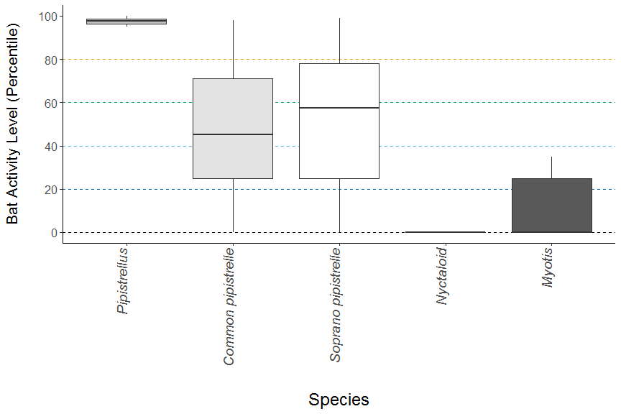

##### Page Break

**Figure 5.** The median activity levels of bats recorded across all detectors each night.

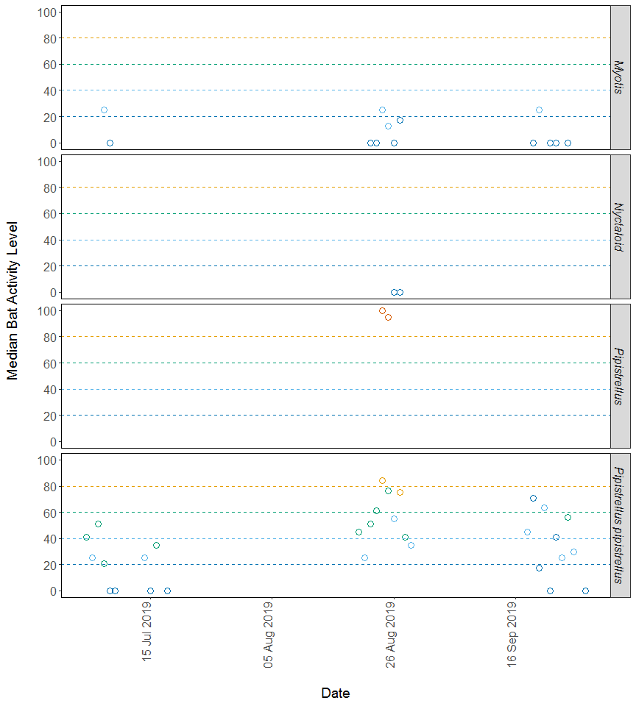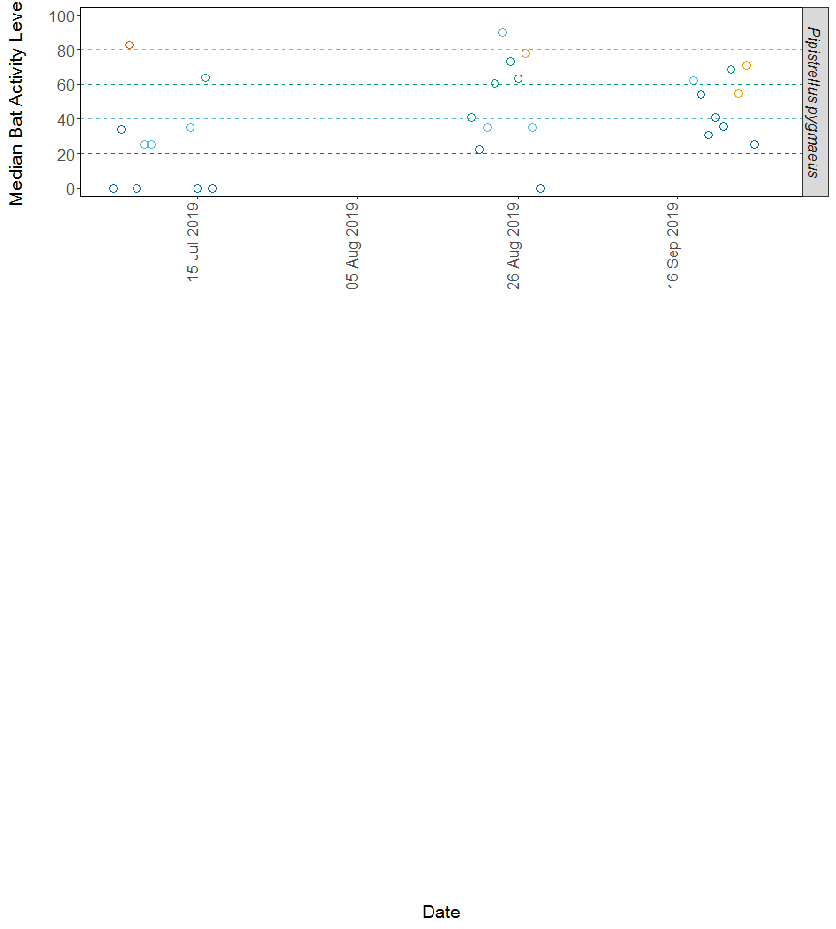

##### Page Break

## PER SITE, PER MONTH

Summary table showing the number of nights recorded bat activity fell into each activity band for each species during each month.

|  |  |  |  |  |  |  |
| --- | --- | --- | --- | --- | --- | --- |
| Species/Species Group | Month | Nights of High Activity | Nights of Moderate/ High Activity | Nights of Moderate Activity | Nights of Low/ Moderate Activity | Nights of Low Activity |
| *Myotis* | Jul | 0 | 0 | 0 | 1 | 1 |
| *Myotis* | Aug | 0 | 0 | 0 | 3 | 6 |
| *Myotis* | Sep | 0 | 0 | 0 | 1 | 5 |
| *Nyctaloid* | Aug | 0 | 0 | 0 | 0 | 2 |
| *Pipistrellus* | Aug | 2 | 0 | 0 | 0 | 0 |
| *Pipistrellus pipistrellus* | Jul | 0 | 0 | 8 | 3 | 12 |
| *Pipistrellus pipistrellus* | Aug | 10 | 13 | 11 | 7 | 0 |
| *Pipistrellus pipistrellus* | Sep | 4 | 6 | 6 | 7 | 9 |
| *Pipistrellus pygmaeus* | Jul | 1 | 2 | 1 | 5 | 7 |
| *Pipistrellus pygmaeus* | Aug | 12 | 14 | 9 | 5 | 4 |
| *Pipistrellus pygmaeus* | Sep | 7 | 8 | 4 | 5 | 8 |

##### Page Break

Summary table showing key metrics for each species recorded per month.

|  |  |  |  |  |  |
| --- | --- | --- | --- | --- | --- |
| Species/Species Group | Month | Median Percentile | 95% CIs | Max Percentile | Nights Recorded |
| *Myotis* | Jul | 13 | 0 - 0 | 25 | 2 |
| *Myotis* | Aug | 0 | 0 - 0 | 35 | 9 |
| *Myotis* | Sep | 0 | 0 - 0 | 25 | 6 |
| *Nyctaloid* | Aug | 0 | 0 - 0 | 0 | 2 |
| *Pipistrellus* | Aug | 98 | 97.5 - 97.5 | 100 | 2 |
| *Pipistrellus pipistrellus* | Jul | 0 | 46 - 66.5 | 56 | 23 |
| *Pipistrellus pipistrellus* | Aug | 67 | 52 - 87 | 98 | 41 |
| *Pipistrellus pipistrellus* | Sep | 38 | 52 - 87 | 95 | 32 |
| *Pipistrellus pygmaeus* | Jul | 25 | 59.5 - 81 | 83 | 16 |
| *Pipistrellus pygmaeus* | Aug | 63 | 59.5 - 81 | 99 | 44 |
| *Pipistrellus pygmaeus* | Sep | 55 | 59.5 - 81 | 97 | 32 |

##### Page Break

### Figures

**Figure 6.** The activity level (percentile) of bats recorded across each night of the bat survey for the entire site, split between months.

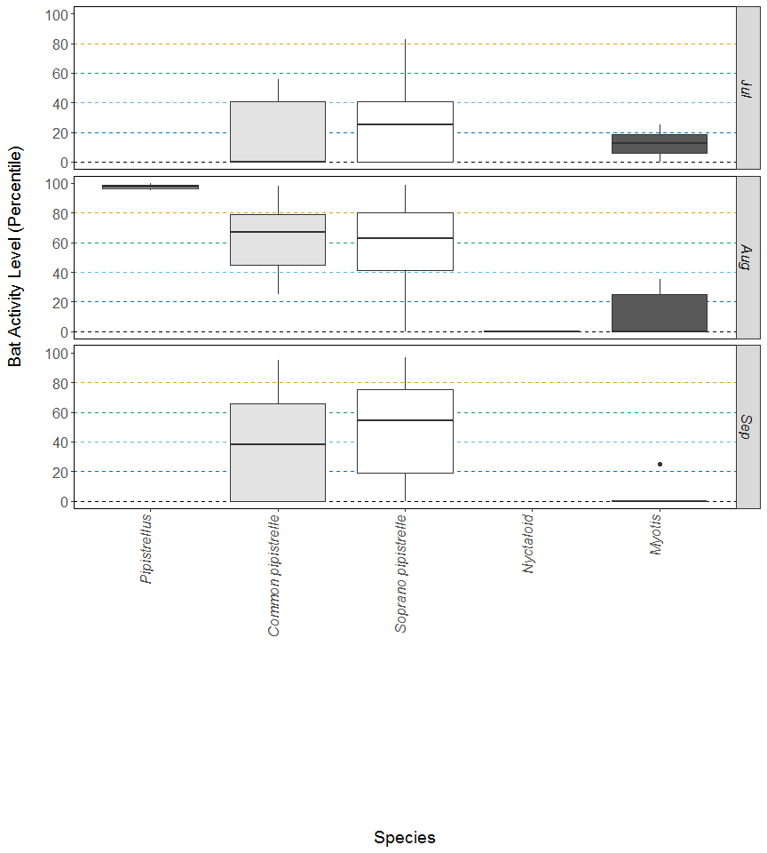

##### Page Break

## PART 2: Nightly Analysis

# ENTIRE SURVEY PERIOD

## Sunrise and Sunset Times

**The times of sunset and sunrise the following morning for surveys beginning on the date shown.**

|  |  |  |  |
| --- | --- | --- | --- |
| Night (y-m-d) | Sunset (hh:mm) | Sunrise (hh:mm) | Night Length (hours) |
| 2019-07-04 | 22:15 | 04:25 | 6.2 |
| 2019-07-05 | 22:14 | 04:26 | 6.2 |
| 2019-07-06 | 22:13 | 04:27 | 6.2 |
| 2019-07-07 | 22:12 | 04:29 | 6.3 |
| 2019-07-08 | 22:11 | 04:30 | 6.3 |
| 2019-07-09 | 22:10 | 04:31 | 6.4 |
| 2019-07-14 | 22:04 | 04:39 | 6.6 |
| 2019-07-15 | 22:03 | 04:40 | 6.6 |
| 2019-07-16 | 22:01 | 04:42 | 6.7 |
| 2019-07-17 | 22:00 | 04:44 | 6.7 |
| 2019-07-18 | 21:58 | 04:45 | 6.8 |
| 2019-08-20 | 20:47 | 05:52 | 9.1 |
| 2019-08-21 | 20:45 | 05:54 | 9.2 |
| 2019-08-22 | 20:42 | 05:56 | 9.2 |
| 2019-08-23 | 20:40 | 05:59 | 9.3 |
| 2019-08-24 | 20:37 | 06:01 | 9.4 |
| 2019-08-25 | 20:34 | 06:03 | 9.5 |
| 2019-08-26 | 20:32 | 06:05 | 9.6 |
| 2019-08-27 | 20:29 | 06:07 | 9.6 |
| 2019-08-28 | 20:26 | 06:09 | 9.7 |
| 2019-08-29 | 20:24 | 06:11 | 9.8 |
| 2019-09-18 | 19:28 | 06:53 | 11.4 |
| 2019-09-19 | 19:25 | 06:55 | 11.5 |
| 2019-09-20 | 19:23 | 06:57 | 11.6 |
| 2019-09-21 | 19:20 | 06:59 | 11.7 |
| 2019-09-22 | 19:17 | 07:01 | 11.7 |
| 2019-09-23 | 19:14 | 07:03 | 11.8 |
| 2019-09-24 | 19:11 | 07:05 | 11.9 |
| 2019-09-25 | 19:09 | 07:07 | 12.0 |
| 2019-09-26 | 19:06 | 07:09 | 12.1 |
| 2019-09-28 | 19:00 | 07:14 | 12.2 |

##### Page Break

# Distribution of Bat Activity Across the Night through Time

## Per Detector

**Figure 7.** Timing of bat calls plotted as minutes before/after sunset, whereby 0 on the y axis represents sunset. Sunrise throughout the survey period is depicted as the red dashed line. Colours indicate kernel densities, with darkest colours showing peaks of activity. These colours are comparative only within each plot, and do not account for overall activity.

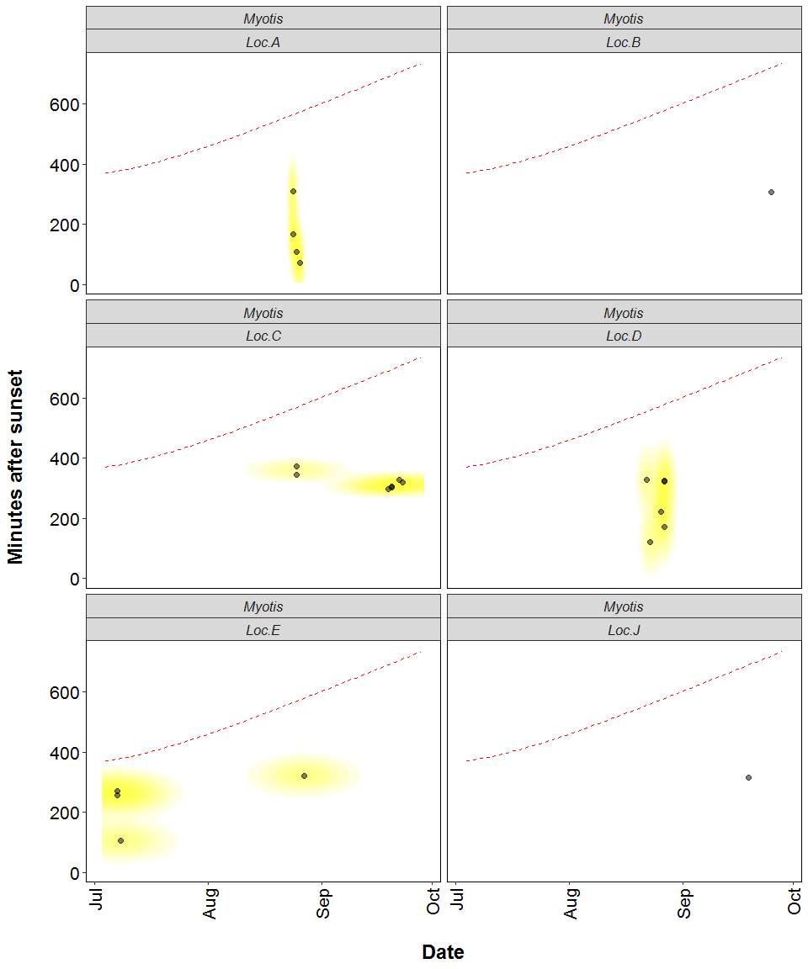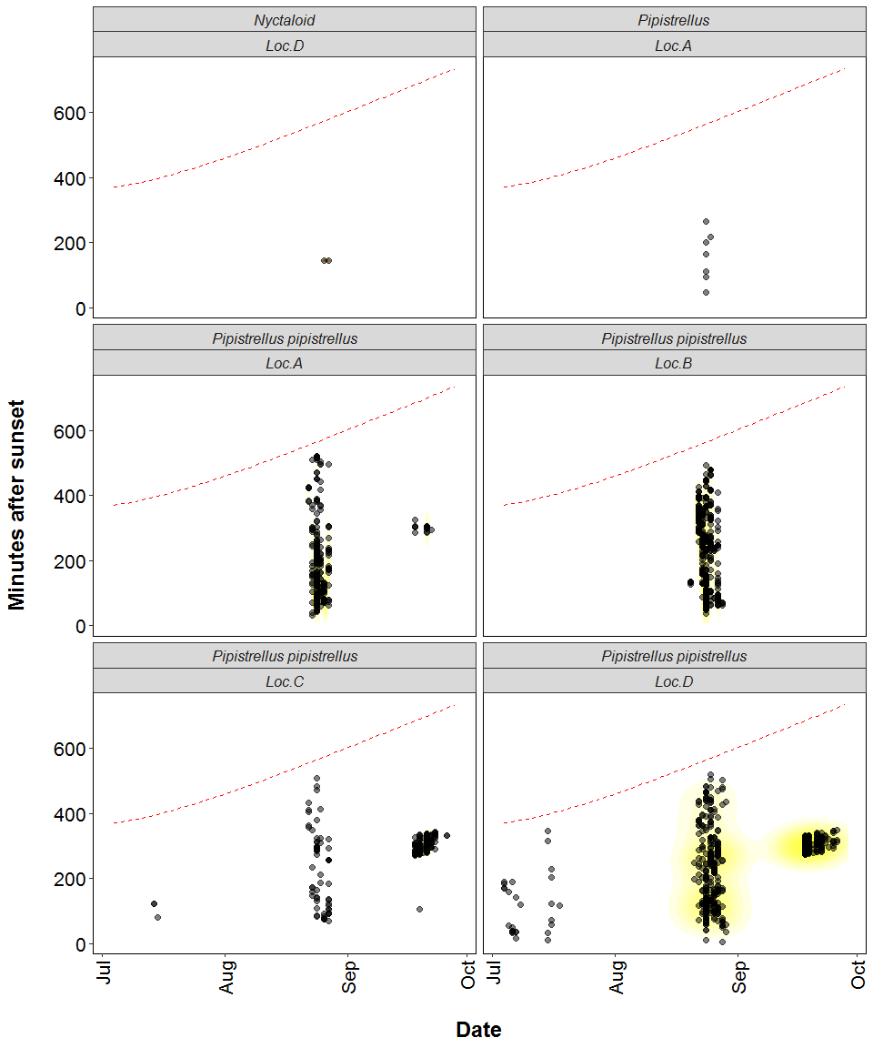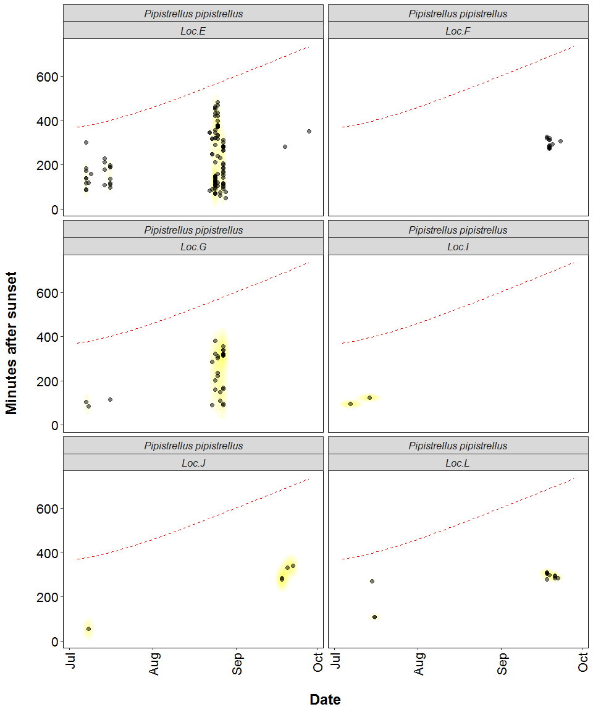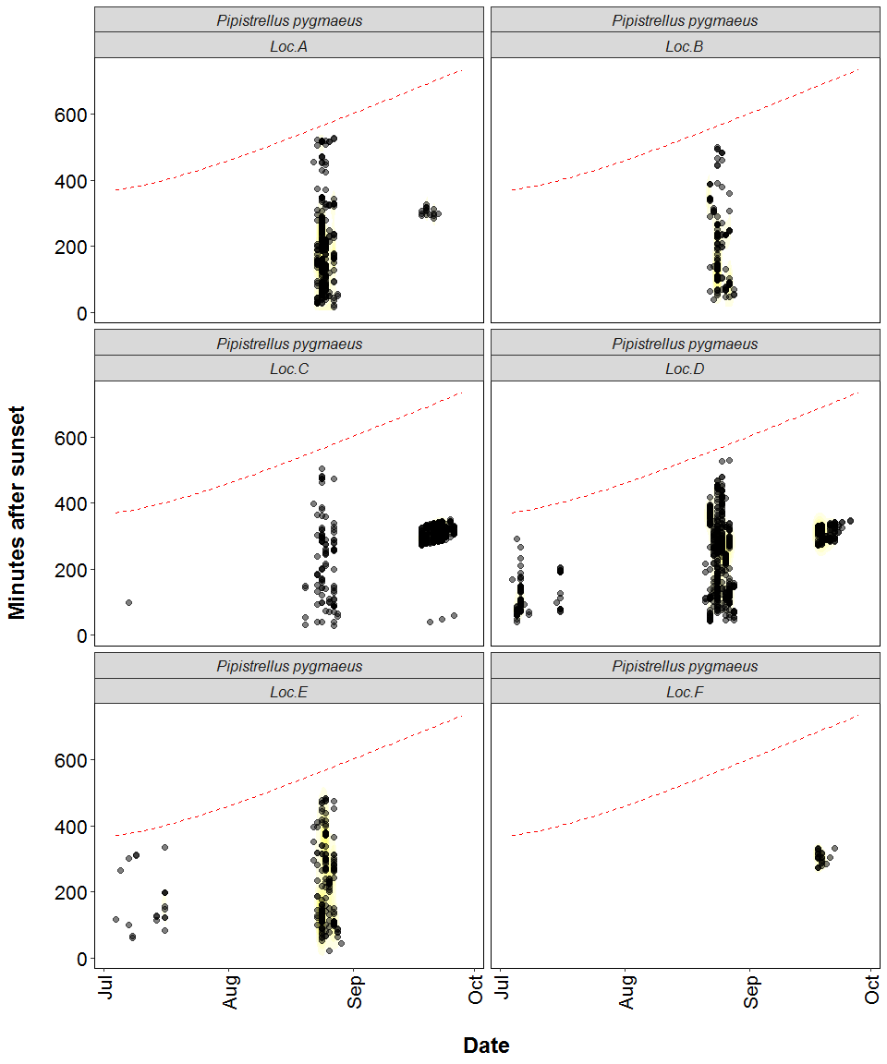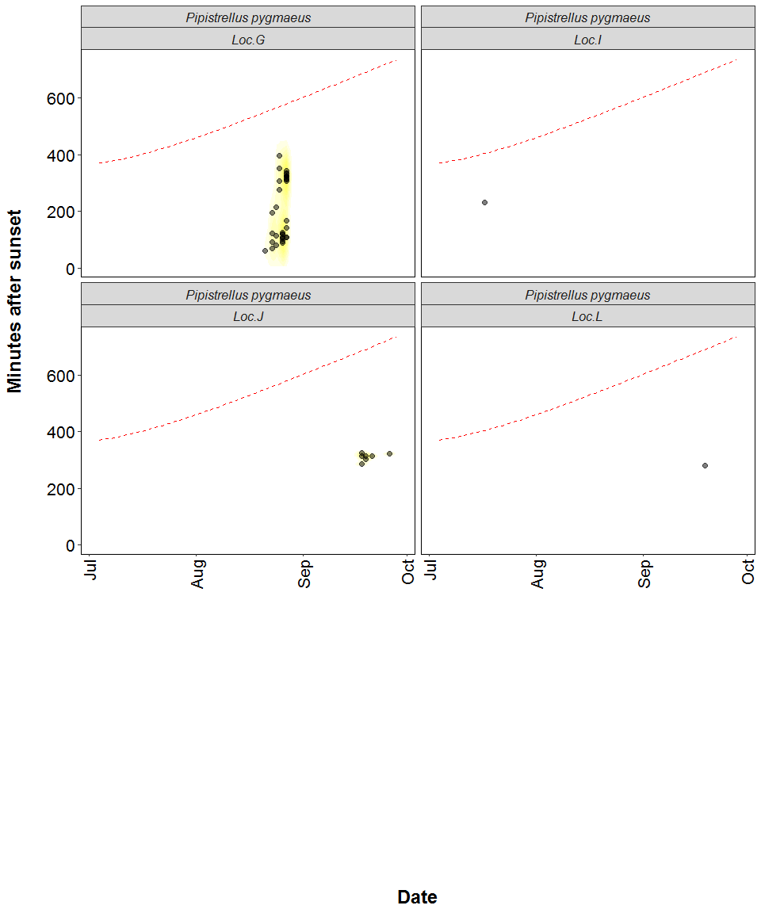

##### Page Break

# Roost Emergence Time and Bat Observation

Based on: *Russ, Jon. 2012. British Bat Calls a Guide to species Identification.* *Pelagic Publishing.*

For more information see <https://rbats-blog.updog.co/2018/05/29/bat-emergence/>

## Bat Passes Potentially Indicating Close Proximity to a Roost (Russ 2012) - Table

**Number of bat calls recorded before the upper time of the species-specific emergence time range, and which therefore may potentially indicate the presence of a nearby roost.**

Table continues below

|  |  |  |  |  |  |  |  |
| --- | --- | --- | --- | --- | --- | --- | --- |
| Species | Detector ID | 2019-07-07 | | 2019-07-15 | 2019-08-23 | 2019-08-24 | 2019-08-26 |
| Common pipistrelle | Loc.A | 0 | | 0 | 1 | 0 | 0 |
| Common pipistrelle | Loc.D | 1 | | 1 | 0 | 1 | 0 |
| Soprano pipistrelle | Loc.A | 0 | | 0 | 0 | 1 | 0 |
| Soprano pipistrelle | Loc.E | 0 | | 0 | 0 | 0 | 1 |
| 2019-08-27 | 2019-08-28 | |
| 0 | 0 | |
| 0 | 1 | |
| 2 | 0 | |
| 0 | 0 | |

##### Page Break

### Bat Passes Potentially Indicating Close Proximity to a Roost (Russ 2012) - Figures

**Figure 8.** Time from 15 minutes before to 90 minutes after sunset. Species-specific emergence time ranges are shown as grey bars. Bat passes overlapping species-specific grey bars, or occuring earlier than this time range, may potentially indicate the presence of a nearby roost.

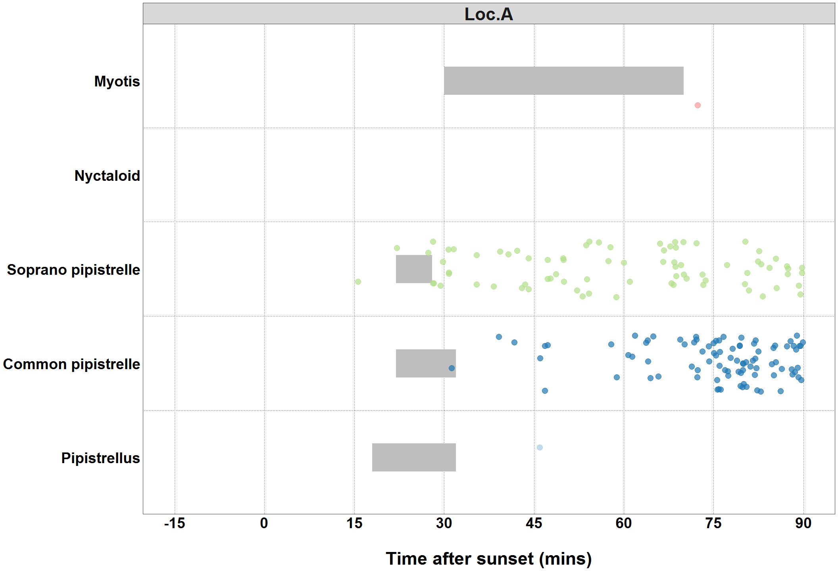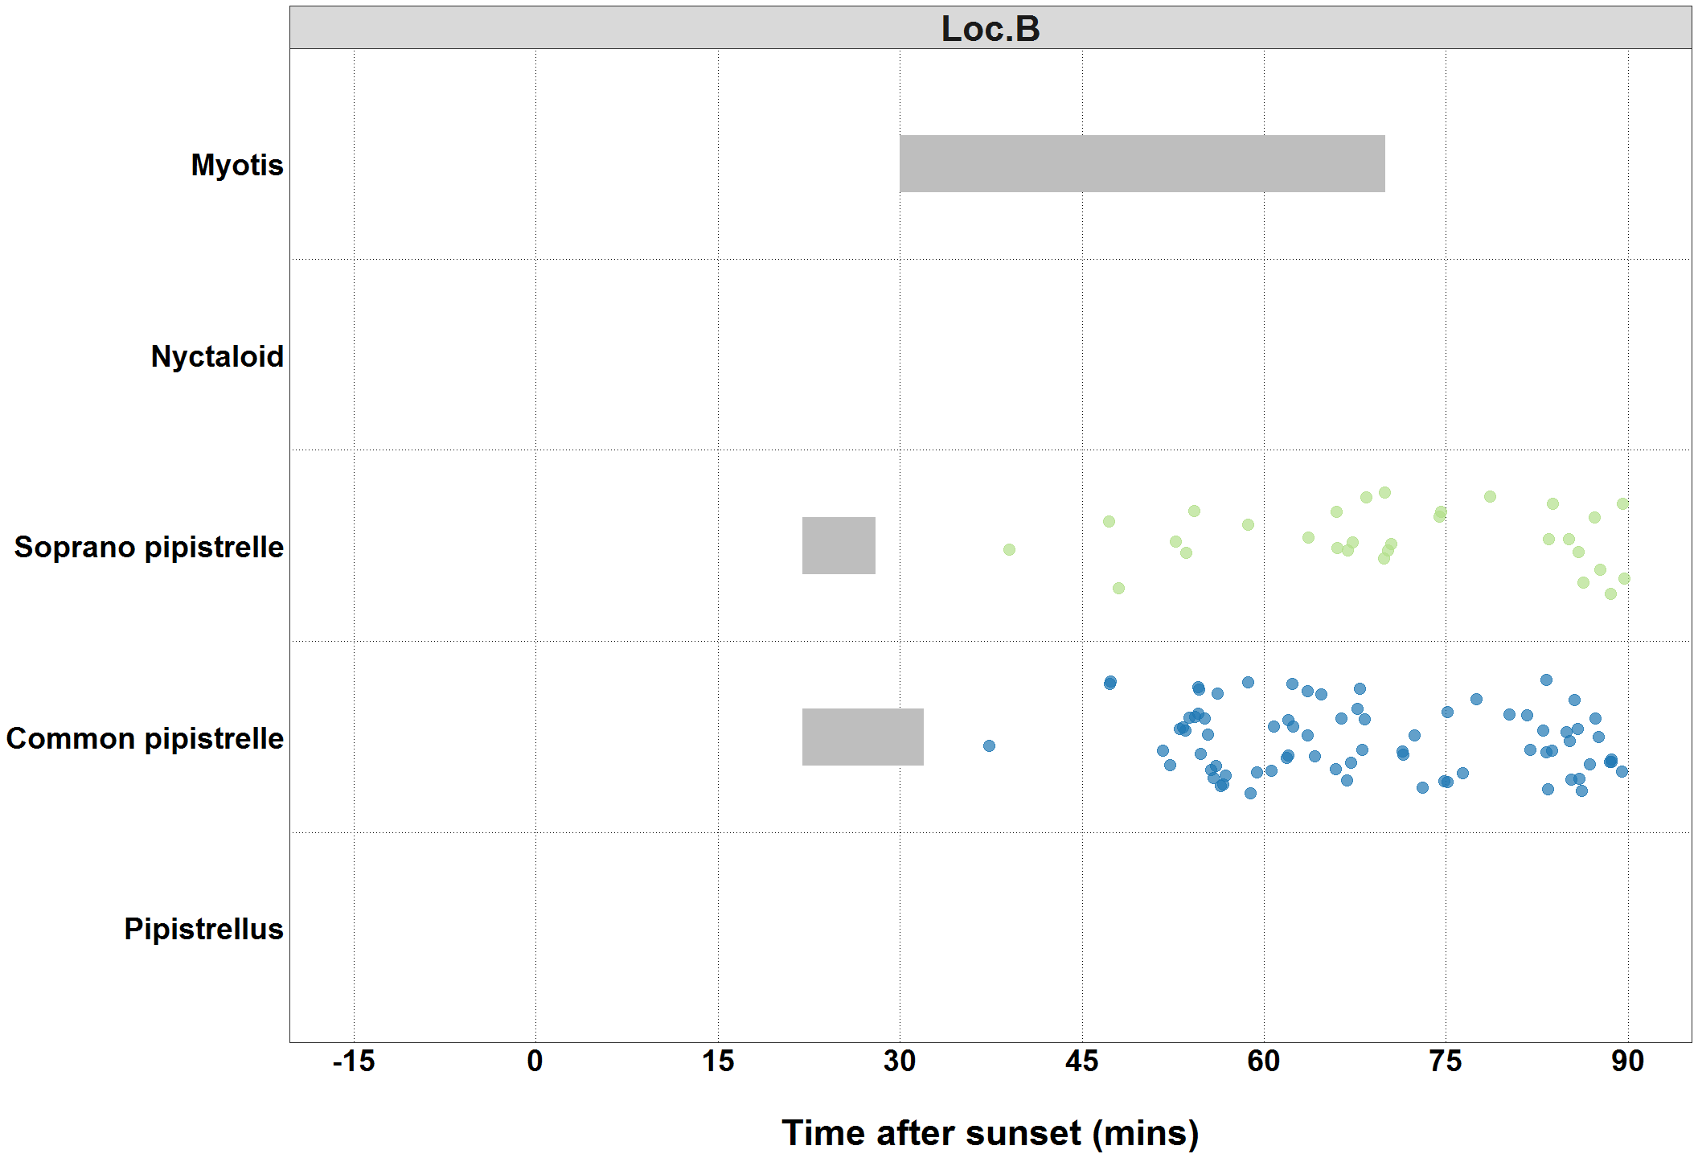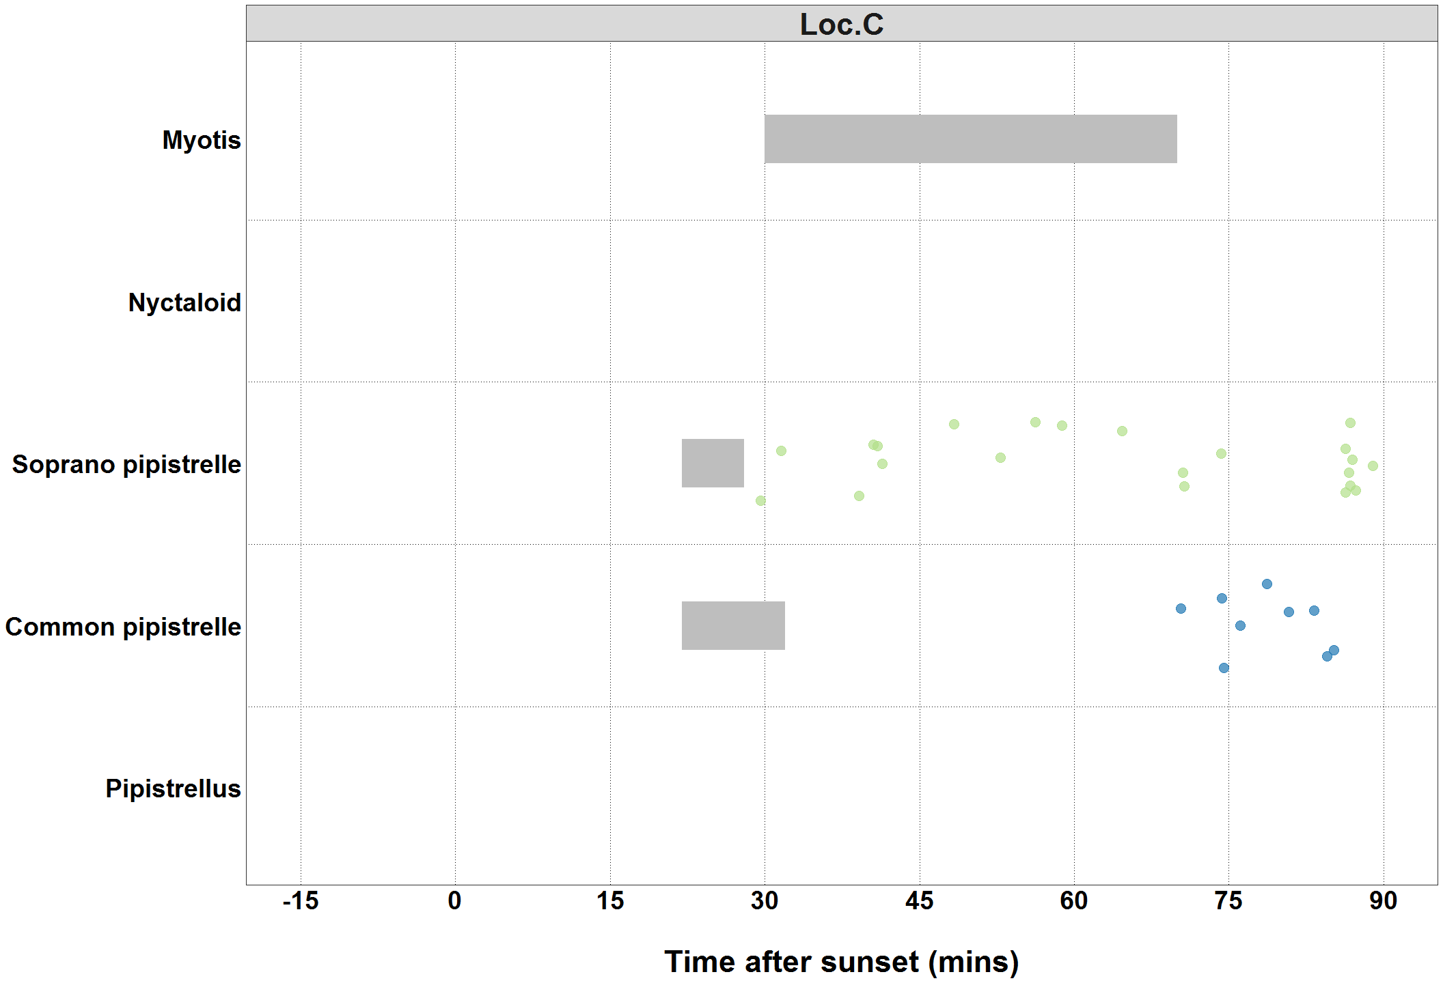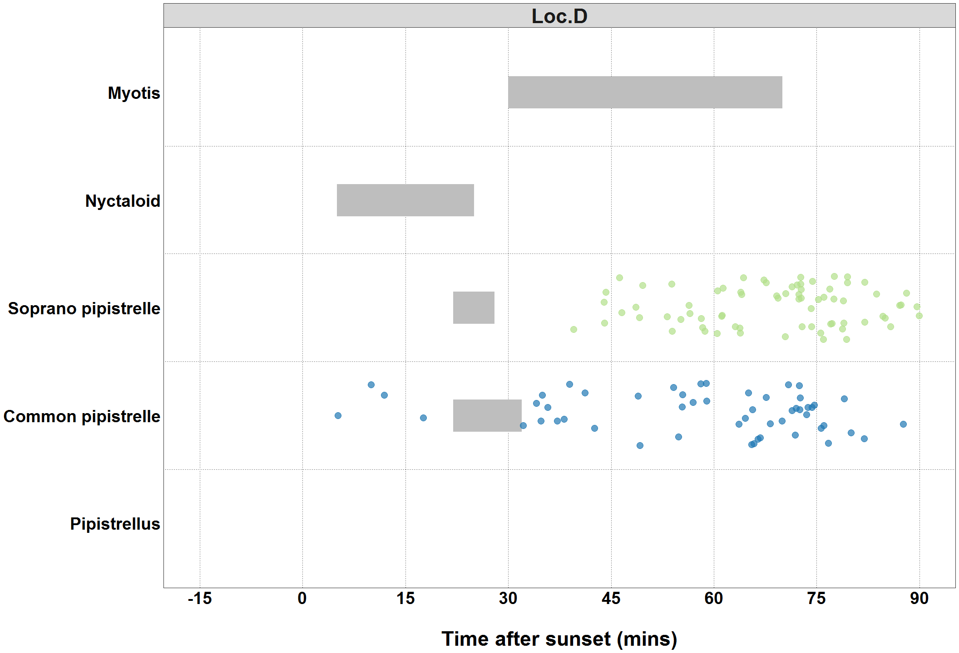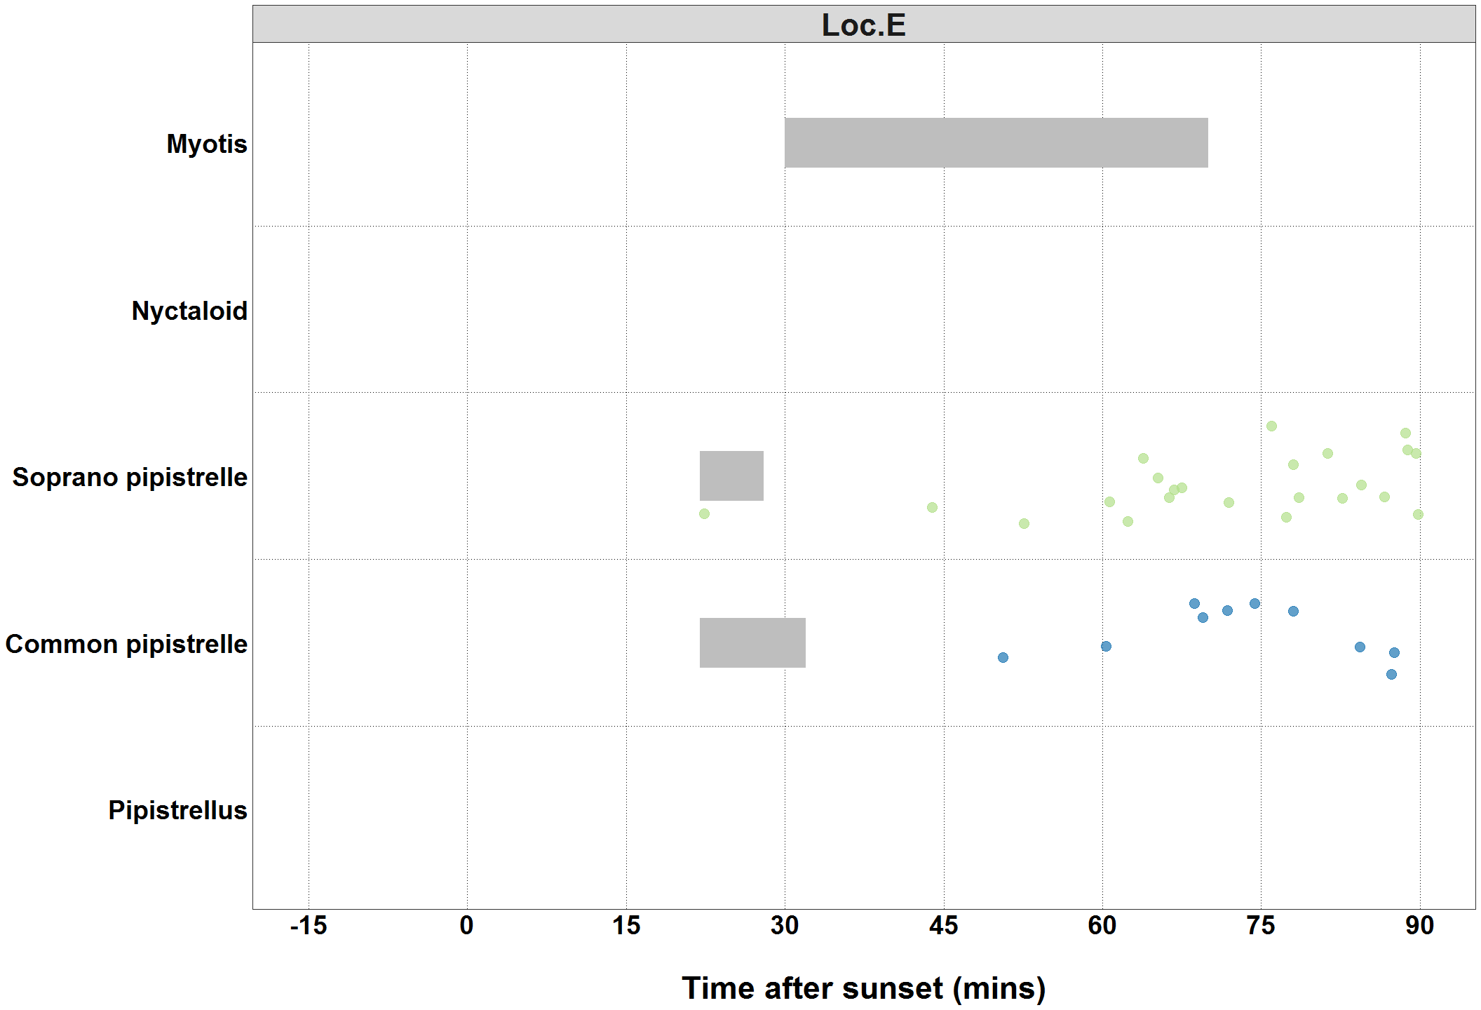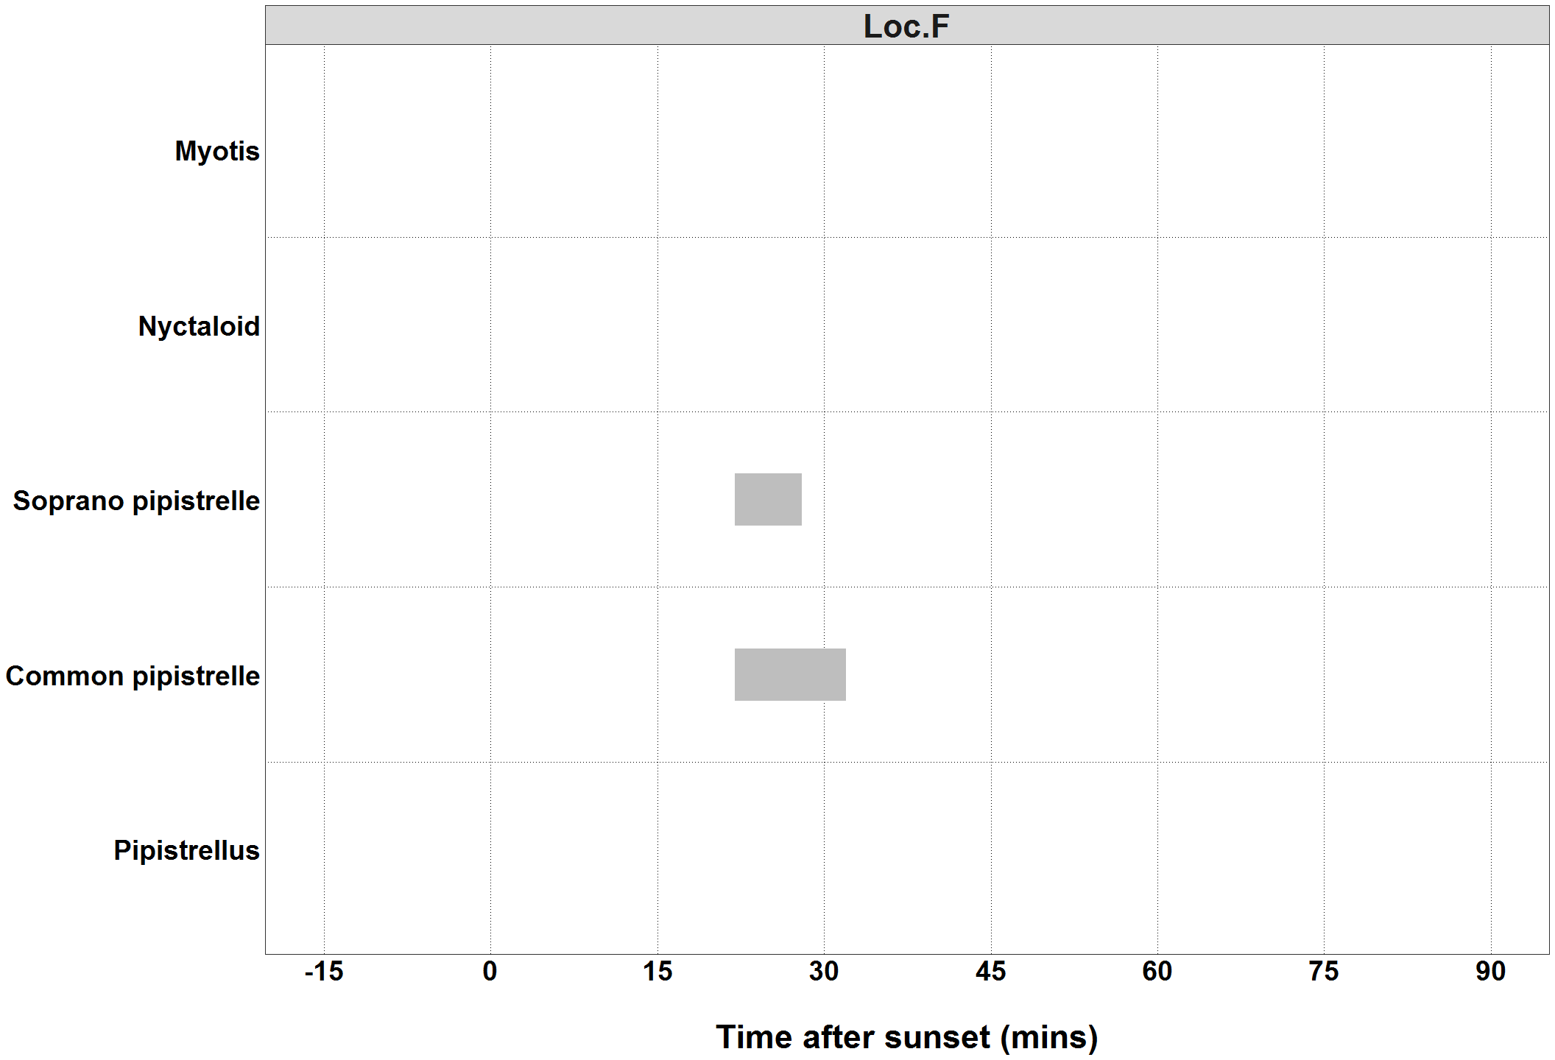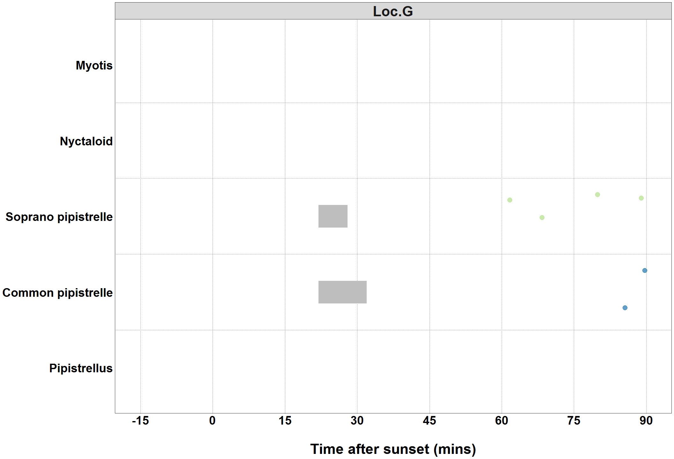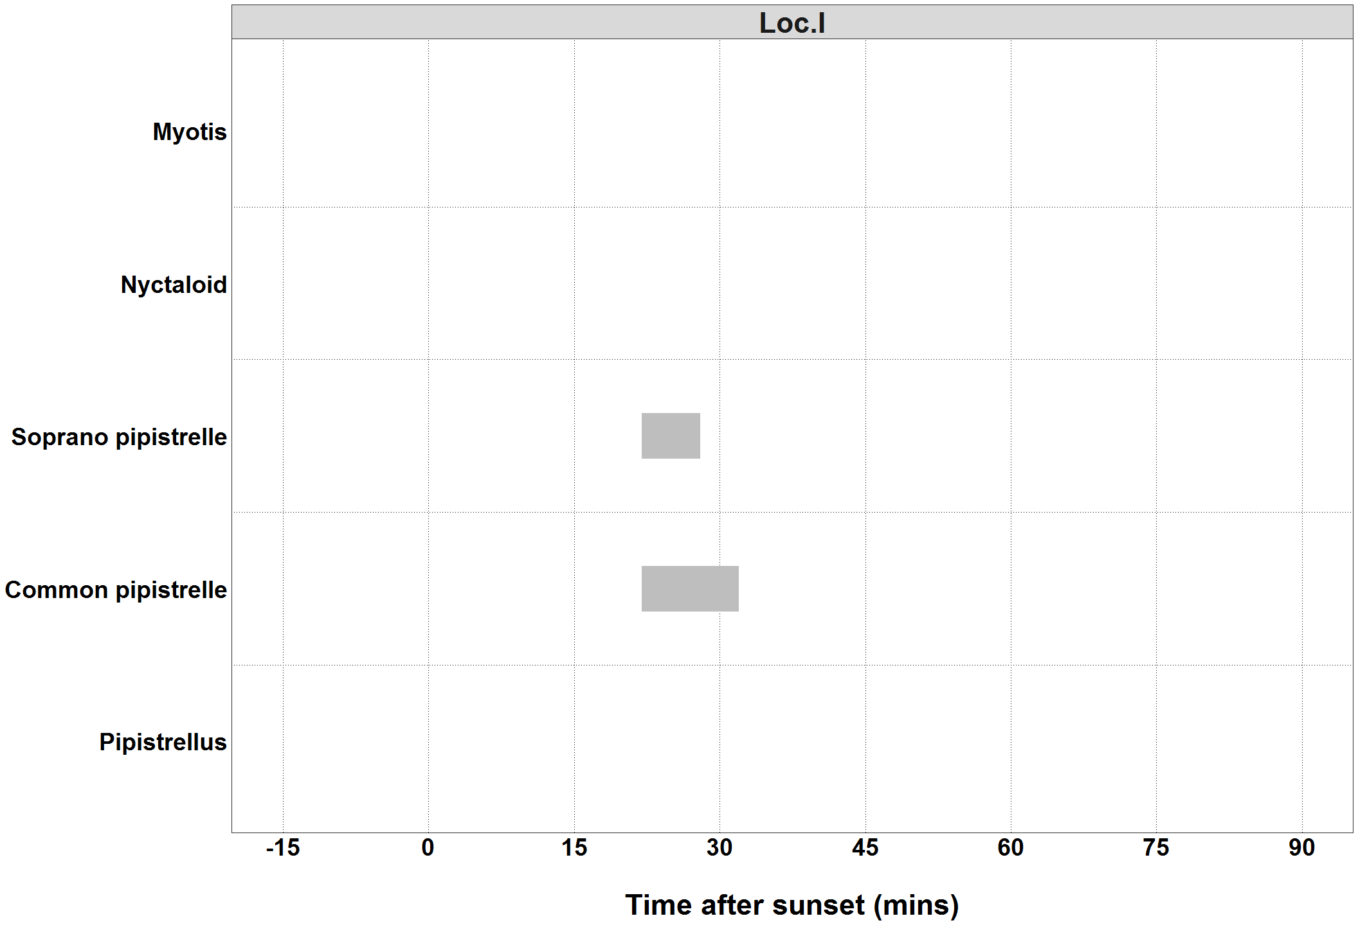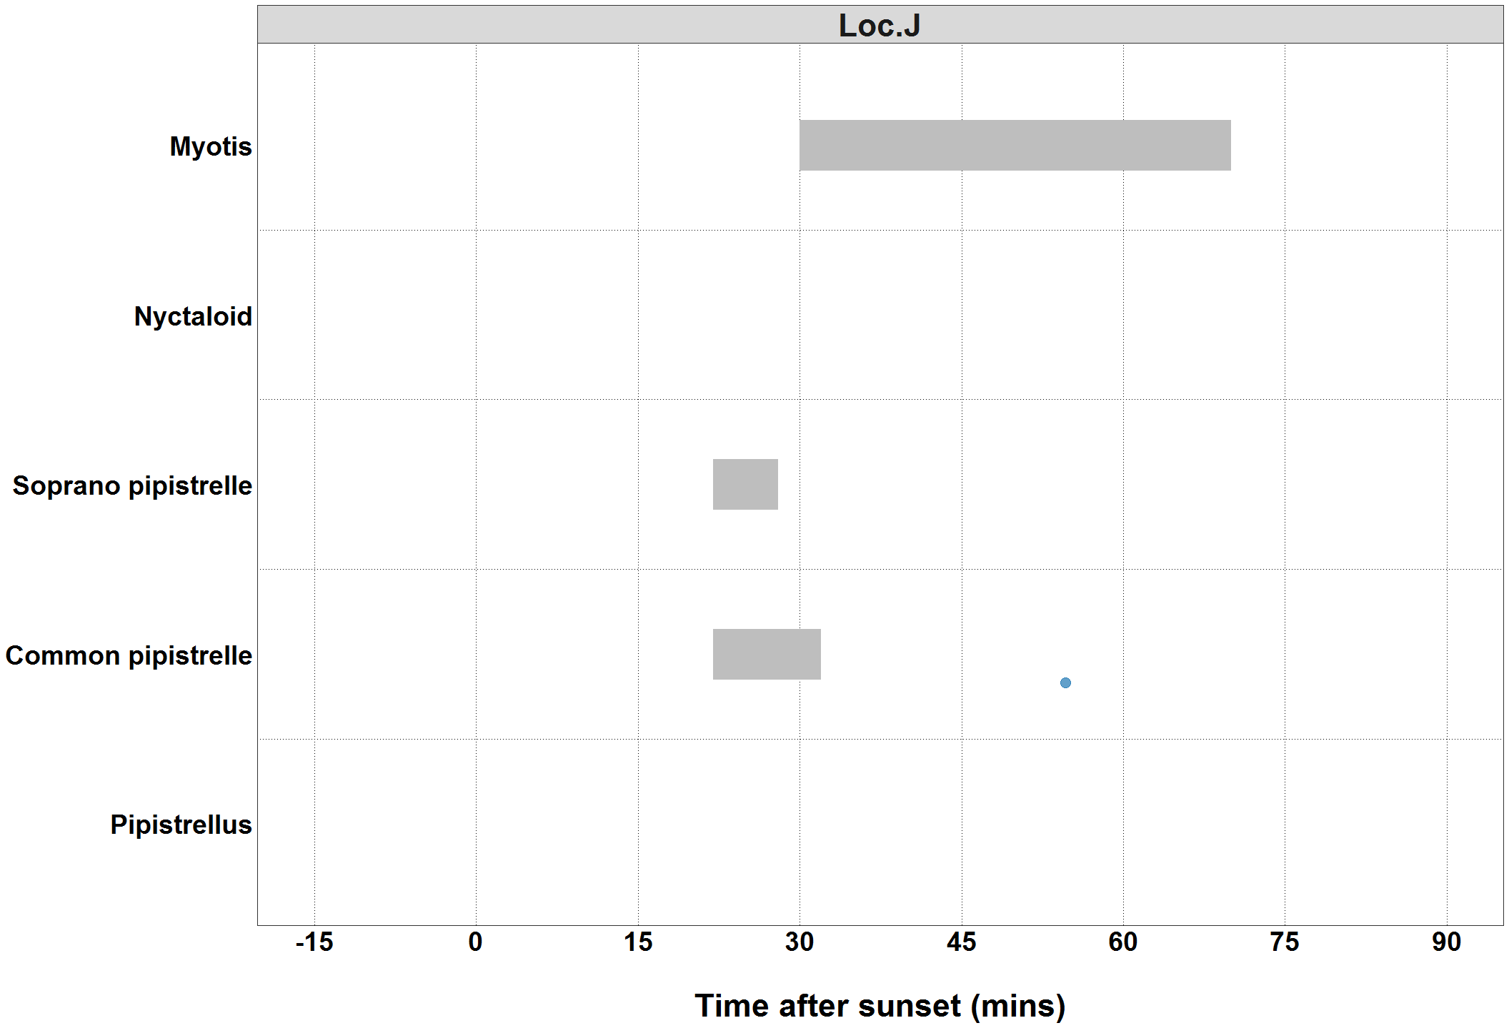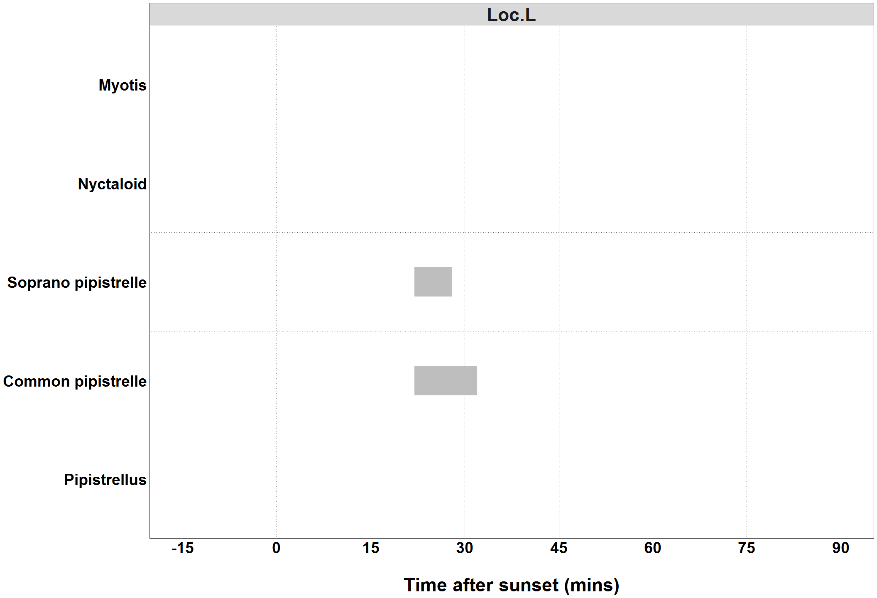

##### Page Break

### Bat Passes Potentially Indicating Close Proximity to a Roost (Maternity Period Only)

**Table:** *Maternity period defined as 15th June - 30th July.*

|  |  |  |  |
| --- | --- | --- | --- |
| Species | Detector ID | 2019-07-07 | 2019-07-15 |
| Common pipistrelle | Loc.D | 1 | 1 |

##### Page Break

### Bat Passes Potentially Indicating Close Proximity to a Roost (Maternity Period Only)

**Figure 9.** *Maternity period defined as 15th June - 30th July.*

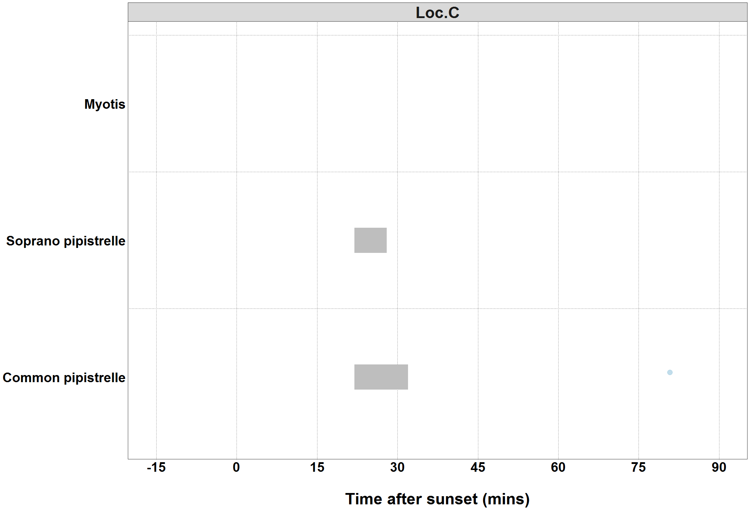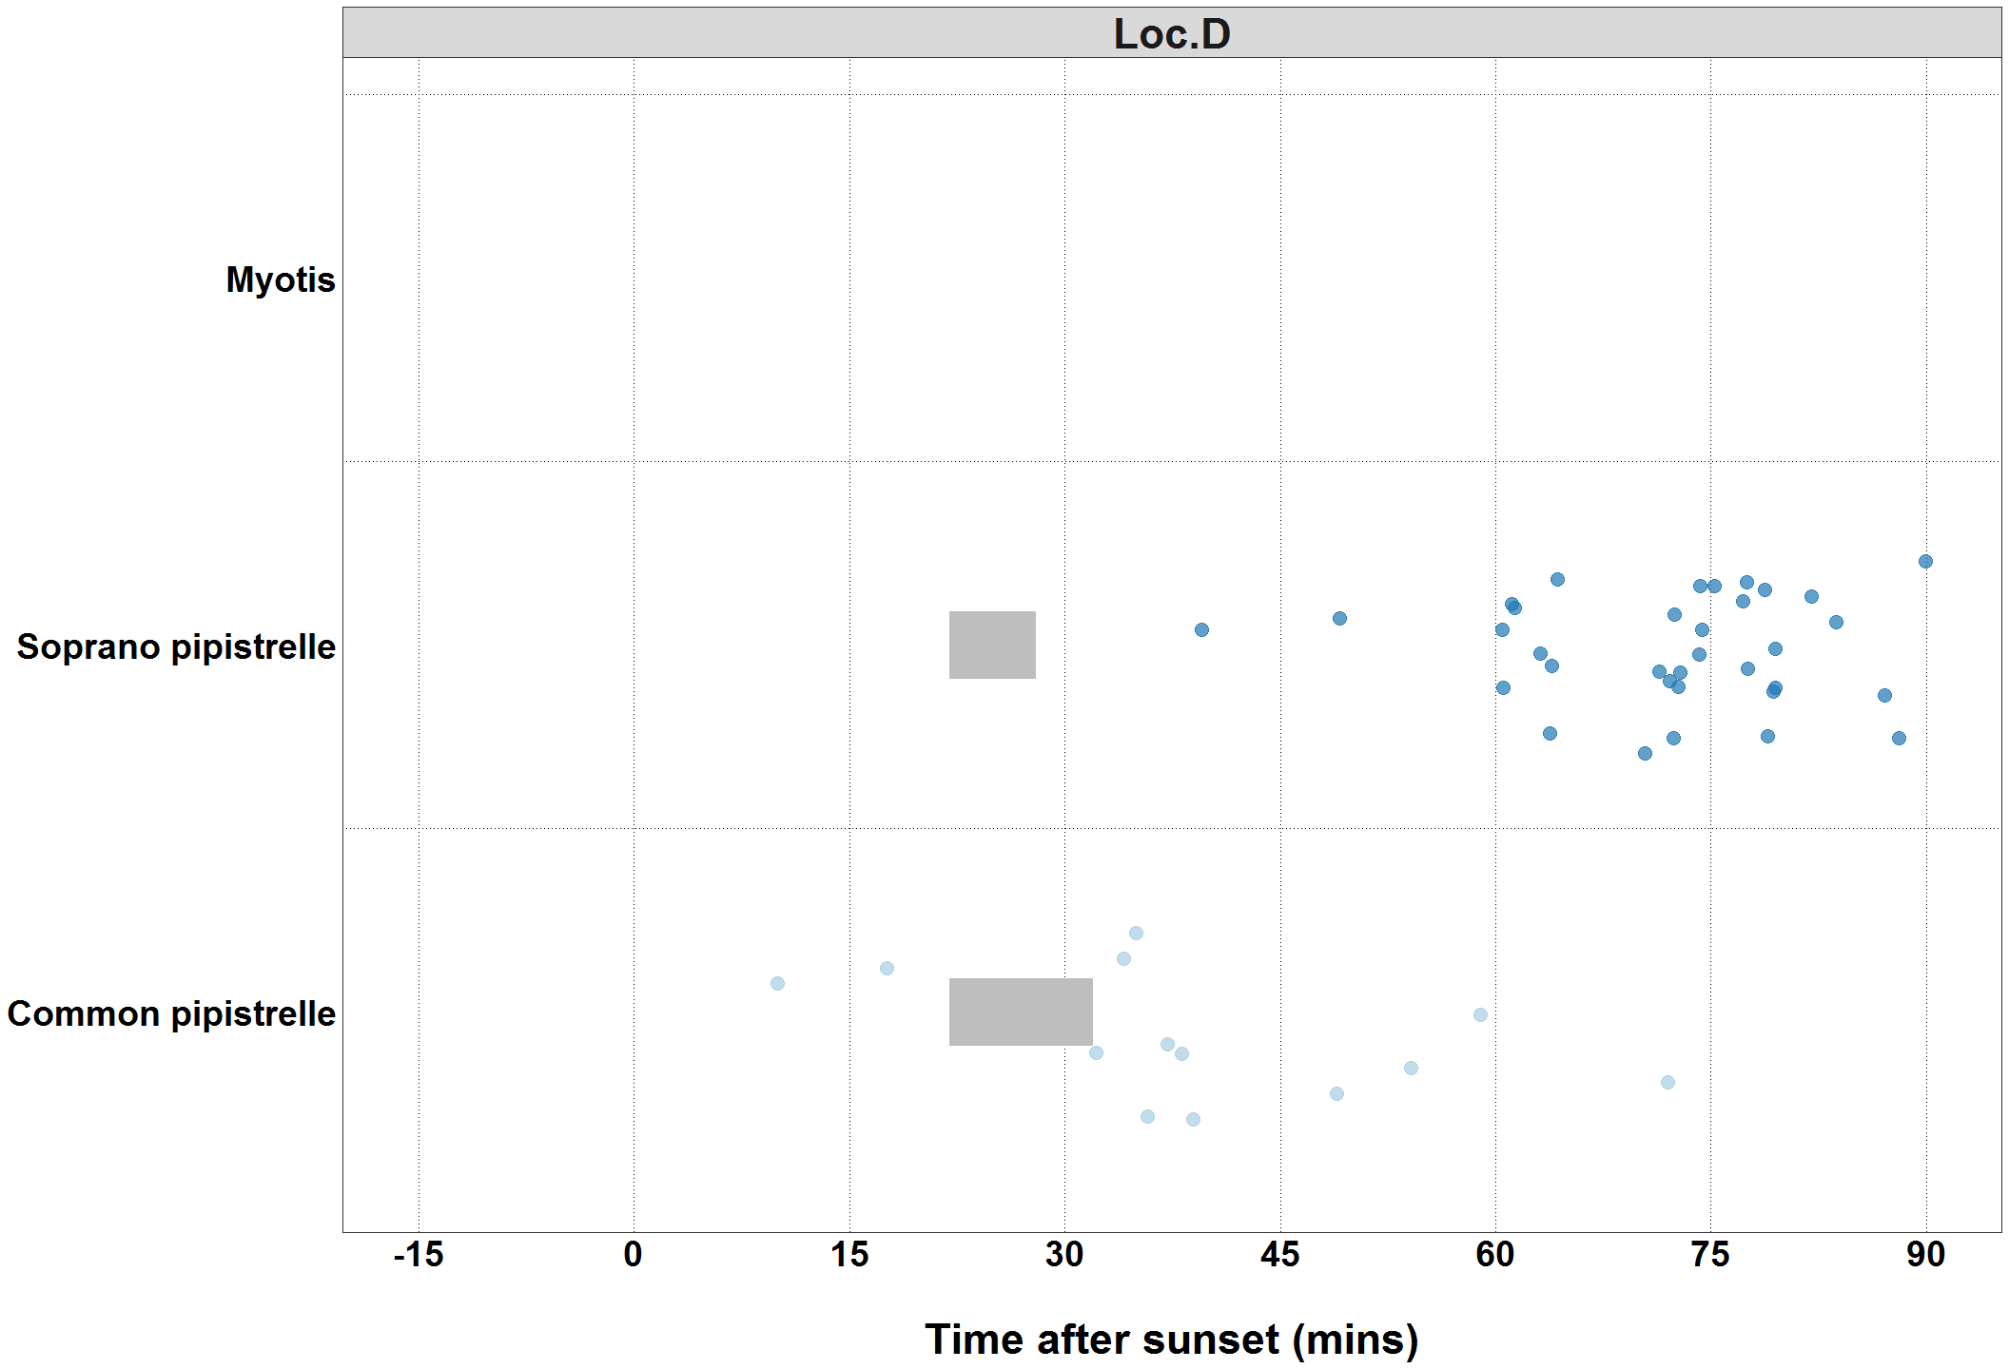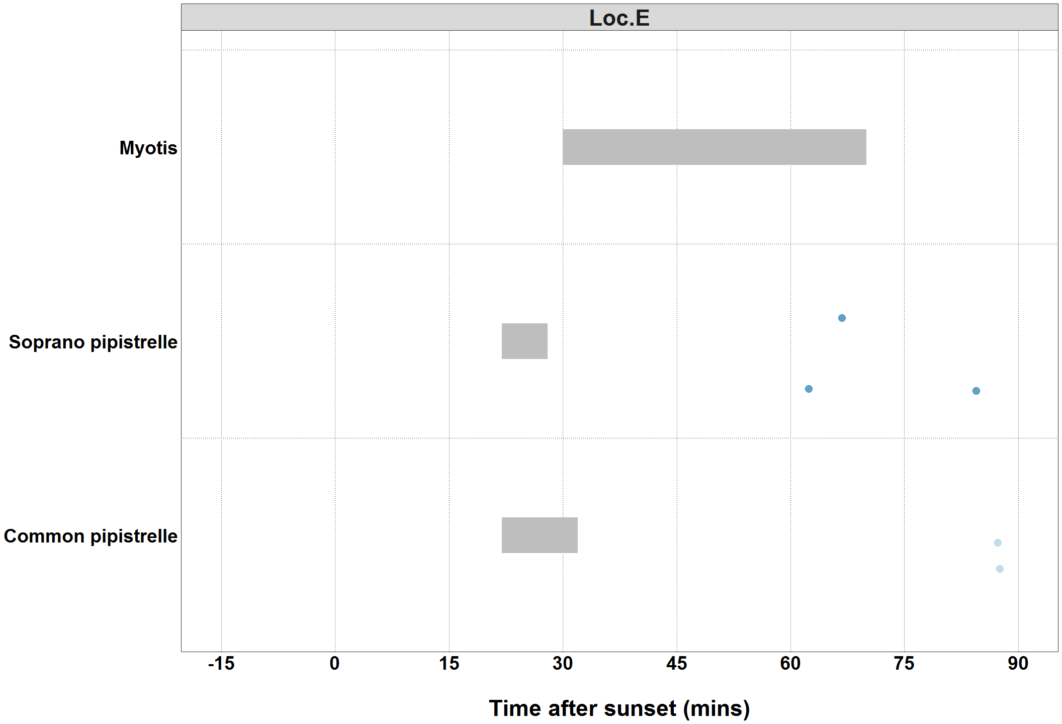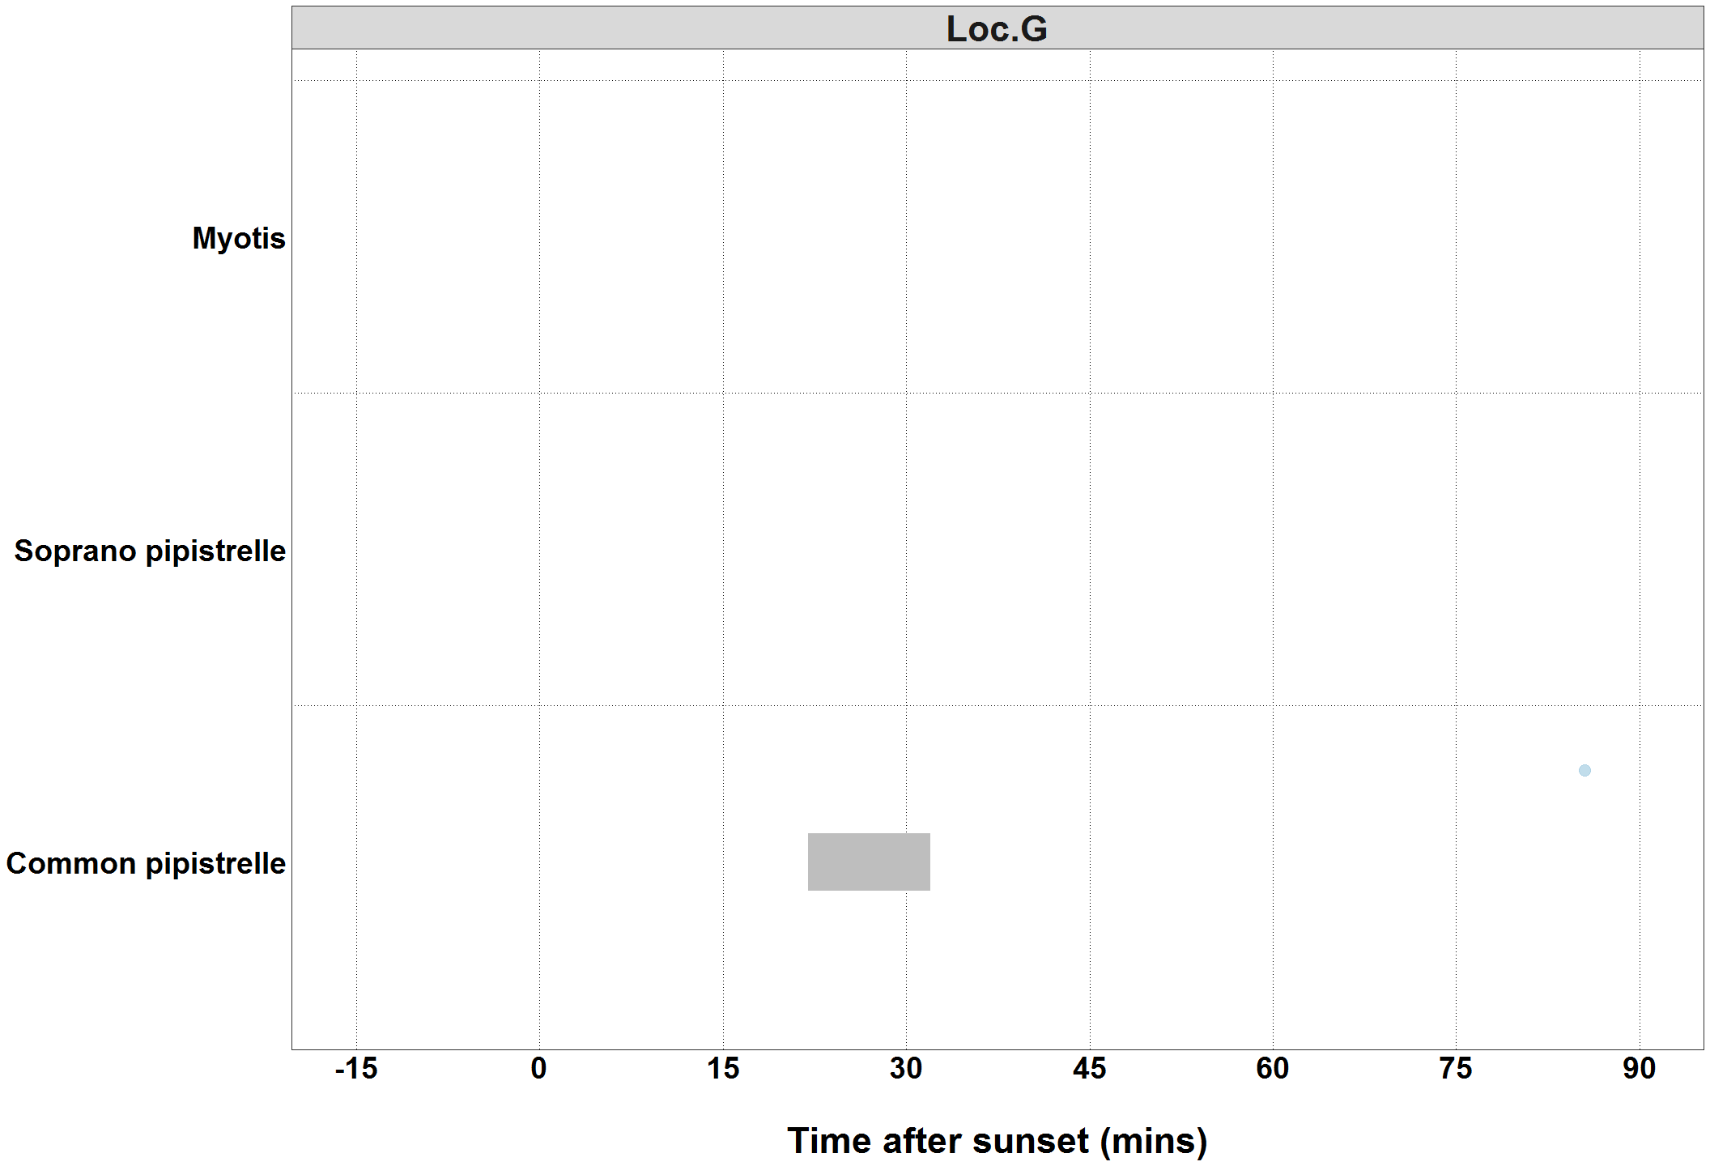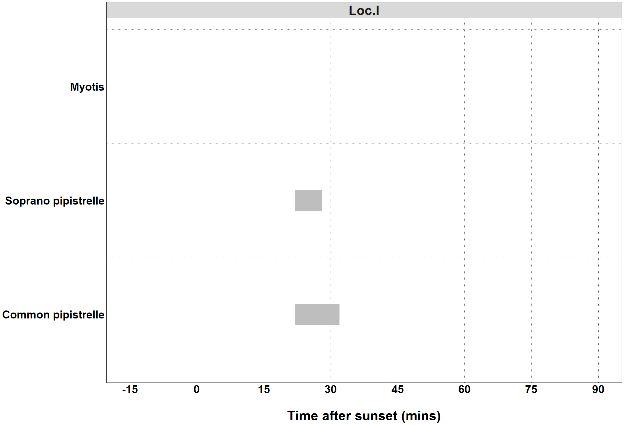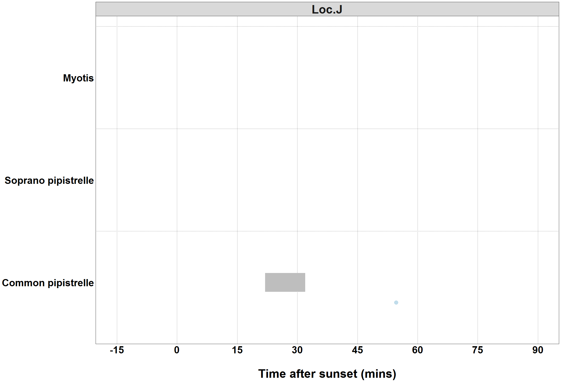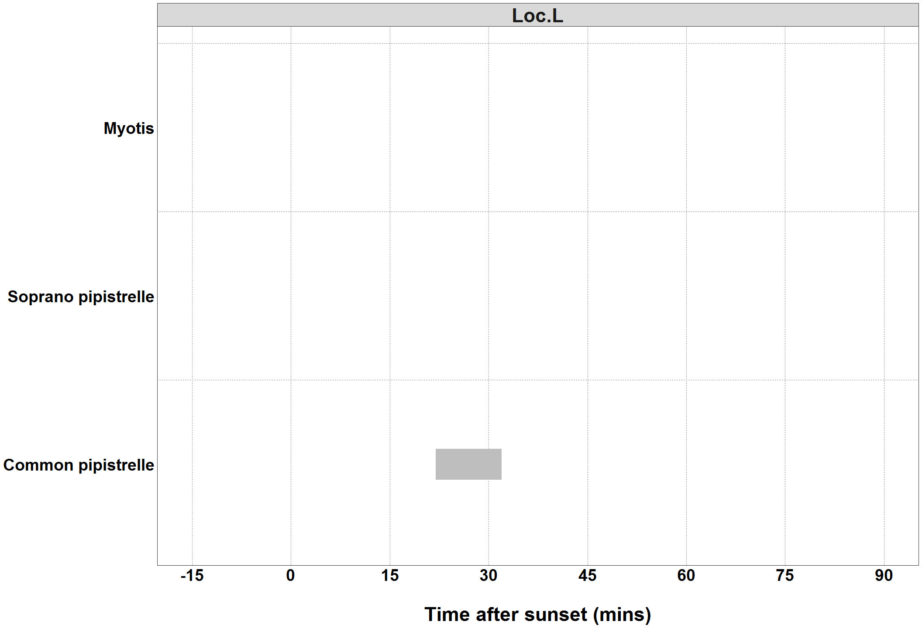

##### Page Break

# Counts of Bat Passes

## All detectors

**The total number of passes recorded for each species across all of the detectors.** The ‘Total’ percentage may not be exactly 100% due to rounding of the percentages per species.

|  |  |  |
| --- | --- | --- |
| Species | Passes (No.) | Percentage of total (%) |
| Pipistrellus | 619 | 12.0 |
| Common pipistrelle | 1909 | 37.0 |
| Soprano pipistrelle | 2601 | 50.5 |
| Nyctaloid | 2 | 0.0 |
| Myotis | 23 | 0.4 |
| Total | 5154 | 99.9 |

##### Page Break

# Counts of Bat Passes

## Per Detector

**The number of passes recorded for each species at each detector.**

|  |  |  |  |
| --- | --- | --- | --- |
| Species | Detector ID | Count (No) | Percentage by Detector (%) |
| Pipistrellus | Loc.A | 619 | 42.3 |
| Common pipistrelle | Loc.A | 368 | 25.2 |
| Common pipistrelle | Loc.B | 485 | 72.6 |
| Common pipistrelle | Loc.C | 293 | 30.3 |
| Common pipistrelle | Loc.D | 570 | 36.4 |
| Common pipistrelle | Loc.E | 119 | 34.4 |
| Common pipistrelle | Loc.F | 26 | 52.0 |
| Common pipistrelle | Loc.G | 28 | 44.4 |
| Common pipistrelle | Loc.I | 2 | 66.7 |
| Common pipistrelle | Loc.J | 5 | 38.5 |
| Common pipistrelle | Loc.L | 13 | 92.9 |
| Soprano pipistrelle | Loc.A | 472 | 32.3 |
| Soprano pipistrelle | Loc.B | 182 | 27.2 |
| Soprano pipistrelle | Loc.C | 668 | 69.0 |
| Soprano pipistrelle | Loc.D | 988 | 63.1 |
| Soprano pipistrelle | Loc.E | 223 | 64.5 |
| Soprano pipistrelle | Loc.F | 24 | 48.0 |
| Soprano pipistrelle | Loc.G | 35 | 55.6 |
| Soprano pipistrelle | Loc.I | 1 | 33.3 |
| Soprano pipistrelle | Loc.J | 7 | 53.8 |
| Soprano pipistrelle | Loc.L | 1 | 7.1 |
| Nyctaloid | Loc.D | 2 | 0.1 |
| Myotis | Loc.A | 4 | 0.3 |
| Myotis | Loc.B | 1 | 0.1 |
| Myotis | Loc.C | 7 | 0.7 |
| Myotis | Loc.D | 6 | 0.4 |
| Myotis | Loc.E | 4 | 1.2 |
| Myotis | Loc.J | 1 | 7.7 |

##### Page Break

# Species Composition

**Figure 10.** Percentage species composition of passes at each detector.

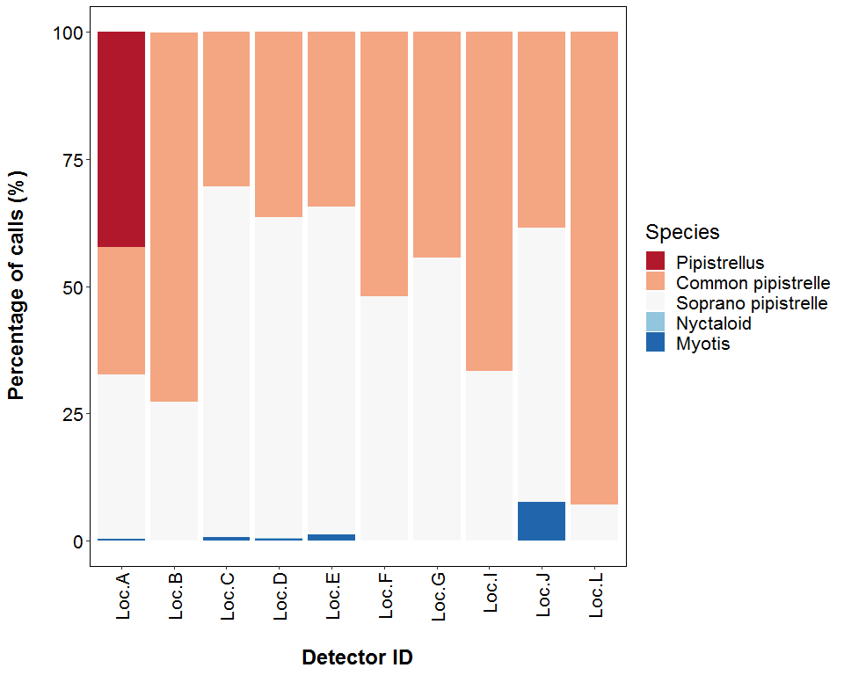

##### Page Break

## PART 2a: Presence Only

**THE NEXT SECTION OF THE REPORT FEATURES THE RAW DATA SUPPLIED TO ECOBAT AND ONLY TAKES INTO ACCOUNT THE PRESENCE, AND NOT THE ABSENCE, OF EACH BAT SPECIES. FOR EACH NIGHT, THERE IS NO ‘ZERO DATA’ FOR WHEN SPECIES WERE NOT DETECTED.**

##### Page Break

## Nightly Bat Pass Rate (Bat passes per hour)

# Median Per Detector

**The median Nightly Pass Rate (bat passes per hour, per night) of each species. If NA, then no bat passes.**

Bat pass rates are often highly variable between nights, with some nights having few or no passes and other nights having high activity. In these circumstances, the median is likely to be a more useful summary of the ‘average’ activity than is the mean. For further information see: *Lintott, P. R., & Mathews, F. (2018). Basic mathematical errors may make ecological assessments unreliable. Biodiversity and Conservation, 27(1), 265-267.* <https://doi.org/10.1007/s10531-017-1418-5>

|  |  |  |
| --- | --- | --- |
| Species | Detector ID | Median Pass Rate |
| Pipistrellus | Loc.A | 32.9 |
| Common pipistrelle | Loc.A | 2.5 |
| Common pipistrelle | Loc.B | 5.1 |
| Common pipistrelle | Loc.C | 0.6 |
| Common pipistrelle | Loc.D | 0.7 |
| Common pipistrelle | Loc.E | 0.4 |
| Common pipistrelle | Loc.F | 0.1 |
| Common pipistrelle | Loc.G | 0.2 |
| Common pipistrelle | Loc.I | 0.2 |
| Common pipistrelle | Loc.J | 0.1 |
| Common pipistrelle | Loc.L | 0.2 |
| Soprano pipistrelle | Loc.A | 0.5 |
| Soprano pipistrelle | Loc.B | 1.5 |
| Soprano pipistrelle | Loc.C | 1.9 |
| Soprano pipistrelle | Loc.D | 2.3 |
| Soprano pipistrelle | Loc.E | 0.5 |
| Soprano pipistrelle | Loc.F | 0.1 |
| Soprano pipistrelle | Loc.G | 0.4 |
| Soprano pipistrelle | Loc.I | 0.2 |
| Soprano pipistrelle | Loc.J | 0.1 |
| Soprano pipistrelle | Loc.L | 0.1 |
| Nyctaloid | Loc.D | 0.1 |
| Myotis | Loc.A | 0.1 |
| Myotis | Loc.B | 0.1 |
| Myotis | Loc.C | 0.1 |
| Myotis | Loc.D | 0.1 |
| Myotis | Loc.E | 0.2 |
| Myotis | Loc.J | 0.1 |

##### Page Break

## Nightly Bat Pass Rate (Bat passes per hour)

# Mean per Detector

**The mean Nightly Pass Rate (bat passes per hour, per night) of each species at each detector. Values are given to 1 decimal place.**

We recommend using the median values given above, for the reasons stated above, but provide the mean values in the table below.

|  |  |  |
| --- | --- | --- |
| Species | Detector ID | Mean Pass Rate |
| Pipistrellus | Loc.A | 32.9 |
| Common pipistrelle | Loc.A | 4.3 |
| Common pipistrelle | Loc.B | 6.5 |
| Common pipistrelle | Loc.C | 1.8 |
| Common pipistrelle | Loc.D | 2.2 |
| Common pipistrelle | Loc.E | 1.0 |
| Common pipistrelle | Loc.F | 0.6 |
| Common pipistrelle | Loc.G | 0.4 |
| Common pipistrelle | Loc.I | 0.2 |
| Common pipistrelle | Loc.J | 0.1 |
| Common pipistrelle | Loc.L | 0.2 |
| Soprano pipistrelle | Loc.A | 4.2 |
| Soprano pipistrelle | Loc.B | 2.8 |
| Soprano pipistrelle | Loc.C | 3.3 |
| Soprano pipistrelle | Loc.D | 4.6 |
| Soprano pipistrelle | Loc.E | 1.6 |
| Soprano pipistrelle | Loc.F | 0.4 |
| Soprano pipistrelle | Loc.G | 0.6 |
| Soprano pipistrelle | Loc.I | 0.2 |
| Soprano pipistrelle | Loc.J | 0.2 |
| Soprano pipistrelle | Loc.L | 0.1 |
| Nyctaloid | Loc.D | 0.1 |
| Myotis | Loc.A | 0.1 |
| Myotis | Loc.B | 0.1 |
| Myotis | Loc.C | 0.1 |
| Myotis | Loc.D | 0.2 |
| Myotis | Loc.E | 0.2 |
| Myotis | Loc.J | 0.1 |

##### Page Break

# Nightly Bat Passes (Bat passes per hour)

## Per Detector - Figures

**Figure 11.** Boxplots for the number of bat passes per hour each night, for each detector. The ‘box’ shows the interquartile range, which is where the middle 50% of the data lie. The line dividing the box is the median, the mid-point of the data. The ‘whiskers’ extend from the box and represent the ranges for the bottom 25% and the top 25% of the data values, excluding outliers. An outlier is any extreme value that lies further away from the box than 1.5 times the interquartile range. Outliers are shown as dots. Where very few passes are recorded it is not possible to produce the box, so the data are shown as a line.

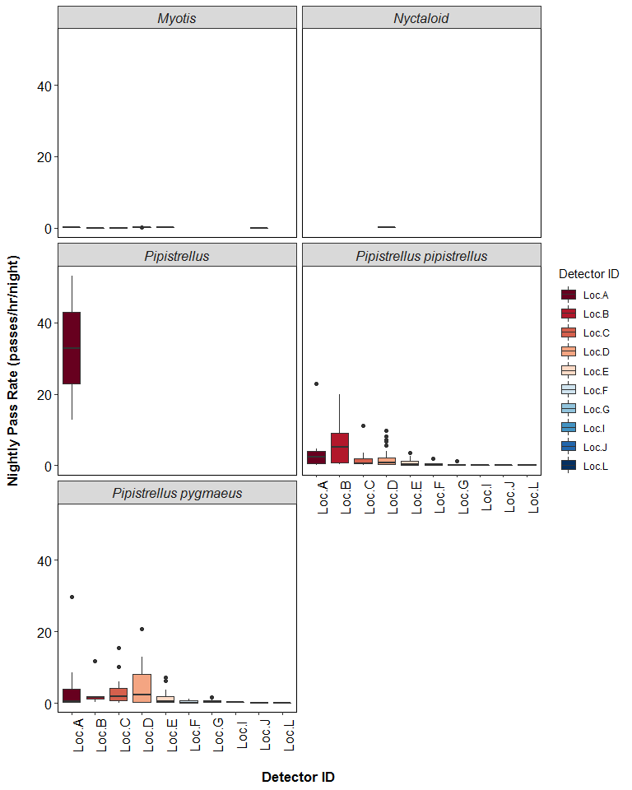

##### Page Break

# SPLIT BY MONTH

# Total Bat Passes per Detector, each Month

## Per Detector

**The total number of bat passes of each species in each month at each detector.** This table simply tells you how many bats of each species were recorded passing each detector during each month. These numbers are not standardised by the night length, or how many nights each detector was active for during each month.

|  |  |  |  |  |
| --- | --- | --- | --- | --- |
| Species | Detector ID | Jul | Aug | Sep |
| Pipistrellus | Loc.A | 0 | 619 | 0 |
| Common pipistrelle | Loc.A | 0 | 353 | 15 |
| Common pipistrelle | Loc.B | 0 | 485 | 0 |
| Common pipistrelle | Loc.C | 3 | 62 | 228 |
| Common pipistrelle | Loc.D | 27 | 343 | 200 |
| Common pipistrelle | Loc.E | 21 | 96 | 2 |
| Common pipistrelle | Loc.F | 0 | 0 | 26 |
| Common pipistrelle | Loc.G | 3 | 25 | 0 |
| Common pipistrelle | Loc.I | 2 | 0 | 0 |
| Common pipistrelle | Loc.J | 1 | 0 | 4 |
| Common pipistrelle | Loc.L | 3 | 0 | 10 |
| Soprano pipistrelle | Loc.A | 0 | 456 | 16 |
| Soprano pipistrelle | Loc.B | 0 | 182 | 0 |
| Soprano pipistrelle | Loc.C | 1 | 105 | 562 |
| Soprano pipistrelle | Loc.D | 97 | 655 | 236 |
| Soprano pipistrelle | Loc.E | 20 | 203 | 0 |
| Soprano pipistrelle | Loc.F | 0 | 0 | 24 |
| Soprano pipistrelle | Loc.G | 0 | 35 | 0 |
| Soprano pipistrelle | Loc.I | 1 | 0 | 0 |
| Soprano pipistrelle | Loc.J | 0 | 0 | 7 |
| Soprano pipistrelle | Loc.L | 0 | 0 | 1 |
| Nyctaloid | Loc.D | 0 | 2 | 0 |
| Myotis | Loc.A | 0 | 4 | 0 |
| Myotis | Loc.B | 0 | 0 | 1 |
| Myotis | Loc.C | 0 | 2 | 5 |
| Myotis | Loc.D | 0 | 6 | 0 |
| Myotis | Loc.E | 3 | 1 | 0 |
| Myotis | Loc.J | 0 | 0 | 1 |

##### Page Break

# Survey Effort

**The number of survey nights per month per detector.**

|  |  |  |
| --- | --- | --- |
| Month | Detector ID | No. of Survey Nights |
| Jul | Loc.C | 3 |
| Jul | Loc.D | 8 |
| Jul | Loc.E | 7 |
| Jul | Loc.G | 3 |
| Jul | Loc.I | 3 |
| Jul | Loc.J | 1 |
| Jul | Loc.L | 2 |
| Aug | Loc.A | 7 |
| Aug | Loc.B | 8 |
| Aug | Loc.C | 8 |
| Aug | Loc.D | 9 |
| Aug | Loc.E | 8 |
| Aug | Loc.G | 6 |
| Sep | Loc.A | 5 |
| Sep | Loc.B | 1 |
| Sep | Loc.C | 9 |
| Sep | Loc.D | 9 |
| Sep | Loc.E | 2 |
| Sep | Loc.F | 6 |
| Sep | Loc.J | 6 |
| Sep | Loc.L | 4 |

##### Page Break

## Nightly Bat Pass Rate for each Month

# Median Per Detector

**The median Nightly Pass Rate (bat passes per hour, per night) of each species throughout each month. If NA, then no bat passes.**

Bat pass rates are often highly variable between nights, with some nights having few or no passes and other nights having high activity. In these circumstances, the median is likely to be a more useful summary of the ‘average’ activity than is the mean. For further information see: *Lintott, P. R., & Mathews, F. (2018). Basic mathematical errors may make ecological assessments unreliable. Biodiversity and Conservation, 27(1), 265-267.* <https://doi.org/10.1007/s10531-017-1418-5>

|  |  |  |  |  |
| --- | --- | --- | --- | --- |
| Species | Detector ID | Jul | Aug | Sep |
| Pipistrellus | Loc.A | NA | 32.9 | NA |
| Common pipistrelle | Loc.A | NA | 3.4 | 0.4 |
| Common pipistrelle | Loc.B | NA | 5.1 | NA |
| Common pipistrelle | Loc.C | 0.2 | 0.6 | 1.3 |
| Common pipistrelle | Loc.D | 0.6 | 2.4 | 0.7 |
| Common pipistrelle | Loc.E | 0.6 | 0.5 | 0.1 |
| Common pipistrelle | Loc.F | NA | NA | 0.1 |
| Common pipistrelle | Loc.G | 0.2 | 0.4 | NA |
| Common pipistrelle | Loc.I | 0.2 | NA | NA |
| Common pipistrelle | Loc.J | 0.2 | NA | 0.1 |
| Common pipistrelle | Loc.L | 0.2 | NA | 0.2 |
| Soprano pipistrelle | Loc.A | NA | 3.4 | 0.3 |
| Soprano pipistrelle | Loc.B | NA | 1.5 | NA |
| Soprano pipistrelle | Loc.C | 0.2 | 0.8 | 4.3 |
| Soprano pipistrelle | Loc.D | 0.3 | 9.5 | 1.4 |
| Soprano pipistrelle | Loc.E | 0.3 | 1.7 | NA |
| Soprano pipistrelle | Loc.F | NA | NA | 0.1 |
| Soprano pipistrelle | Loc.G | NA | 0.4 | NA |
| Soprano pipistrelle | Loc.I | 0.2 | NA | NA |
| Soprano pipistrelle | Loc.J | NA | NA | 0.1 |
| Soprano pipistrelle | Loc.L | NA | NA | 0.1 |
| Nyctaloid | Loc.D | NA | 0.1 | NA |
| Myotis | Loc.A | NA | 0.1 | NA |
| Myotis | Loc.B | NA | NA | 0.1 |
| Myotis | Loc.C | NA | 0.2 | 0.1 |
| Myotis | Loc.D | NA | 0.1 | NA |
| Myotis | Loc.E | 0.2 | 0.1 | NA |
| Myotis | Loc.J | NA | NA | 0.1 |

##### Page Break

## Nightly Bat Pass Rate for each Month

# Mean per Detector

**The mean Nightly Pass Rate (bat passes per hour, per night) of each species throughout each month. Values are given to 1 decimal place.**

We recommend using the median values given above, for the reasons stated above, but provide the mean values in the table below.

|  |  |  |  |  |
| --- | --- | --- | --- | --- |
| Species | Detector ID | Jul | Aug | Sep |
| Pipistrellus | Loc.A | NA | 32.9 | NA |
| Common pipistrelle | Loc.A | NA | 6.2 | 0.4 |
| Common pipistrelle | Loc.B | NA | 6.5 | NA |
| Common pipistrelle | Loc.C | 0.2 | 1.1 | 2.8 |
| Common pipistrelle | Loc.D | 0.5 | 4.0 | 1.9 |
| Common pipistrelle | Loc.E | 0.7 | 1.4 | 0.1 |
| Common pipistrelle | Loc.F | NA | NA | 0.6 |
| Common pipistrelle | Loc.G | 0.2 | 0.5 | NA |
| Common pipistrelle | Loc.I | 0.2 | NA | NA |
| Common pipistrelle | Loc.J | 0.2 | NA | 0.1 |
| Common pipistrelle | Loc.L | 0.2 | NA | 0.2 |
| Soprano pipistrelle | Loc.A | NA | 6.9 | 0.3 |
| Soprano pipistrelle | Loc.B | NA | 2.8 | NA |
| Soprano pipistrelle | Loc.C | 0.2 | 1.4 | 5.3 |
| Soprano pipistrelle | Loc.D | 2.2 | 8.7 | 2.6 |
| Soprano pipistrelle | Loc.E | 0.4 | 2.7 | NA |
| Soprano pipistrelle | Loc.F | NA | NA | 0.4 |
| Soprano pipistrelle | Loc.G | NA | 0.6 | NA |
| Soprano pipistrelle | Loc.I | 0.2 | NA | NA |
| Soprano pipistrelle | Loc.J | NA | NA | 0.2 |
| Soprano pipistrelle | Loc.L | NA | NA | 0.1 |
| Nyctaloid | Loc.D | NA | 0.1 | NA |
| Myotis | Loc.A | NA | 0.1 | NA |
| Myotis | Loc.B | NA | NA | 0.1 |
| Myotis | Loc.C | NA | 0.2 | 0.1 |
| Myotis | Loc.D | NA | 0.2 | NA |
| Myotis | Loc.E | 0.2 | 0.1 | NA |
| Myotis | Loc.J | NA | NA | 0.1 |

##### Page Break

## Nightly Bat Pass Rate for each Month

## Per Detector - Figures

**Figure 12.** Figures show boxplots for the number of bat passes per hour by detector, for each month. The ‘box’ shows the interquartile range, which is where the middle 50% of the data lie. The line dividing the box is the median, the mid-point of the data. The ‘whiskers’ extend from the box and represent the ranges for the bottom 25% and the top 25% of the data values, excluding outliers. An outlier is any extreme value that lies further away from the box than 1.5 times the interquartile range. Outliers are shown as dots. Where very few passes are recorded it is not possible to produce the box, so the data are shown as a line.

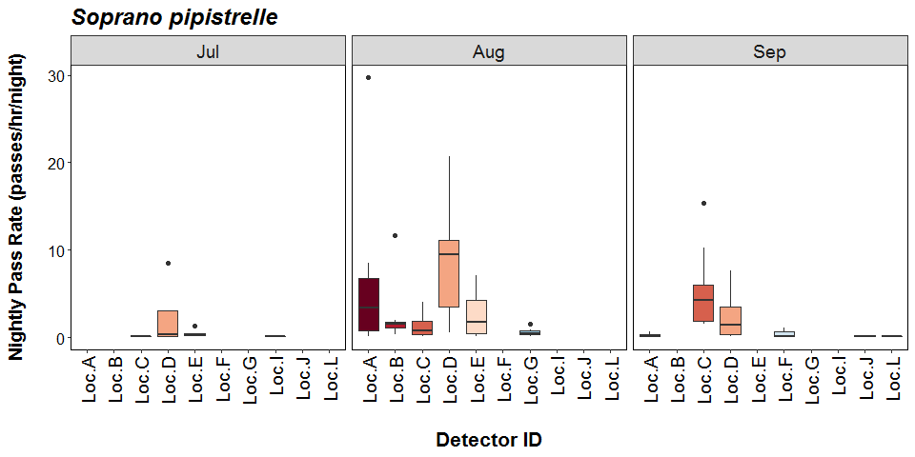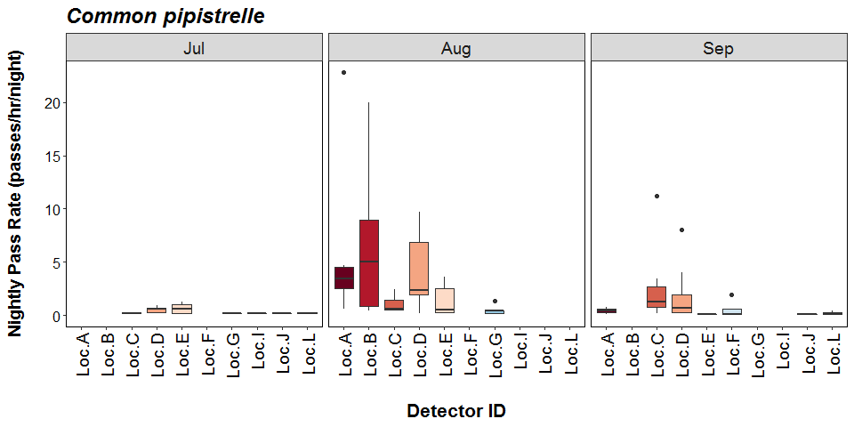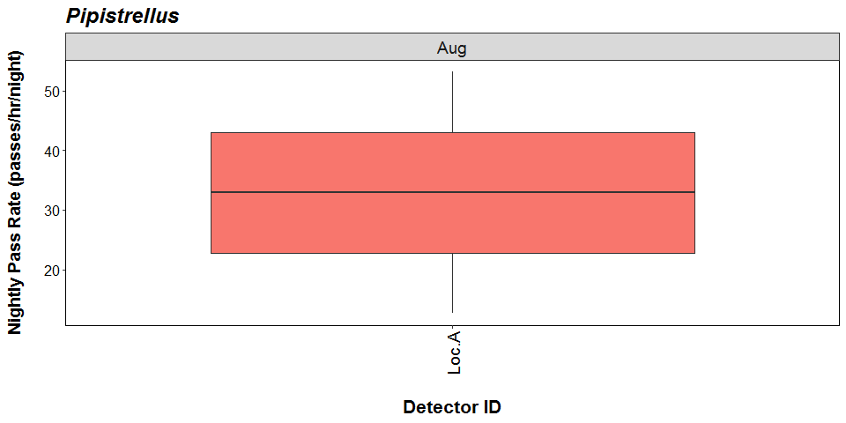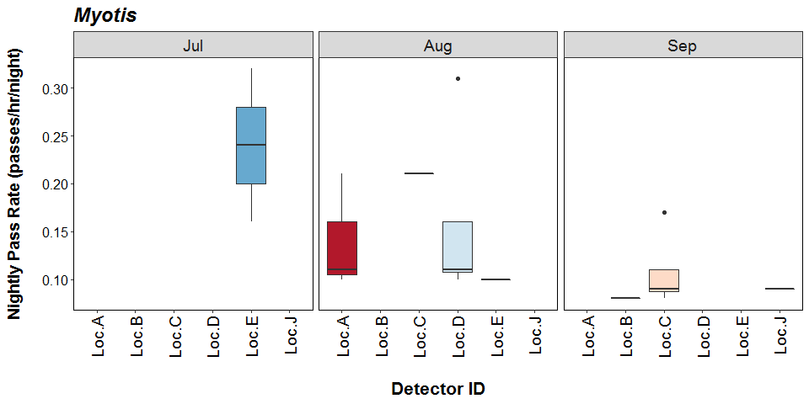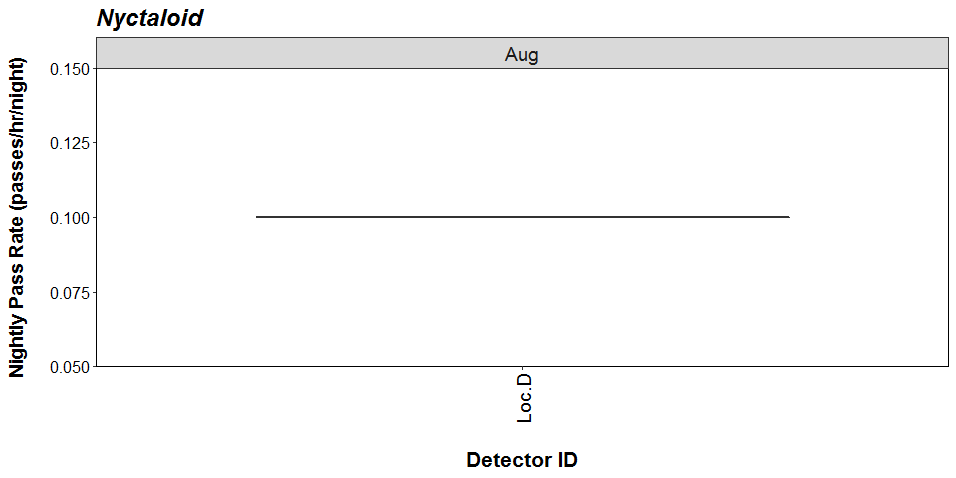

##### Page Break

# Bat Activity per Detector Location

**Figure 13.** Detector ID reference:

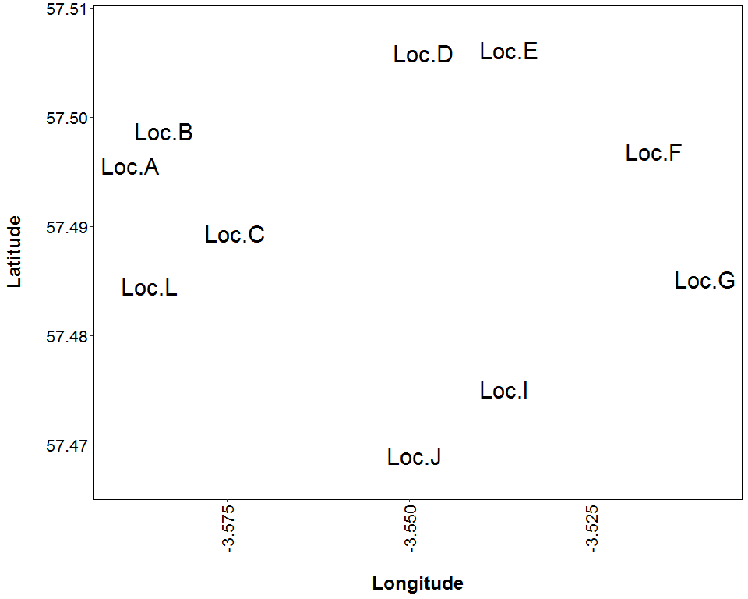

##### Page Break

**Figure 14.** Median Nightly Pass Rate (bat passes/hr/night) throughout the survey period - represented by the size and colour of the point at each detector location.

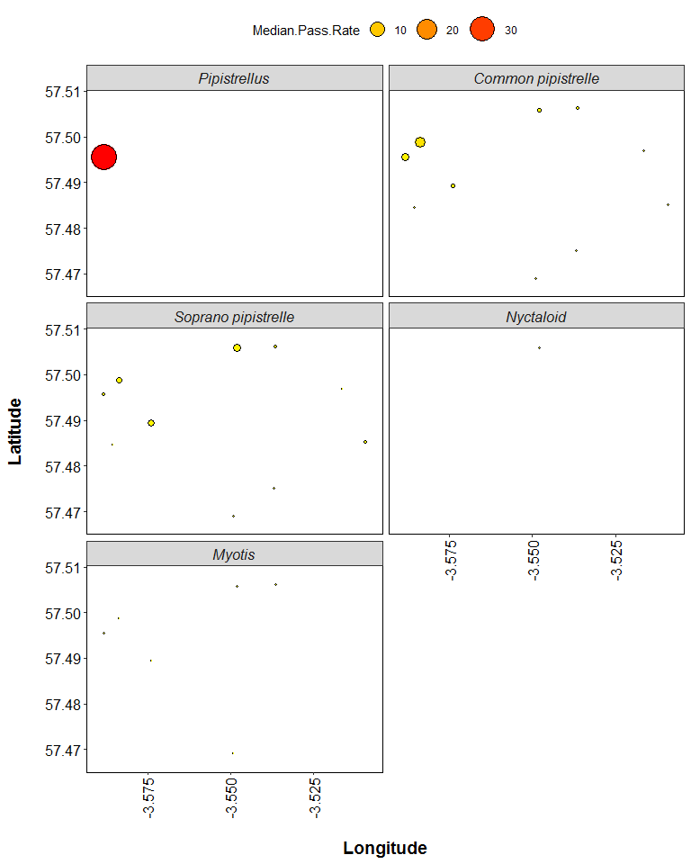

##### Page Break

**Figure 15.** Maximum Nightly Pass Rate (bat passes/hr/night) recorded in a single night throughout the survey period - represented by the size and colour of the point at each detector location.

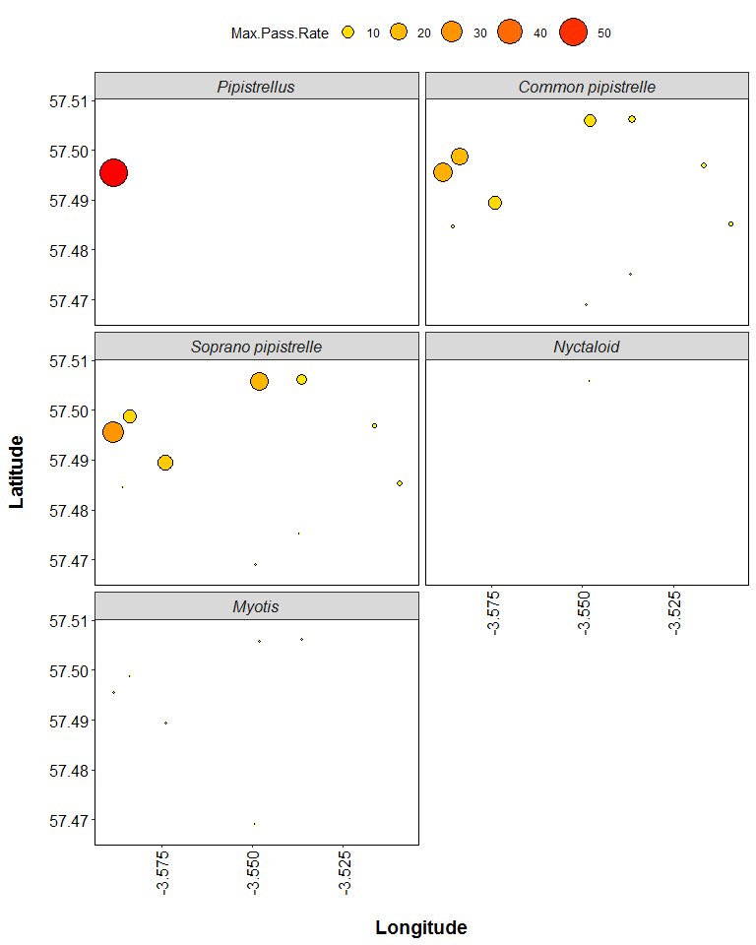

##### Page Break

## PART 2B: Includes absences

**THE NEXT SECTION OF THE REPORT FEATURES THE DATA SUPPLIED TO ECOBAT BUT TAKES INTO ACCOUNT SPECIES ABSENCES, AND THEREFORE INCLUDES ‘ZERO DATA’ FOR WHEN SPECIES WERE NOT DETECTED AT EACH DETECTOR ON A NIGHT. THIS DRAMATICALLY LOWERS THE MEANS AND MEDIANS OF THE DATA PRESENTED.**

##### Page Break

## Nightly Bat Pass Rate (Bat passes per hour)

# Median Per Detector

**The median Nightly Pass Rate (bat passes per hour, per night) of each species. If NA, then no bat passes.**

Bat pass rates are often highly variable between nights, with some nights having few or no passes and other nights having high activity. In these circumstances, the median is likely to be a more useful summary of the ‘average’ activity than is the mean. For further information see: *Lintott, P. R., & Mathews, F. (2018). Basic mathematical errors may make ecological assessments unreliable. Biodiversity and Conservation, 27(1), 265-267.* <https://doi.org/10.1007/s10531-017-1418-5>

|  |  |  |
| --- | --- | --- |
| Species | Detector ID | Median Pass Rate |
| Common pipistrelle | Loc.A | 0.7 |
| Common pipistrelle | Loc.B | 3.7 |
| Common pipistrelle | Loc.C | 0.5 |
| Common pipistrelle | Loc.D | 0.7 |
| Common pipistrelle | Loc.E | 0.3 |
| Common pipistrelle | Loc.F | 0.1 |
| Common pipistrelle | Loc.G | 0.2 |
| Common pipistrelle | Loc.I | 0.2 |
| Common pipistrelle | Loc.J | 0.1 |
| Common pipistrelle | Loc.L | 0.2 |
| Myotis | Loc.A | 0.0 |
| Myotis | Loc.B | 0.0 |
| Myotis | Loc.C | 0.0 |
| Myotis | Loc.D | 0.0 |
| Myotis | Loc.E | 0.0 |
| Myotis | Loc.F | 0.0 |
| Myotis | Loc.G | 0.0 |
| Myotis | Loc.I | 0.0 |
| Myotis | Loc.J | 0.0 |
| Myotis | Loc.L | 0.0 |
| Nyctaloid | Loc.A | 0.0 |
| Nyctaloid | Loc.B | 0.0 |
| Nyctaloid | Loc.C | 0.0 |
| Nyctaloid | Loc.D | 0.0 |
| Nyctaloid | Loc.E | 0.0 |
| Nyctaloid | Loc.F | 0.0 |
| Nyctaloid | Loc.G | 0.0 |
| Nyctaloid | Loc.I | 0.0 |
| Nyctaloid | Loc.J | 0.0 |
| Nyctaloid | Loc.L | 0.0 |
| Pipistrellus | Loc.A | 0.0 |
| Pipistrellus | Loc.B | 0.0 |
| Pipistrellus | Loc.C | 0.0 |
| Pipistrellus | Loc.D | 0.0 |
| Pipistrellus | Loc.E | 0.0 |
| Pipistrellus | Loc.F | 0.0 |
| Pipistrellus | Loc.G | 0.0 |
| Pipistrellus | Loc.I | 0.0 |
| Pipistrellus | Loc.J | 0.0 |
| Pipistrellus | Loc.L | 0.0 |
| Soprano pipistrelle | Loc.A | 0.5 |
| Soprano pipistrelle | Loc.B | 1.5 |
| Soprano pipistrelle | Loc.C | 1.7 |
| Soprano pipistrelle | Loc.D | 1.7 |
| Soprano pipistrelle | Loc.E | 0.3 |
| Soprano pipistrelle | Loc.F | 0.1 |
| Soprano pipistrelle | Loc.G | 0.3 |
| Soprano pipistrelle | Loc.I | 0.0 |
| Soprano pipistrelle | Loc.J | 0.1 |
| Soprano pipistrelle | Loc.L | 0.0 |

##### Page Break

## Nightly Bat Pass Rate (Bat passes per hour)

# Mean per Detector

**The mean Nightly Pass Rate (bat passes per hour, per night) of each species at each detector. Values are given to 1 decimal place.**

We recommend using the median values given above, for the reasons stated above, but provide the mean values in the table below.

|  |  |  |
| --- | --- | --- |
| Species | Detector ID | Mean Pass Rate |
| Common pipistrelle | Loc.A | 3.2 |
| Common pipistrelle | Loc.B | 5.7 |
| Common pipistrelle | Loc.C | 1.3 |
| Common pipistrelle | Loc.D | 2.2 |
| Common pipistrelle | Loc.E | 0.8 |
| Common pipistrelle | Loc.F | 0.4 |
| Common pipistrelle | Loc.G | 0.3 |
| Common pipistrelle | Loc.I | 0.1 |
| Common pipistrelle | Loc.J | 0.1 |
| Common pipistrelle | Loc.L | 0.2 |
| Myotis | Loc.A | 0.0 |
| Myotis | Loc.B | 0.0 |
| Myotis | Loc.C | 0.0 |
| Myotis | Loc.D | 0.0 |
| Myotis | Loc.E | 0.0 |
| Myotis | Loc.F | 0.0 |
| Myotis | Loc.G | 0.0 |
| Myotis | Loc.I | 0.0 |
| Myotis | Loc.J | 0.0 |
| Myotis | Loc.L | 0.0 |
| Nyctaloid | Loc.A | 0.0 |
| Nyctaloid | Loc.B | 0.0 |
| Nyctaloid | Loc.C | 0.0 |
| Nyctaloid | Loc.D | 0.0 |
| Nyctaloid | Loc.E | 0.0 |
| Nyctaloid | Loc.F | 0.0 |
| Nyctaloid | Loc.G | 0.0 |
| Nyctaloid | Loc.I | 0.0 |
| Nyctaloid | Loc.J | 0.0 |
| Nyctaloid | Loc.L | 0.0 |
| Pipistrellus | Loc.A | 5.5 |
| Pipistrellus | Loc.B | 0.0 |
| Pipistrellus | Loc.C | 0.0 |
| Pipistrellus | Loc.D | 0.0 |
| Pipistrellus | Loc.E | 0.0 |
| Pipistrellus | Loc.F | 0.0 |
| Pipistrellus | Loc.G | 0.0 |
| Pipistrellus | Loc.I | 0.0 |
| Pipistrellus | Loc.J | 0.0 |
| Pipistrellus | Loc.L | 0.0 |
| Soprano pipistrelle | Loc.A | 4.2 |
| Soprano pipistrelle | Loc.B | 2.1 |
| Soprano pipistrelle | Loc.C | 3.0 |
| Soprano pipistrelle | Loc.D | 4.0 |
| Soprano pipistrelle | Loc.E | 1.4 |
| Soprano pipistrelle | Loc.F | 0.4 |
| Soprano pipistrelle | Loc.G | 0.4 |
| Soprano pipistrelle | Loc.I | 0.0 |
| Soprano pipistrelle | Loc.J | 0.1 |
| Soprano pipistrelle | Loc.L | 0.0 |

##### Page Break

# Nightly Bat Passes (Bat passes per hour)

## Per Detector - Figures

**Figure 16.** Figures show boxplots for the number of bat passes per hour each night, for each detector. The ‘box’ shows the interquartile range, which is where the middle 50% of the data lie. The line dividing the box is the median, the mid-point of the data. The ‘whiskers’ extend from the box and represent the ranges for the bottom 25% and the top 25% of the data values, excluding outliers. An outlier is any extreme value that lies further away from the box than 1.5 times the interquartile range. Outliers are shown as dots. Where very few passes are recorded it is not possible to produce the box, so the data are shown as a line.

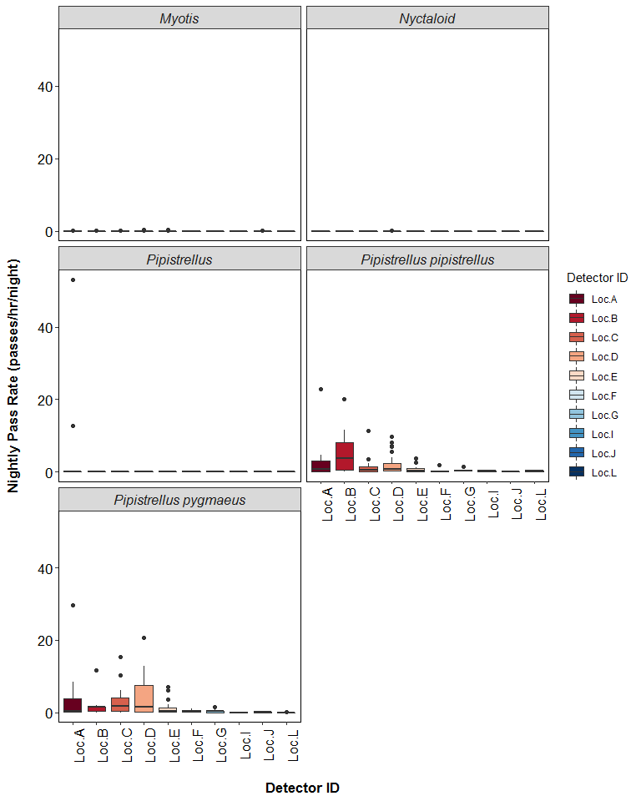

##### Page Break

# Survey Effort

**The number of survey nights per month per detector.**

|  |  |  |
| --- | --- | --- |
| Month | Detector ID | No of Survey Nights |
| Jul | Loc.C | 3 |
| Jul | Loc.D | 8 |
| Jul | Loc.E | 7 |
| Jul | Loc.G | 3 |
| Jul | Loc.I | 3 |
| Jul | Loc.J | 1 |
| Jul | Loc.L | 2 |
| Aug | Loc.A | 7 |
| Aug | Loc.B | 8 |
| Aug | Loc.C | 8 |
| Aug | Loc.D | 9 |
| Aug | Loc.E | 8 |
| Aug | Loc.G | 6 |
| Sep | Loc.A | 5 |
| Sep | Loc.B | 1 |
| Sep | Loc.C | 9 |
| Sep | Loc.D | 9 |
| Sep | Loc.E | 2 |
| Sep | Loc.F | 6 |
| Sep | Loc.J | 6 |
| Sep | Loc.L | 4 |

##### Page Break

## Nightly Bat Pass Rate for each Month

# Median Per Detector

**The median Nightly Pass Rate (bat passes per hour, per night) of each species throughout each month. If NA, then no bat passes.**

Bat pass rates are often highly variable between nights, with some nights having few or no passes and other nights having high activity. In these circumstances, the median is likely to be a more useful summary of the ‘average’ activity than is the mean. For further information see: *Lintott, P. R., & Mathews, F. (2018). Basic mathematical errors may make ecological assessments unreliable. Biodiversity and Conservation, 27(1), 265-267.* <https://doi.org/10.1007/s10531-017-1418-5>

|  |  |  |  |  |
| --- | --- | --- | --- | --- |
| Species | Detector ID | Aug | Jul | Sep |
| Common pipistrelle | Loc.A | 2.8 | NA | 0.1 |
| Common pipistrelle | Loc.B | 5.1 | NA | 0.0 |
| Common pipistrelle | Loc.C | 0.6 | 0.2 | 1.1 |
| Common pipistrelle | Loc.D | 2.4 | 0.6 | 0.7 |
| Common pipistrelle | Loc.E | 0.4 | 0.2 | 0.1 |
| Common pipistrelle | Loc.F | NA | NA | 0.1 |
| Common pipistrelle | Loc.G | 0.3 | 0.2 | NA |
| Common pipistrelle | Loc.I | NA | 0.2 | NA |
| Common pipistrelle | Loc.J | NA | 0.2 | 0.0 |
| Common pipistrelle | Loc.L | NA | 0.2 | 0.2 |
| Myotis | Loc.A | 0.0 | NA | 0.0 |
| Myotis | Loc.B | 0.0 | NA | 0.1 |
| Myotis | Loc.C | 0.0 | 0.0 | 0.0 |
| Myotis | Loc.D | 0.0 | 0.0 | 0.0 |
| Myotis | Loc.E | 0.0 | 0.0 | 0.0 |
| Myotis | Loc.F | NA | NA | 0.0 |
| Myotis | Loc.G | 0.0 | 0.0 | NA |
| Myotis | Loc.I | NA | 0.0 | NA |
| Myotis | Loc.J | NA | 0.0 | 0.0 |
| Myotis | Loc.L | NA | 0.0 | 0.0 |
| Nyctaloid | Loc.A | 0.0 | NA | 0.0 |
| Nyctaloid | Loc.B | 0.0 | NA | 0.0 |
| Nyctaloid | Loc.C | 0.0 | 0.0 | 0.0 |
| Nyctaloid | Loc.D | 0.0 | 0.0 | 0.0 |
| Nyctaloid | Loc.E | 0.0 | 0.0 | 0.0 |
| Nyctaloid | Loc.F | NA | NA | 0.0 |
| Nyctaloid | Loc.G | 0.0 | 0.0 | NA |
| Nyctaloid | Loc.I | NA | 0.0 | NA |
| Nyctaloid | Loc.J | NA | 0.0 | 0.0 |
| Nyctaloid | Loc.L | NA | 0.0 | 0.0 |
| Pipistrellus | Loc.A | 0.0 | NA | 0.0 |
| Pipistrellus | Loc.B | 0.0 | NA | 0.0 |
| Pipistrellus | Loc.C | 0.0 | 0.0 | 0.0 |
| Pipistrellus | Loc.D | 0.0 | 0.0 | 0.0 |
| Pipistrellus | Loc.E | 0.0 | 0.0 | 0.0 |
| Pipistrellus | Loc.F | NA | NA | 0.0 |
| Pipistrellus | Loc.G | 0.0 | 0.0 | NA |
| Pipistrellus | Loc.I | NA | 0.0 | NA |
| Pipistrellus | Loc.J | NA | 0.0 | 0.0 |
| Pipistrellus | Loc.L | NA | 0.0 | 0.0 |
| Soprano pipistrelle | Loc.A | 3.4 | NA | 0.3 |
| Soprano pipistrelle | Loc.B | 1.5 | NA | 0.0 |
| Soprano pipistrelle | Loc.C | 0.8 | 0.0 | 4.3 |
| Soprano pipistrelle | Loc.D | 8.6 | 0.2 | 1.0 |
| Soprano pipistrelle | Loc.E | 1.7 | 0.3 | 0.0 |
| Soprano pipistrelle | Loc.F | NA | NA | 0.1 |
| Soprano pipistrelle | Loc.G | 0.4 | 0.0 | NA |
| Soprano pipistrelle | Loc.I | NA | 0.0 | NA |
| Soprano pipistrelle | Loc.J | NA | 0.0 | 0.1 |
| Soprano pipistrelle | Loc.L | NA | 0.0 | 0.0 |

##### Page Break

## Nightly Bat Pass Rate for each Month

# Mean per Detector

**The mean Nightly Pass Rate (bat passes per hour, per night) of each species throughout each month. Values are given to 1 decimal place.**

We recommend using the median values given above, for the reasons stated above, but provide the mean values in the table below.

|  |  |  |  |  |
| --- | --- | --- | --- | --- |
| Species | Detector ID | Aug | Jul | Sep |
| Common pipistrelle | Loc.A | 5.3 | NA | 0.3 |
| Common pipistrelle | Loc.B | 6.5 | NA | 0.0 |
| Common pipistrelle | Loc.C | 0.8 | 0.2 | 2.2 |
| Common pipistrelle | Loc.D | 4.0 | 0.5 | 1.9 |
| Common pipistrelle | Loc.E | 1.3 | 0.5 | 0.1 |
| Common pipistrelle | Loc.F | NA | NA | 0.4 |
| Common pipistrelle | Loc.G | 0.4 | 0.2 | NA |
| Common pipistrelle | Loc.I | NA | 0.1 | NA |
| Common pipistrelle | Loc.J | NA | 0.2 | 0.1 |
| Common pipistrelle | Loc.L | NA | 0.2 | 0.2 |
| Myotis | Loc.A | 0.1 | NA | 0.0 |
| Myotis | Loc.B | 0.0 | NA | 0.1 |
| Myotis | Loc.C | 0.0 | 0.0 | 0.0 |
| Myotis | Loc.D | 0.1 | 0.0 | 0.0 |
| Myotis | Loc.E | 0.0 | 0.1 | 0.0 |
| Myotis | Loc.F | NA | NA | 0.0 |
| Myotis | Loc.G | 0.0 | 0.0 | NA |
| Myotis | Loc.I | NA | 0.0 | NA |
| Myotis | Loc.J | NA | 0.0 | 0.0 |
| Myotis | Loc.L | NA | 0.0 | 0.0 |
| Nyctaloid | Loc.A | 0.0 | NA | 0.0 |
| Nyctaloid | Loc.B | 0.0 | NA | 0.0 |
| Nyctaloid | Loc.C | 0.0 | 0.0 | 0.0 |
| Nyctaloid | Loc.D | 0.0 | 0.0 | 0.0 |
| Nyctaloid | Loc.E | 0.0 | 0.0 | 0.0 |
| Nyctaloid | Loc.F | NA | NA | 0.0 |
| Nyctaloid | Loc.G | 0.0 | 0.0 | NA |
| Nyctaloid | Loc.I | NA | 0.0 | NA |
| Nyctaloid | Loc.J | NA | 0.0 | 0.0 |
| Nyctaloid | Loc.L | NA | 0.0 | 0.0 |
| Pipistrellus | Loc.A | 9.4 | NA | 0.0 |
| Pipistrellus | Loc.B | 0.0 | NA | 0.0 |
| Pipistrellus | Loc.C | 0.0 | 0.0 | 0.0 |
| Pipistrellus | Loc.D | 0.0 | 0.0 | 0.0 |
| Pipistrellus | Loc.E | 0.0 | 0.0 | 0.0 |
| Pipistrellus | Loc.F | NA | NA | 0.0 |
| Pipistrellus | Loc.G | 0.0 | 0.0 | NA |
| Pipistrellus | Loc.I | NA | 0.0 | NA |
| Pipistrellus | Loc.J | NA | 0.0 | 0.0 |
| Pipistrellus | Loc.L | NA | 0.0 | 0.0 |
| Soprano pipistrelle | Loc.A | 6.9 | NA | 0.3 |
| Soprano pipistrelle | Loc.B | 2.4 | NA | 0.0 |
| Soprano pipistrelle | Loc.C | 1.4 | 0.1 | 5.3 |
| Soprano pipistrelle | Loc.D | 7.7 | 1.9 | 2.3 |
| Soprano pipistrelle | Loc.E | 2.7 | 0.4 | 0.0 |
| Soprano pipistrelle | Loc.F | NA | NA | 0.4 |
| Soprano pipistrelle | Loc.G | 0.6 | 0.0 | NA |
| Soprano pipistrelle | Loc.I | NA | 0.0 | NA |
| Soprano pipistrelle | Loc.J | NA | 0.0 | 0.1 |
| Soprano pipistrelle | Loc.L | NA | 0.0 | 0.0 |

##### Page Break

## Nightly Bat Pass Rate for each Month

## Per Detector - Figures

**Figure 17.** Figures show boxplots for the number of bat passes per hour by detector, for each month. The ‘box’ shows the interquartile range, which is where the middle 50% of the data lie. The line dividing the box is the median, the mid-point of the data. The ‘whiskers’ extend from the box and represent the ranges for the bottom 25% and the top 25% of the data values, excluding outliers. An outlier is any extreme value that lies further away from the box than 1.5 times the interquartile range. Outliers are shown as dots. Where very few passes are recorded it is not possible to produce the box, so the data are shown as a line.

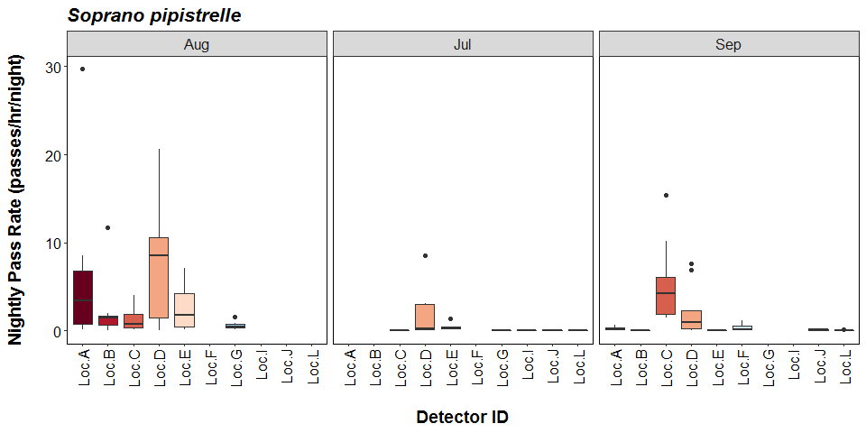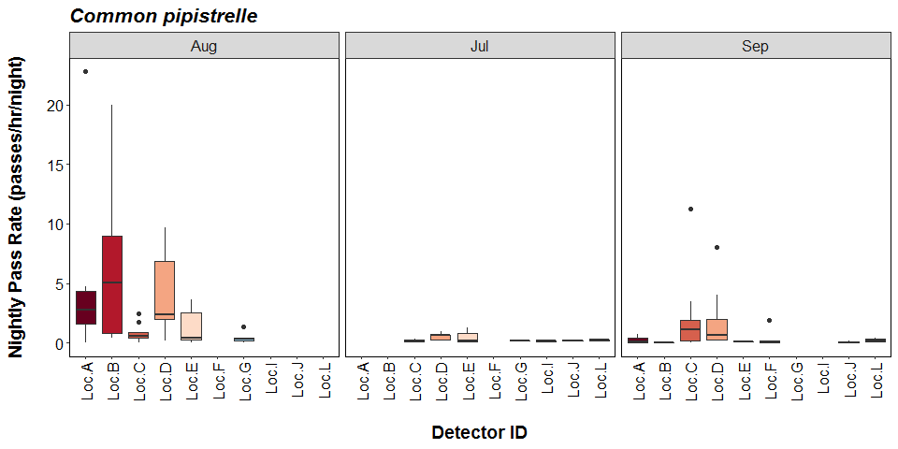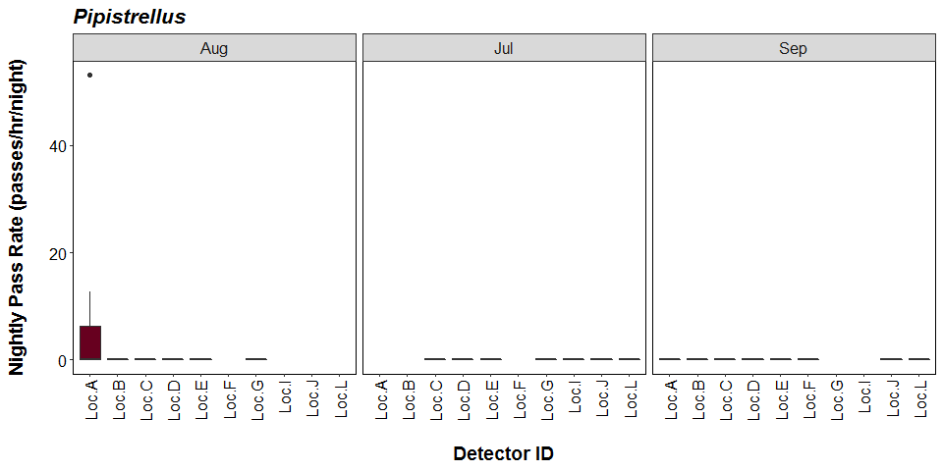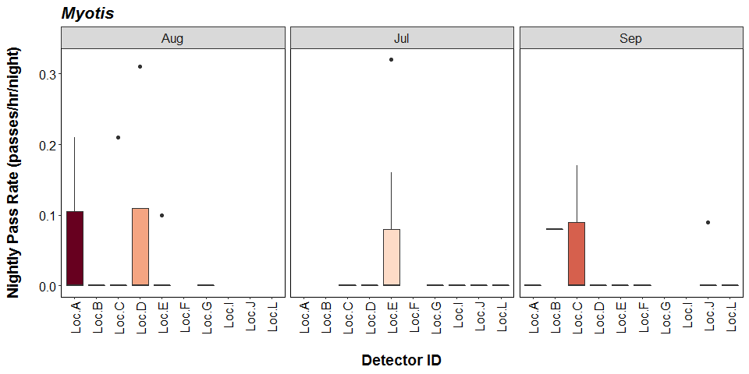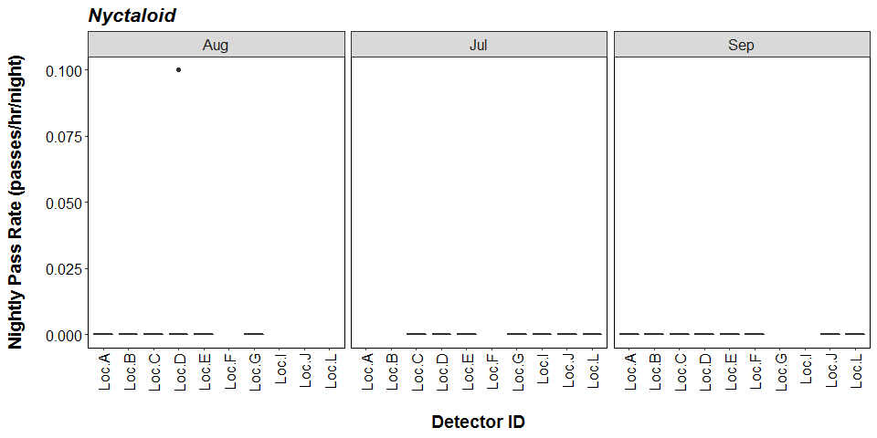

##### Page Break

# Bat Activity per Detector Location

**Figure 18.** Detector ID reference:

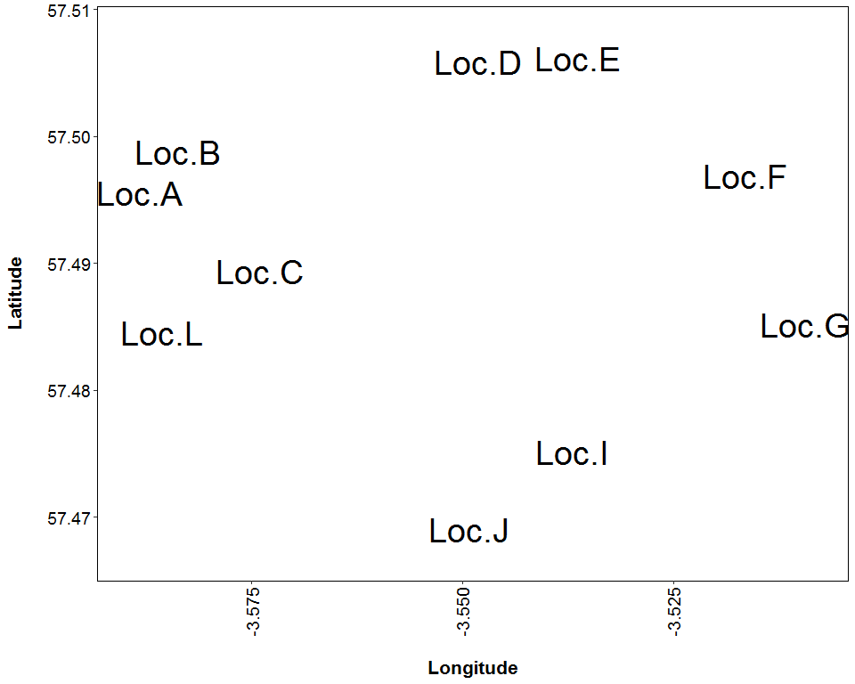

##### Page Break

**Figure 19.** Median Nightly Pass Rate (bat passes/hr/night) throughout the survey period - represented by the size and colour of the point at each detector location.

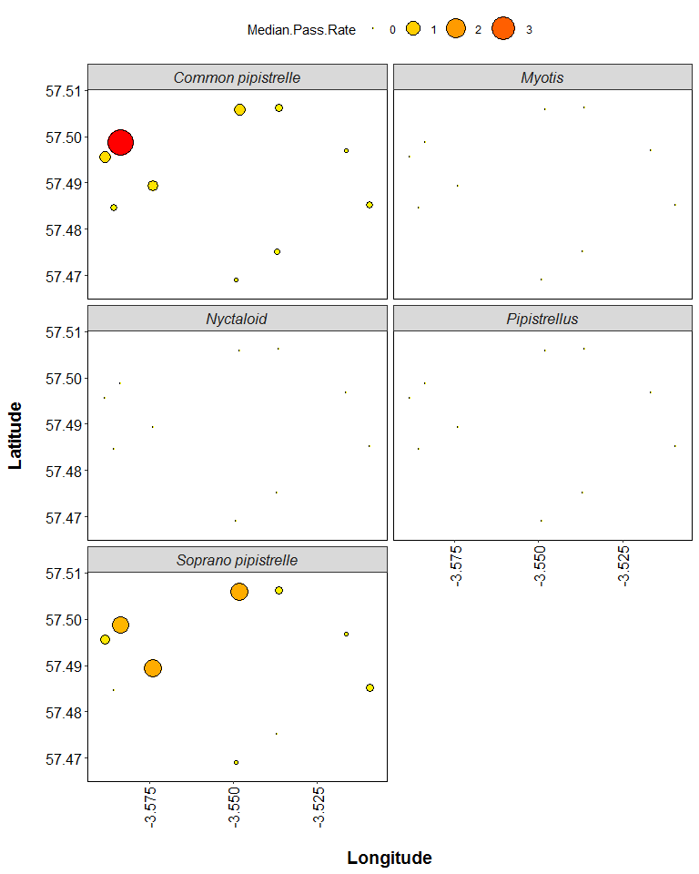

##### Page Break

**Figure 20.** Maximum Nightly Pass Rate (bat passes/hr/night) recorded in a single night throughout the survey period - represented by the size and colour of the point at each detector location.

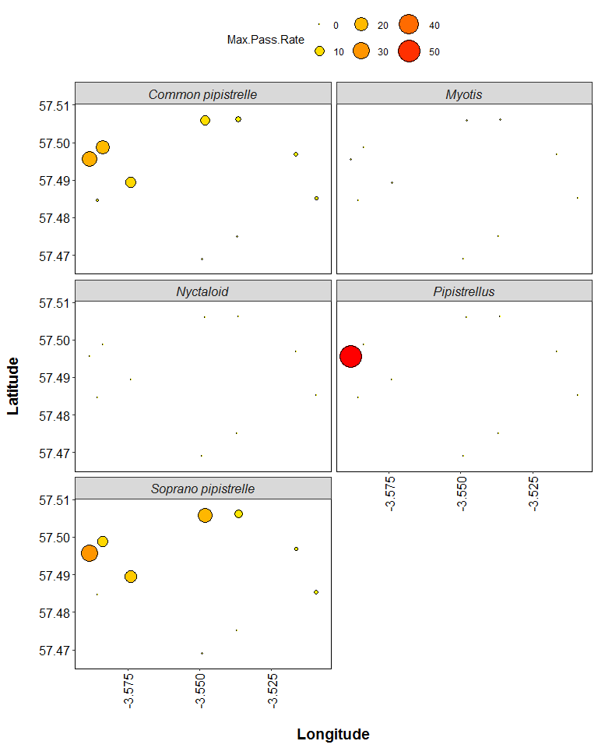

**Thank you for using Ecobat! If you have any questions please email** [**info@themammalsociety.org.uk**](mailto:info@themammalsociety.org.uk)