Ecobat Bat Activity Analysis

Site Name: NA

NA

04/11/2019

### Summary

Bat surveys were conducted at STC, for 60 nights between 2018-06-14 and 2019-05-20, using Elekon static bat detectors. The maximum of passes recorded in a single night was 1644 passes, and 11 species were recorded.

The reference range dataset was stratified to include:

* Only records from within 30 days of the survey date.
* Only records from within 100km2 of the survey location.
* Records using any make of bat detector.

#### Table 1

Summary table showing the number of nights recorded bat activity fell into each activity band for each species.

|  |  |  |  |  |  |  |
| --- | --- | --- | --- | --- | --- | --- |
| Location | Species/Species Group | Nights of High Activity | Nights of Moderate/ High Activity | Nights of Moderate Activity | Nights of Low/ Moderate Activity | Nights of Low Activity |
| STC | *Eptesicus serotinus* | 1 | 13 | 15 | 11 | 3 |
| STC | *Myotis* | 0 | 3 | 17 | 8 | 15 |
| STC | *Nyctaloid* | 4 | 3 | 1 | 0 | 0 |
| STC | *Nyctalus* | 0 | 7 | 7 | 6 | 1 |
| STC | *Nyctalus noctula* | 0 | 4 | 3 | 5 | 8 |
| STC | *Pipistrellus nathusii* | 0 | 0 | 0 | 1 | 1 |
| STC | *Pipistrellus pipistrellus* | 31 | 20 | 1 | 3 | 3 |
| STC | *Pipistrellus pygmaeus* | 3 | 16 | 17 | 8 | 8 |
| STC | *Plecotus* | 0 | 0 | 0 | 1 | 8 |
| STC | *Rhinolophus ferrumequinum* | 5 | 15 | 9 | 8 | 8 |
| STC | *Rhinolophus hipposideros* | 0 | 0 | 0 | 4 | 9 |

#### Table 2

Summary table showing key metrics for each species recorded.

|  |  |  |  |  |  |  |
| --- | --- | --- | --- | --- | --- | --- |
| Location | Species/Species Group | Median Percentile | 95% CIs | Max Percentile | Nights Recorded | Reference Range |
| STC | *Eptesicus serotinus* | 49 | 43 - 56 | 81 | 43 | 575 |
| STC | *Myotis* | 36 | 39.5 - 51 | 71 | 43 | 1029 |
| STC | *Nyctaloid* | 78 | 62 - 85.5 | 87 | 8 | 1419 |
| STC | *Nyctalus* | 43 | 42 - 60.5 | 79 | 21 | 1017 |
| STC | *Nyctalus noctula* | 25 | 36 - 60 | 68 | 20 | 972 |
| STC | *Pipistrellus nathusii* | 13 | 12.5 - 12.5 | 25 | 2 | 51 |
| STC | *Pipistrellus pipistrellus* | 81 | 78 - 85.5 | 100 | 58 | 1511 |
| STC | *Pipistrellus pygmaeus* | 52 | 50.5 - 61 | 91 | 52 | 738 |
| STC | *Plecotus* | 0 | 0 - 0 | 36 | 9 | 373 |
| STC | *Rhinolophus ferrumequinum* | 52 | 52 - 65 | 87 | 45 | 458 |
| STC | *Rhinolophus hipposideros* | 0 | 25 - 25 | 36 | 13 | 804 |

### Figures

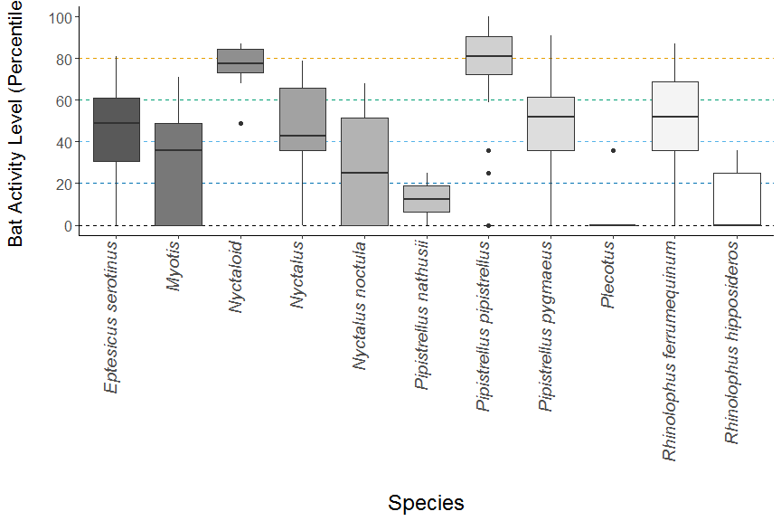

**Figure 1.** The recorded activity of bats during the survey. The centre line indicates the median activity level whereas the box represents the interquartile range (the spread of the middle 50% of nights of activity)

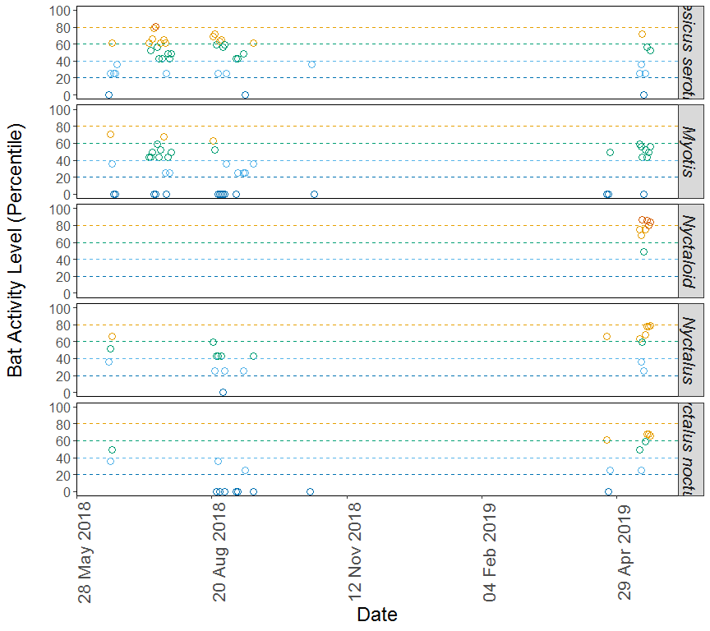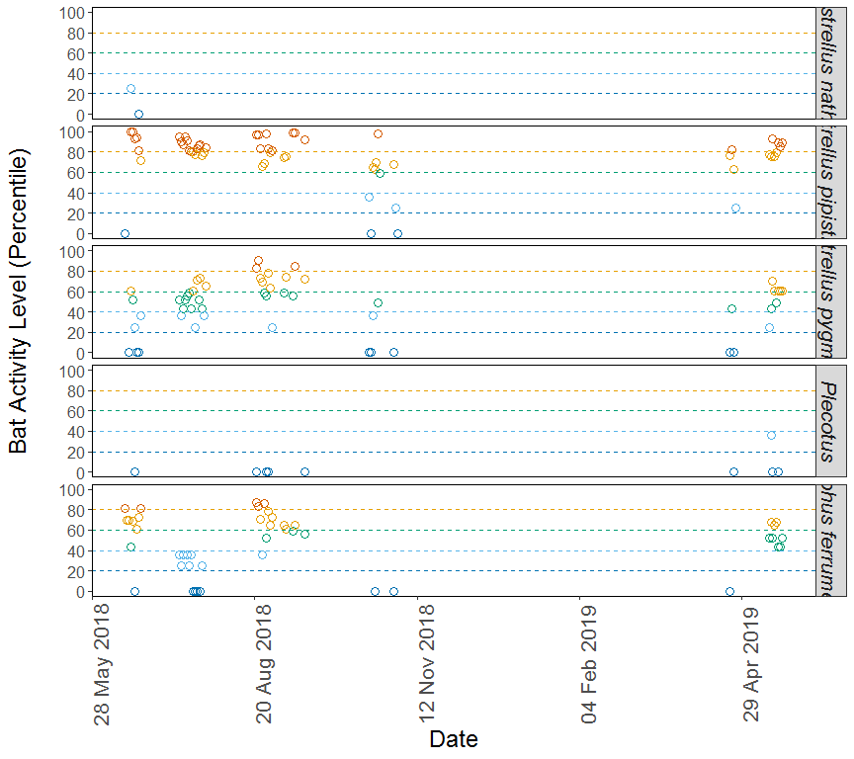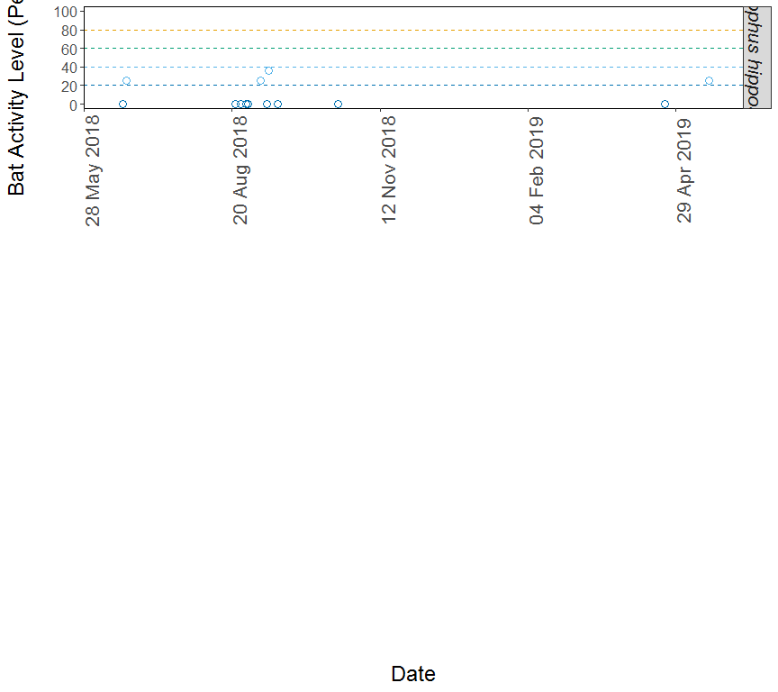

**Figure 2.** The activity level (percentile) of bats recorded across each night of the bat survey, split by species.