

Universit´e Hassiba Benbouali - Chlef Facult´e des Sciences Exactes et Informatiques

D´epartement d’Informatique

Spécialité : Informatique

PROF : MHAMED HADJ HENNI

PROJET : CREATION UN SITE WEB SUJET : GESTION DE RENDEZ-VOUS

## Réalisé par :

**DARMECH MAMMAR**

**GUENDAZ ABD-ELHADI**

## GROUPE : 04

**Année universitaire 2024/2025**

**Summarize**

1. Project Introduction & Goals
2. Programing Langauge Used
3. Brief Explanation & Testing
4. Conclusion

**Project Analysis Report: MediSchedule**

1. **Overview**

**MediSchedule** is a web-based medical appointment scheduling system designed for doctors and patients. The project uses:

* **Frontend:** HTML, CSS, JavaScript, Bootstrap
* **Backend:** PHP, MySQL
* **Security:** Session-based authentication, form validation

1. **Objectives**

* **Simplify Appointment Booking**: Allow patients to easily schedule appointments with doctors based on specialty, location, and availability.
* **Efficient Management**: Enable both patients and doctors to manage appointments, including rescheduling and cancellations.
* **User-Friendly Interface**: Provide an intuitive interface for seamless interaction between users and the system.

1. **Repository Structure**

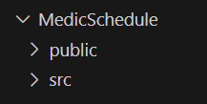

* **Frontend Files**: Contains CSS, and JavaScript files and HTML scripts for the user interface.

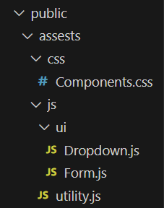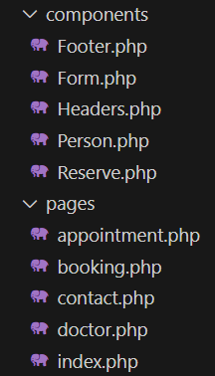

* **Backend Scripts**: PHP scripts handling server-side logic and database interactions.

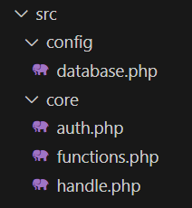

* **Database Schema**: SQL files defining the structure of the database.

**( SQL Script Is in the project folder )**

[Visualize DB Diagram](https://dbdiagram.io/d/MediSchedule-681b5d925b2fc4582f9a93ee)

[Visulaize Website](https://www.figma.com/design/QevEkpxRV6aiAhxWHaNtRk/Untitled?node-id=0-1&t=sdFcHdgBKV22tmbi-1)

HOW TO USE THE WEBSITE ?

* 1. Create an account

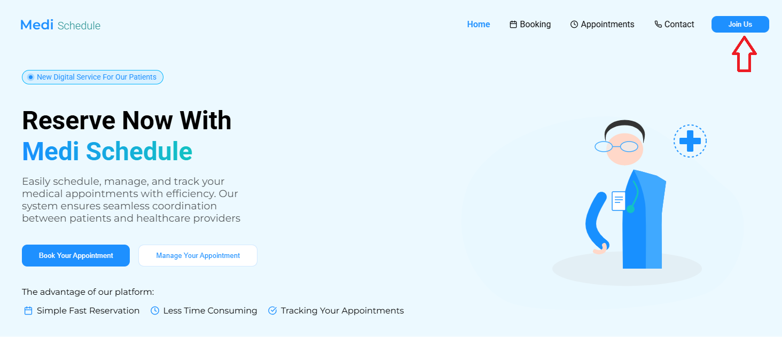

Fill the empty inputs

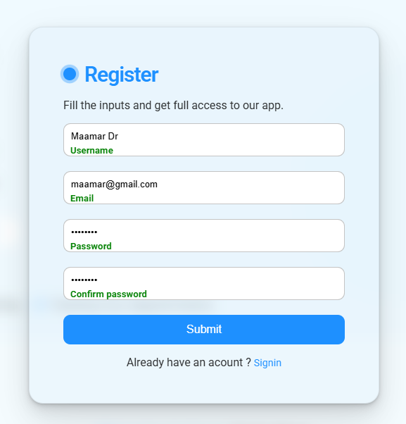

* 1. Add your personal information

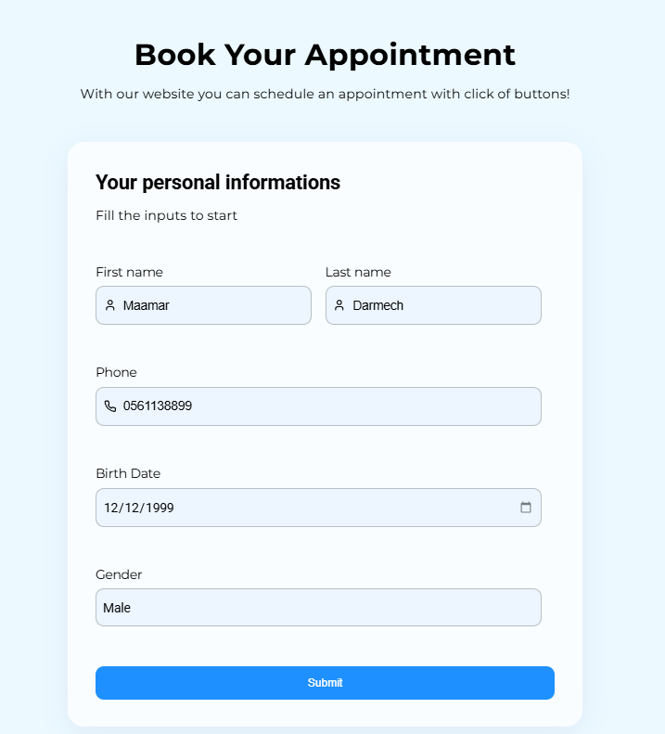

* 1. Book your appointment by choosing date and time

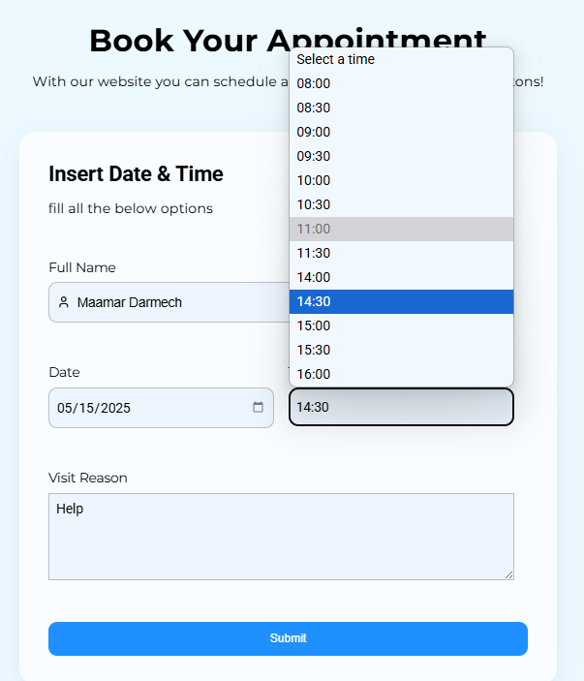

* 1. Confirm that you have pending appointment

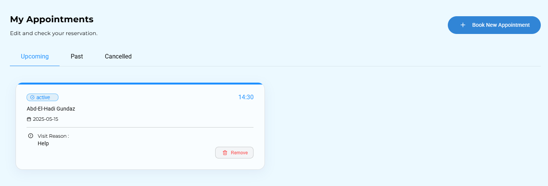

1. After the visit doctor will confirm the appointment or cancel it if u miss it

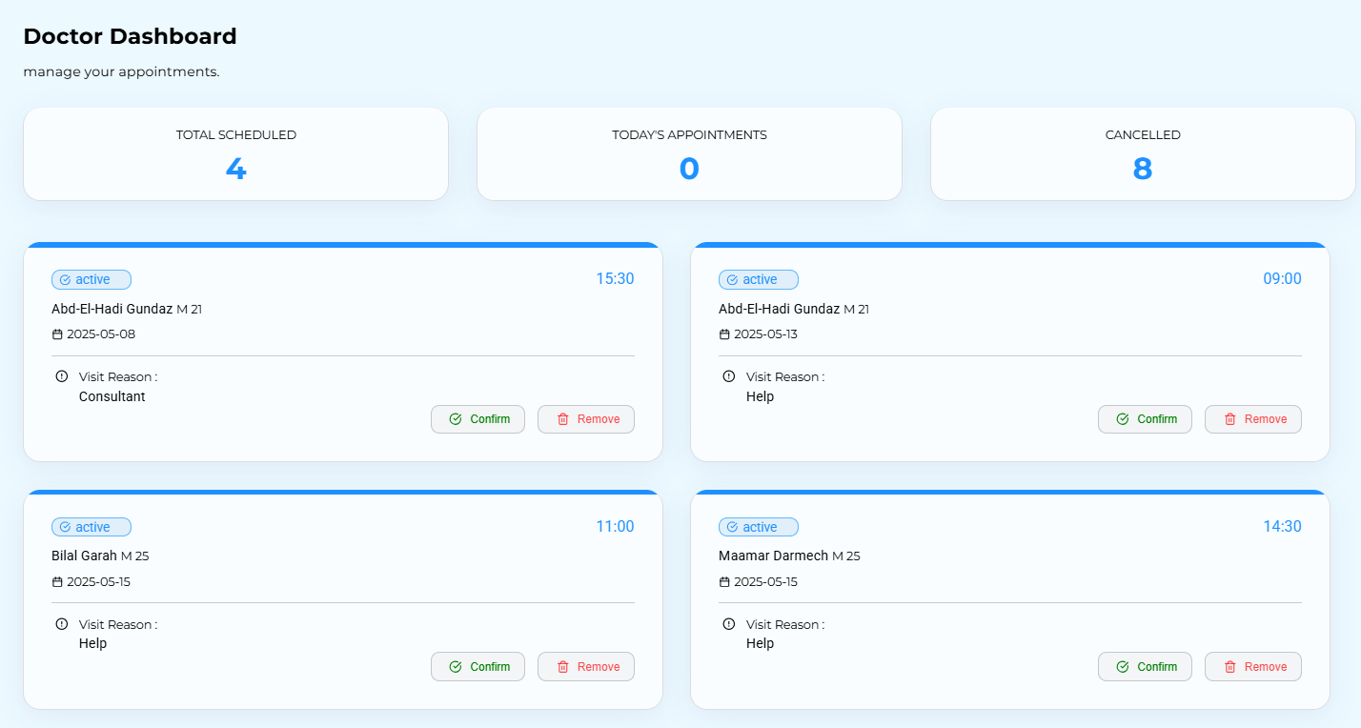

1. It should be like this after confirmation

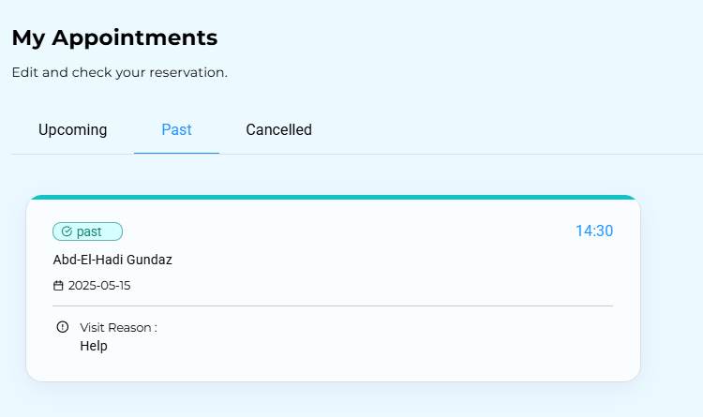

For Testing :

Doctor account :

doctor@gmail.com

Doctor123

User account :

[mohamed@gmail.com](mailto:mohamed@gmail.com)

12345678

**Conclusion:**

This project represents a significant step forward in the digitalization of healthcare systems, offering a comprehensive solution for managing medical appointments with high efficiency. By simplifying appointment scheduling for patients and enabling doctors to easily manage their schedules, the application helps improve the quality of medical services while saving time and effort.