11/17/2025

SYSTEM REQUIREMENT & DESIGN DIAGRAM

231662 – Mamoona
231659 – Maheen Fatima
231617 – Huzaifa Yasir Khan
Table of Contents
1. Introduction & Problem Statement 3
2. Proposed Solution 3
3. Requirements 4
• Functional Requirements (User Stories) 4
• Non-Functional Requirements 10
4. System Design & Artifacts 12
• Class Diagram 12
• Activity Diagram 13
• Architecture Diagram 14
• ERD of the system. 15
• Use Case Diagram 16
• System Sequence Diagram 24
• Sequence Diagram 0
• Domain Model 6
• Deployment Diagram 7
• Package Diagram 8
• Component Diagram 9

Table of Figures
s
Figure 1 - Class diagram 12
Figure 2 - activity diagram 13
Figure 3 - architecture diagram 14
Figure 4 – ERD 15
Figure 5 - usecase 16
Figure 6 - register account ssd 24
Figure 7 - login ssd 0
Figure 8 - logout ssd 0
Figure 9 - searchmovie via tmdbapi ssd 0
Figure 10 - add/update/remove from watchlist ssd 0
Figure 11 - watchtrailer ssd 0
Figure 12 - view streaming platforms ssd 0
Figure 13 - submit / edit / delete review 0
Figure 14 - manage users / reviews / watchlists 0
Figure 15 - purchase plans/ screens ssd 1
Figure 16 - apply age/ genre restrictions 1
Figure 17 - view plans ssd 1
Figure 18 - log user activity and api calls ssd 1
Figure 19 - register account sequence 0
Figure 20 - login sequence 0
Figure 21 - logout sequence 1
Figure 22 - search movie via tmdb api sequence 1
Figure 23 - add/ update / remove from watchlist sequence 2
Figure 24 - watch trailer sequence 2
Figure 25 - submit / edit / delete review sequence 3
Figure 26 - view streaming platforms sequence 3
Figure 27 - manage user / review / watchlist sequence 4
Figure 28 - apply age / genre restrictions sequence 4
Figure 29 - view plans sequence 5
Figure 30 - log user activity and api calls sequence 5
Figure 31 - purchase plan/ screen sequence 6
Figure 32 - domain model diagram 6
Figure 33 - Deployment diagram 7
Figure 34 - Package Diagram 8
Figure 35 - component diagram 9

1. Introduction & Problem Statement
Context: In today’s digital entertainment landscape viewers use multiple streaming platforms, often forgetting titles they wanted to watch, being unsure where a movie streams, and lacking a single personalized hub to manage watchlists and preferences.
Problem Statement:
- Users forget titles and lose track of movies across platforms.
- It is hard to know where a movie is streaming at any given time.
- No unified, free, highly-personalized solution exists that combines search, streaming availability, watchlist management, trailers, and parental controls in one place.
Goal: Build CinaVerse, a full-stack web application that integrates with TMDb (and JustWatch fallback), provides centralized watchlist & review management, streaming availability, parental & age filters, authentication, screens/subscriptions management, and logging/auditing.

2. Proposed Solution
CinaVerse will be a web application with:
- Frontend: React or Vue.js (SPA)
- Backend: Node.js or Express (RESTful services)
- Database: PostgreSQL (or SQLite for small-scale)
- External Integrations: TMDb API for movie data; JustWatch as fallback for streaming availability
- Features: Search, movie details, trailers, watchlist CRUD, reviews, user auth, admin panel, parental controls, screen purchase/plan management, logs (login/API usage)

3. Requirements

Functional Requirements (User Stories)
FR-1: User Registration
- Actor: Visitor / User
- User Story: As a visitor, I want to register an account, so that I can create a personal profile and access watchlists and premium features.
- Preconditions: User is not logged in; registration page is accessible
- Postconditions (Success):
  - Account created in database
  - Confirmation email sent
  - User redirected to dashboard
- Postconditions (Failure):
  - Account not created
  - Error message displayed (e.g., email already exists)

FR-2: User Login / Authentication
- Actor: User
- User Story: As a user, I want to log in securely, so that my personal watchlist and account remain private.
- Preconditions: User has a registered account; login page accessible
- Postconditions (Success):
  - User session created
  - Dashboard displayed
  - Login activity logged
- Postconditions (Failure):
  - User remains logged out
  - Error message displayed (wrong credentials)

FR-3: User Logout
- Actor: User
- User Story: As a user, I want to log out to terminate my session.
- Preconditions: User is logged in
- Postconditions (Success):
  - Session terminated
  - User redirected to home page
  - Logout logged in system
- Postconditions (Failure):
  - Session remains active
  - Error message displayed

FR-4: Fetch Movie via API (TMDb)
- Actor: User
- User Story: As a user, I want to search movies and fetch details via TMDb API, so that I can view information about any movie.
- Preconditions: User logged in; TMDb API accessible
- Postconditions (Success):
  - Movie details displayed (title, poster, description, cast, rating, genres, trailer link)
  - API usage logged
- Postconditions (Failure):
  - Movie details not loaded
  - Error message displayed (API unavailable or rate limit exceeded)

FR-5: Watch Movie Trailer / Demo Video
- Actor: User
- User Story: As a user, I want to watch a movie trailer or demo video via API, so I can preview the movie before adding it to my watchlist.
- Preconditions: Movie selected; video API or YouTube link available
- Postconditions (Success):
  - Video plays in embedded player
  - User can pause, resume, or stop
  - Watch activity logged
- Postconditions (Failure):
  - Video does not play
  - Error message displayed
Only trailers or sample videos can be streamed. Full movie streaming requires licensing.

FR-6: Add / Update / Remove Movies from Watchlist
- Actor: User
- User Story: As a user, I want to manage my watchlist, so I can track movies I want to watch.
- Preconditions: User logged in; movie selected
- Postconditions (Success):
  - Movie added, removed, or updated with status (watched/unwatched)
  - Changes logged
- Postconditions (Failure):
  - Operation fails
  - Error message displayed

FR-7: Submit / View / Delete Reviews
- Actor: User
- User Story: As a user, I want to post reviews and see others’ reviews, so I can share opinions and make decisions.
- Preconditions: User logged in; movie selected
- Postconditions (Success):
  - Review posted, edited, or deleted
  - Aggregated ratings updated
  - Actions logged
- Postconditions (Failure):
  - Review not saved or deleted
  - Error displayed

FR-8: View Streaming Availability
- Actor: User
- User Story: As a user, I want to see where a movie is streaming, so I know which platforms offer it.
- Preconditions: Movie selected; streaming availability API accessible
- Postconditions (Success):
  - Platforms displayed (Netflix, Prime, Disney+, rental options)
  - API call logged
- Postconditions (Failure):
  - Streaming platforms not displayed
  - Error message shown

FR-9: Admin Panel
- Actor: Admin
- User Story: As an admin, I want to manage users, reviews, watchlists, and analytics, so I can moderate content and monitor activity.
- Preconditions: Admin logged in; admin rights verified
- Postconditions (Success):
  - Users, reviews, and watchlists can be managed
  - Analytics accessible
  - Admin actions logged
- Postconditions (Failure):
  - Action blocked
  - Error message displayed

FR-10: Parent / Age Filter Panel
- Actor: Parent
- User Story: As a parent, I want to set age or genre restrictions, so children only see appropriate content.
- Preconditions: Parent account logged in; parental settings page accessible
- Postconditions (Success):
  - Restrictions applied to child accounts
  - Settings logged
- Postconditions (Failure):
  - Restrictions not applied
  - Warning displayed

FR-11: View Available Plans (Subscription / Screens)
- Actor: User
- User Story: As a user, I want to view available subscription plans or “screens” so that I can choose a suitable plan.
- Preconditions: User logged in; plans page accessible
- Postconditions (Success):
  - List of available plans displayed with features and pricing
  - Plans retrieved from database/API
- Postconditions (Failure):
  - Plans not displayed
  - Error message shown

FR-12: Purchase Plan / Screen (Subscription / Stripe API)
- Actor: User
- User Story: As a user, I want to purchase a subscription plan so I can unlock premium features such as additional watchlist capacity, parental filters, or analytics access.
- Preconditions: User logged in; Stripe payment gateway accessible
- Postconditions (Success):
  - Payment processed successfully
  - Premium features unlocked
  - Purchase logged
- Postconditions (Failure):
  - Payment failed
  - Features not unlocked
  - Error displayed

FR-13: Logging & Analytics
- Actor: Admin / Developer
- User Story: As a system admin, I want to log user activity, API calls, and watchlist/review changes, so I can audit the system and detect abuse.
- Preconditions: Logging service active
- Postconditions (Success):
  - Activities recorded securely in database
  - Logs accessible to admin
- Postconditions (Failure):
  - Logs not recorded
  - Admin notified

Non-Functional Requirements
NFR-1: Security
- Description: Protect user accounts, API keys, and payment information.
- Metric / Success: Password hashing, JWT sessions, Stripe PCI compliance.
- Failure / Risk: Data leak, unauthorized access.

NFR-2: Performance
- Description: System should be responsive for all user operations.
- Metric / Success: API calls <500ms; watchlist operations fast.
- Failure / Risk: Lag, slow API responses, poor UX.
NFR-3: Availability
- Description: The app should be accessible to users at all times.
- Metric / Success: 99% uptime for core features.
- Failure / Risk: Downtime, features inaccessible to users.

NFR-4: Scalability
- Description: System should support many concurrent users.
- Metric / Success: Modular backend enabling horizontal scaling.
- Failure / Risk: System slows down or crashes under high load.

NFR-5: Privacy
- Description: Comply with applicable privacy laws.
- Metric / Success: Minimal personal data stored; GDPR/CCPA compliant.
- Failure / Risk: Privacy breach, non-compliance penalties.

NFR-6: Usability
- Description: The application should be user-friendly and accessible.
- Metric / Success: Mobile-first responsive UI, accessible forms (a11y).
- Failure / Risk: Layout breaks on devices; confusing forms; poor UX.

NFR-7: Maintainability
- Description: The system should be easy to maintain and update.
- Metric / Success: Well-documented REST APIs, UML diagrams.
- Failure / Risk: Hard to maintain, undocumented code, slow updates.
NFR-8: Logging & Audit
- Description: Track and audit user and system actions.
- Metric / Success: Logs for login, API usage, watchlist, reviews.
- Failure / Risk: Missing or incomplete logs; poor audit trail.

NFR-9: Reliability
- Description: The system should handle errors gracefully and continue operation.
- Metric / Success: Errors handled properly; retries on API failures.
- Failure / Risk: Crashes, unhandled exceptions, data inconsistency.

4. System Design & Artifacts

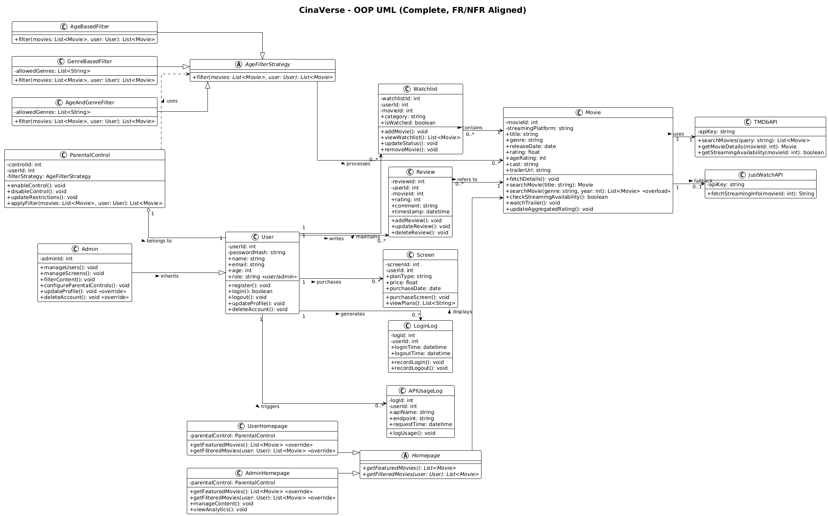
Class Diagram
Figure 1 - Class diagram

Activity Diagram
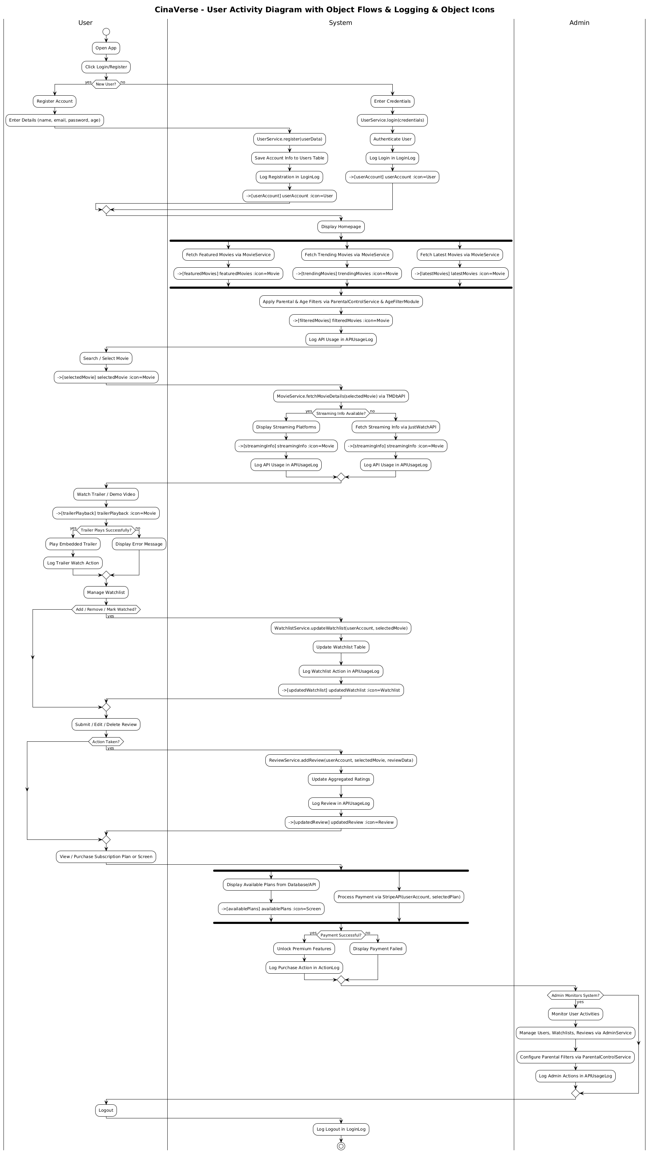
Figure 2 - activity diagram

Architecture Diagram
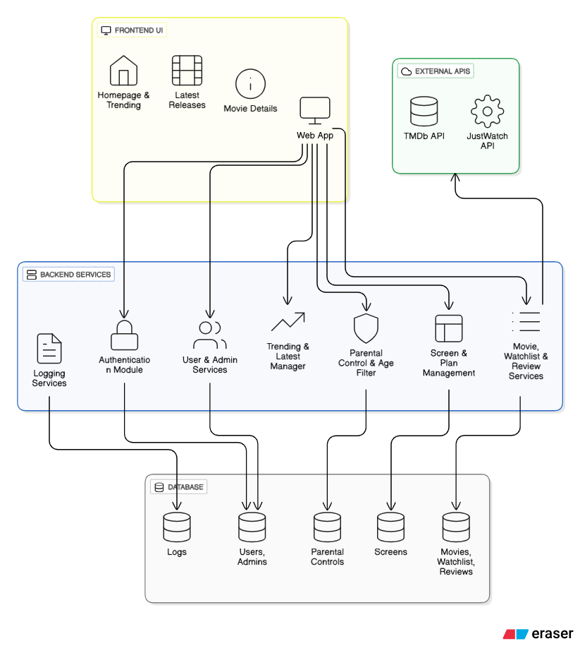
Figure 3 - architecture diagram
Microservices Architecture is used, the overall system's backend is decomposed into multiple, small, independent services (like the Authentication Module, Parental Control & Age Filter, and Movie, Watchlist & Review Services), each owning its distinct data store and operating independently. This structure allows for decoupled development, deployment, and scaling of individual functions. We can use the Model-View-Controller (MVC) pattern within each of these individual services and the frontend component.

ERD of the system.

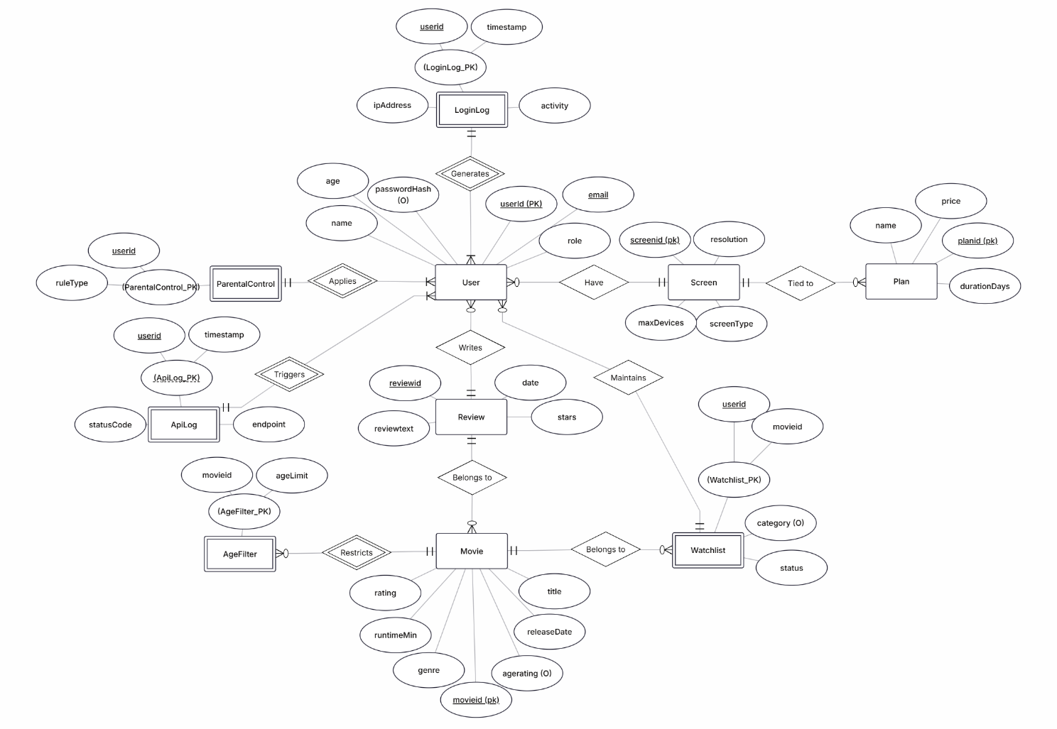
Figure 4 – ERD

Use Case Diagram
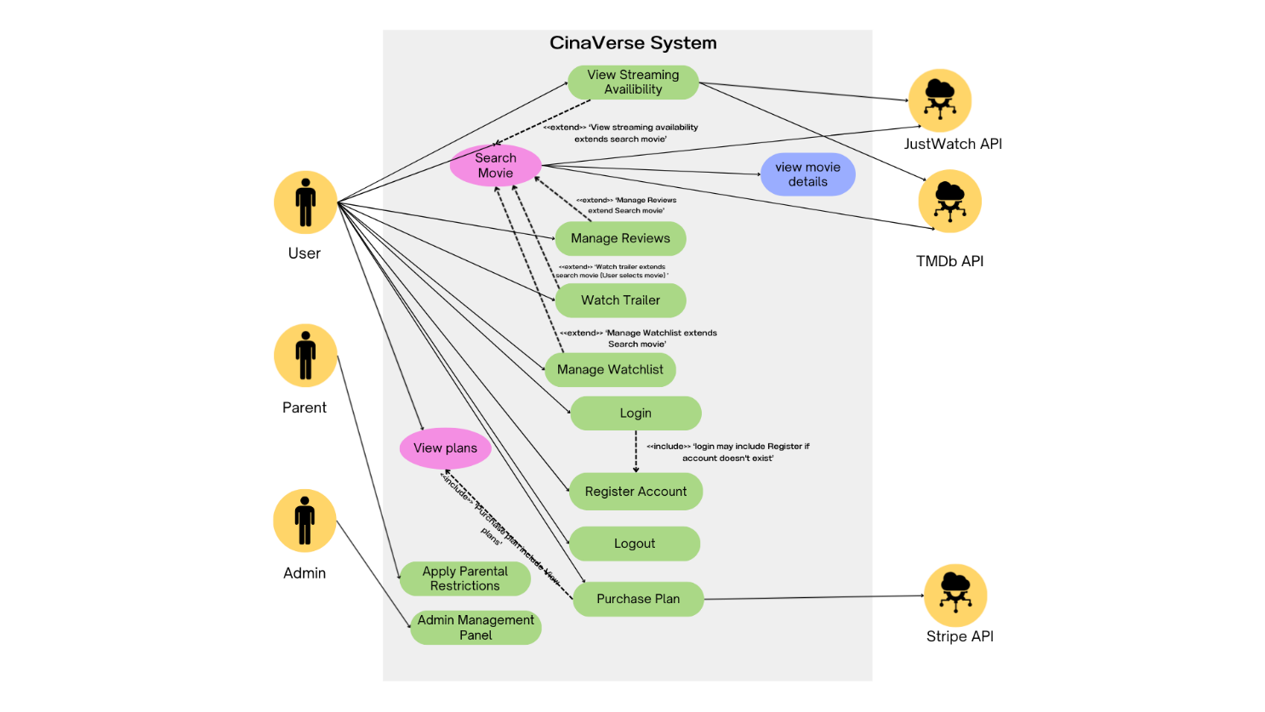
Figure 5 - usecase
UC-01: Register Account (FR-1)
Primary Actor: User
Preconditions:
- User is not already registered
- System is available
Postconditions (Success):
- New user account is created
- User data is saved in the database
Postconditions (Failure):
- Account is not created
- Error message is displayed
Main System Flow:
- User selects the "Register" option
- System displays the registration form
- User enters required details
- User submits the form
- System validates the data
- System creates the account
- System shows confirmation message
Alternate Flows:
- 3a. If email already exists → System displays error message
Exceptions:
- Database connection failure
- Server timeout

UC-02: Login (FR-2)
Primary Actor: User
Preconditions:
- User account exists
Postconditions (Success):
- User is authenticated
- User session is created
Postconditions (Failure):
- Access is denied
- Error message is displayed
Main System Flow:
- User opens the login page
- User enters username and password
- System verifies credentials
- System grants access
Alternate Flows:
- 3a. Invalid credentials → System prompts retry
Exceptions:
- Account locked after multiple failed attempts
UC-03: Logout (FR-3)
Primary Actor: User
Preconditions:
- User is logged in
Postconditions (Success):
- User session is terminated
Postconditions (Failure):
- Session remains active
Main System Flow:
- User clicks the logout button
- System terminates the session
- System redirects to homepage
Alternate Flows:
- 2a. Session already expired → System redirects to login
Exceptions:
- Session storage error

UC-04: Search Movie (FR-4)
Primary Actor: User
Preconditions:
- User is logged in
Postconditions (Success):
- Movie search results are displayed
Postconditions (Failure):
- No results are shown
Main System Flow:
- User enters a movie name
- System sends request to TMDb API
- System receives search results
- System displays results
Alternate Flows:
- 2a. No results found → System displays “No results found”
Exceptions:
- External API timeout

UC-05: Watch Trailer (FR-5)
Primary Actor: User
Preconditions:
- User has selected a movie
Postconditions (Success):
- Trailer video is played
Postconditions (Failure):
- Trailer does not play
Main System Flow:
- User clicks “Watch Trailer”
- System loads video player
- System streams the trailer
Alternate Flows:
- 2a. Trailer unavailable → System displays message
Exceptions:
- Video streaming error

UC-06: Manage Watchlist (FR-6)
Primary Actor: User
Preconditions:
- User is logged in
Postconditions (Success):
- Watchlist is updated
Postconditions (Failure):
- Watchlist remains unchanged
Main System Flow:
- User selects a movie
- User chooses add/update/remove
- System updates watchlist in database
Alternate Flows:
- 2a. Movie already exists in watchlist → System notifies user
Exceptions:
- Database write failure

UC-07: Manage Reviews (FR-7)
Primary Actor: User
Preconditions:
- User is logged in
- A movie is selected
Postconditions (Success):
- Review is saved/edited/deleted
Postconditions (Failure):
- Review is not modified
Main System Flow:
- User opens review section
- User writes or edits a review
- User submits the review
- System stores the review
Alternate Flows:
- 3a. Empty review → System displays validation error
Exceptions:
- Database error
UC-08: View Streaming Platforms (FR-8)
Primary Actor: User
Preconditions:
- A movie is selected
Postconditions (Success):
- List of streaming platforms is displayed
Postconditions (Failure):
- Platform list is not displayed
Main System Flow:
- User clicks “View Streaming Options”
- System sends request to JustWatch API
- System receives data
- System displays platforms
Alternate Flows:
- 2a. No platforms available → System displays message
Exceptions:
- API service failure

UC-09: Manage Users/Reviews/Watchlists (FR-9)
Primary Actor: Admin
Preconditions:
- Admin is logged in
Postconditions (Success):
- Selected data is successfully managed
Postconditions (Failure):
- No data changes are saved
Main System Flow:
- Admin opens admin dashboard
- Admin selects a management option
- Admin performs edit/delete actions
- System saves changes
Alternate Flows:
- 2a. Invalid selection → System shows error
Exceptions:
- Database failure

UC-10: Apply Age/Genre Restrictions (FR-10)
Primary Actor: Parent
Preconditions:
- Parent account is logged in
Postconditions (Success):
- Restrictions are saved and enforced
Postconditions (Failure):
- Restrictions are not applied
Main System Flow:
- Parent opens parental control settings
- Parent selects age and genre restrictions
- System validates the settings
- System saves the restrictions
Alternate Flows:
- 2a. Invalid age range → System shows warning
Exceptions:
- Configuration save failure

UC-11: View Plans (FR-11)
Primary Actor: User
Preconditions:
- User is logged in
Postconditions (Success):
- Subscription plans are displayed
Postconditions (Failure):
- Plans are not loaded
Main System Flow:
- User navigates to plans page
- System retrieves available plans
- System shows plans
Alternate Flows:
- 2a. No plans available → System displays message
Exceptions:
- Service retrieval error

UC-12: Purchase Plan/Screens (FR-12)
Primary Actor: User
Preconditions:
- User is logged in
- A plan is selected
Postconditions (Success):
- Subscription is activated
Postconditions (Failure):
- Payment fails and subscription is not activated
Main System Flow:
- User selects a subscription plan
- System redirects to payment gateway
- User completes payment
- System confirms payment
- System activates subscription
Alternate Flows:
- 3a. User cancels payment → System cancels process
Exceptions:
- Payment gateway error

UC-13: Log User Activity & API Calls (FR-13)
Primary Actor: Admin
Preconditions:
- System is operational
Postconditions (Success):
- Activity is recorded in logs
Postconditions (Failure):
- Log entry is not saved
Main System Flow:
- System captures user activity
- System stores log entry
- Admin can view logs
Alternate Flows:
- 2a. Log storage full → System rotates logs
Exceptions:
- Log database failure

System Sequence Diagram
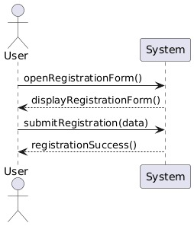
Figure 6 - register account ssd

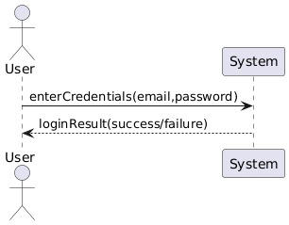
Figure 7 - login ssd
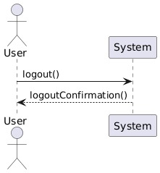
Figure 8 - logout ssd
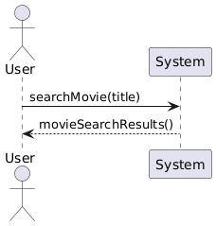
Figure 9 - searchmovie via tmdbapi ssd
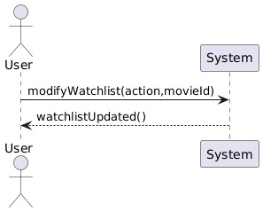
Figure 10 - add/update/remove from watchlist ssd
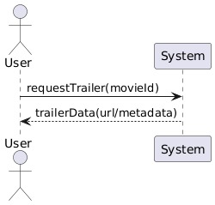
Figure 11 - watchtrailer ssd
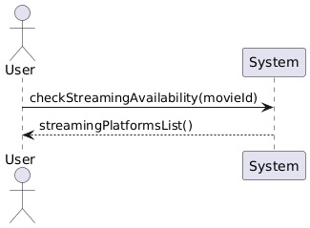
Figure 12 - view streaming platforms ssd
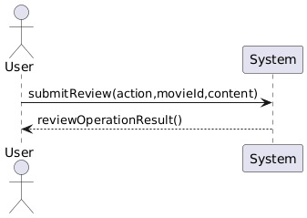
Figure 13 - submit / edit / delete review
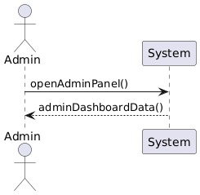
Figure 14 - manage users / reviews / watchlists
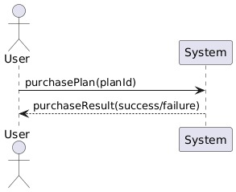
Figure 15 - purchase plans/ screens ssd
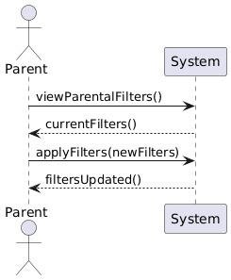
Figure 16 - apply age/ genre restrictions
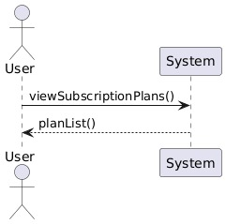
Figure 17 - view plans ssd

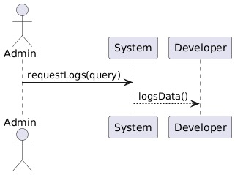
Figure 18 - log user activity and api calls ssd

Sequence Diagram
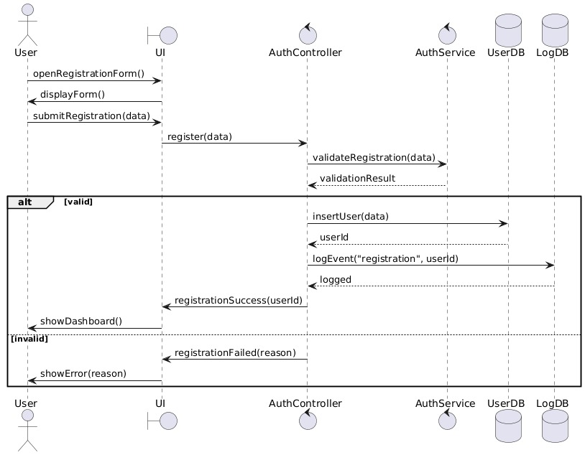
Figure 19 - register account sequence
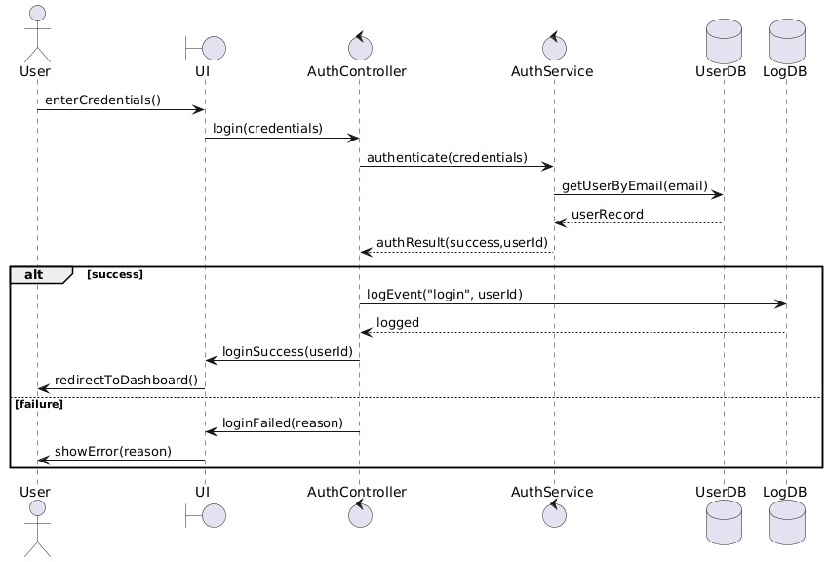
Figure 20 - login sequence
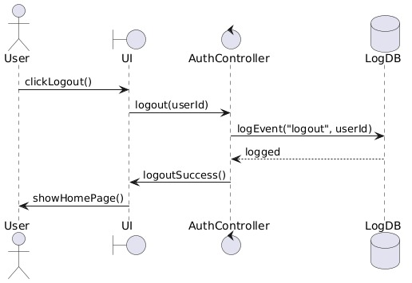
Figure 21 - logout sequence
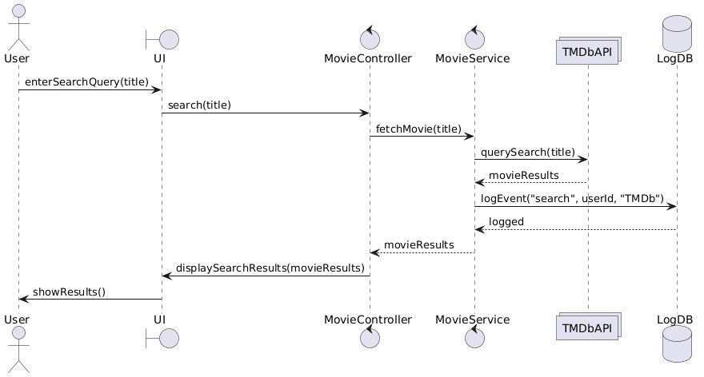
Figure 22 - search movie via tmdb api sequence
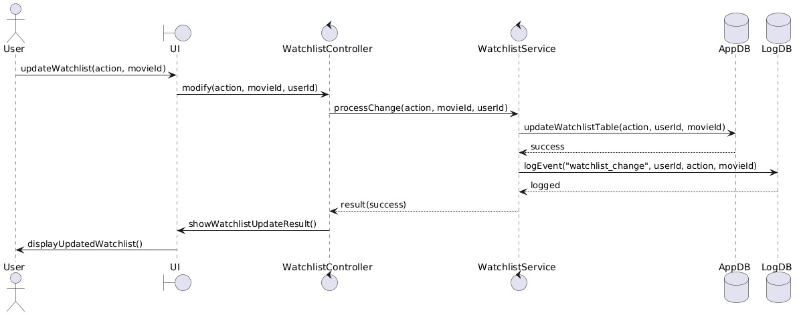
Figure 23 - add/ update / remove from watchlist sequence
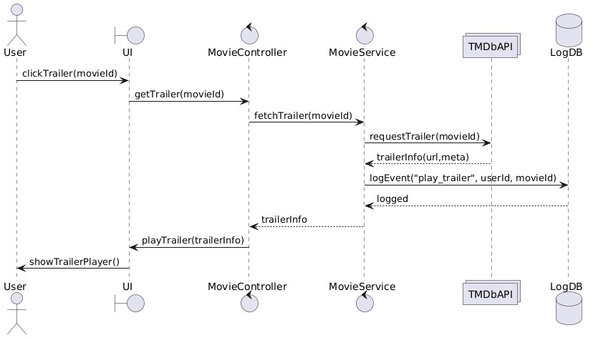
Figure 24 - watch trailer sequence
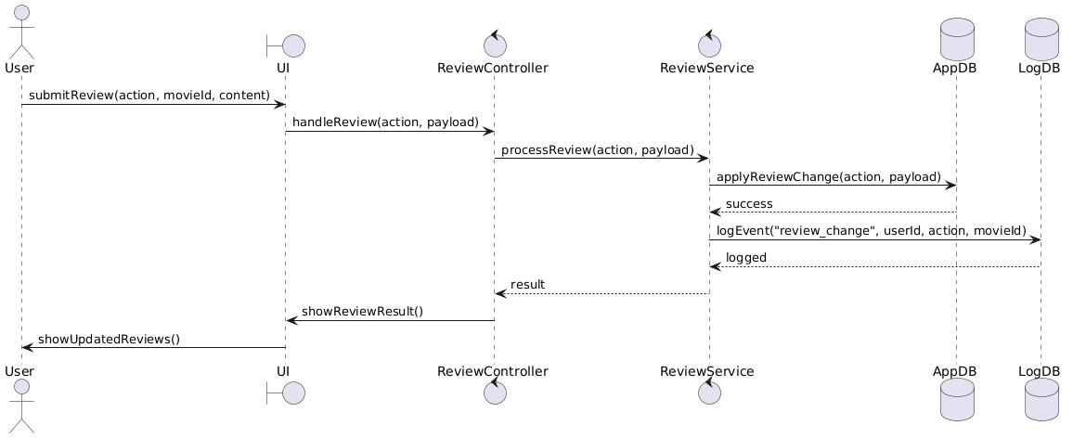
Figure 25 - submit / edit / delete review sequence
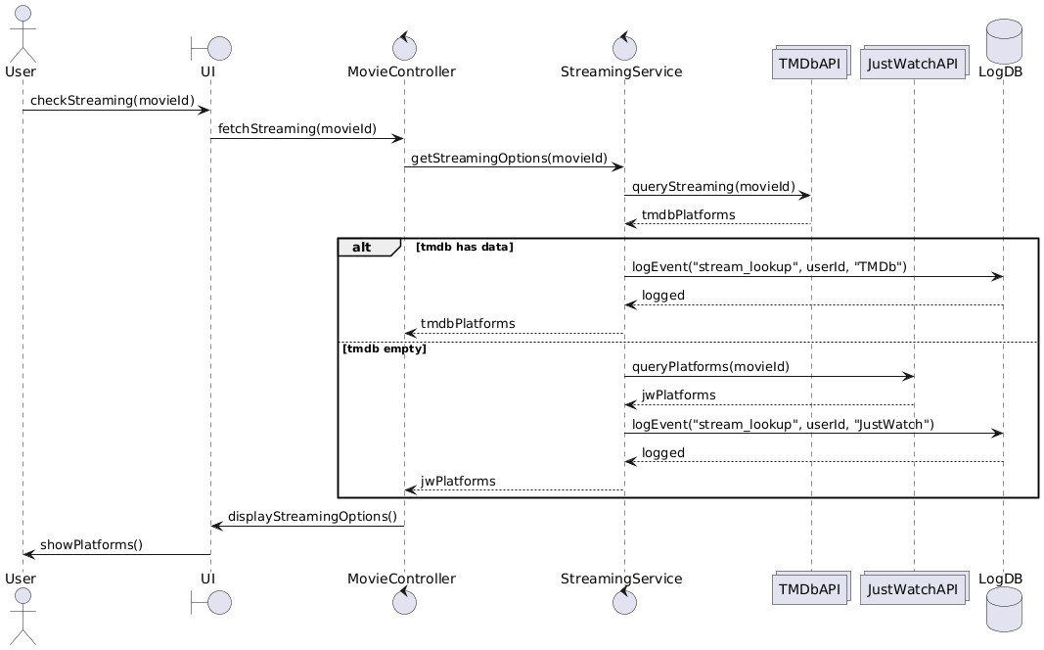
Figure 26 - view streaming platforms sequence
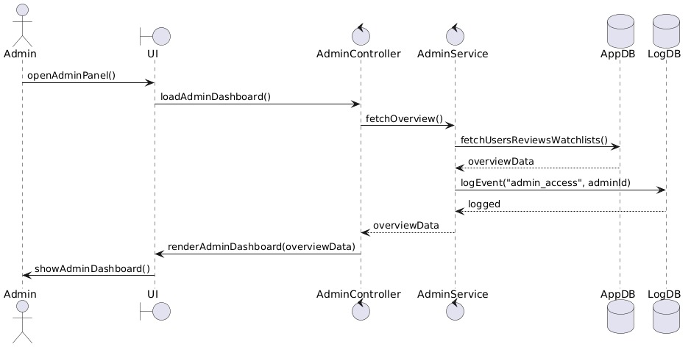
Figure 27 - manage user / review / watchlist sequence
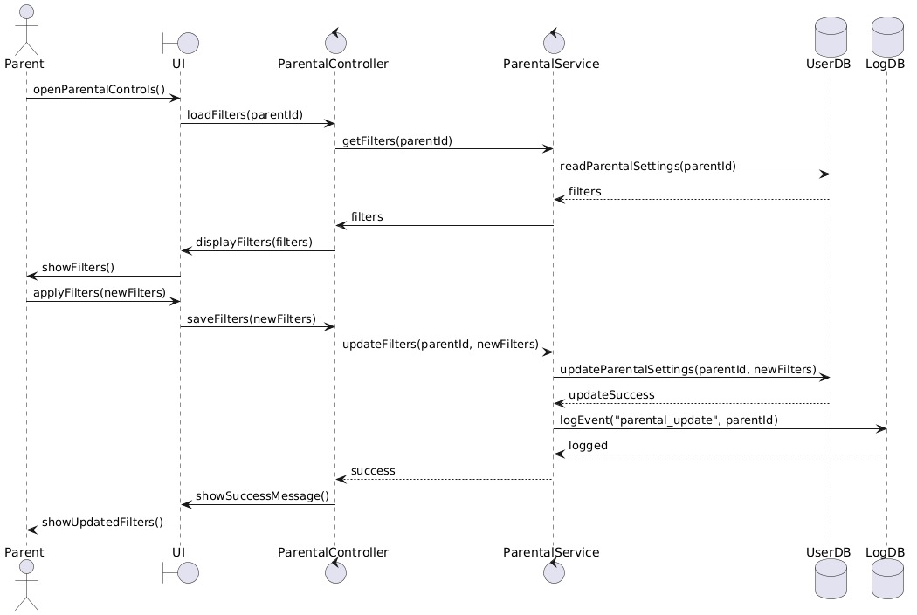
Figure 28 - apply age / genre restrictions sequence
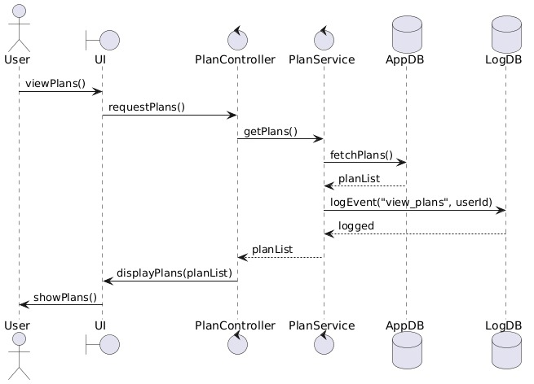
Figure 29 - view plans sequence
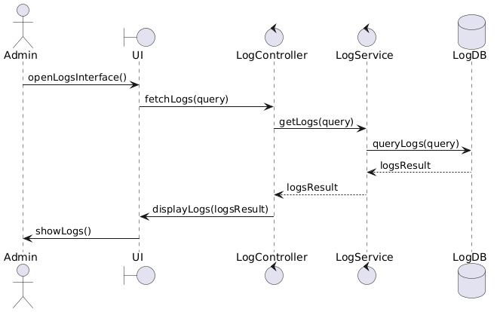
Figure 30 - log user activity and api calls sequence
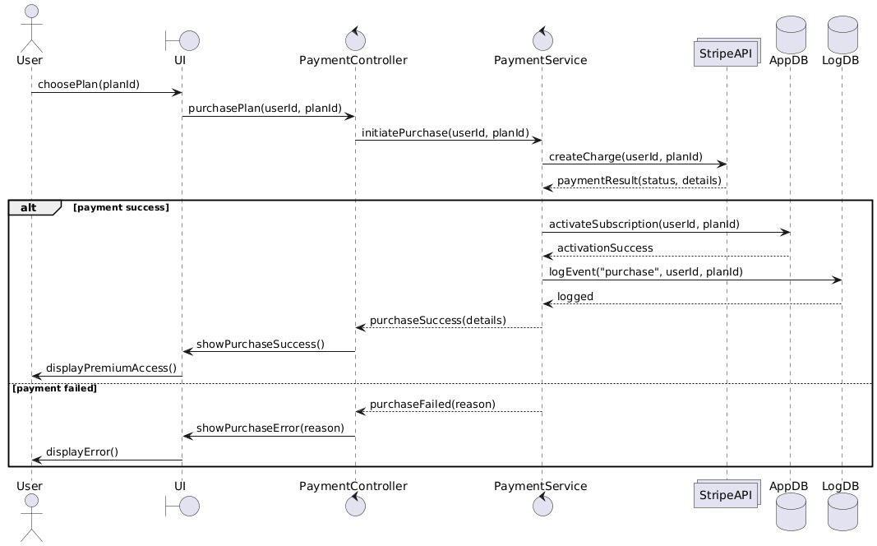
Figure 31 - purchase plan/ screen sequence

Domain Model
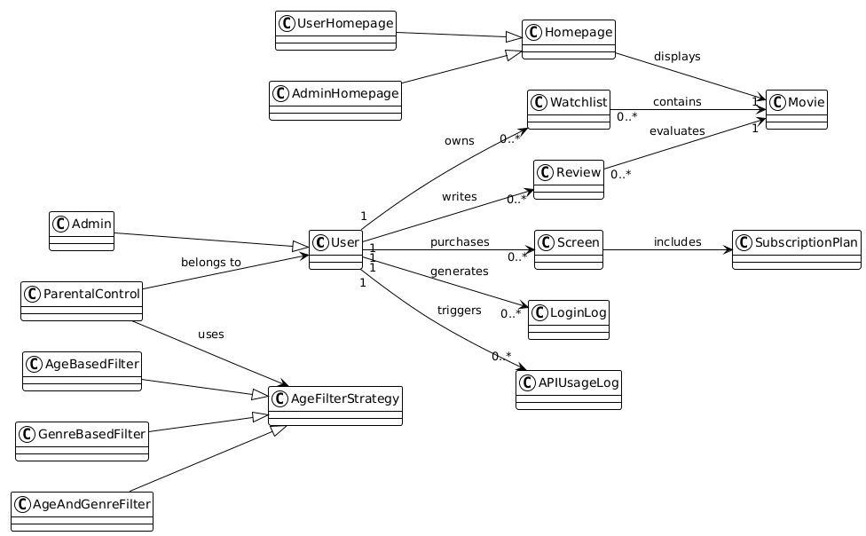
Figure 32 - domain model diagram

Deployment Diagram
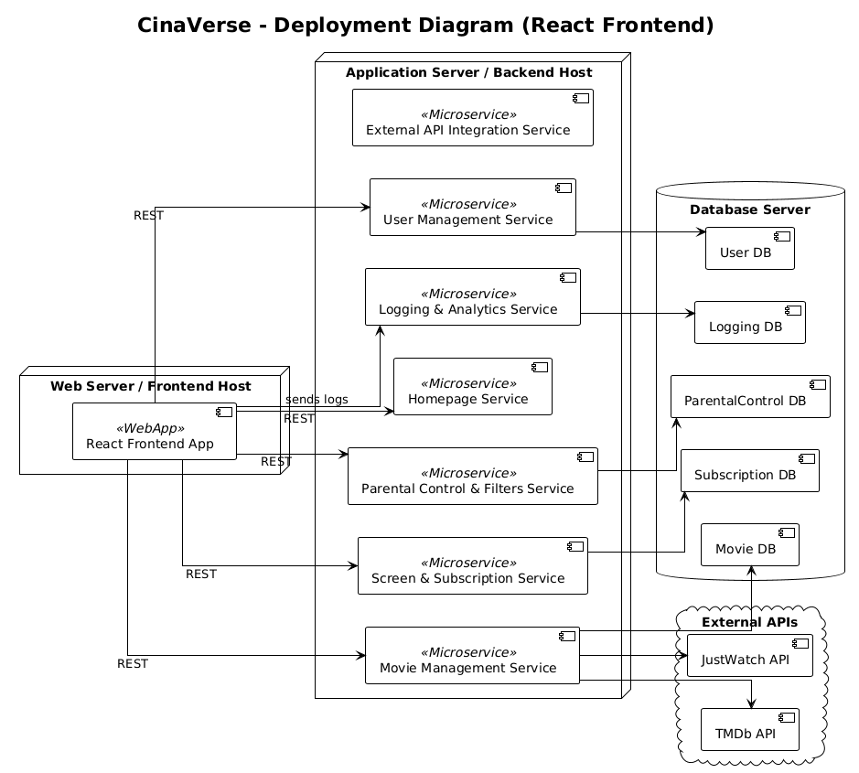
Figure 33 - Deployment diagram

Package Diagram
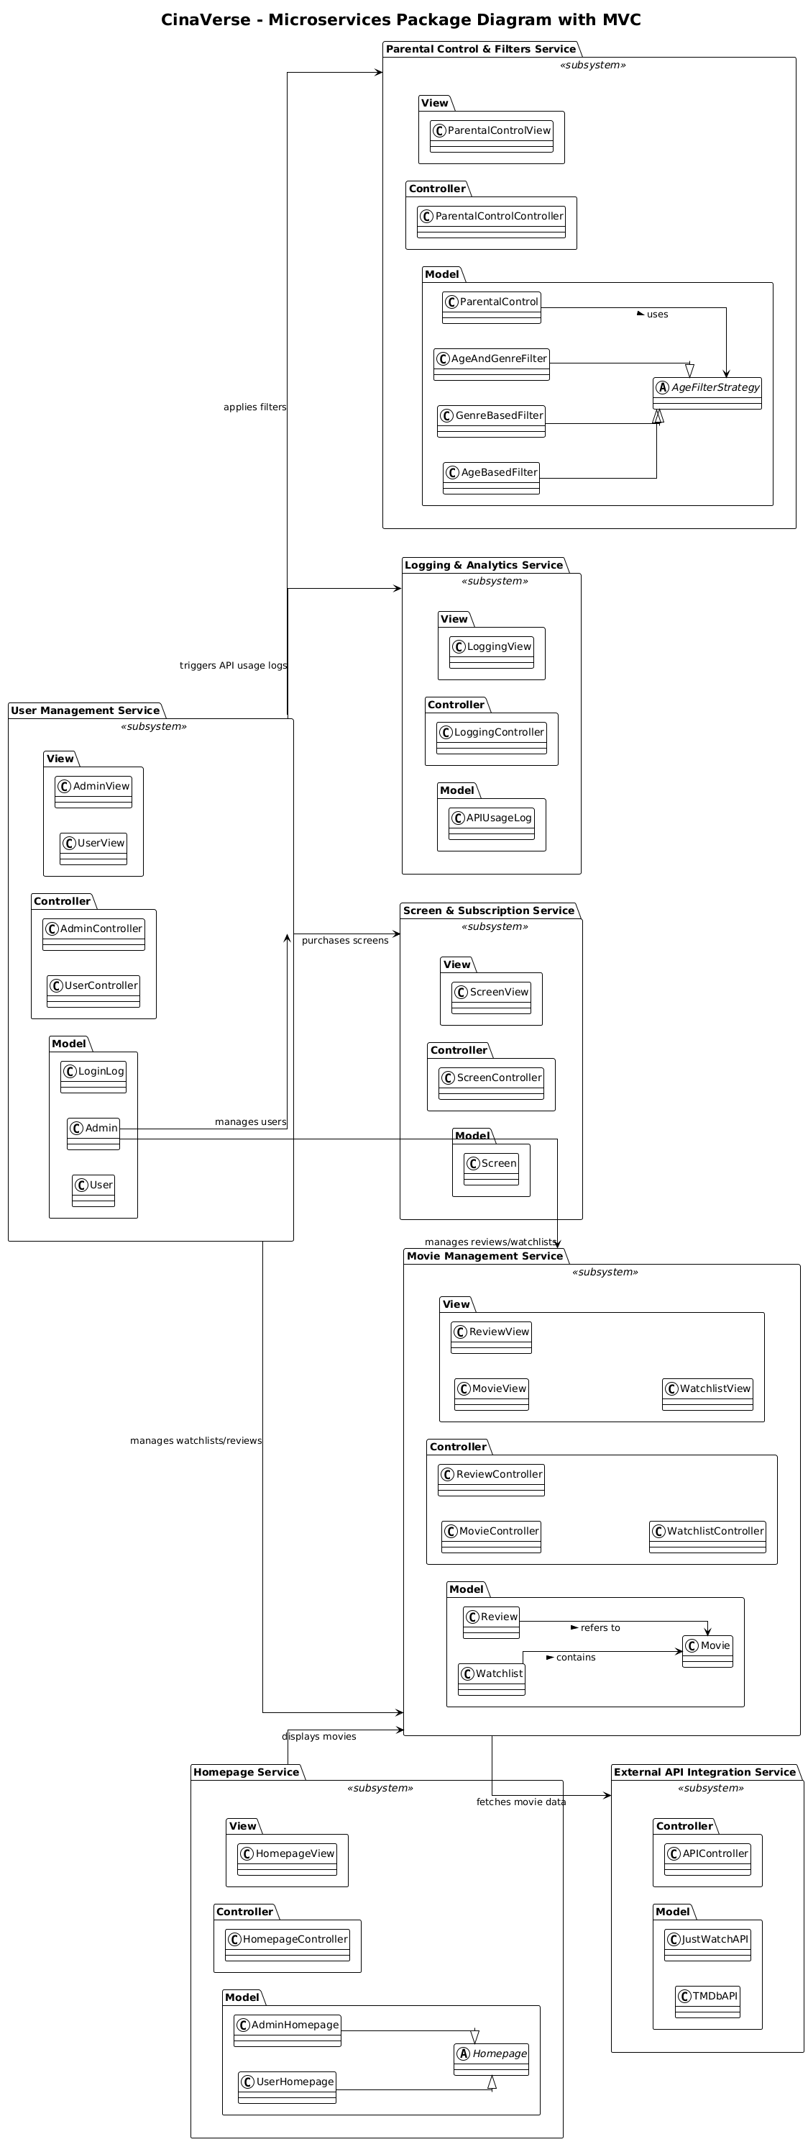
Figure 34 - Package Diagram

Component Diagram
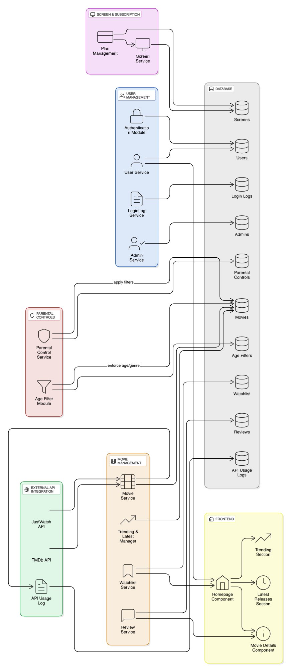
Figure 35 - component diagram

