1 SHOW TABLES

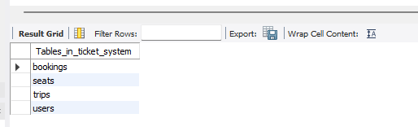

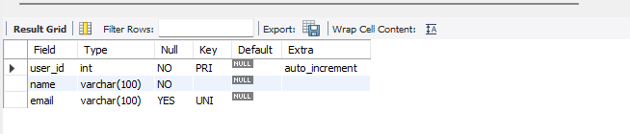

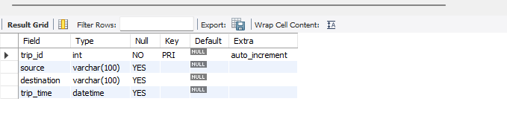

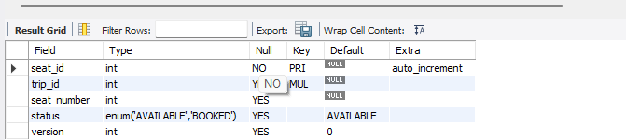

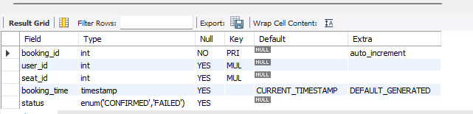

2.booking
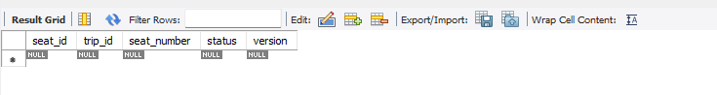
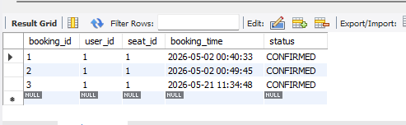

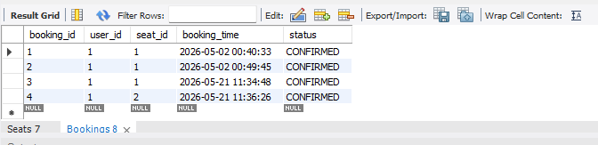

3.Deadlock Simulation
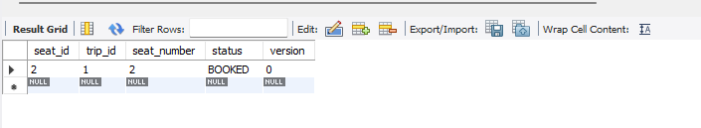
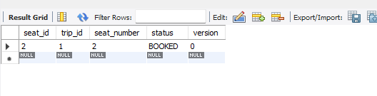
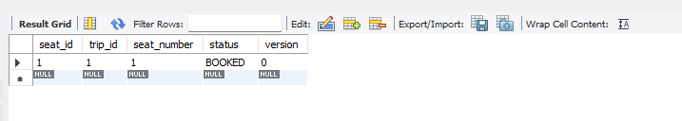
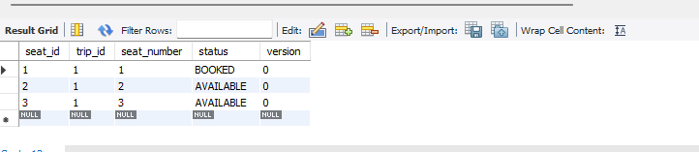

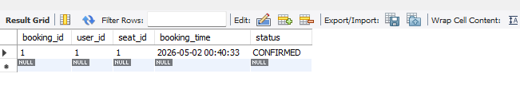

4.Optimistic Locking
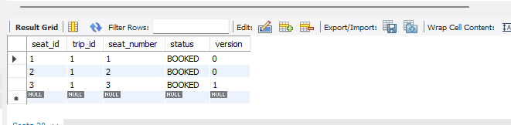

5.Failure & Rollback Handling
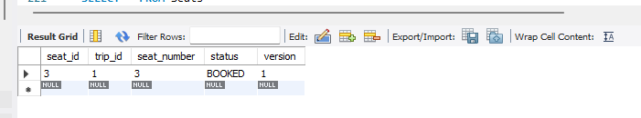
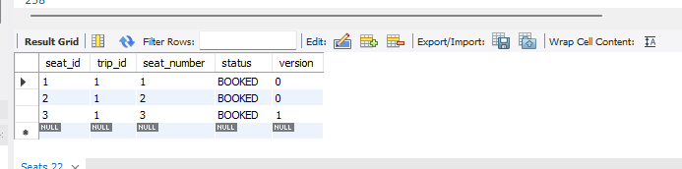

6.Isolation Level Analysis
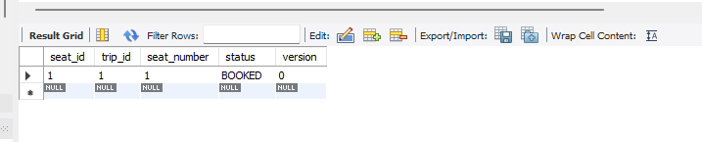

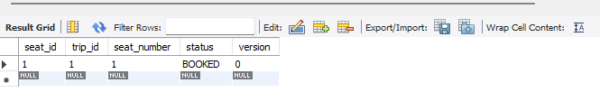

7.Bonus Challenge
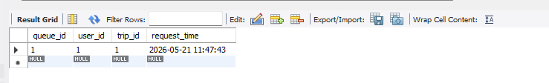

Final output
