|  |
| --- |
| SKILL DEVELOPMENT LABORATORYMINI PROJECT REPORT **ON**  **Real Time Emotion Detection/ Recognition**  **Submitted By:**  **Mamta Pandey TE-B(45)**  **Trupti Patil TE-B(49)**  **Anjali Rathi TE-B(52)**  **Branch : T. E. Computer (2020-2021)**  **Guided By: Kushal Birla/Rutuja Jadhav**  **Department of Computer Engineering**  **K. K. Wagh Institute of Engineering Education & Research**  **Hirabai Haridas Vidyanagari, Amrutdham, Panchavati,**  **Nasik – 422 003.**  **Affiliated to**  **Savitribai Phule Pune University** |

|  |  |  |  |  |  |  |
| --- | --- | --- | --- | --- | --- | --- |
| **K. K. Wagh Institute of engineering education & research, Nasik.**  ***CERTIFICATE***  This is to certify that  **Mamta Pandey TE-B(45)**  **Trupti Patil TE-B(49)**  **Anjali Rathi TE-B(52**  Has Successfully completed  SDL Mini Project on  Real Time Emotion Detection/Recognition  Towards the Partial Fulfilment Of Bachelor’s  Degree In Computer Engineering  Of Savitribai Phule Pune University  During Academic Year 2020 – 2021  Mini Project Guide H.O.D Principal   |  |  |  | | --- | --- | --- | | **Kushal Birla** | **Prof.Dr. S. S.Sane** | **Prof. Dr. K. N. Nandurkar** | |  |  |  | |

**Real Time Emotion Detection/Recognition**

.

**INTRODUCTION**

Human facial expressions are categorized into 7 universal emotions: happy, sad,

surprised, terrified, angry, ugly, and neutral. Our facial emotions are expressed through

the activation of specific sets of facial muscles.

For example

* Retailers can use these metrics to assess customer interest.
* Healthcare providers can provide better services by using additional information about patients' mood during treatment.

The Humans are well-trained to read the feelings of others, in fact, at just 14 months of

age, children can already tell the difference between happy and sad. Computers work

better than us in getting to the mood of humans. Therefore, we have designed/created an

intensive deep learning neural network that gives machines the ability to communicate

about our emotional states

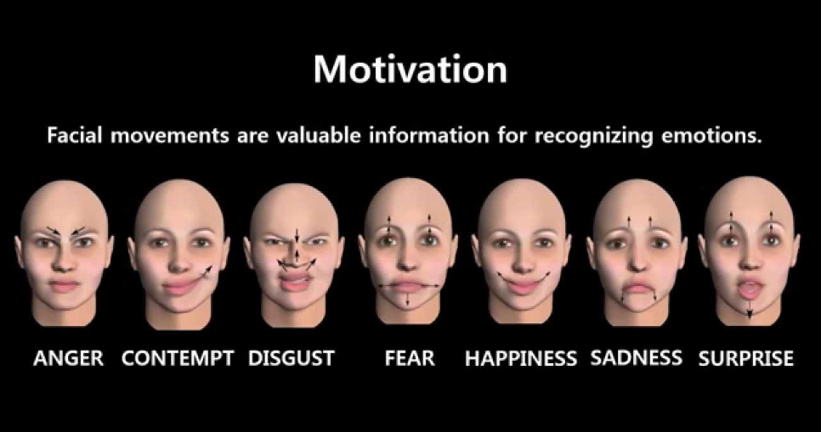

**PROBLEM STATEMENT**

To classify the expression of face from a still image or a real time video into one of seven basic human expressions.

**OBJECTIVE**

Our objective is to predict the expression of human face in real time as fast and as

accurate as possible.

**OUTCOMES**

Real time Facial Recognition and Emotion detection which appears on the screen above the rectangle mapping the face. Detects whether the individual is happy, sad, angry, neutral, scared (fear), surprised or disgust

**SOFTWARE / HARDWARE REQUIREMENTS**

**Software Requirements:**

1. Operating System – Windows 7 onwards

2. Python Version 2.7-3.7

3. Python IDE/Compiler

4. Flask

**Hardware Requirements:**

1. Webcam

2. i5 8th Gen

3. RAM – 4GB

**PLAN TIMELINE**

|  |  |
| --- | --- |
| **Date** | **Task to be completed** |
| **13/10/2020** | **Finalizing Topic** |
| **15/10/2020** | **Finding Dataset** |
| **23/10/2020** | **Designing the Flow** |
| **25/10/2020** | **Dataset Classification** |
| **27/10/2020** | **Deciding and working on algorithms** |
| **7/11/2020** | **Training the model** |
| **12/11/2020** | **Applying on Flask app** |
| **17/11/2020** | **Test Cases and Debugging** |
| **20/11/2020** | **Approval and Documentation** |

**FUNCTIONAL REQUIREMENTS**

* After the user clicks on the button “Analyze my Emotions” the web cam will turn on to capture the real time images for facial recognition and emotion detection.
* Once the face is detected the predicted emotion appears along with a rectangle around the detected face stating one of the emotions amongst happy, sad, angry, neutral, scared (fear), surprised or disgust .
* As the expression of the individual changes the result displayed will also change.

**NON - FUNCTIONAL REQUIREMENTS**

* Usability – the user interface is ease to use and the user doesn’t need to perform any complex processes
* Scalability – it can detect multiple faces at the same time as long as they are in the frame of webcam
* Availability - The application works best when internet service is given.
* Environmental- Application should work even in low light till the face is visible to detect.

**BLOCK DIAGRAM**

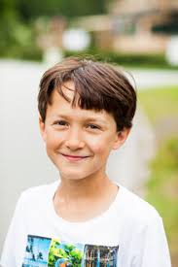

Input Image

Pre Processing

Face Detection

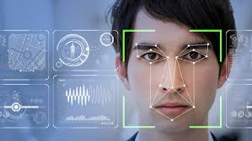

Facial Feature Extraction

Emotion Classification

Output / Identified Expression

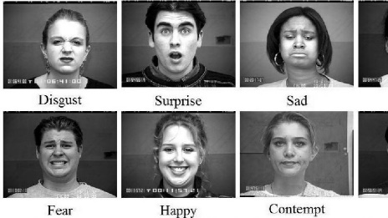

**DATABASE/DATASET**

The dataset used in this project work has been taken from the Kaggle.com available at

(<https://www.kaggle.com/c/challenges-in-representation-learning-facial-expression-recognition-challenge/data>).

The data consists of 48x48 pixel grayscale images of faces.The task is to categorize each face based on the emotion shown in the facial expression in to one of seven categories

(0=Angry, 1=Disgust, 2=Fear, 3=Happy, 4=Sad, 5=Surprise, 6=Neutral).

train.csv contains two columns, "emotion" and "pixels". The "emotion" column contains a numeric code ranging from 0 to 6, inclusive, for the emotion that is present in the image. The "pixels" column contains a string surrounded in quotes for each image.

The training set consists of 28,709 examples.

**METHODOLOGY**

The hands on building this project of Facial Expression Recognition is divided into following tasks/steps:-

**Task 1: Introduction:**

* Introduction to the dataset
* Import essential modules and helper functions from NumPy, Matplotlib, and Keras.

**Task 2: Exploring the Dataset:**

* Display some images from every expression type in the Emotion FER dataset.

## Task 3: Generating Training and Validation Batches:

* Generate batches of tensor image data with real-time data augmentation.
* Specify paths to training and validation image directories and generates batches of augmented data.

## Task 4: Creating a Convolutional Neural Network (CNN) Model:

* Design a convolutional neural network with 4 convolution layers and 2 fully connected layers to predict 7 types of facial expressions.
* Used Adam as the optimizer, categorical cross entropy as the loss function, and accuracy as the evaluation metric.

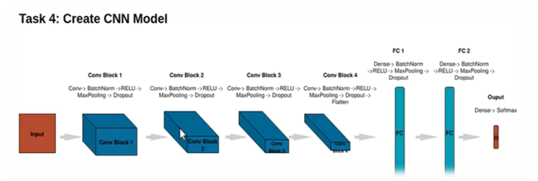

CNN (Convolutional Neural Network) Model

## Task 5: Training and Evaluating Model:

* Training the CNN by invoking the **model.fit()**method.
* Used **ModelCheckpoint()** to save the weights associated with the higher validation accuracy.
* Observed live training loss and accuracy plots in Jupyter Notebook for Keras.

## Task 6: Saving and Serializing Model as JSON String:

* Used **to_json()**, which uses a JSON string, to store the model architecture.

## Task 7: Creating a Flask App to Serve Predictions:

* We used the open-source code from “Video Streaming with Flask Example” to create a flask app to serve the model’s prediction images directly to a web interface.

**Task 8: Creating a Class to Output Model Predictions:**

* Created a FacialExpressionModel class to load the model from the JSON file, load the trained weights into the model, and predict facial expressions.

## Task 9: Designed an HTML Template for the Flask App:

* Designed a basic template in HTML to create the layout for the Flask app.

## Task 10: Used Model to Recognize Facial Expressions at the Real Time using laptops web camera:

* We than run the **main.py** script to create the Flask app and serve the model’s predictions to a web interface.
* Applied the model for real time recognition of facial expressions of users using webcam of the Laptop.

**TEST CASES**

Angry:

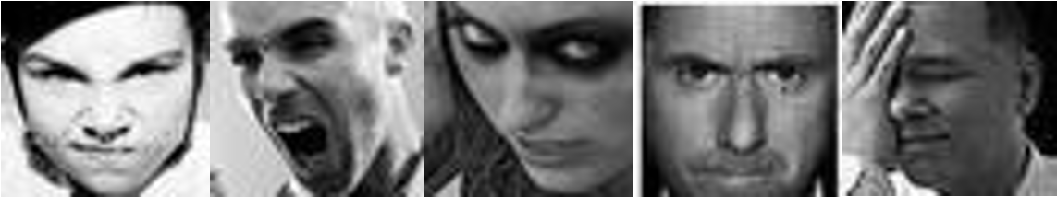

Disgusted:



Fear:



Happy:



Neutral:



Sad:

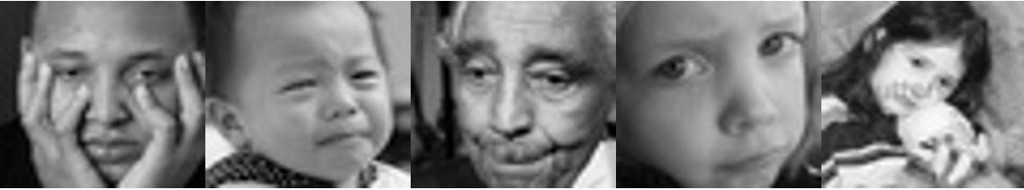

**Surprise**



**USE CASES**

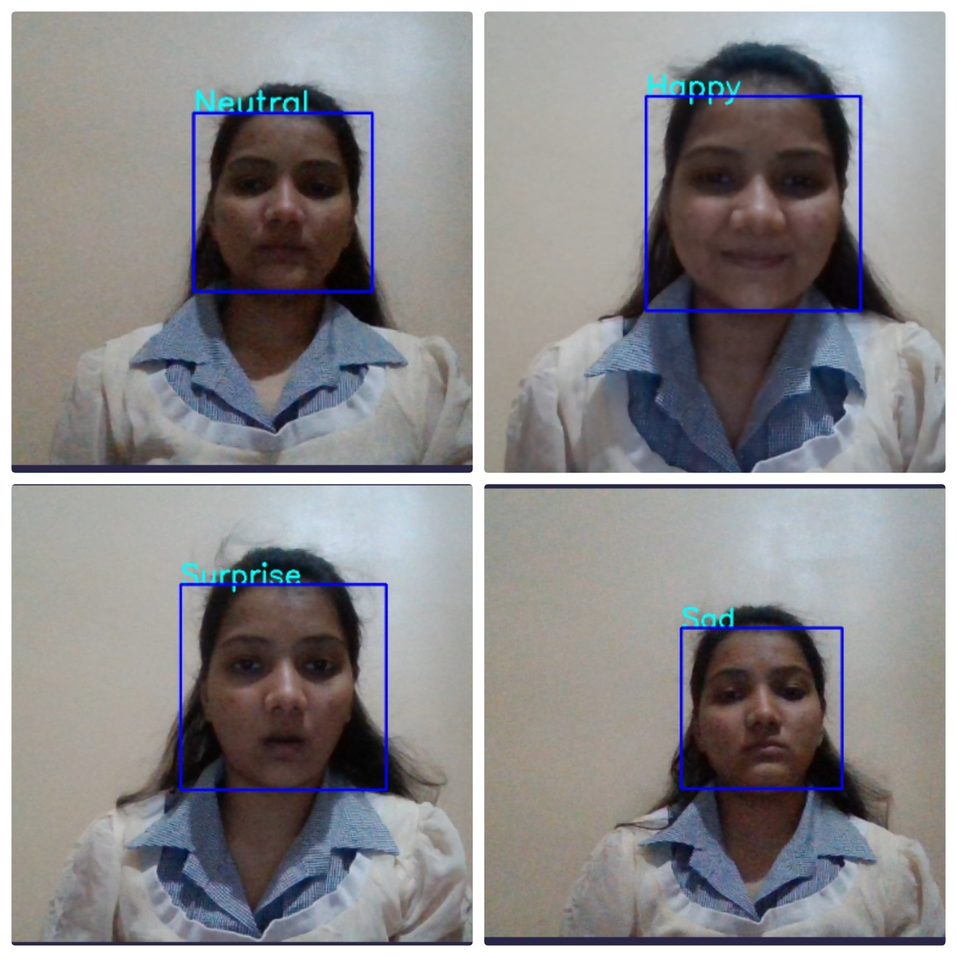

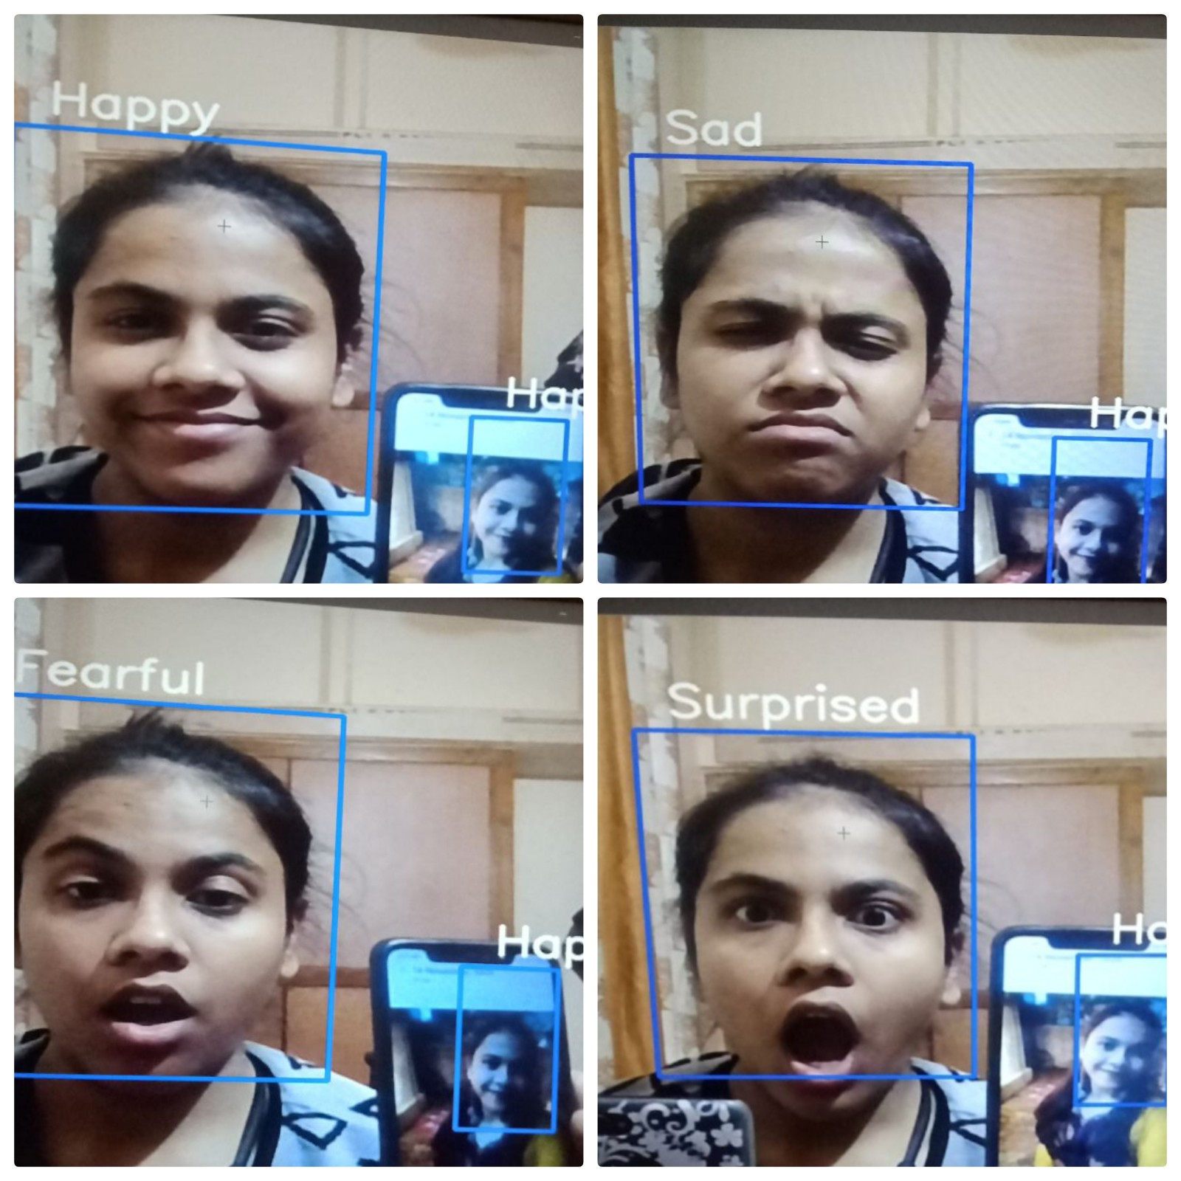**USE CASES**

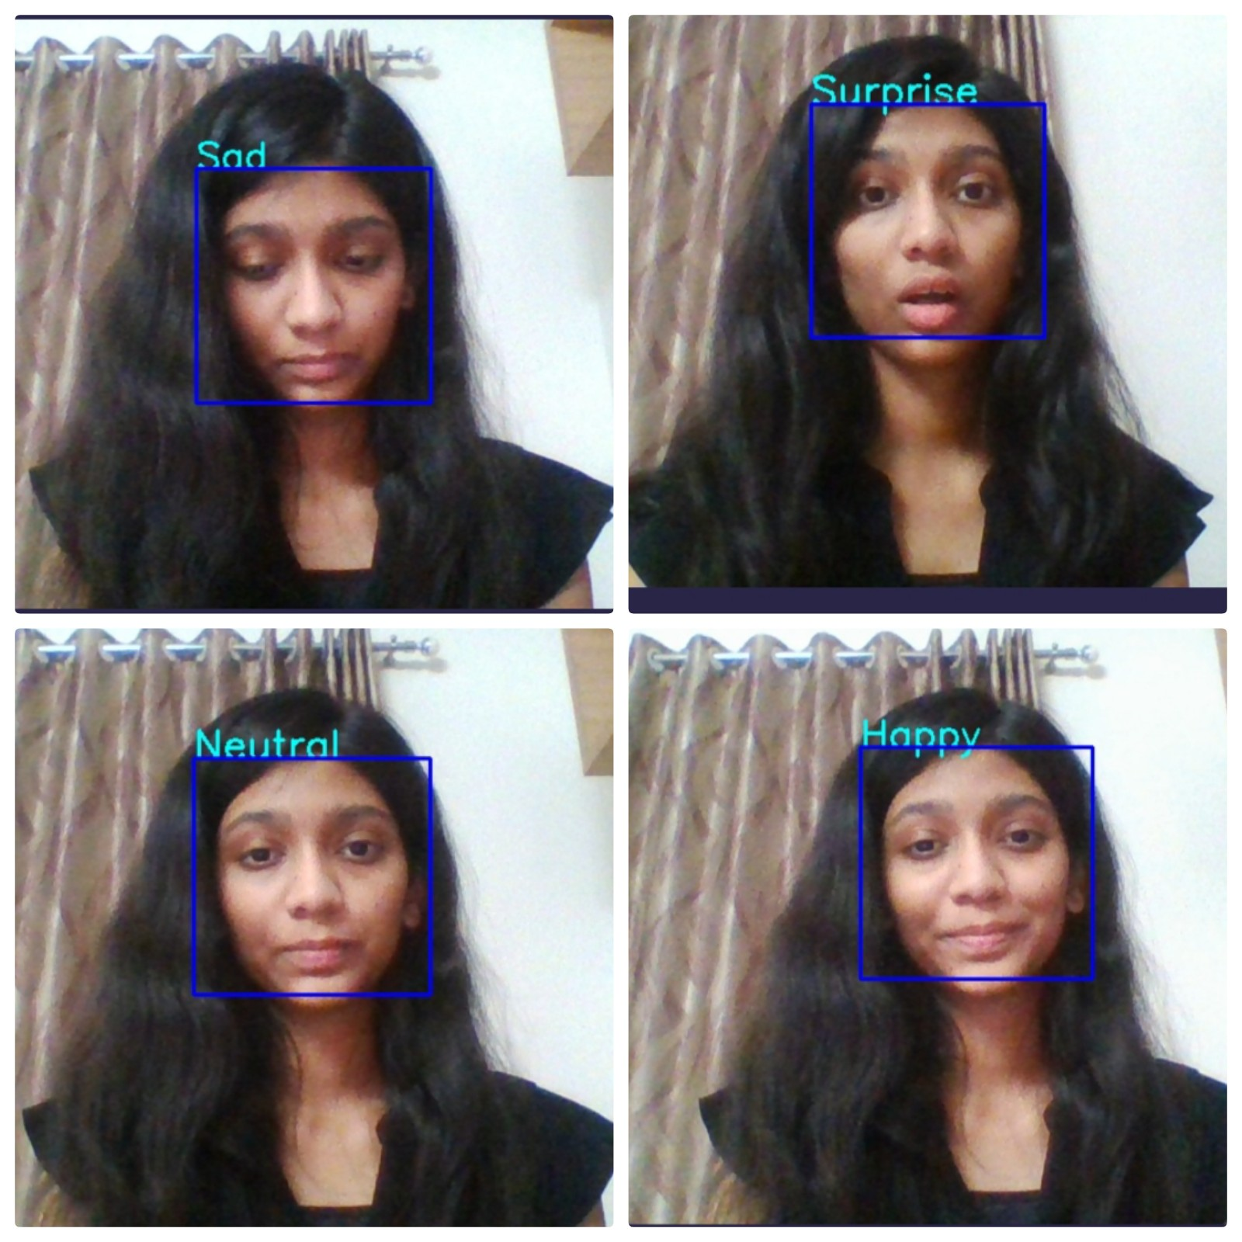**USE CASES**

**RESULT /OBSERVATIONS**

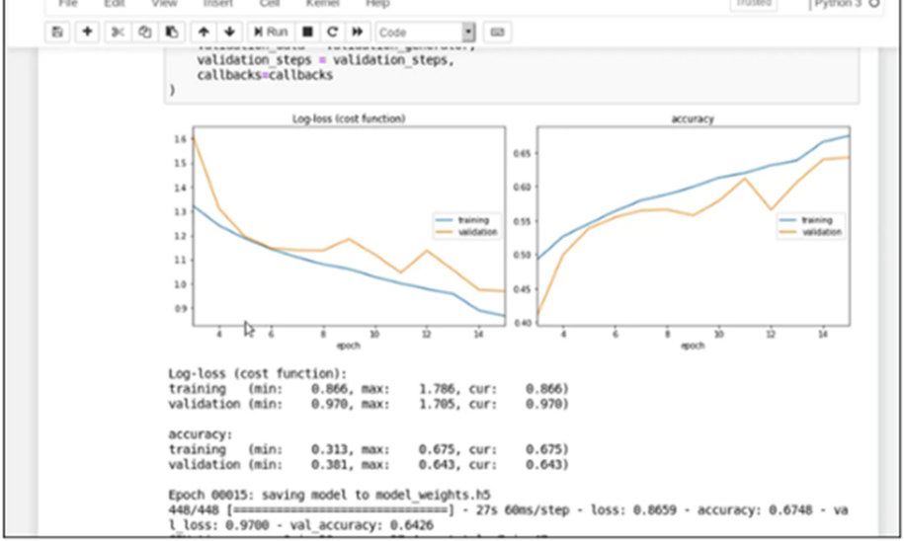

# 

# 

**CONCLUSION**

In this project an Emotion/Facial Recognition model has been trained and saved. It can recognize/detect the facial expressions of an individual on a real time basis that whether the individual is Neutral, Angry, Disgust, Fear, Happy, Sad, and Surprised.

**REFERENCES**

[1] https://www.coursera.org/learn/facial-expression-recognition-keras/supplement/2KrW0/ project-based-course-overview

[2]https://www.kaggle.com/ashishpatel26/tutorial-facial-expression-classification-keras

[3] Fundamentals of Facial/Emotion Recognition

**FUTURE SCOPE**

We have got a pretty good result but still there is a huge scope of improvement.

1. In order to get better accuracy we need much more human images with good variance among them.

2. We can also fine tune last 2 or 3 convolution blocks of CNN layer to increase accuracy.

3. We can also design our own CNN model if we have time and computation power. Of-course, we need much more images for this. But by careful hyper-parameter tuning and training the model on 100k human images with good variance among them and by keeping the size of each image higher than 400*400, we can achieve close to 99% accuracy on real world and in real time.

4. Generate report on the collected data to create live feedback for video calls.

|  |  |  |  |  |  |  |
| --- | --- | --- | --- | --- | --- | --- |
| **Report Documentation & Accounting Page** | | | | | | |
| Report Code: CS-TE-SDL Mini Project 2020-2021 | | | **Report Number: <TE-B>/<45,49,52>** | | | |
| **Address (Details):**  **Computer Department, K. K. Wagh Institute of Engineering Education & Research,**  **Hirabai Haridas Vidyanagari, Amrutdham, Nashik**  **Pin – 422 003, M.S. INDIA.** | | | | | | |
| Report Title: Real time emotion detection/recognition | | | | | | |
| **Author [with Address, phone, E-mail]:**  **Address**  **E-mail :** [**mamtapandey466@gmail.com**](mailto:mamtapandey466@gmail.com)  [**ptrupti976@gmail.com**](mailto:ptrupti976@gmail.com)  [**anjalirathi2018@gmail.com**](mailto:anjalirathi2018@gmail.com) | | | **Author Details (Year, Branch, Roll):**  **Year:** 2020– 2021  **Branch:** Computer Engineering  **Roll: <45,49,52>** | | | |
| Type Of Report: FINAL | Time Covered (From – To)  **01-11-2020**  TO  **01-01-2021** | | **DateOf Report**  (DD-MM-YYYY)  **12-01–2021** | | | **Page Count**  12 | |
| ***Key Words*: <Keywordst>** | | | | | | |
| Report Checked By: Prof Kushal Birla | | Report Checked Date:  12-01-2021 | | **Guides Complete Name:** Kushal Birla | Total Copies    **1** | |
| **Abstract:**  **The Human facial expressions are important for visually expressing a lot more information. Facial expression recognition is essential in the field of human-machine interaction. Two of the most popular methods used in the literature for automated FER systems are geometry and appearance. Facial expression recognition usually performed in four steps, including preprocessing,face detection,feature extraction and expression classification.** | | | | | | |