**Technical assessment for**

**Distributed Energy Storage**

Sector: Electricity generation

Agency Level: Buildings

Keywords: Energy Storage, Batteries, Peak Shaving, Renewables Integration)

Version 2 (November 2019)

**Prepared by:**

Ariel Horowitz, Research Fellow

João Pedro Gouveia, Senior Research Fellow



[info@drawdown.org](mailto:info@drawdown.org) [www.drawdown.org](http://www.drawdown.org)

Table of Contents

List of Figures 3

Acronyms and Symbols 3

Executive Summary 4

1 Literature Review 5

1.1. State of Distributed Energy Storage 5

1.2. Adoption Path 9

1.3 Advantages and disadvantages of Geothermal Power Systems 10

2 Discussion 12

3 References 14

4 Glossary 19

# List of Figures

Figure 1.1. Chart demonstrating both variation of power demand and energy consumption over the course of one day (WE Energies, 2011). 7

Figure 1.2. Generally, peak demand does not occur simultaneously with peak generation from renewable resources. Energy storage can help reconcile this disparity. (Tesla Powerwall, 2015) 7

Figure 1.3. "Own-consumption" rates for PV installations in Germany with and without on-site DES (Grigoleit, 2014). 8

Figure 1.4. Projection of battery + PV prices in Germany as compared to grid electricity prices (Brautigam et al., 2015). 10

Figure 1.5. Economic and system-security curtailment rates at different levels of PV penetration (Trembath & Jenkins, 2015). 13

# Acronyms and Symbols

* AMPERE – Assessment of Climate Change Mitigation Pathways and Evaluation of the Robustness of Mitigation Cost Estimates
* DES - Distributed energy storage
* EV – Electric Vehicles
* PV – Photovoltaics
* TOU - Time-of-Use
* V2G - vehicle-to-grid

# Executive Summary

Project Drawdown defines distributed energy storage as: decentralized energy storage systems, generally based on battery storage, that allow buildings and vehicle owners to act as active participants in the electricity distribution system rather than passive consumers. This solution does not replace a conventional practice, but is key to the development of variable renewable energy sources.

Distributed energy storage systems allow consumers to draw power from the grid at times and rates of their choosing, avoiding steep charges for consumption at peak times or when demand spikes. When combined with distributed electricity generation sources such as rooftop photovoltaics, distributed energy storage can open a path to energy independence for buildings. It can also ease adoption of variable, renewable energy sources on the utility scale by effecting a more predictable and responsive demand pattern. Finally, distributed energy storage is a crucial part of modernizing the energy system at large, through providing smart grid and related services.

Presently, distributed energy storage is practiced only on a very small scale. The systems are generally based on battery storage, which has been prohibitively expensive for many years. Moreover, policy-based incentives for the use of distributed energy storage, such as time-of-use electricity pricing plans, have been lacking in many areas. The status quo has recently begun to shift, however, as batteries decrease sharply in price and utilities seek ways to avoid costly infrastructure upgrades in the face of rising demand. The increased penetration of distributed generation resources has also provided added incentive for consumers to consider the use of  distributed energy storage. As such, distributed energy storage is at a tipping point and is poised to become a major element of the energy system.

Energy storage on the distributed scale is a powerful tool for enabling transformations in the energy system by supporting the integration of variable renewable generation sources in the electricity grid. Because the potential emission reduction impact from distributed energy storage comes principally from the enabling of these technologies, to avoid double counting, it is assumed that the impact is already accounted for in the distributed electricity generation solutions such as wind and solar, as well as in the electric vehicles solution. As such, an independent model was not developed for this enabling solution.

Distributed energy storage is likely to become a major practice in the coming years and financially beneficial to consumers in the long term. It will have an important role to play in increasing the independence of energy consumers, and in helping to balance the load and supply “behind the meter” (i.e. in a building) with the capacity available on the grid. Distributed energy storage is also a key resource for ensuring the reliability of electrical energy services. As a result of these many benefits, it can be expected that adoption of distributed energy storage will increase greatly in the coming years, making it an important part of the changing energy landscape.

However, due to inefficiencies in energy storage and high carbon dioxide emissions associated with the manufacturing of batteries, the use of distributed energy storage might not imply a reduction in emissions when considered in isolation. When vehicle-to-grid storage is considered alongside the increased integration of renewable energy sources for electricity generation, the impacts may prove more favorable. The emissions avoided from diesel and gasoline more than balance the emissions resulting from the manufacturing of batteries. As such, electric vehicles used as distributed energy storage can provide a significant climate benefit. Developing infrastructure and policy frameworks to promote adoption of vehicle-to-grid storage is therefore crucial as electric vehicle penetration increases.

# Literature Review

## State of Distributed Energy Storage

The need for reliable, on-demand access to energy services in residential and commercial buildings has driven much of the development of modern energy systems. In developed nations, citizens expect that the lights will always turn on when needed, that heating and cooling systems will make the indoors a comfortable temperature regardless of the weather outside, and that their personal electronics will be able to be charged at any outlet, at any time. Globally, residential and commercial electricity usage accounts for more than half of all electricity consumption (AMPERE Database, 2015) and therefore approximately 10% of global carbon emissions (IEA, 2014a). In the current electricity system, however, residential and commercial buildings are passive consumers only, separated from centralized electricity generators by an extensive transmission and distribution system. A number of recent developments, including the development of distributed generators such as rooftop solar installations and micro-wind turbines as well as the transition to a “smart” grid, have challenged this status quo. Distributed energy storage (DES) is one key component of this shift (Bussar et al., 2013).

DES is one means of allowing buildings to act as active entities in the energy system. By itself, DES can allow buildings to save money through in power arbitraging, by buying and storing power at night (when it is normally sold at lower prices) for consumption during the daytime. Power arbitrage is possible in many markets with time-of-use (TOU) based pricing (“Con Edison: Customer Central - voluntary time-of-use,” n.d.). TOU pricing schemes are based on market economics: many generator types (including large coal and nuclear plants) cannot be shut down during the night due to technical or economic limitations. Since they continue to supply power even when demand for their product is reduced, they charge a lower price. Some areas also have specific demand response incentive programs, which are designed to avoid situations where load on the grid approaches the system’s capacity (Kintner-Meyer et al., 2010). DES can allow homes and businesses to participate in such programs by flattening their demand curves without actually shifting energy usage patterns. Finally, in many areas consumers are charged both for the energy they use and for the peak power they draw (in other words, for the fastest rate at which they draw energy) (WE Energies, 2011). DES can allow consumer demand patterns to appear to the grid to be smoother and more consistent, avoiding these steep demand charges (Figure 1.1.)

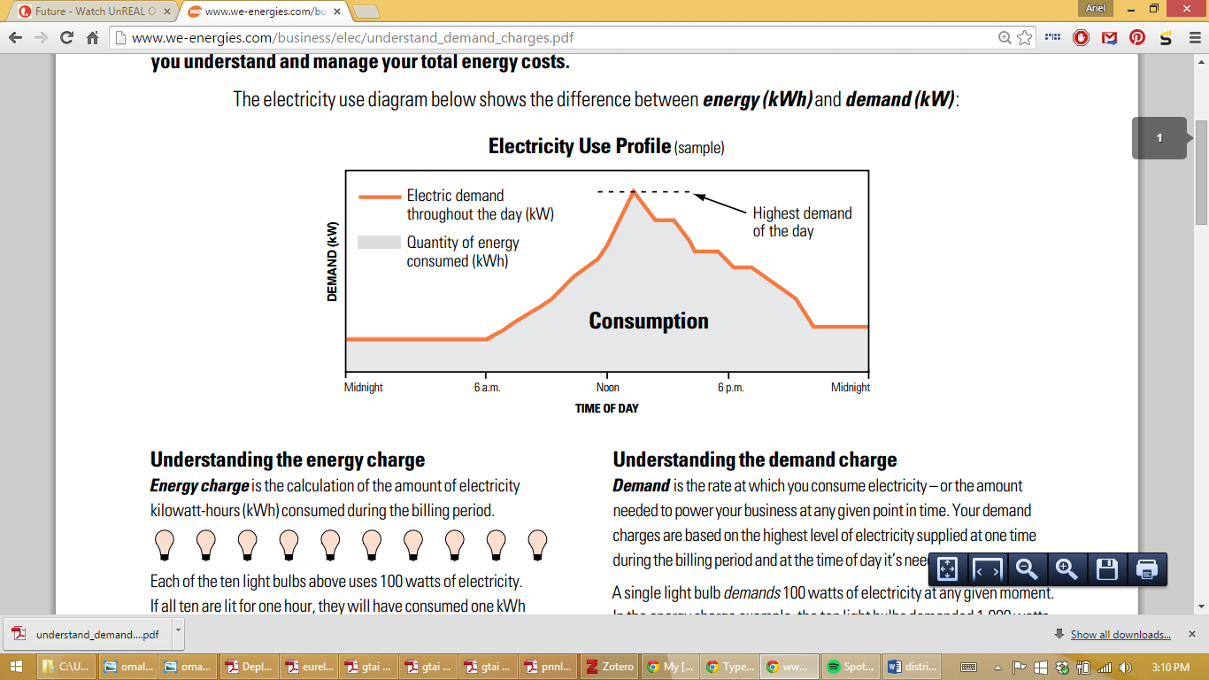

Figure 1.1. Chart demonstrating both variation of power demand and energy consumption over the course of one day (WE Energies, 2011).

When paired with distributed energy generation, such as rooftop solar power, the benefits of DES are multiplied. For example, although many rooftop PV installations have the capacity to provide all of the energy consumed by a building over the course of the year, most buildings with PV systems do not actually act as self-sufficient (Grigoleit, 2014). This is because of mismatches between generation and usage patterns, which lead both to times when the energy generated by a PV array is more than is being consumed in the building (e.g. at noon if no residents are at home) and to times when consumption outpaces generation (e.g. after sundown before residents have gone to sleep). As a result, “self-consumption” of energy from rooftop PV systems is relatively low. In Germany, which has significant market penetration of rooftop PV, solar systems supply only about one-third of a building’s energy needs directly, with the grid both accepting excess generation and making up generation shortfalls as needed at various times (Figure 1.2. and Figure 1.3).

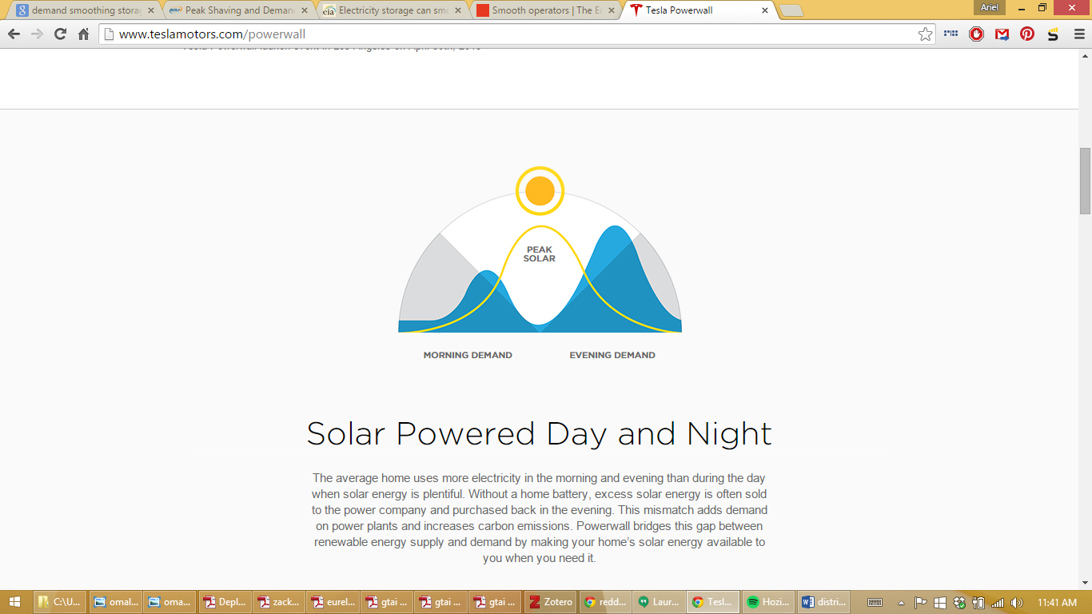

Figure 1.2. Generally, peak demand does not occur simultaneously with peak generation from renewable resources. Energy storage can help reconcile this disparity. (Tesla Powerwall, 2015)



Figure 1.3. "Own-consumption" rates for PV installations in Germany with and without on-site DES (Grigoleit, 2014).

Most distributed energy generation relies on favorable net metering policies in order to be a financially sound investment. Under these schemes, if a building with rooftop solar panels can’t use all of the electricity generated by the panels at a given time, the excess must be accepted by the grid and the panel owners paid for the power it supplies. The price paid for this power is equal or even greater (in the case of feed-in tariffs) than the price the utility charges for electricity, despite the fact that this excess power can be difficult for the grid system to accommodate (Martinot, 2015). However, the building owner still benefits from the reliability and infrastructure provided by the grid system. While this can be accommodated when the penetration of distributed generation is low, it represents a significant financial strain when adopted at high rates, as is presently the case in Germany. As a result, many utilities resist the use of feed-in tariffs and other such incentive systems.

The use of DES can free building owners from such concerns. Net metering is unnecessary if excess generation is simply stored on-site for later use. In some cases, a solar or micro-wind installation with accompanying storage can lead to total or near-total energy independence for a building. This is highly desirable in cases where reliability is of paramount importance. It can also have major financial benefits as the installation of such a system allows a building to “lock in” its effective price for electricity for the lifetime of the system, insulating it from policy and market shifts.

DES technologies fall into two major categories: thermal and electrochemical. Thermal storage involves heating or cooling a fluid with a large thermal mass (normally water) when demand and energy prices are low and then using the fluid for heat-related energy services such as space heating and cooling or bathing (Kintner-Meyer et al., 2010). Thermal energy storage using water is a mature technology, with approximately 2 GW of installed capacity globally, half of which is in the United States (IEA, 2014b). However, energy cannot be returned to the grid using thermal energy storage, nor can it be employed for energy services such as lighting or charging of personal electronics, nor can thermal storage substitute for grid access during power outages or emergency situations. As such, it may be more properly considered to be a type of demand shifting.

Electrochemical storage, primarily using batteries, is the other primary means of storing energy on a distributed scale (Kintner-Meyer et al., 2010). With the advent of personal electronics, batteries have become a ubiquitous technology. Batteries store energy using chemical reactions. During discharge, chemical reactions that release electrical energy occur spontaneously. In order to recharge the battery, electrical energy is used to drive those reactions backwards. The major difference between different battery types is the specific chemical reaction that occurs, which is identified mainly by its constituents.

Many battery types may be suitable for storing electrical energy at the utility scale. However, many of these may not be safe for use at the distributed scale. For example, sodium/sulfur batteries use molten salts at very high temperatures (Hassenzahl & Schoenung, 2003) and zinc/bromine batteries generally have some bromine gas production associated with them (Coad & Lex, 2012). As a result, advanced lead acid and lithium-based technologies are the dominant battery type for distributed applications (Acker, 2014). Advanced lead acid batteries are very similar to the lead acid batteries found in cars, but with some electrode modifications to improve lifetime and rate capability (how quickly the battery can charge and discharge) (Martin, 2013). Lithium-based technologies are predominantly lithium-ion (Li-ion), meaning that neither of the electrodes is lithium metal. Instead, lithium ions travel between a metal oxide electrode on one side and a carbon electrode on the other (Lisbona & Snee, 2011). A wide variety of metal oxides are in use for lithium-ion batteries, including iron phosphate, manganese oxide, and nickel manganese cobalt oxide (LeVine, 2015). Batteries made with these different electrode materials vary in their rate capabilities, energy densities, cycle lifetimes, and safety levels. In recent years, significant lithium-ion battery development has occurred due to the personal electronics and electric vehicle markets, suggesting that the cost of these cells will continue to decrease and performance improve somewhat over the coming years (Nykvist & Nilsson, 2015).

In the present day, DES is a niche practice (Nourai, 2007). Batteries have only recently started undergoing significant decreases in cost and not all areas have time-of-use pricing policies and similar incentives that would allow DES to be financially beneficial to consumers and businesses. Less than 0.01% of daily electricity consumption in buildings can presently be stored in DES systems, with most capacity in the United States, Europe, and Japan (Oudalov, Cherkaoui, & Beguin, 2007). However, this is poised to shift as battery prices drop.

## Adoption Path

As electricity prices rise and the prices for distributed generation and storage technologies fall, the combination of on-site storage with on-site generation offers a significant value proposition to energy consumers. In Germany, for example, photovoltaic systems reached “grid parity” in 2011 (Grigoleit, Rothacher, & Hildebrandt, 2015) (Figure 1.4). In other words, at that point the amortized cost of a PV system over its lifetime divided by the amount of energy the generated by the system was equal to the expected price of buying electricity from the grid for the same length of time. The cost of electricity has continued to rise, however, as the prices of battery modules has fallen. As a result, PV systems paired with batteries are expected to reach grid parity prices in Germany within the next two to three years (Brautigam, Rothacher, Staubitz, & Trost, 2015). This will also allow “self-generation” levels to rise to approximately two-thirds, or double the current rate (Grigoleit, 2014), increasing the energy independence of buildings.



Figure 1.4. Projection of battery + PV prices in Germany as compared to grid electricity prices (Brautigam et al., 2015).

High cost and a lack of consumer knowledge are two of the main hurdles standing in the way of wide adoption of DES. However, battery systems have recently undergone significant cost reductions, partially due to the scale-up of EV adoption. Moreover, as electric power grids are modernized and made “smart,” the potential benefits of DES may become more apparent to consumers. Well-structured incentive programs can accelerate adoption by helping to tip cost-benefit analyses in favor of DES as well as by publicizing the advantages provided by DES.

Distributed battery-based storage systems are generally easy to install. A variety of companies in the United States and elsewhere offer modular, “plug-and-play” systems, complete with integrated power electronics and control software (KEMA, 2012). However, as batteries on the scale of DES systems have only recently become economical, a significant policy gap exists that presents barriers towards their adoption. Policies are needed that allow the owners of DES to be compensated for ancillary services provided “behind-the-meter” (i.e., on the customer side of the transmission and distribution grid) (Kintner-Meyer et al., 2010). In addition to demand smoothing or peak shaving, a DES system connected to a smart grid can also provide reliability and congestion relief services. Besides opening up these paths to revenue, standards and codes are needed to ease installation and adoption for DES (Chang et al., 2014). These regulations, which would guide design of DES facilities and accompanying safety measures, would speed development as municipalities would have an easy way to evaluate new projects rather than considering them on an individual basis from the ground up. Similarly, code development would allow consistent best practices to be employed in connecting DES to the grid and distributed generation resources, as well as in the case of fires or other safety hazards (Chang et al., 2014).

One major potential path to adoption of DES is the use of electric vehicles (EVs) as distributed storage resources. The batteries found in EVs have many of the same properties as, and in some cases are identical to, those used for DES. Since the capacity factor of many cars is quite low (they are only driven for two to three hours out of the day), the rest of the time EVs can act as grid-connected DES resources (Neubauer & Simpson, 2014). Since use of EVs comes with its own benefits that largely offset the cost of such vehicles, this allows the economic and carbon benefits of EVs as DES to be considered as a bonus. As EV adoption increases, it is likely that some percentage of DES resources will be in the form of EVs.

Due to the rapidly-decreasing costs of DES, the distributed storage market is expected to undergo significant growth in the near future. Even a conservative estimate would project DES capacity to increase by over an order of magnitude in the next decade. Optimistically, DES capacity may increase to between one and two percent of the residential and commercial electricity market, with cumulative installations of between 900 and 1100 GWh globally. In markets where policies that incentivize the use of DES and other distributed energy resources are already well-developed, DES may become more common yet. If the policy and infrastructure is developed to support the use of EVs as DES (in vehicle-to-grid or “V2G” systems), however, the EV market may cannibalize the DES market, with most DES capacity being found in the form of EVs.

## Advantages and disadvantages of Geothermal Power Systems

Although DES has many advantages, some of its benefits are diffuse and felt mainly by the electrical system as a whole rather than by the individual consumers and businesses that bear the cost of distributed storage systems (Chang et al., 2014). Moreover, DES has several key competitors from the point of view of individuals and businesses. These include demand shifting as well as efficiency measures. Demand shifting can make a building appear to be more of an active entity on the grid, although it may entail some corresponding behavior change or adaptation to differing availability of energy services. Efficiency measures still position buildings as passive energy consumers, but may significantly reduce consumption levels, thereby providing a more immediate return on investment than DES.

DES may first make headway among the two classes of consumers for whom the benefits are most direct: those with distributed on-site generation already installed, and those with a high need for reliability (DNV KEMA, 2013). This latter class, including hospitals and data centers, tend to already have on-site equipment to ensure uninterrupted electrical power supplies. This equipment often consists of diesel generators, which require regular testing and upkeep to ensure their proper functioning in an emergency situation as well as posing safety and environmental concerns. DES can avoid some of the drawbacks of diesel generators while providing both reliability and the ancillary benefits mentioned above.

Batteries do present some safety concerns. Although lithium-ion batteries are not susceptible to the explosions seen in early lithium metal-based cells, they are still prone to thermal runaway when operated improperly (Lisbona & Snee, 2011; Lu et al., 2013; Wang et al., 2012). When thermal runaway occurs, the temperature inside a battery increases rapidly and various of the battery’s components break down due to heat, releasing gases that may be toxic or flammable. Modern systems include safety mechanisms to prevent thermal runaway as well as vents to prevent catastrophic pressure buildups. However, the gases themselves still pose safety concerns and must be appropriately dealt with in system design, both by accounting for the possibility of thermal runaway in battery siting and by ensuring that battery operation stays within safe operating zones of voltage, discharge and charge rates, and other parameters

# Discussion

Without storage, intermittent renewable energy sources face an effect known as “curtailment”, in which their generation capacity is not used to the fullest. Curtailment occurs due to the fact that the available solar or wind resource can change rapidly on a moment by moment basis (for example, a sudden gust of wind may blow or a cloud may cover the sun within the space of several seconds). Conventional generation resources, such as coal and natural gas plants, cannot ramp, or adjust their generation rates, rapidly enough to respond to these changes. When intermittent sources are a small percentage of the grid’s generation mix, moment-by-moment fluctuations in either demand on the grid or supply can be easily accommodated. However, as the proportion of the grid’s supply that is intermittently available rises, curtailment can become necessary.

Curtailments generally occur for either financial or system security reasons. Financial curtailment is performed when the cost of conventional generators responding to changing conditions would be higher than the loss incurred by not using renewable capacity. In some nations, such as Germany, financial curtailment is not permitted based on current regulations (Barth & Franz, 2013). System security curtailment, however, occurs when the share of renewables is both high and erratic, and conventional generators may not be able to respond quickly enough to a sudden drop in supply (Chardon et al., 2008). In Europe, curtailment rates have ranged from less than 1% to over 10% (Lew et al., 2013), with Germany now considering a policy that would enable utilities to curtail solar generation at rates of up to 5% (Solar Server, 2014) (Figure 1.5).

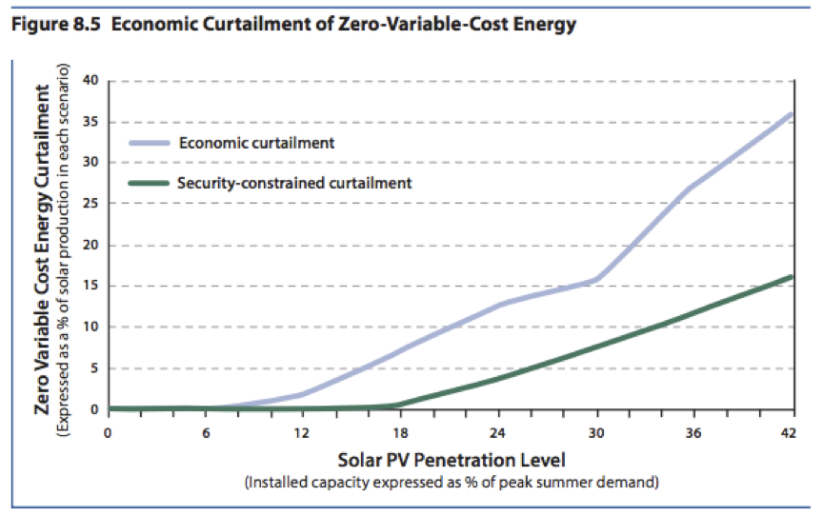

Figure 1.. Economic and system-security curtailment rates at different levels of PV penetration (Trembath & Jenkins, 2015).

DES can significantly reduce the need to curtail distributed generation resources by storing excess generation on-site. This allows both a higher overall penetration of renewable capacity and a more complete utilization of renewable generation resources, leading to a significant indirect climate benefit. In addition, DES can have a financial benefit for the owners of distributed generation resources by allowing them to avoid low market prices and giving them immunity towards changes in net metering policies.

Without time-of-use based pricing and high charges for unusually high power draws, using DES to shift consumption time is not economically favorable. Under these circumstances, DES provides a financial benefit primarily to the owners of distributed generation resources, as it enables them to achieve some measure of energy independence and frees them from relying on net metering and feed-in tariff policies. As demand on the grid increases, however, it can be expected that more areas will adopt TOU and similar policies as a means to delay grid capacity upgrades.

DES is unlikely to be the only form of energy storage on the grid. Centralized, utility-scale storage is more useful for longer-term storage (on the scale of days or seasons) as well as more suited to respond with capacity or conditioning services to fluctuations in supply from large, centralized wind or solar farms. DES has an important role to play, however, in increasing the independence of energy consumers and helping to balance the load and supply “behind the meter” with the capacity available upstream on the grid. DES is also a key resource for ensuring the reliability of electrical energy services. As a result of these many benefits, it can be expected that adoption of DES will increase strongly in the coming years, making it an important part of the changing energy landscape.

# References

Acker, W. (2014). *Energy Storage: Technologies, Applications, and Markets*. Presented at the New York Battery and Energy Storage Technology Consortium.

AMPERE (2015). Database. Retrieved August 8, 2014, from https://secure.iiasa.ac.at/web-apps/ene/AMPEREDB/dsd?Action=htmlpage&page=welcome

Barth, B., & Franz, O. (2013). *PV Curtailment and Prosumer Storage*.

Black, M., & Strbac, G. (2007). Value of Bulk Energy Storage for Managing Wind Power Fluctuations. *IEEE Transactions on Energy Conversion*, *22*(1), 197–205. http://doi.org/10.1109/TEC.2006.889619

Brautigam, A., Rothacher, T., Staubitz, H., & Trost, R. (2015). *The Energy Storage Market in Germany*. Germany Trade and Invest.

Brinkman, G., Lew, D., & Denholm, P. (2012, May). *Impacts of Renewable Generation on Fossil Fuel Unit Cycling: Costs and Emissions*. National Renewable Energy Laboratory. Retrieved from http://www.nrel.gov/docs/fy12osti/55828.pdf

Brown, D. H. (2011). *The impact of rechargeable batteries: quantifying the cost and weight for a Marine Infantry Battalion*. DTIC Document. Retrieved from http://oai.dtic.mil/oai/oai?verb=getRecord&metadataPrefix=html&identifier=ADA556380

Bussar, R., Lippert, M., Bonduelle, G., Linke, R., Crugnola, G., Cilia, J., … Marckx, E. (2013). *Battery Energy Storage for Smart Grid Applications*. Eurobat.

California Energy Storage Alliance. (2011). *Energy Storage - a Cheaper and Cleaner Alternative to Natural Gas-Fired Peakers*. California Energy Storage Alliance.

Carnegie, R., Gotham, D., Nderitu, D., & Preckel, P. V. (2013). Utility scale energy storage systems. *State Utility Forecasting Group. Purdue University*, *1*. Retrieved from http://assets.fiercemarkets.com/public/sites/energy/reports/batterystoragereport.pdf

Chang, J., Pfeifenberger, J., Spees, K., Davis, M., Karkatsouli, I., Regan, L., & Mashal, J. (2014). *The Value of Distributed Electricity Storage in Texas: Proposed Policy for Enabling Grid-Integrated Storage Investments*. The Brattle Group.

Chardon, A., Almén, D., Lewis, D. P. E., Stromback, J., Château, B., & others. (2008). Demand response: a decisive breakthrough for Europe.

Coad, N., & Lex, P. (2012). *Electrolyte Safety Overview*. ZBB Energy Corporation.

Con Edison: Customer Central - voluntary time-of-use. (n.d.). Retrieved July 23, 2015, from http://www.coned.com/customercentral/energyresvoluntary.asp

Conover, D., Ferreira, S., Crawford, A., Schoenwald, D., & Viswanathan, V. (2014). *Protocol for uniformly measuring and expressing the performance of energy storage systems*. PNNL-22010 Rev. Retrieved from http://energystorage.org/system/files/resources/ess_protocol_rev_1_with_microgrids.pdf

Dehamna, A., & Jaffe, S. (2014). *Community, Residential, and Commercial Energy Storage: Distributed Energy Storage Systems for Energy Cost Management and Grid Management: Global Market Analysis and Forecasts*. Navigant Research.

Denholm, P., Ela, E., Kirby, B., & Milligan, M. (2010). *The Role of Energy Storage with Renewable Electricity Generation*. NREL.

Denholm, P., & Kulcinski, G. L. (2004). Life cycle energy requirements and greenhouse gas emissions from large scale energy storage systems. *Energy Conversion and Management*, *45*(13-14), 2153–2172. http://doi.org/10.1016/j.enconman.2003.10.014

DNV KEMA. (2013). *Residential Solar Energy Storage Analysis*. DNV KEMA.

Dunn, B., Kamath, H., & Tarascon, J.-M. (2011). Electrical energy storage for the grid: a battery of choices. *Science*, *334*(6058), 928–935.

EIA. (2014a). Natural gas, solar, and wind lead power plant capacity additions in first-half 2014. Retrieved June 28, 2015, from http://www.eia.gov/todayinenergy/detail.cfm?id=17891

EIA. (2014b). European residential electricity prices increasing faster than prices in United States - Today in Energy - U.S. Energy Information Administration (EIA). Retrieved July 28, 2015, from http://www.eia.gov/todayinenergy/detail.cfm?id=18851

EIA. (2015). Short-Term Energy Outlook - U.S. Energy Information Administration (EIA). Retrieved July 28, 2015, from http://www.eia.gov/forecasts/steo/report/electricity.cfm

Griffiths, G. (2005). Cost vs. performance for fuel cells and batteries within AUVs. *Proceedings UUVS 2005*.

Grigoleit, T. (2014). *Energiewende in Germany: from generation to integration*. Germany Trade and Invest.

Grigoleit, T., Rothacher, T., & Hildebrandt, M. (2015). *Industry Overview: The Photovoltaic Market in Germany*. Germany Trade and Invest.

GTM Research. (2014). *Distributed Energy Storage: Applications and Opportunities for Commercial Energy*. GTM Research.

Hallberg, P., Rios, J. J. A., Birkner, P., Hakan, F., Kroll, A., Lawson, P., … Woyke, W. (2012). *Decentralised storage: impact on future distribution grids*. Eurelectric.

Hassenzahl, W. V., & Schoenung, S. M. (2003). *Long- vs. Short-Term Energy Storage Technologies Analysis: A Life-Cycle Cost Study*. Sandia.

IEA. (2014a). *CO2 Emissions from Fuel Combustion - Highlights 2014*. International Energy Agency. Paris, France.

IEA. (2014b). *Technology Roadmap: Energy storage*. International Energy Agency. Paris, France.

KEMA. (2012). *Distributed Energy Storage: Serving National Interests*. National Alliance for Advanced Technology Batteries. KEMA.

Kintner-Meyer, M. C., Molburg, J. C., Subbarao, K., Wang, J., Kumar, N. P., Zhao, F., … Koritarov, V. S. (2010). The Role of Energy Storage in Commercial Building A Preliminary Report. Retrieved from http://www.researchgate.net/profile/Vladimir_Koritarov/publication/265044885_PNNL-19853_The_Role_of_Energy_Storage_in_Commercial_Building_A_Preliminary_Report/links/545709480cf2cf5164804118.pdf

LeVine, S. (2015). *The powerhouse: inside the invention of a battery to save the world*. New York: VIKING.

Lew, D., Bird, L., Milligan, M., Speer, B., Wang, X., Carlini, E. M., … others. (2013). Wind and solar curtailment. In *Int. Workshop on Large-Scale Integration of Wind Power Into Power Systems* (pp. 1–9). Retrieved from http://www.researchgate.net/profile/Debra_Lew/publication/262057460_Wind_and_Solar_Curtailment_International_Experience_and_Practices/links/54295a270cf26120b7b5f1ae.pdf

Lisbona, D., & Snee, T. (2011). A review of hazards associated with primary lithium and lithium-ion batteries. *Process Safety and Environmental Protection*, *89*(6), 434–442. http://doi.org/10.1016/j.psep.2011.06.022

Lu, T.-Y., Chiang, C.-C., Wu, S.-H., Chen, K.-C., Lin, S.-J., Wen, C.-Y., & Shu, C.-M. (2013). Thermal hazard evaluations of 18650 lithium-ion batteries by an adiabatic calorimeter. *Journal of Thermal Analysis and Calorimetry*, *114*(3), 1083–1088. http://doi.org/10.1007/s10973-013-3137-9

Majeau-Bettez, G., Hawkins, T. R., & Strømman, A. H. (2011). Life Cycle Environmental Assessment of Lithium-Ion and Nickel Metal Hydride Batteries for Plug-In Hybrid and Battery Electric Vehicles. *Environmental Science & Technology*, *45*(10), 4548–4554. http://doi.org/10.1021/es103607c

Martinot, E. (2015). *How is Germany integrating and balancing renewable energy today? – German Energy Transition.* Retrieved August 4, 2015, from http://energytransition.de/2015/02/how-germany-integrates-renewable-energy/

Martin, R. (2013). *Total Installed Capacity of Advanced Lead-Acid Batteries to Surpass 5 Gigawatts by 2020.* Retrieved from https://www.navigantresearch.com/newsroom/total-installed-capacity-of-advanced-lead-acid-batteries-to-surpass-5-gigawatts-by-2020

Neubauer, J., & Simpson, M. (2014). *Deployment of Behind-The-Meter Energy Storage for Demand Charge Reduction*. NREL/TP-5400-63162. Golden, CO: National Renewable Energy Laboratory. Accessed January 26, 2015: http://www. nrel. gov/docs/fy15osti/63162. pdf. Retrieved from http://www.nrel.gov/docs/fy15osti/63162.pdf

Nourai, A. (2007). Installation of the first distributed energy storage system (DESS) at American Electric Power (AEP). *Sandia Report SAND2007-3580*. Retrieved from http://citeseerx.ist.psu.edu/viewdoc/download?doi=10.1.1.454.1713&rep=rep1&type=pdf

Nykvist, B., & Nilsson, M. (2015). Rapidly falling costs of battery packs for electric vehicles. *Nature Climate Change*, *5*(4), 329–332. http://doi.org/10.1038/nclimate2564

On-Peak & Off-Peak Hours. (2015). Retrieved June 25, 2015, from https://www.pacificpower.net/ya/po/otou/ooh.html

Oudalov, A., Cherkaoui, R., & Beguin, A. (2007). Sizing and Optimal Operation of Battery Energy Storage System for Peak Shaving Application (pp. 621–625). IEEE. http://doi.org/10.1109/PCT.2007.4538388

Park, M. S., Ma, S. B., Lee, D. J., Im, D., Doo, S.-G., & Yamamoto, O. (2014). A Highly Reversible Lithium Metal Anode. *Scientific Reports*, *4*. http://doi.org/10.1038/srep03815

Schoenung, S. (2011). Energy storage systems cost update. *Sandia National Laboratories, Albuquerque*. Retrieved from http://prod.sandia.gov/techlib/access-control.cgi/2011/112730.pdf

Solar Server. (2014). *German government proposes new rules for curtailment of solar PV without compensation.* Retrieved July 30, 2015, from: http://www.solarserver.com/solar-magazine/solar-news/archive-2014/2014/kw06/german-government-proposes-new-rules-for-curtailment-of-solar-pv-without-compensation.html

Tesla Powerwall. (2015). Retrieved July 29, 2015, from http://www.teslamotors.com/powerwall

Trembath, A., & Jenkins, J. (2015, May 27). A Look at Wind and Solar -- Part 2: Is There An Upper Limit To Intermittent Renewables? Retrieved July 30, 2015, from http://thebreakthrough.org/index.php/voices/energetics/a-look-at-wind-and-solar-part-2

Turconi, R., O’Dwyer, C., Flynn, D., & Astrup, T. (2014). Emissions from cycling of thermal power plants in electricity systems with high penetration of wind power: Life cycle assessment for Ireland. *Applied Energy*, *131*, 1–8. http://doi.org/10.1016/j.apenergy.2014.06.006

Viswanathan, V., Kintner-Meyer, M., Balducci, P., & Jin, C. (2013). National Assessment of Energy Storage for Grid Balancing and Arbitrage Phase II Volume 2: Cost and Performance. Retrieved from http://energyenvironment.pnnl.gov/pdf/National_Assessment_Storage_PHASE_II_vol_2_final.pdf

Wang, Q., Ping, P., Zhao, X., Chu, G., Sun, J., & Chen, C. (2012). Thermal runaway caused fire and explosion of lithium ion battery. *Journal of Power Sources*, *208*, 210–224. http://doi.org/10.1016/j.jpowsour.2012.02.038

WE Energies. (2011). *Understanding Demand Charges for General Secondary Rates*. WE Energies.

Zackrisson, M., Avellán, L., & Orlenius, J. (2010). Life cycle assessment of lithium-ion batteries for plug-in hybrid electric vehicles – Critical issues. *Journal of Cleaner Production*, *18*(15), 1519–1529. http://doi.org/10.1016/j.jclepro.2010.06.004

# Glossary

**Adoption Scenario** – the predicted annual adoption over the period 2015 to 2060, which is usually measured in **Functional Units**. A range of scenarios is programmed in the model, but the user may enter her own. Note that the assumption behind most scenarios is one of growth. If for instance, a solution is one of reduced heating energy usage due to better insulation, then the solution adoption is translated into an increase in the use of insulation. There are two types of adoption scenarios in use: **Reference (REF)** where global adoption remains mostly constant, and **Project Drawdown Scenarios (PDS)** which illustrate the high growth of the solution.

**Approximate PPM Equivalent** – the reduction in the atmospheric concentration of CO2 (in **PPM**) that is expected to result if the **PDS Scenario** occurs. This assumes a discrete avoided pulse model based on the Bern Carbon Cycle model.

**Average Abatement Cost** – the ratio of the present value of the solution (**Net** **Operating Savings** minus **Marginal First Costs**) and the **Total Emissions Reduction**. This is a single value for each solution for each **PDS Scenario** and is used to build the characteristic “*Marginal Abatement Cost*” curves when Average Abatement Cost values for each solution are ordered and graphed.

**Average Annual Use** – the average number of functional units that a single implementation unit typically provides in one year. This is usually a weighted average for all users according to the data available. For instance, the total number of passenger-km driven by a hybrid vehicle in a year depends on the country and the typical number of occupants. We take global weighted averages for this input. This is used to estimate the **Replacement Time**.

**Cumulative First Cost** – the total **First Cost** of solution **Implementation Units** purchased in the **PDS Scenario** in the analysis period. The number of solution implementation units that are available to provide emissions reduction during the analysis period is dependent on the units installed prior to the analysis period, and hence all implementation units installed after the base year are included in the cumulative first costing (that is 2015-2050).

**Direct Emissions** – emissions caused by the operation of the solution, which are typically caused by the lifetime use of the solution. They should be entered into the model normalized per functional unit.

**Discount Rate**- the interest rate used in discounted cash flow (DCF) analysis to determine the present value of future cash flows. The discount rate in DCF analysis takes into account, not just the time value of money, but also the risk or uncertainty of future cash flows; the greater the uncertainty of future cash flows, the higher the discount rate. Most importantly, the greater the discount rate, the more the future savings are devalued (which impacts the financial but not the climate impacts of the solution).

**Emissions** **Factor**– the average normalized emissions resulting from consumption of a unit of electricity across the global grid. Typical units are kg CO2e/kWh.

**First Cost**- the investment cost per **Implementation Unit** which is essentially the full cost of establishing or implementing the solution. This value, measured in 2014$US, is only accurate to the extent that the cost-based analysis is accurate. The financial model assumes that the first cost is made entirely in the first year of establishment and none thereafter (that is, no amortization is included). Thus, both the first cost and operating cost are factored in the financial model for the first year of implementation, all years thereafter simply reflect the operating cost until replacement of the solution at its end of life.

**Functional Unit** – a measurement unit that represents the value, provided to the world, of the function that the solution performs. This depends on the solution. Therefore, LED Lighting provides petalumen-hours of light, Biomass provides tera-watt-hours of electricity and high-speed rail provides billions of passenger-km of mobility.

**Grid Emissions** – emissions caused by the use of the electricity grid in supplying power to any operation associated with a solution. They should be in the units described below each variable entry cell. Drawdown models assume that the global electric grid, even in a Reference Scenario, is slowly getting cleaner and that emissions factors fall over time resulting in lower grid emissions for the same electricity demand.

**Implementation Unit** – a measurement unit that represents how the solution practice or technology will be installed/setup and priced. The implementation unit depends on the solution. For instance, implementing electric vehicles (EV) is measured according to the number of actual EV’s in use, and adoption of Onshore Wind power is measured according to the total terawatts (TW) of capacity installed worldwide.

**Indirect Emissions** – emissions caused by the production or delivery or setup or establishment of the solution in a specified area. These are NOT caused by day to day operations or growth over time, but they should be entered into the model normalized on a per functional unit or per implementation unit basis.

**Learning Rate/Learning Curve** - Learning curves (sometimes called experience curves) are used to analyze a well-known and easily observed phenomenon: humans become increasingly efficient with experience. The first time a product is manufactured, or a service is provided, costs are high, work is inefficient, quality is marginal, and time is wasted. As experienced is acquired, costs decline, efficiency and quality improve, and waste is reduced. The model has a tool for calculating how costs change due to learning. A 2% learning rate means that the cost of producing a good drops by 2% every time total production doubles.

**Lifetime Capacity** – this is the total average functional units that one implementation unit of the solution or conventional technology or practice can provide before replacement is needed. All technologies have an average lifetime usage potential, even considering regular maintenance. This is used to estimate the **Replacement Time**. and has a direct impact on the cost to install/acquire technologies/practices over time. E.g. solar panels generate, on average, a limited amount of electricity (in TWh) per installed capacity (in TW) before a new solar panel must be purchased. Electric vehicles can travel a limited number of passenger kilometers over its lifetime before needing to be replaced.

**Lifetime Operating Savings**–the operating cost in the PDS versus the REF scenarios over the lifetime of the implementation units purchased during the model period regardless of when their useful life ends.

**Lifetime Cashflow NPV**-the present value (PV) of the net cash flows (PDS versus REF) in each year of the model period (2015-2060). The net cash flows include net operating costs and first costs. There are two results in the model: Lifetime Cashflow NPV for a Single **Implementation Unit**, which refers to the installation of one **Implementation Unit**, and Lifetime Cashflow NPV of All Units, which refers to all **Implementation Units** installed in a particular scenario. These calculations are also available using profit inputs instead of operating costs.

**Marginal First Cost** – the difference between the **First Cost** of all units (solution and conventional) installed in the **PDS Scenario** and the **First Cost** of all units installed in the **REF Scenario** during the analysis period. No discounting is performed. The number of solution implementation units that are available to provide emissions reduction during the analysis period is dependent on the units installed prior to the analysis period, and hence all implementation units installed after the base year are included in the cumulative first costing (that is 2015-2050).

**Net Annual Functional Units (NAFU)** – the adoption in the PDS minus the adoption in the REF in each year of analysis. In the model, this represents the additional annual functional demand captured either by the solution in the **PDS Scenario** or the conventional in the **REF Scenario**.

**Net Annual Implementation Units (NAIU)** – the number of **Implementation Units** of the solution that are needed in the PDS to supply the **Net Annual Functional Units (NAFU).** This equals the adoption in the PDS minus the adoption in the REF in each year of analysis divided by the average annual use.

**Net Operating Savings** – The undiscounted difference between the operating cost of all units (solution and conventional) in the **PDS Scenario** minus that of all units in the **REF Scenario**.

**Operating Costs** – the average cost to ensure the operation of an activity (conventional or solution) which is measured in 2014$US/**Functional Unit**. This is needed to estimate how much it would cost to achieve the adoption projected when compared to the **REF Case**. Note that this excludes **First Costs** for implementing the solution.

**Payback Period** – the number of years required to pay all the **First Costs** of the solution using **Net Operating Savings**. There are four specific metrics each with one of **Marginal First Costs** or **First Costs** of the solution only combined with either discounted or non-discounted values. All four are in the model. Additionally, the four outputs are calculated using the increased profit estimation instead of **Net Operating Savings**.

**PDS/ Project Drawdown Scenario** – this is the high growth scenario for the adoption of the solution.

**PPB/ Parts per Billion** – a measure of concentration for atmospheric gases. 10 million PPB = 1%.

**PPM/ Parts per Million** – a measure of concentration for atmospheric gases. 10 thousand PPM = 1%.

**REF/ Reference Scenario** – this is the low growth scenario for the adoption of the solution against which all **PDS scenarios** are compared.

**Regrets solution** has a positive impact on overall carbon emissions being therefore considered in some scenarios; however, the social and environmental costs could be harmful and high.

**Replacement Time**- the length of time in years, from installation/acquisition/setup of the solution through usage until a new installation/acquisition/setup is required to replace the earlier one. This is calculated as the ratio of **Lifetime Capacity** and the **Average Annual Use**.

**TAM/ Total Addressable Market** – represents the total potential market of functional demand provided by the technologies and practices under investigation, adjusting for estimated economic and population growth. For this solutions sector, it represents the world and regional total addressable markets for electricity generation technologies in which the solutions are considered.

**Total Emissions Reduction** – the sum of the grid, fuel, indirect, and other direct emissions reductions over the analysis period. The emissions reduction of each of these is the difference between the emissions that would have resulted in the **REF Scenario** (from both solution and conventional) and the emissions that would result in the **PDS Scenario**. These may also be considered as “emissions avoided” as they may have occurred in the REF Scenario, but not in the PDS Scenario.

**Transition solutions** - are considered till better technologies and less impactful are more cost-effective and mature.

**TWh/ Terawatt-hour** – A unit of energy equal to 1 billion kilowatt-hours.