**Technical assessment for**

**Grid Flexibility**

Sector: Electricity generation

Agency Level: Utilities

Keywords: Flexibility, Smart Grid, Grid, Electricity, Distribution

Version 2 (November 2019)

**Prepared by:**

Alison Mason, Research Fellow

João pedro Gouveia, Senior Research Fellow



[info@drawdown.org](mailto:info@drawdown.org) [www.drawdown.org](http://www.drawdown.org)

Table of Contents

List of Figures 3

Acronyms and Symbols 4

1 Literature Review 6

1.1. State of the Technologies 6

1.2. Categories of Flexibility 8

1.2.1. System Operation 9

1.2.2. Markets 9

1.2.3. Load 9

1.2.4. Flexible Generation 12

1.2.5. Networks 12

1.2.6. Storage 13

1.2.7. The Integrated Grid 13

1.3. Adoption Path 14

1.4. Advantages and disadvantages of Grid Flexibility 16

2. Methodology 18

3. Discussion 20

4. References 21

5. Glossary 23

# List of Figures

Figure 1.1 Illustration of how VRE increases the need for flexibility (Aggarwal et al., 2016, Cochran et al., 2014) 7

Figure 1.2 Relative Economics of Integration Options (Cochran et al., 2014) 8

Figure 1.3 Shift DR (LBNL, 2016) 11

Figure 1.4 Shed DR (LBNL, 2016) 11

Figure 1.5 Shimmy DR (LBNL, 2016) 11

Figure 1.6 The physical elements of the grid are generation, transmission, distribution, and storage (QER, 2015). 12

# Acronyms and Symbols

* AMI - Advanced Metering Infrastructure
* AMR- Automated meter reading
* CAISO - California Independent System Operator
* CVR - Conservation voltage reduction
* DER - Distributed energy resources
* EIM - Energy Imbalance Market
* ERCOT - Energy Reliability Council of Texas
* EU – European Union
* EV – Electric vehicles
* GHG - Greenhouse gases
* IEA - International Energy Agency
* IT - Information technology
* LBNL – Lawrence Berkeley National Laboratory
* LCOF - Levelized cost of flexibility
* OECD - The Organisation for Economic Co-operation and Development
* PV – Photovoltaics
* V2G – Vehicle to grid
* VPP – Virtual Power Plants
* VRE - Variable renewable energy

Executive Summary

Project Drawdown defines grid flexibility as the ability of an electricity system to integrate variable renewable energy (VRE) while delivering high quality energy reliably, efficiently, and affordably. The properties of a power system that establish how flexible it is, and therefore how easily VRE can be integrated, are the size of the balancing area (the system boundary within which supply must equal demand); the adequacy of transmission to move resource from one region to another; the match between demand and VRE in space and time; the degree of flexibility of the dispatchable generation fleet; how many physical interconnections there are to adjacent power systems; the number and size of power markets cooperating; and the degree to which demand is growing (IEA, 2014).

Grid flexibility is addressed by a portfolio of practices and technologies for managing the flow of electricity into and out of the grid to maintain power quality, stability, and reliability. Every electric power system has some degree of flexibility built in to provide a buffer between supply and demand. Adding VRE to a system increases the need for flexibility; fortunately, many means of providing it are inexpensive or have collateral benefits that offset their cost. Tools to increase grid flexibility fall into six categories - System Operation, Market Design, Dispatchable Load, Flexible Generation, Networks, and Storage. The practices and technologies that constitute grid flexibility are in varying states of maturity; each one contains elements that have existed since the beginning of electrification, such as governors on generators to keep frequency steady as load varies, and elements that continue to evolve to meet modern needs, such as two-way communication, controls to manage distributed energy resources (DER), and advanced batteries.

While flexibility has always been a necessary feature of the electricity grid, today new tools have emerged from advancements in information technology, communications, computation, and energy storage. These new tools have given rise to labels such as “smart grid” and “utility of the future”. Smart grid refers to information-based technology that enhances system function and flexibility using data and intelligent processing of the data to make better decisions about system dispatch. Smart grid also implies a more participatory role for the energy consumer. The utility model is evolving to make better use of new technology to provide consumers the cleaner, cheaper, more reliable energy services they demand. The term “grid modernization” is also used to describe essentially the same set of practices and techniques that provide grid flexibility and accommodate the changing nature of the grid from centralized generation with one-way power flow to distributed generation with two-way power flow.

When determining how much resource to allocate toward grid flexibility, a key consideration is that countries without an established, interconnected grid system have an opportunity to prioritize flexibility from the start, at much lower cost. Another consideration is that distribution problems that in the past were solved with investment in infrastructure (upgrading lines and transformers) can today be solved with grid flexibility (“non-wires alternatives”), thus tapping an existing budget. A third consideration is that batteries, which are a powerful source of flexibility, are set to be deployed in electric vehicles in a big way and could, with the right rate design and infrastructure, be tapped as a major grid asset. As a rough guide, up to around 25% VRE can be accommodated using existing infrastructure and adopting more flexible operation practices and market structures. Beyond 25%, new infrastructure, such as transmission lines and batteries, will be needed to ensure the safe, reliable functioning of the grid, and ultimately, with the addition of distributed intelligence to manage the many sources of energy services, a 100% renewable grid can be achieved (IEA, 2014). Adoption of grid flexibility is driven by adoption of VRE into the electric grid; the age of our existing infrastructure and its unsuitability to manage two-way power flows; and the need to make the grid more resilient in the face of increasing natural disasters. Metrics for quantifying grid flexibility are being developed; however, there are so many factors that contribute to making the grid flexible, this is challenging. For these reasons and the difficulty of quantitatively assigning carbon impact to grid flexibility, it was not modeled using Project Drawdown’s RSS model framework; nevertheless, it is a critical piece that makes possible the integration of more VRE into the grid.

# Literature Review

## State of the Technologies

Frameworks for measuring flexibility are evolving. Cochran et al. (2014) summarize three methods to describe or quantify the flexibility of a grid system. One (Yasuda) is a simple visual chart, showing what types of generation-based flexibility a country has and the maximum share of wind during one hour relative to demand. Another (GIVAR III) graphically scores power systems in terms of power area size, grid strength, interconnection, number of power markets, and flexibility of dispatchable generation portfolio. The third (FAST2) is an analytical method using time-series data to determine how much VRE can be integrated into a particular system.

The International Energy Agency (IEA) used the revised Flexibility Assessment Tool (FAST2) to examine the ability of six grids to support increasing amounts of VRE. FAST2 provides a rough indication of the flexibility of a given power system with respect to four flexible resources: flexible generation, interconnection, demand-side response, and storage. The IEA’s findings suggest that at VRE levels of 2%-3% of annual generation, the magnitude of the variability of generation is less than that of system demand and integration poses no issue at all. At VRE levels of 5%-10%, integration can be achieved simply by spreading the VRE out; ensuring the plants can contribute to grid stabilization when needed; and integrating VRE forecasts into standard grid operation. VRE penetration on the order of 25% to 40% can be supported by operating the system with flexibility as a priority. Of the grids studied, North West Europe and Brazil were the most flexible and could accommodate 40% VRE; North West Europe because of geographical aggregation and a diverse resource pool and Brazil due to an abundance of reservoir hydro generation. The Iberian Peninsula, with a large amount of gas generation and hydro storage, could accommodate 35% VRE. Texas, Italy, and Japan East were able to accommodate 25% VRE (IEA, 2014).

Grid flexibility does not reduce greenhouse gas (GHG) emissions in itself; rather, it is a physical requirement in order to incorporate increasing levels of VRE in the grid. The variable nature of electricity use and our dependence on always-available power at the flip of a switch has meant that the electric grid must have means of ramping generation up and down to create a balance. Loads have also been recruited to assist with balance through demand response programs. When balance fails, power quality suffers and brown or black outs happen. Long before variable renewable energy became a going concern, there were calls for greater flexibility in the power system to increase reliability and efficiency (Lovins, 1977). Now, the accelerating adoption of VRE worldwide is creating an imperative to build more flexibility into the system to buffer the mismatch between supply and demand - moment to moment and day to day. Figure 1.1 illustrates how VRE (green) combines with usage pattern (yellow) to create a more erratic net load (orange). Net load is the usage minus the VRE and must be met with a controllable form of generation. As grid flexibility relates to Project Drawdown, it enables the integration of more VRE solutions. The indirect avoidance of GHG emissions due to the impacts of grid flexibility are therefore counted in the several wind and solar solutions.

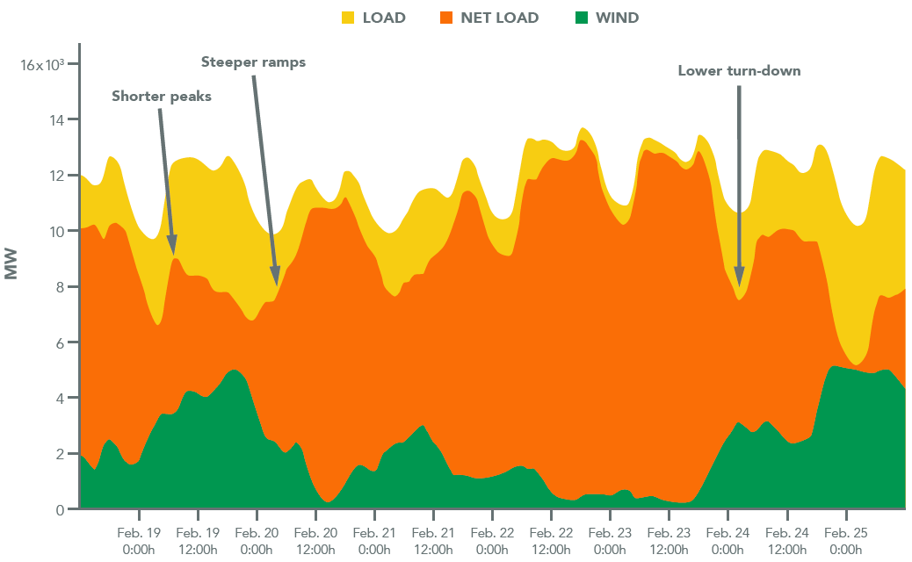

Figure 1.1 Illustration of how VRE increases the need for flexibility (Aggarwal et al., 2016, Cochran et al., 2014)

In addition to brown or blackouts caused by frequency straying outside established safety limits, there are other signs that a system lacks sufficient flexibility. These signs include significant curtailment of VRE, when wind or solar is prevented from outputting as much power as it is capable of; area balance violations, when a system cannot meet its electricity balancing responsibility; negative market prices, when there is more zero marginal cost VRE being generated than can be used by the system; and price volatility (Cochran et al, 2014).

Grid flexibility is fundamentally the operators of the electric grid maintaining balance between supply and demand by scheduling energy dispatch in advance to meet a load forecast; correcting for forecast errors with controllable generation in real time (load following and ramping); and maintaining power quality with fast responding resources (frequency response and regulation) (Denholm et al., 2016). These are the physical mechanisms of balance and can be described in a straightforward way. Actual implementation must navigate the constraints of real markets and regulations and so the ultimate solution is dependent not only on physical system characteristics, but also locally applicable policy, market rules, and government regulation. Tools of flexibility are described from the literature in the following section. Martinot et al. (2016) summarizes the approaches to flexibility in different parts of the world with large scale grid systems and points out that the measures can be understood generically but apply differently according to specifics of jurisdiction.

## Categories of Flexibility

The literature varies in division of flexibility sources into categories. Aggarwal et al. (2016) refines the description in Denholm et al. (2010) and Cochran et al. (2014) uses System Operation, Markets, Load, Flexible Generation, Networks, and Storage which is similar and provides a useful and simple framework. Figure 2 illustrates the categories, lists specific examples, and gives an idea of their relative costs.

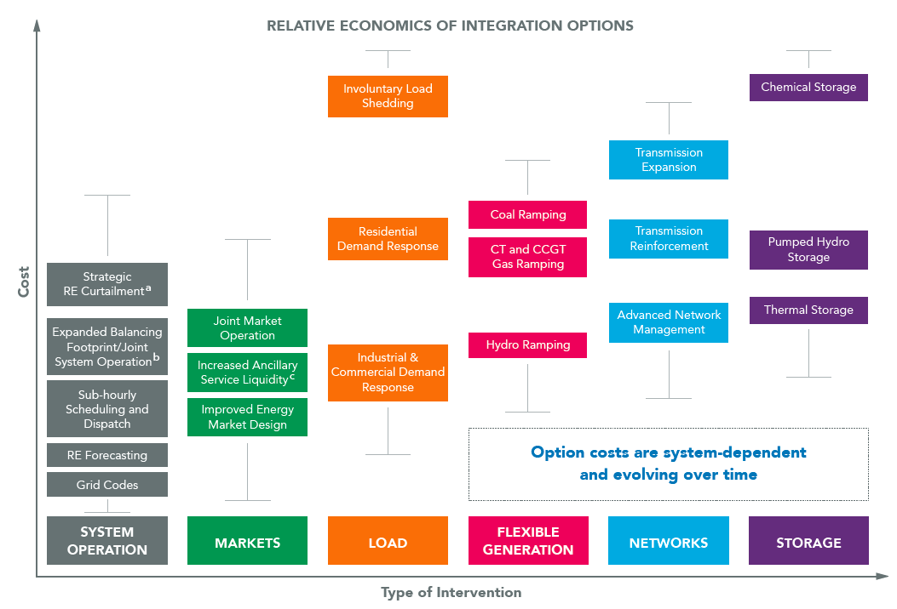

Figure 1.2 Relative Economics of Integration Options (Cochran et al., 2014)

Denholm et al. (2016) further identify reduced minimum generation levels, increased export capacity, expanded demand response, and optimized charging of electric vehicles as four particularly useful specific examples to increase grid flexibility to minimize the need for energy storage.

Milligan et al. (2015) provide lists of physical and institutional flexibility measures which are substantially similar to those identified by Denholm, Cochran, and Aggarwal; and are described in detail in Milligan (2015) and its companion, Hurlburt et al. (2015).

### System Operation

Three ways to increase flexibility through operations (Aggarwal et al., 2016) are to shorten dispatch schedules (and thus make the grid more responsive); improve weather forecasting (and thus minimize the correction needed to the planned dispatch); and consolidate balancing areas (and thus diversify the resources available) as demonstrated by the US West’s Energy Imbalance Market (EIM) extending its north-south reach with the integration of Arizona Public Service and Puget Sound Energy in 2016 (RTO Insider, 2017). To this list, Cochran et al. (2014) adds two more: strategic curtailment of renewable energy and grid codes. Also known as interconnection agreements, grid codes establish rules and standards with which VRE must comply to gain authorization to connect to the grid and can include limits on backfeed (how much electricity flows to the grid), compensation for backfed electricity, limits on ramp rate (how quickly the electricity changes power level) and frequency and voltage requirements.

### Markets

A variety of market elements increase flexibility – settlement on short intervals (rewards flexibility); trading energy with neighboring markets (reducing the aggregate need for generating capacity); neutral with regard to technology (generation, storage, load); performance based (FERC Order 755); and ancillary services. Ancillary services (e.g. scheduling, voltage control, load following, and frequency response) are compensated for ensuring reliability of the delivery of capacity and energy. New ancillary services can be designed to accommodate increased variability in the system – for example ramping or flexible reserve, as in the California Independent System Operator (CAISO). The Energy Reliability Council of Texas (ERCOT) is exploring synchronous inertial response, fast frequency response, primary frequency response, up and down regulating reserve, and contingency reserve (Milligan, 2015). Martinot et al. (2016) describe three additional market mechanisms that affect renewable integration: negative prices signal fuel-based generators to curtail during low load periods so wind and solar can produce; capacity markets and resource adequacy must adapt with the changing needs of the grid; and ramping markets directly procure the flexible resources needed to meet rapid changes in net load. Due to improvements in power electronics and control software, ancillary services can also be provided from wind and solar plants themselves.

### Load

Greater intelligence on the grid – data to tell operators when and where electricity use (load) tends to rise – is making it possible to shift the paradigm of “electricity whenever you want it” to “electricity when it is cost effective”. In other words, within pragmatic operational considerations, price signals and rewards can be used to change the timing of electricity use to smooth demand and relieve burden on generators. In this way, loads can be shifted to coincide with the highest output of VRE, thus solving potential over-voltage problems. Heating and cooling systems, some industrial processes, and electric vehicles are examples of loads that can have their use shifted to times of low demand without impacting comfort or quality. Furthermore, loads can be aggregated to provide capacity and ancillary services to markets, if regulations allow. Making use of load in this way is called demand response. A thorough review of demand response programs is provided in Milligan (2016). They explain and illustrate how programs to incentivize energy efficiency, price response, peak shaving, reliability response, and regulation response function to shape load for grid reliability.

For decades, demand response (DR) has been used to shed loads to relieve generation and transmission constraints arising from peaking demand. The increase in VRE is changing the shape and timing of system peak loads, necessitating a different approach to demand response. At the same time, advances in analytics and communications are opening up new opportunities for DR to contribute to grid operations and power markets. The California Public Utilities Commission and US DOE funded Lawrence Berkeley lab (Alstone et al.) to estimate to what extent demand could be used to meet California’s resource planning needs and operational requirements as the state addresses the high renewable future of the grid. The first phase of the study addressed the ability of DR to meet capacity requirements using conventional and emerging load shedding technologies such as direct control of air conditioners, pool pumps, and battery chargers. The second phase of the study expanded the concept of DR to a new set of services made possible by technology and quantified the contribution it could make in California. The authors introduce terminology to describe the new DR services – shape, shift , shed, and shimmy. Shape uses economic or behavioral incentives to get customers to use energy at particular times, incorporating, in effect, both shift and shed, but achieved through rates. Shift (see figure 1.3) is achieved through a market and dispatched according to a contract. Shed (see figure 1.4) is conventional DR, dispatched through market mechanisms to reduce peak demand. Shimmy (see figure 1.5) is fast response to a dispatch signal either increasing or decreasing load to provide ancillary services (regulation and load following).



Figure 1.3 Shift DR (LBNL, 2016)



Figure 1.4 Shed DR (LBNL, 2016)



Figure 1.5 Shimmy DR (LBNL, 2016)

### Flexible Generation

When VRE output is high, it becomes necessary to dial down or turn off traditional generation sources to avoid curtailing VRE; however, the system needs a certain amount of backup generation quickly available (reserve) to make up for sudden increases in demand or decreases in VRE. If this minimum generation level is high, VRE will more frequently need to be curtailed. Plants running on natural gas, coal, hydroelectric and even nuclear can be turned up and down to provide flexible output (older ones may need modification); however, operating like this can damage equipment, reduce life expectancy, and increase emissions. The savings from avoided fuel cost far outweigh the cycling cost; however, the traditional generator will need to be compensated for running less, which could be achieved through the creation of new auxiliary service markets (Milligan, 2016 and Martinot, 2016).

### Networks

Transmission moves bulk electricity from the point of generation to the distribution system where it will be consumed (see figure 6). Increased transmission capacity can move supply to where it is needed and allows trading across balancing areas and between regional markets (Martinot, 2016). Modern distribution infrastructure (aka Smart Grid) includes two-way communication between the system operator and distributed energy resources. Communication of data enabled by Advanced Metering Infrastructure (AMI) provides the system operator with visibility of usage and conditions on the distribution grid, where until recently power flow was one way. New control software aggregates geographically dispersed energy resources into virtual power plants (VPP) to participate in energy markets. Smart inverters installed with rooftop solar photovoltaic (PV) panels have advanced features so they can help support grid stability. Codes and standards are being updated so that the many brands of such devices can be more easily integrated into the system and aggregated for bigger effect.

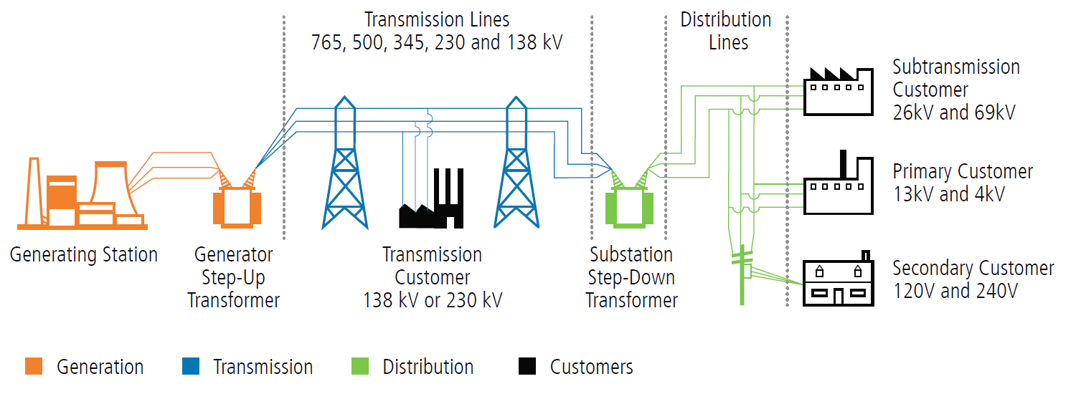

Figure 1.6 The physical elements of the grid are generation, transmission, distribution, and storage (QER, 2015).

### Storage

Energy storage is capable of many kinds of flexibility services; expensive in terms of capital and embodied carbon, it has the potential to return much greater value due to its ability to provide load leveling, frequency regulation, contingency reserves, and firm capacity as required. The amount of energy storage required to achieve a given penetration of VRE is inversely related to the degree of flexibility of the electricity grid. As an example, Denholm et al. (2016) conclude that in California, one can achieve 40% PV (annual energy basis) and 20% curtailment with 30 GW of energy storage in a low flexibility grid but can achieve the same PV penetration and only require 15 GW of storage in a high flexibility grid. As energy storage becomes cost effective on many scales, it will be important to optimize grid flexibility before adopting storage to integrate renewables, since the round-trip efficiency penalty of storage results in increased energy demand. Energy storage is discussed in more detail in two other Project Drawdown Solutions – Utility Scale Energy Storage and Distributed Energy Storage.

### The Integrated Grid

Looking at integration of VRE from the utility planning perspective, it becomes a problem of understanding how and where distributed energy resources (DER) are being added to the system; where they would provide the most benefit; and what measures are needed to ensure safe and reliable delivery of electricity. EPRI (2015) has developed a framework (entitled “The Integrated Grid”) for incorporating increasing amounts of DER (generation, storage, and controllable loads) which considers the benefits and costs of choices with respect to grid modernization; strategies and tools for grid planning and operations; interconnection rules and standards; and enabling policy and regulations.

Denholm’s (2016) analysis underscores the relevance of the concept of the Integrated Grid. Denholm shows that curtailment of PV, which is always more expensive than reducing fuel-dependent generation, but more practical than curtailing other sources of renewable energy like small hydro and geothermal, is reduced by increasing grid flexibility. One of Denholm’s important conclusions is that it becomes increasingly challenging to integrate PV at levels above 40%, exposing the need to examine the optimal mix of generation sources in any given grid to achieve higher levels of VRE penetration.

The International Energy Agency defined a levelized cost of flexibility (LCOF) to compare the cost of providing flexibility from the different sources. Highly flexible generation, grid infrastructure (network), and demand response (load) can provide flexibility at costs as low as $1/MWh to $5/MWh (energy) and reaching $20/MWh under less favorable conditions. Electricity storage is considerably costlier, ranging from $20/MWh for pumped hydro storage to more than $500/MWh for distributed battery storage (IEA, 2014).

## Adoption Path

Greater grid flexibility is, at once, a direct result of policies to increase adoption of VRE and so included in the costs to do so and an enabling characteristic for increasing the share of VRE. Grid flexibility will necessarily be increased along with adoption of VRE; it can be achieved most effectively with sufficient information to select the best options and deploy them through an open process and with advance planning to minimize costs and maximize benefits. This will require considered and timely reform of regulations and adoption of policy. Barriers to adoption of flexibility include public objection to new infrastructure such as transmission lines; reluctance on the part of regulated utilities to share data about system needs with unregulated competitors; privacy issues with regard to two-way communications; slow rate of changing regulation as regulators face the challenge of encouraging innovation that benefits the system while protecting the interests of all rate payers.

The many options for increasing system flexibility are of no use if they cannot be implemented due to unfavorable policy or market barriers. For example, energy storage can provide every possible kind of energy service; however, legacy regulation designed with fossil generation in mind constrains storage from full participation (Energy Storage Association, 2016). In the US, the Federal Electricity Regulatory Commission (FERC), which governs interstate power transmission and wholesale markets, has issued several orders (755, 784) to allow batteries to participate in the wholesale markets and be compensated according to the degree of service they provide, to make the regulatory environment more equitable to storage (Utility Dive, 2016). FERC continues to explore how best to include energy storage in the market and convened a technical conference (Docket AD 16-25) to “discuss the utilization of electric storage resources as transmission assets compensated through transmission rates, for grid support services that are compensated in other ways, and for multiple services” (RTO Insider, 2016). In November 2016, FERC proposed a rule that would require each regional transmission organization (RTO) and independent system operator (ISO) to create rules for energy storage to participate in wholesale markets, recognizing the multitude of functions electric storage resources can provide (Greentech Media, 2016b).

Cochran et al. (2016) review policy best practices for integrating VRE in five categories. The first relates to the need for new transmission capacity, which may be to transmit electricity from a remote VRE location to a population center; to enlarge balancing areas; to reduce transmission congestion; or to fully access flexible resources. The second is to coordinate and integrate planning (of generation, transmission, and system performance). The third is to develop rules for market evolution that enable system flexibility (scheduling on shorter time intervals, establishing capacity and ancillary service markets, setting zonal or nodal pricing to encourage flexible storage and demand response). The fourth is to expand access to diverse resources and geographic footprint of operations (enlarge balancing areas, diversify portfolio of load and VRE). The fifth is to improve system operations (advanced forecasting and grid codes, or interconnection policies). Because the public may have concerns over land use, environmental damage, property values, health, and cost, engagement is most effective when begun early and the public is given many opportunities to comment throughout the process. The sooner policies are adopted to make way for new markets and new infrastructure to support flexibility, the less costly they are and therefore the less costly it is to integrate increasing levels of VRE.

Three trends stand out that will accelerate adoption. The first relates to the availability, communication, and processing of data. As information technology (IT) has become more and more accessible – available and cost effective, it has begun to transform the way that electricity is metered, billed, and valued; and made way for a host of new data-based services. The visibility and opportunities to optimize management of energy systems that IT brings to utilities and energy providers alike are enabling new business models that in turn promote investment in VRE and the infrastructure to integrate it. What began as an investment in automated meter reading (AMR) in the 1990s has evolved into advanced metering infrastructure (AMI) and that is evolving to include the exchange of many kinds of grid data over multiple communication networks (radio, cell, fiber, and conductor). This trend is discussed in depth in Smart Grid.

The second trend relates to energy storage and is discussed in detail in Utility Scale Energy Storage and Distributed Energy Storage Drawdown solutions. The acceleration in advancement of Lithium Ion batteries beginning around 2010 and their recent rapid decline in cost have made them increasingly useful and cost effective.

The third trend, closely related to the second, is the uptake in adoption of electric vehicles (EVs). Wherever the infrastructure to allow EVs to support the grid with energy and ancillary services is developed (i.e. smart charging and V2G systems), the grid will become more flexible. If battery costs remain high, then once past their useful life in cars, they will be available for a second life in buildings. If battery costs fall enough to make battery second life use impractical, then energy storage will have become cheap enough to be widely deployed to support a high penetration of VRE.

The emphasis on flexibility in the modern grid to integrate more VRE and the resulting increase in the grid’s efficiency, reliability and security has, in combination with a trend toward electricity market deregulation, motivated reform and renovation of the utility business model and opened up opportunities for companies to provide new and innovative energy services. Some utilities are seizing the opportunity to create new revenue streams while providing customers more choice (Utility of the Future Center, www.utilityofthefuturecenter.org); others are compelled to evolve their operations under pressure from public utility commissions (California and New York); and islands across the world have little choice but to embrace renewables, and therefore flexibility, due to the high cost of imported fuel. While too soon to predict what the utility of the future will look like, it is clear that consumers and third party providers will take a larger role in the provision of energy services through decentralized generation (e.g. PV solar panels) and decentralized storage from vehicles or batteries.

Given the localized nature of grid flexibility, it is useful to examine a specific country to observe how grid flexibility is related to VRE targets. As a body, the European Union (EU) has adopted a goal of 20% renewable energy by 2020. Each member State has a target corresponding to its natural resources and existing energy portfolio. Portugal, with no indigenous sources of fossil fuels, has long been at the forefront of developing renewable energy sources, primarily hydro and wind; in 2008, Portugal already generated 23% from renewables. Portugal’s renewable energy goal for 2020 is 31% of total energy use and 55% of electricity. Portugal’s plan to achieve the goal includes a mixture of renewable sources, some variable (solar and wind), others dispatchable (biomass and hydro), as well as flexibility measures such as additional pumped hydro storage, harmonization of regulations to make the management of the grid more standard across the country, and a requirement that new renewable sources be equipped to support the grid in the event of a voltage drop. In 2014, the EU agreed to a new target of 27% renewable energy by 2030.

Regarding current adoption, the grids in developed countries (OECD) have all begun the process of incorporating more flexibility to keep up as policy targets require more VRE. Systems with higher current adoption of VRE (such as the Iberian Peninsula [21%], Italy [12%], Texas [9%] – in 2012, IEA, 2014) necessarily have more flexible grids. Grids that are expanding rapidly even while adopting VRE (such as China and India) have the opportunity to build in the necessary flexibility from the outset, at much lower cost.

## Advantages and disadvantages of Grid Flexibility

Within the portfolio of grid flexibility options, there are tradeoffs to be made in employing one or another. In the end, a package of solutions that provides the required flexibility at the lowest cost will need to be customized for each grid operator. Optimizing system operation and structuring the market to incentivize investment in flexible infrastructure are the least costly and can take VRE to 25%-40%. Investment in new, more flexible generation, transmission infrastructure, and energy storage become necessary beyond that level of VRE. Nevertheless, energy storage must be adopted cautiously since it might increase the amount of generation needed due to round-trip efficiency; furthermore, the overall life cycle assessment is still penalizing due to the materials used. Another concern with energy storage is the possibility that narrowly focused solutions to integrate VRE (energy storage co-located with utility scale VRE) result in a non-optimized system wherein energy storage is also used downstream in the system to reduce the variability of loads, thus doubling the inefficiencies.

The evolution of the grid to rely to a much greater extent on distributed energy resources, through the implementation of smart grid technology, customer-owned VRE, and unregulated energy service providers, will give consumers a more personal experience of energy. This in turn is likely to result in an increase in public awareness of energy, where it comes from, and a sense of pride in optimizing their own consumption patterns. Smart grid services will evolve to offer consumers the energy experience they desire, much as smart phones have done for telecommunications. Another collateral benefit of a more flexible grid is reliability - a flexible grid is one that has multiple options for supplying power.

# Methodology

Grid Flexibility practices and technologies were not modelled as specific solutions using Project Drawdown RSS model framework. In general, the practices and technologies that make the grid more flexible are challenging to quantify in a meaningful way, particularly for the kind of adoption prognostication useful to Project Drawdown. For example, expanding an energy imbalance region, which could be measured in kW of load, will have varying costs from market to market and produce different results based on local conditions including geographic load density and renewable resource potential. Researchers have begun to explore methods of quantifying grid flexibility; a good review of the work to date is presented in Cochran et al. (2014). Development of these methods in a data-driven, comprehensive way would be a powerful tool for making policy and design decisions regarding grid infrastructure investment.

It can however be discussed the probable climate impacts of grid flexibility in a qualitative manner. In general, flexibility tools that rely on changes in law, changes in behavior, and changes in standards have only negative impacts on carbon emissions. In so far as these effects increase the penetration of VRE, they are counted in Project Drawdown models of the different solutions for wind and solar.

There is another mechanism for reduction of carbon dioxide emissions. Grid flexibility measures result in increased efficiency of the grid and therefore reduce the demand for primary electricity generation. One example of this effect is bringing generation closer to secondary use, as in the installation of a PV system on the consumer’s roof. Another example is reducing the need for spinning reserves (generation standing ready to provide energy in short order if made necessary by an increase in demand or the loss of another generation resource) through better load and renewables forecasting. A third example is using network data to determine the lowest viable set point for voltage on a distribution system (conservation voltage reduction (CVR)). A fourth example is the use of more flexible generation technology; when generators are able to come on line faster or run efficiently at lower loads, they also decrease the amount of spinning reserve required.

Flexibility tools that rely on new infrastructure, such as energy storage and new transmission, do have a component of positive impact on carbon dioxide emissions due to carbon embodied during manufacture and installation and inefficient management of electricity. While transmission can increase VRE penetration by bringing electricity from remote installations to urban load centers, it requires energy and resources to build and maintain, and it imposes inefficiency on the system because of transmission losses.

Of the grid flexibility solutions, battery energy storage could most readily be modeled if there were more data available to support the adoption projections. The estimates of battery energy storage growth available today are published behind paywalls and the assumptions of the projections are unknown. What is known is that the manufacture of batteries is carbon intensive and that use of energy storage decreases the energy efficiency of the system due to round-trip losses, which range from 5% for flywheels and supercapacitors to 35% for vanadium redox flow batteries. In the middle of the range are pumped hydro and various battery chemistries (Schoenung, 2011). For these reasons, it is important to address integration of VRE in a comprehensive way and prioritize flexibility tools with lower embodied and secondary carbon effects (refer to Figure 1.2).

# Discussion

Grid flexibility represents a portfolio of practices and technologies (System Operation, Markets, Load, Flexible Generation, Networks, and Storage) that increase grid efficiency, resilience, and ability to integrate VRE. In every category of flexibility, there are mature solutions with decades of use (energy imbalance markets) as well as cutting edge innovation just commercialized or on the horizon (e.g. software platforms to enable dynamic trading of energy services between all parties inclusive of wholesale market operators, distribution utility operators, consumers, third party energy service providers, and aggregators). There are few downsides to making the grid more flexible; however, the means selected to do so should be carefully evaluated with a system level view to ensure the greatest returns for the least investment of time and resources. In particular, transmission and energy storage should be selected thoughtfully as they have the most potential to increase carbon intensity and are likely to be the most expensive options. One potential danger to be aware of is the financial incentive baked into today’s regulatory models across the world to invest in infrastructure with a guaranteed return, funded by the ratepayers. Infrastructure investment should be a last resort to integrate higher levels of VRE with the objective of decarbonizing the grid. The amount of VRE that can be accommodated without resort to infrastructure investment varies with the characteristics of the grid; however, the IEA (2014) has suggested 25-40% penetration can be achieved without energy storage.

Much good work has been done on the topic of grid flexibility and energy storage. Better, more detailed and comprehensive methods of quantifying costs and benefits of the various practices and technologies would enable policy makers, regulators, and market operators to craft optimized solutions for integrating VRE into the grid. Collection of data on current adoption and likely growth of grid flexibility and energy storage would allow their inclusion in the Project Drawdown integrated model, which in turn would help decision makers allocate available resources most efficiently.

# References

Aggarwal, S. and Orvis, R. (2016). *Grid Flexibility: Methods for Modernizing the Power Grid.* Energy Innovation.

Alstone, P. et al. (2015). *California Demand Response Potential Study: Final Report on Phase 2 Results*. Lawrence Berkeley National Laboratory.

California Independent System Operator (2016). *Mexico grid operator CENACE to explore EIM participation for Baja California Norte.* California Independent System Operator

Cochran, J. et al. (2014). *Flexibility in 21st Century Power Systems.* 21st Century Power Partnership.

Cochran, J., Bird, L., Heeter, J., and Arent, D. (2012). *Integrating Variable Renewable Energy in Electric Power Markets: Best Practices from International Experience.* National Renewable Energy Lab*.*

Cochran, J., Denholm, P., Speer, B., and Miller, M. (2015). *Grid Integration and the Carrying Capacity of the US Grid to Incorporate Variable Renewable Energy.* National Renewable Energy Lab.

Cohn, L. (2016). *FERC: How to Compensate Multi-Use Energy Storage*. Microgrid Knowledge.

Denholm, P. and Margolis, R. (2016). *Energy Storage Requirements for Achieving 50% Solar Photovoltaic Energy Penetration in California*. National Renewable Energy Lab.

Denholm, P., Diakov, V., and Margolis, R. (2015). The Relative Economic Merits of Storage and Combustion Turbines for Meeting Peak Capacity Requirements under Increased Penetration of Solar Photovoltaics. National Renewable Energy Lab.

Denholm, P., Ela, E., Kirby, B., and Milligan, M. (2010). *The Role of Energy Storage with Renewable Electricity Generation.* National Renewable Energy Lab.

Electric Power Research Institute (2012). *Integrating Smart Distributed Energy Resources with Distribution Management Systems*

Electric Power Research Institute (2015). *The Integrated Grid- A Benefit-Cost Framework.* Electric Power Research Institute

EY (2014). *From defense to offense - distributed energy and the challenge of transformation in the utilities sector*. Ernst and Young.

Goldman, C. (2016). *Grid Modernization: Institutional Support*. IEEE. Lawrence Berkeley National Lab.

Gridwise Alliance (2014). *The Future of the Grid; Evolving to Meet America's Needs.* Gridwise Alliance

Hansen, L. and Lovins, A. (2010). *Keeping the Lights on While Transforming Electric Utilities.* Rocky Mountain Institute.

Hogan, Mike (2013). *Aligning Power Markets to Deliver Value*. The Regulatory Assistance Project.

Huang, B., Li, Y., Zhang, H., and Sun, Q. (2016). *Distributed Optimal Co-multi-microgrids Energy Management for Energy Internet.* IEEE.

Hurlburt, D., Zhou, E., Porter, K., and Arent, D. (2015). *‘Renewables-Friendly’ Grid Development Strategies: Experience in the United States, Potential Lessons for China*. National Renewable Energy Laboratory.

IEA (2014). *The Power of Transformation; Wind, Sun, and the Economics of Flexible Power Systems.* International Energy Agency, Paris, France.

Letendre, S. (2016). *Autonomous Electric Vehicles - Mobility Services and Grid Flexibility.* Renewable Energy World.

Lovins, A. (1977). *Resilience in Energy Strategy*. Rocky Mountain Institute. Retrieved from www.rmi.org.

Martinot, E. (2016). *Grid Integration of Renewable Energy: Flexibility, Innovation, Experience.* Annual Review of Environment and Resources, Beijing Institute of Technology.

Milligan, M., Frew, B., Zhou, E., and Arent, D. (2015). *Advancing System Flexibility for High Penetration Renewable Integration*. National Renewable Energy Laboratory.

Navigant (2016). *Navigating the Energy Transformation - Building a Competitive Advantage for Energy Cloud 2.0.* Navigant.

NREL (2016). *Energy Storage - Possibilities for Expanding Electric Grid Flexibility.* National Renewable Energy Lab

Schoenung, S. (2011). *Energy Storage Systems Cost Update: A Study for the DOE Energy Storage Systems Program*. Sandia National Lab.

Sims, R., Mercado, P., and Krewitt, W. (2012). *Chapter 8 - Integration of Renewable Energy into Present and Future Energy Systems.* Intergovernmental Panel on Climate Change.

Spector, J. (2016). *FERC Proposes to Open Up Wholesale Markets for Energy Storage and Aggregation*. Greentech Media.

St. John, J.(2016a). *Doing the Hard Math to Unlock Grid Flexibility at ARPA-E.* Greentech Media.

Trabish, H.K. (2016). *For grid flexibility, utilities pushed to think beyond gas plants and storage.* Utility Dive.

US DOE (2015). Quadrennial Energy Review (QER): Chapter III: Modernizing the Electric Grid: Energy Transmission, Storage, and Distribution Infrastructure (2015). US Department of Energy.

Wang, J. (2016). *Guideline for Implementing Distribution Management Systems*. IEEE. Argonne National Lab*.*

Wilder, C. (2016). *Baseload Vs. Flexibility: Standing the Traditional Generation Model on Its Head.* Huffington Post, Edition US.

WorldBank (2016). *Transmission and Distribution Losses (% of Output) – 1960-2013.* IEA Statistics, OECD/IEA 2014. Available at: http://data.worldbank.org/indicator/EG.ELC.LOSS.ZS

# Glossary

**Adoption Scenario** – the predicted annual adoption over the period 2015 to 2060, which is usually measured in **Functional Units**. A range of scenarios is programmed in the model, but the user may enter her own. Note that the assumption behind most scenarios is one of growth. If for instance, a solution is one of reduced heating energy usage due to better insulation, then the solution adoption is translated into an increase in the use of insulation. There are two types of adoption scenarios in use: **Reference (REF)** where global adoption remains mostly constant, and **Project Drawdown Scenarios (PDS)** which illustrate the high growth of the solution.

**Approximate PPM Equivalent** – the reduction in the atmospheric concentration of CO2 (in **PPM**) that is expected to result if the **PDS Scenario** occurs. This assumes a discrete avoided pulse model based on the Bern Carbon Cycle model.

**Average Abatement Cost** – the ratio of the present value of the solution (**Net** **Operating Savings** minus **Marginal First Costs**) and the **Total Emissions Reduction**. This is a single value for each solution for each **PDS Scenario** and is used to build the characteristic “*Marginal Abatement Cost*” curves when Average Abatement Cost values for each solution are ordered and graphed.

**Average Annual Use** – the average number of functional units that a single implementation unit typically provides in one year. This is usually a weighted average for all users according to the data available. For instance, the total number of passenger-km driven by a hybrid vehicle in a year depends on the country and the typical number of occupants. We take global weighted averages for this input. This is used to estimate the **Replacement Time**.

**Cumulative First Cost** – the total **First Cost** of solution **Implementation Units** purchased in the **PDS Scenario** in the analysis period. The number of solution implementation units that are available to provide emissions reduction during the analysis period is dependent on the units installed prior to the analysis period, and hence all implementation units installed after the base year are included in the cumulative first costing (that is 2015-2050).

**Direct Emissions** – emissions caused by the operation of the solution, which are typically caused by the lifetime use of the solution. They should be entered into the model normalized per functional unit.

**Discount Rate**- the interest rate used in discounted cash flow (DCF) analysis to determine the present value of future cash flows. The discount rate in DCF analysis considers, not just the time value of money, but also the risk or uncertainty of future cash flows; the greater the uncertainty of future cash flows, the higher the discount rate. Most importantly, the greater the discount rate, the more the future savings are devalued (which impacts the financial but not the climate impacts of the solution).

**Emissions** **Factor**– the average normalized emissions resulting from consumption of a unit of electricity across the global grid. Typical units are kg CO2e/kWh.

**First Cost**- the investment cost per **Implementation Unit** which is essentially the full cost of establishing or implementing the solution. This value, measured in 2014$US, is only accurate to the extent that the cost-based analysis is accurate. The financial model assumes that the first cost is made entirely in the first year of establishment and none thereafter (that is, no amortization is included). Thus, both the first cost and operating cost are factored in the financial model for the first year of implementation, all years thereafter simply reflect the operating cost until replacement of the solution at its end of life.

**Functional Unit** – a measurement unit that represents the value, provided to the world, of the function that the solution performs. This depends on the solution. Therefore, LED Lighting provides petalumen-hours of light, Biomass provides tera-watt-hours of electricity and high-speed rail provides billions of passenger-km of mobility.

**Grid Emissions** – emissions caused by the use of the electricity grid in supplying power to any operation associated with a solution. They should be in the units described below each variable entry cell. Drawdown models assume that the global electric grid, even in a Reference Scenario, is slowly getting cleaner and that emissions factors fall over time resulting in lower grid emissions for the same electricity demand.

**Implementation Unit** – a measurement unit that represents how the solution practice or technology will be installed/setup and priced. The implementation unit depends on the solution. For instance, implementing electric vehicles (EV) is measured according to the number of actual EV’s in use, and adoption of Onshore Wind power is measured according to the total terawatts (TW) of capacity installed worldwide.

**Indirect Emissions** – emissions caused by the production or delivery or setup or establishment of the solution in a specified area. These are NOT caused by day to day operations or growth over time, but they should be entered into the model normalized on a per functional unit or per implementation unit basis.

**Learning Rate/Learning Curve** - Learning curves (sometimes called experience curves) are used to analyze a well-known and easily observed phenomenon: humans become increasingly efficient with experience. The first time a product is manufactured, or a service is provided, costs are high, work is inefficient, quality is marginal, and time is wasted. As experienced is acquired, costs decline, efficiency and quality improve, and waste is reduced. The model has a tool for calculating how costs change due to learning. A 2% learning rate means that the cost of producing a good drop by 2% every time total production doubles.

**Lifetime Capacity** – this is the total average functional units that one implementation unit of the solution or conventional technology or practice can provide before replacement is needed. All technologies have an average lifetime usage potential, even considering regular maintenance. This is used to estimate the **Replacement Time**. and has a direct impact on the cost to install/acquire technologies/practices over time. E.g. solar panels generate, on average, a limited amount of electricity (in TWh) per installed capacity (in TW) before a new solar panel must be purchased. Electric vehicles can travel a limited number of passenger kilometers over its lifetime before needing to be replaced.

**Lifetime Operating Savings**–the operating cost in the PDS versus the REF scenarios over the lifetime of the implementation units purchased during the model period regardless of when their useful life ends.

**Lifetime Cashflow NPV**-the present value (PV) of the net cash flows (PDS versus REF) in each year of the model period (2015-2060). The net cash flows include net operating costs and first costs. There are two results in the model: Lifetime Cashflow NPV for a Single **Implementation Unit**, which refers to the installation of one **Implementation Unit**, and Lifetime Cashflow NPV of All Units, which refers to all **Implementation Units** installed in a particular scenario. These calculations are also available using profit inputs instead of operating costs.

**Marginal First Cost** – the difference between the **First Cost** of all units (solution and conventional) installed in the **PDS Scenario** and the **First Cost** of all units installed in the **REF Scenario** during the analysis period. No discounting is performed. The number of solution implementation units that are available to provide emissions reduction during the analysis period is dependent on the units installed prior to the analysis period, and hence all implementation units installed after the base year are included in the cumulative first costing (that is 2015-2050).

**Net Annual Functional Units (NAFU)** – the adoption in the PDS minus the adoption in the REF in each year of analysis. In the model, this represents the additional annual functional demand captured either by the solution in the **PDS Scenario** or the conventional in the **REF Scenario**.

**Net Annual Implementation Units (NAIU)** – the number of **Implementation Units** of the solution that are needed in the PDS to supply the **Net Annual Functional Units (NAFU).** This equals the adoption in the PDS minus the adoption in the REF in each year of analysis divided by the average annual use.

**Net Operating Savings** – The undiscounted difference between the operating cost of all units (solution and conventional) in the **PDS Scenario** minus that of all units in the **REF Scenario**.

**Operating Costs** – the average cost to ensure the operation of an activity (conventional or solution) which is measured in 2014$US/**Functional Unit**. This is needed to estimate how much it would cost to achieve the adoption projected when compared to the **REF Case**. Note that this excludes **First Costs** for implementing the solution.

**Payback Period** – the number of years required to pay all the **First Costs** of the solution using **Net Operating Savings**. There are four specific metrics each with one of **Marginal First Costs** or **First Costs** of the solution only combined with either discounted or non-discounted values. All four are in the model. Additionally, the four outputs are calculated using the increased profit estimation instead of **Net Operating Savings**.

**PDS/ Project Drawdown Scenario** – this is the high growth scenario for the adoption of the solution.

**PPB/ Parts per Billion** – a measure of concentration for atmospheric gases. 10 million PPB = 1%.

**PPM/ Parts per Million** – a measure of concentration for atmospheric gases. 10 thousand PPM = 1%.

**REF/ Reference Scenario** – this is the low growth scenario for the adoption of the solution against which all **PDS scenarios** are compared.

**Regrets solution** has a positive impact on overall carbon emissions being therefore considered in some scenarios; however, the social and environmental costs could be harmful and high.

**Replacement Time**- the length of time in years, from installation/acquisition/setup of the solution through usage until a new installation/acquisition/setup is required to replace the earlier one. This is calculated as the ratio of **Lifetime Capacity** and the **Average Annual Use**.

**TAM/ Total Addressable Market** – represents the total potential market of functional demand provided by the technologies and practices under investigation, adjusting for estimated economic and population growth. For this solutions sector, it represents the world and regional total addressable markets for electricity generation technologies in which the solutions are considered.

**Total Emissions Reduction** – the sum of the grid, fuel, indirect, and other direct emissions reductions over the analysis period. The emissions reduction of each of these is the difference between the emissions that would have resulted in the **REF Scenario** (from both solution and conventional) and the emissions that would result in the **PDS Scenario**. These may also be considered as “emissions avoided” as they may have occurred in the REF Scenario, but not in the PDS Scenario.

**Transition solutions** - are considered till better technologies and less impactful are more cost-effective and mature.

**TWh/ Terawatt-hour** – A unit of energy equal to 1 billion kilowatt-hours.