Technical assessment Of Municipal Water Distribution Efficiency

(Utility)

(Non-Revenue Water, Water Loss Control, Pressure Management, Active Leakage Control)

Draft 1.1

November, 2016

**Prepared by:**

Kenneth Zame, Research Fellow

**Modified by:**

Dattakiran Jagu, Research Fellow

ROJECT**DRAWDOWN**

27 GATE 5 RD., SAUSALITO, CA 94965 [info@drawdown.org](mailto:info@drawdown.org) [www.drawdown.org](http://www.drawdown.org)

Table of Contents

Executive Summary 4

1 Literature Review 5

1.1 Pressure Management (PM) in Water Distribution Systems (WDSs) 6

1.2 Impact of Pressure Management on Reducing NRW 8

1.2.1 How Pressure Management (PM) in WDSs Works 8

1.2.2 PRVs for Modulating System Pressure 9

1.3 Active Leakage Control (ALC) in Water Distribution Systems (WDSs) 10

1.4 Adoption of Pressure Management in WDSs 11

1.4.1 Trends in Pressure Management 11

1.4.2 Advances in Pressure Management 12

1.4.3 Trends in Active Leakage Control 12

1.4.4 Advances in Active Leakage Control 12

1.5 Advantages and Disadvantages of PM and ALC 12

1.5.1 Advantages of Water Loss Reduction 12

1.5.2 Benefits of reducing losses in WDSs 14

1.5.3 Concerns with Pressure Management in WDSs 15

2 Methodology 16

2.1 Total Addressable Market 16

2.2 Adoption Scenarios 17

2.2.1 Business-As-Usual Optimistically Plausible Scenarios 17

2.2.2 Optimistically Plausible Scenarios 17

2.3 Climate and Financial Impact Data 18

2.4 ASSUMPTIONS 18

2.5 LIMITATIONS 18

3 Results 19

4 Discussion 20

References 21

**List of Figures**

Figure 1: Estimates of Physical and Commercial losses in Water utilities worldwide 6

Figure 2: Relationship between total municipal water use with both population and GDP 7

Figure 3: International Water Association's Water Balance Framework. 8

Figure 4: Schematic of a typical pressure management zone (PMZ) 9

Figure 5: Typical RPV installation with a bypass and flow meter 9

Figure 6: Determining Economic Level of Leakage 11

Figure 7: Intervention tools for real loss reduction programs. 13

Figure 8: Leak run time and volume of water loss 13

Figure 9:The virtuous NRW cycle 15

Figure 10: The Water-Energy-Climate Nexus. 20

**List of Tables**

*Table 1: Benefits of pressure management in water distribution networks*. 14

Table 2: Summary of Global Municipal Water Use (km3/year) Data from Literature. 17

Table 3: Summary of Climate Impact 19

Table 4: Summary of Financial Impacts. 19

# Executive Summary

Water utilities are among the biggest consumers of electricity globally, corresponding to about 1% of total electricity use in the world. Energy consumption by public drinking water and wastewater utilities typically represent 30-40% of a municipality’s energy bill, with up to 80% of the energy used for pumping alone. However, a significant part of this water is lost through leakage in the distribution network. The volume of water lost worldwide is estimated to be a staggering 48 billion m3 per year. In some low-income countries, these losses represent 50-60% of the water supplied, with the global average estimated at 35%. And for every liter of water lost in distribution, another liter of water has to be treated and pumped. This has a direct impact on the production cost of water, as well as on the available quantity of potable water. Saving just half of these losses would supply water to an additional 100 million people and generate $2.9 billion of savings for the water sector.

Typically, before water supply from the distribution network reaches its final destination, it is extracted by pumping it from its source to a treatment plant, where further energy is used in the treatment process. The treated water is usually pumped to a reservoir, from where it is typically distributed through the water distribution network through pumping. Of importance to this study are the water losses that occur in the distribution networks leading to what is referred to as non-revenue water (NRW). Because significant energy is involved throughout the pumping process reducing NRW in water distribution networks significantly impacts on minimizing the carbon footprint of water supply. According to the International Water Association (IWA’), NRW includes real or physical losses (leakage), apparent or commercial losses (e.g., meter error, unauthorized consumption), and unbilled authorized consumption.

From a technical and an economic point of view, it is impossible to completely avoid water losses in a distribution network; however, there are a number of ways to minimize leakage. Pressure management, active leak detection, the speed and quality of leakage repairs and water distribution network infrastructure rehabilitation management are the four main methods for combating real water losses. Pressure management in water distribution systems is the practice of managing system pressures to the optimum levels of service while ensuring sufficient and efficient supply to legitimate users. The practice of pressure management involves first, creating a district meter area (DMA) by installing additional valves to hydraulically isolate an area/portion of the distribution network. The creation of the DMA enables the monitoring of water flows to determine the volume of real losses and other losses that constitute NRW thereby estimating the water balance. Secondly, the DMA is converted to a pressure management zone (PMZ) by installing a pressure valve at the outlet to regulate the pressure of the water in the system. Effectively managing the pressure positively impacts on decreasing real water losses by reducing unnecessary or excess pressures as well as eliminating strong pressure fluctuations or transients that frequently result in new pipe breaks and bursts in water distribution networks. Thus, pressure management in WDSs reduce leakage due to two factors: reduction in background leakage and burst flow rates - as leakage flow is directly related to pressure; and reduction in burst frequency rates - as a result of reduced stress on the pipe network. In effect, pressure management is the only intervention method to have a positive impact on all three components of real water losses (i.e. background leakage, reported and unreported leakage).

Using a top down approach that estimates global water use based on existing research data in the literature this research models the impact of pressure management and active leakage control in WDSs to reduce NRW globally. Based on the results from Project Drawdown’s Reduction and Replacement Solutions (RRS) Model, reducing non-revenue water (NRW) in water distribution networks globally from 35.7% to 25% by 2045 would yield 0.38 Gt CO2 reduction in global emissions (between 2015 to 2045). By the models estimation, this is expected to drawdown global CO2 in the atmosphere by 0.0022 ppm by 2045. The model results indicate financial benefit estimates of $435.34 billion USD in net operating cost savings; and $ 458.14 billion USD in lifetime savings (from 2015 to 2045); with a total lifetime savings net present value (NPV) of $ 49.20 billion USD. Reducing NRW has other manifold benefits. Though not quantitatively estimated in this study, reducing NRW boosts the revenues of utilities, allows for postponement of investments and improves customer satisfaction.

Since water, energy, and climate change are intricately related, the sustainable water management practice of pressure management and active leakage control in WDSs to reduce NRW globally would drawdown climate change in no less significant way. Aside the climate change abatement imperative, water scarcity is equally an important concern for which such sustainable water management practices are needed at a global scale. For there already exist scarcity of unpolluted water in many regions of the world and regions with plenty amounts of water are not guaranteed infinite water resources.

# Literature Review

Water utilities are among the biggest consumers of electricity globally. Energy consumption by public drinking water and wastewater utilities can represent 30-40% of a municipality’s energy bill, with up to 80% of the energy used for pumping alone (Copeland, 2014). However, a significant part of this water is lost through leakage in the distribution network. The volume of water lost worldwide is estimated to be a staggering 32 billion m3 per year (Figure 1). Most of these losses are in developing countries, where public utilities require for additional revenues to finance expansion of services and where most connected customers suffer from intermittent supply and poor water quality. In some low-income countries, these losses represent 50-60% of the water supplied, with the global average estimated at 35% (Farley et al., 2008). Reducing the current level of losses in developing countries by half could generate an estimated additional $2.9 billion in cash every year for the water sector (from both increased revenues and reduced costs) and could potentially service an additional 100 million people without any new investments in production facilities and without drawing further on scarce water resources (Farley at al. 2008). Therefore, reducing water losses for water distribution networks is of utmost importance and must be considered as the first step towards providing improving potable water supply.

Water loss/leakage reduction in municipal water service delivery has a significant impact on energy consumption too. However, this is often considered as a separate set of activities at water utilities due to its technical and institutional complexity. Electricity—a critical input for delivering municipal water and wastewater services—is the second biggest contributor to the operating expense for water and wastewater utilities. Public drinking water systems use several trillion kWh of electricity per year, which corresponds to about 1% of total electricity use in the world. Addressing water distribution therefore has an impact on global electricity consumption and consequently on carbon emissions from electricity use.

Reducing the amount of water lost through leakage depends on both the distribution pressure and the amount of time taken to address a leak. Where losses stem from relatively small but steady leaks from a joint or fitting, such leaks can be especially hard to detect. Controlling and minimizing the consequences of a leak therefore requires close monitoring and detection of potential leaks at the earliest possible stage.

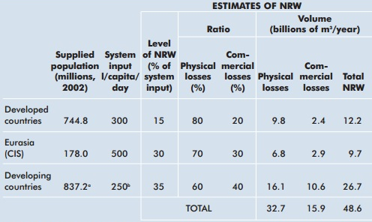

Figure 1: Estimates of Physical and Commercial losses in Water utilities worldwide

Source: (Kingdom et al., 2006)

## Pressure Management (PM) in Water Distribution Systems (WDSs)

Water losses occur in all water distribution systems, and the foremost challenge facing many water utilities is how to deal with high levels of water losses. The volume of water losses varies widely from region to region, and between developed and developing countries. For instance, the amount of water loss in water distribution systems in the Netherlands is as low as 3-7% (Beuken, et al., 2006), whereas in developing countries losses can be as high as 45 to 50% of the total system input volume (SIV) (Dighade, et al., 2014) . Such losses in water distribution networks put more constraints on utilities as global population and economic growth continue to increase (Hejazi, et al., 2013). The impact of population increase and economic growth on the demand for water is shown below in Figure 2; (a) and (b) respectively.

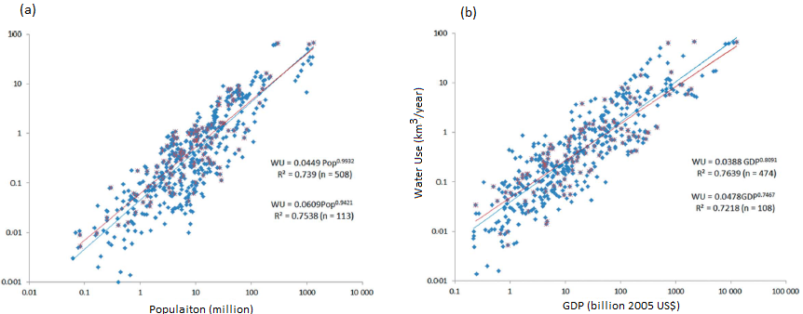

Figure 2: Relationship between total municipal water use with both population and GDP

Source: (Hejazi, et al., 2013)

Water losses in a distribution network is usually attributable to aging, deterioration of system components (such as pipes and valves), and incorrect management. A World Bank study in 2006 noted that, about 48 billion m3 of water is lost annually from water distribution systems, costing water utilities approximately US$14 billion per year around the world (Kingdom, et al., 2006). Reducing water distribution losses improves energy efficiency in the distribution network as less water must be extracted, treated, and transported to meet demand, thereby reducing greenhouse gas emissions from energy generation (Stokes, et al., 2013).

Efficient management of the water pressure in a distribution network is the initial and the most important solution that influences water loss control as it is responsible for substantial prevention of leakage and burst pipes. In order to maintain the needed amount of pressure at a critical point (CP) in the distribution network, traditional water distribution systems (WDSs) are designed to have excessive pressure. Intrinsically however, the rate of water lost through leakage increases with increased pressure especially during off-peak periods such as overnight periods (Mutikanga, et al., 2013).

Background leaks and drips occurring at joints, as well as small pinhole leaks are technically inevitable in water distribution systems. Pipe bursts (damages) sometimes occur in distribution networks as a result of surge and transient waves from the closing and opening of valves by large consumers. However, constant active pressure management delivers adequate pressure that enables constant service to customers while minimizing the extent of background leakagesand pipe breaks (Vicente, et al., 2015).

Not all the water losses in a water distribution network is actual physical leakage or what is known as real losses. Some of the water losses are due to unauthorized consumption and customer meter inaccuracies and these are referred to as apparent losses. Real and apparent water losses plus unbilled water consumed are usually referred to as non-revenue water (NRW), which translates to significant revenue loss for water utilities (see Figure 3).

|  |  |  |  |  |
| --- | --- | --- | --- | --- |
| System Input Volume (SIV) | Authorized Consumption | Billed Authorized Consumption | Billed Metered Consumption | Revenue Water (RW) |
| Billed Unmetered Consumption |
| Unbilled Authorized Consumption | Unbilled Metered Consumption | Non-Revenue Water (NRW) |
| Unbilled Unmetered Consumption |
| Water Losses | Apparent Losses | Unauthorized Consumption |
| Customer Meter Inaccuracies |
| Leakage on Transmission & Distribution Mains |
| Real Losses | Leakage on Service Connections up to the point of Customer Meter |
| Leakage and Overflows at Storage Tanks |

Figure 3: International Water Association's Water Balance Framework.

Preparing a baseline that establishes current levels of water loss is the first step undertaken by utilities aiming at reducing water losses. This is accomplished by performing a water balance based on the framework shown in Figure 3, or on similar frameworks. A water balance serves as the standard approach to defining and quantifying the components of a water utility’s NRW and this can be done by carrying out a water audit.

## Impact of Pressure Management on Reducing NRW

### How Pressure Management (PM) in WDSs Works

Pressure management in WDSs involves a number of activitiescarried out with different regulation elements such as pump control, tank regulation, and pressure reduction (by using automatic valves, among others).The use of pressure-regulating valves (PRVs) to reduce excessive pressure at certain times of the day is an increasingly common practice (Vicente, et al., 2015).

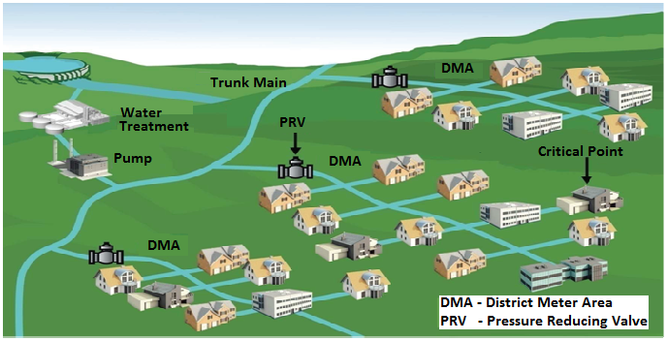

Figure 4: Schematic of a typical pressure management zone (PMZ)

(Source: Burrows, 2010).

The practice of pressure management involves first, creating a district meter area (DMA) by installing additional valves to hydraulically isolate an area/portion of the distribution network. The DMA enables water flows to be metered and demand monitored so as to observe changes in real losses (i.e. volume of physical leaks of treated-pumped water). The DMA is subsequently converted to a pressure management zone (PMZ)[1] by installing a pressure reducing valve (PRV) at the outlet (Stokes, et al. 2013) (see Figure 4 above). For advance pressure control (APC) methods based on a programmable logic controller (PLC), the PLC records, processes and archives the measured sensor data to control the PRV. A typical PRV installation is illustrated below in Figure 5.

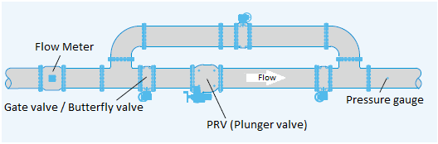

Figure 5: Typical PRV installation with a bypass and flow meter

(Source: GIZ, 2015).

### PRVs for Modulating System Pressure

There are four primary operational methods for PRVs and for modulating system pressrue (GIZ, 2011):

* **Fixed outlet:** is the most basic pressure control system where the PRV’s outlet pressure is maintained at a chosen level at all times.
* **Time-based pressure modulation:** here, the outlet pressure of the PRV is modulated according to the time, in order to reduce pressure during night time when flow rates are low. Time-based pressure modulation is the simplest form of APC methods. It consists of a local controller with an internal timer device. The timer device is connected to the controlling pilot of the PRV and an open-loop profile. The profile connects downstream pressure at time intervals and this ensures pressure is varied during each period.
* **Flow-based pressure modulation:** allows for different outlet pressures to be set for different flow rates in order to maintain the minimum required pressure in the zone during peak flow or to open the PRV when a threshold flow is exceeded (e.g. fire flow). Flow-based modulation is therefore a real-time, closed-loop control that allows dynamic local control of pressure according to the demand placed on the system. Use of a flow meter gauge is compulsory for this type of control. The controller is configured with a pressure-flow relationship curve and the downstream pressure is varied according to this curve.
* **Remote-controlled pressure modulation:** uses data from a remote sensor to reduce output pressure while at the same time delivering the required pressure at the critical point (CP). It is the most advanced pressure modulating approach. It regulates the PRV’s outlet pressure by continuously adjusting and keeping the pressure stable at a desired level via telemetry from pressure sensors at one or more critical points in the PMA.

## Active Leakage Control (ALC) in Water Distribution Systems (WDSs)

ALC is the process of proactively looking for un-reported leaks and bursts (in order to reduce their run time) and pinpointing those leaks that come to the surface and are reported to the water supply company (WSC). ALC consists of two distinct stages:

* Leak monitoring and localization
* Leak location and pinpointing

A leakage control policy can be either passive or active. However, for utilities where there is competition for scarce water resources and the where operating costs are substantial, an active policy is appropriate. An active policy necessarily demands human and financial resources in order to gain the benefits derived from that policy. In particular, a management and organizational structure needs to be established to arrange and coordinate policy activities. Staff should be available and committed to the continual monitoring and maintenance of leakage control procedures and processes.

An active leakage control policy means monitoring the distribution system closely for signs of leakage, including those that are unseen and do not have significant local impacts, as well as providing the resources needed to detect and repair leaks as they occur and are reported. The objective is to continuously monitor network leakage levels to maintain them at acceptable levels and to actively detect leaks when the leakage level rises above an acceptable level. For the water utilities, setting leakage control targets requires consideration of:

* Economic leakage level – the optimum between cost and benefit (Figure 6)
* Practicality in terms of data needs and implementation
* Sustainability in the long term and flexibility in the short term
* Consistency with the utility’s water resources plan
* Social and political aspects

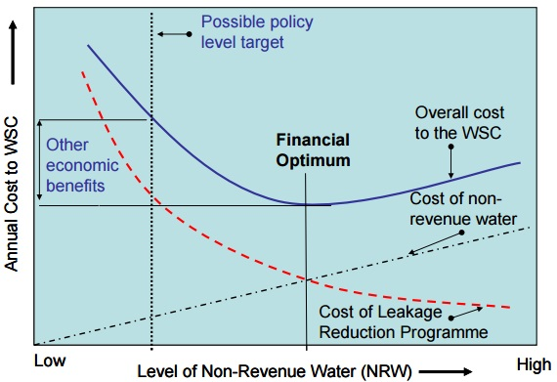

Figure 6: Determining Economic Level of Leakage

(Source: WRDMAP, 2010)

## Adoption of Pressure Management in WDSs

### Trends in Pressure Management

Pressure management (PM) in water distribution systems (WDSs) is widely used in England, Germany and other European countries (Vicente, et al., 2015). In England for instance, PM has been recognized for over 30 years as an effective tool for managing leakage in WDSs, making the U.K. one the main drivers of PM. A number of utilities in European countries are carrying out large-scale PM projects, including Spain’s Canal de Isabel II Gestion PM project which comprises of 104 PMAs. Following Australia’s severe drought between 2001 and 2009, the country embarked on large-scale water demand management programs. These programs included PM by large water utility distribution networks (van Dijk, et al., 2013). Comparatively, PM has been less implemented in most developing countries, as water loss control tend to be more reactive in some of these countries (Stokes, et al., 2013) (Vicente, et al., 2015). According to a number of studies, many developing countries operate inefficient WDSs. This is attributable to a number of factors including; poor infrastructure, excessive pressure, and illegal water tapings, among others. These have resulted in high water and revenue loses (Mutikanga, et al., 2013) (Branislav, et al., 2014). However, cases of large pressure management (PM) in developing countries such as is in South Africa and Malaysia, have been cited by many as examples of how PM programs can effectively benefit developing or emerging economics (Vicente, et al., 2015).

### Advances in Pressure Management

Advances in computer software control and telemetry systems have made APC systems practical. A number of mathematical programming techniques have been deployed for use to investigate minimizing leakage through determining appropriate PRV locations and settings. Optimization methods including mathematical and metaheuristic methods have also been developed and used in a number of studies to investigate the minimization of leakage in WDSs (Mutikanga, et al., 2013) (Vicente, et al., 2015). Existing literature on these developing advance approaches indicate that the application of a number of such advanced pressure management tools and methods are limited. This is especially the case in and developing countries (Mutikanga, et al., 2013).

### Trends in Active Leakage Control

The current water leakage control actions are relatively comprehensive. There is still, however, great room for improvement, in particular the development and application of more reliable pipe break prediction models in leakage monitoring, the invention of low cost leakage detection devices, optimization of pipe maintenance strategies, and establishment of updated decision support systems. High cost is the biggest barrier for most water utilities in low income countries. Therefore, low-cost devices with high accuracy should be invented for ALC to be adopted at a larger scale.

### Advances in Active Leakage Control

There are a vast number of techniques to detect where leakage is occurring in the distribution network. Some techniques – listed below - are able to approximate or localize the position of a leak while others can find exact location.

* Gas Injection Method:
* Manual Listening Stick:
* Leak Noise Correlation:
* In-line Leak Detection:
* Noise Loggers:
* Electronic Amplified Listening Devices
* Thermal Imaging
* Ground Penetrating Radar
* Ultrac Method
* Optimization tools for leak location

## Advantages and Disadvantages of PM and ALC

### Advantages of Water Loss Reduction

Reducing water losses in WDSs from pressure management, infrastructural management, active leakage control, and the speed and quality of repairs are illustrated in below (Figure 7).

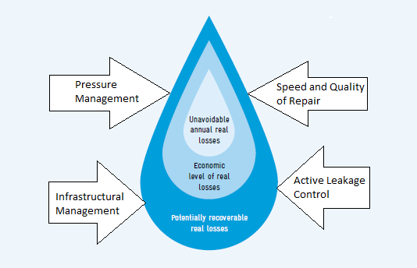

Figure 7: Intervention tools for real loss reduction programs.

Source: GIZ, 2011.

Active leakage control (ALC) aims mainly at reducing the runtime of hidden leaks in order to reduce real water losses and this involves using technical equipment to actively detect and repair underground leaks. This is important because underground leakage constitutes about 90% of the water that is lost physically and such leaks do not show at the surface and also the volume of water loss depends not only on the flow rate but is also a function of run time (Frauendorfer & Liemberger, 2010).

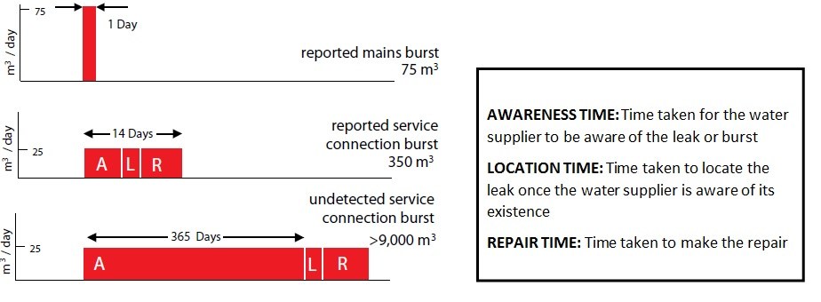

Figure 8: Leak run time and volume of water loss

Source: Farley at al. 2008.

Pressure management reduces real water losses by lower unnecessary or excess pressure, as well as eliminating strong fluctuations or transients, which are often responsible for new pipe breaks and bursts within water distribution networks. Though pressure management prolongs the lifetime of water distribution networks, maintaining, rehabilitating, and in some cases disposing, and acquiring of new assets are indispensable from a water loss reduction standpoint. Also, the fact that the overall runtime of leaks depends on the awareness, location and repair time, makes the speed and quality of repair an important factor in reducing water losses.

One of the main factors making pressure management stand-out, is that is it is the only intervention method that has a positive impact on all three components of real water loss - background leakage, reported and unreported leakage.

### Benefits of reducing losses in WDSs

A number of specific benefits of implementing pressure management and active leakage control in WDSs are listed below.

* Water loss reduction: reduced surges, new leak frequencies and natural rate of rise of leakage;
* Water Savings: savings in production cost of water, increasing savings in sales of water saved;
* Improved customer service: better service reliability due to less water supply interruptions;
* System deterioration: extended useful life of infrastructure, deferred system expansion and capital expenditure;
* Operating and maintenance costs: reduced pumping energy and repairs and active leakage control;
* Social costs: reduced frequency of main breaks and disruptions of road users;
* Capital costs: deferment of infrastructure renewal and expansion;
* Demand management: less consumption from pressure related uses of water.
* Increased firefighting capability;
* Reduced property damage, reduced legal liability, and reduced insurance because of the fewer main breaks; and
* Reduced risk of water contamination.

Some of the added benefits of pressure management are summarized below in Table 1.

*Table 1: Benefits of pressure management in water distribution networks.*

Source: (GIZ, 2011)

|  |  |  |  |  |  |  |
| --- | --- | --- | --- | --- | --- | --- |
| **Pressure management: reduction of excess average and maximum pressure** | | | | | | |
| Conservation Benefits | | Water Utility Benefits | | | Customer Benefits | |
| Reduced flow rates | | Reduced frequency of bursts and leaks | | | | |
| Reduced consumption | Reduced rates of leaks and bursts | Reduced repair costs at mains and services | Deferred renewals and extended asset life | Reduced cost of active leakage control | Fewer customer complains | Fewer problem on customer plumbing and appliances |
|
|
|

For water utilities, high levels of NRW lead to a vicious cycle of water loss, water collection, treatment and distribution cost increase, water sales decrease and substantial capital expenditures to meet ever-increasing demand. More so, repairs to fix detected leaks are expensive in terms of the costs and personnel required and usually interrupt service to customers (GIZ, 2011).

On the other hand, reducing NRW loss leads to a virtuous cycle as illustrated in Figure 9 below. Reducing NRW results in substantial efficiency gains that can be used to further finance ongoing NRP management programs, leading to minimum production cost and maximum revenues.

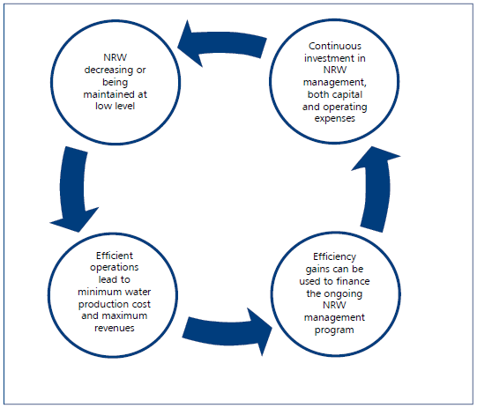.

Figure :The virtuous NRW cycle

Source: (Frauendorfer & Liemberger, 2010)

### Concerns with Pressure Management in WDSs

Three common critiques regarding the implementation of pressure management impeded firefighting capacity, water quality degradation, and revenue loss. However, with advancements in electronic and hydraulic controllers, it is now possible to reduce leakage efficiently and cost-effectively. For instance, revenue losses which are mainly as a result of reduction in pressure-dependent water consumption have been proven to be more than compensated for in real case studies by the cost of direct reduction in system input volume (SIV) and reduced maintenance cost (Kanakoudis & Gonelas, 2016). Also, real case pressure management implementation programs in Europe, North American and elsewhere have demonstrated that fire flow and water quality standards can be met within a PMZ without significantly affecting revenue (Stokes, et al., 2013). In many cases, negative effects of pressure management on firefighting capacity is eliminated by means of a bypass or by using s flow modulation approach. Limitations of pressure management relating to the negative effect of meeting the pressure requirement of certain domestic and commercial appliances (such as instantaneous hot water systems and fire sprinkler systems) are eliminable by installing booster pumps in multi-story buildings in order to distribute water to upper floors (GIZ, 2011).

# Methodology

## Total Addressable Market

A top down approach was used in modeling the potential carbon dioxide emissions reductions associated with reducing NRW water in water distribution systems. Carbon dioxide emission estimate is based on the embedded energy associated in potential NRW water savings. Two different approaches were used parallel to arrive at estimates for the Total Addressable Market (TAM).

In the first approach, we developed an estimate of global municipal water use (in km3/year) based on data from various literature sources (including Alcamo et al. 2000, Shiklomanov 2000, Alcamo et al. 2003, 2007, Shen et al. 2008, and Hejazi et al., 2013). A summary of these projections are listed below in Table 2. The global municipal water use data in Table 2 was plotted to obtain the relational model of global municipal water use (MWU) as shown below in equation 1.

$MWU=5*{10}^{-184}*{Year}^{56.297}$…… *Equation 1.*

Using the relational equation above (i.e. equation 1), the annual global municipal water use (MWU) is calculated for the period 2015 to 2045. Regional proportions of per capital water use was applied to the calculated global municipal water use to obtain regional municipal water use for the same period.

The total addressable market (TAM) for increasing water distribution efficiency in WDSs in this study is the total system input volume (SIV) of water (in m3/year). This is expressed by equation 2(a). The TAM (thus the SIV) comprises of revenue water (RV) and non-revenue water (NRW), (see Figure 3). This is mathematically expressed by equation 2(b). As municipal water use (MWU) is the volume of water that gets to municipal water users, MWU is considered as the revenue water (RW) portion of the water distribution network’s system input volume (SIV) and this is expressed by equation 2(c). The TAM is therefore determined based on equation 2(d) below.

*TAM = SIV…………. Equation 2(a).*

*SIV = RW + NRW…………………. Equation 2(b).*

*RW = MWU……………Equation 2(c).*

$TAM=\frac{MWU}{(1-Xi)}$*…………Equation 2(d).*

Where Xi is the fraction of the SIV that constitutes

non-revenue water (NRW). Thus *NRW = Xi*SIV.*

Table 2: Summary of Global Municipal Water Use (km3/year) Data from Literature.

|  |  |  |  |  |  |
| --- | --- | --- | --- | --- | --- |
| Reference | Assessment | | Reference | Assessment | |
| Year | Water Use | Year | Water Use |
| *Shiklomanov (2000)* | 1900 | 22* | *Shen et al. (2008)* | 2000 | 390* |
|  | 1940 | 61* | *FAO (2011)* | 2005 | 467* |
|  | 1950 | 87* | *Shiklomanov (2000)* | 2000 | 384 |
|  | 1960 | 118* |  | 2010 | 472* |
|  | 1970 | 160* |  | 2025 | 607 |
|  | 1980 | 219* | *Alcamo et al. (2000)* | 2025 | 859 |
|  | 1990 | 305* | *Alcamo et al. (2007)* | 2025 | 836 |
|  | 1995 | 345* |  | 2055 | 1492 |
| *Shiklomanov & Rodda (2003)* | 1995 | 356* |  | 2075 | 1679 |
| *Alcamo et al. (2000)* | 1995 | 357* | *Hejazi et al. (2013)* | 2005 | 466 |
| *Alcamo et al. (2007)* | 1995 | 344* |  | 2025 | 680* |

*Water use values plotted in Figure 2.

Source: (Hejazi, et al., 2013)

In the second approach, we used data reported by hundreds of water utilities in World Bank’s International Benchmark Network Database (IB-NET) to arrive at estimates for per-capita water production for all regions in the world. We then used the water supply statistics from WHO/UNICEF to arrive at Urban and Rural share of the addressable market for each region and thereby the total TAM. Relying on such recently reported benchmark data and supply statistics enabled to further strengthen our estimates that were based solely on empirical data.

## Adoption Scenarios

### Business-As-Usual Optimistically Plausible Scenarios

A reference “business-as-usual” (BAU) scenario of 35.7% non-revenue water (NRW) at the global level for the year 2014 is assumed in this study. This is based on the global median value of NRW reported by all the utilities in the IB-NET database. This estimate is close to the International Water Association’s (IWA’s) estimate of global NRW of 25 to 50%. The assumed 35.7% of NRW and 64.3% of revenue water (RW) were held as a constant percent of the total addressable market throughout the period of study.

### Optimistically Plausible Scenarios

Leakage reduction impacts of pressure management schemes and for leakage control methods (discussed in this research) follow a law of diminishing returns. The greater the level of resources employed in a pressure management scheme, the lower the additional marginal benefit. As leakage is proportional to pressure, a break-even point is reached when the additional cost of the scheme deployed equals the marginal cost of water production (Pearson & Trow, 2005). The balance between the costs and benefits of leakage control gives rise to the concept of economic level of leakage (ELL). Leakage reduction targets based on the idea of ELL are therefore location specific. Also, such targets are dynamic. This research assumes an optimistically plausible reduction of NRW to 25% in 2045 from a BAU scenario of 35.7% globally. This is based on the World Bank’s suggestion of keeping NRW level below 25%.

## Climate and Financial Impact Data

The components of the energy intensity factor data used in the model constituted the energy components of water extraction by pumping, including water conveyance and the energy involved in the treatment works. A set of estimates of energy intensity from a number of studies giving a range of 0.5–4 kWh/m3 for surface water, 1–6 kWh/m3 for recycled water, and 4–8 kWh/m3 for desalination (Parsons, et al., 2012) are used in the model. Emission factors associated with water supply from a number of studies ranging from 0.289 kg CO2/ m3 in France to 1.44 kg CO2/ m3 in Spain (Parsons, et al., 2012) are used in the model.

The investment cost associated with pressure management involves a one-off equipment purchase and installation cost occurring at the beginning of the investment for each PM scheme. This one-off equipment purchase constitutes the cost of all valves, flanges, by-pass pipes and other fitments for the proper installation of each PRV and all advanced leakage detection devices. The operational cost of a WDS that has implemented PM and ALC is lower relative to a one which has no such PM in place. Data from existing real PM and/or ALC implementation studies are used in the model.

## ASSUMPTIONS

1. Using global historical and projected municipal water demand, and a global NRW%, the study establishes a total addressable market. Given that the implementation of pressure management in WDSs is location and situation specific, this assumption was made in order to enable a “top-down” estimation of the impact of reducing NRW globally.
2. Environmental and social cost associated with water extraction, conveyance and treatment works is not included in the study. Revenue losses as a result of reduced (pressure dependent) water consumption are not factored into the financial analyses. This is because these costs are usually difficult to determine at the global scale and most studies do not include these.

## LIMITATIONS

The appropriate path to apply a PM / ALC project starts by dividing the entire network in smaller

“hydraulically isolated” regions (DMAs) as it is easier to manage and inspect them compared to the

entire WDS. However, the top-down simplified approached of this study assumes a single large pressure management implementation. This limits this study in establishing the optimal economic level of leakage of reducing NRW. However, assuming a reduction level based on the World Bank’s suggestions, this study has been able to adequately give a good indication of the impact of reducing NRW on climate change drawdown.

The financial benefits assessed in this study include reduction of the net energy cost due to the reduction of the SIV and the reduction of energy and maintenance cost. Indirect costs such as reduction in maintenance personnel and such associated costs were not included. Also replacement cost, and revenue losses as a result of reduced (pressure dependent) water consumption are not factored into the financial analyses.

# Results

Reducing non-revenue water (NRW) in water distribution networks globally from 37% to 25% by 2045 is estimated to yield 2.43 Gt CO2 reduction in global emissions (between 2015 to 2045). This is expected to drawdown global CO2 in the atmosphere by 0.0137 ppm by 2045 (see Table 3 below).

Table 3: Summary of Climate Impact

|  |  |  |  |
| --- | --- | --- | --- |
| **Max Annual Emissions Reduction** | **Total Emissions Reduction** | **Approximate PPM Equivalent** | **Approximate PPM rate of change in 2045** |
| 0.03 | 0.38 | 0.03 | 0.0022 |
| Gt CO2 / yr. | Gt CO2 (2015-2045) | ppm CO2-eq (2045) | ppm CO2-eq |

The results from the model indicate net financial gains over time. These financial benefits are attributable to reduced operating and maintenance cost as a result of reduced new leaks and breaks frequency as well as reduced cost of energy consumed in all the processes involved of water supply (i.e. abstraction, treatment, storage and distribution). These accruals are estimated by the model as $435.34 billion USD in net operating cost savings; and $458.14 billion USD in lifetime savings (from 2015 to 2045). This results in a total lifetime gain of $ 49.20 billion USD as NPV (see Table 4 below).

Table 4: Summary of Financial Impacts.

|  |  |  |
| --- | --- | --- |
| **Net Operating Savings** | **Lifetime Savings** | **Lifetime Savings NPV** |
| $ 435.34 | $ 458.14 | $ 49.20 |
| Billion USD | Billion USD | Billion USD |

# Discussion

The results of this study substantially demonstrates that driving down NRW in water distribution systems will contribute to drawing down climate change and also lead to significant money savings. This is because, the cumulative cubic meters of water losses reduced in water distribution systems all around the world means a reduction in the kilowatt hour of energy embedded in water supply; and every energy unit reduced consequently reduces carbon dioxide emissions.

However, a number of factors make it so difficult to reduce NRW; especially in developing countries where NRW levels are usually high. Findings from a World Bank study indicates that one of the main factors that particularly adversely influences reduction of NRW is the very low opportunity costs of water losses (van den Berg, 2014). The World Bank study further noted that social, political, culture, and financial factors are some of the other factors that influence the level of NRW across the globe (van den Berg, 2014).

Though pressure management in water distribution networks is an important cost effective initial step in curbing water losses, it is important to note that pressure management is not the total solution to reducing real water losses in WDSs as it does not repair a single leak but considerable reduces leak rates and pipe bursts as well as offer additional benefits to utilities and water end-users. Utilities therefore would need to determine where to deploy PM or ALC, as well as which combinations of PM, ALC and other solutions to managing water losses would be best for their specific situations.

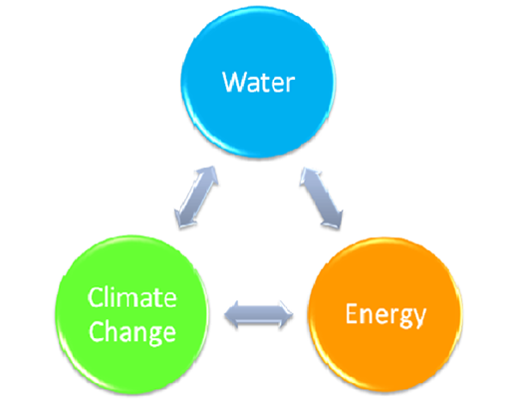Water, energy, and climate change; these are intricately related. Sustainable water practices impact positively on energy; sustainable energy implementation impacts water in a positive way; both

Figure 10: The Water-Energy-Climate Nexus.

resources impact climate change; and climate change will impact both resources. The sustainable management of water and energy at a global scale will contribute to climate change mitigation. The water side of the water-energy-climate nexus therefore requires that there be sustainable management of all natural water resources; and this includes reducing water losses in utility water supply distribution systems. Aside the climate change abatement argument, water scarcity is probably the next most important concern for which such sustainable water management practices needed at a global scale. For there already exist scarcity of unpolluted water in many regions of the world and regions with plenty amounts of water are not guaranteed infinite water resources.

# References

Beuken, R., Lavooij, C., Bosch, A. & Schaap, P. G., 2006. *Low leakage in the Netherlands Confirmed.* Cincinnati, USA, Proceedings of the 8th Annual Water Distribution Systems Analysis Symposium (ASCE), pp. 1-8.

Branislav, B., Đukić, A. & Stanić, M., 2014. Managing water pressure for water savings in developing countries. *Water SA, 40(2), 221–232.,* 40(2), p. 221–232.

Burrows, A., 2010. "Bringing Intelligence to Water Control." Proceedings of the 4th Annual Global Leakage Summit (CD-ROM), London, UK.. In: *Water Loss Management: Tools and Methods for Developing Countrires.* the Netherlands: Ph.D. Dissertation, UNESCO-IHE Institute for Water Education.

Copeland, C., 2014. *Energy-Water Nexus: The Water Sector's Energy Use*, Congressional Research Service, USA.

Dighade, R. R., Kadu, M. S. & Pande, A. M., 2014. Challenges in Water Loss Management of Water Distribution Systems in Developing Countries. *International Journal of Innovative Research in Science, Engineering and Technology,* 3(6), pp. 13838-13846.

ERM and Solventa, 2013. *Resource and Economic Efficiency of Water Distribution Networks in the EU,* s.l.: European Commission.

EU, 2015. *Good Practices on Leakage Management: Case Studies,* s.l.: European Union.

Farley, M., Wyeth, G., Ghazali, Z.B., Istandar, A., and Singh, S., 2008. *The Manager’s*

*Non-Revenue Water Handbook: A Guide to Understanding Water Loss,* Ranhill Utilities Berhad and the United States Agency for International Development, Bangkok, Thailand.

Fontana, N., Giugni, M. & Portolano, D., 2012. Losses Reduction and Energy Production in Water-Distribution Networks. *Journal of Water Resources Planning and Management,* 138(3), pp. 237-244.

Frauendorfer, R. & Liemberger, R., 2010. *The Issues and Challenges Reducing Non-Revenue Water,* Mandaluyong City, Philippines: Asian Development Bank.

GIZ, 2011. *Guidelines for water loss reduction: A focus on pressure management,* Eschborn, Germany: Deutsche Gesellschaft für Internationale Zusammenarbeit (GIZ) GmbH.

Hejazi, M. et al., 2013. Scenarios of global municipal water-use demand projections over the 21st Century. *Hydrological Sciences Journal,* 58(3), pp. 519-538.

Jägerskog, A., Clausen, T. J., Holmgren, T. and Lexén, K., (eds.) 2014. *Energy and Water: The Vital Link for a Sustainable Future*. *Report Nr. 33.* SIWI, Stockholm.

Kanakoudis, V. & Gonelas, K., 2016. Non-revenue water reduction through pressure management in Kozani’s water distribution network: from theory to practice. *Desalination and water treatment,* 57(25), pp. 11436-11446.

Kingdom, B., Liemberger, R. & Marin, P., 2006. *The Challenge of Reducing Non-Revenue Water (NRW) in Developing Countries,* Washington, DC: The World Bank Group.

Mutikanga, H. E., Sharma, S. K. & Vairavamoorthy, K., 2013. Methods and Tools for Managing Losses in Water Distribution Systems. *Journal of Water Resources Planning and Management,* 139(2), pp. 166-174.

Parsons, D., Marcet, E. C. & Jeffrey , P., 2012. *Carbon sensitive urban water futures,* E.U: Tansitions to the Urban Water Services of Tomorrow (TRUST).

Pearson, D. & Trow, S. W., 2005. *Calculating Economic Levels of Leakage.* Halifax, Canada, IWA.

Stokes, J. R., Horvath, A. & Sturm, R., 2013. Water Loss Control Using Pressure Management: Life-cycle Energy and Air Emission Effects. *Environmental Science and Technology,* Volume 47, p. 10771−10780.

van den Berg, C., 2014. *The Drivers of Non-Revenue Water: How Effective Are Non-Revenue Water Reduction Programs?,* s.l.: The World Bank Group.

van Dijk, A. I. J. M. et al., 2013. The Millennium Drought in southeast Australia (2001–2009): Natural and human causes and implications for water resources, ecosystems, economy, and society. *Water Resources Research,* 49(2), pp. 1040-1057.

Vicente, D. J., Garrote, L., Sánchez, R. & Santillán, D., 2015. Pressure Management in Water Distribution Systems: Current Status, Proposals, and Future Trends. *Journal of Water Resources Planning and Management.*

WRDMAP, 2010. *Active Leakage Control as a Key Component in Increasing fficiency in Urban Water Supplies [Thematic Paper 3.3]*, Water Resource Demand Management Assistance Project, China, pp. 28.

1. In some jurisdictions, PMZs are also referred to as pressure management areas (PMAs).