**Mawlana Bhashani Science and Technology University**



**Lab-Report**

Report No: 06

Course code: ICT-4202

Course title: Wireless and Mobile Communication Lab

Date of Performance: 25.09.2020

Date of Submission: 30.09.2020

**Submitted by Submitted To**

**Nazrul Islam**

Assistant Professor

Dept. of ICT

MBSTU.

**Name: Abdullah-Al-Mamun**

**ID: IT-16049**

4th year 2ndsemester

Session: 2015-2016

Dept. of ICT

MBSTU.

**Exp No: 06**

**Experiment name:** Switching an interface to move a host around a network using mininet.

**Objectives:** From this lab we can learn:-

* How to install mininet and use it
* How to [prototyping](https://searcherp.techtarget.com/definition/prototype) a large network on a single machine by mininet.

**Source code:**

from mininet.net import Mininet

from mininet.node import OVSSwitch

from mininet.topo import LinearTopo

from mininet.log import info, output, warn, setLogLevel

from random import randint

class MobilitySwitch( OVSSwitch ):

"Switch that can reattach and rename interfaces"

def delIntf( self, intf ):

"Remove (and detach) an interface"

port = self.ports[ intf ]

del self.ports[ intf ]

del self.intfs[ port ]

del self.nameToIntf[ intf.name ]

def addIntf( self, intf, rename=False, **kwargs ):

"Add (and reparent) an interface"

OVSSwitch.addIntf( self, intf, **kwargs )

intf.node = self

if rename:

self.renameIntf( intf )

def attach( self, intf ):

"Attach an interface and set its port"

port = self.ports[ intf ]

if port:

if self.isOldOVS():

self.cmd( 'ovs-vsctl add-port', self, intf )

else:

self.cmd( 'ovs-vsctl add-port', self, intf,

'-- set Interface', intf,

'ofport_request=%s' % port )

self.validatePort( intf )

def validatePort( self, intf ):

"Validate intf's OF port number"

ofport = int( self.cmd( 'ovs-vsctl get Interface', intf,

'ofport' ) )

if ofport != self.ports[ intf ]:

warn( 'WARNING: ofport for', intf, 'is actually', ofport,

'\n' )

def renameIntf( self, intf, newname='' ):

"Rename an interface (to its canonical name)"

intf.ifconfig( 'down' )

if not newname:

newname = '%s-eth%d' % ( self.name, self.ports[ intf ] )

intf.cmd( 'ip link set', intf, 'name', newname )

del self.nameToIntf[ intf.name ]

intf.name = newname

self.nameToIntf[ intf.name ] = intf

intf.ifconfig( 'up' )

def moveIntf( self, intf, switch, port=None, rename=True ):

"Move one of our interfaces to another switch"

self.detach( intf )

self.delIntf( intf )

switch.addIntf( intf, port=port, rename=rename )

switch.attach( intf )

def printConnections( switches ):

"Compactly print connected nodes to each switch"

for sw in switches:

output( '%s: ' % sw )

for intf in sw.intfList():

link = intf.link

if link:

intf1, intf2 = link.intf1, link.intf2

remote = intf1 if intf1.node != sw else intf2

output( '%s(%s) ' % ( remote.node, sw.ports[ intf ] ) )

output( '\n' )

def moveHost( host, oldSwitch, newSwitch, newPort=None ):

"Move a host from old switch to new switch"

hintf, sintf = host.connectionsTo( oldSwitch )[ 0 ]

oldSwitch.moveIntf( sintf, newSwitch, port=newPort )

return hintf, sintf

def mobilityTest():

"A simple test of mobility"

info( '* Simple mobility test\n' )

net = Mininet( topo=LinearTopo( 3 ), switch=MobilitySwitch )

info( '* Starting network:\n' )

net.start()

printConnections( net.switches )

info( '* Testing network\n' )

net.pingAll()

info( '* Identifying switch interface for h1\n' )

h1, old = net.get( 'h1', 's1' )

for s in 2, 3, 1:

new = net[ 's%d' % s ]

port = randint( 10, 20 )

info( '* Moving', h1, 'from', old, 'to', new, 'port', port, '\n' )

hintf, sintf = moveHost( h1, old, new, newPort=port )

info( '*', hintf, 'is now connected to', sintf, '\n' )

info( '* Clearing out old flows\n' )

for sw in net.switches:

sw.dpctl( 'del-flows' )

info( '* New network:\n' )

printConnections( net.switches )

info( '* Testing connectivity:\n' )

net.pingAll()

old = new

net.stop()

if __name__ == '__main__':

setLogLevel( 'info' )

mobilityTest()

**Output:**

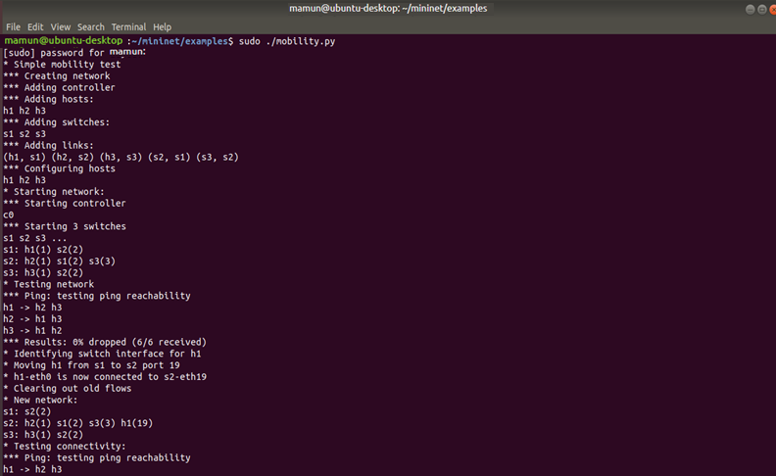

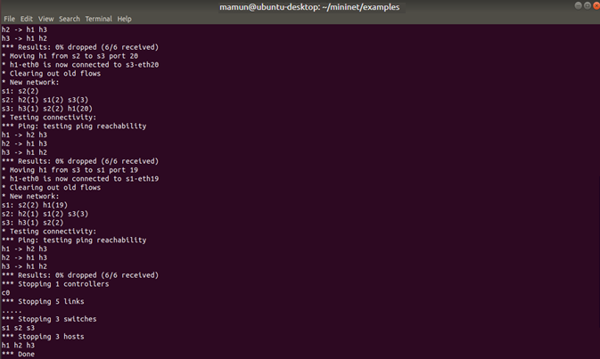

**Discussion:**

Mininet enables to quickly [create](http://mininet.org/sample-workflow/#create), [interact with](http://mininet.org/sample-workflow/#interact), [customize](http://mininet.org/sample-workflow/#customize) and [share](http://mininet.org/sample-workflow/#share) a software defined network prototype, and provides a smooth path to [running on hardware](http://mininet.org/sample-workflow/#run). From the lab, We check simple mobility test by mininet.

h1,h2,h3 are hosts and s1,s2,s3 are switches. We move a host from s1 to s2, s2 to s3, and then back to s1.Thus we check simple mobility test among the hosts.