**Graphs:**

A graph data structure consists of a finite (and possibly mutable) set of vertices (also called nodes or points), together with a set of unordered pairs of these vertices for an undirected graph or a set of ordered pairs for a directed graph.

Graphs are mathematical structures that reflect the pairwise relationship between things. A graph is a type of flow structure that displays the interactions of several objects. It may be represented by utilizing the two fundamental components, nodes and edges.

* **Nodes**: These are the most crucial elements of every graph. Edges are used to represent node connections. For example, a graph with two nodes connected using an undirected edge shows a bi-directional connection between those two nodes.
* **Edges**: Edges are part of a graph showing the connections between nodes. An edge represents the connection between two nodes.

**An application in real life**

* **Google Maps**: link your journey from the start to the end.
* **Social Networks**: friends are connected with each other using an edge where each user represents a vertex.
* **Recommendation System**: relationship data between user’s recommendations uses graphs for connection.

A data structure is an efficient way of organising data in a database so that that data can be accessed easily and used effectively. There are many types of databases, but why graphs play a vital role in data management is discussed in this article.

Spoiler alert: you use **Graphs in data structure** every day to fetch the best route to your office, to get suggestions for your lunch, movie and to optimise your next flight route. Sounds interesting! Let us see about the graph’s properties and its application.

First, let’s see **what a Graph is?**It is a representation of data in a non-linear structure consisting of nodes (or vertices) and edges (or paths).

A**Graph in the data structure** can be termed as a data structure consisting of data that is stored among many groups of edges(paths) and vertices (nodes), which are interconnected. Graph data structure (N, E) is structured with a collection of Nodes and Edges. Both nodes and vertices need to be finite.

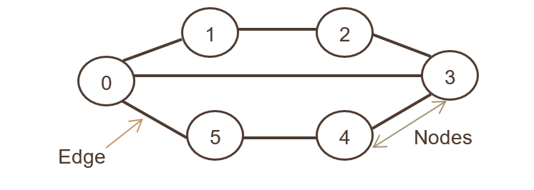

In the above graph representation, Set of Nodes are N={0,1,2,3,4,5,6}and set of edges are

G={01,12,23,34,45,05,03}

Now let’s study the types of graphs.

## Types of Graphs

### Weighted Graph

Graphs whose edges or paths have values. All the values seen associated with the edges are called weights. Edges value can represent weight/cost/length.

Values or weights may also represent:

Distance covered between two points- Ex: To look for that shortest path to the office, the distance between two workstations in an office network.

Speed of the data packet in a network or bandwidth.

**2. Unweighted Graph**

Where there is no value or weight associated with the edge. By default, all the graphs are unweighted unless there is a value associated.

**3. Undirected Graph**

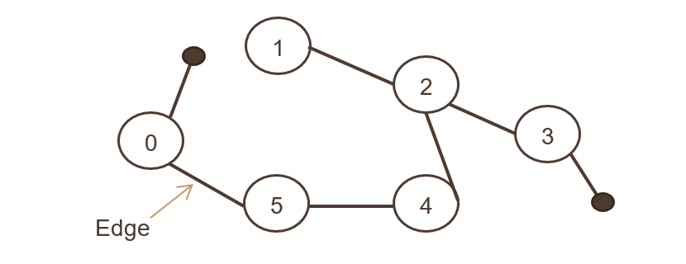

Where a set of objects are connected, and all the edges are bidirectional. The below image showcases the undirected graph,

It’s like the associativity of two Facebook users after connecting as a friend. Both users can refer and share photos, comment among each other.

**4. Directed Graph**

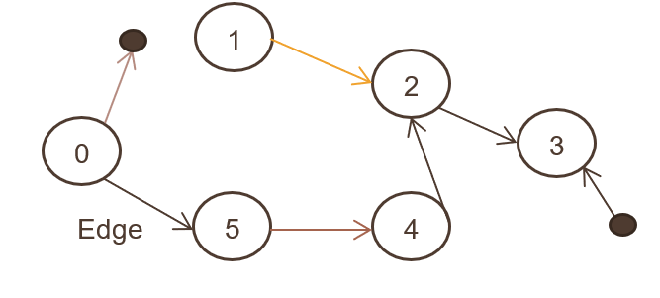

Also called a digraph, where a set of objects (N, E) are connected, and all the edges are directed from one node to another. The above image showcases the directed graph.

## Storing of Graph

Every storage method has its pros and cons, and the right storage method is chosen based on the complexity. The two most commonly used data structures to store graphs are:

### 1. Adjacency list

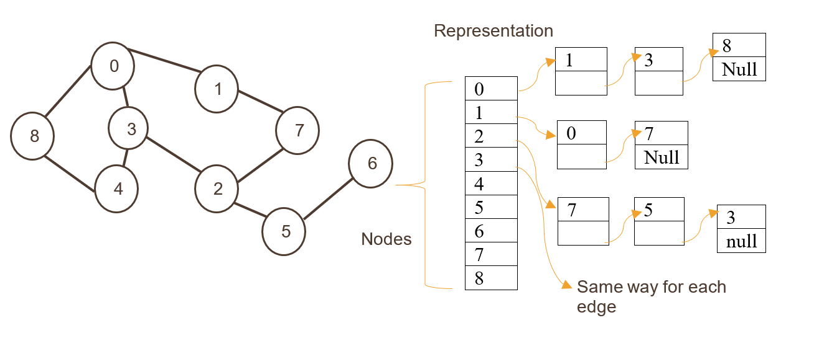

Here nodes are stored as an index of the one-dimension array followed by edges being stored as a list.

**2. Adjacency matrix**

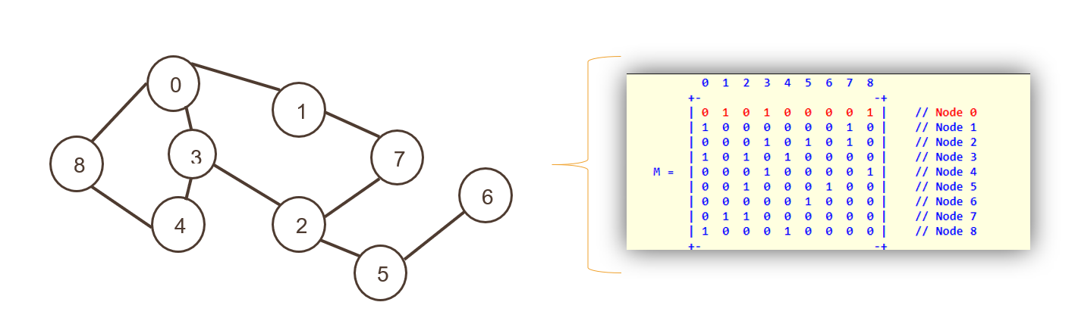

Here nodes are represented as the index of a two-dimensional array, followed by edges represented as non-zero values of an adjacent matrix.

Both rows and columns showcase Nodes; the entire matrix is filled with either “0” or “1”, representing true or false. Zero represents that there is no path, and 1 represents a path.