**Inheritance:**

Inheritance allows you to define a class in terms of another class, which makes it easier to create and maintain an application. To use inheritance, you start with a base (parent) class and then derive a child class from the base class. Inheritance works under the “is a” relationship model.

What is unique about an “is a” relation is that it works only in one direction, which is a child to parent. The following diagram demonstrates the “is a” relationship for some animals.

[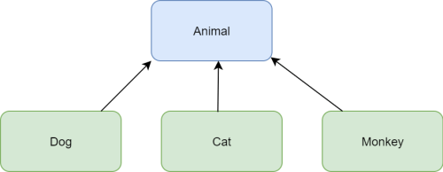](https://i2.wp.com/www.brightdevelopers.com/wp-content/uploads/2017/07/cpp_inheritance_basics.png?ssl=1)

The base class is Animal and the derived classes (children) are Dog, Cat, and Monkey. Translating one of the relationships into a statement, you would get along the lines of “A monkey is an animal”. Notice that the other way around doesn’t work. The phrase, “An animal is a monkey” is not a true statement.

Inheritance is one of the most important aspects of Object Oriented Programming (OOP). The key to understanding Inheritance is that it provides code re-usability. In place of writing the same code, again and again, we can simply inherit the properties of one class into the other.

OOP is all about real-world objects and inheritance is a way of representing real-world relationships. Here’s an example – **car, bus, bike** – all of these come under a broader category called **Vehicle**. That means they’ve inherited the properties of class vehicles i.e all are used for transportation.

We can represent this relationship in code with the help of inheritance.

**What is Inheritance in Object Oriented Programming:**

Inheritance is the procedure in which one class inherits the attributes and methods of another class. The class whose properties and methods are inherited is known as the Parent class. And the class that inherits the properties from the parent class is the Child class.

**The interesting thing is, along with the inherited properties and methods, a child class can have its own properties and methods.**

You may use the following syntax:\ to implement inheritance in Python:

class parent_class:

body of parent class

class child_class( parent_class):

body of child class

Let’s see the implementation:

class Car: #parent class

   def __init__(self, name, mileage):

       self.name = name

        self.mileage = mileage

   def description(self):

        return f"The {self.name} car gives the mileage of {self.mileage}km/l"

class BMW(Car): #child class

pass

class Audi(Car): #child class

def audi_desc(self):

return "This is the description method of class Audi."

obj1 = BMW("BMW 7-series",39.53)

print(obj1.description())

obj2 = Audi("Audi A8 L",14)

print(obj2.description())

print(obj2.audi_desc())

**Output:**

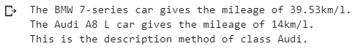

We have created two child classes namely “BMW” and “Audi” that have inherited the methods and properties of the parent class “Car”.  We have provided no additional features and methods in the class BMW. Whereas there is one additional method inside the class Audi.

Notice how the instance method description() of the parent class is accessible by the objects of child classes with the help of obj1.description() and obj2.description(). And the separate method of class Audi is also accessible using obj2.audi_desc().

We can check the base or parent class of any class using a built-in class attribute **__bases__**

print(BMW.__bases__, Audi.__bases__)

Inheritance in Object Oriented Programming - Print Class

As we can here, the base class of both sub-classes is **Car.**Now, let’s see what happens when using __base__ with the parent class Car:

print( Car.__bases__ )

Inheritance in Object Oriented Programming - Print sub-class

Whenever we create a new class in Python 3.x, it is inherited from a built-in basic class called **Object.** In other words, the Object class is the root of all classes.