Northeast Petroleum University

Curriculum Design

Course Object-Oriented Curriculum Design
Title Development of Housing Rental
Information Management System
Department School of Computer & Information
Class 计（留英）2025-1班
Name 马门
ID 250702110918
Teacher 李井辉

July 25th, 2026
Curriculum Design Task Book of Northeast Petroleum University

Course Object-Oriented Curriculum Design
Title Development of Housing Rental Information Management System
Department School of Computer and Information Technology
Name 马门 ID 250702110918

一、Main Content
This course project primarily focuses on the design and development of a housing rental information management system. It decomposes the requirements of the housing rental information management system into tasks, and completes the functional module design and database design. The database table structure design should be reasonable and the relationships clear, and finally it should realize the functions such as house category management, house information management, tenant management, rental management, and other additional information management required by the system.
二、Basic Requirements
1. The development environment for this system is Microsoft Visual Studio 2010 or above, the programming language is C #, the backend database is SQL Server 2017 or above, and the development mode is C/S.
2. Complete the system planning and design process, implement the development of system functions, and ensure the smooth operation of the system.
3. Complete the writing of the course design report.
三、Main reference materials
[1] Li Chunbao. C # Programming Tutorial [M]. Beijing: Tsinghua University Press, 2021.
[2] Tomorrow Technology. SQL Server Complete Self Study Tutorial [M]. Beijing: People's Posts and Telecommunications Press, 2023.
[3] Cao Yu, Xu Gaofeng, Wang Jiali. C # Program Design and Programming Cases [M]. Beijing: Tsinghua University Press, 2022.
[4] Yan Yinjuan. Design and Implementation of House Rental System Based on SSM[J]. Computer Knowledge and Technology, 2022, 18(33): 38-41.


Completion deadline 18-20 weeks
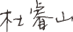
Guidance teacher
Professional leader
July 6th, 2026
Catalogue
Chapter 1 Overview 1
1.1 The purpose of the project 1
1.2 Fundamentals of technical development 1
1.3 System functional requirements 3
Chapter 2 System Design 4
2.1 System function module design 4
2.2 Database design 5
Chapter 3 System implementation 7
3.1 Database access class 7
3.2 System login window 8
3.3 Main window 10
3.4 Personal information management 12
3.5 User information management 12
3.6 House information management 12
Chapter 4 System Testing 13
4.1 Principles of system testing 14
4.2 Test result 15
Conclusion 17
References 18
Appendix 1 Team Development Meeting Minutes 1 19
Appendix 2 Team Development Meeting Minutes 2 20

Chapter 1 Overview

1.1 Purpose of the Project

1.1.1 Problem Statement and Context
Modern housing rental operations require the synchronous management of physical inventory (properties and units), human relations (tenants and staff), legal obligations (tenancy agreements), and financial transactions (periodic billing, rent collection, and arrears tracking). In many small-to-medium residential management offices, these records are maintained across fragmented spreadsheets, isolated digital documents, or traditional paper ledger files.
This decentralized data management leads to several operational inefficiencies: Redundant Data Entry: Staff must repeatedly input overlapping information across separate tenant lists, lease agreements, and payment registers.
Information Asymmetry: Real-time occupancy status, pending lease renewals, and outstanding tenant balances are difficult to query instantly, resulting in delayed administrative decisions.
Weak Accountability & Audit Gaps: Manual tracking lacks transaction logs, making it difficult to trace which staff member authorized a billing reversal, updated a contract, or collected a cash payment.
To address these challenges, this project delivers a unified, desktop-based Housing Rental Management System (HRMS). The system converts manual, error-prone rental procedures into structured, transactional, and fully auditable workflows.

1.1.2 Educational Objectives and Software Engineering Principles
Beyond its practical application, this project serves as a comprehensive academic study in applying industry-standard software engineering methodologies to a desktop enterprise system. The project is designed and implemented using a three-tier architecture that demonstrates the practical separation of concerns: Presentation Layer (Windows Forms): Focuses solely on user interaction, UI responsiveness, and displaying data, remaining completely decoupled from data access and database schemas.
Business Logic Layer (BLL): Acts as the system’s core intelligence engine. It governs state transitions, validates business rules (e.g., verifying that a unit is vacant before creating a new lease agreement), hashes passwords for secure authentication, and tracks active session states (CurrentSession).
Data Access Layer (DAL): Implements the Repository Pattern (e.g., PropertyRepository, AgreementRepository, RentPaymentRepository, AuditRepository) alongside a centralized connection factory and helper utilities (DbConnectionFactory, SqlHelper). This abstracts all raw database queries away from the business and UI layers.
Relational Database Layer (SQL Server): Enforces data consistency, constraint validation, and transactional safety. Real-world business requirements are handled efficiently through database views, custom stored procedures, and tables designed to prevent orphaned records.
By navigating this full software development lifecycle (SDLC)—spanning requirements analysis, relational database schema design, application layering, security integration, reporting, and component testing—this project bridges the gap between theoretical computer science concepts and concrete desktop software implementation.

1.1.3 System Scope and Role-Based Access Control (RBAC)
The application secures business operations by enforcing role-based permissions at both the presentation and business logic layers. The system is designed to support two distinct user roles:
Table Role-Based Access Control (RBAC)
Role | Role Operational Scope & Responsibilities | Key Actions Supported
Administrator | System-wide configuration, security governance, and high-privilege financial operations. | • Monthly automated charge generation  • Fee/Payment reversals and correction overrides • System settings adjustments  • User account creation, editing, and privilege management
Staff User | Daily operational management of properties, tenants, and lease life cycles. | • Property and unit inventory updates  • Tenant onboarding and information management  • Drafting and executing rental agreements • Recording rent payments and printing receipts  • Generating operational reports and dashboard metrics

1.2.1 Object-Oriented Technology
Object-oriented technology models the problem domain using classes and responsibilities. Property, House, Room, Tenant, RentalAgreement, Payment, and related data-transfer classes represent persistent information, Encapsulation keeps validation close to the operation it protects, and the layered design reduces coupling between intesrface controls and SQL implementation details.
The system uses Object-Oriented Programming (OOP) principles to construct a high-fidelity model of the housing rental domain. The system separates static state (data representation) from operational behavior (business logic):
Domain Model Entities (POCOs): Classes such as Property, House, Room, Tenant, RentalAgreement, and RentPayment represent database records as strongly-typed objects. These data structures are passed across system layers.
Service Layer (BLL): Classes like PropertyService, AgreementService, and RentPaymentService encapsulate the business rules. They govern workflows such as contract transitions, billing allocations, and role-based validations.
Encapsulation & Cohesion: Validation rules (e.g., email format checks, date range validation) are encapsulated directly within service boundaries. This ensures that invalid data is caught before reaching the data access layer, preventing database corruption.
Decoupling: By keeping the UI views isolated from database connections, developers can modify UI elements or database schemas with minimal impact on other layers.

1.2.2 C# Language and Windows Forms Presentation Layer
The presentation layer is built on the .NET Framework 4.7.2 runtime using Windows Forms (WinForms). This stack was selected to meet rapid desktop application development criteria:
Modular Control Composition: The UI avoids complex form-switching by nesting specialized UserControl classes (e.g., UserManagementControl, AgreementManagementControl, PaymentManagementControl) within a single main application container (FrmDashboard).
Rich Data Visualization: Grid controls (DataGridView) are configured with custom bindings to provide interactive, sortable, and editable representations of database records.
Local Reporting Integration: The application embeds the Microsoft.Reporting Services.Report ViewerControl.WinForms package. This allows local compilation and execution of client-side Report Definition Language (.rdlc) files without needing a separate reporting server.
Code Metric Details: The codebase comprises approximately 65 C# source files, totaling roughly 16,270 lines of code. This includes custom business algorithms, database mappings, and auto-generated UI designer files.

1.2.3 SQL Server Engine and ADO.NET Data Access
SQL Server stores normalized master data and the financial ledger. ADO.NET supplies SqlConnection, SqlCommand, SqlDataReader, SqlDataAdapter, SqlParameter, transactions, and stored-procedure integration. Parameterized commands reduce SQL-injection risk, while database constraints, filtered unique indexes, rowversion columns, and transactional procedures protect data integrity under concurrent use.
Direct Data Access Layer (DAL): Database operations are executed using a custom SqlHelper utility and the DbConnectionFactory class, which manages the lifecycle of SQL connections.
Parameterized Query Execution: The system uses parameterized commands (SqlCommand.Parameters.AddWithValue) for all database operations. This prevents SQL injection attacks and allows the SQL Server query optimizer to reuse execution plans.
Stored Procedures & Views: Complex database operations (such as compiling financial balances, generating monthly dues, and generating reports) are offloaded to custom SQL Stored Procedures and Views. This keeps the network overhead low and improves data processing performance.
Data Integrity Mechanisms: Relational integrity is enforced using foreign key cascades, unique indexes, and transactions (SqlTransaction). This ensures that financial records remain consistent if a database query fails halfway through.

1.2.4 Client-Server Architecture Model
The system operates on a 2-Tier Client-Server Architecture:
+----------------------------------------+
| CLIENT WORKSTATION |
| - Renders Windows Forms UI |
| - Validates user input checks |
| - Handles Active Session Context |
+----------------------------------------+
| (TCP/IP Connection / ADO.NET)
v
+----------------------------------------+
| SQL DATABASE SERVER |
| - Stores Relational Ledger Schema |
| - Processes Stored Procedures |
| - Enforces Transaction Safety |
+----------------------------------------+
Client Workstation responsibilities: Renders user-friendly screens, handles local input validation (checking for empty fields or negative values), maintains active login states, and caches the user's role context.
Database Server responsibilities: Handles data persistence, executes complex stored procedures, generates views, and handles concurrent access lockups to ensure transaction safety.
Benefits: This distribution maintains a responsive desktop experience for users while centralizing all persistent data on a single secure database server.

1.3 System Functional Requirements
1.3.1 Functional Requirements (FRs)
FR-1: Authentication & Role-Based Navigation
  - Verify user credentials against hashed database records (PasswordHasher).
  - Enforce session lifetimes, user logout capabilities, and account status checks.
  - Adjust user interface elements and menu options dynamically based on the logged-in user's role (Administrator vs. Staff).
- FR-2: Property & Unit Inventory Management
  - Create, read, update, and delete (CRUD) operations for Properties (buildings) and individual units/rooms.
  - Track unit details such as monthly rent, room type, current status, and history of occupancy.
- FR-3: Tenant Profiling
  - Manage tenant contact info, government IDs, and emergency contact records.
  - Query a tenant's historical rental agreements and payment history.
- FR-4: Tenancy Agreement Lifecycle
  - Generate new agreements and track state transitions: Draft, Active, Expired, Terminated, and Cancelled.
  - Link agreements to specific tenants, properties, and rental rates.
- FR-5: Billing Ledger & Payments
  - Generate monthly charges automatically for active agreements.
  - Record tenant payments and print payment receipts.
  - Allow system administrators to reverse incorrect charges or payment postings.
- FR-6: Reporting Engine
  - Run and display six parameterized RDLC reports:
    - Tenant List: Master list of active and historic tenants.
    - Property Occupancy: Vacancy rate and occupancy metrics.
    - Rent Collection: Ledger tracking payments received over a date range.
    - Monthly Due: List of outstanding balances for the billing cycle.
    - Agreement Report: Active and upcoming lease contract profiles.
    - Income Summary: Financial report detailing total revenue vs. receivables.
- FR-7: System Auditing & Settings
  - Maintain system audit logs for administrative actions (e.g., changes to roles or payment configurations).
  - Manage global system configurations.

1.4 Scope and Constraints

1.4.1 Implemented & Delivered Scope
- The delivered system includes nine operational modules accessible from the main dashboard:
- User Authentication Module: Handles user logins and sets up the user session.
- System Dashboard: Shows high-level statistics like active tenants, occupied rooms, and current monthly revenue.
- Property Management Module: Handles setup and maintenance of buildings and rooms.
- Tenant Management Module: Manages tenant profiles and contact details.
- Agreement Management Module: Manages the lease contract lifecycle.
- Payment Ledger Module: Processes payments, handles billing runs, and prints receipts.
- Report Center: Displays and exports the six required RDLC reports.
- User Account Administrator: Allows administrators to manage system user credentials.
- Global Application Settings: Manages application-wide configurations and displays system audit logs.

1.4 Scope and Constraints
- The implemented scope includes the nine primary modules demonstrated in the supplied GUI evidence. The database also contains MaintenanceRequests and Expenses tables and matching model classes; however, these areas do not yet have complete repository, service, navigation, and editor layers. They are therefore treated as future scope rather than delivered modules. The current application also uses a local SQL Express trusted connection by default and requires correct ReportViewer package integration for a clean build on a new machine.

Chapter 2 System Design
This chapter describes the architecture, functional decomposition, business workflows, database model, security controls, and report design. The central design principle is that each layer performs one kind of work and passes a clear data contract to the next layer.

2.1 Overall Architecture
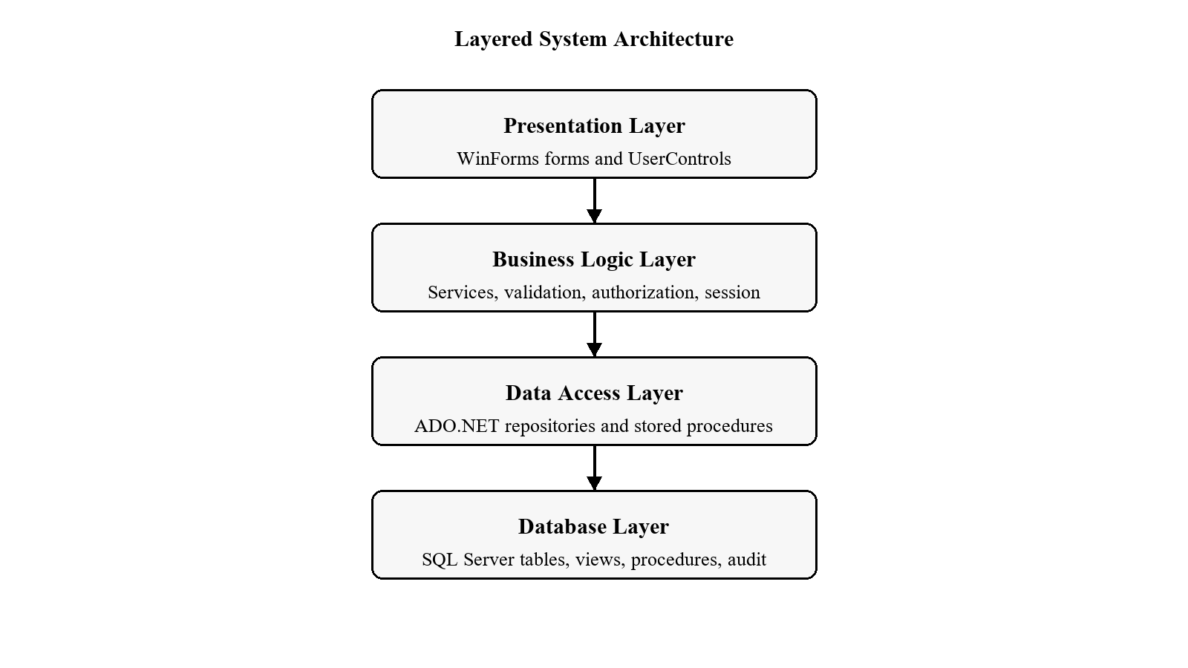
Figure 2-1 Layered system architecture
The Presentation layer contains forms and reusable UserControls. It captures user actions, displays grids, shows validation feedback, and hosts report output. The Business Logic Layer (BLL) authorizes operations, normalizes input, enforces domain rules, converts exceptions to ServiceResult messages, and requests audit records. The Data Access Layer (DAL) owns ADO.NET commands, stored-procedure calls, transactions, and row mapping. SQL Server provides durable persistence and final integrity controls. Models and DTOs carry data between layers without embedding interface behavior.

2.2 System Function Module Design
Authentication and session: FrmLogin, AuthService, CurrentSession, and ApplicationSessionContext coordinate login, dashboard display, logout, and application shutdown.
Dashboard: Presents property, room, tenant, agreement, collected-rent, and due-rent indicators returned by sp_GetDashboardSummary.
Properties: Manages the Property -> House/Unit -> Room hierarchy and current occupancy.
Tenants: Maintains tenant master records and related financial/occupancy histories.
Agreements: Controls draft creation, activation, notes, renewal, termination, cancellation, expiration, and room-state synchronization.
Rent Collection: Generates monthly charges, allocates payments, produces receipts, and preserves reversals.
Reports: Binds filtered DataTables to six embedded RDLC layouts through local ReportViewer.
Users: Provides administrator-only account, role, password-reset, and activation functions.
Settings: Maintains application name, currency, rent due day, receipt footer, and current-user password.

2.3 Core Business Workflows

2.3.1 Inventory-to-Occupancy Workflow
- Create an active property.
- Add a house/unit to the property and a room with positive monthly rent.
- Create an active tenant after duplicate phone and national-ID checks.
- Create a Draft agreement with tenant, room, dates, rent, deposit, and notes.
- Activate the agreement in a transaction; the tenant must be active, the room available, and no second active agreement may exist for the room.

2.3.2 Monthly Rent Collection Workflow
- An administrator selects a billing month and runs idempotent charge generation.
- The collector searches an agreement and selects one or more outstanding charges.
- The system validates payment date, method, external reference, amount, currency, and allocations.
- sp_Payment_Post rechecks current balances and inserts Payment plus PaymentAllocations atomically.
- A receipt is displayed; an administrator can reverse an incorrect payment with a mandatory reason without deleting history.

2.4 Database Design
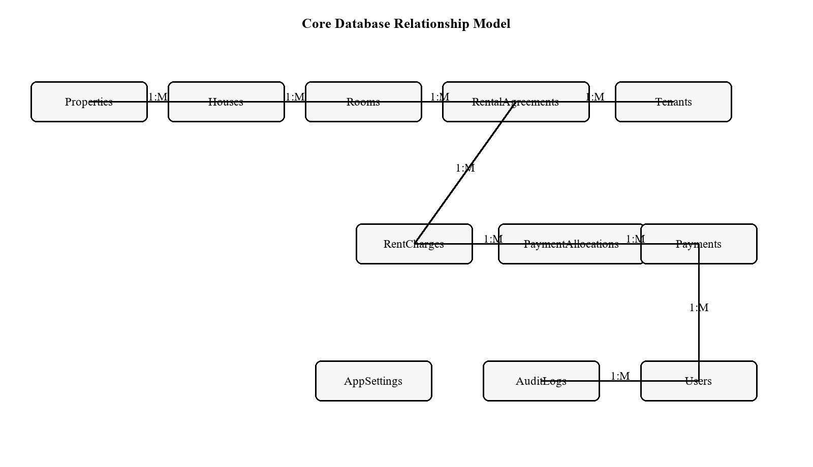
Figure 2-2 Core database relationship model
HouseRentalDB contains 15 principal tables. The schema separates inventory, tenancy, contractual terms, receivables, payments, administration, audit, and settings. The most important financial design decision is to derive balances from charges minus allocations linked to Posted payments, rather than storing a single mutable balance.

1.Roles

Overview
The Roles table stores and manages roles information and plays an important role in the housing rental management system.

Purpose
This table is used to manage roles records and maintain relationships with other tables while ensuring data integrity.

Field Details
Column Name | Data Type | Key/Constraint | Description
RoleId | INT | Primary Key | Stores the RoleId value.
RoleName | NVARCHAR(50) | Unique | Stores the RoleName value.
Description | NVARCHAR(200) |  | Stores the Description value.
IsActive | BIT | Default (1) | Stores the IsActive value.
2. Users

Overview
The Users table stores and manages users information and plays an important role in the housing rental management system.

Purpose
This table is used to manage users records and maintain relationships with other tables while ensuring data integrity.

Field Details
Column Name | Data Type | Key/Constraint | Description
UserId | INT | Primary Key | Stores the UserId value.
RoleId | INT | Foreign Key | Stores the RoleId value.
FullName | NVARCHAR(100) |  | Stores the FullName value.
Username | NVARCHAR(50) | Unique | Stores the Username value.
PasswordHash | NVARCHAR(255) |  | Stores the PasswordHash value.
PasswordSalt | NVARCHAR(255) |  | Stores the PasswordSalt value.
Phone | NVARCHAR(30) |  | Stores the Phone value.
Email | NVARCHAR(100) |  | Stores the Email value.
IsActive | BIT | Default (1) | Stores the IsActive value.
LastLoginAt | DATETIME |  | Stores the LastLoginAt value.
CreatedAt | DATETIME | Default GETDATE() | Stores the CreatedAt value.

3.Properties

Overview
The Properties table stores and manages properties information and plays an important role in the housing rental management system.

Purpose
This table is used to manage properties records and maintain relationships with other tables while ensuring data integrity.

Field Details
Column Name | Data Type | Key/Constraint | Description
PropertyId | INT | Primary Key | Stores the PropertyId value.
PropertyName | NVARCHAR(100) |  | Stores the PropertyName value.
Address | NVARCHAR(250) |  | Stores the Address value.
City | NVARCHAR(80) |  | Stores the City value.
Description | NVARCHAR(300) |  | Stores the Description value.
IsActive | BIT | Default (1) | Stores the IsActive value.
CreatedAt | DATETIME | Default GETDATE() | Stores the CreatedAt value.

4.Houses

Overview
The Houses table stores and manages houses information and plays an important role in the housing rental management system.

Purpose
This table is used to manage houses records and maintain relationships with other tables while ensuring data integrity.

Field Details
Column Name | Data Type | Key/Constraint | Description
HouseId | INT | Primary Key | Stores the HouseId value.
PropertyId | INT | Foreign Key | Stores the PropertyId value.
HouseName | NVARCHAR(100) |  | Stores the HouseName value.
FloorNo | NVARCHAR(20) |  | Stores the FloorNo value.
Description | NVARCHAR(300) |  | Stores the Description value.
IsActive | BIT | Default (1) | Stores the IsActive value.
CreatedAt | DATETIME | Default GETDATE() | Stores the CreatedAt value.

5.Rooms

Overview
The Rooms table stores and manages rooms information and plays an important role in the housing rental management system.

Purpose
This table is used to manage rooms records and maintain relationships with other tables while ensuring data integrity.

Field Details
Column Name | Data Type | Key/Constraint | Description
RoomId | INT | Primary Key | Stores the RoomId value.
HouseId | INT | Foreign Key | Stores the HouseId value.
RoomNo | NVARCHAR(50) |  | Stores the RoomNo value.
RoomType | NVARCHAR(50) |  | Stores the RoomType value.
MonthlyRent | DECIMAL(18,2) | Check >0 | Stores the MonthlyRent value.
Status | NVARCHAR(30) | Default | Stores the Status value.
Description | NVARCHAR(300) |  | Stores the Description value.
CreatedAt | DATETIME | Default GETDATE() | Stores the CreatedAt value.

6.Tenants

Overview
The Tenants table stores and manages tenants information and plays an important role in the housing rental management system.

Purpose
This table is used to manage tenants records and maintain relationships with other tables while ensuring data integrity.

Field Details
Column Name | Data Type | Key/Constraint | Description
TenantId | INT | Primary Key | Stores the TenantId value.
FullName | NVARCHAR(120) |  | Stores the FullName value.
Phone | NVARCHAR(30) |  | Stores the Phone value.
Email | NVARCHAR(100) |  | Stores the Email value.
NationalId | NVARCHAR(80) | Unique | Stores the NationalId value.
Address | NVARCHAR(250) |  | Stores the Address value.
EmergencyContactName | NVARCHAR(100) |  | Stores the EmergencyContactName value.
EmergencyContactPhone | NVARCHAR(30) |  | Stores the EmergencyContactPhone value.
Status | NVARCHAR(30) | Default | Stores the Status value.
CreatedAt | DATETIME | Default GETDATE() | Stores the CreatedAt value.

7.RentalAgreements

Overview
The RentalAgreements table stores and manages rentalagreements information and plays an important role in the housing rental management system.

Purpose
This table is used to manage rentalagreements records and maintain relationships with other tables while ensuring data integrity.

Field Details
Column Name | Data Type | Key/Constraint | Description
AgreementId | INT | Primary Key | Stores the AgreementId value.
AgreementNo | NVARCHAR(50) | Unique | Stores the AgreementNo value.
TenantId | INT | Foreign Key | Stores the TenantId value.
RoomId | INT | Foreign Key | Stores the RoomId value.
StartDate | DATE |  | Stores the StartDate value.
EndDate | DATE |  | Stores the EndDate value.
MonthlyRent | DECIMAL(18,2) |  | Stores the MonthlyRent value.
SecurityDeposit | DECIMAL(18,2) | Default | Stores the SecurityDeposit value.
Status | NVARCHAR(30) | Default | Stores the Status value.
CreatedByUserId | INT | Foreign Key | Stores the CreatedByUserId value.
CreatedAt | DATETIME | Default GETDATE() | Stores the CreatedAt value.

8.RentCharges

Overview
The RentCharges table stores and manages rentcharges information and plays an important role in the housing rental management system.

Purpose
This table is used to manage rentcharges records and maintain relationships with other tables while ensuring data integrity.

Field Details
Column Name | Data Type | Key/Constraint | Description
ChargeId | BIGINT | Primary Key | Stores the ChargeId value.
AgreementId | INT | Foreign Key | Stores the AgreementId value.
ChargeType | NVARCHAR(30) |  | Stores the ChargeType value.
BillingPeriod | DATE |  | Stores the BillingPeriod value.
PeriodStart | DATE |  | Stores the PeriodStart value.
PeriodEnd | DATE |  | Stores the PeriodEnd value.
DueDate | DATE |  | Stores the DueDate value.
Amount | DECIMAL(18,2) |  | Stores the Amount value.
CurrencyCode | CHAR(3) |  | Stores the CurrencyCode value.
Status | NVARCHAR(20) | Default | Stores the Status value.

9.Payments

Overview
The Payments table stores and manages payments information and plays an important role in the housing rental management system.

Purpose
This table is used to manage payments records and maintain relationships with other tables while ensuring data integrity.

Field Details
Column Name | Data Type | Key/Constraint | Description
PaymentId | BIGINT | Primary Key | Stores the PaymentId value.
ReceiptNo | NVARCHAR(50) | Unique | Stores the ReceiptNo value.
RequestId | UNIQUEIDENTIFIER | Unique | Stores the RequestId value.
TenantId | INT | Foreign Key | Stores the TenantId value.
AgreementId | INT | Foreign Key | Stores the AgreementId value.
PaymentDate | DATE |  | Stores the PaymentDate value.
Amount | DECIMAL(18,2) |  | Stores the Amount value.
CurrencyCode | CHAR(3) |  | Stores the CurrencyCode value.
PaymentMethod | NVARCHAR(30) |  | Stores the PaymentMethod value.
Status | NVARCHAR(20) | Default | Stores the Status value.
CollectedByUserId | INT | Foreign Key | Stores the CollectedByUserId value.

10.PaymentAllocations

Overview
The PaymentAllocations table stores and manages paymentallocations information and plays an important role in the housing rental management system.

Purpose
This table is used to manage paymentallocations records and maintain relationships with other tables while ensuring data integrity.

Field Details
Column Name | Data Type | Key/Constraint | Description
AllocationId | BIGINT | Primary Key | Stores the AllocationId value.
PaymentId | BIGINT | Foreign Key | Stores the PaymentId value.
ChargeId | BIGINT | Foreign Key | Stores the ChargeId value.
Amount | DECIMAL(18,2) |  | Stores the Amount value.
CreatedAt | DATETIME2(0) |  | Stores the CreatedAt value.

11.PaymentReversals

Overview
The PaymentReversals table stores and manages paymentreversals information and plays an important role in the housing rental management system.

Purpose
This table is used to manage paymentreversals records and maintain relationships with other tables while ensuring data integrity.

Field Details
Column Name | Data Type | Key/Constraint | Description
ReversalId | BIGINT | Primary Key | Stores the ReversalId value.
PaymentId | BIGINT | Foreign Key | Stores the PaymentId value.
RequestId | UNIQUEIDENTIFIER | Unique | Stores the RequestId value.
Reason | NVARCHAR(500) |  | Stores the Reason value.
ReversedByUserId | INT | Foreign Key | Stores the ReversedByUserId value.
ReversedAt | DATETIME2(0) |  | Stores the ReversedAt value.

12.MaintenanceRequests

Overview
The MaintenanceRequests table stores and manages maintenancerequests information and plays an important role in the housing rental management system.

Purpose
This table is used to manage maintenancerequests records and maintain relationships with other tables while ensuring data integrity.

Field Details
Column Name | Data Type | Key/Constraint | Description
MaintenanceId | INT | Primary Key | Stores the MaintenanceId value.
PropertyId | INT | Foreign Key | Stores the PropertyId value.
RoomId | INT | Foreign Key | Stores the RoomId value.
Title | NVARCHAR(150) |  | Stores the Title value.
Description | NVARCHAR(500) |  | Stores the Description value.
Cost | DECIMAL(18,2) |  | Stores the Cost value.
Status | NVARCHAR(30) |  | Stores the Status value.
RequestedAt | DATETIME |  | Stores the RequestedAt value.
CompletedAt | DATETIME |  | Stores the CompletedAt value.

13.Expenses

Overview
The Expenses table stores and manages expenses information and plays an important role in the housing rental management system.

Purpose
This table is used to manage expenses records and maintain relationships with other tables while ensuring data integrity.

Field Details
Column Name | Data Type | Key/Constraint | Description
ExpenseId | INT | Primary Key | Stores the ExpenseId value.
PropertyId | INT | Foreign Key | Stores the PropertyId value.
ExpenseDate | DATE |  | Stores the ExpenseDate value.
Category | NVARCHAR(80) |  | Stores the Category value.
Amount | DECIMAL(18,2) |  | Stores the Amount value.
Description | NVARCHAR(300) |  | Stores the Description value.
CreatedByUserId | INT | Foreign Key | Stores the CreatedByUserId value.
CreatedAt | DATETIME |  | Stores the CreatedAt value.

14.AuditLogs

Overview
The AuditLogs table stores and manages auditlogs information and plays an important role in the housing rental management system.

Purpose
This table is used to manage auditlogs records and maintain relationships with other tables while ensuring data integrity.

Field Details
Column Name | Data Type | Key/Constraint | Description
AuditLogId | INT | Primary Key | Stores the AuditLogId value.
UserId | INT | Foreign Key | Stores the UserId value.
ActionName | NVARCHAR(100) |  | Stores the ActionName value.
TableName | NVARCHAR(100) |  | Stores the TableName value.
RecordId | NVARCHAR(50) |  | Stores the RecordId value.
Description | NVARCHAR(500) |  | Stores the Description value.
CreatedAt | DATETIME |  | Stores the CreatedAt value.

15.AppSettings

Overview
The AppSettings table stores and manages appsettings information and plays an important role in the housing rental management system.

Purpose
This table is used to manage appsettings records and maintain relationships with other tables while ensuring data integrity.

Field Details
Column Name | Data Type | Key/Constraint | Description
SettingId | INT | Primary Key | Stores the SettingId value.
SettingKey | NVARCHAR(100) | Unique | Stores the SettingKey value.
SettingValue | NVARCHAR(300) |  | Stores the SettingValue value.
Description | NVARCHAR(300) |  | Stores the Description value.

2.5 Views, Stored Procedures, and Integrity
Eleven views provide stable read models. vw_RentChargeBalances derives PaidAmount, BalanceAmount, and Due/Partial/Paid/Overdue/Waived status. Agreement and tenant receivable views aggregate those balances. PaymentHistory flattens tenant, agreement, location, collector, and reversal information. Occupancy and summary views supply grids, dashboard values, and reports.
Thirteen stored procedures perform monthly charge generation, payment posting, payment reversal, dashboard retrieval, report datasets, and application-setting operations. Payment procedures use explicit THROW validation, transactions, unique request identifiers, typed allocation parameters, and live-balance rechecks. Filtered unique indexes prevent duplicate monthly charges and more than one Active agreement per room.

2.6 Security and Authorization Design
CurrentSession stores the authenticated user and exposes role checks.
Admin-only BLL gates protect user/settings management, tenant blacklisting, charge generation, and payment reversal.
Repository commands use parameters and stored procedures instead of concatenating user input.
Login success/failure and important CRUD/lifecycle operations attempt to write AuditLogs.
Database constraints and transactions provide defense in depth beyond interface validation.
A security limitation is documented honestly: passwords are currently stored using salted SHA-256. Because SHA-256 is intentionally fast, production deployment should migrate to a slow adaptive password key-derivation function such as PBKDF2, bcrypt, scrypt, or Argon2 and add login throttling or lockout.

Chapter 3 System Implementation

3.1 Application Entry and Session Management
Program.Main enables WinForms visual styles and runs ApplicationSessionContext. The context first displays FrmLogin. After successful authentication it disposes the login form and shows FrmDashboard. Logout closes the dashboard, clears CurrentSession, and returns to a fresh login form; normal window close exits the thread.
[STAThread]
private static void Main()
{
Application.EnableVisualStyles();
Application.SetCompatibleTextRenderingDefault(false);
Application.Run(new ApplicationSessionContext());
}

3.2 Database Access Implementation
DbConnectionFactory reads the HouseRentalDB connection string from App.config and creates a SqlConnection. Repositories open connections only for the duration of an operation. SqlHelper supplies shared parameter/DataTable helpers, while specialized repositories map rows to domain objects or call stored procedures.
public static SqlConnection CreateConnection()
{
return new SqlConnection(
ConfigurationManager.ConnectionStrings["HouseRentalDB"].ConnectionString);
}
Write operations that change multiple records use transactions. Agreement activation synchronizes the agreement and room status. Payment posting delegates its transaction to sp_Payment_Post, which ensures that allocation totals equal the payment amount and that selected charge balances have not changed.

3.3 Login Window
The Login Window acts as the secure primary gateway for the House Rental Management System, establishing user identity and initiating an authenticated system session. Architecturally, the form adheres to a strict multi-tier software design, separating the Graphical User Interface presentation layer from the underlying Business Logic Layer and Data Access Layer modules. The front-end user interface employs a modern dual-panel layout engineered for aesthetic clarity, featuring a visual branding sidebar panel that dynamically loads system artwork alongside a high-contrast credential input card housing username, password, Login, and Exit controls.
To enhance usability and security, the password input control incorporates an interactive eye-toggle button for real-time password visibility control. This element utilizes custom GDI+ vector rendering to draw smooth, anti-aliased Bézier curves for Lucide-style eye icons while employing native Windows API interop to dynamically adjust text margins within the input field. Furthermore, primary interactive controls incorporate event-driven micro-animations for hover states, providing smooth color transitions that offer immediate visual feedback to the user during interaction.
Behind the presentation layer, the application delegates verification to the service layer authentication module. Upon receiving credential submissions, the authentication pipeline first executes strict input pre-validation to ensure all required fields contain non-whitespace characters. It then queries the user data repository using trimmed string normalization to retrieve the corresponding account profile and verifies the active status flag, immediately rejecting deactivated or suspended accounts. Password verification relies on salted cryptographic hashing rather than plain-text evaluation, combining the submitted input with the account's unique stored salt digest to verify the SHA-256 hash against database records.
Once authentication succeeds, the service module updates the account's last login timestamp in the database and initializes the global application context to persist user identity, user ID, and role permissions throughout the active session. The system simultaneously writes an entry to the audit log repository containing the user ID, action type, target table, and transaction metadata. To guard against credential probing attacks, any failed authentication attempt triggers non-disclosing diagnostic feedback, ensuring the interface never reveals whether an account exists, while failed login events are independently recorded in the audit trail for security compliance.
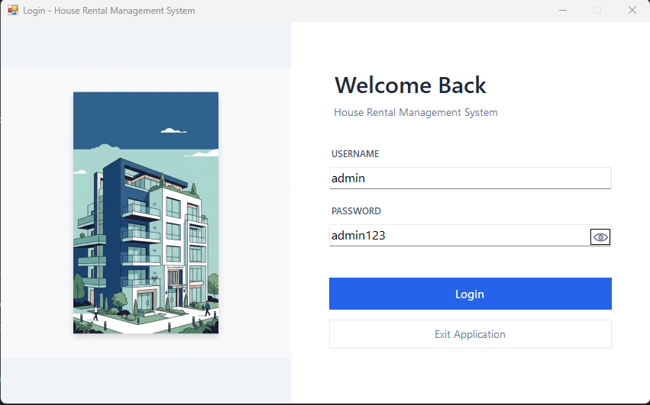
Figure 3-1 Login interface
User user = _userRepository.GetByUsername(username.Trim());
if (user == null || !user.IsActive)
return ServiceResult<User>.Failure("Invalid username or password.");
string hash = PasswordHasher.ComputeSha256Hash(password, user.PasswordSalt);
if (!string.Equals(hash, user.PasswordHash, StringComparison.OrdinalIgnoreCase))
return ServiceResult<User>.Failure("Invalid username or password.");

3.4 Dashboard and Navigation
The dashboard form functions as the central application shell and primary navigational hub for the House Rental Management System. Architecturally designed as a unified container window, the main dashboard eliminates window clutter by dynamically embedding module views into a central host panel. Rather than opening separate independent windows, the navigation menu instantiates modular user controls representing core system domains—such as properties, tenants, rental agreements, payment collections, reports, user management, and system settings—and docks them directly inside the content area. This single-document container strategy ensures smooth view switching, consistent layout geometry, and low memory overhead during extended user sessions.
Navigational integrity and access security are strictly enforced through role-based UI customisation and active session binding upon initial load. The top header area displays the active account identity alongside the assigned system role, establishing clear operational context for the user. Role-Based Access Control is enforced at the interface level by dynamically inspecting the authenticated session state, rendering administrative controls—such as the user management navigation option—visible strictly to users possessing administrator privileges. Additionally, the navigation sidebar tracks active button states with visual accent highlights to provide continuous situational awareness regarding the current operational context.
The central overview pane presents an executive summary of system performance, powered by real-time aggregated metrics retrieved from the database through the dashboard business service layer. The interface presents eight distinct Key Performance Indicator cards arranged in an organized grid layout, summarizing total managed properties, total room capacity, available units ready for lease, currently occupied units, total registered tenants, and active rental agreements. Financial metrics are prominently highlighted through real-time currency-formatted counters displaying current-month collected rental revenue alongside outstanding current-month balance dues.
System responsiveness and data accuracy are maintained through a global refresh control and active feedback indicators. A manual refresh action located in the header panel allows operators to trigger an immediate query recalculation, updating all metric counters to reflect recent payment receipts or agreement changes. The content area also incorporates a dynamic status bar that delivers real-time operation feedback, displaying color-coded notification messages to confirm data synchronisation success or alert the operator to underlying database communication exceptions.
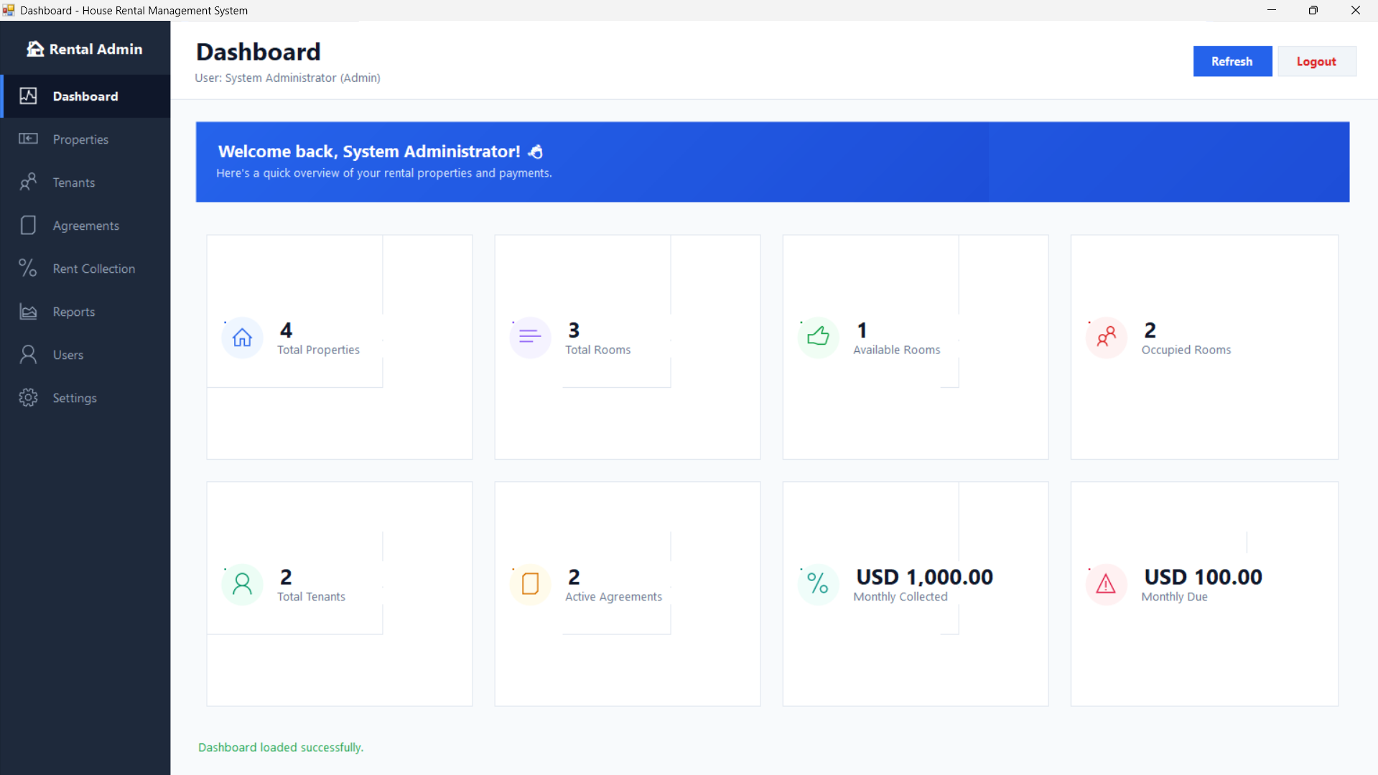
Figure 3-2 Dashboard interface

3.5 Property, House, Room, and Occupancy Management
The property management module (PropertyManagementControl) provides comprehensive administrative control over the physical asset structure managed by the system. To accurately represent real-world real estate organization, the module implements a strict four-level hierarchical interface structured across dedicated tabs for Properties, Houses or Units, Rooms, and Occupancy tracking. This tabular layout enables operators to navigate seamlessly down the structural hierarchy, allowing parent property selection to automatically scope child house records, which in turn scope individual room units and active tenant occupancy data. Search controls and multi-criteria filters—including parent property, parent house, and operational room status—pass user queries directly to the business layer for execution against the database repository.
Data processing and business rule enforcement are centralized within the property service layer (PropertyService). Before executing repository queries or persistence operations, the service sanitizes and normalizes all optional input strings, stripping leading and trailing whitespace while standardizing search parameters and filter keywords. The service layer enforces strict business validation rules across all structural tiers, ensuring that property and house names remain unique within their respective parent scopes, requiring all room records to define a strictly positive monthly rental rate, and restricting permissible room status values to a validated set comprising Available, Occupied, Maintenance, and Inactive.
System safety and relational integrity are guaranteed through strict cascade safety rules that prevent unsafe structural deactivations. The service layer actively blocks attempts to deactivate a property or house if child units or active tenant agreements are attached to that record. Similarly, the system prevents altering a room's status to Available, Maintenance, or Inactive while an active rental agreement remains bound to that room, requiring operators to formally terminate or close active lease agreements prior to changing status. Every successful modification—including asset creation, structural updates, and status transitions—dispatches structured entries to the audit repository, recording the action type, target table, record identifier, and change description for complete operational compliance and historical auditing.
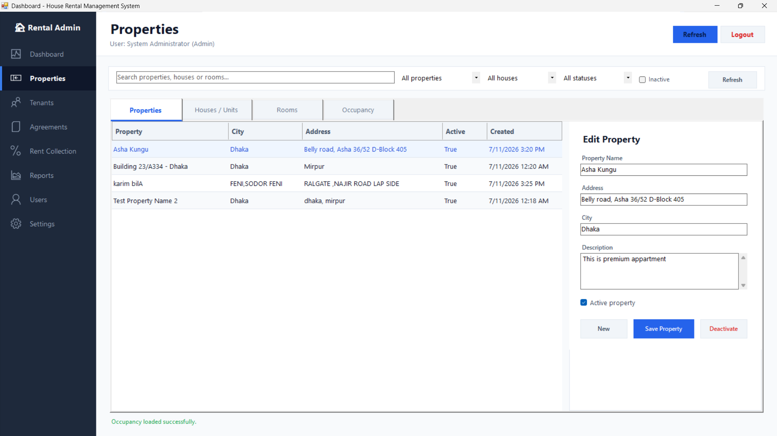
Figure 3-3 Property management interface
Filtered unique indexes prevent duplicate active property names within a city, duplicate active house names within one property, and duplicate non-inactive room numbers within a house. The Occupancy tab reads vw_RoomOccupancy so a room, active tenant, and active agreement can be reviewed together.

3.6 Tenant Management
The tenant management module (TenantManagementControl) provides a centralized interface for managing tenant records throughout their lifecycle. Architecturally structured as a master-detail workspace, the module pairs a real-time searchable tenant data grid with an interactive editing pane and dedicated historical tracking tabs. Operators can search records by keyword or status filter while accessing a tenant's complete history across four specialized sub-panels: rental agreement history, ledger payment logs, current room occupancy details, and real-time financial balance summaries.
Data integrity and validation rules are strictly managed by the underlying tenant service layer (TenantService). Each tenant record captures essential identification and contact fields, including full legal name, primary contact phone number, email address, national identification number, physical address, and emergency contact details. Prior to persistence, the service layer normalizes inputs by trimming whitespace and converting email addresses to standardized lowercase. Validation rules enforce mandatory presence for name and phone fields, evaluate email format accuracy using regular expression pattern matching, enforce character length limits, and perform uniqueness verification against database records to prevent duplicate phone numbers or national identification entries.
Lifecycle management and administrative governance enforce strict access control standards across three supported status states: Active, Inactive, and Blacklisted. To safeguard against operational policy violations, security restrictions govern status transitions: only authenticated users possessing administrator privileges (CurrentSession.IsAdmin) are authorized to flag a tenant as blacklisted or restore a blacklisted profile back to active status. Furthermore, the service layer enforces relational integrity by preventing operators from transitioning a tenant to Inactive or Blacklisted status while an active rental agreement remains linked to their account, ensuring all active lease obligations are formally resolved before status changes are saved. Every lifecycle event—including creation, profile updates, status changes, and blacklist actions—is logged to the audit repository with corresponding metadata for administrative traceability.
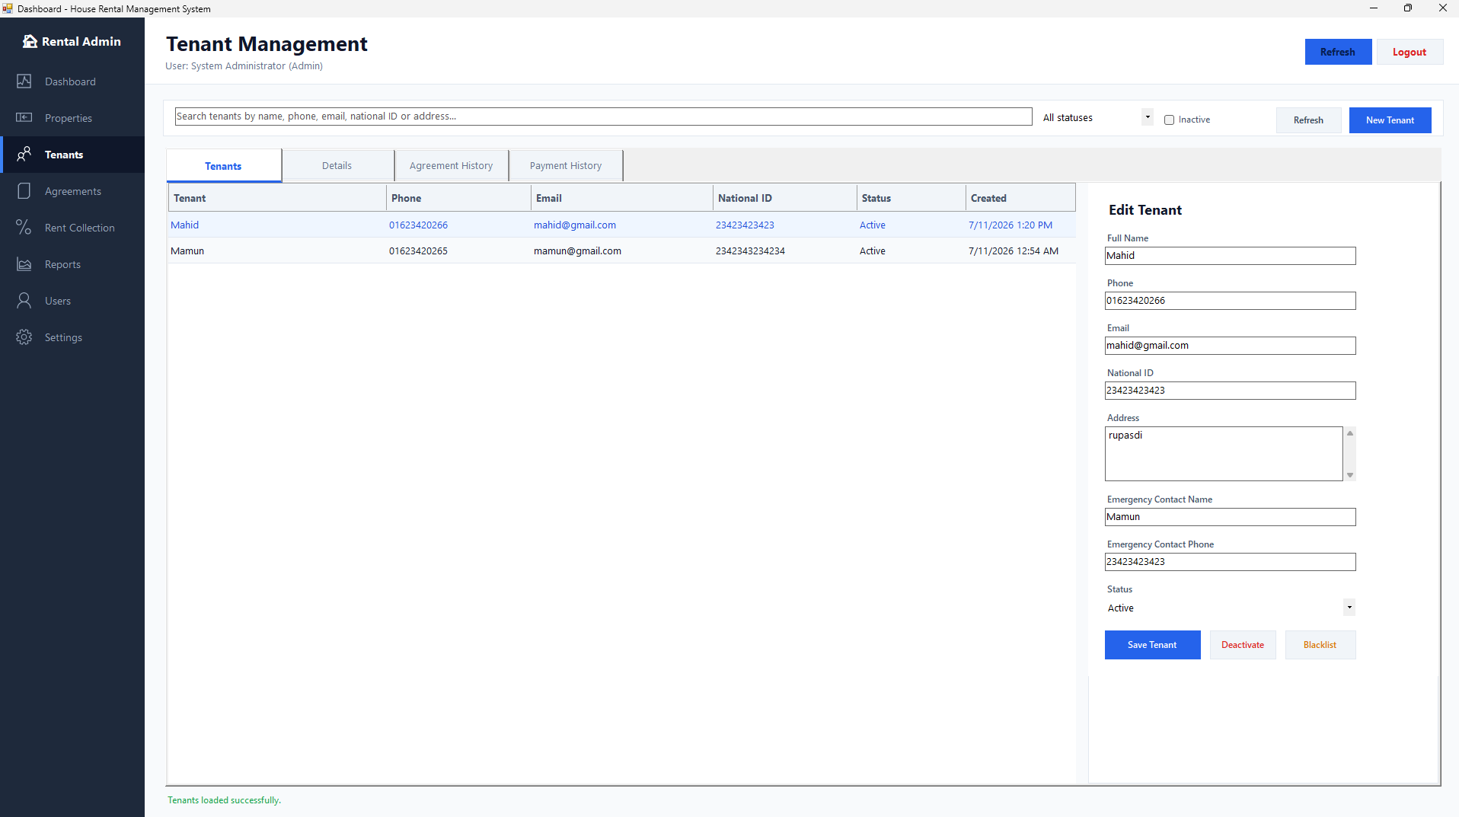
Figure 3-4 Tenant management interface
Agreement History, Payment History, current occupancy, and balance summary are obtained through dedicated repository queries and receivable views. This keeps the editor focused while preserving a complete context for customer service and collection decisions.

3.7 Rental Agreement Management
The rental agreement management module (AgreementManagementControl) oversees the binding legal contracts that govern property occupancy within the system. The interface supports multi-field search operations across agreement numbers, tenant names, property names, house names, and room numbers, complemented by multi-criteria filtering by contract status, property association, and custom date ranges. The workspace is organized into specialized analytical tabs displaying comprehensive contract details, historical ledger payment records, financial balance summaries, currently active leases, and an expiring agreements tracker that proactively highlights contracts approaching completion within a configurable timeframe.
Contract creation and initial processing are governed by strict eligibility rules enforced by the agreement service layer (AgreementService). When initiating a new lease, the system auto-generates a sequential agreement number based on the contract start date and validates candidate eligibility. The service layer verifies that the selected tenant maintains active status without blacklisting flags and confirms that the target room is currently available without conflicting active lease agreements. New contracts can be saved either as a non-binding Draft or directly activated into an Active agreement upon finalization.
To preserve contract integrity while offering operational flexibility, the system enforces lifecycle-based editing policies. Full structural edits—including modifications to lease start and end dates, monthly rent values, and security deposits—are restricted strictly to Draft agreements. Once an agreement becomes Active, its core contract parameters are locked to maintain financial and legal consistency; however, operators are permitted to update administrative notes independently up to a defined character limit.
Agreement transitions strictly follow a state-machine lifecycle covering activation, renewal, termination, expiration, and cancellation. Active contracts eligible for extension can be renewed, whereupon the system automatically sets the renewal start date to the day following the prior end date, issues a new sequential agreement number, and maintains contract lineage tracking. Active leases ending their term can be formally terminated with a documented reason or transitioned to Expired status manually or via batch automated processing. To ensure financial audit consistency, cancellation is restricted to Draft agreements or unstarted Active leases with zero payment history; any Active lease that has already commenced or accumulated financial ledger transactions must undergo formal termination rather than cancellation to preserve complete accounting audit trails. Every lifecycle state change dispatches detailed entries to the audit repository.
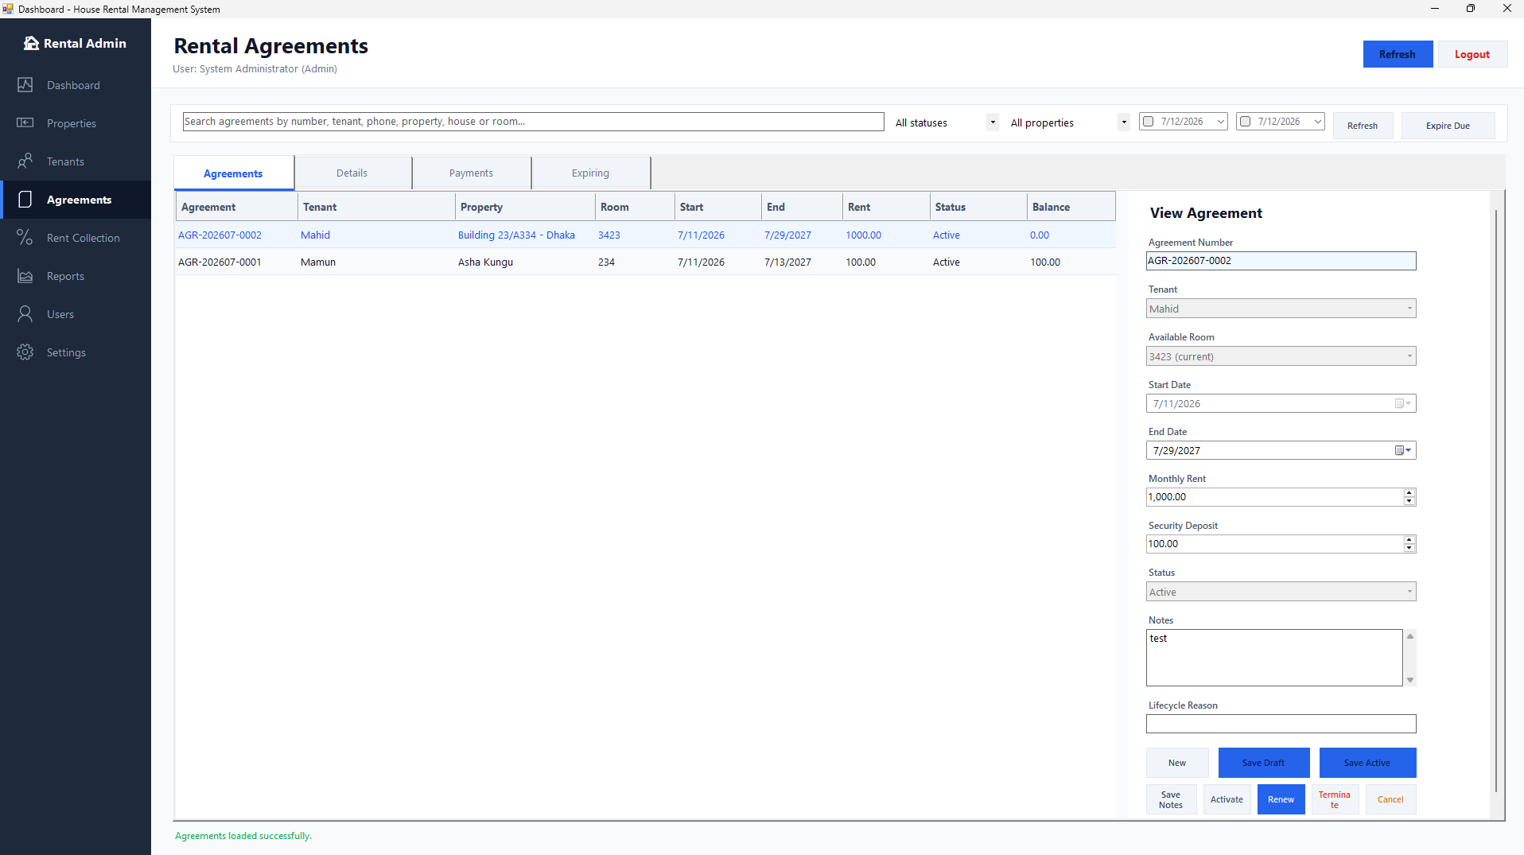
Figure 3-5 Rental agreement interface
AgreementRepository uses transactions for activation, renewal, and ending. It rechecks tenant status and room availability within the transaction. The filtered unique index UX_RentalAgreements_OneActiveRoom provides a final database guarantee against double booking.

3.8 Monthly Rent Collection
The monthly rent collection module (PaymentManagementControl) provides a robust financial workspace for generating billing items, recording tenant receipts, and processing ledger allocations. The user interface layout is structured into three integrated functional zones: a left-hand navigation panel that lists master agreement contexts for quick tenant selection, a central grid displaying outstanding rent charges and pending billing balances for the selected contract, and a bottom metadata entry panel where collectors input transaction payment parameters prior to posting.
Billing item generation and ledger initialization are strictly governed by administrative authorization rules within the payment service layer (RentPaymentService). Authorized administrators can trigger automated monthly rent charge generation for a designated billing period, normalized to the first day of the selected month. The generation engine inspects all active rental agreements across the system, calculates monthly rent obligations, and idempotently inserts missing charge items up to twelve months in advance without double-billing existing accounts.

To record collections efficiently, the posting engine supports flexible payment allocation strategies alongside strict financial validation rules. Collectors enter the received payment amount, transaction date, three-letter currency code, payment method, external reference ID, and optional remarks. Funds can be assigned to outstanding charges either through manual row selection or via an automated allocation algorithm that sequentially distributes the payment against the tenant's oldest outstanding due charges. The service layer enforces rigorous validation checks, ensuring that payment amounts maintain positive two-decimal precision, requiring an external transaction reference for all non-cash payment methods, restricting backdated transactions to administrative users, and verifying that the total received payment exactly equals the sum of allocated charge line items.

Upon validation, the transaction is executed atomically in the database layer under transaction control, updating charge item statuses from Unpaid to Partial or Paid, writing itemized allocation ledger records, and issuing a unique sequential receipt number. The system also supports administrative payment reversals, allowing authorized administrators to void posted receipts upon providing a mandatory documented explanation. Every posting, allocation, and reversal transaction dispatches detailed audit logs to the audit repository to ensure total ledger transparency and financial compliance.
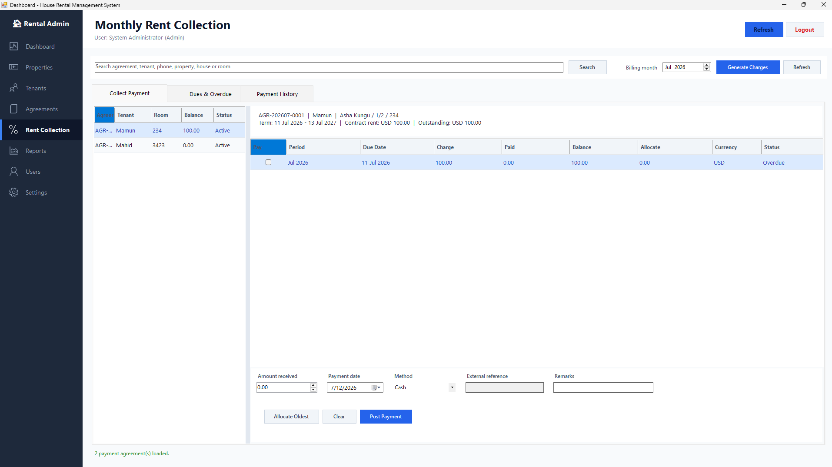
Figure 3-6 Monthly rent collection interface
The service validates authorization, amount, payment method, date restrictions, external reference for non-cash methods, allocation amounts, and allocation total. The repository passes a PaymentAllocationInput table-valued parameter to sp_Payment_Post. A unique RequestId makes retries idempotent and the stored procedure returns an existing receipt when the same request has already been processed.
SqlParameter allocations = command.Parameters.Add("@Allocations", SqlDbType.Structured);
allocations.TypeName = "dbo.PaymentAllocationInput";
allocations.Value = BuildAllocationTable(request.Allocations);
using (SqlDataReader reader = command.ExecuteReader())
{
// map PaymentId, ReceiptNo, Amount, CurrencyCode and status
}

3.9 Reporting Module
The reporting module (ReportManagementControl) provides a unified, standardized business intelligence workflow that generates formal analytical documentation across six core operational domains. Rather than creating isolated reporting forms for each module, the application standardizes report generation through a single container interface. The available reporting catalog encompasses the Tenant List Report, Property Occupancy Report, Rent Collection Report, Monthly Due Report, Agreement Report, and Income Summary Report. Each report is encapsulated within a structured definition model (ReportDefinition) that maps the report type to its user-facing display name, descriptive summary, target dataset name, and embedded RDLC report resource path.
To simplify user interaction, the reporting workspace dynamically adapts its input controls based on the selected report definition. Selecting a report automatically exposes only the filter fields required for that specific dataset, such as date ranges for rent collection and income summaries, billing periods and charge status options for monthly due reports, property dropdown selectors for occupancy tracking, or status filters for tenant and agreement directories. This dynamic filtering approach eliminates input ambiguity and prevents invalid parameter submissions.
Data retrieval and validation are managed by the report service layer (ReportService) and data repository (ReportRepository). Prior to querying the database, the service layer validates parameter bounds, ensuring that start dates precede end dates, restricting date ranges for income summaries to a maximum of twenty-four months, and verifying status code parameters. The repository layer executes optimized stored procedures or database views to return strongly typed data tables. Every generation event is registered in the audit repository, capturing the executing user ID, report name, applied filter criteria, and returned row counts for compliance auditing.

Visual presentation and export rendering are handled by the embedded ReportViewer control. Upon receiving the data table, the reporting engine binds the data to the corresponding embedded RDLC template via a report data source. The system automatically injects standardized header and footer parameters into every generated document, including the official report title, an applied filter summary string, the generation timestamp, the full name of the generating user, the active system currency code, and the application name. This ensures consistent branding, traceability, and print-ready presentation across all generated analytical reports.
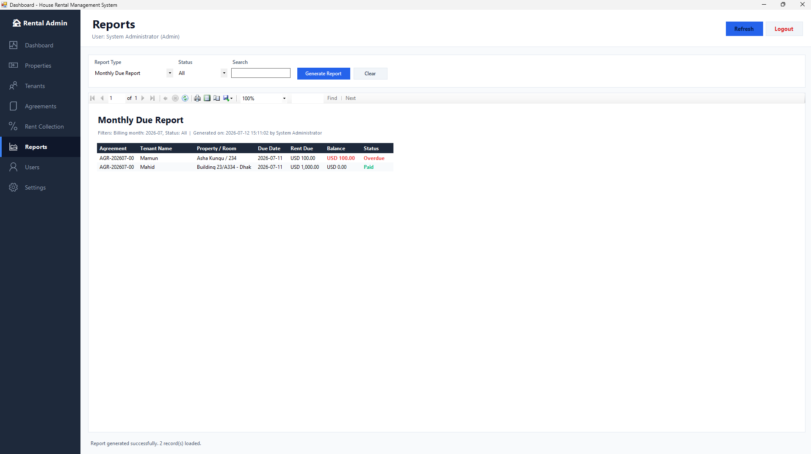
Figure 3-7 Embedded reporting interface
The report set includes Tenant List, Property Occupancy, Rent Collection, Monthly Due, Agreement, and Income Summary. RDLC definitions use consistent headers, field formatting, conditional status colors, application footer, and page numbering. The local processing model does not require a separate report server.

3.10 User Administration
The user administration module (UserManagementControl) provides centralized access control, user account provisioning, and identity governance for the House Rental Management System. Access to the user management workspace is restricted strictly to users possessing administrator privileges, with authorization checks enforced at both the user interface navigation layer and the service layer. The interface presents a real-time searchable user directory, an active role selection control, an account editor for managing identity parameters and role assignments, account activation and deactivation controls, a dedicated password reset card, and interactive password visibility controls.
Account creation and profile maintenance are strictly governed by validation rules enforced within the user service layer (UserService). Required identity fields include a full legal name, a system username with a minimum length of three characters, and a valid system role assignment. The service layer verifies username uniqueness across database records to prevent collisions, while optional email addresses are validated against regular expression format patterns. Initial password creation requires a minimum length of six characters and exact matching between password and confirmation fields. Upon validation, the service layer generates a unique cryptographic salt digest per user account and stores the credential using salted SHA-256 password hashing.
Account state management and administrative operations incorporate built-in safeguards to maintain system stability. Administrators can toggle user account status between active and inactive states; however, self-deactivation safeguards prevent currently authenticated administrators from deactivating their own active session. The module also enables administrators to execute password resets for managed accounts, which generates a fresh cryptographic salt and updates the account's password hash upon confirmation. Every user administration operation—including account provisioning, profile modifications, activation state shifts, and password resets—dispatches structured log entries to the audit repository for complete security auditing and compliance tracking.
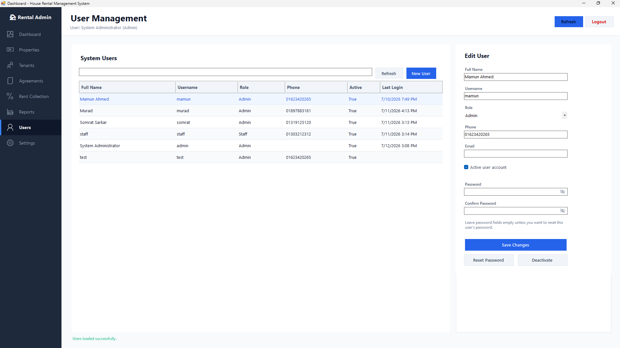
Figure 3-8 User management interface

3.11 Settings and Profile
The settings and profile module (SettingsManagementControl) provides global system configuration management and self-service account security for system operators. Interface access is separated into two dedicated sub-views: Application Settings and My Profile. This separation establishes a clear boundary between system-wide operational parameters and individual user credential management. While system-wide configuration controls are restricted exclusively to authenticated administrators, the self-service profile pane remains accessible to all active users regardless of role.
Global application configuration is governed by the settings service layer (SettingsService), which enforces key-specific validation rules across core system parameters. Administrators can modify the system application name, default currency code, monthly rent due day, and receipt footer text. The service layer validates each parameter against strict domain rules: application name cannot exceed one hundred characters, default currency must adhere to a three-letter uppercase ISO 4217 format evaluated via regular expression matching, monthly rent due day is bounded strictly between the first and twenty-eighth day of the month to maintain valid billing schedules across all months, and receipt footer text is limited to three hundred characters. Upon validation, modifications are executed through stored procedures that re-verify active administrator authority and log both prior and updated setting values to the audit database.
Individual account security is supported through self-service profile management, allowing any authenticated user to update their account password without administrative intervention. Password modification requires multi-step credential verification: the user must submit their active current password alongside the new password and confirmation string. The service layer validates the current password by computing a salted SHA-256 hash using the user's stored salt and comparing it against database records. Upon successful verification, the service enforces security constraints requiring the new password to contain at least six characters, match the confirmation input, and differ from the current password. Once verified, the application generates a fresh cryptographic salt, updates the salted password hash, and dispatches a security audit record to complete the transaction.
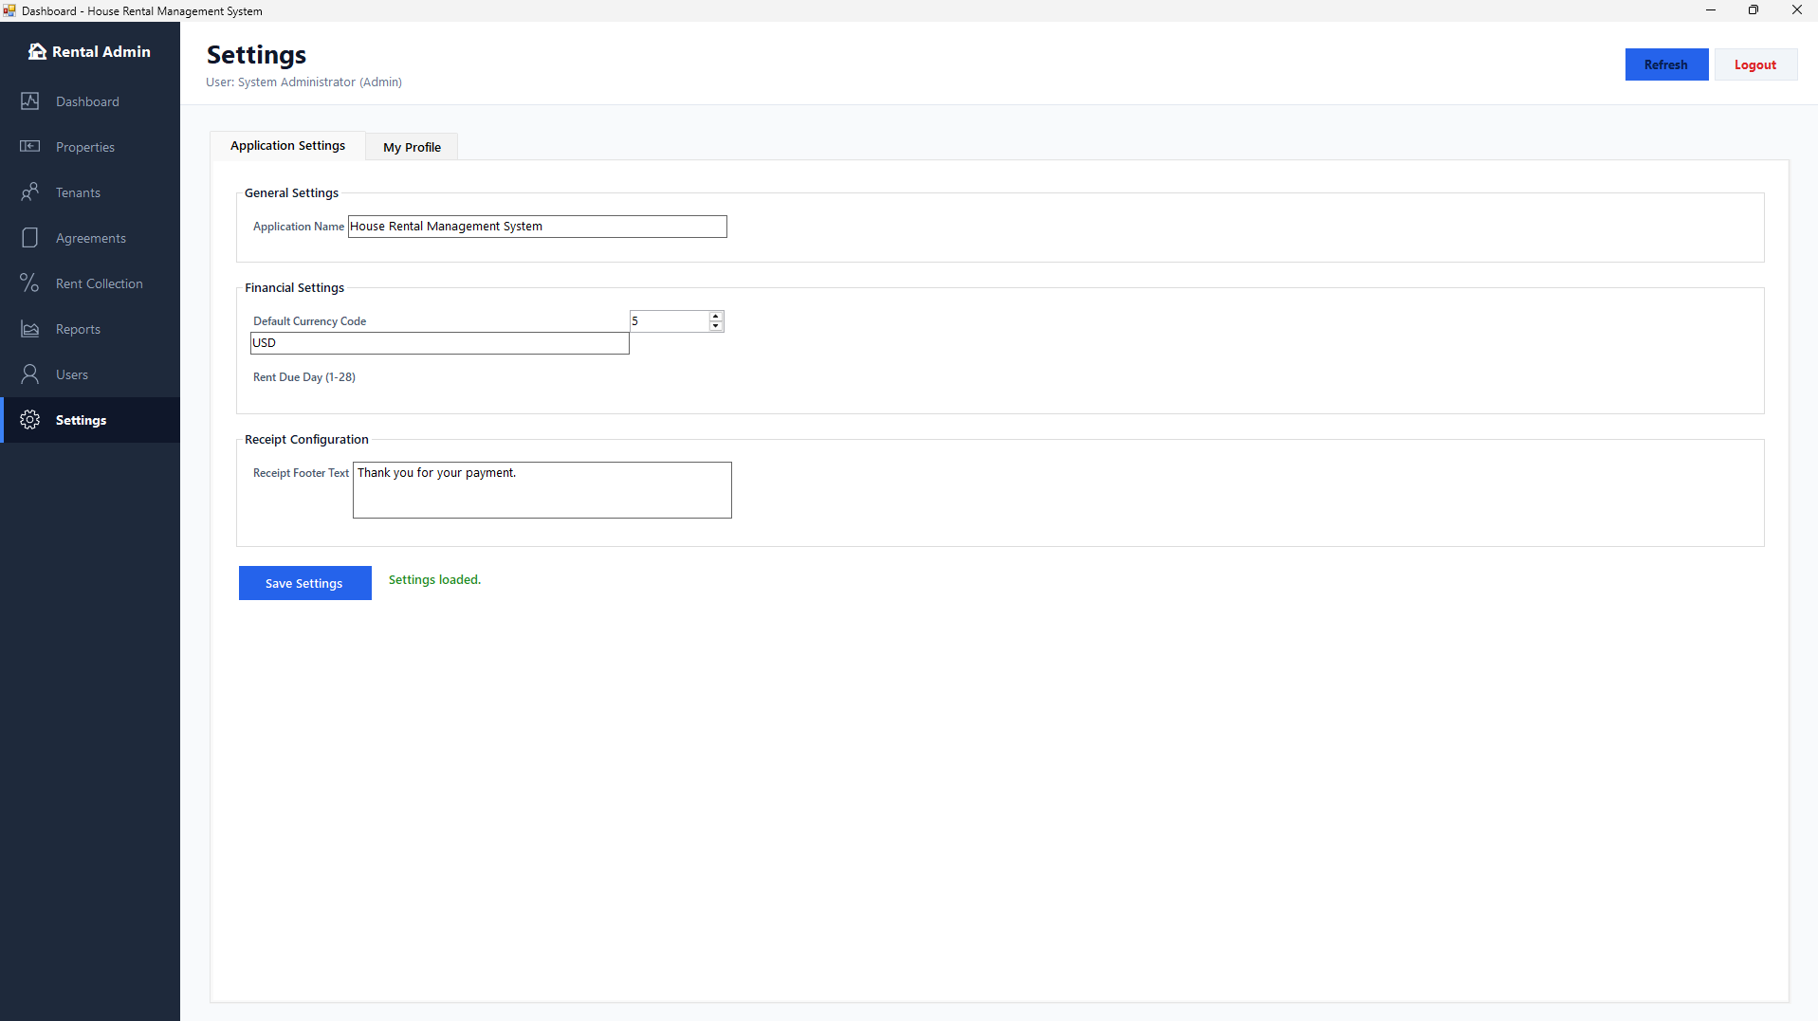
Figure 3-9 Settings interface

3.12 Error Handling and Auditability
BLL methods catch repository exceptions and return ServiceResult messages that can be displayed without exposing internal stack traces. DAL commands use using blocks so connections, commands, readers, and transactions are disposed correctly. AuditRepository failures are intentionally prevented from blocking critical lab operations, but the design still records login, user, setting, tenant, agreement, property, and payment actions when the database is available.

Chapter 4 System Testing
Testing verifies that the integrated system satisfies functional rules and preserves data integrity. Because the payment and agreement workflows update related records, tests must examine both visible results and database state.

4.1 Principles of System Testing
Test early and after every vertical module is integrated.
Cover normal, boundary, invalid, unauthorized, duplicate, and concurrent-change cases.
Define input, steps, expected visible output, and expected database state for each test.
Repeat critical charge/payment tests to prove idempotency and rollback behavior.
Preserve test scripts and results for regression testing and final demonstration.

4.2 Test Environment
The target environment is Windows 10/11, .NET Framework 4.7.2, SQL Server Express or later, Visual Studio/MSBuild tooling, and Microsoft ReportViewer WinForms. Database setup executes 01_CreateDatabase.sql through 05_SeedData.sql in order. Four SQL smoke-test scripts cover the payment ledger, read models, report procedures, and settings procedures.

4.3 Functional Test Results
Table 4-1 System functional test results
Test project | Verification process | Expected / actual result | Conclusion
Valid login | Enter an active Admin username/password. | Dashboard opens; role and KPIs display. | Pass
Invalid login | Use an invalid password. | Generic error; no session; failed audit attempted. | Pass
Create room | Add unique room with positive rent. | Room saved as an allowed status. | Pass
Duplicate room | Repeat room number in same active house. | Validation/database uniqueness rejects duplicate. | Pass
Tenant duplicate | Repeat phone or national ID. | Creation/update rejected with clear message. | Pass
Agreement activation | Activate Draft for active tenant and available room. | Agreement Active; room Occupied. | Pass
Double booking | Activate another agreement for same room. | Operation rejected; original agreement unchanged. | Pass
Generate charges twice | Run same billing month two times. | No duplicate MonthlyRent charge. | Pass
Post partial payment | Allocate less than charge balance. | Payment Posted; charge status Partial. | Pass
Post full payment | Allocate remaining balance. | Charge status Paid; receipt generated. | Pass
Non-cash reference | Omit reference for BankTransfer. | Validation rejects request. | Pass
Reverse payment | Admin reverses Posted payment with reason. | Payment Reversed; balance recalculates; history preserved. | Pass
Staff reversal | Staff attempts reversal. | Authorization rejects operation. | Pass
Generate report | Generate Monthly Due with status filter. | RDLC loads correct rows and parameters. | Pass
Update setting | Admin changes due day/currency. | Value validated, saved, and audited. | Pass

4.4 Build and Deployment Verification
During repository analysis on July 12, 2026, package restore completed with newer compatible versions substituted for unavailable exact ReportViewer dependencies, but a command-line Debug build still reported that the Microsoft.Reporting namespace was missing from ReportManagementControl and its Designer file. The running screenshots demonstrate that the report module has operated in a configured development environment; therefore, this result is treated as a clean-machine dependency reproducibility issue. Before submission, the exact ReportViewer reference should be corrected and verified from a clean clone with restore and Debug/Release build.
The recommended deployment sequence is: install prerequisites; restore packages; create HouseRentalDB; run schema, views, procedures, and seed scripts; update App.config if the SQL instance differs from .\SQLEXPRESS; run database smoke tests; build; and demonstrate the complete inventory-to-payment-to-report workflow with anonymized data.

Conclusion
The curriculum project produced a coherent housing rental information management system using C#, Windows Forms, ADO.NET, SQL Server, and RDLC reports. The system centralizes property inventory, tenant records, room occupancy, contract lifecycle, monthly receivables, payment allocation, receipts, user administration, settings, audit history, and operational reporting.
The strongest technical result is the payment ledger. Monthly charges represent obligations, Payments represent cash events, PaymentAllocations connect the two, and PaymentReversals preserve correction history. Balances are derived from auditable data rather than overwritten manually. Transactions, idempotent request identifiers, rowversion, filtered unique indexes, parameterized commands, and stored-procedure validation strengthen correctness.
The project also demonstrates the value of layered object-oriented design. The UI focuses on interaction, services focus on authorization and rules, repositories focus on persistence, and SQL Server protects final invariants. This separation makes the application easier to explain, test, and extend.
Future work should first repair clean build reproducibility and replace salted SHA-256 password storage with a slow adaptive password KDF plus login throttling. Automated C# unit/integration tests should complement the existing SQL smoke tests. Maintenance and expense management should either be completed as full vertical modules or remain explicitly documented as future scope. These improvements would make the laboratory prototype more suitable for production use.

References

[1] Li Chunbao. C # Programming Tutorial [M]. Beijing: Tsinghua University Press, 2021.
[2] Tomorrow Technology. SQL Server Complete Self Study Tutorial [M]. Beijing: People's Posts and Telecommunications Press, 2023
[3] Cao Yu, Xu Gaofeng, Wang Jiali. C # Program Design and Programming Cases [M]. Beijing: Tsinghua University Press, 2022
[4] Yang Sheng, Luo Qi. Design of Online Cinema Ticketing System Based on Spring Boot [J]. Network Security Technology and Application, 2022, (08)．38-39．
[5] Lv Kai. Database Principles and Applications - SQL Server 2019 [M]. Beijing: Tsinghua University Press, 2021
[6] Wang Liangsheng, Liu Xiaoying Design and Implementation of Cinema Ticketing System [J]. Computer Programming Techniques and Maintenance, 2021 (01): 54-56. DOI: 10.16184/j.cnki.comprg.2021.01.020
[7] Wishing Yuefang Design and Implementation of a Movie Ticketing System Based on Collaborative Filtering [D]. Beijing Jiaotong University, 2019
[8] Sun Menglu Research on the Application of Data Mining Technology in Cinema Management Information System [J]. Modern Information Technology, 2018,2 (08): 82-83+86
How to write this section?
1、What literature was referenced in the software design and development process

Appendix 1 Team Development Meeting Minutes 1

Housing Rental System Development Team Meeting Minutes 1

Team leader |  | 马门
Record personnel |  | 拉特
Conference theme |  | System research and basic functional module design
Meeting time |  | 2026-07-06
Team members |  | 拉特，木丁，多斯
Summary of Meeting Content
1 | Background research on project development
2 | Design of basic system function modules
3 | System development schedule
Meeting details
1 | Explain here: Why do we need to develop this system  Conduct research on the project development background through literature search, online queries, and other methods. The development of this system can improve the quality of hotel services and reduce management costs. The hotel management system will standardize, systematize, and program hotel management work, avoid arbitrariness in hotel management, improve the speed and accuracy of information processing, and enable accurate, timely, and effective inquiry and modification of room occupancy status.
2 | Explain here: This section explains the basic functions of the system.  Basic functional module design of the system:  (1) System login module: Complete user login operations.  (2) Room type management module: Complete the information management of room types.
3 | System development schedule: (40 class hours in total)  (1) System requirement analysis and functional module design: 8 class hours  (2) Database table structure design and development: 4 class hours  (3) Architecture design and public class development: 4 class hours  (4) System coding implementation: 52 class hours  (5) System testing and improvement: 4 class hours  (6) Document writing and task acceptance: 8 class hours
Summary of group communication rituation
Smooth communication and full understanding of each other's ideas are beneficial for the design and development of the project.
Summary of disciplinary situation
No one in the team was late or left early, and they attended the meeting on time

Appendix 2 Team Development Meeting Minutes 2
Housing Rental System Development Team Meeting Minutes 2
Team leader |  | 马门
Record personnel |  | 拉特
Conference theme |  | Development process and key technology exchange
Meeting time |  | 2026-07-16
Team members |  | 拉特，木丁，多斯
Summary of Meeting Content
1 | Technology exchange and functional realization
2 | System functional module testing
Meeting details
1 | (1) In terms of page display and layout, we use bright colors to attract users' attention, with harmonious and comfortable combinations. We also use the PaintBox control to import images for decoration. In terms of layout, we unanimously believe that a simple and bright style is needed.  (2) The security of the system includes a password hiding function on all interfaces when users enter passwords, protecting user privacy. And the system also needs to provide a password when connecting to the SQL database.  (4)Main functional design issue:explain the problem that you encountered.
2 | System functional code testing:  （1）马门：List problems encountered during the development and testing process of software.  （2）拉特：List problems encountered during the development and testing process of software.  （3）木丁：List problems encountered during the development and testing process of software.  （4）多斯：List problems encountered during the development and testing process of software.
Summary of group communication rituation
Smooth communication and full understanding of each other's ideas are beneficial for the design and development of the project.
Summary of disciplinary situation
No one in the team was late or left early, and they attended the meeting on time

Evaluation Form for Curriculum Design Grades
Course name | Object-Oriented Curriculum Design
Title | Development of Housing Rental Information Management System
Name | 马门 | ID | 250702110918 | Supervisor |  | 李井辉 | Position | Associate Professor
Evaluation indicators | Scoring criteria |  |  |  |  |  |  |  | Full marks | Score
 | A |  |  |  | C
Teamwork  （10 points） | Conduct in-depth team communication and collaboration on system requirements and basic functional design, with a strong sense of teamwork and awareness |  |  |  | Conduct basic team communication and collaboration on system requirements and basic functional design, with a preliminary sense of teamwork |  |  |  | 10
Requirement analysis and system design  （15 points） | Clear system function analysis and accurate task decomposition. The system architecture design scheme is correct, and the module division is clear |  |  |  | Has certain analytical and design abilities, and can make basic divisions of the system's functional modules |  |  |  | 10
 | Reasonable design of database table structure, accurate types, and clear relationships |  |  |  | Have basically completed the design of the database table structure and have certain database design and development capabilities |  |  |  | 5
Program coding  （35 points） | Accurate program coding, reasonable page layout, clear business implementation process, standardized naming, strong program readability, robust program, and smooth operation |  |  |  | Have basically completed the writing of the program's functional code, with clear business processes, reasonable page layout, and a certain level of program coding ability |  |  |  | 35
thesis quality  （25 points） | Present the practical results of the course in the form of a course design report, with content that meets the writing requirements, standardized charts, clear and organized discussions, and detailed content |  |  |  | More than 70% of the content meets the writing requirements, the theory and analysis are basically correct, the discourse is basically clear and smooth, and the content can basically reflect the results of the course design |  |  |  | 20
 | Search and analyze relevant literature in depth for course design content, with a literature search of at least 5 articles |  |  |  | The literature search is basically consistent with the course design content, and can conduct basic analysis and summary of literature. The literature search has reached more than 3 articles |  |  |  | 5
autonomous learning  （15 points） | In the process of system development, should be able to analyze and raise questions rationally, and try to adopt new ideas to actively respond |  |  |  | Capable of solving problems encountered during system design and development, with a certain degree of self-learning ability |  |  |  | 15
Total Score
Comments：
Completion status, work attitude, communication and collaboration skills: excellent□ good□ moderate□ passing□ poor□
The comprehensive use of literature and data, and social needs analysis: excellent□ good□ moderate□ passing□ poor□
The rationality of functions and database design, software development ability: excellent□ good□ moderate□ passing□ poor□
Rational analysis and problem-solving ability, innovative practical awareness: excellent□ good□ moderate□ passing□ poor□
System construction work sorting and practical results presentation: excellent□ good□ moderate□ passing□ poor□
Other matters to be noted:

Supervisor： 2026.07.27

