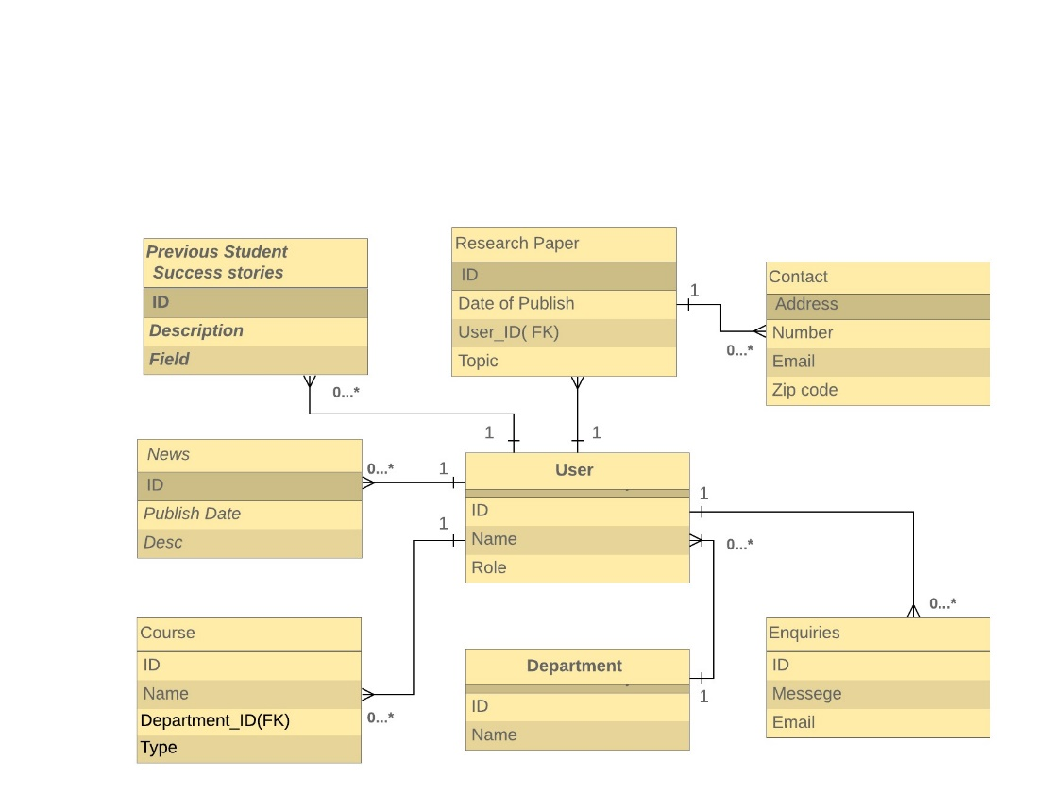

Figure-1: Entity Relationship Diagram