LIST OF TABLES

Table 1:Methodologies and Tools 6

LIST OF FIGURES

Figure 1: Gantt chart for activity schedule 8

Contents

1. CHAPTER 4

1.1. INTRODUCTION 4

1.2. PROBLEM STATEMENT 4

1.3. OBJECTIVES 5

1.3.1. GENERAL OBJECTIVE 5

1.3.2. SPECIFIC OBJECTIVE 5

1.4. RESEARCH QUESTIONS 5

1.5. SIGNIFICANCE OF THE STUDY 6

2. CHAPTER 7

2.1. LITERATURE REVIEW 7

3. CHAPTER 8

3.1. METHODOLOGY 8

4. CHAPTER 9

4.1. SCHEDULE OF ACTIVITIES 9

# CHAPTER

# INTRODUCTION

* + 1. PROBLEM DEFINITION.

Documents, policies and minutes from different meetings are stored in isolated and non-related form. This results in high cost on storage of physical documents, time consuming in accessing documents when needed, security issues on accessibility of the documents and difficulties in tracking progress of agendas discussed in different meetings. This leads to the need to build the document management system with different access levels.

# PROBLEM STATEMENT

Documents are important to every organization, and they play a very big role in the success of an organization as they store very crucial information and data of organizations. Therefore, they are to be preserved and managed very well. Over the years, there have been many forms of document management and the rise of IT have accelerated the evolution of document management systems day by day. Today, many organizations store documents electronically, but they still face difficulties such as following up on matters discussed over different staff meetings and referencing relative documents have been a cumbersome process

For the case of ARU, they mostly use traditional method for storing documents, which includes use of physical files and cupboards to store documents, as a result availability of studying and reference documents to students such as past tests, assignments, research and dissertations is poor; due to task reallocation, continuing on a task that begun under supervision of another staff, have been difficult; also tracking path and history of documents take much time and the process is inaccurate because there is no metadata to support these documents.

The purpose of the proposed study is to develop a system that will solve the challenges faced by ARU on management of documents, policies and minutes from meetings and to enable history tracking and access management of documents based on user’s title.

# OBJECTIVES

# GENERAL OBJECTIVE

Build a system that manages access to documents and tracks history of agenda as discussed in different documents.

# SPECIFIC OBJECTIVE

1. To determine the challenges of current methods that manage access to documents and track the history of different agendas
2. To gather requirements of the system that will solve the problems of access level to documents and tracking history of agenda.
3. To design and develop a system that would solve the challenges faced by the current document management system of ARU.

# RESEARCH QUESTIONS

1. How does ARU repository store documents, policies and minutes with different levels of access?
2. What are the key design features required in the institutional repository so as to ensure positive results regarding different access levels of documents, policies and minutes in the system?
3. What are the logic and algorithms required in the institutional repository so as to ensure positive results regarding different access levels of documents, policies and minutes in the system?
4. Will the institutional repository solve the problem with the current document management system?

# SIGNIFICANCE OF THE STUDY

Repository for documents, policies and minutes is crucial for better operations and management of organization processes and activities. This is even further important as it facilitates advantageous functionalities such as access level to documents in the repository and history tracking of documents through various meetings. These will make it easy for a staff to carry on or proceed an activity that was begun by another staff, by being provided with enough information on the agenda, such as history of comments and response as was discussed in staff/senate meetings.

# CHAPTER

# LITERATURE REVIEW

* + 1. ELECTRONIC DOCUMENT MANAGEMENT TO SUPPORT WORLD-CLASS UNIVERSITY (Case study Airlangga university).

This is a paper that aims to study and investigate how the use of paper work can be reduced at Airlangga university. This study used a qualitative approach with descriptive methods for the purpose of this study is to investigate the implementation of a document management system in university Airlangga which is the result of development of SIKD which developed and improved more to Electronic document management(EDM) or E-office. The research data obtained through an observation, interview and analysis of existing documents.

The main focus of discussion was there should have a central repository for all the documents, also they focus on indexing and classifications for easy retrieval of the documents and issues of version control. Lastly focus was on the issues of searching and retrieval of the document after the documents are classified and indexed.(Srirahayu, 2018)

Airlangga university was not focused on access levels on documents which are stored in the repository, that is which document should be accessed by whom. Hence ARU repository system will cover and implement the issues of access levels.

# CHAPTER

# METHODOLOGY

Table :Methodologies and Tools

|  |  |  |  |
| --- | --- | --- | --- |
| S/N | SPECIFIC OBJECTIVES | METHODOLOGY | DELIVERABLES |
| 1. | Identifying challenges of the current system. | Literature review and interview. | Analytical report. |
| 2 | To gather requirements. (users and system requirements) | Questionnaire, observation, literature reviews. | System requirement specification document(SRS). |
| 3. | Analysis and design | Object Oriented Analysis and Design (OOAD), Unified Modeling Language (UML) diagrams | System designs. |
| 4. | System development. | Laravel framework, HTML, CSS, JAVASCRIPT, BOOTSTRAP, AJAX, JQUERY. | ARU repository system. |

# CHAPTER

# SCHEDULE OF ACTIVITIES

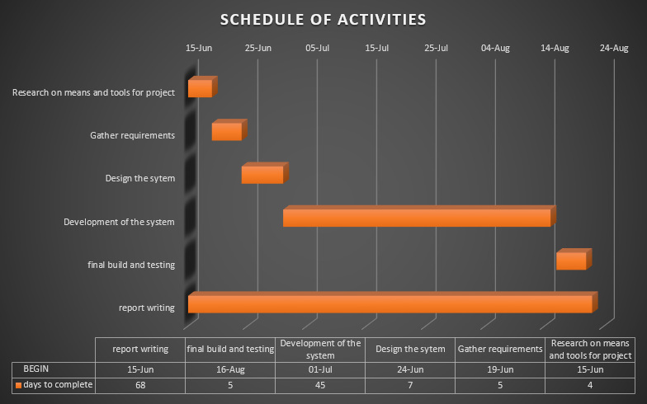

Figure : Gantt chart for activity schedule