ΕΡΓΑΣΙΑ ΣΤΑΤΙΣΤΙΚΗΣ

# Το πρόβλημα της εργασίας

# Το σύνολο δεδομένων

## Από την εκφώνηση της εργασίας

Έχουμε 10 ανεξάρτητες και 1 εξαρτημένη μεταβλητές

5 ποιοτικές

6 ποσοτικές

Οι 6 αυτές ποσοτικές είναι στην πράξη 6 εννοιολογικές κατασκευές, που συγκροτούνται από 23 επιμέρους μεταβλητές. Οι 23 αυτές μεταβλητές είναι απαντήσεις σε ερωτηματολόγια που ομαδοποιούνται ανάλογα με την κατηγορία της ερώτησης. Πιο συγκεκριμένα η περιγραφή τους είναι παρακάτω:

imag1 First MV of the block Image

imag2 Second MV of the block Image

imag3 Third MV of the block Image

imag4 Fourth MV of the block Image

imag5 Fifth MV of the block Image

expe1 First MV of the block Expectations

expe2 Second MV of the block Expectations

expe3 Third MV of the block Expectations

expe4 Fourth MV of the block Expectations

qual1 First MV of the block Quality

qual2 Second MV of the block Quality

qual3 Third MV of the block Quality

qual4 Fourth MV of the block Quality

val1 First MV of the block Value

val2 Second MV of the block Value

val3 Third MV of the block Value

val4 Fourth MV of the block Value

sat1 First MV of the block Satisfaction

sat2 Second MV of the block Satisfaction

sat3 Third MV of the block Satisfaction

loy1 First MV of the block Loyalty

loy2 Second MV of the block Loyalty

loy3 Third MV of the block Loyalty

## Διερεύνηση δεδομένων:

ένα πρώτο describe

δεν υπάρχουν καθόλου ελλείπουσες.

ποια προβλήματα προκύπτουν

τι χρειάζεται παρέμβαση

## Προετοιμασία δεδομένων:

Average των block/entities μεταβλητών

Ordered factors

κλπ

# Περιγραφική στατιστική

Ποιοτικές

vars n mean sd median trimmed mad min max range skew kurtosis se

Gender* 1 1707 1.58 0.49 2 1.60 0.00 1 2 1 -0.33 -1.89 0.01

Age* 2 1707 3.71 1.35 4 3.68 1.48 1 6 5 0.14 -0.86 0.03

Education* 3 1707 2.97 1.16 3 3.05 1.48 1 5 4 -0.63 -0.82 0.03

Occupation* 4 1707 2.98 1.30 3 2.97 1.48 1 5 4 0.23 -1.27 0.03

Region* 5 1707 1.93 0.80 2 1.91 1.48 1 3 2 0.13 -1.41 0.02

Gender

Freq % Valid % Valid Cum. % Total % Total Cum.

------------ ------ --------- -------------- --------- --------------

Female 714 41.83 41.83 41.83 41.83

Male 993 58.17 100.00 58.17 100.00

<NA> 0 0.00 100.00

Total 1707 100.00 100.00 100.00 100.00

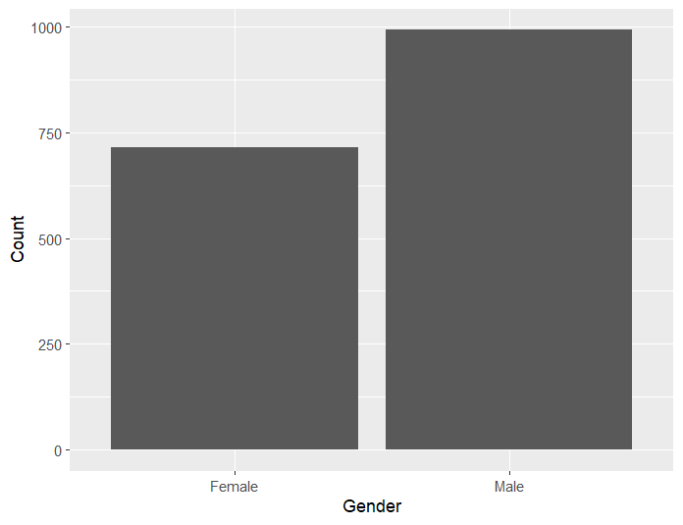

Age

Freq % Valid % Valid Cum. % Total % Total Cum.

----------- ------ --------- -------------- --------- --------------

<=25 51 2.99 2.99 2.99 2.99

26-35 295 17.28 20.27 17.28 20.27

36-45 467 27.36 47.63 27.36 47.63

46-55 401 23.49 71.12 23.49 71.12

56-65 268 15.70 86.82 15.70 86.82

>=66 225 13.18 100.00 13.18 100.00

<NA> 0 0.00 100.00

Total 1707 100.00 100.00 100.00 100.00

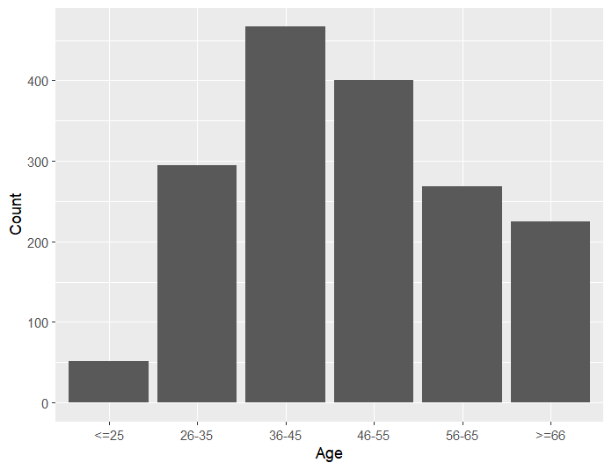

Education

Freq % Valid % Valid Cum. % Total % Total Cum.

---------------- ------ --------- -------------- --------- --------------

Elementary 351 20.56 20.56 20.56 20.56

Graduated 85 4.98 25.54 4.98 25.54

Highschool 579 33.92 59.46 33.92 59.46

Undergrad 651 38.14 97.60 38.14 97.60

Unfinished 41 2.40 100.00 2.40 100.00

<NA> 0 0.00 100.00

Total 1707 100.00 100.00 100.00 100.00

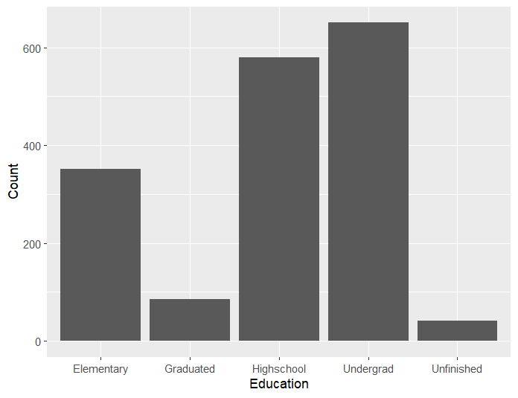

Occupation

Freq % Valid % Valid Cum. % Total % Total Cum.

----------------- ------ --------- -------------- --------- --------------

Manager 173 10.13 10.13 10.13 10.13

MediumEmplo 657 38.49 48.62 38.49 48.62

Notemploy 203 11.89 60.52 11.89 60.52

OwnFreelan 381 22.32 82.84 22.32 82.84

Retired 293 17.16 100.00 17.16 100.00

<NA> 0 0.00 100.00

Total 1707 100.00 100.00 100.00 100.00

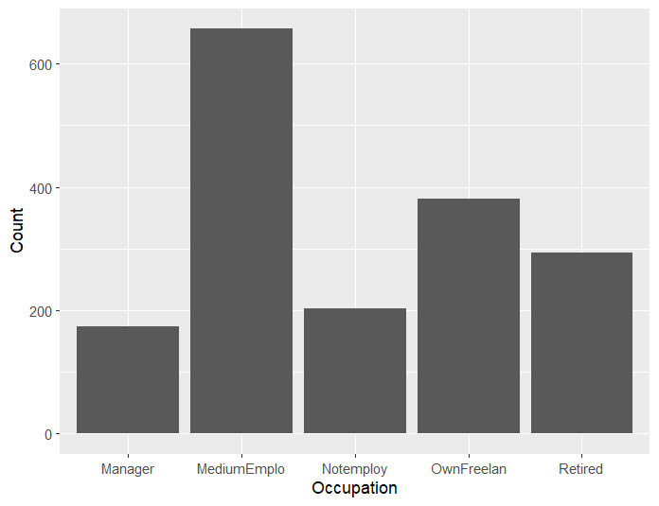

Region

Freq % Valid % Valid Cum. % Total % Total Cum.

------------ ------ --------- -------------- --------- --------------

Center 607 35.56 35.56 35.56 35.56

East 618 36.20 71.76 36.20 71.76

North 482 28.24 100.00 28.24 100.00

<NA> 0 0.00 100.00

Total 1707 100.00 100.00 100.00 100.00

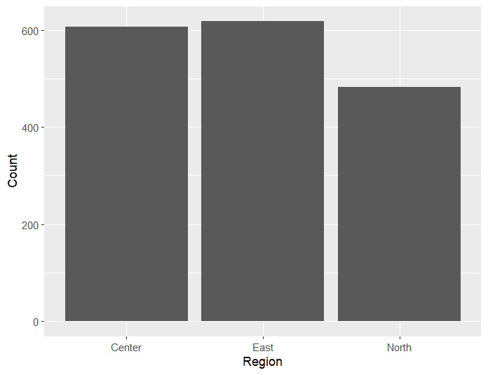

Ποσοτικές

vars n mean sd median trimmed mad min max range skew kurtosis se

Image 1 1707 7.38 1.41 7.40 7.46 1.19 0 10 10 -0.95 2.58 0.03

Expectation 2 1707 7.73 1.65 8.00 7.87 1.48 0 10 10 -0.92 1.26 0.04

Quality 3 1707 7.46 1.68 7.75 7.59 1.48 0 10 10 -1.03 2.06 0.04

Value 4 1707 6.94 1.87 7.25 7.07 1.85 0 10 10 -0.86 1.27 0.05

Satisfaction 5 1707 7.09 1.86 7.33 7.25 1.48 0 10 10 -1.07 1.85 0.04

Loyalty 6 1707 6.90 2.24 7.33 7.13 1.98 0 10 10 -0.96 0.86 0.05

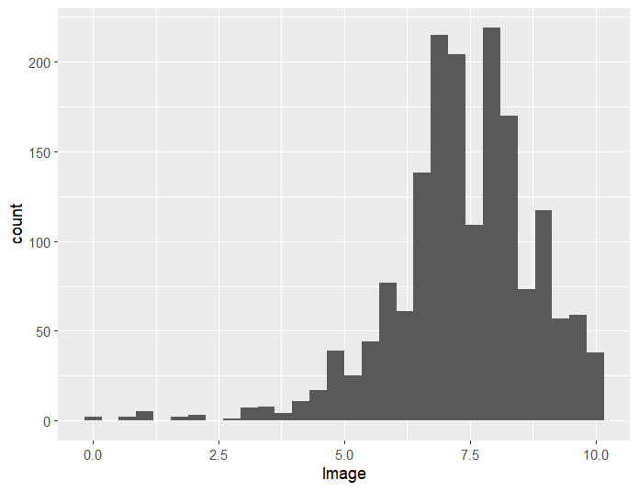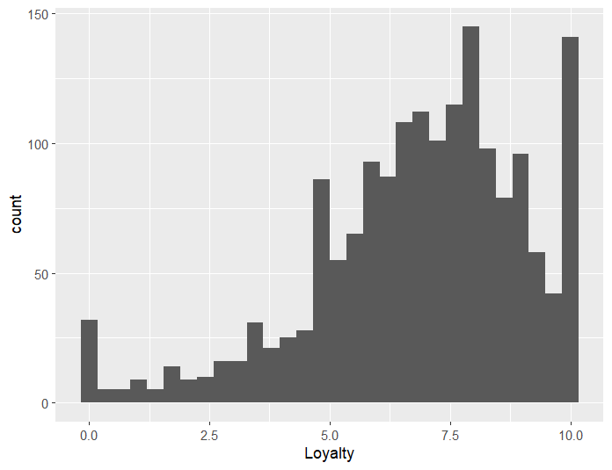

Διερευνητική στατιστική

group: Female

vars n mean sd median trimmed mad min max range skew kurtosis se

X1 1 714 6.92 2.28 7.33 7.16 1.98 0 10 10 -0.95 0.73 0.09

------------------------------------------------------------------------------------

group: Male

vars n mean sd median trimmed mad min max range skew kurtosis se

X1 1 993 6.89 2.22 7.33 7.11 1.98 0 10 10 -0.97 0.95 0.07

group: <=25

vars n mean sd median trimmed mad min max range skew kurtosis se

X1 1 51 7.14 2.07 7.33 7.24 2.47 3 10 7 -0.33 -1.06 0.29

------------------------------------------------------------------------------------

group: 26-35

vars n mean sd median trimmed mad min max range skew kurtosis se

X1 1 295 6.72 2.56 7.33 6.99 2.47 0 10 10 -0.83 0.14 0.15

------------------------------------------------------------------------------------

group: 36-45

vars n mean sd median trimmed mad min max range skew kurtosis se

X1 1 467 6.74 2.27 7 6.95 1.98 0 10 10 -0.88 0.57 0.11

------------------------------------------------------------------------------------

group: 46-55

vars n mean sd median trimmed mad min max range skew kurtosis se

X1 1 401 6.78 2.2 7 7.02 1.98 0 10 10 -1.08 1.21 0.11

------------------------------------------------------------------------------------

group: 56-65

vars n mean sd median trimmed mad min max range skew kurtosis se

X1 1 268 7.1 2.06 7.33 7.29 1.98 0 10 10 -0.96 1.08 0.13

------------------------------------------------------------------------------------

group: >=66

vars n mean sd median trimmed mad min max range skew kurtosis se

X1 1 225 7.39 1.98 7.67 7.56 1.98 0 10 10 -1.08 1.79 0.13

group: Elementary

vars n mean sd median trimmed mad min max range skew kurtosis se

X1 1 351 7.31 2.24 7.67 7.58 1.98 0 10 10 -1.05 1.04 0.12

------------------------------------------------------------------------------------

group: Graduated

vars n mean sd median trimmed mad min max range skew kurtosis se

X1 1 85 6.28 2.54 7 6.5 2.47 0 10 10 -0.77 -0.11 0.28

------------------------------------------------------------------------------------

group: Highschool

vars n mean sd median trimmed mad min max range skew kurtosis se

X1 1 579 7.04 2.08 7.33 7.22 1.98 0 10 10 -0.83 0.65 0.09

------------------------------------------------------------------------------------

group: Undergrad

vars n mean sd median trimmed mad min max range skew kurtosis se

X1 1 651 6.63 2.3 7 6.88 1.98 0 10 10 -1.04 0.93 0.09

------------------------------------------------------------------------------------

group: Unfinished

vars n mean sd median trimmed mad min max range skew kurtosis se

X1 1 41 7.09 2.19 7 7.26 1.98 1.67 10 8.33 -0.53 -0.42 0.34

group: Manager

vars n mean sd median trimmed mad min max range skew kurtosis se

X1 1 173 6.49 2.46 7 6.73 1.98 0 10 10 -0.88 0.21 0.19

------------------------------------------------------------------------------------

group: MediumEmplo

vars n mean sd median trimmed mad min max range skew kurtosis se

X1 1 657 6.81 2.29 7.33 7.03 1.98 0 10 10 -0.92 0.63 0.09

------------------------------------------------------------------------------------

group: Notemploy

vars n mean sd median trimmed mad min max range skew kurtosis se

X1 1 203 7.21 2.14 7.33 7.42 1.98 0 10 10 -0.85 0.51 0.15

------------------------------------------------------------------------------------

group: OwnFreelan

vars n mean sd median trimmed mad min max range skew kurtosis se

X1 1 381 6.86 2.17 7 7.08 1.98 0 10 10 -1.04 1.33 0.11

------------------------------------------------------------------------------------

group: Retired

vars n mean sd median trimmed mad min max range skew kurtosis se

X1 1 293 7.19 2.11 7.67 7.39 1.98 0 10 10 -1.01 1.28 0.12

group: Center

vars n mean sd median trimmed mad min max range skew kurtosis se

X1 1 607 6.71 2.21 7 6.92 1.98 0 10 10 -0.88 0.66 0.09

------------------------------------------------------------------------------------

group: East

vars n mean sd median trimmed mad min max range skew kurtosis se

X1 1 618 7.1 2.15 7.33 7.32 1.98 0 10 10 -1.01 1.08 0.09

------------------------------------------------------------------------------------

group: North

vars n mean sd median trimmed mad min max range skew kurtosis se

X1 1 482 6.88 2.38 7 7.14 1.98 0 10 10 -0.99 0.79 0.11

Επαγωγική στατιστική

> describeBy(csibank$log_loy, csibank$Gender )

Descriptive statistics by group

group: Female

vars n mean sd median trimmed mad min max range skew kurtosis se

X1 1 714 2 0.43 2.12 2.08 0.26 0 2.4 2.4 -2.59 8.21 0.02

----------------------------------------------------------------

group: Male

vars n mean sd median trimmed mad min max range skew kurtosis se

X1 1 993 2 0.42 2.12 2.08 0.22 0 2.4 2.4 -2.72 9.05 0.01

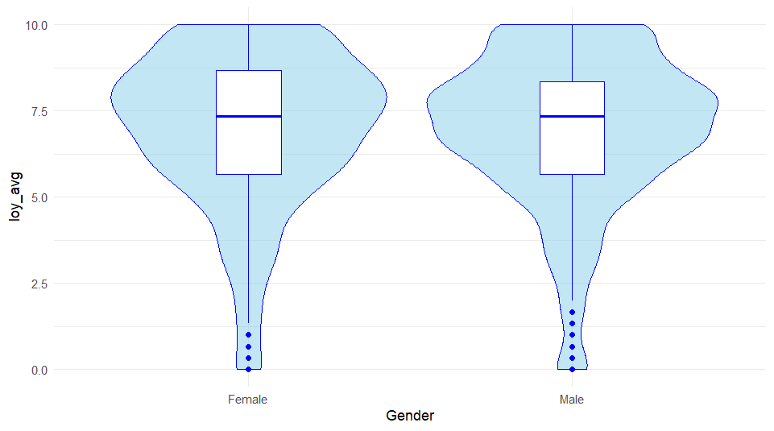

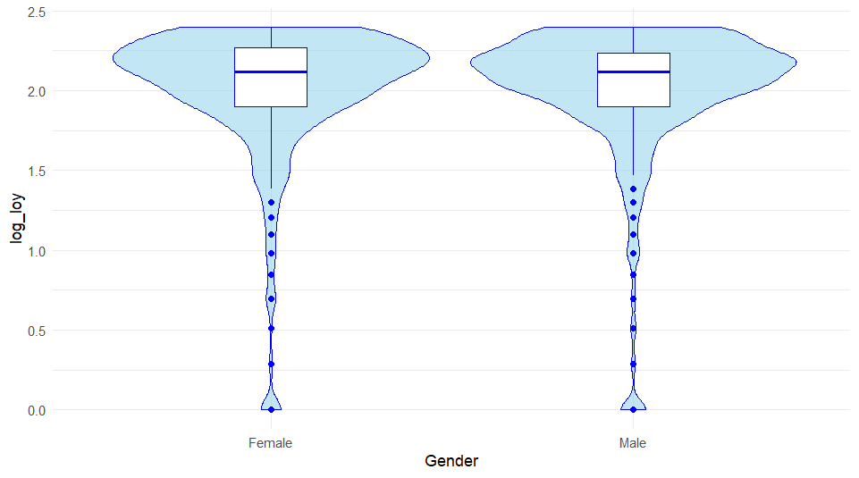

> leveneTest(log_loy ~ Gender,

+ center=mean,

+ data=csibank)

Levene's Test for Homogeneity of Variance (center = mean)

Df F value Pr(>F)

group 1 0.4391 0.5077

1705

Two Sample t-test

data: log_loy by Gender

t = 0.11149, df = 1705, p-value = 0.9112

alternative hypothesis: true difference in means between group Female and group Male is not equal to 0

95 percent confidence interval:

-0.03869069 0.04335420

sample estimates:

mean in group Female mean in group Male

2.002482 2.000150

Από τον έλεγχο t-test για δύο ανεξάρτητες μεταβλητές επιβεβαιώνεται η υπόθεση ισότητας:

**Ο έλεγχος t-test για δύο ανεξάρτητους πληθυσμούς δεν φανέρωσε την ύπαρξη στατιστικά σημαντικής διαφοράς στις πληθυσμιακές μέσες τιμές των log(scores) της εννοιολογικής κατασκευής Loyalty, μεταξύ των Γυναικών και Ανδρών χρηστών (Μ = 2.00, SD = 0.42), t(1673) = 0.11149, p>0.001. Ο έλεγχος Levene υπέδειξε ίσες διασπορές F = 0.44391, p>0.001, και για το λόγο αυτό έγινε χρήση του ελέγχου t-test κάτω από την υπόθεση των ίσων διασπορών.**