JOULE generative AI copilot

<https://www.sap.com/products/artificial-intelligence/ai-assistant.html>

joule interface on different services

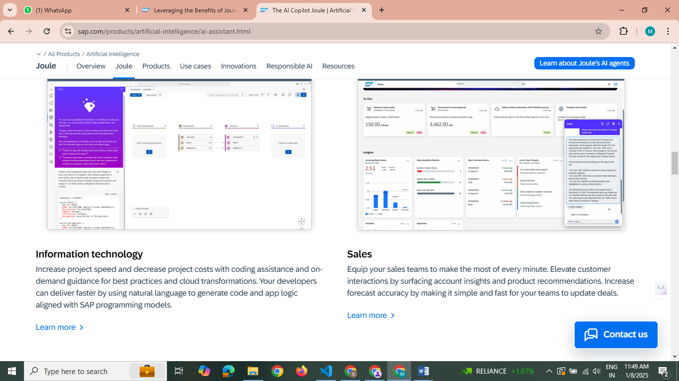  
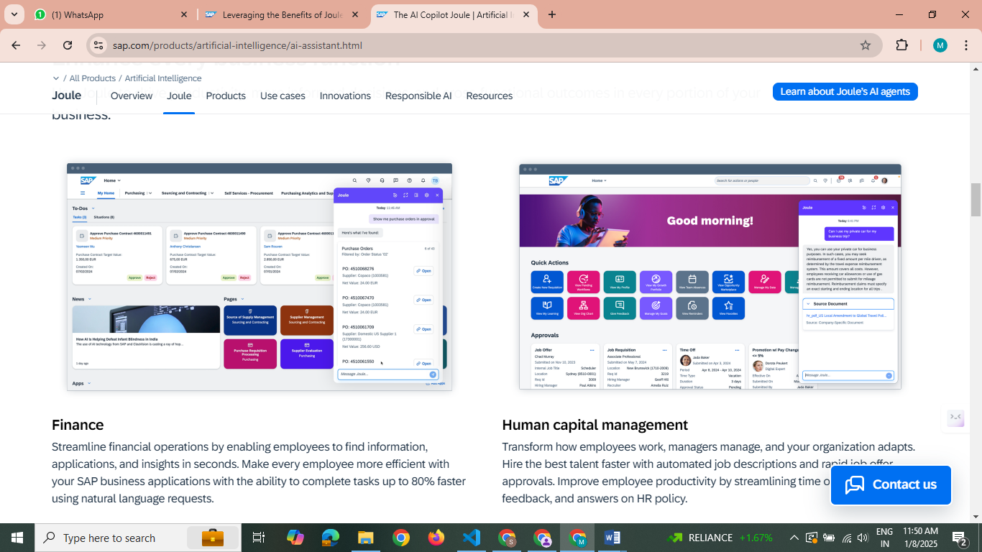

JUST like github AI copilot

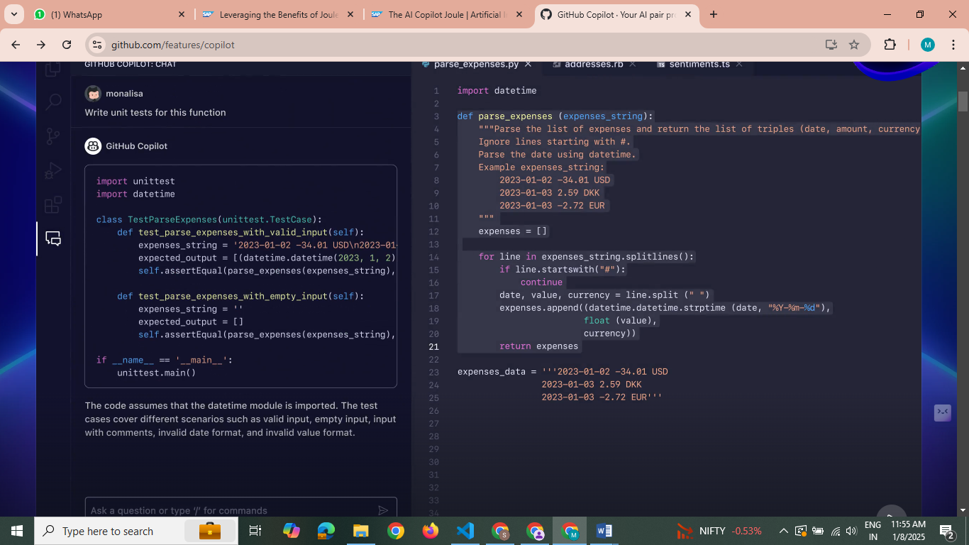

Whole understanding of AI copilot and generative AI all relations in this link with joule, how does AI copilot work https://community.sap.com/t5/technology-blogs-by-sap/generative-ai-with-sap-part-3-joule-sap-s-generative-ai-copilot/ba-p/13581304

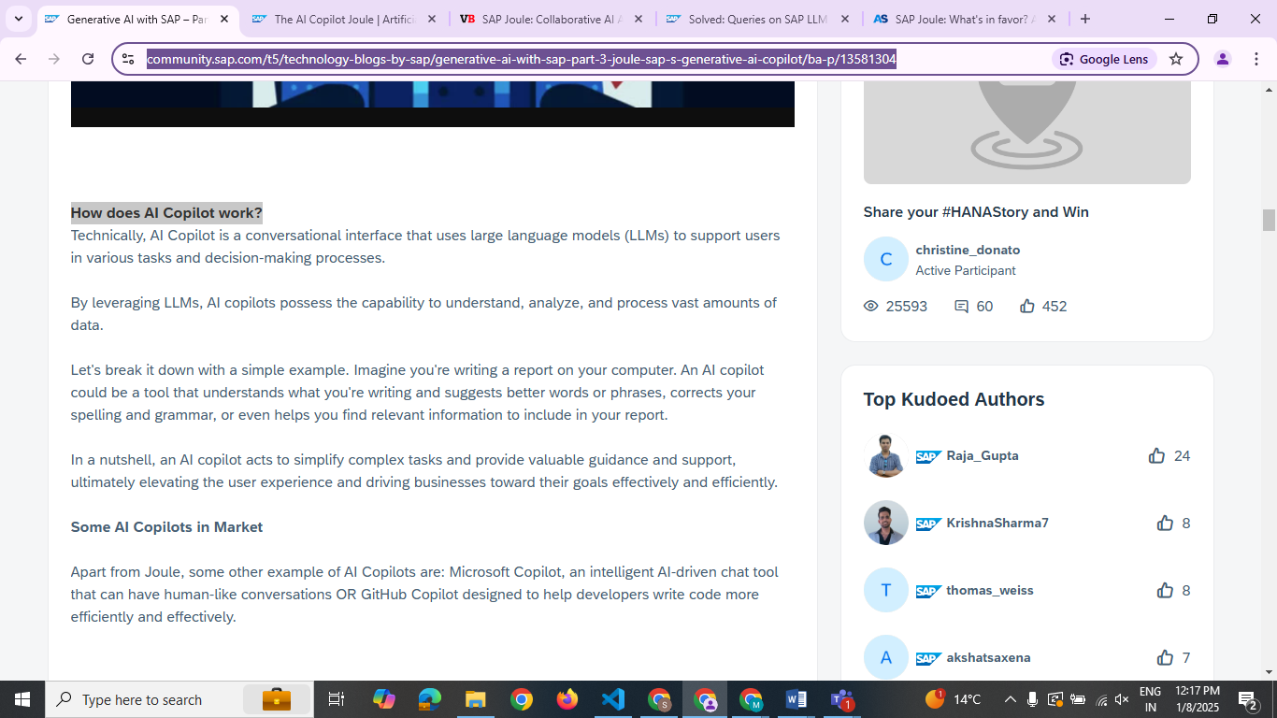

LLM data privacy from other partners like meta ,google etc

<https://www.sap.com/india/products/artificial-intelligence/ai-assistant.html#:~:text=As%20with%20all%20SAP%20AI,or%20improve%20their%20foundation%20models>.

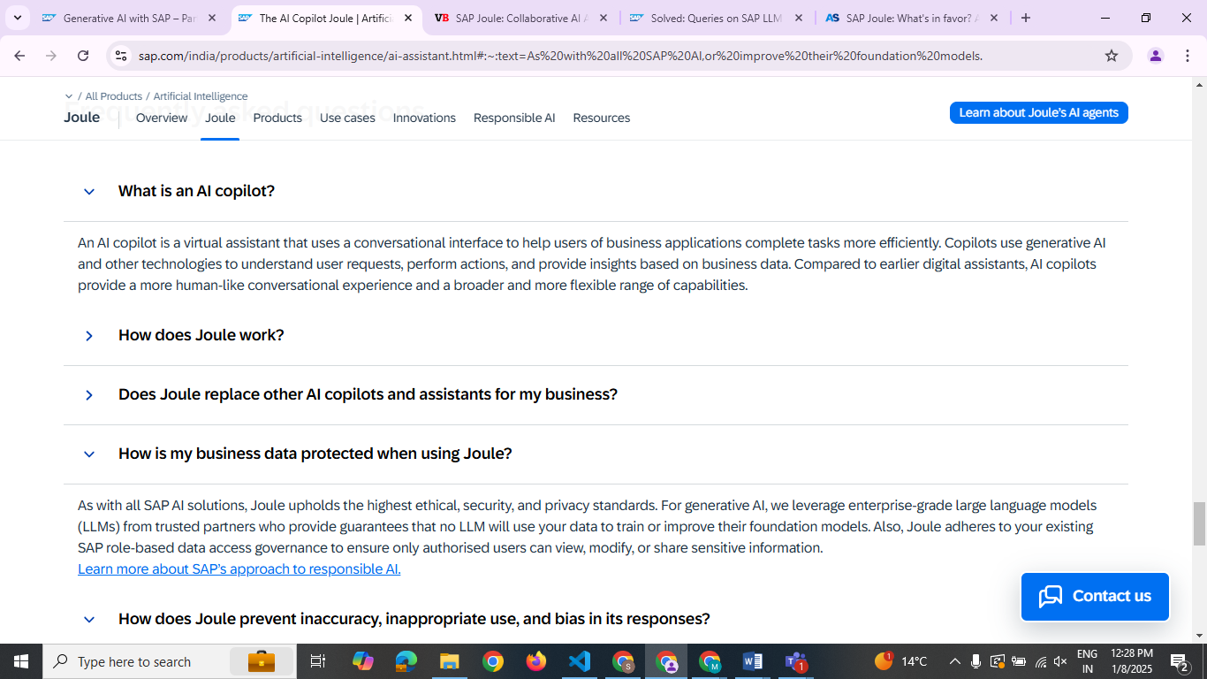

Different partnership platforms from where llms are taken

<https://www.arvato-systems.com/blog/sap-joule-what-s-in-favor-and-what-against>

and screenshot for SAP

SAP Joule accesses the LLMs of AI

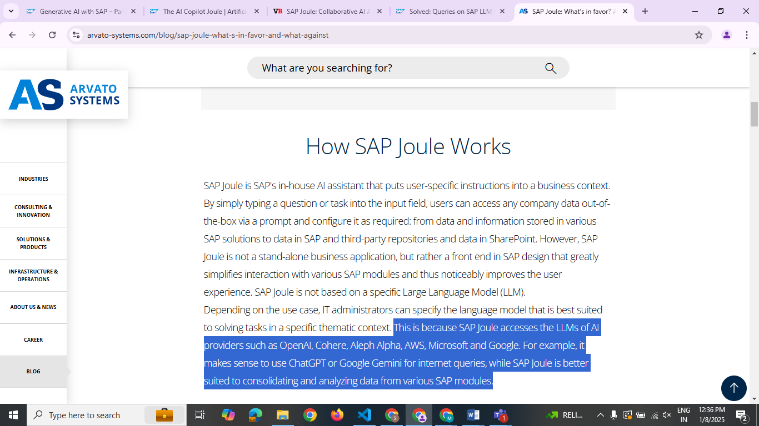

SAP verified(meta mentioned)

<https://learning.sap.com/learning-journeys/provisioning-and-implementing-joule/unlocking-the-benefits-of-joule>

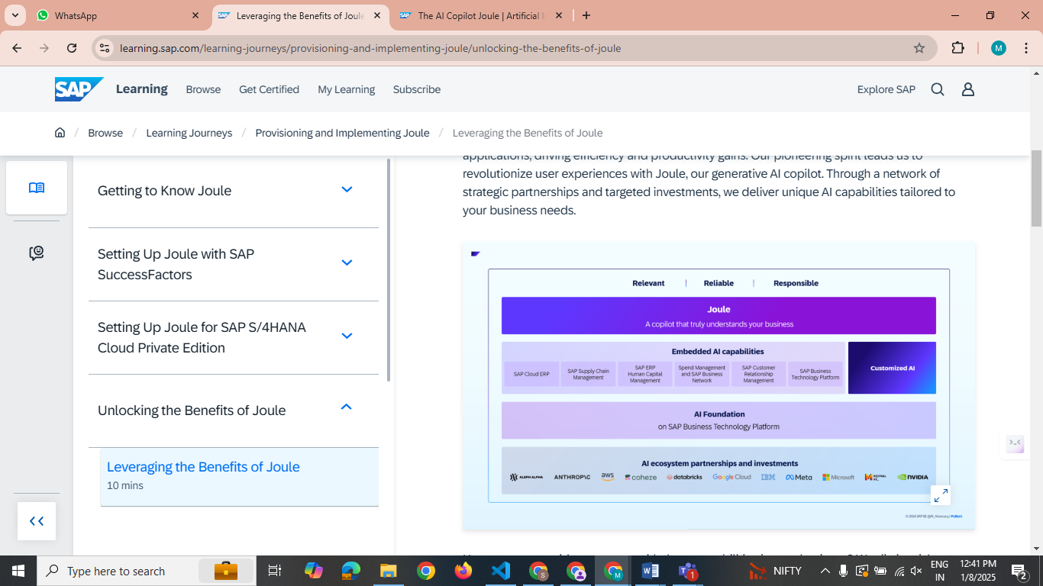

WHY sap had to partners with different big companies

<https://community.sap.com/t5/technology-blogs-by-sap/why-sap-joule-is-a-different-attempt-this-time/ba-p/13579674>

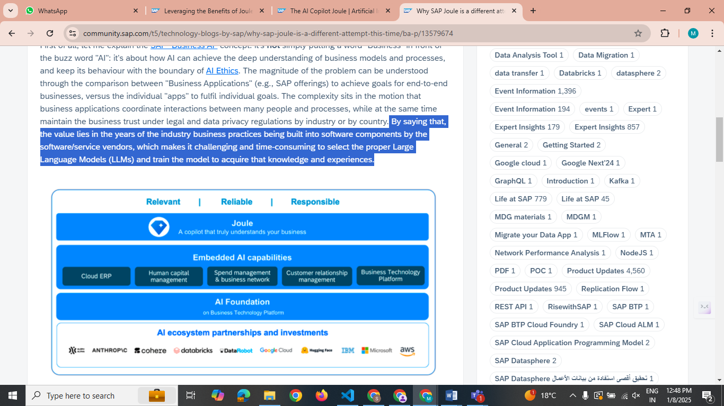

Sap ai joule works on proprietary data from sap

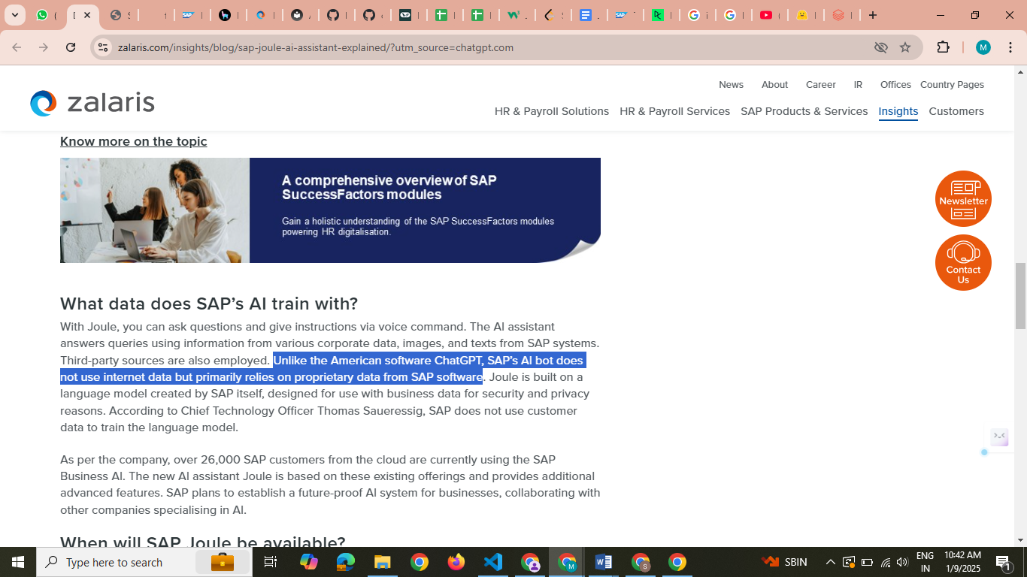

<https://zalaris.com/insights/blog/sap-joule-ai-assistant-explained/?utm_source=chatgpt.com>