# Hierarchy:

# Board grid:

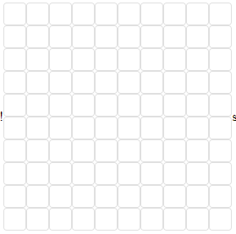

# Implementation:

**<Grid container direction='column' alignItems="center">**

**<Grid item container justify="center" alignItems="center">**

**<Grid item>**

**<Paper elevation={3} variant="outlined" className={classes.paper} />**

**</Grid>**

**</Grid>**

**</Grid>**

# Board state

const [board, setBoard] = useState(Array(19).fill().map(x **=>** Array(19).fill("+")))

…

**const rows =** board.map**(**(r, i) **=>** {**return** (

**<**tr key**=**{"row_"**+**i}**>**

{

r.map((d, j) **=>** { **return**(

**<**Square

key**=**{i**+**"_"**+**j}

dims**=**{**this**.dims}

onClick**=**{()**=>**{**this**.handleOnClick(i,j)}}

contents**=**{d**==**"+"?" ":d} />

)})

}

**<**/tr>)

}**);**

**return** **(**

**<**table cellSpacing**=**"0" id**=**"table" style**=**{style}**>**

**<**tbody**>**

{rows}

**<**/tbody>

**<**/table>

**<**br **/>**

**);**