**ABESEC Ghaziabad**



**Department of Computer Science & Engineering**

**Mini Project REPORT- KCS-354**

**(2021-22)**

|  |  |  |  |  |
| --- | --- | --- | --- | --- |
| **Project Title:**  **E-Commerce Website** | | | | |
| **Project Type**(application, product, research, review etc.) | |  | | |
|  | **Name** | **Roll Number** | **Section** | **Signature** |
| **Group member (1)** | Manas Gupta | **1900320100084** | **CSE-B** | Manas Gupta |
| **Group member (2)** | Prazual Flodya | **1900320100112** | **CSE-B** | Prazual Flodya |
| **Group member (3)** |  |  |  |  |
| **Project Guide** | **-** | **Remarks:** | | |
| **Signature** | **-** |
| **Date of submission** | **22/12/2021** |

**DECLARATION**

We, hereby, declare that the Report entitled E-Commerce website is an authentic record of my own work, based on my personal study or research and that I have acknowledged all material and sources used in its preparation, whether they be books, article, reports and any other kind of document as requirements of Mini Project.

Signature:

Manas Gupta

Prazual Flodya

**Table Of Contents**

* **Problem Introduction**

1. **Motivation**
2. **Objective**
3. **Scope of project**

* **Related Previous Work**
* **Hardware and software**
* **Flowchart**

1. **Flowchart of project**
2. **Zero level DFD**

* **Snapshots**
* **Deliverables**
* **Stakeholders**
* **Gantt Chart**
* **Conclusion**
* **References**

**Introduction**

This project is about a E-commerce website that sells clothes on a decent and reasonable price. This project also helps others who needs clothes and we also help environment with respect to our product sold. It not only aims at targeting fashion enthusiasts and providing them with clothing at reasonable rates, but also aims towards helping people in need by donating to environment friendly NGO’s .

**Motivation**

To increase my efficiency of front end web development which I learnt from online course of coursera and from this knowledge I wanted to built a project. A project that will train me for future endeavours and honing my skills. This will also help me in a good project prospective.

**Objective**

The objective of the project is to become first choice of customers and provide the best quality. Another objective was to help the consumer to buy product from home easily and quickly. With this project consumer will get time saving platform with wide variety of exquisite products. And one of the most important objective was to gain some profit and help needy and environment.

**Scope of project**

The scope of the project is very wide as the website can be accessed from any part of the world.

The consumers can buy from many brands including ADIDAS, NIKE, ZARA, UNDERARMOUR etc.

To give consumer wide variety of products irrespective of gender, age, and financial status.

**Related previous work**

Myntra is an Indian fashion e-commerce company headquartered in Bengaluru, Karnataka, India.

The company was founded in 2007 to sell personalized gift items.

In July, 2016 Myntra acquired their rival Jabong.com to become India’s largest fashion platform.

Myntra is a fashion destination that is committed to making customers look good anytime.

**Hardware and software**

Hardware requirement

CPU Quad 2GHz+

INTEL i3/i5/i7

RAM-4GB

Software requirement

WINDOWS OS(10/8.1/VISTA/7)

NOTEPAD++

INTERNET BROWSER(CHROME)

**Flowchart**

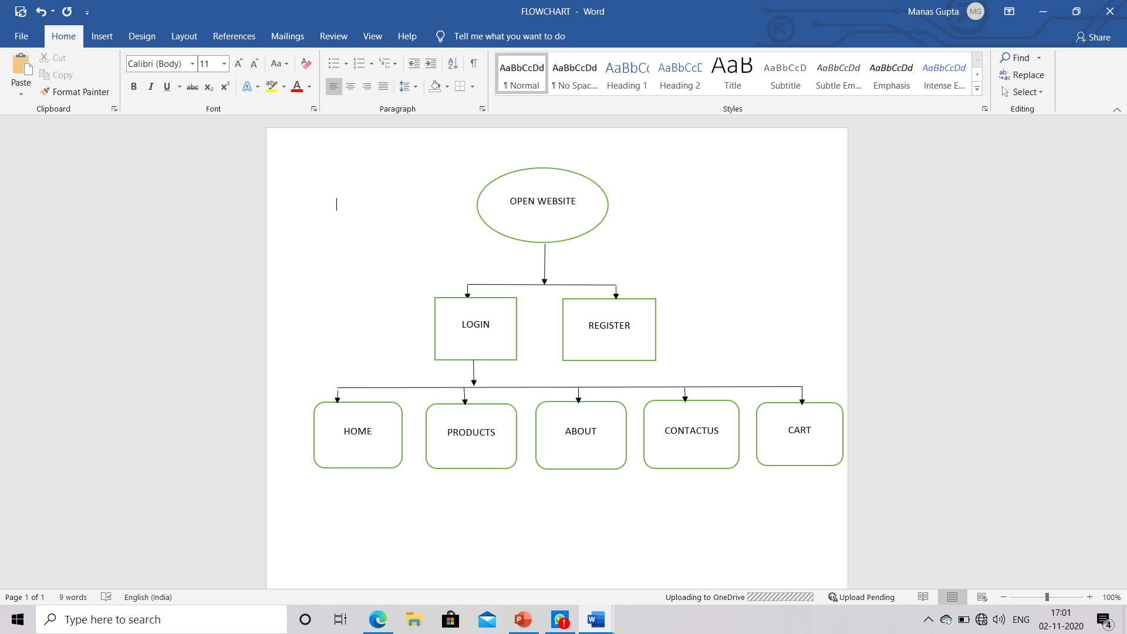

**Zero Level Dfd**

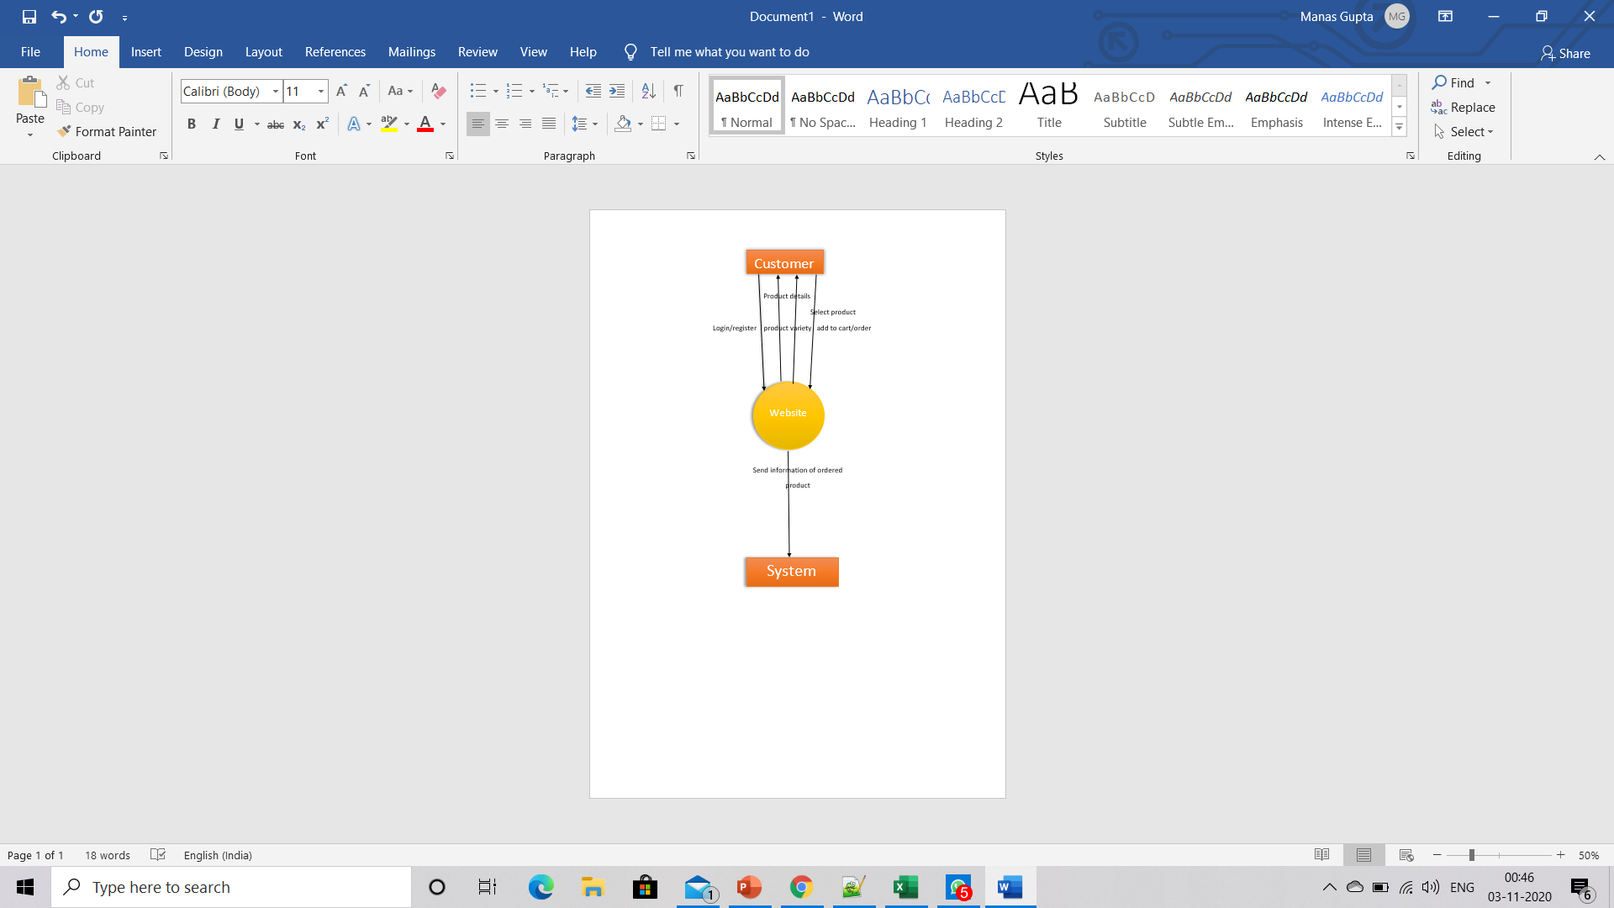

**Snapshots**

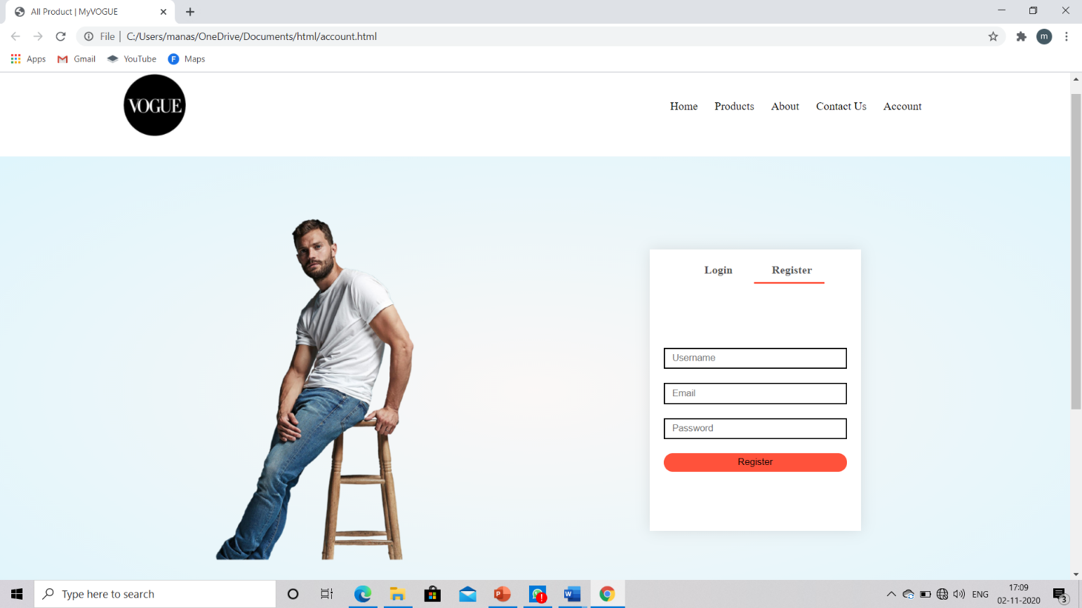

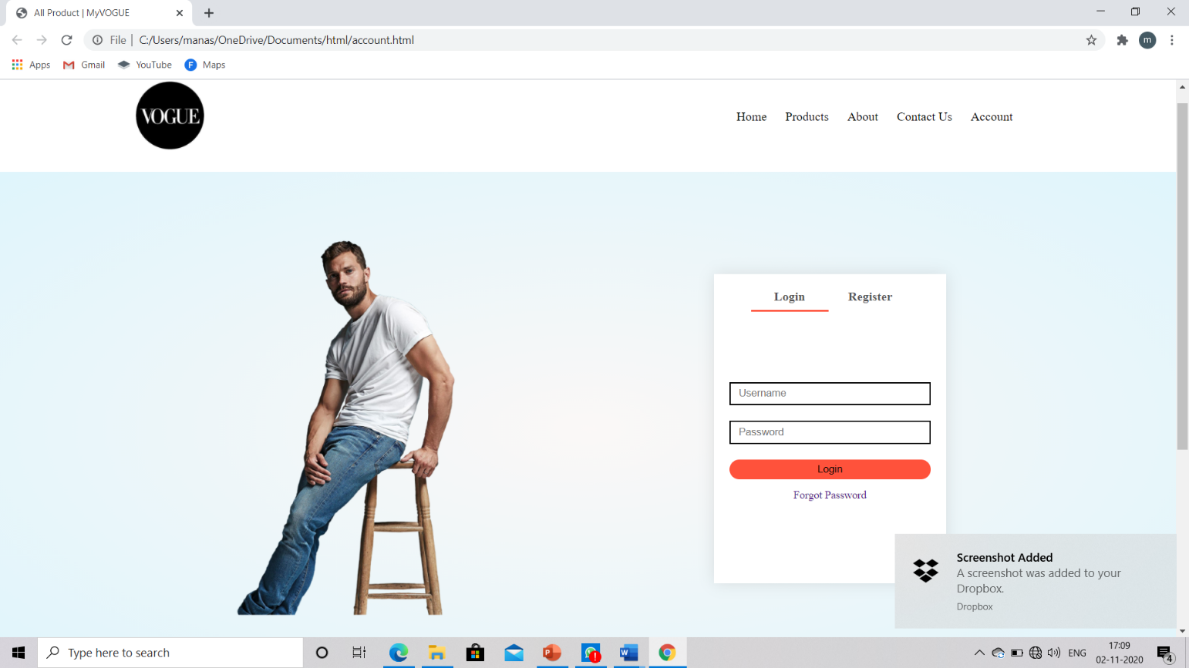

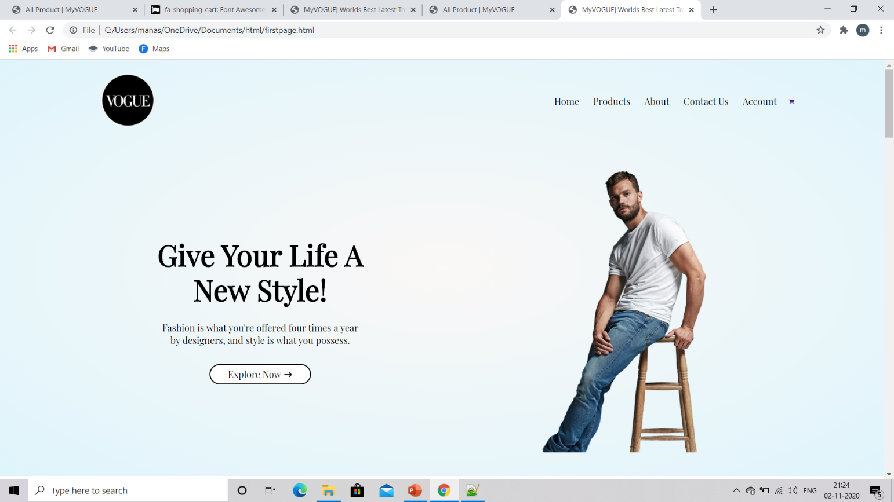

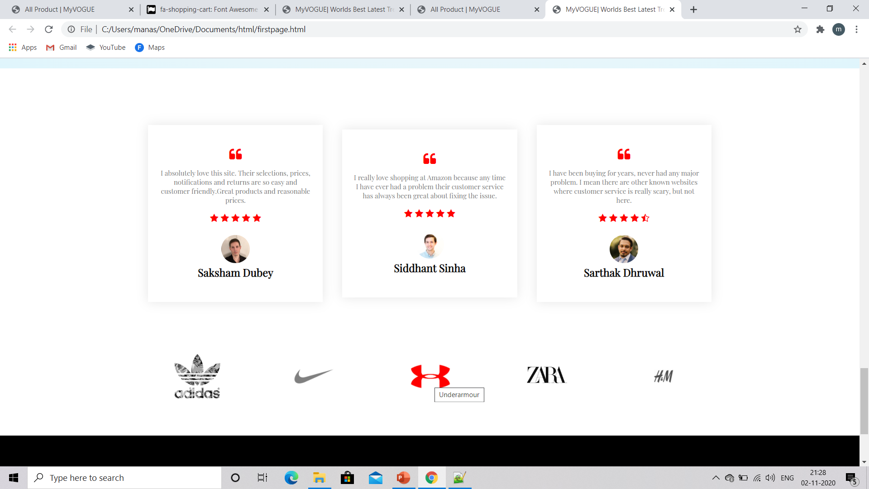

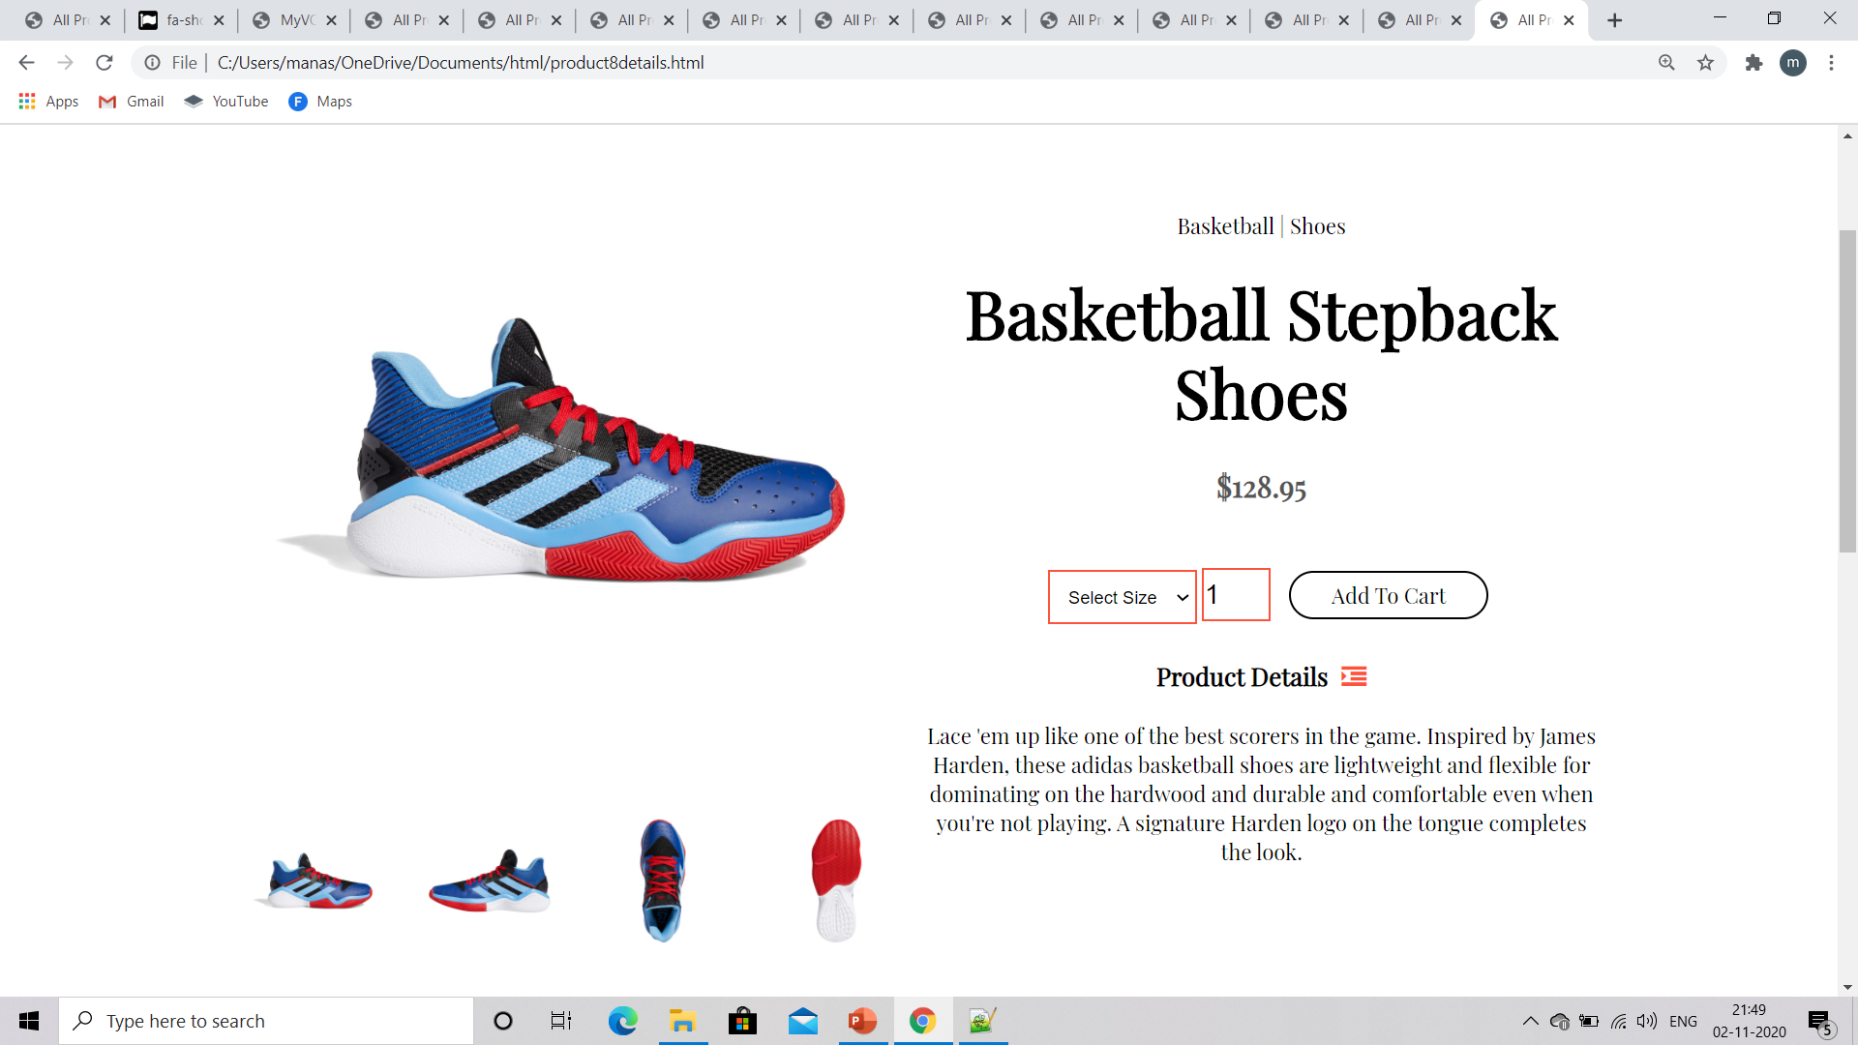

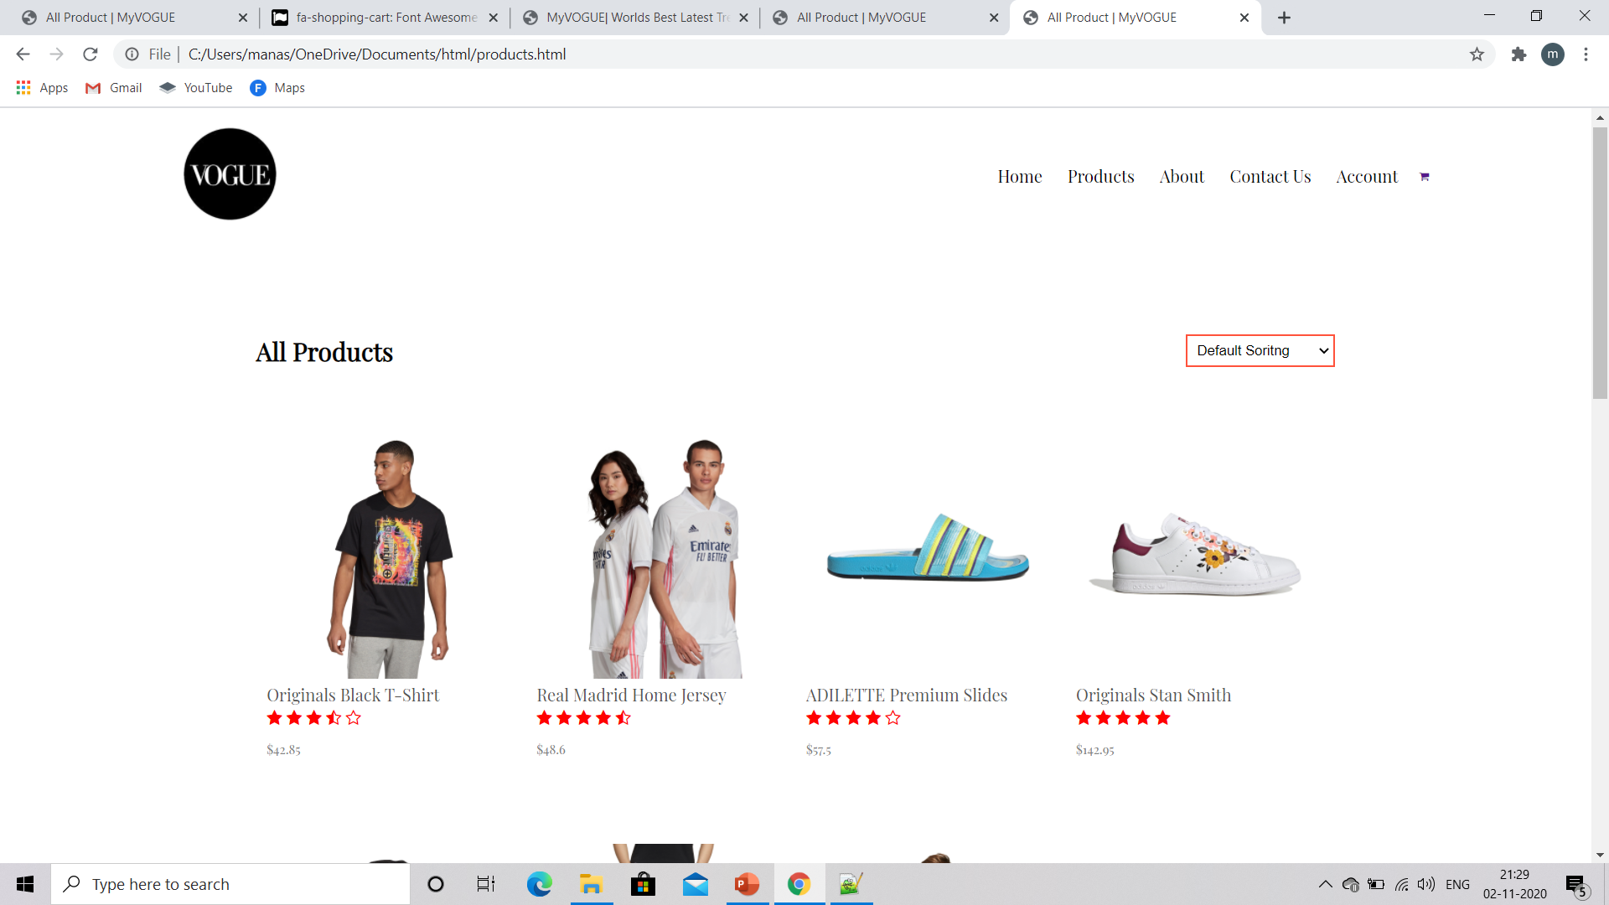

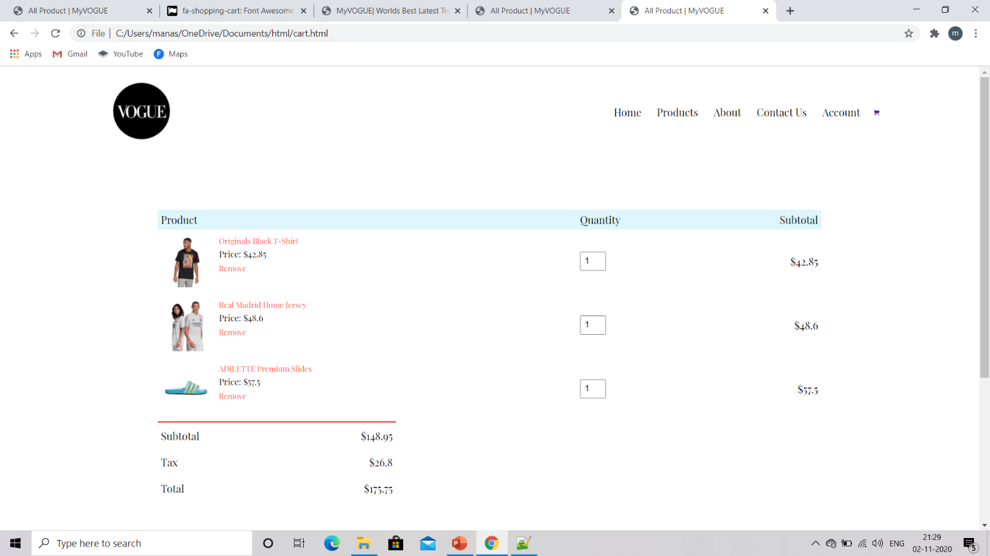

**Deliverables**

Deliverables of this project are:

Make account and login.

Choose the wearable.

Select the size and all other option.

Add to cart.

Give your details for future complaints and query.

**Stakeholders**

This website targets mainly fashion enthusiasts.

It is helpful for the customers seeking decent products at reasonable price.

It is also helpful for small business organization who will buy product at cheaper price and make profit by selling them.

For every third product we will give some amount of money to NGOs working for environment as our one motive is also to contribute in saving greens.

**Gantt Chart**

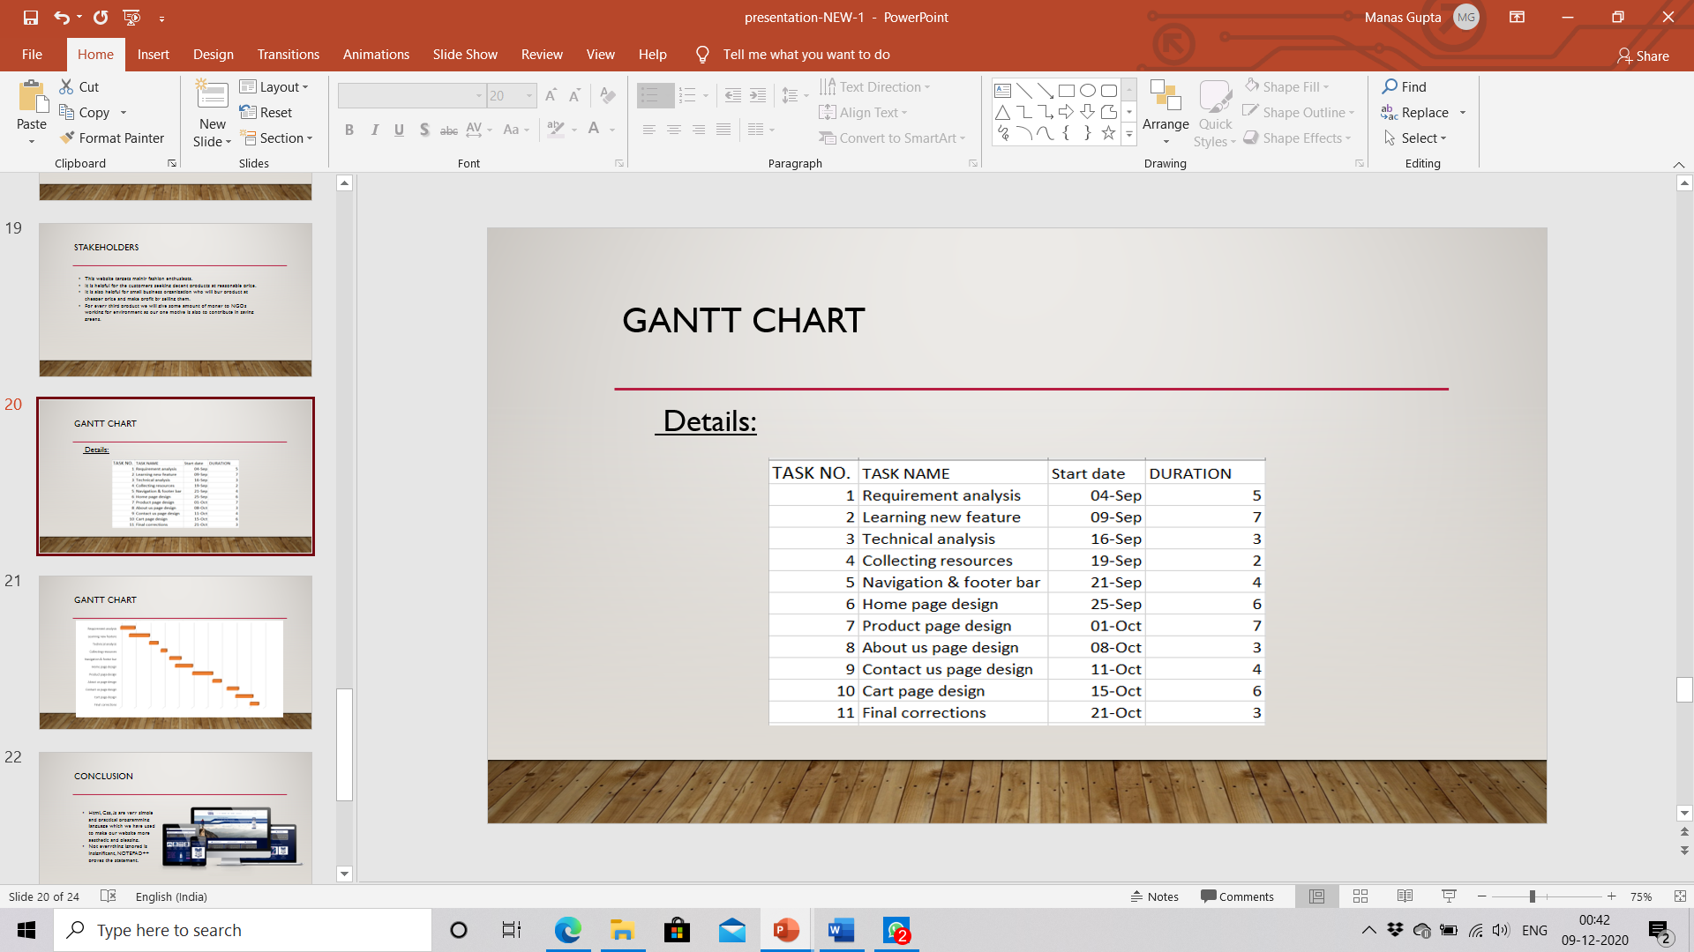

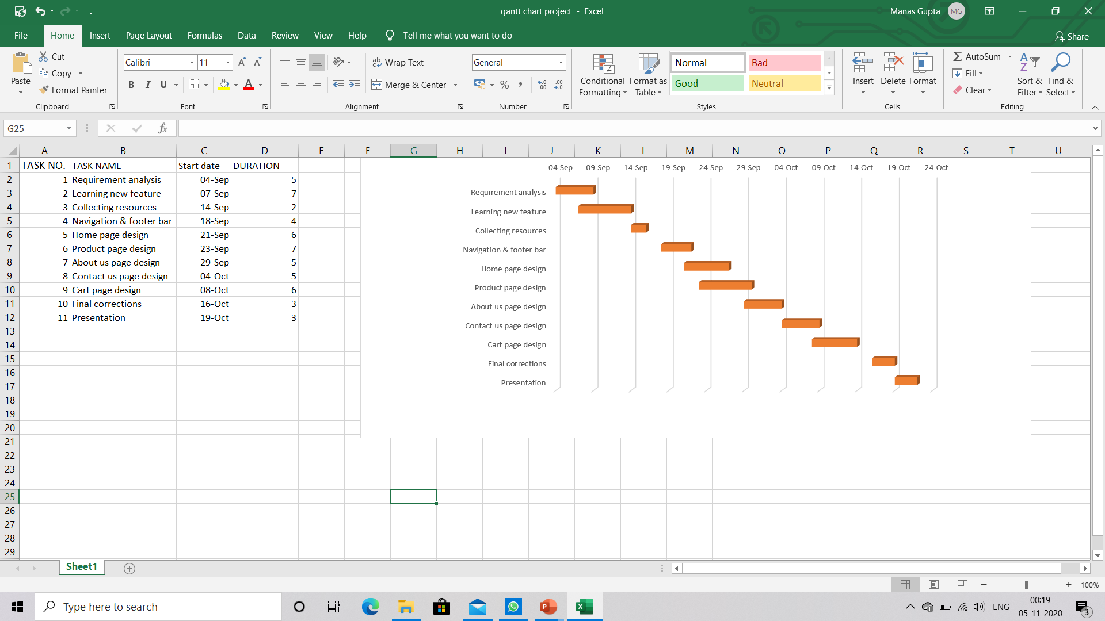

**Conclusion**

The conclusion of this project is that from this project consumer can get product at reasonable price and also save time by shopping from where ever they are. This will also help fashion enthusiast who always want trendy clothes. This will help to provide the best quality product and in less time. It also provide other accessories than clothes like watches, shoes and other necessary products.

**Future Scope**

To add backend and make this website fully working so that a customer can login or create an account and order and also add there favorite product in their cart. By adding backend we can make this website fully working. Another future scope is that to increase the variety of products on the website.

**References**

* [**Myntra,<https://en.wikipedia.org/wiki/Myntra**](https://en.wikipedia.org/wiki/Myntra)**>**
* [**Javascript,<https://www.w3schools.com/js/DEFAULT.asp**](https://www.w3schools.com/js/DEFAULT.asp)**>**
* [**HTML,<https://developer.mozilla.org/en-US/docs/Web/HTML**](https://developer.mozilla.org/en-US/docs/Web/HTML)**>**
* [**CSS,<https://www.w3schools.com/css/**](https://www.w3schools.com/css/)**>**