**Branch :- Computer Sci. & Engg. Class :- Final Year**

**Subject :-System and Software Security Lab manual Sem :- VII**

**Teacher Manual**

**PRACTICAL NO 05**

**Practical no. 2**

**AIM:-** Assess Nessus tool to scan the network for vulnerabilities.

**S/W REQUIRED:-** Nessus Vulnerability Scanner

**THEORY:-**

Nessus is a proprietary comprehensive vulnerability scanner which is developed by Tenable Network Security. It is free of charge for personal use in a non-enterprise environment.

Nessus is a remote security scanning tool, which scans a computer and raises an alert if it discovers any vulnerabilities that malicious hackers could use to gain access to any computer you have connected to a network.  It does this by running over 1200 checks on a given computer, testing to see if any of these attacks could be used to break into the computer or otherwise harm it.

If you are an administrator in charge of any computer (or group of computers) connected to the internet, Nessus is a great tool help keep their domains free of the easy vulnerabilities that hackers and viruses commonly look to exploit.

Operation

* Nessus allows scans for the following types of vulnerabilities:
* Vulnerabilities that allow a remote hacker to control or access sensitive data on a system.
* Misconfiguration (e.g. open mail relay, missing patches, etc.).

**Screeenshots:**

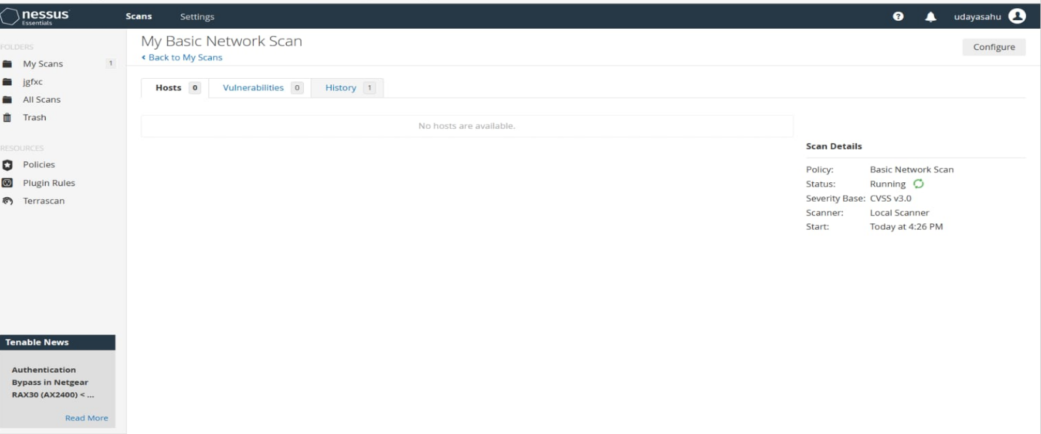

**CONCLUSION:** Thus, we have assessed Nessus tool to scan the network for vulnerabilities.