**Branch :- Computer Sci. & Engg. Class :- Final Year**

**Subject :-System and Software Security Lab manual Sem :- VII**

**Teacher Manual**

**PRACTICAL NO 7**

**AIM**:- Implement the simple substitution technique named Caesar cipher.

**S/W REQUIRED:-** GCC Compiler

**THEORY:-**

To encrypt a message with a Caesar cipher, each letter in the message is changed using a simple rule: shift by three. Each letter is replaced by the letter three letters ahead in the alphabet. A becomes D, B becomes E, and so on. For the last letters, we can think of the alphabet as a circle and "wrap around". W becomes Z, X becomes A, Y becomes B, and Z becomes C. To change a message back, each letter is replaced by the one three before it.

o

**Example:**

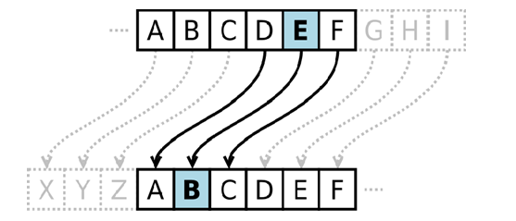

**Algorithm:**

**STEP-1:** Read the plain text from the user.

**STEP-2:** Read the key value from the user.

**STEP-3:** If the key is positive then encrypt the text by adding the key with each character in the plain text.

**STEP-4:** Else subtract the key from the plain text.

**STEP-5:** Display the cipher text obtained above.

**Program: (Caesar Cipher)**

#include <stdio.h> #include <string.h> #include<conio.h> #include <ctype.h> void main()

{

char plain[10], cipher[10]; int key,i,length;

int result; clrscr();

printf("\n Enter the plain text:"); scanf("%s", plain);

printf("\n Enter the key value:"); scanf("%d", &key);

printf("\n \n \t PLAIN TEXt: %s",plain); printf("\n \n \t ENCRYPTED TEXT: ");

for(i = 0, length = strlen(plain); i < length; i++)

{

cipher[i]=plain[i] + key;

if (isupper(plain[i]) && (cipher[i] > 'Z')) cipher[i] = cipher[i] - 26;

if (islower(plain[i]) && (cipher[i] > 'z')) cipher[i] = cipher[i] - 26;

printf("%c", cipher[i]);

}

printf("\n \n \t AFTER DECRYPTION : "); for(i=0;i<length;i++)

{

plain[i]=cipher[i]-key; if(isupper(cipher[i])&&(plain[i]<'A')) plain[i]=plain[i]+26; if(islower(cipher[i])&&(plain[i]<'a')) plain[i]=plain[i]+26; printf("%c",plain[i]);

}

getch();

}

**Output:**

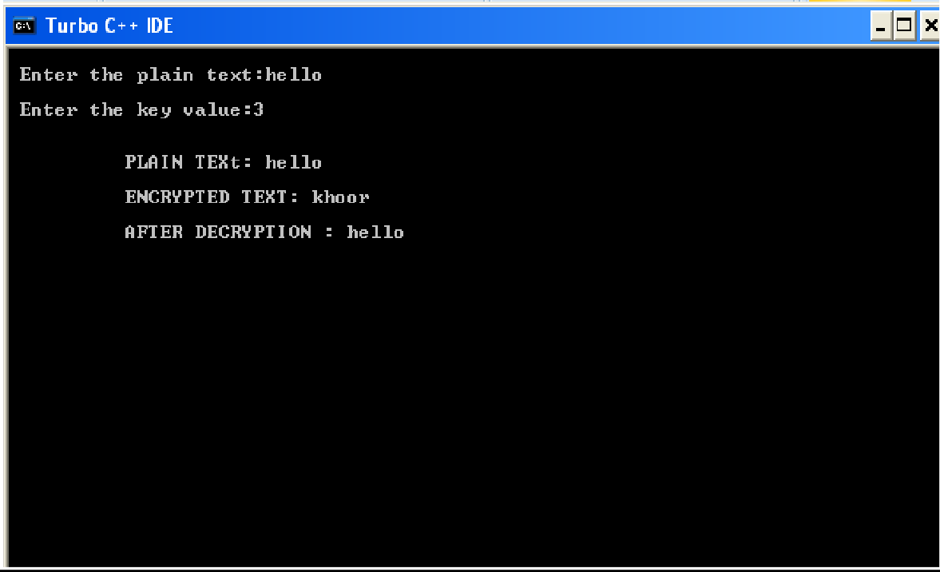

**CONCLUSION:** Thuswe have implemented Caesar cipher technique successfully.