**OpenGL绘制奥运五环**

日期 2020/6/15

**一、实验目的**

1、掌握OpenGL基本绘图工具；

2、熟练OpenGL中绘制基本图形关键代码。

**二、实验要求**

利用本学期OpenGL知识绘制奥运五环

**二、实验内容（代码及注释）**

#include <GL/glut.h>

GLuint OlympicRings;

void Initial(void)

{

glClearColor(1.0f,1.0f,1.0f,1.0f);

glMatrixMode(GL_PROJECTION);

gluOrtho2D(0.0,400.0,0.0,300.0);

}

void Display(void)

{

glClear(GL_COLOR_BUFFER_BIT);

glColor3f(0.0f,0.0f,1.0f);

OlympicRings=glGenLists(1);//获得一个 显示列表标识

glNewList(OlympicRings,GL_COMPILE);//创建显示列表

glColor3f(1.0f,1.0f,0.0f);

glTranslatef( 142.0,150.0,0.0);//沿x轴负向平移

glutSolidTorus( 1 ,20.0,15,50);//绘制黄色环

glColor3f(0.0f,1.0f,0.0f);

glTranslatef(44.0,0.0,0.0);//沿x轴正向平移

glutSolidTorus( 1,20.0,15,50);//绘制绿色环

glColor3f(0.0f,0.0f,0.0f);

glTranslatef(-22.0,30.0,0.0);//沿x轴负向和y轴正向平移

glutSolidTorus(1,20.0,15,50);//绘制黑色环

glColor3f(0.0f,0.0f,1.0f);

glTranslatef(-42.0,0.0,0.0);//沿x轴负向平移

glutSolidTorus(1,20.0,15,50);//绘制蓝色环

glColor3f(1.0f,0.0f,0.0f);

glTranslatef( 84.0,0.0,0.0);//沿x轴正向平移

glutSolidTorus(1,20.0,15,50);//绘制红色环

glEndList();

glCallList(OlympicRings);//调用显示列表

glFlush();

}

int main(int argc,char* argv[])

{

glutInit(&argc,argv);

glutInitDisplayMode(GLUT_SINGLE|GLUT_RGB);//初始化窗口的显示模式

glutInitWindowSize(400,300);

glutInitWindowPosition(100,120);

glutCreateWindow("奥运五环");

glutDisplayFunc(Display);

Initial();

glutMainLoop();

return 0;

}

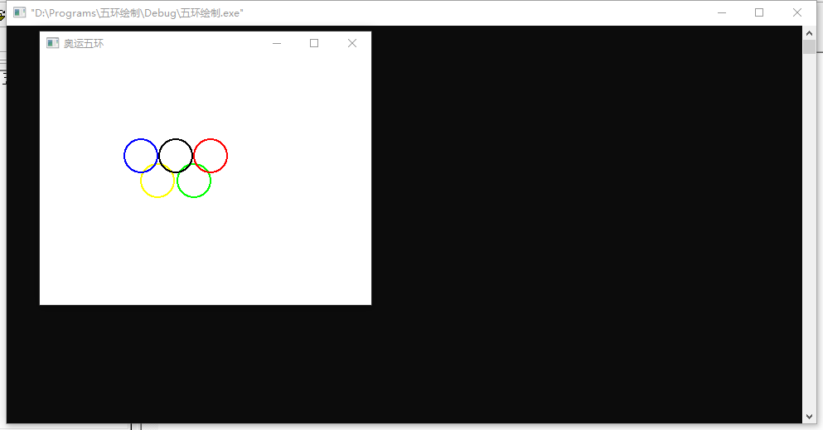

1. **实验总结**

通过实验掌握了层次模型的实现：系统的层次模型可以通过将一个图段嵌套到另一个图段中形成图段树来创建。不同的段和基本图形元素在各自的建模坐标系中定义。图层通过把功能相同的部分归类，并将它们绘制在同一层上， 一般图层不再嵌套。