**Site Purpose**

The target audience will be temple workers, patrons, people, couples that are planning to marry and need specialized services and accommodations for families , people from the church from the world that are planning to visit different countries and need accommodations . The hotel accommodations and services are available to anyone willing to abide by the terms and policies outlined by the company.

**Personnas:**

The Wellness Seeker

**Occupation:** Worker and professionals from the church and guests.

**Demographics and education:** 35-45 years old.

**Goal and motivations for using the site:** To book a reservation rooms knowing that the hotel has the values of the church.

**Social:** Very active individuals, who likes to help people from his community.

**Environment:** They expect healthy menu items and access to a fitness center, and looking for mindful wellness will expect a meditation room .

**Target Audience**

The purpose of the website is to promote and provide information about the specialized services that this hotel chain offers to meet the needs of temple patrons who come to serve in the temple or who participate in events such as sealings, weddings, receptions, and youth trips.

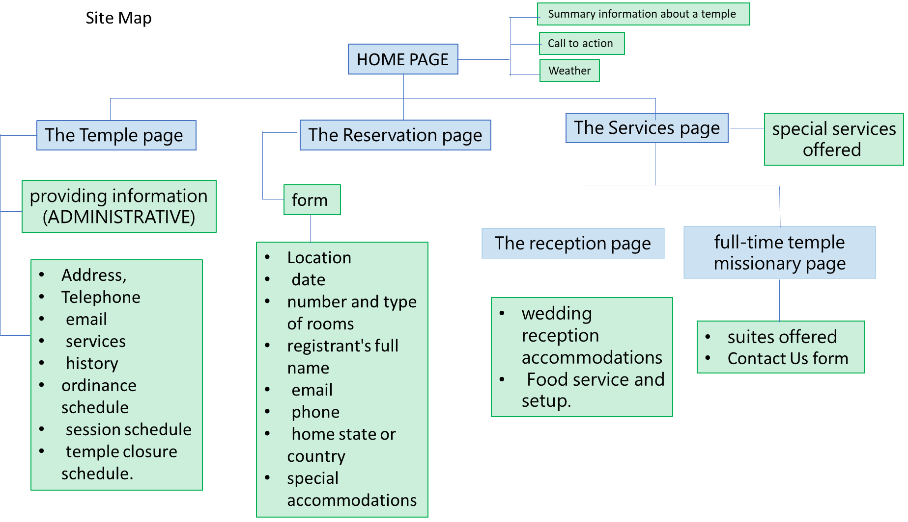

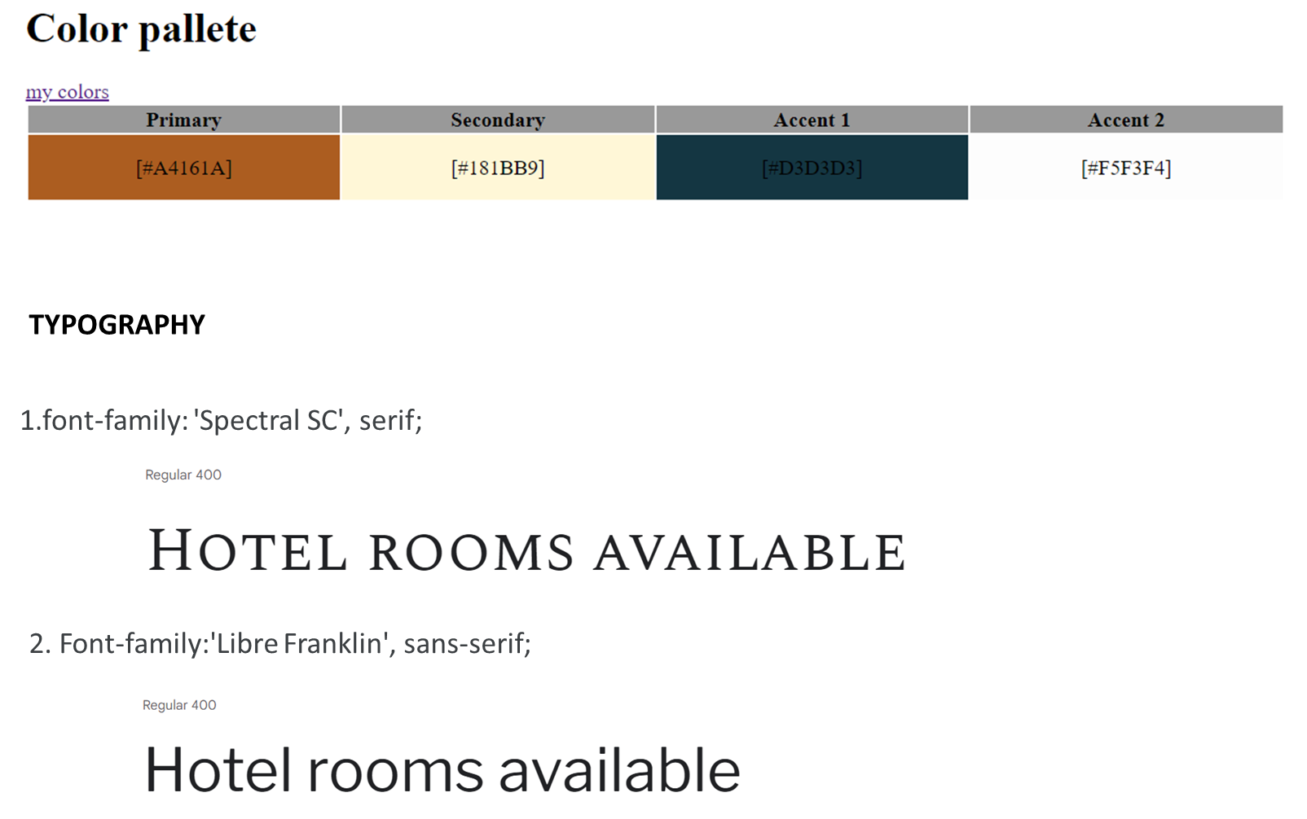

WIREFRAME (LARGE VIEW)

Current weather

TITLE

NAVIGATION BAR

LOGO

Description: xxxxxxxxxxxxxxxxxxxxxxxxxxxxxxxxxxxxxxxxxxxxxxxxxxxxxxxxxxxxxxxxxxxxxxxxxxxxxxxxxxxxxxxxxxxxxxxxxxxxxxxxxxxxxxxxxxxxxxx

Description: xxxxxxxxxxxxxxxxxxxxxxxxxxxxxxxxxxxxxxxxxxxxxxxxxxxxxxxxxxxxxxxxxxxxxxxxxxxxxxxxxxxxxxxxxxxxxxxxxxxxxxxxxxxxxxxxxxxxxxx

Description: xxxxxxxxxxxxxxxxxxxxxxxxxxxxxxxxxxxxxxxxxxxxxxxxxxxxxxxxxxxxxxxxxxxxxxxxxxxxxxxxxxxxxxxxxxxxxxxxxxxxxxxxxxxxxxxxxxxxxxx

Description: xxxxxxxxxxxxxxxxxxxxxxxxxxxxxxxxxxxxxxxxxxxxxxxxxxxxxxxxxxxxxxxxxxxxxxxxxxxxxxxxxxxxxxxxxxxxxxxxxxxxxxxxxxxxxxxxxxxxxxx

forecast

footer

TEMPLES

forecast

WIREFRAME (MEDIUM VIEW)

TITLE

NAVIGATION BAR

LOGO

Description: xxxxxxxxxxxxxxxxxxxxxxxxxxxxxxxxxxxxxxxxxxxxxxxxxxxxxxxxxxxxxxxxxxxxxxxxxxxxxxxxxxxxxxxxxxxxxxxxxxxxxxxxxxxxxxxxxxxxxxx

Description: xxxxxxxxxxxxxxxxxxxxxxxxxxxxxxxxxxxxxxxxxxxxxxxxxxxxxxxxxxxxxxxxxxxxxxxxxxxxxxxxxxxxxxxxxxxxxxxxxxxxxxxxxxxxxxxxxxxxxxx

Footer

TEMPLES

forecast

Current weather

WIREFRAME (SMALL VIEW)

TITLE

LOGO

Footer

TEMPLES

NAVIGATION BAR

xxxxxxxxxxxxxxxxxxxxxxxxxxxxxxxxxxxxxxxxxxxxxxxxxxxxxxxxxxxxxxxxxxxxxxxxxxxxxxxxxxxxxxxxxxxxxxxxxxxxxxxxxxxxx

xxxxxxxxxxxxxxxxxxxxxxxxxxxxxxxxxxxxxxxxxxxxxxxxxxxxxxxxxxxxxxxxxxxxxxxxxxxxxxxxxxxxxxxxxxxxxxxxxxxxxxxxxxxxx

xxxxxxxxxxxxxxxxxxxxxxxxxxxxxxxxxxxxxxxxxxxxxxxxxxxxxxxxxxxxxxxxxxxxxxxxxxxxxxxxxxxxxxxxxxxxxxxxxxxxxxxxxxxxx

Current weather

forecast