|  |
| --- |
|  |
| Book Store Database |
| Management System |
|  |
| **Manish Kumar Gupta**  **260/CO/08**  **COE-I** |
|  |

|  |
| --- |
|  |

**Information Systems and Data Management Lab**

**COE-317**

*Project name:* Book Store Management System

*Project members:* **MANISH KUMAR GUPTA (260/CO/08)**

*Front end:* Visual Basic

*Back end:* MS SQL server

*Synopsis:*

This project is a basic Book Store Management system. The project provides basic functionality of viewing the books available, and ordering them by a customer. The project provides the employee the privileges to add new books, maintain customer records, maintain ordering information, and maintain inventory.

The project secures the internal database by asking for a master ID and a password before granting access to it. The employee can then insert a new book. The employee can also add, delete, and modify the employee records. Employees can also view information about the publishers, customers, orders, and the inventory. Employees can also order books from the store.

The customers can browse and order books from the book store. They can also edit their information stored in the database but cannot modify their names and Credit card numbers for security purposes.

**Overview**

This project is a basic Book Store Management system. The project provides basic functionality of viewing the books available, and ordering them by a customer. The project provides the employee the privileges to add new books, maintain customer and employee records, maintain ordering information, and maintain inventory.

The project secures the internal database by asking for a master ID and a password before granting access to it. The employee can then insert a new book. The employee can also add, delete, and modify the employee records. Employees can also view information about the authors, publishers, customers, orders, and the inventory. Employees can also order books from the store.

The customers can browse and order books from the book store. They can also edit their information stored in the database but cannot modify their names and Credit card numbers for security purposes.

The project has been created in Visual Basic (Visual Studio 2008) and the database uses the Microsoft SQL Server Express as back-end. The needs to be connected to the application using a connection string before use. The application requires *.NET Framework 3.5* and *SQL Server 2005 Express Edition SP2(x86)* as a prerequisite to run.

In the documentation, the ER diagram and the relational diagram showing various tables have been provided, after which the code and the output has been given.

**Schema**

Books (BID, Name, Author, Publisher, Price)

Inventory (BID, Quantity)

Order (Order ID, CustID, Book ID, Status, Amount)

Person (Name, Address, Contact, ID, Code, Salary, CreditCard)

**Tables**

|  |  |  |  |
| --- | --- | --- | --- |
| Books | Inventory | Order | Person |
| BID | BID | OrderID | Name |
| Name | Quantity | BookID | Address |
| Author |  | CustID | Contact |
| Publisher |  | Status | ID |
| Price |  | Amount | Code |
|  |  |  | Salary |
|  |  |  | CreditCard |

**Screenshots of output**

Main Form(1)

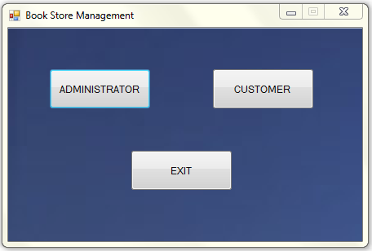

Login Form(2)

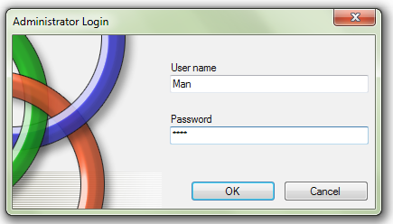

Customer Form(3)

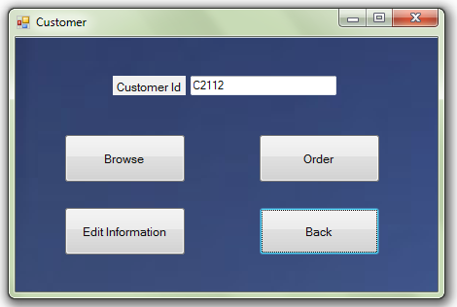

Administrator Form(4)

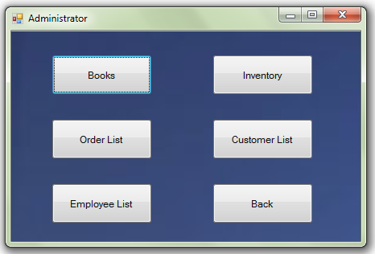

Edit Customer Details Form(5)

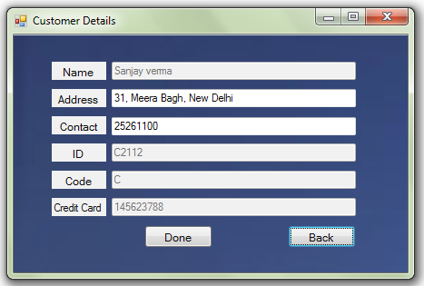

Edit Employee Details Form(6)

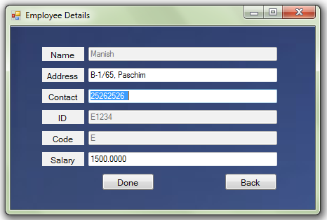

Book Details Form(7)

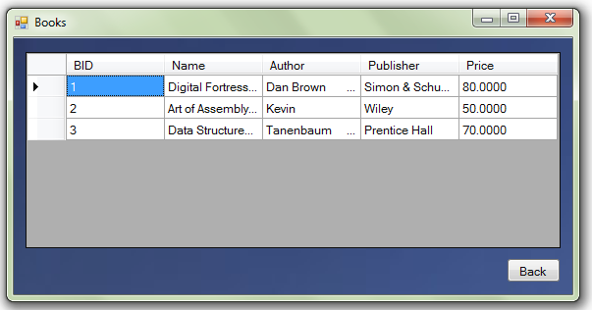

Customer List(8)

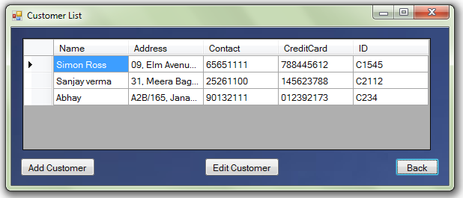

Employee List(9)

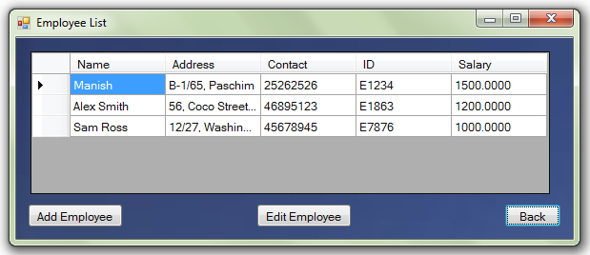

Inventory(10)

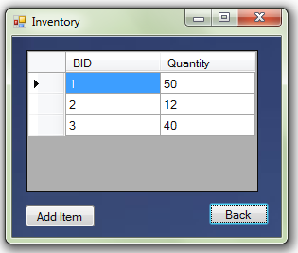

Orders(11)

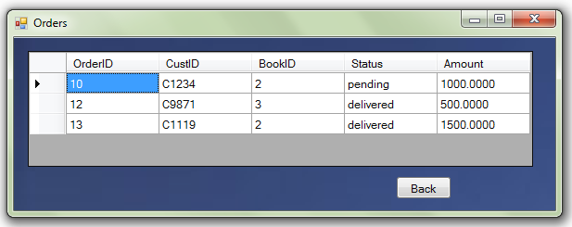

Input box

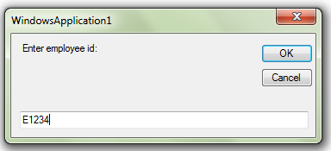

**E-R Diagram**

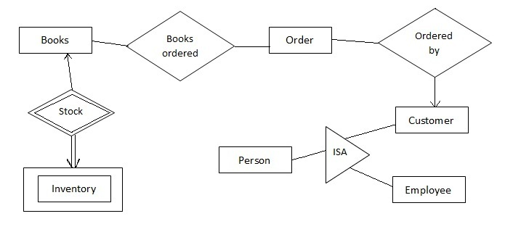

**Entities with attributes**

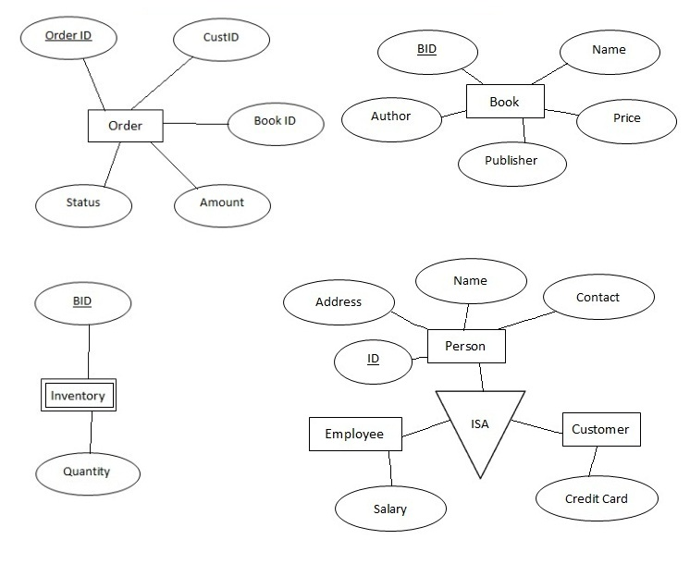

**Queries**

* UPDATE [dbo].[Person] SET [Address] = @Address, [Contact] = @Contact, [CreditCard] = @CreditCard WHERE ([ID] = @ID);
* SELECT * FROM Person WHERE (ID = @ID)
* UPDATE [dbo].[Person] SET [Address] = @Address, [Contact] = @Contact, [Salary] = @Salary WHERE ([ID] = @ID);
* SELECT Name, Address, Contact, ID, Code, Salary, CreditCard FROM dbo.Person
* INSERT INTO [dbo].[Inventory] ([BID], [Quantity]) VALUES (@BID, @Quantity);
* SELECT BID, Quantity FROM Inventory WHERE (BID = @BID)
* UPDATE [dbo].[Inventory] SET [Quantity] = @Quantity WHERE ([BID] = @BID);
* SELECT BID, Name, Author, Publisher, Price FROM dbo.Books
* SELECT OrderID, CustID, BookID, Status, Amount FROM dbo.[Order]
* INSERT INTO [dbo].[Books] ([BID], [Name], [Author], [Publisher], [Price]) VALUES (@BID, @Name, @Author, @Publisher, @Price);
* SELECT BID, Name, Author, Publisher, Price FROM Books WHERE (BID = @BID)
* INSERT INTO [dbo].[Order] ([OrderID], [CustID], [BookID], [Status], [Amount]) VALUES (@OrderID, @CustID, @BookID, @Status, @Amount);
* SELECT OrderID, CustID, BookID, Status, Amount FROM [Order] WHERE (OrderID = @OrderID)
* INSERT INTO [dbo].[Person] ([Name], [Address], [Contact], [ID], [Code], [Salary], [CreditCard]) VALUES (@Name, @Address, @Contact, @ID, @Code, @Salary, @CreditCard);
* SELECT Name, Address, Contact, ID, Code, Salary, CreditCard FROM Person WHERE (ID = @ID)

**Relational Diagram**

