Biostatistics

V. Inácio de Carvalho & M. de Carvalho

We will start by reproducing the plots we have in slides 7 and 9 of the lectures (sampling distributions of $\hat{\text{OR}}$ and $log\hat{\text{OR}}$). We will also make the corresponding plots for the sampling distributions of $\hat{\text{RR}}$ and $log\hat{\text{RR}}$. The key is to remember that, under a cohort design, the entry $a$ in the $2×2$ contingency table (slide 3) follows a binomial distribution whose parameters are the number of exposed individuals and probability of disease given exposure. Similarly, the entry $c$ (in the same contingency table) also follows a binomial distribution whose parameters are, in turn, the number of individuals who are not exposed and the probability of disease given no exposure. We will be assuming that $p_{1}=Pr\left(D∣E\right)=0.2$ and that $p_{2}=Pr\left(D∣\text{not }E\right)=0.2$ and, further, that we have 50 individuals in the exposed group and another 50 individuals in the unexposed group. To make the results reproducible, I will be fixing the seed. The code is as follows.

n_exp <- 500 # com exposição  
n_unexp <- 50  
p1 <- 0.2  
p2 <- 0.2  
  
nsim <- 1000  
OR <- RR <- numeric(nsim)  
  
set.seed(123)  
for(i in 1:nsim){  
 a <- rbinom(1, n_exp, p1) # distribuição binomial, da contagem associada! a doença e exposição  
 c <- rbinom(1, n_unexp, p2)  
 b <- n_exp - a  
 d <- n_unexp - c # simular 1000 tabelas de contigência!  
 OR[i] <- (a*d)/(b*c)  
 RR[i] <- (a/(a+b))/(c/(c+d))  
}  
  
df_OR <- data.frame("Mean" = c(mean(OR), mean(log(OR))),   
 "Median" = c(median(OR), median(log(OR))),  
 "Min" = c(min(OR), min(log(OR))),  
 "Max" = c(max(OR), max(log(OR)))  
 )  
  
rownames(df_OR) <- c("OR", "log OR")   
knitr::kable(df_OR, escape = FALSE, digits = 3,  
 caption = "Summary statistics of the sampling distributions of the OR and log OR")

Summary statistics of the sampling distributions of the OR and log OR

|  | Mean | Median | Min | Max |
| --- | --- | --- | --- | --- |
| OR | 1.137 | 0.988 | 0.369 | 6.457 |
| log OR | 0.040 | -0.013 | -0.996 | 1.865 |

hist(OR, nclass = 20, xlab = "Estimated odds ratio",  
 ylab = "Frequency", main = "Sampling distribution estimated OR")  
abline(v = 1, lwd = 2, col = "red")

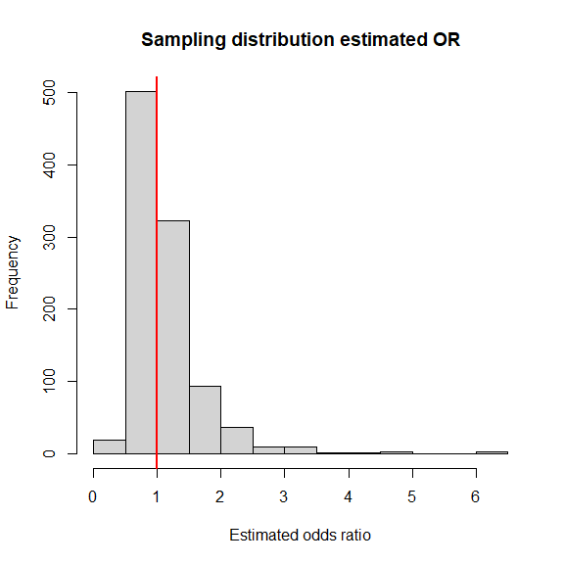

hist(log(OR), nclass = 20, xlab = "Estimated log odds ratio",  
 ylab = "Frequency", main = "Sampling distribution estimated log OR")  
abline(v = 0, lwd = 2, col = "red")

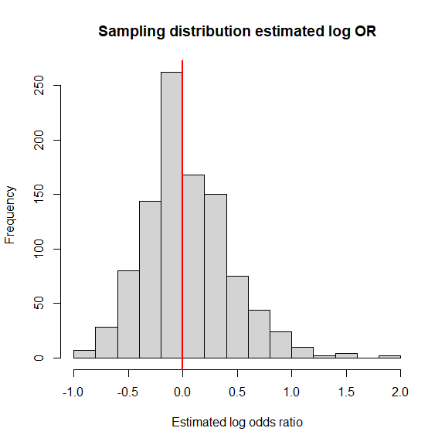

df_RR <- data.frame("Mean" = c(mean(RR), mean(log(RR))),   
 "Median" = c(median(RR), median(log(RR))),  
 "Min" = c(min(RR), min(log(RR))),  
 "Max" = c(max(RR), max(log(RR)))  
 )  
  
rownames(df_RR) <- c("RR", "log RR")   
knitr::kable(df_RR, escape = FALSE, digits = 3,  
 caption = "Summary statistics of the sampling distributions of the RR and log RR")

Summary statistics of the sampling distributions of the RR and log RR

|  | Mean | Median | Min | Max |
| --- | --- | --- | --- | --- |
| RR | 1.107 | 0.99 | 0.478 | 5.300 |
| log RR | 0.042 | -0.01 | -0.739 | 1.668 |

hist(RR, nclass = 20, xlab = "Estimated relative risk",   
 ylab = "Frequency", main = "Sampling distribution estimated RR")  
abline(v = 1, lwd = 2, col = "red")

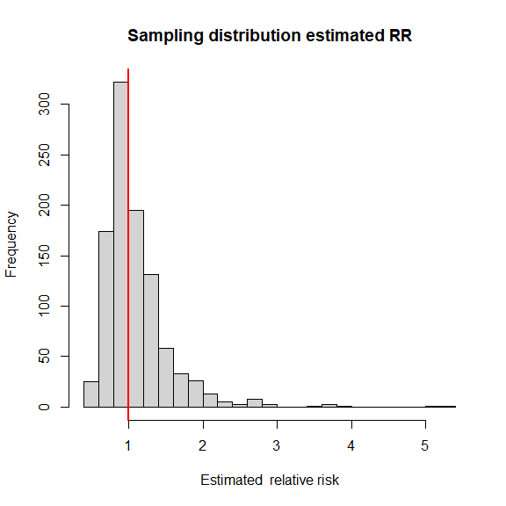

hist(log(RR), nclass = 20, xlab = "Estimated log relative risk ",   
 ylab = "Frequency", main = "Sampling distribution estimated log RR")  
abline(v = 0, lwd = 2, col = "red")

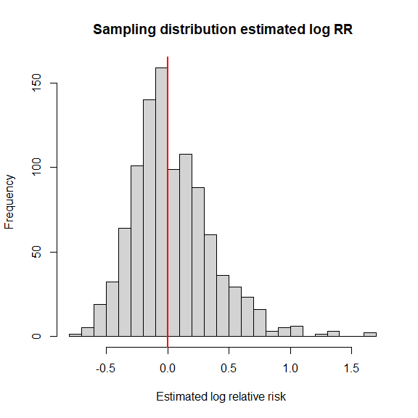

I now illustrate the usage of the and packages which, among many things, have functions to compute estimates and CIs for different measures of association. We will use the data from the example in slide 17.

require(epiR)

## Warning: package 'epiR' was built under R version 4.3.3

data <- c(62, 76, 5, 55)  
epi.2by2(data, method = "case.control", conf.level = 0.95, units = 100,  
 interpret = TRUE, outcome = "as.columns")

## Outcome + Outcome - Total Odds  
## Exposed + 62 76 138 0.82 (0.59 to 1.12)  
## Exposed - 5 55 60 0.09 (0.02 to 0.20)  
## Total 67 131 198 0.51 (0.37 to 0.68)  
##   
## Point estimates and 95% CIs:  
## -------------------------------------------------------------------  
## Exposure odds ratio 8.97 (3.38, 23.79)  
## Attrib fraction (est) in the exposed (%) 88.75 (69.69, 96.69)  
## Attrib fraction (est) in the population (%) 82.23 (57.71, 92.53)  
## -------------------------------------------------------------------  
## Uncorrected chi2 test that OR = 1: chi2(1) = 25.013 Pr>chi2 = <0.001  
## Fisher exact test that OR = 1: Pr>chi2 = <0.001  
## Wald confidence limits  
## CI: confidence interval  
## Measures of association strength:  
## The exposure odds among cases was 8.97 (95% CI 3.38 to 23.79) times the exposure odds among controls: the odds of the outcome among cases was greater than the odds of the outcome among controls.   
##   
## Measures of effect in the exposed:  
## 88.7% of outcomes in the exposed were attributable to exposure (95% CI 69.7% to 96.7%).   
##   
## Measures of effect in the population:  
## 82.2% of outcomes in the population were attributable to exposure (95% CI 57.7% to 92.5%).

require(epitools)

## Warning: package 'epitools' was built under R version 4.3.1

oddsratio(data, method = "wald", conf = 0.95, correct = FALSE)

## $data  
## Outcome  
## Predictor Disease1 Disease2 Total  
## Exposed1 62 76 138  
## Exposed2 5 55 60  
## Total 67 131 198  
##   
## $measure  
## odds ratio with 95% C.I.  
## Predictor estimate lower upper  
## Exposed1 1.000000 NA NA  
## Exposed2 8.973684 3.384777 23.79093  
##   
## $p.value  
## two-sided  
## Predictor midp.exact fisher.exact chi.square  
## Exposed1 NA NA NA  
## Exposed2 1.225344e-07 1.967011e-07 5.693107e-07  
##   
## $correction  
## [1] FALSE  
##   
## attr(,"method")  
## [1] "Unconditional MLE & normal approximation (Wald) CI"