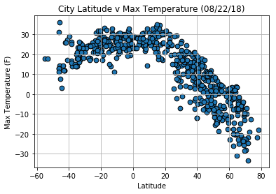Latitude v Temperature:

Cities with latitude between -20 to 20 have the highest temperature, and as the latitude increase the temperature drops significantly.

Latitude v Humidity:

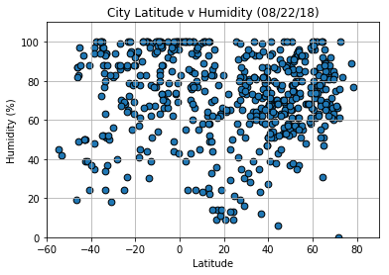Most cities have humidity above 50% and higher concentration of cities with above 50% humidity were in the latitude greater then 20.

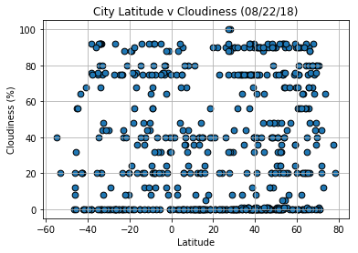Latitude v Cloudiness:

Some cities have the similar percent of cloudiness with changes in latitude, either 0% or 90% cloudiness. A little more cloudiness with cities in a higher latitude range.

Latitude v Wind Speed:

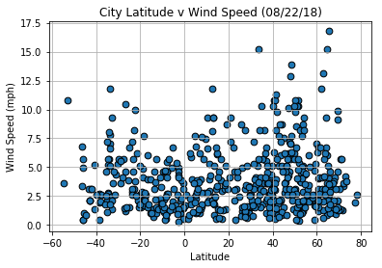Wind speed of 2.5 mph are for cities in a similar range of latitude of -40 thru 70, but higher wind speed gear toward cities in a higher latitude.