***Group9*** *Insurance self-service query system*

*642115503 Haoxuan Yu*

*642115502 Guangcheng Zhou*

*642115008 Jirapat Namwong*

*642115508 Yingyi Mao*

*642115509 Zhenyu Pan*

**SRS and URS**

URS-001: Users can open the insurance self-service query system after logging in  
URS-002: Users can choose Thai, English, and Chinese as the system languages  
URS-003: Users can use their mobile phone number, ID card number or passport number to check the insurance purchased under their own names  
URS-004: After querying, users can choose to view the detailed information of a certain insurance, including type, purchase time, status, effective time, premium, insurance coverage, insurance details, etc.  
URS-005: Users can save the currently viewed policy in PDF format in their phone's memory.  
URS-006: If the currently viewed policy can be renewed, users can choose to schedule offline renewal services at a specific time.  
URS-007: After the appointment is completed, the user will receive a successful SMS message.

SRS-001: The system should provide a user login function, and after logging in, users can access the insurance self-service query system.  
——In the event of any network or system malfunction, the system should provide an error prompt.  
SRS-002: The system should support a multilingual interface, including Thai, English, and Chinese. After the user changes the language settings, the system should immediately update all visible text to the selected language.  
SRS-003: The system shall allow users to use their mobile phone number, ID card number or passport number to query the insurance purchased under their own names.  
——When entering invalid or non-existent information, the system should provide an error prompt and return to the query page.  
SRS-004: After querying, the system should allow users to view detailed information about a certain insurance, including type, purchase time, status, effective time, premium, insurance coverage, insurance details, etc.  
SRS-005: The system should allow users to save the currently viewed policy in PDF format in their phone's memory.  
——When encountering any issues during the save process, the system should provide an error prompt and return to the previous step.  
SRS-006: If the currently viewed policy can be renewed, the system should allow users to choose to make an appointment for offline renewal services.  
——When encountering an unavailable appointment time while saving an appointment, the system should provide a prompt stating that the time is not available  
SRS-007: After the appointment is completed, the system should send a successful appointment SMS to the user's phone number and email.

**use case diagram**

**use case description**

|  |  |  |  |  |
| --- | --- | --- | --- | --- |
| Use Case ID | 001 | | | |
| Use Case Name | Ask about insurance price types | | | |
| Created By | Haoxuan Yu | | Last Update By | Haoxuan Yu |
| Date Created | 16/09/2023 | | Last Revision Date | 18/09/2023 |
| Actors | User | | | |
| Description | When users ask about the type of insurance they need, the robot will help them automatically provide corresponding prices or reply to messages | | | |
| Trigger | When users ask for different types of prices | | | |
| Preconditions | Users inquire about different types of prices.  Robots in sufficient conditions | | | |
| Use Case Input Specification | | | | |
| Input | type | Constraint | | Example |
| Life insurance price | Text | Insurance must have information about life | | 50000THB |
| Accident insurance | Text | Insurance must have information about accident | | 70000THB |
| Post conditions | A user can only have one robot at a time.  Human clients can take over at any time | | | |
| Normal Flows | User | | System | |
| 1. Insurance type   2.Life insurance price  3.Accident insurance price | 1. What are the types of insurance and which one is recommended  2. Inquire about the life insurance price  3. Inquire about the accident insurance price | | 1. The robot automatically replies with insurance types and provides some insurance types  2.The robot replied to inquire about the life insurance price.  3.The robot replied to inquire about the accident insurance price. | |
| Alternative Flow | Sometimes robots take up too much space, and manual clients will also help respond | | | |
| Exception Flow | When the user indicates that it is not this insurance, the robot will ask the user again which insurance is specific | | | |
| Assumption | If the user asks about the insurance price, the robot will automatically reply with the general price of each insurance. If there are other details, the user needs to inquire | | | |

**activity diagram**

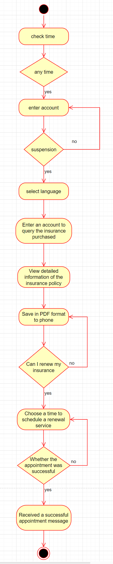

**Non-functional requirement**

Appearance: We only need to ensure that users have a clear idea when using it for the first time.

Usability: Users know what they want to do or observe to understand what they should be able to input.

Performance: We use cloud computing and cloud storage to improve processing speed. There are no restrictions on operation and can be used on Android, Apple, Windows, and Harmony systems.

Support and Maintenance: We offer three languages: Chinese, English, and Thai. We will send emails and text messages after completing the operation.

Security: We will not disclose users' personal information and provide protection and data recovery for personal information. When abnormal situations occur, we will prompt the user and seek necessary permissions from them in a prominent manner.

Culture and Politics: Provide services to users without affecting local governments and make appropriate adjustments based on local culture.

Legitimacy: Our software must comply with local laws when providing services to protect consumers' rights.

**UI**

*Link：*[*Miro | Online Whiteboard for Visual Collaboration*](https://miro.com/app/board/uXjVMkfiPFo=/?share_link_id=815772549342)