PhenoMan [UK/Canada/USA] PhenoMan Gummies Reviews UK, Does PhenoMan Gummies Work For Males? Consumer Reports 2024 & Price!

**PhenoMan Gummies** It is vital to carry on with a sound and healthy lifestyle however that is beyond the realm of possibilities similarly as with the difference in time. We have seen that with our bustling timetable we lack the opportunity to deal with our wellbeing and for that reason we could confront numerous physical and emotional well-being issues like misery, uneasiness, low resistance power, unfortunate digestion level, low body strength, body torment, constant agony, unfortunate absorption power, low energy level and numerous different issues which clearly deteriorates with time and for that reason you really want a viable wellbeing helping equation which not just settles every one of these medical problems and makes areas of strength for you sound from inside and to that end we have **PhenoMan Gummies** for you which is a high level technique which essentially tackles all the psychological and actual medical problems simultaneously and it will supports your invulnerability and processing power and gives you other medical advantages additionally and makes you fit from inside.

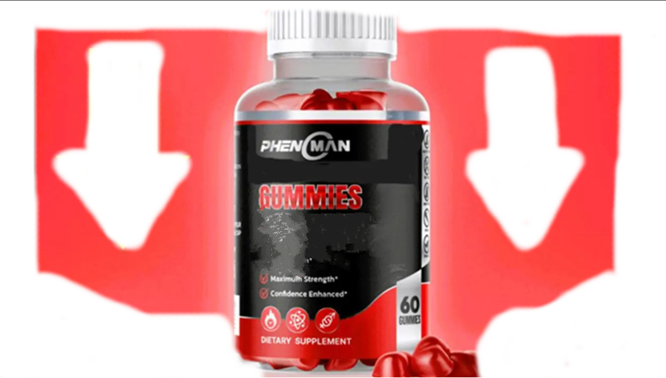

**PhenoMan Gummies** is appropriate for all people and certainly gives you safe outcomes as PhenoMan Gummies is liberated from all sort of synthetic substances and it is loaded up with the assistance of regular fixings that makes it alright for your use and you should peruse ahead for knowing more insights concerning PhenoMan Gummies and you can attempt it without figuring overabundance and it will clearly work on your entire wellbeing without leaving any aftereffects on your body.

**[[Official Website] Click Here to Buy PhenoMan in UK (United Kingdom)](https://supplementcarts.com/phenoman-gummies-official-website-UK/)**

# **What is PhenoMan Gummies?**

**PhenoMan Gummies** are recently planned chewy candies which helps in working on your entire wellbeing and makes areas of strength for you fit without leaving any destructive effect on your wellbeing. PhenoMan Gummies helps in battling all the psychological and actual medical issues simultaneously and further develops your memory power so you remember anything. PhenoMan Gummies contains no synthetic substances in it and it is planned with the assistance of natural and regular fixings and it will doubtlessly give you many advantages simultaneously. PhenoMan Gummies is framed for working on your wellbeing and you can attempt PhenoMan Gummies without a second thought.

**[[Official Website] Click Here To Buy PhenoMan in USA (UNITED STATES)](https://supplementcarts.com/phenoman-gummies-official-website-USA/)**

No, you won't confront any incidental effects with the utilization of PhenoMan Gummies as these chewy candies are planned with the assistance of natural and regular fixings which are tried by specialists and it will give you anticipated results. PhenoMan Gummies doesn't contains any synthetic substances in it and it is use by many individuals and the clients referenced nothing regrettable about this item and you will unquestionably acquire anticipated brings about brief timeframe. PhenoMan Gummies is protected until you consume suggested portion of it and you should counsel your primary care physician once before begin utilizing these chewy candies and you should attempt it decisively.

**[[Official Website] Click Here To Buy PhenoMan in CA (Canada) [Best Price}](https://supplementcarts.com/phenoman-gummies-official-website-canada/)**

PhenoMan Gummies is accessible in month to month pack which come at the most sensible cost which doesn't hampers your month to month financial plan and the ongoing cost is referenced on its true site. The produces of PhenoMan Gummies is giving your limits and different proposals simultaneously. They are likewise offering you 30 days unconditional promise and on the off chance that you are not happy with the outcome with the utilization of PhenoMan Gummies then you can guarantee your cash back and they will discount your entire sum without asking you any inquiry.

# **How PhenoMan Gummies Functions?**

**PhenoMan Gummies** are the best chewy candies which chips away at your entire wellbeing and gives you numerous medical advantages as PhenoMan Gummies helps in working on your psychological and actual wellbeing simultaneously. It helps in decreasing all the agony from your brain and body and makes your bones sound areas of strength for and. It helps in upgrading your body strength, endurance and energy level and will make you string from inside. It assists in helping your processing with fueling, digestion level and your resistance additionally and makes you fit from inside. It helps in battling against nervousness, stress and gloom and makes you cheerful and loose. It is useful in adjusting your sugar level, cholesterol level and your circulatory strain level and makes you gain numerous medical advantages simultaneously and it will gives you sharp memory and improves your fixation power and center level and it additionally helps in your skin surface and makes your skin sound.

# **Fixings in PhenoMan Gummies:**

**PhenoMan Gummies** is shaped with the assistance of numerous normal fixings and they all are chosen and tried by specialists and they are useful in helping your entire wellbeing simultaneously and not many of the fixings are talked about beneath: -

Coconut Oil: - It helps in keeping up with your entire wellbeing and just improves your absorption and digestion level. It helps in mending your body from inside.

CBD Oil: - It helps in diminishing all sort of body torment and makes you bones solid and sound. It helps in diminishing persistent agony and other torment from your body.

Ginger Concentrate: - It helps in battling against the issue of despondency, stress and tension in brief timeframe and supports your safe framework too. It will improve your psychological wellness in brief timeframe.

The wide range of various fixings are referenced on the rear of its container and you should peruse them all and in the event that you find any fixing which isn't really great for your wellbeing then try not to utilize it.

**[[OFFICIAL WEBSITE] Buy Now Click Here FOR PhenoMan UK [Best Price]](https://supplementcarts.com/phenoman-gummies-official-website-UK/)**

# Advantages of **PhenoMan Gummies:**

**PhenoMan Gummies** will makes you fit and gives you numerous medical advantages simultaneously as PhenoMan Gummies contains just regular fixings in it and you won't find any synthetic compounds in it and not many of the advantages are referenced underneath: -

It lessens all the pressure from your body and make you loose

It improves your fixation and centre level

It improves your physical and psychological well-being at same time

It upgrades your energy level, body strength and endurance level

It assists in upgrading your digestion with evening out and processing power

It will improve your safe power and makes major areas of strength for you

It gives you sharp memory and never let you fail to remember anything

It diminishes torment from your entire body.

**[[Discounted Offer] Click Here to Buy PhenoMan UK [Official Website]](https://supplementcarts.com/phenoman-gummies-official-website-UK/)**

# **How to Consume PhenoMan Gummies?**

Consuming **PhenoMan Gummies** consistently will certainly give you numerous medical advantages and makes you fit without any problem. PhenoMan Gummies is accessible in month-to-month pack which contains 60 chewy candies in it and you want to consume 2 chewy candies in a day without missing a solitary portion and you will acquire anticipated results in the event that you consume them for one month without missing a solitary portion. PhenoMan Gummies is destructive assuming you consume abundance portion of it and rest admission subtleties are referenced on the rear of its container and you should peruse and follow every one of them.

# Where to buy PhenoMan Gummies?

You can purchase **PhenoMan Gummies** from its true site as PhenoMan Gummies is accessible on the web. You really want to fill every one of the asked subtleties for booking your pack and when you complete all of that your request will get booked and conveyed at your home inside brief timeframe. As the stock is restricted it is important to book your pack today as there are chances that you probably won't get your pack today.

**[[Official Website] Click Here to Buy PhenoMan in UK (United Kingdom)](https://supplementcarts.com/phenoman-gummies-official-website-UK/)**

# Final Summary:

**PhenoMan Gummies** are the most remarkable chewy candies which helps in working on your entire wellbeing and makes you sound areas of strength for and inside. PhenoMan Gummies assists in improving your psychological and actual wellbeing simultaneously and makes you with acquiring better fixation and concentration and lessen all the aggravation from your body.

You can attempt it without thinking abundance. You will most likely addition expected brings about brief timeframe and that is because of the tried elements of PhenoMan Gummies and you should attempt it without reconsidering.