Cresco Engineering Labs Portal
Frappe UI Inventory Report — POC components vs Frappe UI
Prepared by | Tristan
Date | 2026-10-27
Revision | 3 — added component 33 (automation rule cards). Revision 2 added components 25–32 (collapsed sidebar, PDF / JSON / code / Excel previews, toast, back link, full Calculation Catalogue screen)
Evaluated against | frappe-ui 1.0.2 (latest on npm; components and props checked against the frappe/frappe-ui GitHub source and ui.frappe.io docs on 2026-10-27)
Input | 33 screenshots of POC components (components/ folder)

1. Purpose
To assess whether Frappe UI (the frappe-ui Vue component library) can deliver the UI/UX of the Cresco Engineering Labs Portal POC. Each POC component is matched to the closest frappe-ui component, marked as available or not, and given a recommendation, effort estimate and source code example.

2. How to read this report
- Available in Frappe UI (Yes / No): Yes = frappe-ui has a dedicated component for this element; it may be combined with other frappe-ui components and Tailwind layout classes. No = there is no dedicated component, so a custom component, an external library or a per-instance CSS override is needed.
- Fit: how it is achieved — Out of the box (use as documented); Theme (works, but the POC's brand colours need a one-time Tailwind theme setting, not per-component code); Compose (several frappe-ui components together); Custom (new component, external library or CSS override).
- Effort: Low (under 1 hour), Medium (half a day), High (more than a day).
- Source code: each component has a Vue 3 example in section 5, written against the frappe-ui 1.0.2 API. The examples have not been run here: this bench has no frappe-ui setup yet (see finding 1). They show the intended usage and should be checked once frappe-ui is installed.

3. Key findings
- Coverage: 29 of 33 POC components have a dedicated frappe-ui component. The 4 that don't: tool cards, notes list, PDF preview, Excel spreadsheet preview. Within the metrics dashboard, two small parts are also custom: the coloured quota bars and the two-number review headline.
- 1 — Vue version: frappe-ui 1.0.2 requires Vue 3.5 or newer. The Frappe v16 bench in this project bundles Vue 3.3.9 for its own build, so frappe-ui can't simply be imported into the current portal bundle. The usual setup is a separate Vite frontend (a frontend/ folder in the app, as Frappe CRM and Helpdesk do), which has its own Vue version.
- 2 — Brand colours: Button themes are gray, blue, green and red; Badge adds amber and violet. The POC's purple/indigo primary colour and orange action buttons are not built-in themes. They can be set once in the Tailwind theme, or the client could accept frappe-ui's palette (blue primary).
- 3 — Sidebar: Sidebar supports collapsing to icons natively (covers the collapsible-sidebar task). A dark sidebar on a light page works by setting data-theme="dark" on the sidebar only; the exact navy and purple of the POC would need theme overrides.
- 4 — No Card / comments / pagination components: frappe-ui has no general Card, no notes/comments component and no pagination bar. These are small custom components built from frappe-ui primitives (Badge, Button, TextInput, Select). Pagination matters because the 2026-10-20 meeting requires first/prev/next/last + rows-per-page on the Tools Registry.
- 5 — Progress colour: Progress has no colour option (its bar is always gray), so coloured usage bars need a small custom bar.
- 6 — Charts: the frappe-ui/charts module (NumberCard, BarChart, …) covers the metric cards and bar charts. It is built on ECharts, which adds to the bundle size.
- 7 — Previews: JSON and source-code previews are covered by frappe-ui's code-editor (CodeMirror, read-only, with JSON and Python highlighting). Two previews are not covered: the PDF viewer (recommended: a Frappe Print Format rendered to PDF on the server, shown in the browser's own viewer) and the Excel spreadsheet grid (needs an external library — licences differ — or a simpler inputs-form + results-table design). The spreadsheet is the single largest item in this report.
- 8 — Notifications: toast messages are built in (frappe-ui toast, based on vue-sonner).
- 9 — Look and feel: frappe-ui components follow Frappe's own design language. They match the POC's layout and behaviour, but colours, spacing and some details (e.g. native select vs frappe-ui popover select) will look different unless themed. This should be confirmed with the client before committing to frappe-ui.

4. Inventory summary
Rows 2a–2g break down the metrics dashboard screenshot (row 2). Full screenshots, details and source code for every row are in section 5.
# | Screenshot | Component | Used in | Frappe UI component | Available  (Yes/No) | Fit | Gap / notes | Recommendation | Effort | Source code
1 | 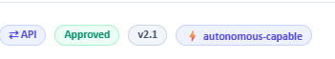 | Pills / badges | Tools Registry cards, calculation details modal | Badge | Yes | Out of the box | Themes are fixed to gray, blue, green, amber, red and violet. The POC colours map closely: API → blue, Approved → green, version → gray, autonomous → violet. Icons go in the #prefix slot. | Use Badge as-is. | Low | See §5.1
2 | 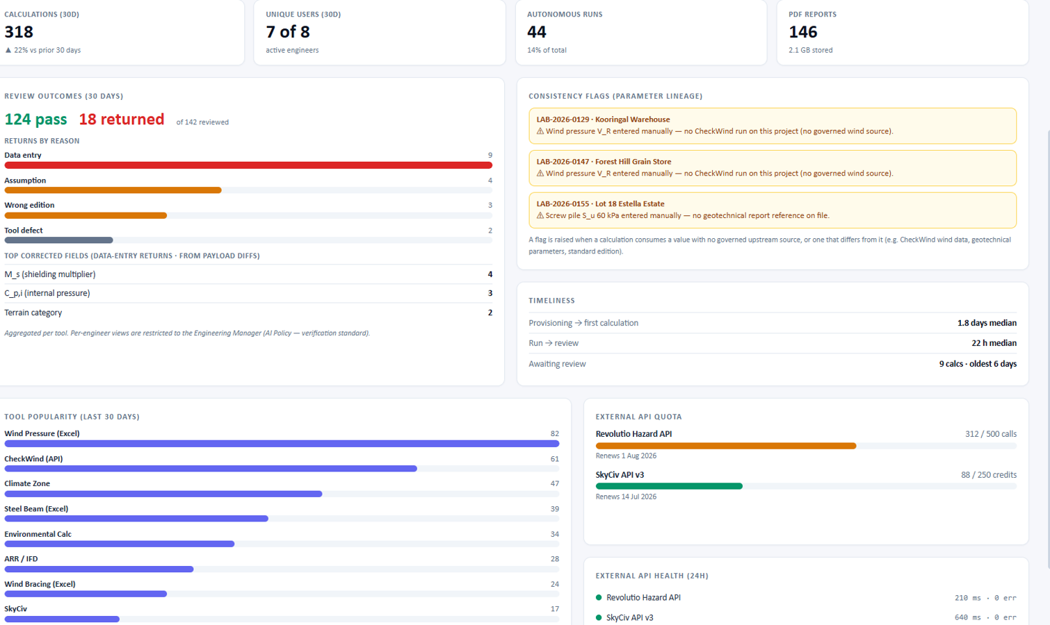 | Metrics dashboard (composite) | Engineering Labs Home / Metrics | NumberCard, BarChart, Alert, List, Progress | Yes | Compose | Mostly covered by the charts module. Exceptions: the coloured quota bars (Progress has no colour option, see 2f), the two-number "124 pass / 18 returned" headline (2b) and the status dots (2g). Broken down in 2a–2g below. | Build the page from the charts module plus List and Alert. Add two small custom pieces (quota bar, outcome headline). | Medium | See §5.2
2a | (part of row 2) | KPI cards (calculations, users, runs, reports) |  | NumberCard | Yes | Out of the box | value, delta (▲ 22%), deltaCaption and the #caption slot cover every line of the card. |  | Low | See §5.2
2b | (part of row 2) | Review outcome headline (124 pass · 18 returned) |  | — (none) | No | Custom | Two coloured numbers side by side with a caption; NumberCard shows one value. A few lines of markup with Tailwind text colours. |  | Low | See §5.2
2c | (part of row 2) | Horizontal bars (returns by reason, tool popularity) |  | BarChart (horizontal) | Yes | Compose | BarChart supports horizontal. One colour per category (red / orange / slate) needs each category as its own series (splitBy) with seriesConfig colours, which should be checked visually. |  | Low | See §5.2
2d | (part of row 2) | Key–value lists (top corrected fields, timeliness) |  | List | Yes | Compose | A two-column List (label | value), or plain markup. |  | Low | See §5.2
2e | (part of row 2) | Consistency flag callouts (amber) |  | Alert (theme amber) | Yes | Out of the box | Alert's title and description map to the reference line and the message. |  | Low | See §5.2
2f | (part of row 2) | External API quota bars (orange / green) |  | Progress | No | Custom | Progress exists, but its bar colour is fixed to gray (no theme or colour prop). The design colours each bar by usage, so it needs a small custom bar or a CSS override of Progress internals. |  | Low | See §5.2
2g | (part of row 2) | External API health rows (status dot, latency) |  | List | Yes | Compose | Rows via List; the green dot is a small span (no dedicated status-dot component). |  | Low | See §5.2
3 |  | KPI stat boxes | Calculation Catalogue / Projects overview | NumberCard | Yes | Out of the box | The coloured value (green / orange / indigo) uses the color prop; captions use the #caption slot or deltaCaption. The card border and shadow follow frappe-ui's own card style. | Use NumberCard from frappe-ui/charts. | Low | See §5.3
4 | 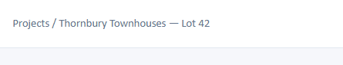 | Breadcrumb | Page header (project detail) | Breadcrumbs | Yes | Out of the box | None. items[] accepts label and route; the last item is the current page. | Use Breadcrumbs (optionally inside PageHeader). | Low | See §5.4
5 | 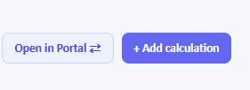 | Action buttons | Project / calculation page actions | Button | Yes | Theme | Variants (solid, subtle, outline, ghost) and icons are built in. Button themes are only gray, blue, green and red, so the POC's purple/indigo primary colour needs a one-time brand override in the Tailwind theme (or use theme="blue"). | Use Button. Agree the primary brand colour and set it once in the Tailwind config. | Low | See §5.5
6 | 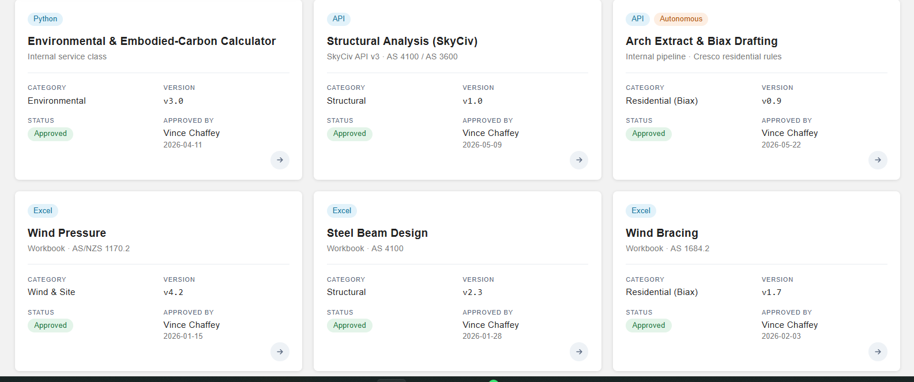 | Tool cards (grid view) | Tools Registry — grid view | — (no Card); built from Badge + Button | No | Custom | frappe-ui has no general-purpose Card component (ChartCard is for charts only). The card layout (badges, title, subtitle, divider, 2×2 label/value grid, round arrow button) is a small custom component using frappe-ui Badge and Button inside it. | Create a reusable ToolCard.vue (≈40 lines) from frappe-ui primitives + Tailwind. | Medium | See §5.6
7 | 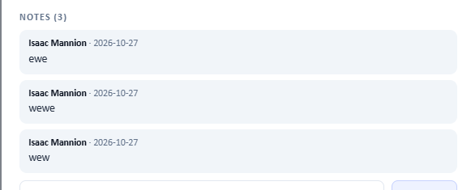 | Notes / comment list with input | Calculation details modal (Notes) | — (no comment component); TextInput + Button | No | Custom | There's no comments/notes component in frappe-ui. The note bubbles (author · date, text) are simple custom markup; the input and the Add note button are frappe-ui TextInput and Button. | Small custom NotesList.vue using TextInput + Button. | Low | See §5.7
8 | 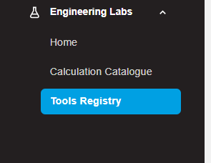 | Collapsible menu group (Engineering Labs) | Sidebar navigation | SidebarSection (collapsible) + SidebarItem | Yes | Theme | SidebarSection collapsible and SidebarItem active cover the behaviour. The dark background and the solid blue active pill differ from frappe-ui's light, subtle active style. Dark mode can be scoped to the sidebar with data-theme="dark"; the solid active colour needs a theme override. | Use SidebarSection + SidebarItem; decide whether to keep the solid blue active style. | Low | See §5.8
9 | 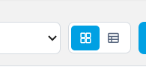 | Grid / table view toggle (icon buttons) | Tools Registry header | TabButtons (icon-only options) | Yes | Out of the box | TabButtons supports icon-only options (icon + label used as accessible text). Active colour follows frappe-ui's style rather than the solid blue in the screenshot. | Use TabButtons with v-model. | Low | See §5.9
10 | 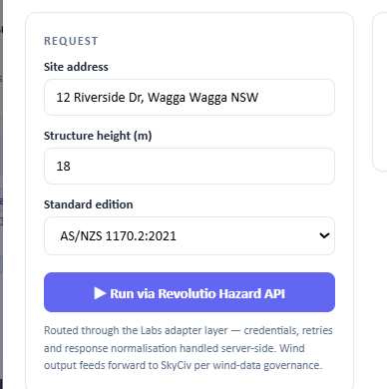 | Request form (inputs, select, run button) | Tool runner / calculation preview | TextInput, Select (or FormControl), Button | Yes | Out of the box | Labels, text/number inputs, select and a full-width primary button are all built in. frappe-ui's Select renders its own popover list rather than the browser's native dropdown. | Use TextInput/Select with their label props (or FormControl). | Low | See §5.10
11 |  | App identity block (logo + title + subtitle) | Sidebar header | SidebarHeader | Yes | Out of the box | SidebarHeader has title, subtitle and logo props, and an optional workspace menu. | Use SidebarHeader. | Low | See §5.11
12 | 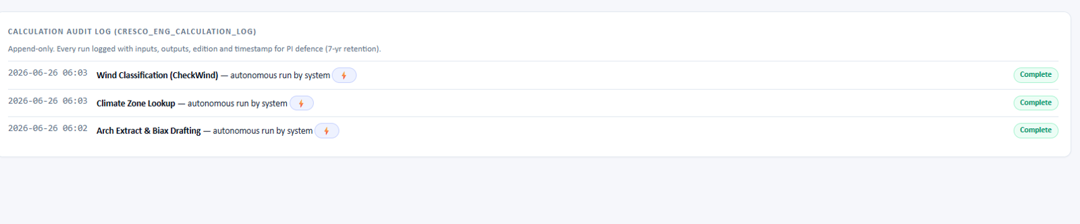 | Audit log list | Calculation audit log | List (frappe-ui/list) + Badge | Yes | Compose | Rows with a mono timestamp, title text, bolt pill and a green "Complete" badge map to a three-column List. The card wrapper and the description line are plain markup. | Use List with columns ['9rem', 'minmax(0,1fr)', 'auto']. | Low | See §5.12
13 | 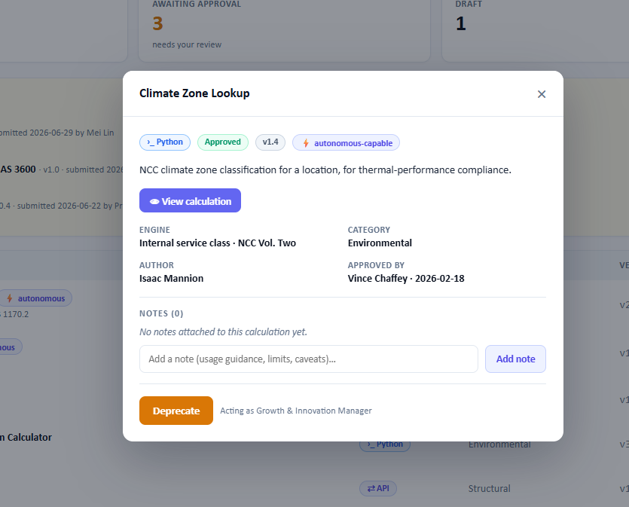 | Details modal | Tool / calculation details | Dialog (+ Badge, Button, TextInput) | Yes | Compose | Dialog provides the title, close button, sizes and an #actions slot. The body (badges, 2-column details, notes) is composed. Button has no amber/orange theme, so the orange "Deprecate" button needs a class override or theme="red". | Use Dialog; reuse NotesList (component 7) inside it. | Medium | See §5.13
14 |  | Info banner | Calculation preview | Alert (theme blue) | Yes | Out of the box | None. Alert theme="blue" with a title or description. | Use Alert. | Low | See §5.14
15 | 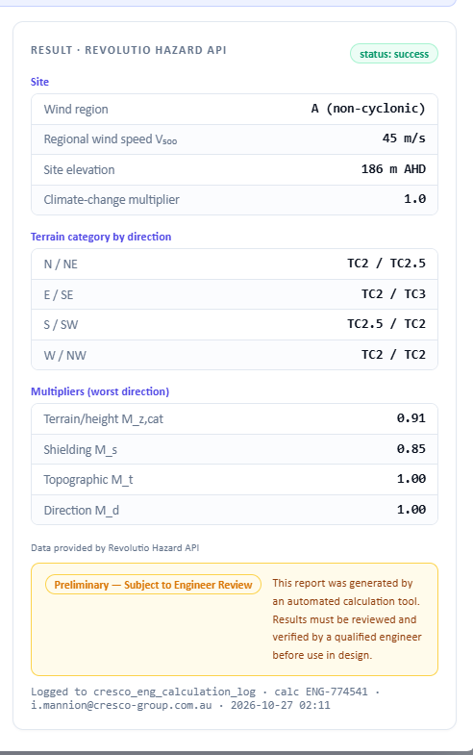 | Result panel (key–value tables + disclaimer) | Tool runner result | List (2 columns) + Badge + Alert (amber) | Yes | Compose | Section headings, label/value rows (values in monospace) and the status pill map to List and Badge. The amber disclaimer maps to Alert theme="amber" with the pill in its #prefix slot. The layout matches only approximately. | Compose; make a small ResultSection.vue for the repeated label/value groups. | Medium | See §5.15
16 | 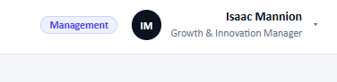 | User profile (role pill, avatar, name, title) | Top header | Avatar + Badge + Dropdown | Yes | Compose | Avatar shows initials from label. The role pill is a Badge. The name block plus caret becomes the Dropdown's #trigger (see component 18). | Compose with Avatar, Badge and Dropdown. | Low | See §5.16
17 | 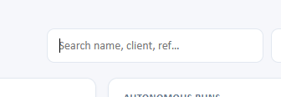 | Search bar | Projects / Tools Registry lists | TextInput (type search) | Yes | Out of the box | None. The debounce prop is built in (useful for server-side search); an optional icon goes in the #prefix slot. | Use TextInput with debounce. | Low | See §5.17
18 | 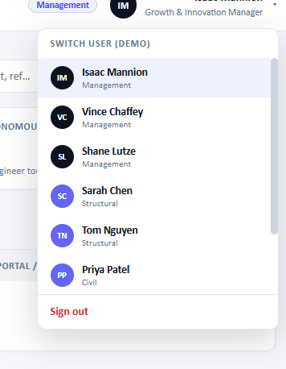 | User switcher menu (avatars, groups, sign out) | Header profile menu | Dropdown (grouped options, #item-prefix slot) | Yes | Compose | Grouped options ({ group, options }), a red-themed item for Sign out, and the #item-prefix slot for avatars. Two-line items (name + role) use the description field or the #item-label slot. | Use Dropdown with the profile block (16) as its #trigger. | Low | See §5.18
19 | 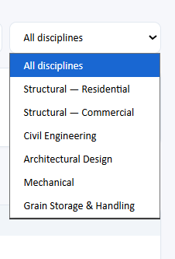 | Filter select (All disciplines) | Projects list filter | Select | Yes | Out of the box | Works as a filter. The visual differs: the screenshot is the browser's native select, while frappe-ui renders its own styled popover. | Use Select (accept frappe-ui's look, or confirm with the client). | Low | See §5.19
20 | 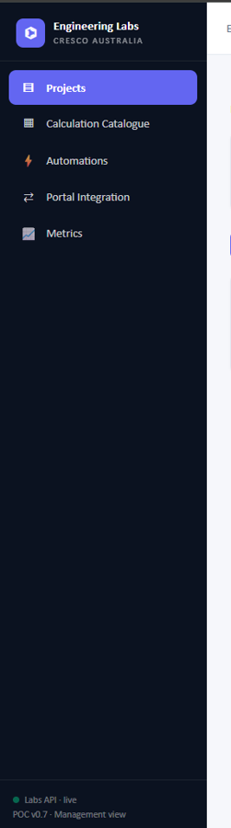 | Application sidebar (dark) | Main navigation | Sidebar, SidebarHeader, SidebarItem, SidebarCollapseToggle | Yes | Theme | Header, items with icons, active state and collapsing (icons-only) are built in. This also covers the collapsible-sidebar requirement. The sidebar can be dark while the page stays light by setting data-theme="dark" on it. The exact navy background and purple active pill need theme overrides. The footer status line goes in the bottom of the default slot. | Use Sidebar. Decide with the client whether frappe-ui's dark palette is acceptable or the exact navy/purple is required. | Medium | See §5.20
21 | 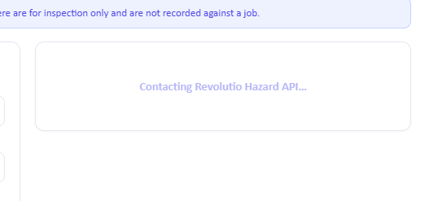 | Loading placeholder | Tool runner (while the API responds) | LoadingText / Skeleton / Spinner | Yes | Out of the box | LoadingText shows a message with a spinner; Skeleton gives a pulsing placeholder block. | Use LoadingText inside the result panel. | Low | See §5.21
22 | 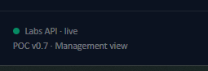 | API status indicator (dot + text) | Sidebar footer | Badge (variant ghost, dot in #prefix) | Yes | Compose | There's no dedicated status-dot component. A ghost Badge with a coloured dot in its #prefix slot gives the same result; the version line is plain text. | Badge ghost + dot, or a 3-line custom span. | Low | See §5.22
23 | 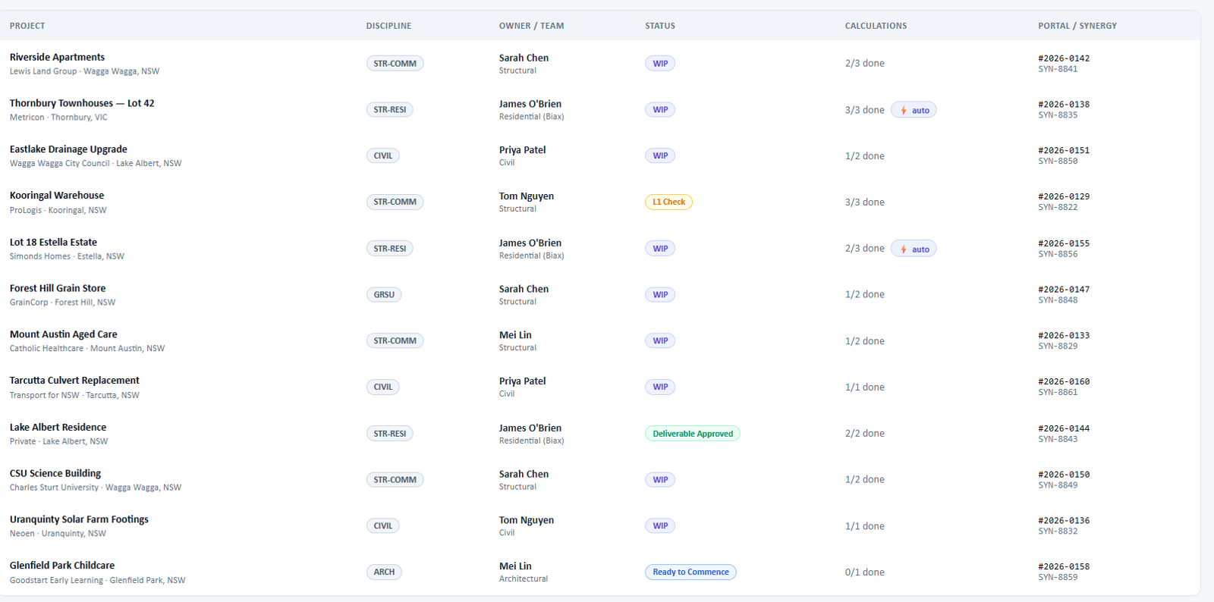 | Data table (projects) | Projects list, Tools Registry table view | List (frappe-ui/list) + Badge | Yes | Compose | List provides grid columns, a header with sortable cells, row selection and virtual scrolling. Two-line cells and status pills are composed with Badge. List has no built-in pagination bar; the first/prev/next/last + rows-per-page control required in the 2026-10-20 meeting must be built from Button + Select. | Use List; add a small Pagination.vue (Buttons + Select) under it. | Medium | See §5.23
24 | 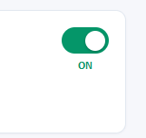 | On/off toggle | Automations / settings | Switch | Yes | Out of the box | Switch with v-model. The "ON" caption below the switch is a custom label position (Switch puts its label beside it). | Use Switch. | Low | See §5.24
25 | 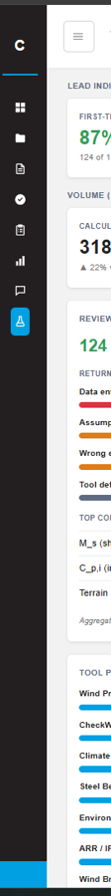 | Collapsed sidebar (icons only) | Main navigation (collapsed state) | Sidebar (collapsed) + SidebarCollapseToggle | Yes | Theme | Sidebar collapses to icons natively (collapsedWidth, default 3rem) and is controlled with v-model:collapsed; SidebarCollapseToggle adds the toggle. The dark colours follow component 20. Still to check once frappe-ui is installed: how a collapsed SidebarSection exposes its sub-items (the portal currently shows them in a pop-out). | Use Sidebar's built-in collapse; verify sub-item behaviour when collapsed. | Low | See §5.25
26 | 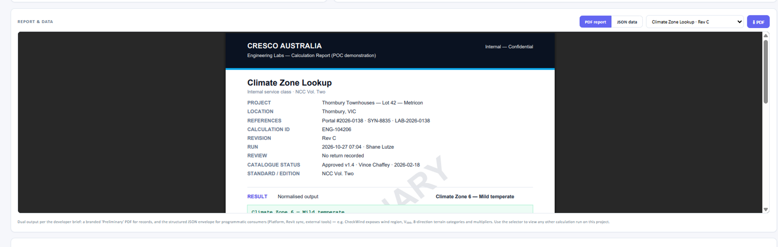 | Report & data panel — PDF preview | Project calculation page (Report & Data) | TabButtons + Select + Button; PDF viewer: none | No | Custom | The panel's controls (PDF/JSON switch, calculation selector, download button) are frappe-ui TabButtons, Select and Button. frappe-ui has no PDF viewer. The usual approach: generate the PDF on the server with a Frappe Print Format (permission-checked) and show it in the browser's built-in viewer through an <iframe>; pdf.js is an option if a custom-styled viewer is required. | Frappe Print Format for the branded PDF + <iframe> preview; controls from frappe-ui. | Medium | See §5.26
27 | 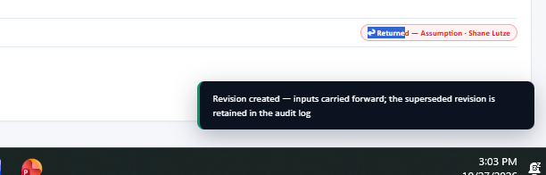 | Toast notification | Feedback after actions (e.g. revision created) | toast() + ToastProvider | Yes | Out of the box | frappe-ui ships toast (built on vue-sonner) with success / error / warning / info variants. Add <ToastProvider /> once at the app root. The dark style with a green accent may differ slightly from frappe-ui's default toast look. The red "Returned" pill in the screenshot is a Badge (theme red). | Use toast.success(...) after actions; ToastProvider in App.vue. | Low | See §5.27
28 | 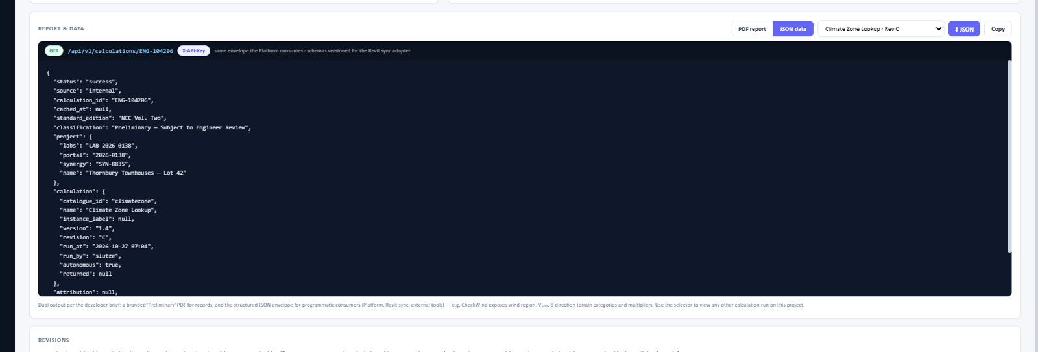 | Report & data panel — JSON preview | Project calculation page (Report & Data) | CodeEditor (read-only, JSON) + TabButtons + Badge + Button | Yes | Compose | frappe-ui's code-editor molecule (CodeMirror) shows JSON read-only with syntax highlighting (editable=false). The header strip (GET badge, endpoint, X-API-Key pill) is Badge + text; Copy and Download are Buttons. The dark code background can come from data-theme="dark" on the panel. | Use CodeEditor read-only with loadLanguage('json'). | Medium | See §5.28
29 | 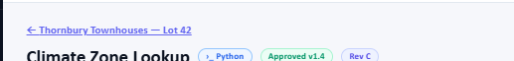 | Back link + page title with badges | Calculation page header | Button (ghost, route) + Badge (or PageHeader / Breadcrumbs) | Yes | Compose | The back link is a ghost Button with a left-arrow icon and a route; the badges are Badge. PageHeader (with its back button) or Breadcrumbs (component 4) are frappe-ui alternatives for the same "go up one level" pattern. | Ghost Button with route + title + Badges. | Low | See §5.29
30 | 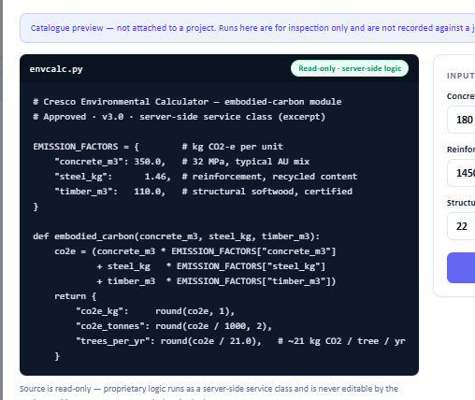 | Read-only source code viewer | Calculation preview (Python tools) | CodeEditor (read-only, Python) + Badge | Yes | Compose | Same code-editor molecule as component 28 with loadLanguage('python'). The header (file name + "Read-only · server-side logic" badge) is plain markup + Badge. Note: the code shown must come from the server and only to users allowed to see it — the viewer itself doesn't restrict anything. | Use CodeEditor read-only with loadLanguage('python'). | Low | See §5.30
31 | 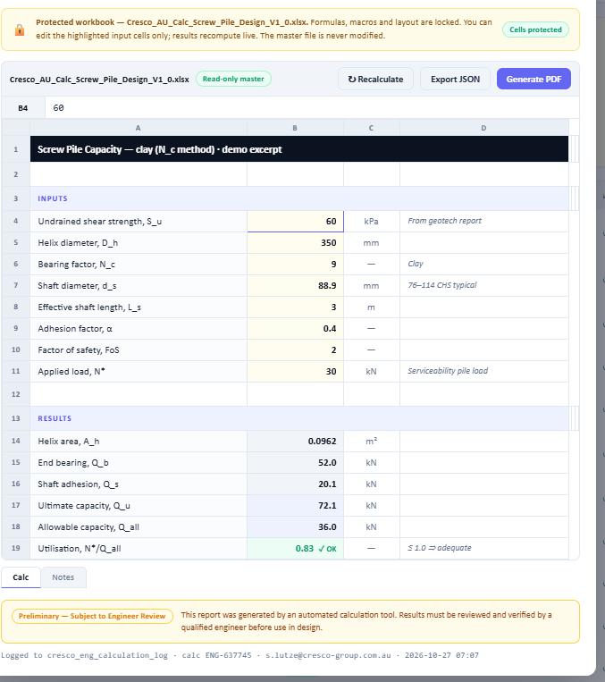 | Protected Excel workbook preview (spreadsheet) | Calculation preview (Excel tools) | — (no spreadsheet); Alert, Button, Tabs, Badge around it | No | Custom | frappe-ui has no spreadsheet grid (cell references, formula bar, row/column headers, sheet tabs, live recalculation). The surrounding parts are covered: protected-workbook banner (Alert amber), toolbar (Button), sheet tabs (Tabs), disclaimer (Alert). Two routes: (a) an external spreadsheet library — e.g. Jspreadsheet CE (MIT), Univer (Apache-2.0), Handsontable (paid licence for commercial use) — plus server-side formula evaluation; or (b) since only the input cells are editable, show the workbook as an inputs form + results table (TextInput + List), which frappe-ui covers fully. | Decide with the client whether a true spreadsheet look is required. If not, use route (b); if yes, evaluate the libraries' licences and bundle size first. | High | See §5.31
32 | 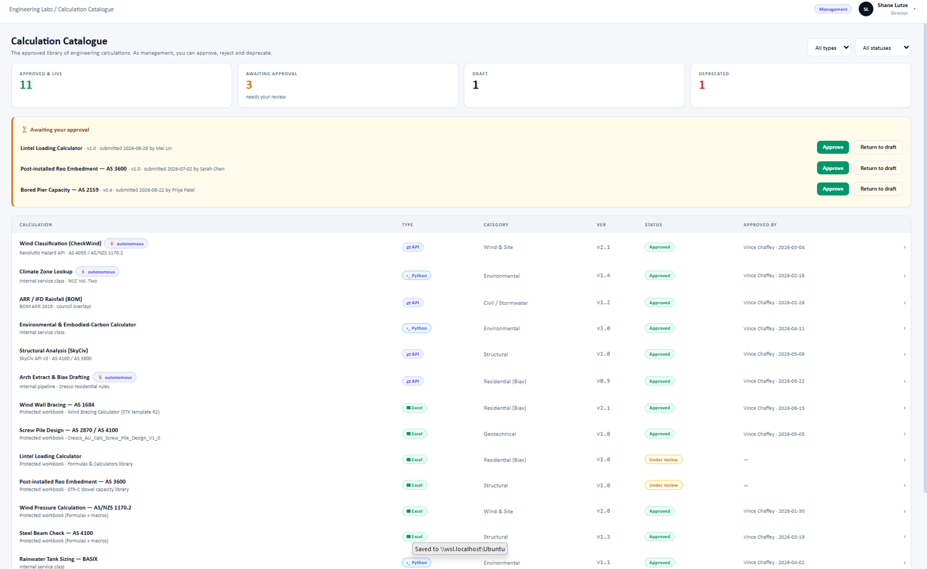 | Calculation Catalogue page (complete screen) | Calculation Catalogue | Breadcrumbs, Select, NumberCard, List, Button, Badge, Avatar | Yes | Compose | A full page assembled from rows already covered: header breadcrumb (4) and profile (16), filters (19), stat boxes (3), the calculation table (23) and badges (1). The amber "Awaiting your approval" panel is a styled container with List rows and Approve / Return to draft Buttons (Alert only has one primary + one secondary action, so it doesn't fit a multi-row list). | Compose from the components above; the approval panel is a small custom wrapper. | Medium | See §5.32
33 | 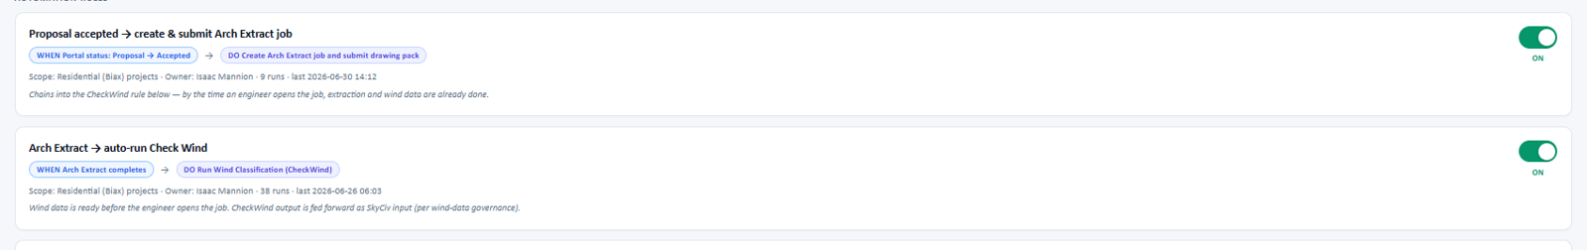 | Automation rule cards (horizontal list) | Automations page | List (frappe-ui/list) + Badge + Switch | Yes | Compose | Each rule is one full-width row: title, a WHEN pill → DO pill (Badge, blue / violet, with an arrow icon between), a meta line (scope · owner · runs · last run), an italic description and an ON/OFF Switch. List gives one row per rule with a content cell and a switch cell. List draws rows with dividers, so the separate rounded, spaced cards in the screenshot need a small wrapper class (or render the rows with v-for in plain bordered divs). The ON caption under the switch is the same custom label as component 24. | Use List (or v-for over bordered divs) with Badge + Switch; reuse the toggle from component 24. | Medium | See §5.33

5. Component details and source code
Imports: core components from 'frappe-ui', charts from 'frappe-ui/charts', the list from 'frappe-ui/list' and the code viewer from 'frappe-ui/code-editor'. Icons use Lucide, either as strings (icon="lucide-plus") via frappe-ui's Vite plugin, or as imports from '~icons/lucide/…'.

5.1 Pills / badges
Screenshot: components/badge.png
Used in | Tools Registry cards, calculation details modal
Frappe UI component | Badge
Available in Frappe UI | Yes
Fit / effort | Out of the box · Low
Gap / notes | Themes are fixed to gray, blue, green, amber, red and violet. The POC colours map closely: API → blue, Approved → green, version → gray, autonomous → violet. Icons go in the #prefix slot.
Recommendation | Use Badge as-is.
Documentation | https://ui.frappe.io/docs/components/badge
Source code (Vue 3 + frappe-ui 1.0.2)
<script setup>
import { Badge } from 'frappe-ui'
import LucideArrowLeftRight from '~icons/lucide/arrow-left-right'
import LucideZap from '~icons/lucide/zap'
</script>

<template>
<div class="flex flex-wrap gap-1.5">
<Badge theme="blue" label="API">
<template #prefix><LucideArrowLeftRight class="size-3" /></template>
</Badge>
<Badge theme="green" label="Approved" />
<Badge theme="gray" label="v2.1" />
<Badge theme="violet" label="autonomous-capable">
<template #prefix><LucideZap class="size-3 text-amber-600" /></template>
</Badge>
</div>
</template>

5.2 Metrics dashboard (composite)
Screenshot: components/bar_and_graph.png
Used in | Engineering Labs Home / Metrics
Frappe UI component | NumberCard, BarChart, Alert, List, Progress
Available in Frappe UI | Yes
Fit / effort | Compose · Medium
Gap / notes | Mostly covered by the charts module. Exceptions: the coloured quota bars (Progress has no colour option, see 2f), the two-number "124 pass / 18 returned" headline (2b) and the status dots (2g). Broken down in 2a–2g below.
Recommendation | Build the page from the charts module plus List and Alert. Add two small custom pieces (quota bar, outcome headline).
Documentation | https://ui.frappe.io/docs/charts/numbercard  https://ui.frappe.io/docs/charts/barchart  https://ui.frappe.io/docs/charts/dashboard

# | Part | Frappe UI component | Available | Notes
2a | KPI cards (calculations, users, runs, reports) | NumberCard | Yes | value, delta (▲ 22%), deltaCaption and the #caption slot cover every line of the card.
2b | Review outcome headline (124 pass · 18 returned) | — (none) | No | Two coloured numbers side by side with a caption; NumberCard shows one value. A few lines of markup with Tailwind text colours.
2c | Horizontal bars (returns by reason, tool popularity) | BarChart (horizontal) | Yes | BarChart supports horizontal. One colour per category (red / orange / slate) needs each category as its own series (splitBy) with seriesConfig colours, which should be checked visually.
2d | Key–value lists (top corrected fields, timeliness) | List | Yes | A two-column List (label | value), or plain markup.
2e | Consistency flag callouts (amber) | Alert (theme amber) | Yes | Alert's title and description map to the reference line and the message.
2f | External API quota bars (orange / green) | Progress | No | Progress exists, but its bar colour is fixed to gray (no theme or colour prop). The design colours each bar by usage, so it needs a small custom bar or a CSS override of Progress internals.
2g | External API health rows (status dot, latency) | List | Yes | Rows via List; the green dot is a small span (no dedicated status-dot component).
Source code (Vue 3 + frappe-ui 1.0.2)
<script setup>
import { Alert } from 'frappe-ui'
import { NumberCard, BarChart } from 'frappe-ui/charts'

const toolPopularity = [
{ tool: 'Wind Pressure (Excel)', runs: 82 },
{ tool: 'CheckWind (API)', runs: 61 },
{ tool: 'Climate Zone', runs: 47 },
]
</script>

<template>
<div class="grid grid-cols-4 gap-3">
<NumberCard title="Calculations (30d)" :value="318"
:delta="22" delta-suffix="%" delta-caption="vs prior 30 days" />
<!-- …three more NumberCards (see component 3) -->
</div>

<div class="grid grid-cols-2 gap-4 mt-4">
<BarChart title="Tool popularity (last 30 days)" :data="toolPopularity"
x="tool" y="runs" horizontal />
<div class="space-y-2">
<Alert theme="amber" title="LAB-2026-0129 · Kooringal Warehouse"
description="Wind pressure V_R entered manually — no CheckWind run on this project." />
</div>
</div>
</template>

5.3 KPI stat boxes
Screenshot: components/boxes.png
Used in | Calculation Catalogue / Projects overview
Frappe UI component | NumberCard
Available in Frappe UI | Yes
Fit / effort | Out of the box · Low
Gap / notes | The coloured value (green / orange / indigo) uses the color prop; captions use the #caption slot or deltaCaption. The card border and shadow follow frappe-ui's own card style.
Recommendation | Use NumberCard from frappe-ui/charts.
Documentation | https://ui.frappe.io/docs/charts/numbercard
Source code (Vue 3 + frappe-ui 1.0.2)
<script setup>
import { NumberCard } from 'frappe-ui/charts'
</script>

<template>
<div class="grid grid-cols-4 gap-3">
<NumberCard title="First-time pass (30d)" value="87%" color="#059669">
<template #caption>124 of 142 reviewed</template>
</NumberCard>
<NumberCard title="Consistency flags" value="3 open" color="#d97706">
<template #caption>parameter lineage</template>
</NumberCard>
<NumberCard title="Calculations (30 days)" :value="318" color="#6366f1"
:delta="22" delta-suffix="%" delta-caption="vs prior 30 days" />
<NumberCard title="Autonomous runs" :value="44">
<template #caption>no engineer touch</template>
</NumberCard>
</div>
</template>

5.4 Breadcrumb
Screenshot: components/breadcrumb.png
Used in | Page header (project detail)
Frappe UI component | Breadcrumbs
Available in Frappe UI | Yes
Fit / effort | Out of the box · Low
Gap / notes | None. items[] accepts label and route; the last item is the current page.
Recommendation | Use Breadcrumbs (optionally inside PageHeader).
Documentation | https://ui.frappe.io/docs/components/breadcrumbs  https://ui.frappe.io/docs/components/pageheader
Source code (Vue 3 + frappe-ui 1.0.2)
<script setup>
import { Breadcrumbs } from 'frappe-ui'

const items = [
{ label: 'Projects', route: '/projects' },
{ label: 'Thornbury Townhouses — Lot 42' },
]
</script>

<template>
<Breadcrumbs :items="items" />
</template>

5.5 Action buttons
Screenshot: components/buttons.png
Used in | Project / calculation page actions
Frappe UI component | Button
Available in Frappe UI | Yes
Fit / effort | Theme · Low
Gap / notes | Variants (solid, subtle, outline, ghost) and icons are built in. Button themes are only gray, blue, green and red, so the POC's purple/indigo primary colour needs a one-time brand override in the Tailwind theme (or use theme="blue").
Recommendation | Use Button. Agree the primary brand colour and set it once in the Tailwind config.
Documentation | https://ui.frappe.io/docs/components/button  https://ui.frappe.io/docs/foundations/colors
Source code (Vue 3 + frappe-ui 1.0.2)
<script setup>
import { Button } from 'frappe-ui'
</script>

<template>
<div class="flex gap-2">
<Button variant="outline" label="Open in Portal" icon-right="lucide-arrow-left-right" />
<Button variant="solid" label="Add calculation" icon-left="lucide-plus" />
</div>
</template>

5.6 Tool cards (grid view)
Screenshot: components/cards.png
Used in | Tools Registry — grid view
Frappe UI component | — (no Card); built from Badge + Button
Available in Frappe UI | No
Fit / effort | Custom · Medium
Gap / notes | frappe-ui has no general-purpose Card component (ChartCard is for charts only). The card layout (badges, title, subtitle, divider, 2×2 label/value grid, round arrow button) is a small custom component using frappe-ui Badge and Button inside it.
Recommendation | Create a reusable ToolCard.vue (≈40 lines) from frappe-ui primitives + Tailwind.
Documentation | https://ui.frappe.io/docs/components/badge  https://ui.frappe.io/docs/components/button
Source code (Vue 3 + frappe-ui 1.0.2)
<!-- ToolCard.vue -->
<script setup>
import { Badge, Button } from 'frappe-ui'

defineProps({ tool: { type: Object, required: true } })
defineEmits(['open'])
</script>

<template>
<div class="rounded-lg border border-outline-gray-1 bg-surface-base p-4 shadow-sm">
<div class="flex gap-1.5">
<Badge theme="blue" :label="tool.type" />
<Badge v-if="tool.autonomous" theme="amber" label="Autonomous" />
</div>
<h3 class="mt-3 text-lg font-semibold text-ink-gray-9">{{ tool.name }}</h3>
<p class="text-sm text-ink-gray-5">{{ tool.source }}</p>
<hr class="my-3 border-outline-gray-1" />
<dl class="grid grid-cols-2 gap-3 text-sm">
<div><dt class="text-xs uppercase text-ink-gray-5">Category</dt><dd>{{ tool.category }}</dd></div>
<div><dt class="text-xs uppercase text-ink-gray-5">Version</dt><dd class="font-mono">{{ tool.version }}</dd></div>
<div><dt class="text-xs uppercase text-ink-gray-5">Status</dt>
<dd><Badge theme="green" :label="tool.status" /></dd></div>
<div><dt class="text-xs uppercase text-ink-gray-5">Approved by</dt>
<dd>{{ tool.approvedBy }}<br /><span class="text-xs text-ink-gray-5">{{ tool.approvedOn }}</span></dd></div>
</dl>
<div class="mt-2 flex justify-end">
<Button variant="subtle" icon="lucide-arrow-right" @click="$emit('open', tool)" />
</div>
</div>
</template>

5.7 Notes / comment list with input
Screenshot: components/comment-box.png
Used in | Calculation details modal (Notes)
Frappe UI component | — (no comment component); TextInput + Button
Available in Frappe UI | No
Fit / effort | Custom · Low
Gap / notes | There's no comments/notes component in frappe-ui. The note bubbles (author · date, text) are simple custom markup; the input and the Add note button are frappe-ui TextInput and Button.
Recommendation | Small custom NotesList.vue using TextInput + Button.
Documentation | https://ui.frappe.io/docs/components/textinput  https://ui.frappe.io/docs/components/button
Source code (Vue 3 + frappe-ui 1.0.2)
<script setup>
import { ref } from 'vue'
import { TextInput, Button } from 'frappe-ui'

const props = defineProps({ notes: { type: Array, default: () => [] } })
const emit = defineEmits(['add'])
const text = ref('')

function add() {
if (text.value.trim()) emit('add', text.value.trim())
text.value = ''
}
</script>

<template>
<section>
<h4 class="text-xs font-semibold uppercase text-ink-gray-5">Notes ({{ notes.length }})</h4>
<div v-for="(note, i) in notes" :key="i" class="mt-2 rounded-lg bg-surface-gray-2 px-3 py-2">
<div class="text-xs text-ink-gray-5">
<strong class="text-ink-gray-8">{{ note.author }}</strong> · {{ note.date }}
</div>
<p class="text-sm text-ink-gray-8">{{ note.text }}</p>
</div>
<div class="mt-3 flex gap-2">
<TextInput v-model="text" class="flex-1"
placeholder="Add a note (usage guidance, limits, caveats)…" @keydown.enter="add" />
<Button label="Add note" :disabled="!text.trim()" @click="add" />
</div>
</section>
</template>

5.8 Collapsible menu group (Engineering Labs)
Screenshot: components/dropdown.png
Used in | Sidebar navigation
Frappe UI component | SidebarSection (collapsible) + SidebarItem
Available in Frappe UI | Yes
Fit / effort | Theme · Low
Gap / notes | SidebarSection collapsible and SidebarItem active cover the behaviour. The dark background and the solid blue active pill differ from frappe-ui's light, subtle active style. Dark mode can be scoped to the sidebar with data-theme="dark"; the solid active colour needs a theme override.
Recommendation | Use SidebarSection + SidebarItem; decide whether to keep the solid blue active style.
Documentation | https://ui.frappe.io/docs/components/sidebar
Source code (Vue 3 + frappe-ui 1.0.2)
<script setup>
import { SidebarSection, SidebarItem } from 'frappe-ui'
import { useRoute } from 'vue-router'
const route = useRoute()
</script>

<template>
<SidebarSection label="Engineering Labs" collapsible>
<SidebarItem label="Home" route="/engineering-labs/home"
:active="route.path === '/engineering-labs/home'" />
<SidebarItem label="Calculation Catalogue" route="/engineering-labs/calculation-catalogue"
:active="route.path.startsWith('/engineering-labs/calculation-catalogue')" />
<SidebarItem label="Tools Registry" route="/engineering-labs/tools-registry"
:active="route.path.startsWith('/engineering-labs/tools-registry')" />
</SidebarSection>
</template>

5.9 Grid / table view toggle (icon buttons)
Screenshot: components/dual-button.png
Used in | Tools Registry header
Frappe UI component | TabButtons (icon-only options)
Available in Frappe UI | Yes
Fit / effort | Out of the box · Low
Gap / notes | TabButtons supports icon-only options (icon + label used as accessible text). Active colour follows frappe-ui's style rather than the solid blue in the screenshot.
Recommendation | Use TabButtons with v-model.
Documentation | https://ui.frappe.io/docs/components/tabbuttons
Source code (Vue 3 + frappe-ui 1.0.2)
<script setup>
import { ref } from 'vue'
import { TabButtons } from 'frappe-ui'

const view = ref('grid')
const options = [
{ value: 'grid', label: 'Grid view', icon: 'lucide-layout-grid' },
{ value: 'table', label: 'Table view', icon: 'lucide-table' },
]
</script>

<template>
<TabButtons v-model="view" :options="options" />
</template>

5.10 Request form (inputs, select, run button)
Screenshot: components/form.png
Used in | Tool runner / calculation preview
Frappe UI component | TextInput, Select (or FormControl), Button
Available in Frappe UI | Yes
Fit / effort | Out of the box · Low
Gap / notes | Labels, text/number inputs, select and a full-width primary button are all built in. frappe-ui's Select renders its own popover list rather than the browser's native dropdown.
Recommendation | Use TextInput/Select with their label props (or FormControl).
Documentation | https://ui.frappe.io/docs/components/textinput  https://ui.frappe.io/docs/components/select  https://ui.frappe.io/docs/components/formcontrol
Source code (Vue 3 + frappe-ui 1.0.2)
<script setup>
import { reactive } from 'vue'
import { TextInput, Select, Button } from 'frappe-ui'

const form = reactive({ address: '', height: '', edition: null })
const editions = [
{ label: 'AS/NZS 1170.2:2021', value: '2021' },
{ label: 'AS/NZS 1170.2:2011', value: '2011' },
]

function run() {
// call the permission-checked whitelisted method that runs the tool
}
</script>

<template>
<form class="space-y-4 rounded-lg border border-outline-gray-1 p-4" @submit.prevent="run">
<p class="text-xs font-semibold uppercase text-ink-gray-5">Request</p>
<TextInput v-model="form.address" label="Site address" />
<TextInput v-model="form.height" type="number" label="Structure height (m)" />
<Select v-model="form.edition" :options="editions" label="Standard edition" />
<Button type="submit" variant="solid" class="w-full" icon-left="lucide-play"
label="Run via Revolutio Hazard API" />
<p class="text-xs text-ink-gray-5">Routed through the Labs adapter layer…</p>
</form>
</template>

5.11 App identity block (logo + title + subtitle)
Screenshot: components/icon-badge.png
Used in | Sidebar header
Frappe UI component | SidebarHeader
Available in Frappe UI | Yes
Fit / effort | Out of the box · Low
Gap / notes | SidebarHeader has title, subtitle and logo props, and an optional workspace menu.
Recommendation | Use SidebarHeader.
Documentation | https://ui.frappe.io/docs/components/sidebar
Source code (Vue 3 + frappe-ui 1.0.2)
<script setup>
import { SidebarHeader } from 'frappe-ui'
import logo from '@/assets/cresco-logo.svg'
</script>

<template>
<SidebarHeader title="Engineering Labs" subtitle="Cresco Australia" :logo="logo" />
</template>

5.12 Audit log list
Screenshot: components/logs.png
Used in | Calculation audit log
Frappe UI component | List (frappe-ui/list) + Badge
Available in Frappe UI | Yes
Fit / effort | Compose · Low
Gap / notes | Rows with a mono timestamp, title text, bolt pill and a green "Complete" badge map to a three-column List. The card wrapper and the description line are plain markup.
Recommendation | Use List with columns ['9rem', 'minmax(0,1fr)', 'auto'].
Documentation | https://ui.frappe.io/docs/molecules/list  https://ui.frappe.io/docs/components/badge
Source code (Vue 3 + frappe-ui 1.0.2)
<script setup>
import { Badge } from 'frappe-ui'
import { List, ListRows, ListRow, ListCell } from 'frappe-ui/list'

defineProps({ logs: { type: Array, required: true } })
</script>

<template>
<List :columns="['9rem', 'minmax(0,1fr)', 'auto']">
<ListRows :items="logs" row-key="name" v-slot="{ item, value }">
<ListRow :value="value">
<ListCell class="font-mono text-ink-gray-5">{{ item.ran_at }}</ListCell>
<ListCell><strong>{{ item.tool }}</strong> — {{ item.description }}</ListCell>
<ListCell><Badge theme="green" variant="outline" label="Complete" /></ListCell>
</ListRow>
</ListRows>
</List>
</template>

5.13 Details modal
Screenshot: components/modal.png
Used in | Tool / calculation details
Frappe UI component | Dialog (+ Badge, Button, TextInput)
Available in Frappe UI | Yes
Fit / effort | Compose · Medium
Gap / notes | Dialog provides the title, close button, sizes and an #actions slot. The body (badges, 2-column details, notes) is composed. Button has no amber/orange theme, so the orange "Deprecate" button needs a class override or theme="red".
Recommendation | Use Dialog; reuse NotesList (component 7) inside it.
Documentation | https://ui.frappe.io/docs/components/dialog
Source code (Vue 3 + frappe-ui 1.0.2)
<script setup>
import { Dialog, Badge, Button } from 'frappe-ui'

const open = defineModel('open', { type: Boolean })
defineProps({ tool: { type: Object, required: true } })
</script>

<template>
<Dialog v-model:open="open" :title="tool.name" size="xl">
<div class="space-y-4">
<div class="flex gap-1.5">
<Badge theme="blue" :label="tool.type" />
<Badge theme="green" :label="tool.status" />
<Badge :label="tool.version" />
</div>
<p class="text-sm">{{ tool.description }}</p>
<Button variant="solid" icon-left="lucide-eye" label="View calculation" />
<!-- 2-column details grid + <NotesList /> -->
</div>
<template #actions>
<Button variant="solid" theme="red" label="Deprecate" />
<span class="ml-3 text-sm text-ink-gray-5">Acting as Growth &amp; Innovation Manager</span>
</template>
</Dialog>
</template>

5.14 Info banner
Screenshot: components/notification-box.png
Used in | Calculation preview
Frappe UI component | Alert (theme blue)
Available in Frappe UI | Yes
Fit / effort | Out of the box · Low
Gap / notes | None. Alert theme="blue" with a title or description.
Recommendation | Use Alert.
Documentation | https://ui.frappe.io/docs/components/alert
Source code (Vue 3 + frappe-ui 1.0.2)
<script setup>
import { Alert } from 'frappe-ui'
</script>

<template>
<Alert theme="blue"
title="Catalogue preview — not attached to a project. Runs here are for inspection only and are not recorded against a job." />
</template>

5.15 Result panel (key–value tables + disclaimer)
Screenshot: components/one-column-table.png
Used in | Tool runner result
Frappe UI component | List (2 columns) + Badge + Alert (amber)
Available in Frappe UI | Yes
Fit / effort | Compose · Medium
Gap / notes | Section headings, label/value rows (values in monospace) and the status pill map to List and Badge. The amber disclaimer maps to Alert theme="amber" with the pill in its #prefix slot. The layout matches only approximately.
Recommendation | Compose; make a small ResultSection.vue for the repeated label/value groups.
Documentation | https://ui.frappe.io/docs/molecules/list  https://ui.frappe.io/docs/components/alert  https://ui.frappe.io/docs/components/badge
Source code (Vue 3 + frappe-ui 1.0.2)
<script setup>
import { Alert, Badge } from 'frappe-ui'
import { List, ListRows, ListRow, ListCell } from 'frappe-ui/list'

defineProps({ result: { type: Object, required: true } })
</script>

<template>
<div class="space-y-4">
<div class="flex items-center justify-between">
<p class="text-xs font-semibold uppercase text-ink-gray-5">Result · Revolutio Hazard API</p>
<Badge theme="green" variant="outline" :label="`status: ${result.status}`" />
</div>
<section v-for="section in result.sections" :key="section.title">
<h4 class="mb-1 text-sm font-semibold text-ink-blue-6">{{ section.title }}</h4>
<List :columns="['minmax(0,1fr)', 'auto']">
<ListRows :items="section.rows" :row-key="(row) => row[0]" v-slot="{ item, value }">
<ListRow :value="value">
<ListCell>{{ item[0] }}</ListCell>
<ListCell class="font-mono font-semibold">{{ item[1] }}</ListCell>
</ListRow>
</ListRows>
</List>
</section>
<Alert theme="amber"
description="This report was generated by an automated calculation tool. Results must be reviewed and verified by a qualified engineer before use in design.">
<template #prefix><Badge theme="amber" variant="outline" label="Preliminary — Subject to Engineer Review" /></template>
</Alert>
</div>
</template>

5.16 User profile (role pill, avatar, name, title)
Screenshot: components/profile.png
Used in | Top header
Frappe UI component | Avatar + Badge + Dropdown
Available in Frappe UI | Yes
Fit / effort | Compose · Low
Gap / notes | Avatar shows initials from label. The role pill is a Badge. The name block plus caret becomes the Dropdown's #trigger (see component 18).
Recommendation | Compose with Avatar, Badge and Dropdown.
Documentation | https://ui.frappe.io/docs/components/avatar  https://ui.frappe.io/docs/components/badge  https://ui.frappe.io/docs/components/dropdown
Source code (Vue 3 + frappe-ui 1.0.2)
<script setup>
import { Avatar, Badge } from 'frappe-ui'
defineProps({ user: { type: Object, required: true } })
</script>

<template>
<div class="flex items-center gap-3">
<Badge theme="violet" :label="user.role" />
<Avatar :label="user.full_name" :image="user.image" size="lg" />
<div class="text-right leading-tight">
<div class="text-sm font-semibold text-ink-gray-9">{{ user.full_name }}</div>
<div class="text-xs text-ink-gray-5">{{ user.job_title }}</div>
</div>
</div>
</template>

5.17 Search bar
Screenshot: components/search-bar.png
Used in | Projects / Tools Registry lists
Frappe UI component | TextInput (type search)
Available in Frappe UI | Yes
Fit / effort | Out of the box · Low
Gap / notes | None. The debounce prop is built in (useful for server-side search); an optional icon goes in the #prefix slot.
Recommendation | Use TextInput with debounce.
Documentation | https://ui.frappe.io/docs/components/textinput
Source code (Vue 3 + frappe-ui 1.0.2)
<script setup>
import { ref } from 'vue'
import { TextInput } from 'frappe-ui'
import LucideSearch from '~icons/lucide/search'

const search = ref('')
</script>

<template>
<TextInput v-model="search" type="search" :debounce="300" placeholder="Search name, client, ref…">
<template #prefix><LucideSearch class="size-4 text-ink-gray-5" /></template>
</TextInput>
</template>

5.18 User switcher menu (avatars, groups, sign out)
Screenshot: components/select-modal.png
Used in | Header profile menu
Frappe UI component | Dropdown (grouped options, #item-prefix slot)
Available in Frappe UI | Yes
Fit / effort | Compose · Low
Gap / notes | Grouped options ({ group, options }), a red-themed item for Sign out, and the #item-prefix slot for avatars. Two-line items (name + role) use the description field or the #item-label slot.
Recommendation | Use Dropdown with the profile block (16) as its #trigger.
Documentation | https://ui.frappe.io/docs/components/dropdown
Source code (Vue 3 + frappe-ui 1.0.2)
<script setup>
import { Dropdown, Avatar } from 'frappe-ui'

const users = [
{ label: 'Isaac Mannion', description: 'Management' },
{ label: 'Sarah Chen', description: 'Structural' },
]
const switchTo = (user) => { /* demo only */ }
const logout = () => (window.location.href = '/?cmd=web_logout')
const options = [
{ group: 'Switch user (demo)', options: users.map((u) => ({ ...u, onClick: () => switchTo(u) })) },
{ label: 'Sign out', theme: 'red', onClick: logout },
]
</script>

<template>
<Dropdown :options="options" align="end">
<template #trigger><!-- profile block from component 16 --></template>
<template #item-prefix="{ item }">
<Avatar v-if="item.description" :label="item.label" size="sm" />
</template>
</Dropdown>
</template>

5.19 Filter select (All disciplines)
Screenshot: components/select.png
Used in | Projects list filter
Frappe UI component | Select
Available in Frappe UI | Yes
Fit / effort | Out of the box · Low
Gap / notes | Works as a filter. The visual differs: the screenshot is the browser's native select, while frappe-ui renders its own styled popover.
Recommendation | Use Select (accept frappe-ui's look, or confirm with the client).
Documentation | https://ui.frappe.io/docs/components/select
Source code (Vue 3 + frappe-ui 1.0.2)
<script setup>
import { ref } from 'vue'
import { Select } from 'frappe-ui'

const discipline = ref('')
const options = [
{ label: 'All disciplines', value: '' },
{ label: 'Structural — Residential', value: 'STR-RESI' },
{ label: 'Structural — Commercial', value: 'STR-COMM' },
{ label: 'Civil Engineering', value: 'CIVIL' },
]
</script>

<template>
<Select v-model="discipline" :options="options" placeholder="All disciplines" />
</template>

5.20 Application sidebar (dark)
Screenshot: components/sidebar.png
Used in | Main navigation
Frappe UI component | Sidebar, SidebarHeader, SidebarItem, SidebarCollapseToggle
Available in Frappe UI | Yes
Fit / effort | Theme · Medium
Gap / notes | Header, items with icons, active state and collapsing (icons-only) are built in. This also covers the collapsible-sidebar requirement. The sidebar can be dark while the page stays light by setting data-theme="dark" on it. The exact navy background and purple active pill need theme overrides. The footer status line goes in the bottom of the default slot.
Recommendation | Use Sidebar. Decide with the client whether frappe-ui's dark palette is acceptable or the exact navy/purple is required.
Documentation | https://ui.frappe.io/docs/components/sidebar  https://ui.frappe.io/docs/components/sidebarrail
Source code (Vue 3 + frappe-ui 1.0.2)
<script setup>
import { ref } from 'vue'
import { Sidebar, SidebarHeader, SidebarItem, SidebarCollapseToggle } from 'frappe-ui'
import logo from '@/assets/cresco-logo.svg'

const collapsed = ref(false)
</script>

<template>
<Sidebar v-model:collapsed="collapsed" data-theme="dark">
<SidebarHeader title="Engineering Labs" subtitle="Cresco Australia" :logo="logo" />
<div class="flex-1 overflow-y-auto">
<SidebarItem label="Projects" icon="lucide-folder" route="/projects" />
<SidebarItem label="Calculation Catalogue" icon="lucide-calculator" route="/catalogue" />
<SidebarItem label="Automations" icon="lucide-zap" route="/automations" />
<SidebarItem label="Portal Integration" icon="lucide-arrow-left-right" route="/integration" />
<SidebarItem label="Metrics" icon="lucide-line-chart" route="/metrics" />
</div>
<div class="px-3 py-2 text-xs text-ink-gray-5">● Labs API · live</div>
<SidebarCollapseToggle />
</Sidebar>
</template>

5.21 Loading placeholder
Screenshot: components/skeleton.png
Used in | Tool runner (while the API responds)
Frappe UI component | LoadingText / Skeleton / Spinner
Available in Frappe UI | Yes
Fit / effort | Out of the box · Low
Gap / notes | LoadingText shows a message with a spinner; Skeleton gives a pulsing placeholder block.
Recommendation | Use LoadingText inside the result panel.
Documentation | https://ui.frappe.io/docs/components/loadingtext  https://ui.frappe.io/docs/components/skeleton
Source code (Vue 3 + frappe-ui 1.0.2)
<script setup>
import { LoadingText } from 'frappe-ui'
</script>

<template>
<div class="flex h-28 items-center justify-center rounded-lg border border-outline-gray-1">
<LoadingText text="Contacting Revolutio Hazard API…" />
</div>
</template>

5.22 API status indicator (dot + text)
Screenshot: components/small-badge.png
Used in | Sidebar footer
Frappe UI component | Badge (variant ghost, dot in #prefix)
Available in Frappe UI | Yes
Fit / effort | Compose · Low
Gap / notes | There's no dedicated status-dot component. A ghost Badge with a coloured dot in its #prefix slot gives the same result; the version line is plain text.
Recommendation | Badge ghost + dot, or a 3-line custom span.
Documentation | https://ui.frappe.io/docs/components/badge
Source code (Vue 3 + frappe-ui 1.0.2)
<script setup>
import { Badge } from 'frappe-ui'
</script>

<template>
<div class="text-xs text-ink-gray-5">
<Badge variant="ghost" theme="green" label="Labs API · live">
<template #prefix><span class="size-2 rounded-full bg-surface-green-3" /></template>
</Badge>
<div>POC v0.7 · Management view</div>
</div>
</template>

5.23 Data table (projects)
Screenshot: components/table.png
Used in | Projects list, Tools Registry table view
Frappe UI component | List (frappe-ui/list) + Badge
Available in Frappe UI | Yes
Fit / effort | Compose · Medium
Gap / notes | List provides grid columns, a header with sortable cells, row selection and virtual scrolling. Two-line cells and status pills are composed with Badge. List has no built-in pagination bar; the first/prev/next/last + rows-per-page control required in the 2026-10-20 meeting must be built from Button + Select.
Recommendation | Use List; add a small Pagination.vue (Buttons + Select) under it.
Documentation | https://ui.frappe.io/docs/molecules/list  https://ui.frappe.io/docs/experimental/listview
Source code (Vue 3 + frappe-ui 1.0.2)
<script setup>
import { Badge } from 'frappe-ui'
import { List, ListHeader, ListHeaderCell, ListRows, ListRow, ListCell } from 'frappe-ui/list'

defineProps({ projects: { type: Array, required: true } })
const stageTheme = { 'WIP': 'blue', 'L1 Check': 'amber', 'Deliverable Approved': 'green' }
</script>

<template>
<List :columns="['minmax(0,2fr)', '7rem', 'minmax(0,1fr)', '9rem', '8rem', '8rem']">
<ListHeader>
<ListHeaderCell>Project</ListHeaderCell>
<ListHeaderCell>Discipline</ListHeaderCell>
<ListHeaderCell>Owner / Team</ListHeaderCell>
<ListHeaderCell>Status</ListHeaderCell>
<ListHeaderCell>Calculations</ListHeaderCell>
<ListHeaderCell>Portal / Synergy</ListHeaderCell>
</ListHeader>
<ListRows :items="projects" row-key="name" v-slot="{ item, value }">
<ListRow :value="value" :route="`/projects/${item.name}`">
<ListCell><strong>{{ item.project_name }}</strong><br /><small>{{ item.client }}</small></ListCell>
<ListCell><Badge variant="outline" :label="item.discipline" /></ListCell>
<ListCell>{{ item.owner }}<br /><small>{{ item.team }}</small></ListCell>
<ListCell><Badge :theme="stageTheme[item.stage] || 'gray'" :label="item.stage" /></ListCell>
<ListCell>{{ item.calcs_done }}/{{ item.calcs_total }} done</ListCell>
<ListCell class="font-mono text-sm">{{ item.portal_ref }}<br />{{ item.name }}</ListCell>
</ListRow>
</ListRows>
</List>
</template>

5.24 On/off toggle
Screenshot: components/toggle.png
Used in | Automations / settings
Frappe UI component | Switch
Available in Frappe UI | Yes
Fit / effort | Out of the box · Low
Gap / notes | Switch with v-model. The "ON" caption below the switch is a custom label position (Switch puts its label beside it).
Recommendation | Use Switch.
Documentation | https://ui.frappe.io/docs/components/switch
Source code (Vue 3 + frappe-ui 1.0.2)
<script setup>
import { ref } from 'vue'
import { Switch } from 'frappe-ui'

const enabled = ref(true)
</script>

<template>
<div class="flex flex-col items-center gap-1">
<Switch v-model="enabled" />
<span class="text-xs font-semibold" :class="enabled ? 'text-ink-green-3' : 'text-ink-gray-5'">
{{ enabled ? 'ON' : 'OFF' }}
</span>
</div>
</template>

5.25 Collapsed sidebar (icons only)
Screenshot: components/collapsed-sidebar.png
Used in | Main navigation (collapsed state)
Frappe UI component | Sidebar (collapsed) + SidebarCollapseToggle
Available in Frappe UI | Yes
Fit / effort | Theme · Low
Gap / notes | Sidebar collapses to icons natively (collapsedWidth, default 3rem) and is controlled with v-model:collapsed; SidebarCollapseToggle adds the toggle. The dark colours follow component 20. Still to check once frappe-ui is installed: how a collapsed SidebarSection exposes its sub-items (the portal currently shows them in a pop-out).
Recommendation | Use Sidebar's built-in collapse; verify sub-item behaviour when collapsed.
Documentation | https://ui.frappe.io/docs/components/sidebar  https://ui.frappe.io/docs/components/sidebarrail
Source code (Vue 3 + frappe-ui 1.0.2)
<script setup>
import { ref } from 'vue'
import { Sidebar, SidebarHeader, SidebarItem, SidebarCollapseToggle } from 'frappe-ui'

const collapsed = ref(true) // icons only
</script>

<template>
<Sidebar v-model:collapsed="collapsed" collapsed-width="4rem" data-theme="dark">
<SidebarHeader title="Cresco Australia" />
<SidebarItem label="Dashboard" icon="lucide-layout-grid" route="/portal" />
<SidebarItem label="Engineering Labs" icon="lucide-flask-conical" route="/engineering-labs/home" />
<!-- labels are hidden automatically while collapsed -->
<SidebarCollapseToggle />
</Sidebar>
</template>

5.26 Report & data panel — PDF preview
Screenshot: components/pdf-preview.png
Used in | Project calculation page (Report & Data)
Frappe UI component | TabButtons + Select + Button; PDF viewer: none
Available in Frappe UI | No
Fit / effort | Custom · Medium
Gap / notes | The panel's controls (PDF/JSON switch, calculation selector, download button) are frappe-ui TabButtons, Select and Button. frappe-ui has no PDF viewer. The usual approach: generate the PDF on the server with a Frappe Print Format (permission-checked) and show it in the browser's built-in viewer through an <iframe>; pdf.js is an option if a custom-styled viewer is required.
Recommendation | Frappe Print Format for the branded PDF + <iframe> preview; controls from frappe-ui.
Documentation | https://ui.frappe.io/docs/components/tabbuttons  https://ui.frappe.io/docs/components/select  https://ui.frappe.io/docs/components/button
Source code (Vue 3 + frappe-ui 1.0.2)
<script setup>
import { ref, computed } from 'vue'
import { TabButtons, Select, Button } from 'frappe-ui'

const view = ref('pdf')
const calc = ref('ENG-104206')
const runs = [{ label: 'Climate Zone Lookup · Rev C', value: 'ENG-104206' }]

// Frappe renders the Print Format to PDF on the server (permission-checked).
// "Labs Calculation Run" and "Cresco Calculation Report" are example names — neither exists yet.
const pdfUrl = computed(() =>
`/api/method/frappe.utils.print_format.download_pdf?doctype=Labs Calculation Run` +
`&name=${calc.value}&format=Cresco Calculation Report&no_letterhead=0`)
</script>

<template>
<section class="rounded-lg border border-outline-gray-1 p-4">
<div class="mb-3 flex items-center justify-between">
<p class="text-xs font-semibold uppercase text-ink-gray-5">Report &amp; Data</p>
<div class="flex gap-2">
<TabButtons v-model="view" :options="[{ value: 'pdf', label: 'PDF report' }, { value: 'json', label: 'JSON data' }]" />
<Select v-model="calc" :options="runs" />
<Button variant="solid" icon-left="lucide-download" label="PDF" :href="pdfUrl" />
</div>
</div>
<iframe v-if="view === 'pdf'" :src="pdfUrl" class="h-[480px] w-full rounded" />
</section>
</template>

5.27 Toast notification
Screenshot: components/toast.png
Used in | Feedback after actions (e.g. revision created)
Frappe UI component | toast() + ToastProvider
Available in Frappe UI | Yes
Fit / effort | Out of the box · Low
Gap / notes | frappe-ui ships toast (built on vue-sonner) with success / error / warning / info variants. Add <ToastProvider /> once at the app root. The dark style with a green accent may differ slightly from frappe-ui's default toast look. The red "Returned" pill in the screenshot is a Badge (theme red).
Recommendation | Use toast.success(...) after actions; ToastProvider in App.vue.
Documentation | https://ui.frappe.io/docs/components/toast
Source code (Vue 3 + frappe-ui 1.0.2)
<!-- App.vue (once) -->
<script setup>
import { ToastProvider } from 'frappe-ui'
</script>
<template>
<RouterView />
<ToastProvider />
</template>

<!-- Anywhere after an action -->
<script setup>
import { toast } from 'frappe-ui'

function onRevisionCreated() {
toast.success('Revision created — inputs carried forward; the superseded revision is retained in the audit log')
}
</script>

5.28 Report & data panel — JSON preview
Screenshot: components/json-preview.png
Used in | Project calculation page (Report & Data)
Frappe UI component | CodeEditor (read-only, JSON) + TabButtons + Badge + Button
Available in Frappe UI | Yes
Fit / effort | Compose · Medium
Gap / notes | frappe-ui's code-editor molecule (CodeMirror) shows JSON read-only with syntax highlighting (editable=false). The header strip (GET badge, endpoint, X-API-Key pill) is Badge + text; Copy and Download are Buttons. The dark code background can come from data-theme="dark" on the panel.
Recommendation | Use CodeEditor read-only with loadLanguage('json').
Documentation | https://ui.frappe.io/docs/molecules/code-editor  https://ui.frappe.io/docs/components/tabbuttons
Source code (Vue 3 + frappe-ui 1.0.2)
<script setup>
import { ref, shallowRef, onMounted } from 'vue'
import { Badge, Button } from 'frappe-ui'
import { CodeEditor, CodeEditorContent, CodeKit, loadLanguage } from 'frappe-ui/code-editor'

const props = defineProps({ payload: { type: Object, required: true } })
const json = ref(JSON.stringify(props.payload, null, 2))
const extensions = shallowRef([CodeKit.configure({ lineNumbers: false })])

onMounted(async () => {
extensions.value = [CodeKit.configure({ lineNumbers: false }), await loadLanguage('json')]
})
const copy = () => navigator.clipboard.writeText(json.value)
</script>

<template>
<div data-theme="dark" class="rounded-lg bg-surface-gray-1">
<div class="flex items-center gap-2 px-3 py-2 text-xs">
<Badge theme="green" label="GET" />
<code class="text-ink-blue-6">/api/v1/calculations/ENG-104206</code>
<Badge theme="violet" label="X-API-Key" />
<Button class="ml-auto" label="Copy" @click="copy" />
</div>
<CodeEditor v-model="json" :extensions="extensions" :editable="false">
<CodeEditorContent />
</CodeEditor>
</div>
</template>

5.29 Back link + page title with badges
Screenshot: components/back-option.png
Used in | Calculation page header
Frappe UI component | Button (ghost, route) + Badge (or PageHeader / Breadcrumbs)
Available in Frappe UI | Yes
Fit / effort | Compose · Low
Gap / notes | The back link is a ghost Button with a left-arrow icon and a route; the badges are Badge. PageHeader (with its back button) or Breadcrumbs (component 4) are frappe-ui alternatives for the same "go up one level" pattern.
Recommendation | Ghost Button with route + title + Badges.
Documentation | https://ui.frappe.io/docs/components/button  https://ui.frappe.io/docs/components/pageheader  https://ui.frappe.io/docs/components/badge
Source code (Vue 3 + frappe-ui 1.0.2)
<script setup>
import { Button, Badge } from 'frappe-ui'
</script>

<template>
<div>
<Button variant="ghost" icon-left="lucide-arrow-left" label="Thornbury Townhouses — Lot 42"
route="/projects/SYN-8835" />
<div class="mt-1 flex items-center gap-2">
<h1 class="text-xl font-semibold text-ink-gray-9">Climate Zone Lookup</h1>
<Badge theme="blue" label="Python" />
<Badge theme="green" label="Approved v1.4" />
<Badge theme="violet" label="Rev C" />
</div>
</div>
</template>

5.30 Read-only source code viewer
Screenshot: components/code-preview.png
Used in | Calculation preview (Python tools)
Frappe UI component | CodeEditor (read-only, Python) + Badge
Available in Frappe UI | Yes
Fit / effort | Compose · Low
Gap / notes | Same code-editor molecule as component 28 with loadLanguage('python'). The header (file name + "Read-only · server-side logic" badge) is plain markup + Badge. Note: the code shown must come from the server and only to users allowed to see it — the viewer itself doesn't restrict anything.
Recommendation | Use CodeEditor read-only with loadLanguage('python').
Documentation | https://ui.frappe.io/docs/molecules/code-editor
Source code (Vue 3 + frappe-ui 1.0.2)
<script setup>
import { shallowRef, onMounted } from 'vue'
import { Badge } from 'frappe-ui'
import { CodeEditor, CodeEditorContent, CodeKit, loadLanguage } from 'frappe-ui/code-editor'

defineProps({ fileName: String, source: String })
const extensions = shallowRef([CodeKit])
onMounted(async () => { extensions.value = [CodeKit, await loadLanguage('python')] })
</script>

<template>
<div data-theme="dark" class="overflow-hidden rounded-lg bg-surface-gray-1">
<div class="flex items-center justify-between px-3 py-2 text-xs">
<span class="font-mono font-semibold">{{ fileName }}</span>
<Badge theme="green" label="Read-only · server-side logic" />
</div>
<CodeEditor :model-value="source" :extensions="extensions" :editable="false">
<CodeEditorContent />
</CodeEditor>
</div>
</template>

5.31 Protected Excel workbook preview (spreadsheet)
Screenshot: components/excel-preview.png
Used in | Calculation preview (Excel tools)
Frappe UI component | — (no spreadsheet); Alert, Button, Tabs, Badge around it
Available in Frappe UI | No
Fit / effort | Custom · High
Gap / notes | frappe-ui has no spreadsheet grid (cell references, formula bar, row/column headers, sheet tabs, live recalculation). The surrounding parts are covered: protected-workbook banner (Alert amber), toolbar (Button), sheet tabs (Tabs), disclaimer (Alert). Two routes: (a) an external spreadsheet library — e.g. Jspreadsheet CE (MIT), Univer (Apache-2.0), Handsontable (paid licence for commercial use) — plus server-side formula evaluation; or (b) since only the input cells are editable, show the workbook as an inputs form + results table (TextInput + List), which frappe-ui covers fully.
Recommendation | Decide with the client whether a true spreadsheet look is required. If not, use route (b); if yes, evaluate the libraries' licences and bundle size first.
Documentation | https://ui.frappe.io/docs/components/alert  https://ui.frappe.io/docs/components/tabs  https://ui.frappe.io/docs/molecules/list
Source code (Vue 3 + frappe-ui 1.0.2)
<!-- Route (b): inputs form + results table, all frappe-ui -->
<script setup>
import { reactive } from 'vue'
import { Alert, Button, TextInput, Badge } from 'frappe-ui'
import { List, ListRows, ListRow, ListCell } from 'frappe-ui/list'

const inputs = reactive({ s_u: 60, d_h: 350, n_c: 9 }) // editable input cells
defineProps({ results: { type: Array, default: () => [] } }) // computed on the server
</script>

<template>
<Alert theme="amber" title="Protected workbook — Cresco_AU_Calc_Screw_Pile_Design_V1_0.xlsx"
description="Formulas, macros and layout are locked. You can edit the input cells only." />
<div class="my-3 flex justify-end gap-2">
<Button label="Recalculate" icon-left="lucide-refresh-cw" />
<Button label="Export JSON" />
<Button variant="solid" label="Generate PDF" />
</div>
<div class="grid grid-cols-3 gap-3">
<TextInput v-model="inputs.s_u" type="number" label="Undrained shear strength, S_u (kPa)" />
<TextInput v-model="inputs.d_h" type="number" label="Helix diameter, D_h (mm)" />
<TextInput v-model="inputs.n_c" type="number" label="Bearing factor, N_c" />
</div>
<List :columns="['minmax(0,1fr)', '8rem', '5rem']" class="mt-4">
<ListRows :items="results" row-key="label" v-slot="{ item, value }">
<ListRow :value="value">
<ListCell>{{ item.label }}</ListCell>
<ListCell class="font-mono text-right">{{ item.value }}</ListCell>
<ListCell>{{ item.unit }}</ListCell>
</ListRow>
</ListRows>
</List>
</template>

5.32 Calculation Catalogue page (complete screen)
Screenshot: components/ready-made-panek.png
Used in | Calculation Catalogue
Frappe UI component | Breadcrumbs, Select, NumberCard, List, Button, Badge, Avatar
Available in Frappe UI | Yes
Fit / effort | Compose · Medium
Gap / notes | A full page assembled from rows already covered: header breadcrumb (4) and profile (16), filters (19), stat boxes (3), the calculation table (23) and badges (1). The amber "Awaiting your approval" panel is a styled container with List rows and Approve / Return to draft Buttons (Alert only has one primary + one secondary action, so it doesn't fit a multi-row list).
Recommendation | Compose from the components above; the approval panel is a small custom wrapper.
Documentation | https://ui.frappe.io/docs/charts/numbercard  https://ui.frappe.io/docs/molecules/list  https://ui.frappe.io/docs/components/breadcrumbs
Source code (Vue 3 + frappe-ui 1.0.2)
<script setup>
import { Breadcrumbs, Select, Button } from 'frappe-ui'
import { NumberCard } from 'frappe-ui/charts'
import { List, ListRows, ListRow, ListCell } from 'frappe-ui/list'

defineProps({ stats: Object, awaiting: Array })
</script>

<template>
<Breadcrumbs :items="[{ label: 'Engineering Labs', route: '/engineering-labs' }, { label: 'Calculation Catalogue' }]" />
<div class="mt-4 flex items-end justify-between">
<h1 class="text-2xl font-semibold">Calculation Catalogue</h1>
<div class="flex gap-2">
<Select :options="['All types', 'API', 'Python', 'Excel']" placeholder="All types" />
<Select :options="['All statuses', 'Approved', 'Draft']" placeholder="All statuses" />
</div>
</div>
<div class="mt-4 grid grid-cols-4 gap-3">
<NumberCard title="Approved & live" :value="stats.approved" color="#059669" />
<NumberCard title="Awaiting approval" :value="stats.awaiting" color="#d97706" />
<NumberCard title="Draft" :value="stats.draft" />
<NumberCard title="Deprecated" :value="stats.deprecated" color="#dc2626" />
</div>
<section class="mt-4 rounded-lg border-l-4 border-amber-500 bg-surface-amber-1 p-4">
<p class="mb-2 font-semibold text-ink-amber-3">Awaiting your approval</p>
<List :columns="['minmax(0,1fr)', 'auto']">
<ListRows :items="awaiting" row-key="name" v-slot="{ item, value }">
<ListRow :value="value">
<ListCell><strong>{{ item.title }}</strong> · {{ item.version }} · submitted by {{ item.submitted_by }}</ListCell>
<ListCell class="flex gap-2">
<Button variant="solid" theme="green" label="Approve" />
<Button variant="outline" label="Return to draft" />
</ListCell>
</ListRow>
</ListRows>
</List>
</section>
<!-- calculation table: see component 23 -->
</template>

5.33 Automation rule cards (horizontal list)
Screenshot: components/horizontal-cards.png
Used in | Automations page
Frappe UI component | List (frappe-ui/list) + Badge + Switch
Available in Frappe UI | Yes
Fit / effort | Compose · Medium
Gap / notes | Each rule is one full-width row: title, a WHEN pill → DO pill (Badge, blue / violet, with an arrow icon between), a meta line (scope · owner · runs · last run), an italic description and an ON/OFF Switch. List gives one row per rule with a content cell and a switch cell. List draws rows with dividers, so the separate rounded, spaced cards in the screenshot need a small wrapper class (or render the rows with v-for in plain bordered divs). The ON caption under the switch is the same custom label as component 24.
Recommendation | Use List (or v-for over bordered divs) with Badge + Switch; reuse the toggle from component 24.
Documentation | https://ui.frappe.io/docs/molecules/list  https://ui.frappe.io/docs/components/badge  https://ui.frappe.io/docs/components/switch
Source code (Vue 3 + frappe-ui 1.0.2)
<script setup>
import { Badge, Switch } from 'frappe-ui'
import LucideArrowRight from '~icons/lucide/arrow-right'

const props = defineProps({ rules: { type: Array, required: true } })
const emit = defineEmits(['toggle'])
</script>

<template>
<div class="space-y-3">
<div v-for="rule in rules" :key="rule.name"
class="flex items-start justify-between gap-4 rounded-lg border border-outline-gray-1 bg-surface-base p-4">
<div class="min-w-0 space-y-1.5">
<h3 class="font-semibold text-ink-gray-9">{{ rule.title }}</h3>
<div class="flex flex-wrap items-center gap-2">
<Badge theme="blue" variant="outline" :label="`WHEN ${rule.trigger}`" />
<LucideArrowRight class="size-3 text-ink-gray-5" />
<Badge theme="violet" variant="outline" :label="`DO ${rule.action}`" />
</div>
<p class="text-xs text-ink-gray-5">
Scope: {{ rule.scope }} · Owner: {{ rule.owner }} · {{ rule.runs }} runs · last {{ rule.last_run }}
</p>
<p class="text-xs italic text-ink-gray-5">{{ rule.description }}</p>
</div>
<div class="flex flex-col items-center gap-1">
<Switch :model-value="rule.enabled" @update:model-value="(on) => emit('toggle', rule, on)" />
<span class="text-xs font-semibold" :class="rule.enabled ? 'text-ink-green-3' : 'text-ink-gray-5'">
{{ rule.enabled ? 'ON' : 'OFF' }}
</span>
</div>
</div>
</div>
</template>

6. Sources
- frappe-ui documentation — https://ui.frappe.io/docs/introduction
- frappe-ui source (component list, props, theme tokens) — https://github.com/frappe/frappe-ui
- frappe-ui on npm (latest version 1.0.2, peer dependency vue >= 3.5.0) — https://www.npmjs.com/package/frappe-ui
- POC screenshots — components/ folder of this project

