Data-Driven Packaging Optimization: Maximizing Demand, Trends, and Cost Efficiency in Packaging Industry

**A Proposal report for the BDM capstone Project**

Submitted by

Name: SAI MANASA NADIMPALLI

Roll number:22f1000477



IITM Online BS Degree Program,

Indian Institute of Technology, Madras, Chennai Tamil Nadu, India, 600036

Executive summary:

The project focuses on a packaging company located at Prashanth Nagar, Kukatpally, Hyderabad- 500072, Telangana, India. The business is B2B and deals in the segment of product packaging and distribution.

The major business issues that the organization is facing are related to no further

information of future demand and sale, no proper cost benefit analysis. The packaging industry is a highly competitive market where companies constantly strive to meet

customer demands while optimizing costs and maintaining high product quality. To achieve these objectives, it is crucial for the packaging contract with the tile company to be well-informed and data-driven.

The issues will be addressed by analysing the data via different analytical approaches to obtain a fruitful outcome. Cost-benefit analysis helps in assessing the cost-effectiveness of different packaging options, descriptive analysis can involve analysing sales data to identify the products that have consistently shown high demand over a specific period, such as the past 2-3 years and time series analysis can be used to find out how the demand varies with time.

The expected outcome helps the organization predict future demand of products and give better cost-benefit analysis.

Organization Background:

The company I would be approaching for this project is Techpack Solutions. Company Overview:

Techpack Solution is a technology-oriented company specializing in packaging solutions. Techpack Solution is a technology-driven company based in Prashanth Nagar,

Kukatpally, Hyderabad- 500072, Telangana, India. The company focuses on providing innovative and cutting-edge packaging solutions to its clients. With a team of

experienced professionals, Techpack Solutions aims to provide next generation

technology in packaging. The mission of the company to improve work environment through low-cost automation and bringing in innovative technologies in packaging and material handling. Techpack Solutions has partnership with many companies and one such sector is the tiles companies.

Partnerships Worldwide:

Exclusive Partner for ErgoPack – Germany from India. Patented Innovation by Mr. Andreas Kimmerle of ErgoPack – Germany for improved work environment,

productivity in pallet strapping and Man-hour savings for Pallet Strapping with Polypropelene & Polyester straps.

Client & Industry Exposure:

Pharma & Chemicals –Hetero Drugs, Aurobindo, Cipla, Ranbaxy Paper & Graphic –Eenadu, Times Network, HT, IE, Century, ITC Automobile – Hero, Delphi, Maruti, Bosch

Companies Strengths:

1. Customised material handling
2. Innovative process improvement
3. Economical comprehensive online packaging
4. Use of next generation technologies.

Official website of the company: <http://techpack.co.in/> Objectives of the project:

1. Finding which product has the maximum demand.
2. Understanding the different market trend over years.
3. Understanding how the demand of products vary over years, months.
4. Provide better cost optimization.
5. Accurate demand forecasting.
6. Doing the analysis in both in companies and customers aspect.

Background of the Problem:

The packaging industry is a highly competitive market where companies constantly

strive to meet customer demands while optimizing costs and maintaining high product quality. To achieve these objectives, it is crucial for the packaging contract with the tile company to be well-informed and data-driven.

Finding which product has the maximum demand:

The tile company needs to identify which of its products are in high demand to focus its resources efficiently. By analysing data from the past 2-3 years, the company can gain

insights into the products that have consistently shown the highest demand. This information allows the company to prioritize its packaging efforts and allocate resources accordingly.

Understanding the different market trends over years:

Market trends play a significant role in influencing the demand and production of tiles. By analysing historical data, the company can understand how market dynamics have changed over the years. This knowledge helps in aligning packaging strategies with

current market trends, anticipating shifts in demand, and adapting packaging solutions accordingly.

Understanding how the demand of products varies over years and months:

By analysing data on product demand over the years and months, the can identify

seasonal variations or recurring patterns in customer preferences. This understanding

allows for better inventory management, production planning, and resource allocation, ensuring that packaging materials are available in line with fluctuating demand.

Providing better cost optimization:

Different types of tiles may require specific packaging materials and processes. By

conducting a thorough analysis of packaging costs and performance, the company can identify cost-effective packaging solutions without compromising product quality.

Accurate demand forecasting:

Accurate demand forecasting is crucial for efficient production and inventory management. By analysing historical sales data, market trends the tile company can forecast future demand with greater accuracy

Conducting analysis from both the company and customer perspectives:

From the company's standpoint, analysing cost-effectiveness, packaging performance, and production efficiency are critical. From the customer's perspective, understanding current market trends, popular tile choices, and customer preferences assists in

developing packaging solutions that align with customer expectations.

Problem Solving Approach:

Methods Used:

1. Descriptive Analysis:

It summarizing and visualizing the data to gain a better understanding of the patterns and trends. Descriptive analysis can involve analysing sales data to identify the products that have consistently shown high demand over a specific period, such as the past 2-3 years. By summarizing the sales data and visualizing it through charts or graphs, the company can identify the top-selling products and prioritize their packaging efforts accordingly. Descriptive analysis can be applied to historical data to identify market trends that have influenced the demand and production of tiles. By summarizing the data and creating visualizations, such as line charts or bar graphs, the tile company can observe the fluctuations in demand over the years and identify any notable trends or patterns. This analysis can help the company understand the factors driving market trends and adjust their packaging strategies accordingly.

1. Time Series Analysis:

This method can be used to find out how the demand varies with time. It involves analysing historical demand data to identify seasonal patterns, trends, and forecast future demand accurately. Time series analysis allows for the identification of seasonal patterns in demand. By analysing historical demand

data, the tile company can detect recurring patterns that occur within specific time intervals, such as monthly, quarterly, or annually. This information is essential for aligning packaging production and inventory management with seasonal demand fluctuations, ensuring sufficient packaging materials are available during peak periods.

1. Cost-Benefit Analysis:

Cost-benefit analysis helps in assessing the cost-effectiveness of different packaging options.

1. Regression Analysis:

Regression analysis can be used to identify the factors influencing demand, such as market trends, pricing, or promotional activities. By analysing historical data and applying regression models, the impact of various factors on demand can be quantified.

Intended data collection:

1. Sales Data:

Sales data provides information about the demand for different products over time. This is the data that will be collected from the company. This data is

essential for identifying the product with maximum demand and analysing demand variations so that appropriate packaging can be planned.

1. Historical Data:

Historical data on sales, pricing, and other relevant factors over the past 2-3 years can be collected. This data forms the basis for demand forecasting and understanding demand variations. So that the company can be prepared for various situations.

1. Cost Data:

Cost data related to packaging materials, transportation, and storage can be collected from internal accounting or cost management systems. This data is crucial for cost optimization analysis.

Analysis tools:

1. Excel:

Excel can be used for basic data manipulation, descriptive analysis, and

visualizations. Excel offers a range of built-in functions and formulas that enable descriptive analysis. Users can calculate measures such as mean, median, mode, standard deviation, and count to summarize the data. Excel's pivot tables and pivot charts are useful for creating interactive summaries and visualizations, allowing the company to explore patterns and trends in the data.

1. Business Intelligence Tools:

Business intelligence tools like Power BI offer interactive dashboards and

visualizations for exploring and presenting the analysed data. They can be useful for communicating the insights. Power BI offers a wide range of interactive

visualizations, including charts, graphs, maps, and tables. These visualizations can be tailored to represent the analysed data and insights effectively. By

presenting the data visually, Power BI makes it easier for stakeholders to grasp complex information, identify patterns, and understand trends. Power BI can be connected to live data sources or scheduled data refreshes, ensuring that the dashboards and visualizations reflect the most current information. This real- time monitoring capability enables the tile company to track sales trends,

demand variations, and packaging performance in real-time.

1. Statistical Software:

Statistical software like Python with libraries such as Pandas, NumPy, and stats models provide a wide range of statistical analysis tools, regression models, and data visualization capabilities. These tools are suitable for more advanced analysis and modelling

Expected Timeline:

* 1. Project Initiation (1 week):
     + Getting in touch with the company and obtaining information from them.
  2. Data Collection and Preparation (1 weeks):
     + Identify relevant data sources
     + Cleanse and validate data
     + Perform data transformations as necessary
  3. Descriptive Analysis (1 week):
     + Conduct descriptive analysis on historical data
     + Identify products with maximum demand
  4. Midterm Submission (1 day):
  5. Time Series Analysis (1 weeks):
     + Analyse demand variations over years and months
     + Identify seasonal patterns and trends
  6. Demand Forecasting (1 week):
     + Use historical data and time series models to forecast demand
     + Identify peak demand periods
  7. Report Preparation and Presentation (1 week):
     + Create visualizations and charts to support the analysis
     + Prepare a presentation to communicate the results
  8. Final Submission(1day):

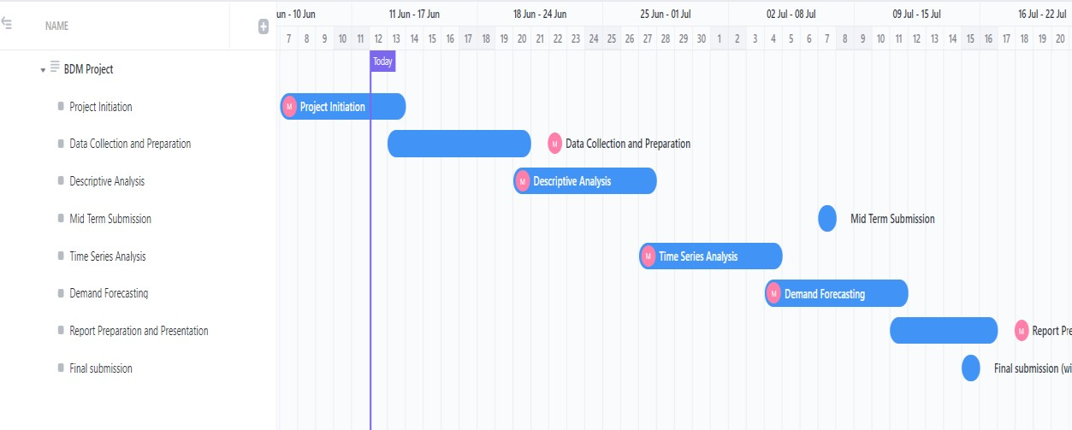

Expected Outcome:

1. Coming up with a proper Power Bi interactive dashboard for all the analysis
2. Coming up with a proper demand forecasting analysis.
3. The expected outcome is to identify the tile products with the maximum

demand. By analysing historical data and market trends, the project aims to determine which products are most sought after by customers. This

information will guide the packaging contract, ensuring that the packaging solutions are aligned with the demand for specific products.

1. Coming up with proper time series analysis
2. Doing proper analysis on the data provided by the company and solve any problem which is encountered while doing data analysis
3. Actionable Insights and Recommendations: The expected outcome is to generate actionable insights and recommendations based on the data analysis.