Project proposal

Application Objectives Look over again

Timeline

**Stories Interactive**

**Application objective**

The purpose of this application created by me is to make a particular kind of game available to me and others through their phone. This specific media is called interactive fiction also known as a texted based game. What I wish to accomplish is to bring these texted based games onto the mobile platform as well as encourage people to make their own and share their imaginations to the world.

I am going to accomplish brining the format to the mobile platform by first making an application that you can play these kinds of games as well as download others from a large website that houses them.

The other is making an application that will allow the user to make their own interactive fiction right from their phone. Do to the nature of this particular media I do not expect this to be a huge hit.

**Interactive pattern specs**

This application that is being made has some contemporary design with the minimalist and easily recognizable tool bar, but in some aspects it is not too contemporary with sections of the screen dedicated to text. Some of these spaces that hold lots of text show both that the spaces are meant to be tapped on as well as showing what the text will be used for. Other spaces in the app are filled in with text because that is how the application tells a story. Though I think the integration of “>>” symbols merge the text bar and the screen of play very well.

While completing this project I will be using a whole mess of icons that are universally used throughout many different kinds of media. These icons include: The world wide web icon, Settings icon, Create new icon, search/ magnify glasses icon, Info icon, play, forward, back, save, upload, refresh, stop loading, and a keyboard icon. All of which are located in the IconsForProject folder. The reasons I am using these icons that are so recognizable is because I want this application to be easy to use so anyone can pick it up and start playing or creating (though the creating portion will need practice).

Some other point I thought about is the look of the application. I wanted it to have the default color scheme to make the user feel like they are reading something old, like the discolored pages of an old book. For this I stuck with a few colors. These colors being these Hex codes: 9597B1 (for outlines and outer edges), E0E5D0 (for a few letters outlines and search bars), F8ECC2 (as the main background for the text the user would read, sections too), E2D09C (other backgrounds of sections, some text), 51445F (mostly texts and outlines).

I found these colors at this website <http://www.colourlovers.com/palette/4266625/Nostalgia>

**Competitor comparisons**

One competitor I found calls themselves Frotz. This application has the website where you can download other interactive fiction to play. I have appropriated the website and more or less the layout of the menus and playing of the interactive fiction because the layouts work well with this media.

Also like before, I am appropriating the way the in app browser works for downloading the different stories to the application. The reason I am doing this is it seems relatively easy for me since it is just another browser inside the application.

Unlike the competitor the application I am proposing also includes a feature that you can make your own interactive story. So that could be an application all on its own but wrapped up in one; in my application.

I have come across another two interactive fiction apps, these being 80 Days and Ryan North’s to be or not to be. These apps are themselves stories to play through instead of being a larger application, like the one I plan on creating, to play many different interactive fiction. In fact Ryan North’s to be or not to be is actually an interactive book that has been made into interactive fiction on android. Both of these applications do have extra visual appeals in the screen itself with drawn visuals, but that itself goes against the purpose of interactive fiction. Because it goes against the purpose of interactive fiction and leads its users to be less imaginative I will be not appropriating the visuals of these two applications.

The Competitor’s picture in order from right to left:

The web browser in the application that allows you to download more interactive fiction stories

The main menu that allows you to pick an interactive story to play

The about story screen that lets you see some basic information from the interactive fiction

The last of Frotz is the in game screen.

Next is a screen from 80Days

And the last is from Ryan North’s to be or not to be

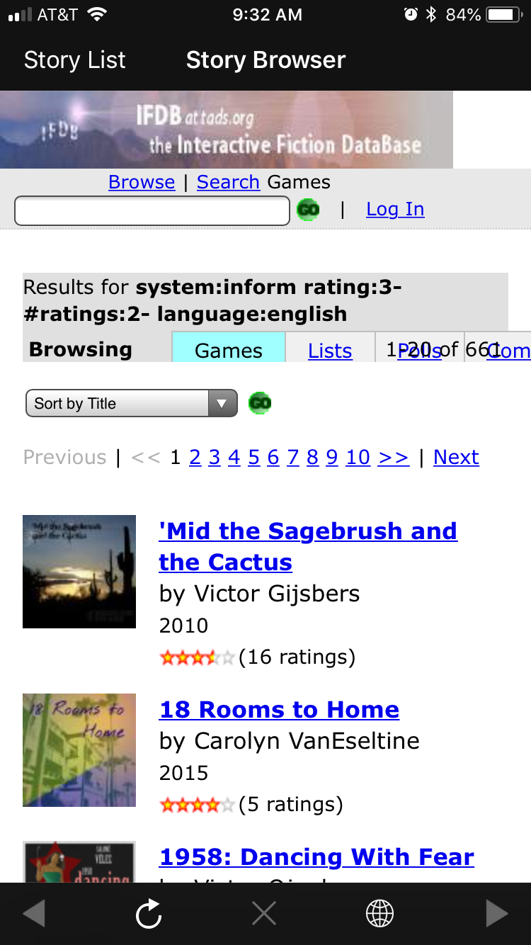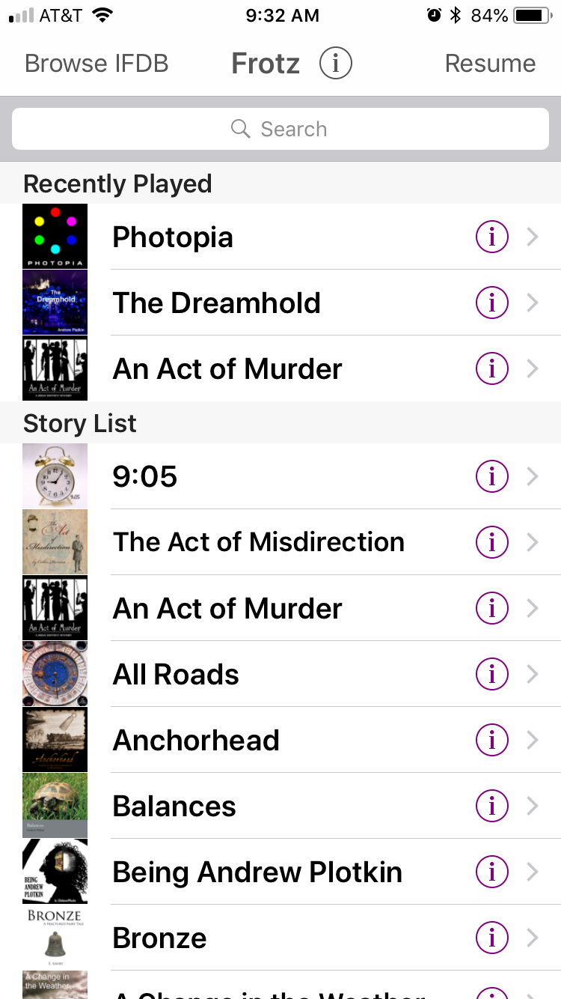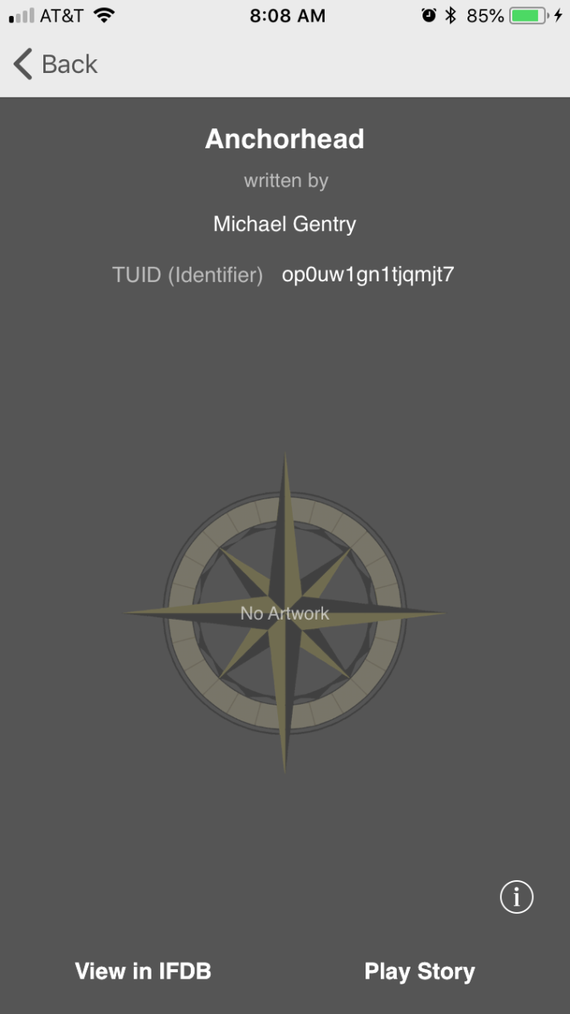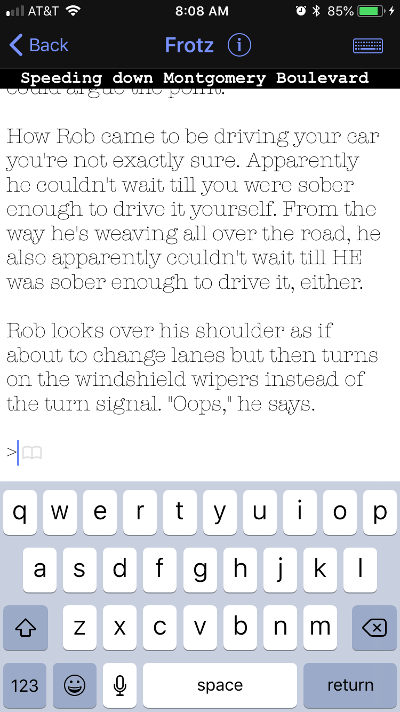

**Testing the physical application**

While testing this application myself as well as others found this fairly intuitive and gave mostly positive feedback with little ideas to improve on. Because of the lack of suggested improvements I stepped in and added my own thoughts while I tested the app. The total number of people that has tested has been three, one including me. The total number of tests have been somewhere in the thirties.

Most of the comments that were given back to me were generally positive with such phrases as “Cool app dude” and “oh that is cool”. When I would get these responses I often asked a few follow up questions such as “Did you get stuck anywhere”, “Is there anything that you didn’t understand at first glance?”, and “Can you think of anything to help me improve this application?”. The replys often included that they did not find themselves getting stuck anywhere nor had any trouble moving around the application.

When I stepped in and tested the application myself I was more critical. I found three problems. One of these problems included no way to make overarching commands that people would have to type in while creating their own interactive fiction. This is an easy fix. I propose that I add an extra part to the StoryEditer where a user would be able to add commands that would work for whatever room the character in the interactive story could be. Another solution to this is adding another command sections to the RoomEditer that is labeled “universal commands” where the commands saved in that box is applied to all other rooms.

The second problem that I noticed was the lack of ability to delete a downloaded story or a created story. My solution for this would be to add an option to delete the story in the main menu. Most likely add an icon to press for it to prompt an “are you sure you want this to be deleted” message before deleting.

The last problem I have known about is the settings screen, rather it leads nowhere at the moment. Solution is to make content for it.

Pictures of some testing:

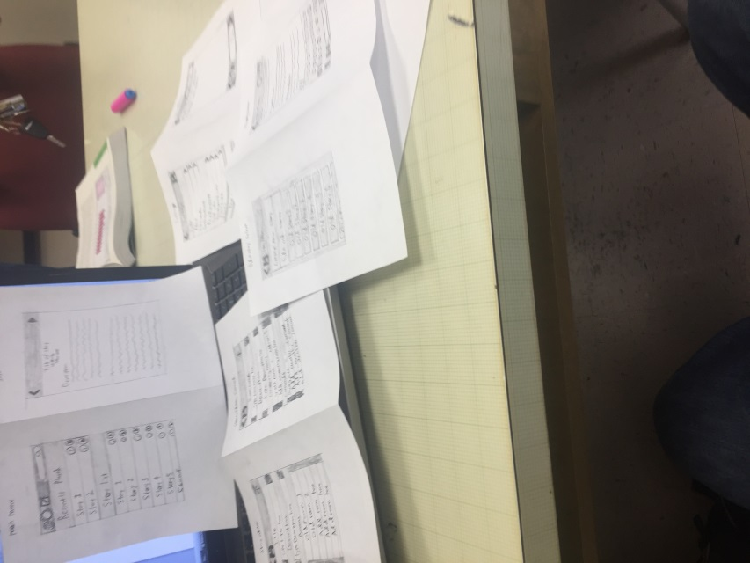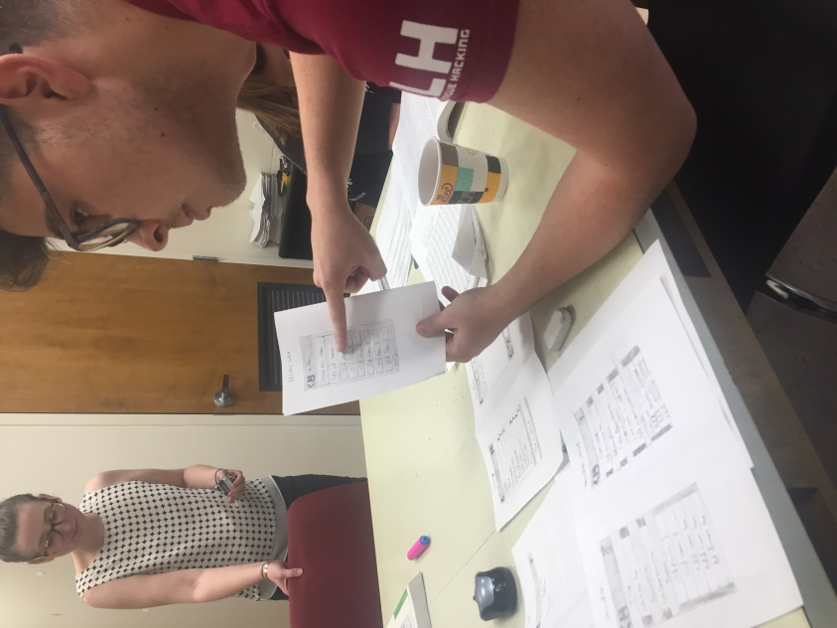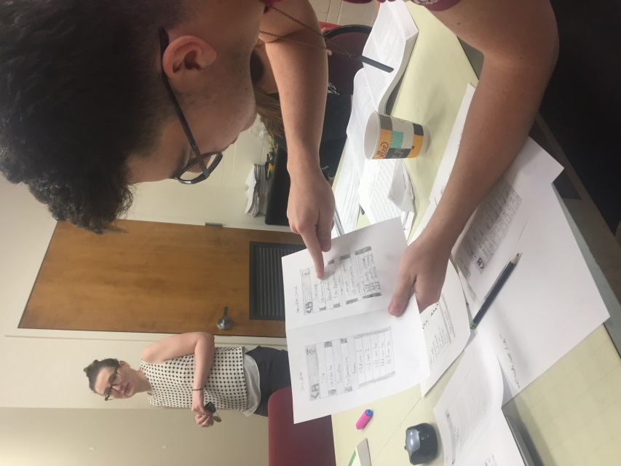

**TimeLine**

4/19

Thinking of idea

Picked topic of application/what the application is going to do.

* An interactive fiction player that can download other interactive fiction to the mobile device

Found a competitor that also does this.

* From this competitor I have found a website that would be of use.

Found an interactive fiction website to download interactive fiction from.

4/20

Had an idea to also make my application both play the interactive fiction and allows the user to make and uploading it to a server for others too.

Worked on the physical drawings of the layouts for the application

4/23

Timeline.

Creation of the physical application screens

Started coding the application

4/24

Proposal of my application.

Creation of Application images

Continued to code application

4/25

Added competitor pictures to proposal

Create a working application on invisionapp.com

Test application and record reactions as well as pictures of the testing

Finished the entirety of the **Paper** **prototype** part

Continued to code application

4/26

Finish up on creation of application images

* Apply images to : <https://www.invisionapp.com/>

Continued to code application

4/27

4/28

Found out that the file containing the code for my application was corrupted.