Sebastian Larsson  Full-Stack Developer · AI Enthusiast  sebbelarsson9601@gmail.com | linkedin.com/in/sebastian-larsson-b45803246 | github.com/ManaInfectedRP | Halmstad, Sweden | 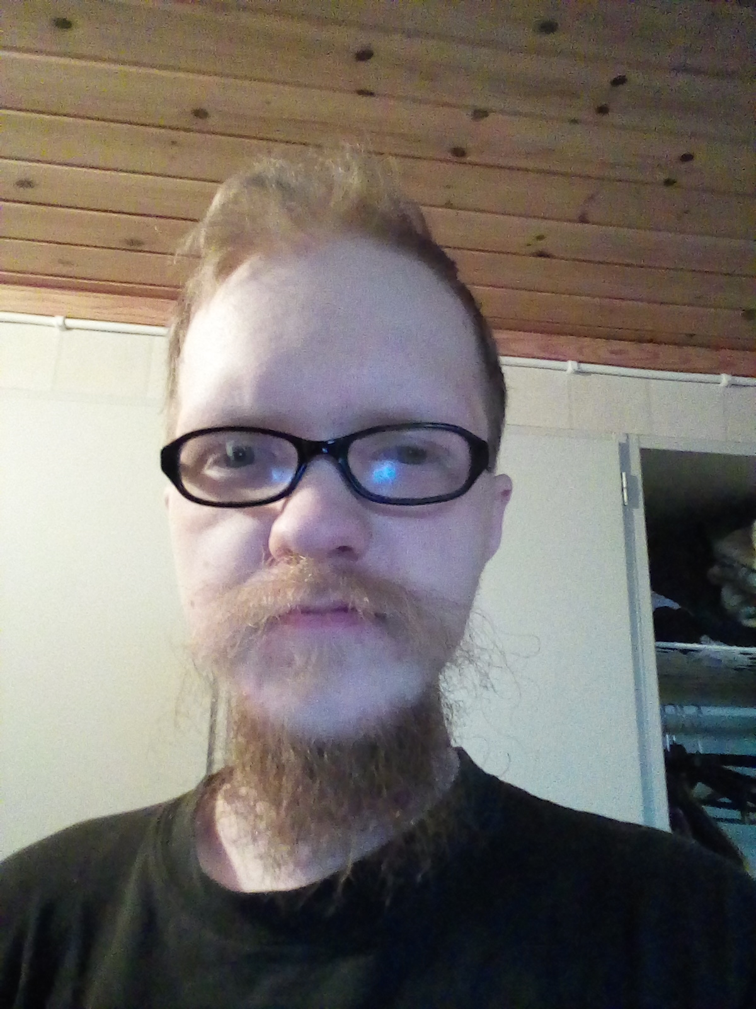

PROFILE

I started my career as a mechanic and warehouse worker in the automotive industry. That background taught me how to break down problems, follow procedures, and ship results — skills I now apply to building software. Today I'm focused on full-stack development and AI. I enjoy building real things people can use: video conferencing apps, REST APIs, desktop games, and AI experiments. Actively looking for work.

EXPERIENCE

2nd LIA Full-Stack Developer — Podmanager.AI 2026
Full-Stack Developer LIA Intern — Podmanager.AI 2025
Software Development Student (AI spec.) — NBI/Handelsakademin, Halmstad 2024 – 2026
Warehouse Worker & Picker — Enyroom AB, Halmstad 2023
Mechanic — Göstorps Nissan Bil AB, Laholm
2019 – 2020
TECHNICAL SKILLS

Languages: TypeScript · JavaScript · Python · C# · HTML / CSS · SQL
Frontend: React · React Native · Vite · Tailwind CSS
Backend: Node.js · Express · FastAPI · .NET · REST APIs · WebRTC
Databases: PostgreSQL · MongoDB · SQLite · Entity Framework Core
AI / ML: PyTorch · OpenAI API · Coqui TTS · MusicGen · AI tooling
DevOps: Docker · Git · Render · Nginx · CI/CD
Other: Unity · Pygame · Tkinter · Expo (React Native) · Zustand

SELECTED PROJECTS

PodPlayer AI [Private] 2026
Full-stack podcast & audiobook platform — PWA + React Native app sharing one FastAPI backend.
Tech: React 18, TypeScript, React Native, Expo SDK 54, FastAPI, MongoDB, Tailwind CSS
- Audio/video streaming with background playback, lock-screen controls, and offline downloads
- AI playlists — 'Made For You' and Calendar Picks built from the user's upcoming events
- Creator Hub with episode analytics, Flash Drop recorder, and RSS podcast import
- In-app PodCoin store with 11 themes, avatar frames, and paywalled content
SweetTeams 2026
Microsoft Teams-like web app — WebRTC video for 50+ participants, screen sharing & chat.
Tech: JavaScript, WebRTC, Node.js, SQLite, SendGrid, Render
- WebRTC P2P video for 50+ concurrent users
- Passwordless magic-link auth via SendGrid
- Real-time chat & screen sharing
WorkSearcher 2026
Swedish job aggregator — React dashboard + FastAPI backend, AI-scored postings.
Tech: React, FastAPI, Python, PostgreSQL, OpenAI gpt-4o-mini, MinHash LSH, Docker
- Pluggable connector protocol: JobTech, Adzuna, Greenhouse, Lever
- MinHash LSH near-duplicate removal + per-job summary & relevance score (OpenAI)
Song Studio [Private] 2026
Desktop app that turns a one-line idea into a full song — lyrics, vocals & instrumentation.
Tech: Python, OpenAI API, MusicGen, Suno Bark, PyTorch, customtkinter
- Two audio backends: local (MusicGen + Bark) or Suno cloud singing
- CUDA-aware: ~30 s per song on GPU
VoiceClone Studio 2026
Clone any voice and synthesize speech — GUI + CLI, 17+ languages, zero-shot.
Tech: Python 3.11, Coqui XTTS-v2, Faster Whisper, FFmpeg, CUDA, Tkinter, PyInstaller
- Zero-shot voice cloning — no training required
- Standalone Windows GUI + PyInstaller single-file exe
Sebbes Kokbok 2026
Bilingual recipe collection — 45 dishes across Swedish, Korean, Chinese & Japanese cuisines.
Tech: React, Vite, JavaScript, Node.js, Express, Docker, Nginx, Render
- Bilingual UI with full English/Swedish toggle
- Native script preservation: Hangul, Hanzi, Kanji/Kana
SebbePyGame [Private] 2025
Endless wave survival ARPG — 15 spells, support gems, deep skill tree.
Tech: Python 3.11, Pygame, JSON Save
- 15 auto-cast spells with 3 support-gem socket slots each
- Passive skill tree, 12-slot equipment, crafting, breach events
Shop API Tester 2025
C# .NET REST API for an e-commerce shop with full CRUD.
Tech: C#, .NET, EF Core, REST, Swagger
- CRUD endpoints, Entity Framework Core migrations, Swagger/OpenAPI docs

EDUCATION

Higher Vocational Education — Software Development with AI Specialization 2024 – 2026
NBI/Handelsakademin, Halmstad

REFERENCES

Marcus Granberg · Manager · Podmanager.AI
Supervisor during LIA internship at Podmanager.AI
marcus.granberg@podmanager.ai
Antonio Prgomet · Teacher · NBI/Handelsakademin
Teacher and mentor during software development with AI studies
antonio.prgomet@nbi-handelsakademin.se
Robert Ploski · Thesis partner & Class Mate · NBI/Handelsakademin
Student colleague during software development with AI at NBI/Handelsakademin
robert.ploski90@gmail.com

