2.2 – Disabling the sudo timer

Capture output of step 7 (sudo -l)

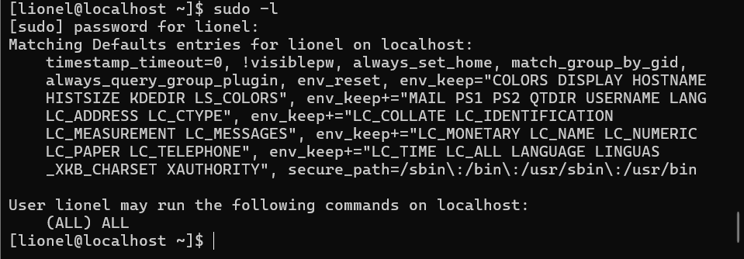

3.2 - Setting password complexity criteria

Capture content of the pwquality.conf file

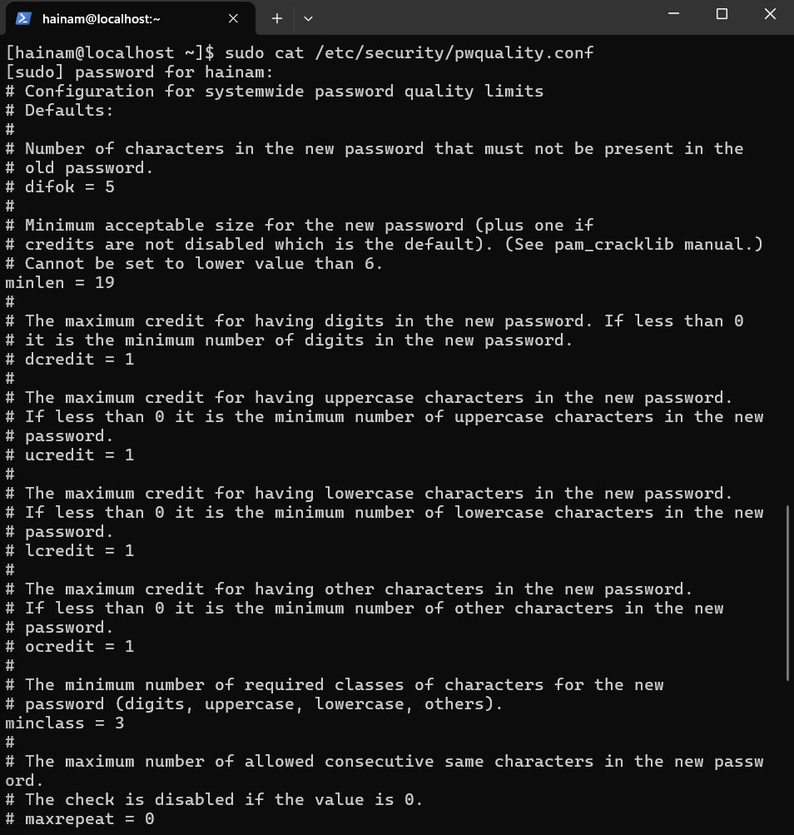

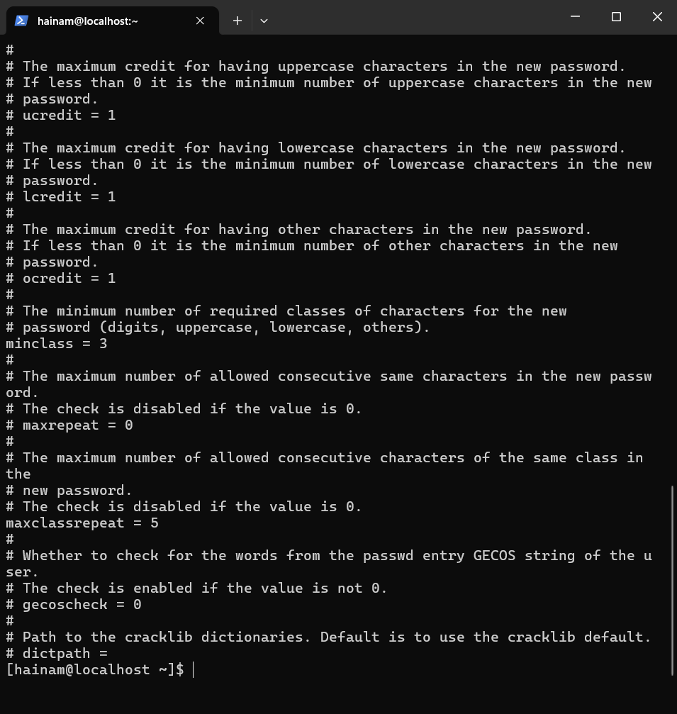

3.3 - Setting account and password expiry data

Capture output of step 5 (sudo chage -l samson)

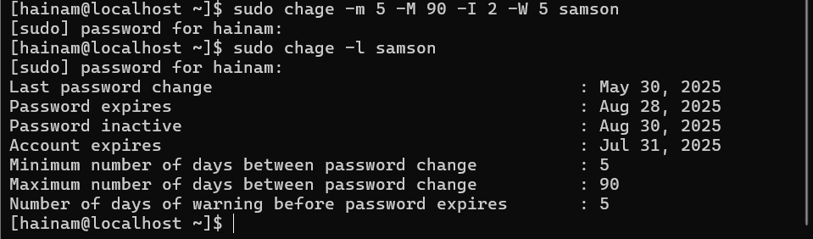

3.5: Follow 2 steps to check PAM

1. Try logging in with an incorrect password 5 times.

2. sudo faillock --user <username>

Capture output of step 2.

