**6.1 – Creating and transferring SSH keys**

**Capture output of step 6 (cat .ssh/authorized_keys)**

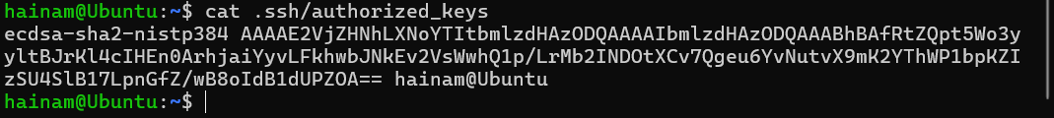

**6.2 – Disabling root login and password authentication**

**Capture content of /etc/ssh/sshd_config file (Show all changes in this exercise)**

**Before**

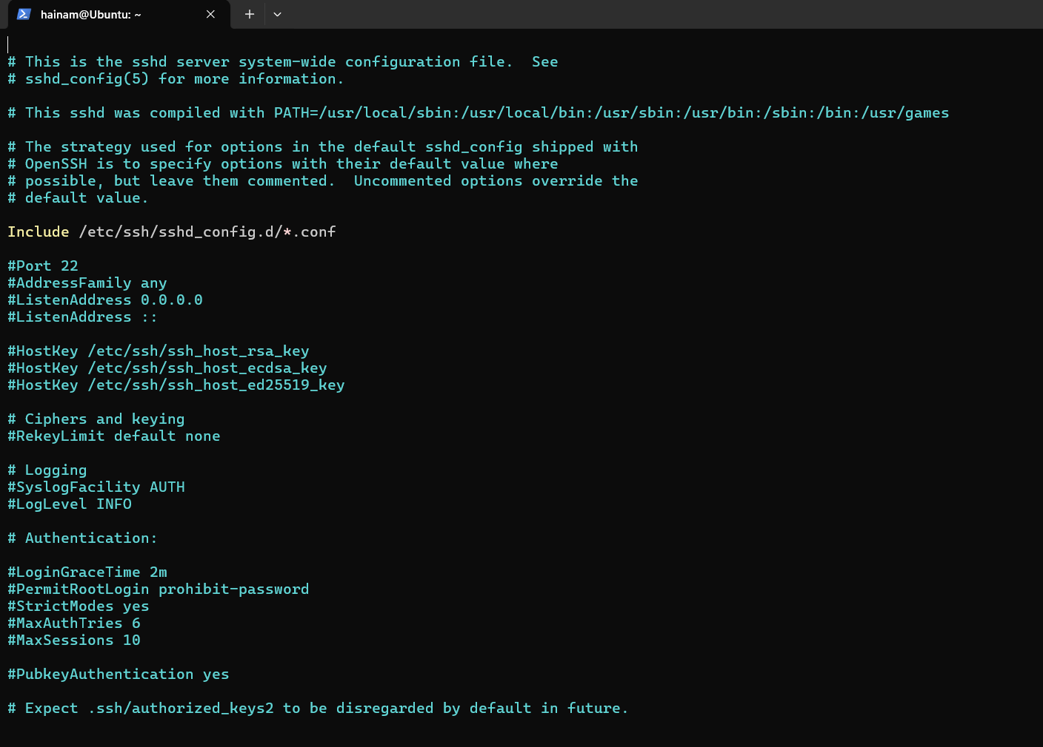

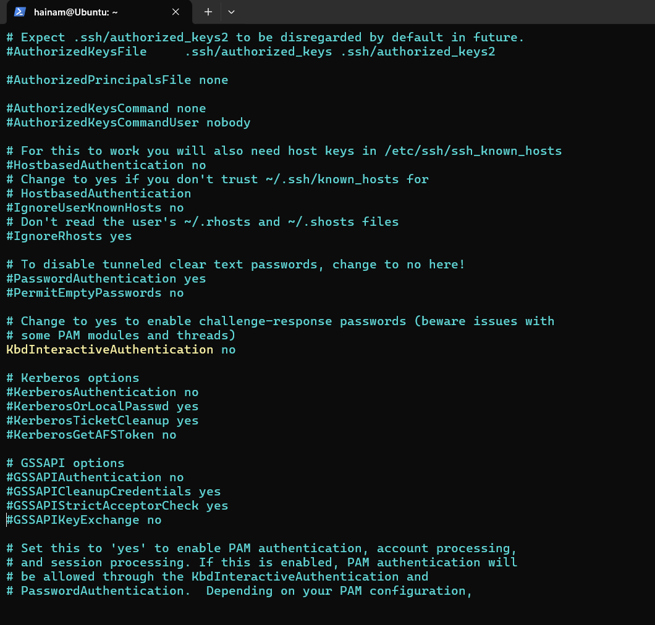

**After**

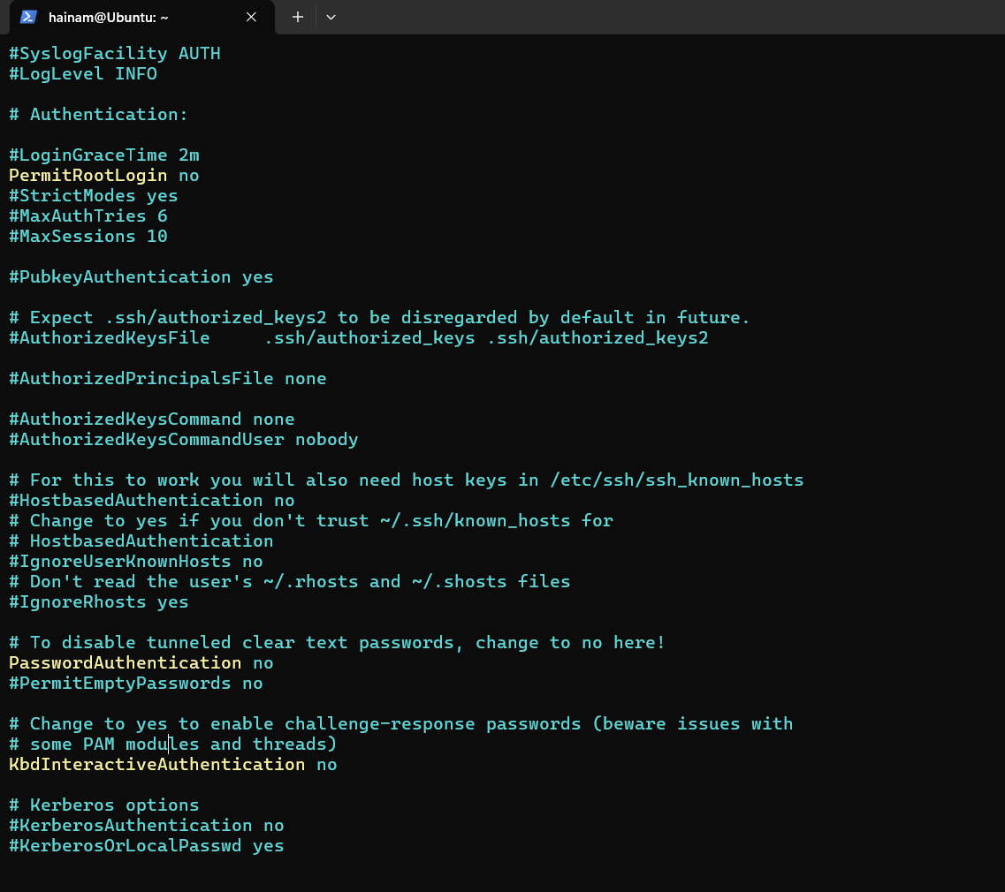

6.6 – Disabling weak SSH encryption algorithms – Ubuntu 22.04

Capture output of step 7, 8, 9

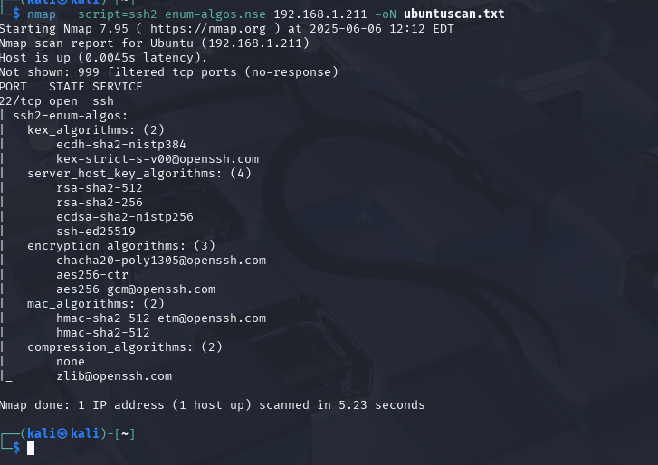

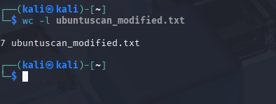

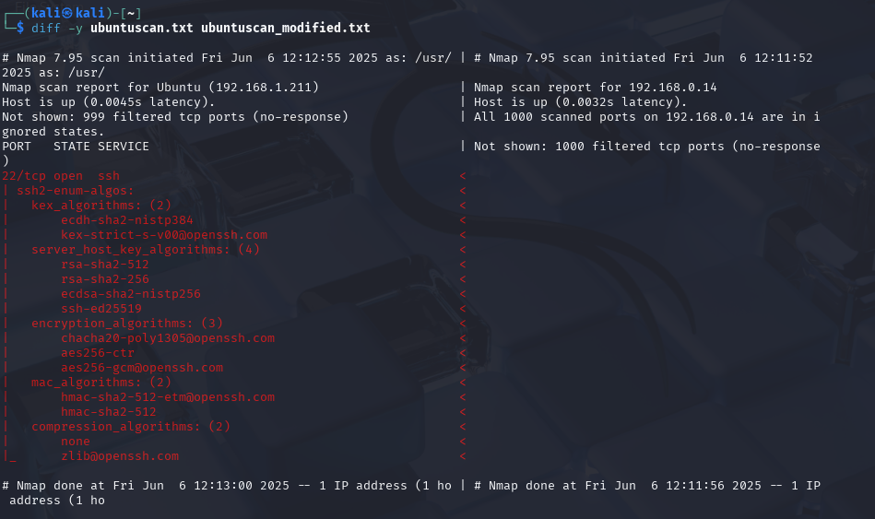

6.10 – Configuring whitelists within sshd_config

Capture content of /etc/ssh/sshd_config file (Show all changes in this exercise)

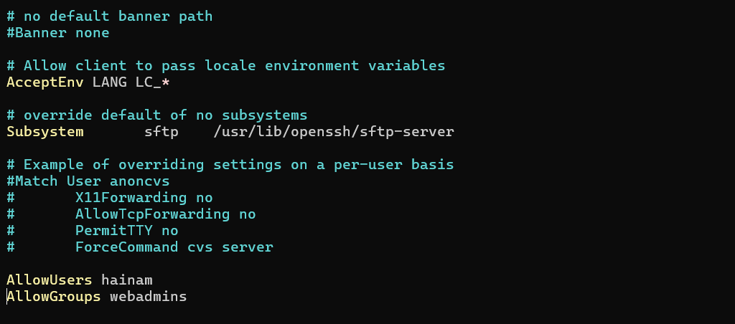

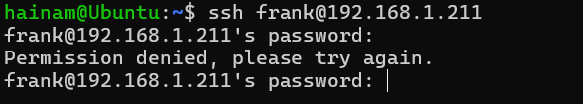

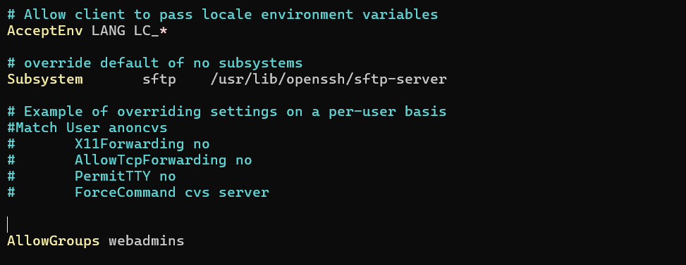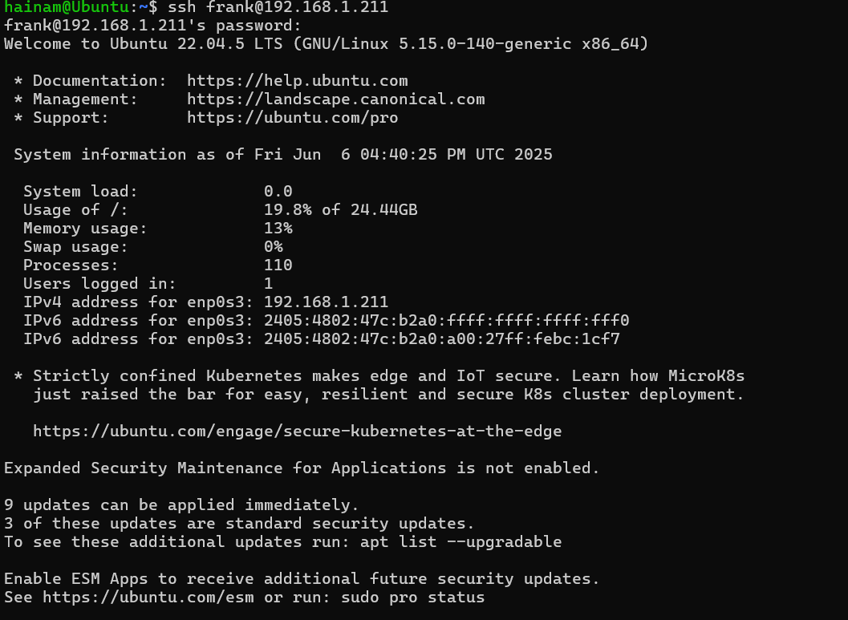

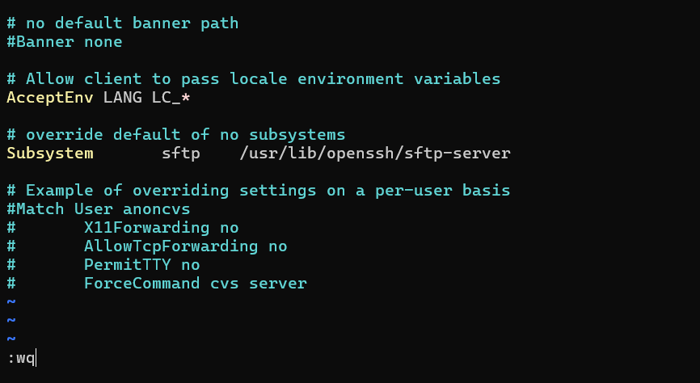

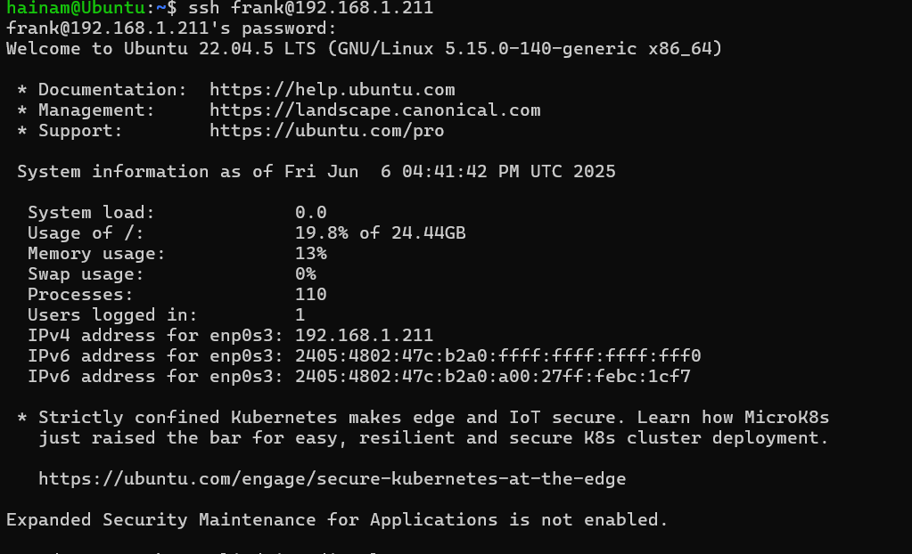

7.2 – Setting security-related extended file attributes

Capture output of “ls -l” command at the folder containing some_file.txt

