5.1: Capture output of step 11 (ls -l .gnupg/)

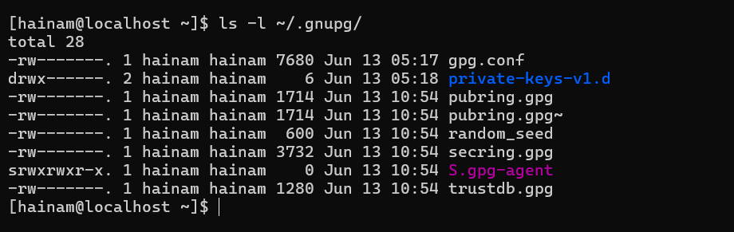

5.2: Capture output of step 8 (gpg -o secret_squirrel_stuff.txt -d secret_)



5.3: Capture output of step 8 (gpg -d secret_stuff_for_frank.txt.gpg)

5.4: Capture output of step 8 (gpg --verify not_secret_for_frank.txt.gpg)



5.10: Capture output of step 8 (veracrypt -l)

