8.1: Capture all output of step 8 (Can take multiple photos if can not display all)

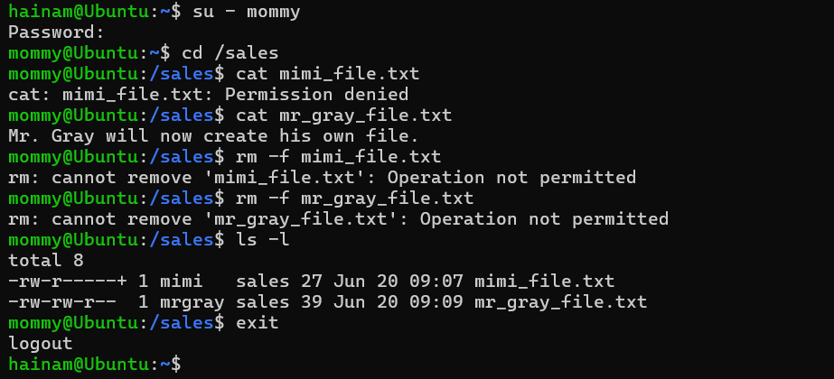

8.2: Capture output of step 7 (ls -Z index.html)

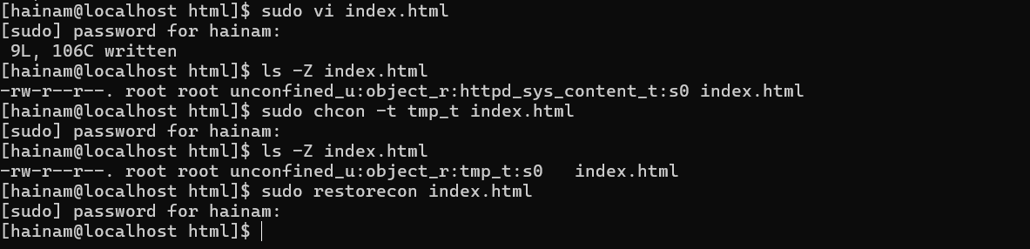

9.1: Capture output of step 4 (sudo semanage port -l)

