10.1: Capture content of 60-secure_values.conf file

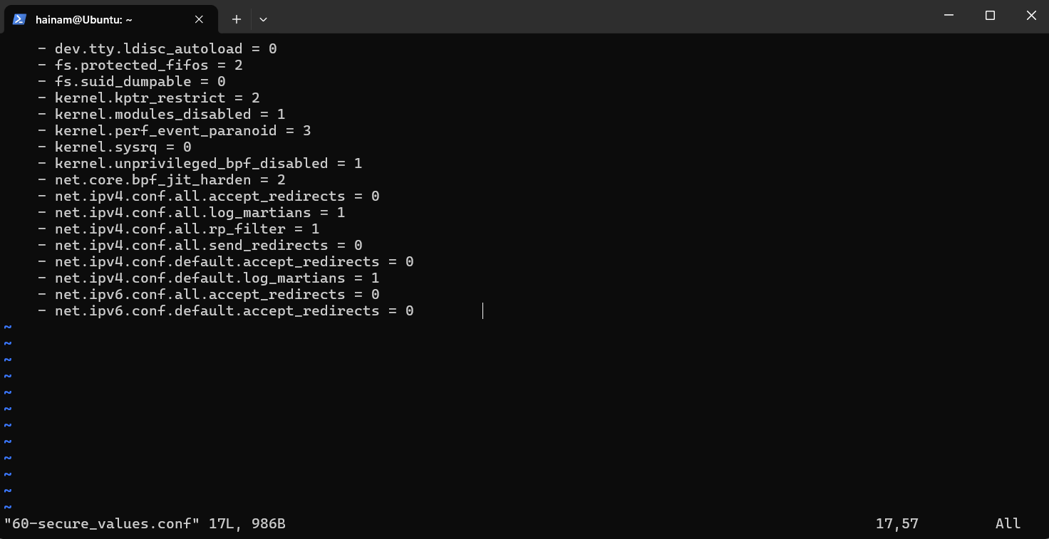

10.2: Capture output of step 9 (getcap /usr/bin/ping)



10.3: Capture output of step 10 (ls -l /usr/local/bin)

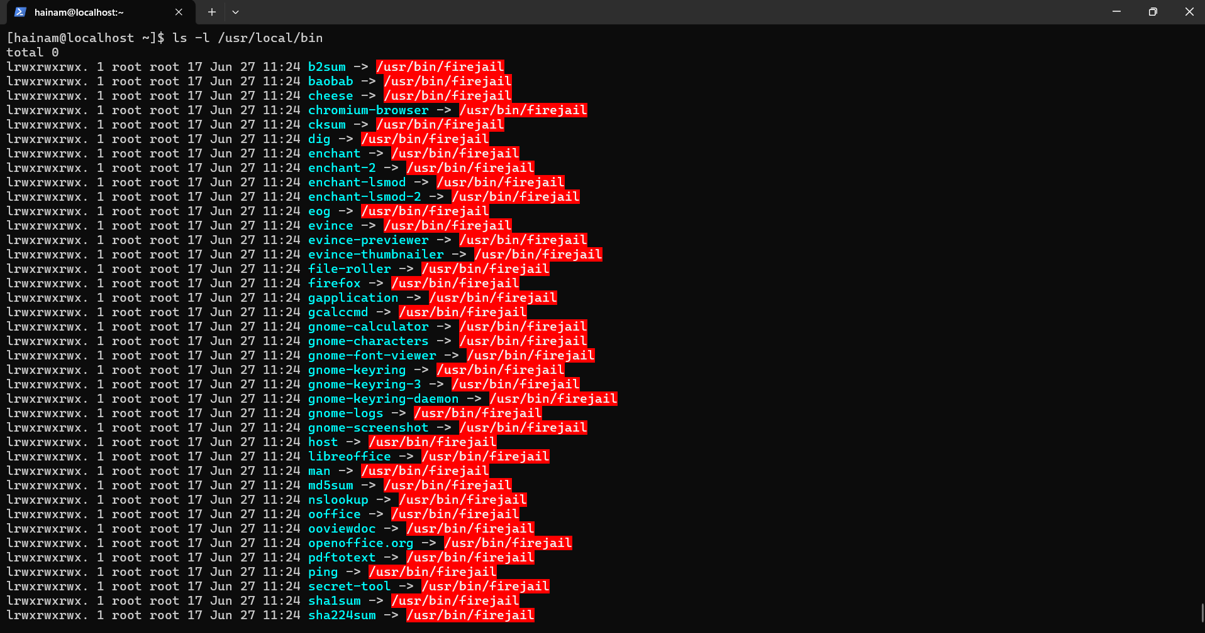

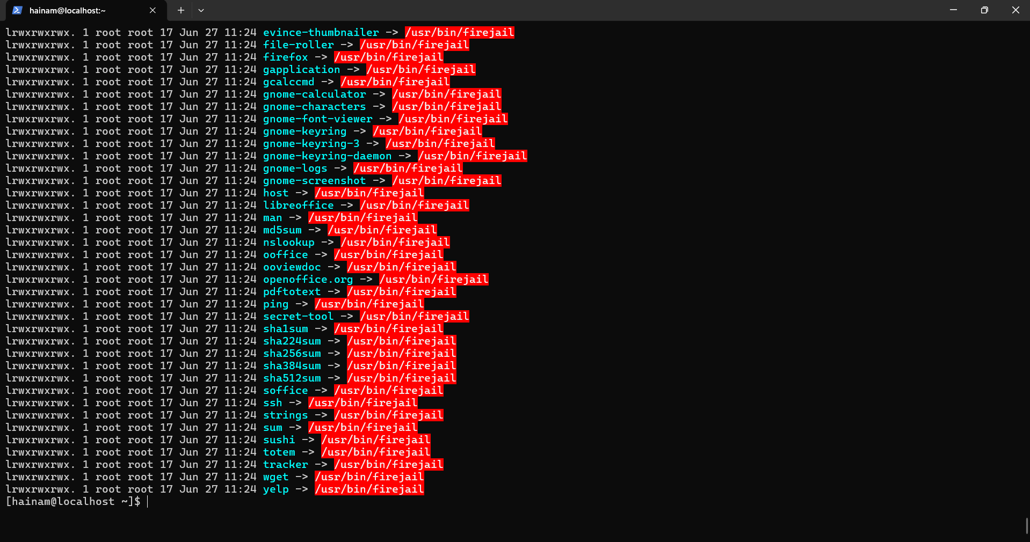

**Paste all image into a word file and upload this file to Edunext**