LAB 8 – Applying Best Practices for Secure Software Management

1.6: Capture content of the 50unattended-upgrades and 20auto-upgrades file

**50unattended-upgrades file**

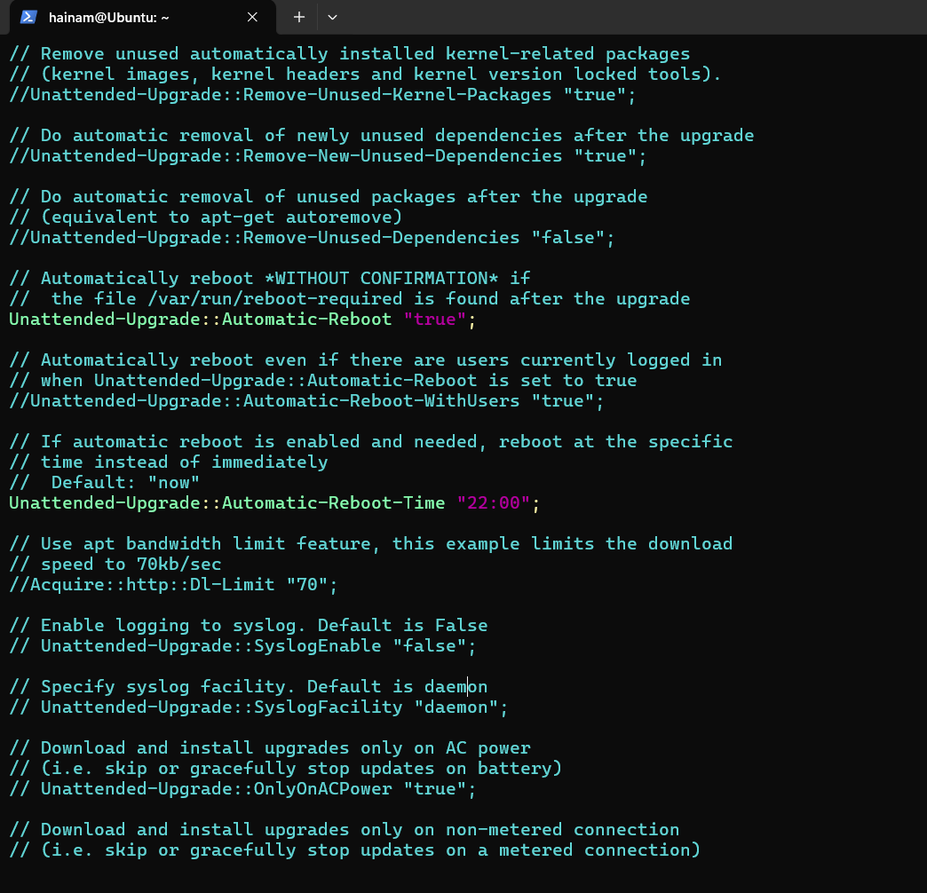

**20auto-upgrades file**

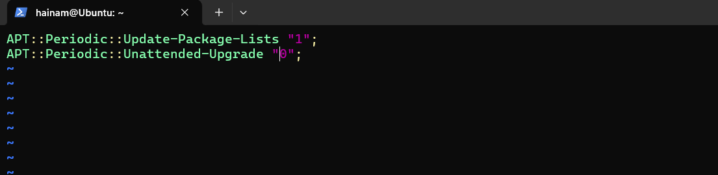

1.7: Capture content of the yum-cron.conf file

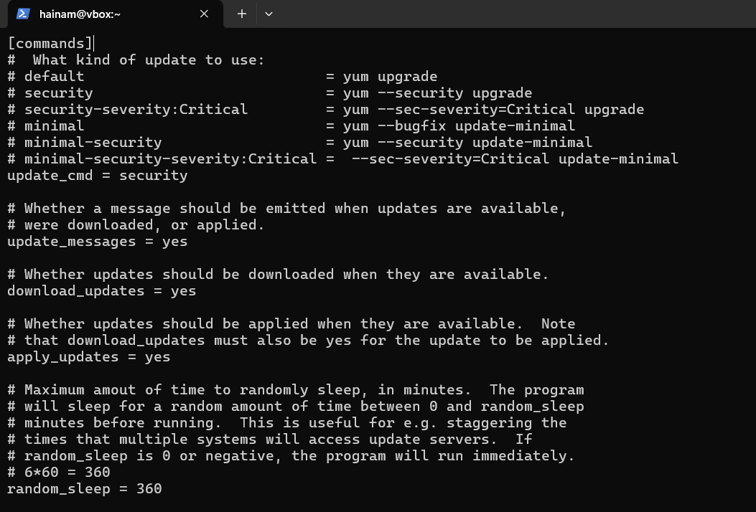

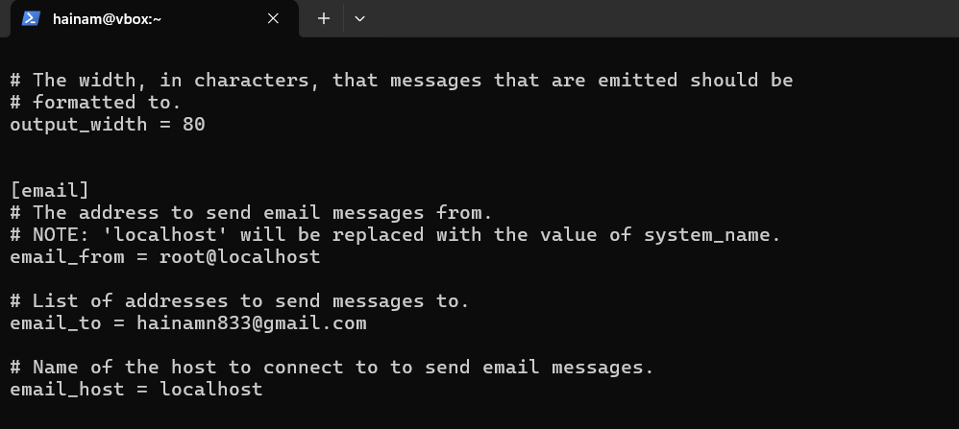

1.8: Capture output of step 4 (sudo systemctl status dnf-automatic.timer)

