**LAB 9 – Loging, auditing, and hardening the server**

**11.1: Capture output of `mutt` command after performing all the steps of this section**

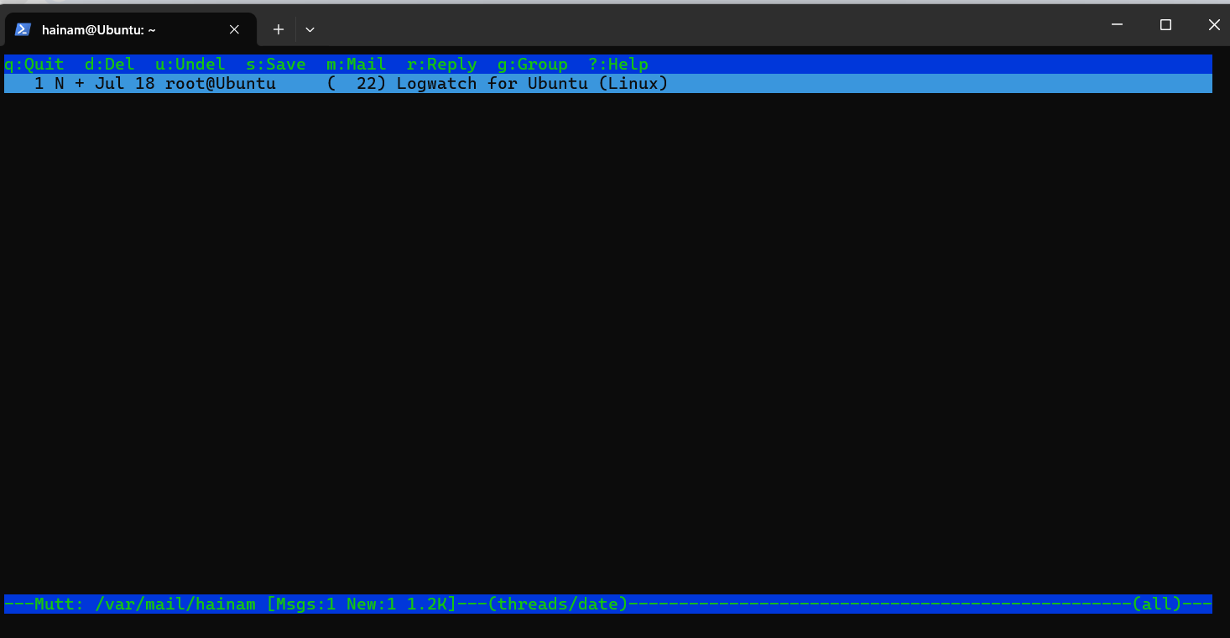

**11.2: Capture content of Rsyslog file (depends on operating system) after performing all the steps of this section.**

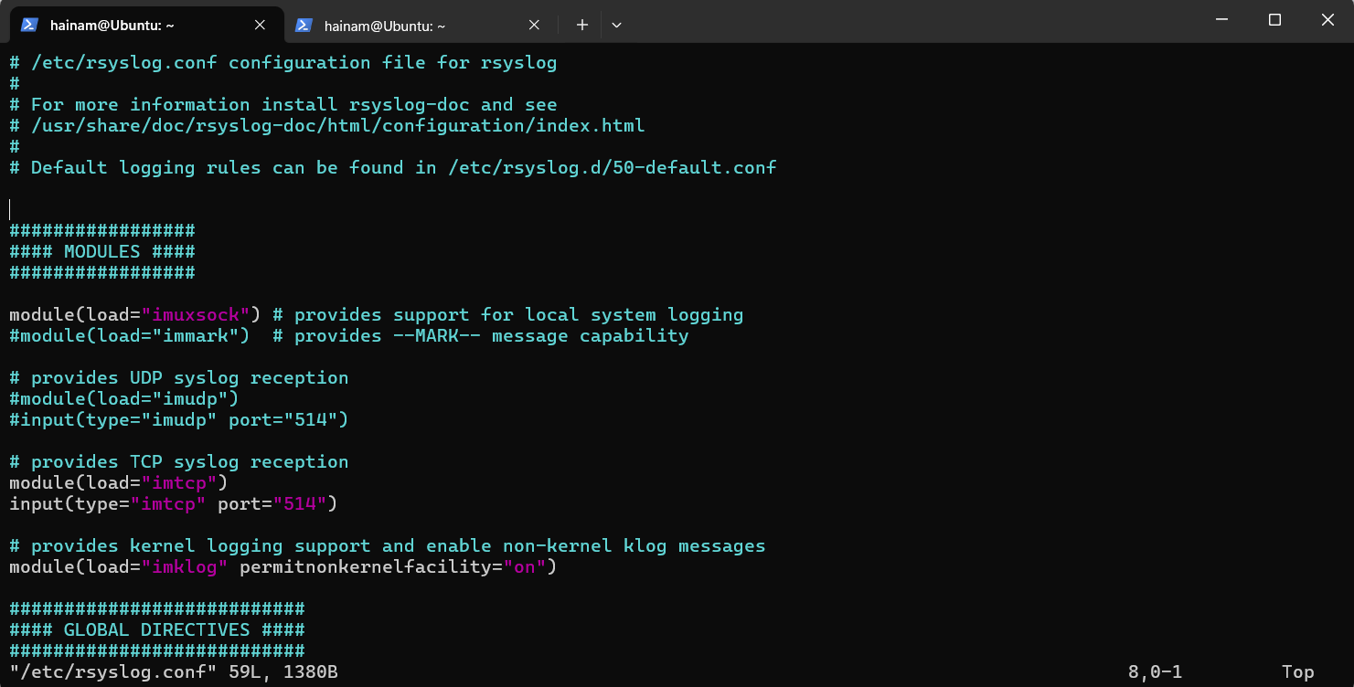

**12.1: Capture content of README file in step 4** 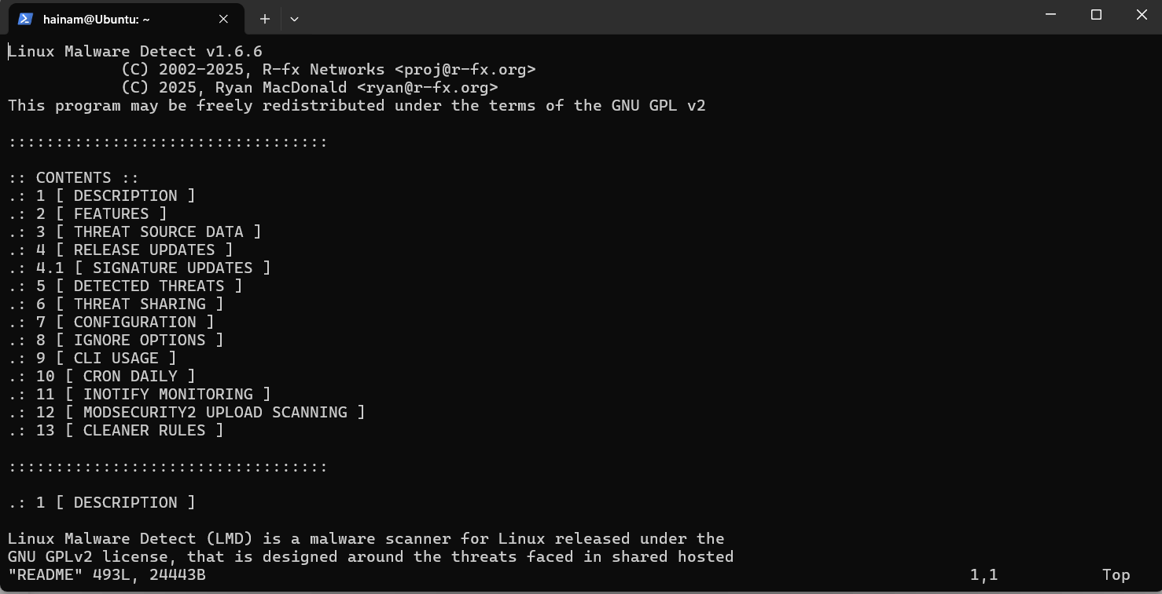

**12.2: Capture output of sudo systemctl show maldet command after performing all the steps of this section**

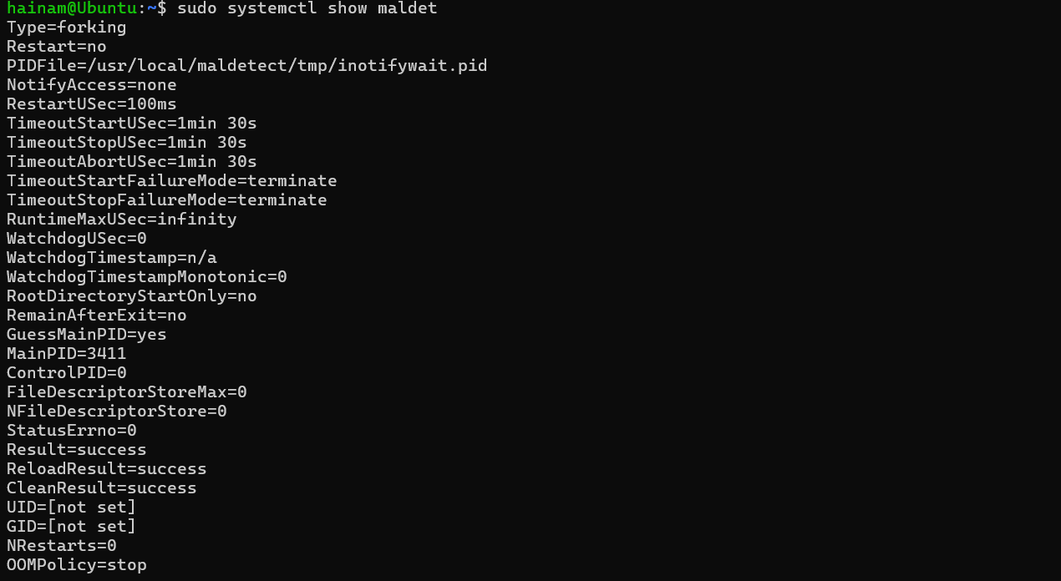

**12.4: Capture output of step 13**

