畜産加工品 業界の動向 -タイ市場-

最終更新日：2023年12月13日（最終訂正日：2023年12月13日）

# レポートサマリー

### Industry Overview

Processed Chicken Products Dominated Total Exports, Underpinned by High Volume Chicken Production; Players Mainly Operate Agro-Industrial and Integrated Food Businesses

Largest Exporter of Processed Meat Products in ASEAN, Supported by Strategic Location and Labour Supply

Thai-Dominated Industry Led by Vertically Integrated Players; Contract Farming Business Model to Further Ensure Sufficient Supply and Minimise Quality Risk

### Market Trends

Exports of Processed Chicken Soared in 2022 Due to Strong Overseas Demand; Japan Remains the Major Export Destination Since 2014

Exports of Processed Duck Dropped as Demand from Japan Weakened

Exports of Sausages and Similar Products Began to Recover Post-COVID-19 Pandemic; Cambodia Emerged as Thailand’s Largest Export Destination

Exports of Processed Pork Continued to Drop Since COVID-19 Pandemic; Japanese Market the Main Influence on Products

### Competitive Trends

Consolidated Industry Led by CPF and Betagro Given their Complementary Integrated Businesses to Support Production and Distribution

CPF: Leading Agro-Industrial and Food Conglomerate with Dominant Position in Sausage and Similar Product Industry

Betagro: Second Largest Player in Sausage and Similar Product Market

Thai Nippon Foods: Thai Subsidiary of Nipponham Group Mainly Caters to Export Market, Particularly to Japan

# Industry Overview

**Processed Chicken Products Dominated Total Exports, Underpinned by High Volume Chicken Production; Players Mainly Operate Agro-Industrial and Integrated Food Businesses**

Thailand’s exports of processed meat products stood at USD 3.2 billion in 2022. The processed chicken meat product (such as grilled chicken, smoked chicken, nuggets, etc., excluding sausages and similar products) segment was the largest contributor, accounting for 92.3% of the total exports in 2022. This was distantly followed by processed duck meat products (4.0%), sausages and similar products (2.1%), and processed pork meat products (1.0%). The high value of processed chicken products is likely underpinned by the abundance of chicken supply. Thailand’s overall production of broiler meat and broiler meat products was the seventh largest producer globally in 2022, as per the Office of Agricultural Economics (OAE). In the same year, the country also ranked the fourth largest exporter of broiler meat and broiler meat products, making up 7.1% (0.97 million tonnes) of global broiler meat exports. In addition, almost 60% of the chicken exports in terms of value were processed products, while the remainder were fresh chicken in 2022. This illustrates the country’s capability to compete on a global level in terms of production of chicken meat and its related products.

The export value of processed chicken (excluding sausages and similar products) soared 26.2% YoY in 2022 due to strong overseas demand for the products, especially from Japan, the UK, and the Netherlands. Prior to this, the exports decreased 4.4% YoY and 6.6% YoY in 2021 and 2020, respectively. The declining exports in these years may be due to insufficient domestic production, which also witnessed a decline of 4.8% YoY and 9.9% YoY over the same periods.

Thailand’s processed meat product industry is consolidated with Charoen Pokphand Foods (CPF; THA) and Betagro (THA) dominating the industry given that they are pioneers in the agro-industrial and integrated food businesses. Leading industry players are vertically and horizontally integrated to ensure economies of scale and an efficient supply chain. Moreover, they are present in multiple product segments to stay competitive.

**Largest Exporter of Processed Meat Products in ASEAN, Supported by Strategic Location and Labour Supply**

The abundance of natural resources, with most ingredients being harvested year-round, and the relatively low-cost yet highly skilled labour force are factors that made products affordable and the country a high-potential global player. Given these conditions, the country is also a manufacturing hub for international companies.

In 2022, Thailand was the largest exporter of processed meat products in the ASEAN-6 region, with its export value equivalent to 92.8% of the region’s total export value. Thailand was followed distantly by Malaysia (5.0%) and Vietnam (0.9%). Since 2002 until the present, Japan and the UK have been the largest export destinations for Thailand’s processed meat products. Free trade agreements (FTAs) have also made the products highly competitive in the global market. As per the Department of Trade Negotiations, Thailand holds FTAs with 18 countries (including ASEAN nations, Australia, New Zealand, China, Hong Kong, Chile, Peru, Japan, South Korea, and India) as of July 2022.

**Thai-Dominated Industry Led by Vertically Integrated Players; Contract Farming Business Model to Further Ensure Sufficient Supply and Minimise Quality Risk**

The processed meat industry is largely controlled by Thai manufacturers witnessed by the presence of large-scale players. Most players are vertically integrated, and they are engaged in the in-house livestock business to ensure sufficient raw materials for the continuity of production plans. Some of them, such as CPF, Betagro, and Thai Foods Group (THA), also adopt the contract farming business model to further ensure adequate supply and minimise quality risk. Meanwhile, some players are only engaged in processing and sourcing meat externally. While most Thai players focus on both domestic and overseas markets, several players (such as Cargill (Thailand) [THA] and Thai Nippon Foods [THA]) primarily focus on exports.

**Value Chain of Thailand's Processed Meat Product Industry**

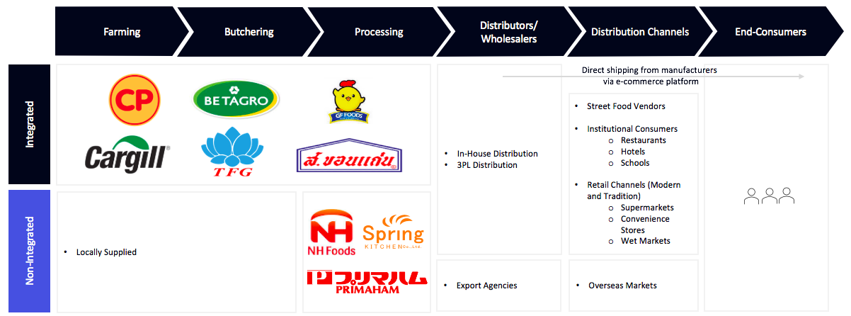

Source: Compiled by Uzabase

# Market Trends

**Exports of Processed Chicken Soared in 2022 Due to Strong Overseas Demand; Japan Remains the Major Export Destination Since 2014**

The export value of processed chicken (excluding sausages and similar products) soared 26.2% YoY in 2022 due to strong overseas demand for the products, especially from Japan, the UK, and the Netherlands. Prior to this, the exports decreased 4.4% YoY and 6.6% YoY in 2021 and 2020, respectively. The declining exports in these years may be due to insufficient domestic production, which also witnessed a decline of 4.8% YoY and 9.9% YoY over the same periods. Consequently, this caused a slump in exports to major export destinations, such as Japan (down 5.0% YoY and 1.3% YoY) and the UK (down 10.1% YoY and 13.3% YoY). Japan has been Thailand’s major export partner over 2014–22 with its export value accounting for 49.6% of the total processed chicken exports in 2022. This was followed by the UK (24.8%) and Netherlands (8.5%).

Prior to this, the exports of processed chicken increased steadily at a CAGR of 6.3% during 2014–19, moving relatively in line with the broiler domestic production which rose at a CAGR of 5.2% over the same period. In addition, the major export partners remained unchanged since 2014.

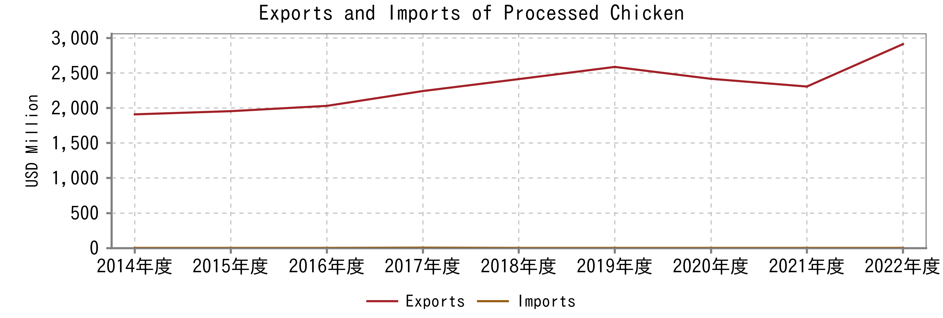

 Source: Trade Map

Note: HS Code 160232

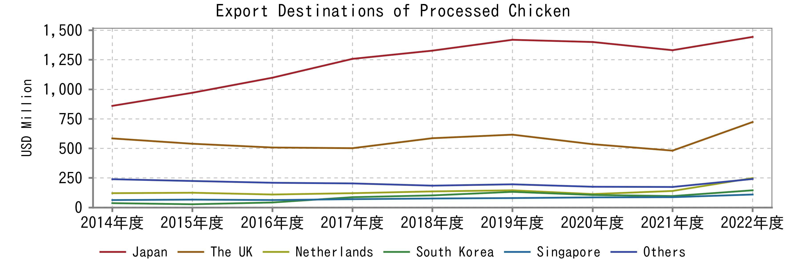

Source: Trade Map

Note: HS Code 160232

**Exports of Processed Duck Dropped as Demand from Japan Weakened**

In 2022, the export value from processed duck products experienced a 6.2% YoY decline primarily due to a decrease in demand from Japan (down 15.7% YoY), which is the primary export market. This was in contrast to the 3.4% YoY increase in exports witnessed in 2021, which was driven by a rise in overseas demand. Prior to this, the export value dropped 21.0% YoY in 2020 during the COVID-19 pandemic, moving in line with the drop in the number of duck livestock which fell by 12.9% YoY in 2020.

Before that, the exports of processed duck fluctuated downwards during 2016–20 though the number of duck livestock was on the rise, after remaining broadly flat over 2014–16.

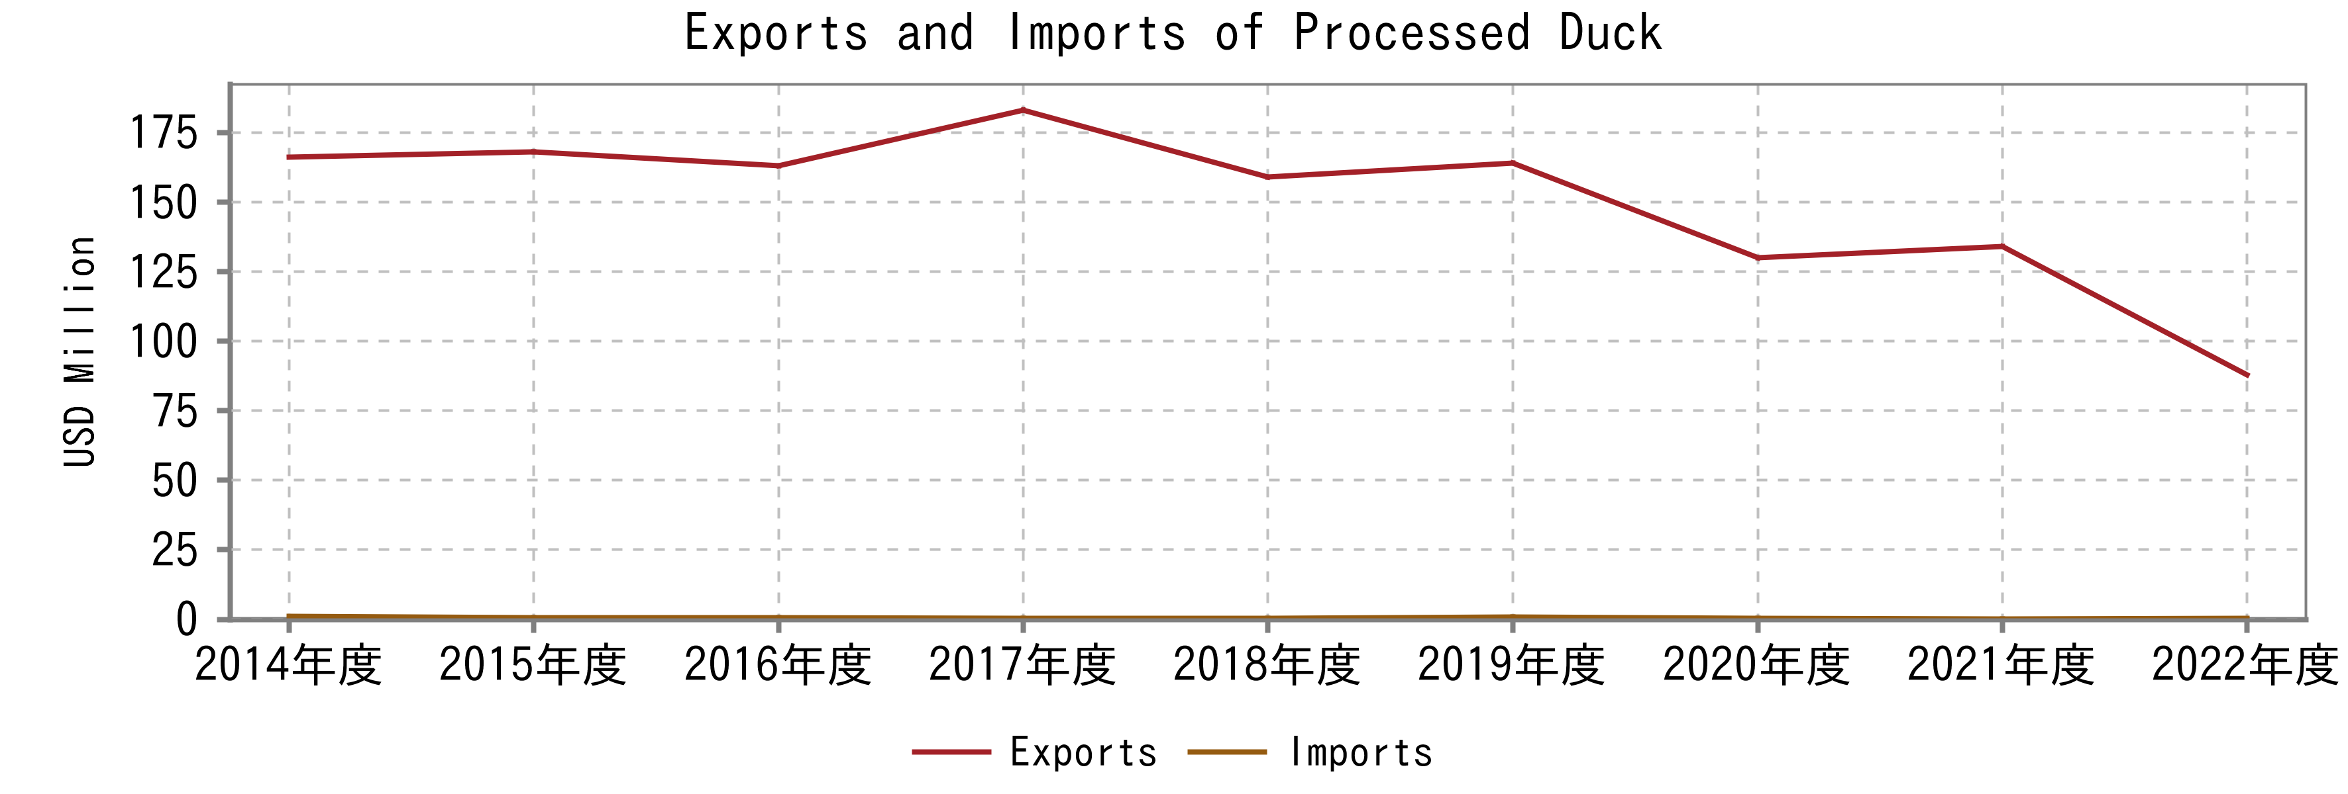

Source: Trade Map

Note: HS Code 160239

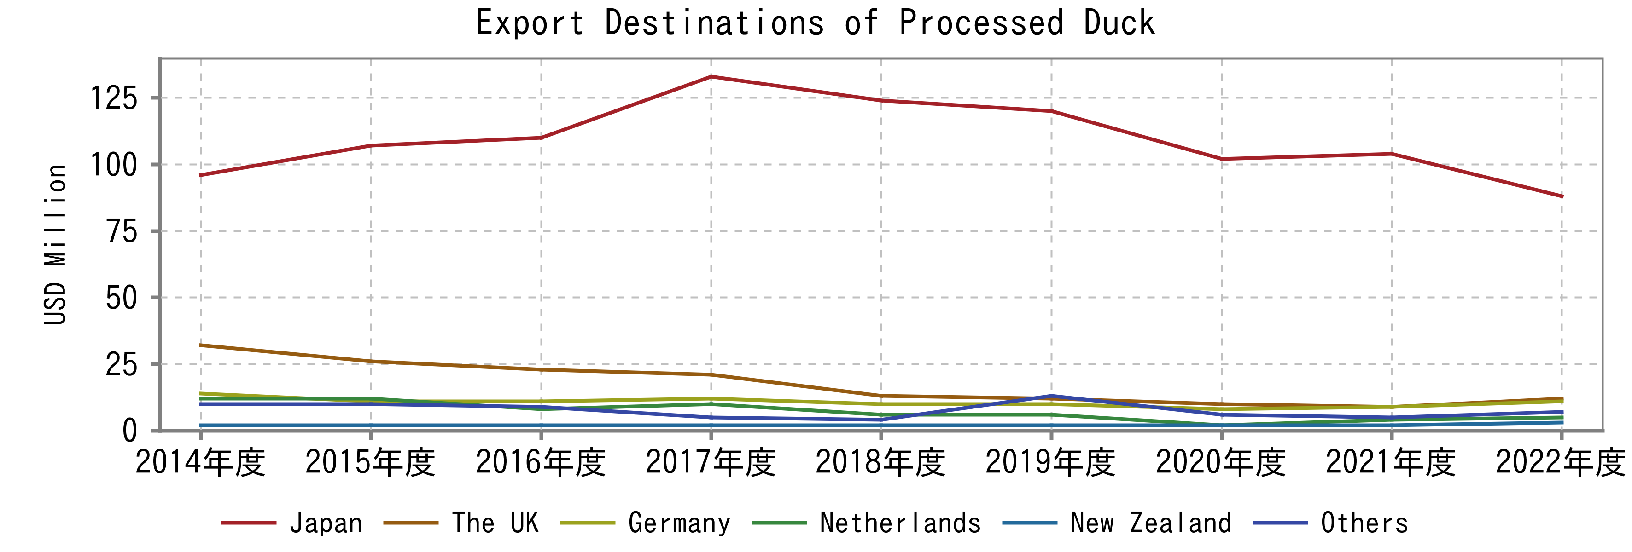

Source: Trade Map

Note: HS Code 160239

**Exports of Sausages and Similar Products Began to Recover Post-COVID-19 Pandemic; Cambodia Emerged as Thailand’s Largest Export Destination**

During 2020–22, the export value of Thai sausages and similar products began to recover, increasing at a CAGR of 16.2%, driven mainly by strong demand for economy-grade products from neighbouring countries and premium-grade products from Japan. In 2020, the export value decreased 8.7% YoY, attributable to the disruptions amidst the COVID-19 pandemic, given that restaurants in the major export destinations and the purchasing power of consumers were affected. Prior to this, the export value has been on a general uptrend over 2017–19.

Cambodia recently took over Japan’s first place in 2021 and was reported as Thailand’s major export partner, accounting for 42.2% of the total exports in 2022. This was followed by Japan (35.4%) and Myanmar (15.9%). On a related note, Japan and Cambodia have long been the major export destinations of Thai sausages and similar products, accounting for more than 70% of the total export value each year. In terms of pricing, Japan mainly imported the premium grade and premium grade products from Thailand indicated by that the price was USD 4,494 per tonne in 2022, whereas Cambodia imported the economy grade (USD 1,995 per tonne).

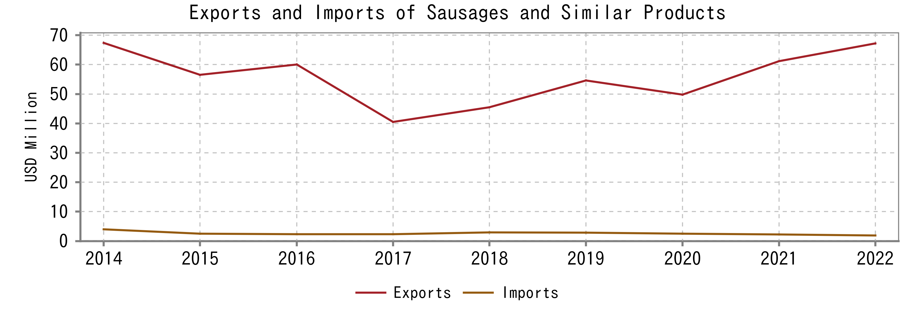

Source: Trade Map

 Note: HS Code 1601

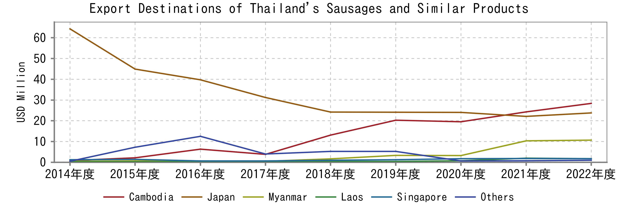

 Source: Trade Map

 Note: HS Code 1601

**Exports of Processed Pork Continued to Drop Since COVID-19 Pandemic; Japanese Market the Main Influence on Products**

During 2020–22, the export value of processed pork plummeted at a CAGR of 22.7% due to the American Swine Fever outbreaks in the period, which subsequently caused exporting counterparts to set restrictions on imports of pork and related products. Prior to this, the export value also dropped 18.6% YoY in 2020 during the pandemic after growing consecutively over 2018–20.

The exports of processed pork products rely dominantly on Japan as the country accounted for 80–90% of the total exports in each year over 2014–22. In particular, exports to Japan decreased 6.1% YoY and 33.3% YoY in 2022 and 2021, respectively.

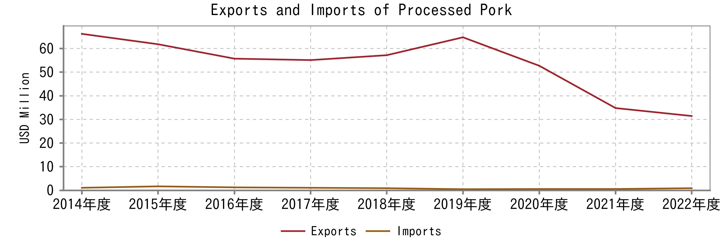

 Source: Trade Map

 Note: HS Code 160249, 160241, and 160242

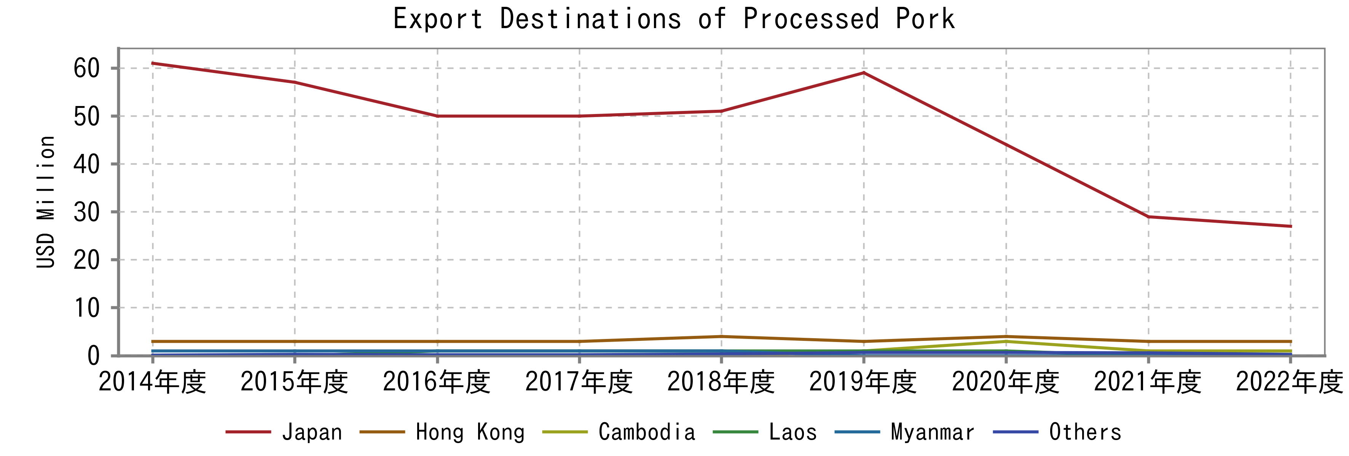

 Source: Trade Map

Note: HS Code 160249, 160241, and 160242

# Competitive Trends

**Consolidated Industry Led by CPF and Betagro Given their Complementary Integrated Businesses to Support Production and Distribution**

The industry is consolidated with most players operating in multiple product segments. Based on revenue, it is likely that CPF and Betagro lead the processed meat product industry in Thailand. The dominance of these two players is likely due to the fact that they are pioneers in the agro-industrial and integrated food businesses and have been established longer than other players. In addition, they have a high number of distribution channels as they also have their own stores to sell their products.

Upon witnessing the characteristics of eight large-scale players, none is solely catering to the domestic market. Some players equally focus on both markets, while a few (Cargill Meats (Thailand), Thai Nippon Foods, and Primaham (Thailand) [THA]) primarily export. The export-oriented industry creates fewer opportunities for small-scale players (with limited funding) and heightens export sector entry barriers. Additionally, small-scale players (such as Ekchai Look Chin [THA] and Siam Suda Food Products [THA]) likely tend to only cater to local areas whereas larger-scale players distribute across the country and globe.

**List of Major Players in the Processed Meat Product Industry**

|  |  |  |  |  |  |
| --- | --- | --- | --- | --- | --- |
| **Company Name** | **Year Established** | **Nationality** | **Brands and Processed Meat Products** | **Other Business Units** | **Segmental Revenue (THB billion; 2022)** |
| CPF | 1978 | Thai | CP, BKP, Super Chef, and Mr. Sausage: sausages and similar products  CP: ready-to-cook marinated pork, chicken steak burgers, seasoned chicken breast, smoked chicken, roasted chicken wings, nuggets, wontons | Farm and Processing, and Feed | 52.5 |
| Betagro | 1980 | Thai | Betagro: sausages and similar products, bacon, meatballs  S Pure: seasoned cooked chicken  Itoham: seasoned cooked chicken, sausages and similar products | Food and Protein, Agro, International, and Pet | 33.9 |
| Thai Nippon Foods | 1989 | Japanese | NH Foods: sausages and similar products, steamed seasoned chicken, frozen fried chicken, charcoal grilled chicken, seamed seasoned pork, hamburg | Other processed food products (frozen vegetables and ready-to-cook prepared meals) | 2.9 |
| Cargill Meats (Thailand) | 1989 | American | Cargill: seasoned cooked chicken | Agriculture, Animal nutrition and health, Food and beverages, and Poultry | N/A |
| Thai Foods Further (THA) (a processed meat subsidiary of Thai Foods Group) | 2016 | Thai | TFG: sausages, meatballs | Meat, Livestock, Animal feed, Food R&D, Animal feed and farming equipment packaging, Condiments | 3.6 |
| Spring Kitchen (THA) | 2014 | Thai | Spring Kitchen: steamed chicken, roasted chicken, fried chicken | - | 2.5 |
| Primaham (Thailand) | 1992 | Japanese | Primaham: smoked chicken  Ko-Kun: Bacon, ham, sausages  Takumi: Ham steak, seasoned chicken, sausages, bacon, hamburg, meatballs | Meat, ready-to-cook foods | 2.0 |
| S. Khonkaen Foods (THA) | 1993 | Thai | S. Khonkaen: sausages, Thai-style fermented sausages, meat floss, pork chips  Moo Dee: sausages, meatballs, meat floss | Processed seafood, Quick service restaurants, Swine farming | 1.6 |

Source: Compiled by Uzabase

Note: The revenue is not only from the processed meat product business

**CPF: Leading Agro-Industrial and Food Conglomerate with Dominant Position in Sausage and Similar Product Industry**

CPF is Thailand’s leading agro-industrial and food conglomerate. The company’s operations are divided into three segments: Farm and Processing (54.6% of the total revenue of Thailand’s operations in 2022), Food (23.4%), and Feed (22.0%). In June 2019 (latest available), the company held a share of around 31% of the domestic market share of sausages and similar products, penetrating the market with its four different brands. In addition, its convenience store chain ‘7-Eleven’ was the main channel of distribution for its sausages and similar products, accounting for roughly half of the sales while Makro (its warehouse clubs) contributed about 28%. Besides sausages and similar products, CPF also has other processed food products such as ready-to-cook marinated pork, chicken steak burgers, seasoned chicken breast, etc.

Over 2017–22, about 50–55% of the company’s Food Business (including ready-to-eat food, beverages, etc.) revenue was derived domestically while exports constituted the remainder. In 2022, the segmental revenue increased at a CAGR of 9.9% over 2020–22, driven mainly by the robust growth from the domestic market during this period. Prior to this, the segmental revenue dropped 9.5% YoY in 2020 during the COVID-19 pandemic, mainly due to weak exports in the year.

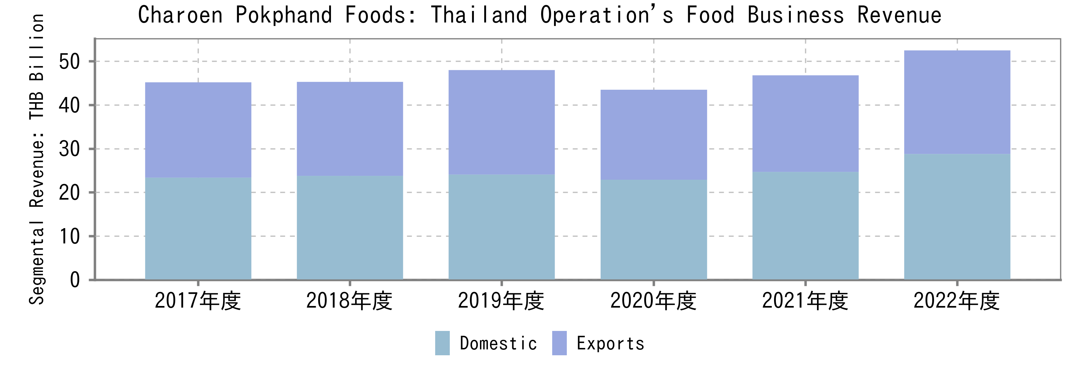

Source: Company filings

Note 1: The figures also include ready-to-eat food and beverages.

Note 2: The segmental operating margin N/A

**Betagro: Second Largest Player in Sausage and Similar Product Market**

Betagro is also one of the leading agro-industrial and food conglomerates in Thailand. The company operations are divided into four main business units: Food and Protein (67.2% of the total revenue in 2022), Agro (25.2%), International (5.5%), Pet (2.0%), and others (less than 0.1%). Domestically, Betagro was the second largest player in Thailand’s sausage and similar product market, capturing a share of around 10–15% of total market value in July 2019 (latest available). The company’s sausages and similar products are sold through several distribution channels such as supermarkets, convenience stores, restaurant/hotel chains, and its own stores (namely ‘Betagro Shop’ and ‘Betagro Daily’). In addition to physical establishments, the company has also expanded to e-commerce platforms.

Under the Food and Protein business unit, Consumer Food (which processed foods are catergorised under) is the largest segment, contributing 44.8% to the total revenue of the business unit in 2022. The sales of consumer food products increased at a CAGR of 17.1% over 2019–22. Meanwhile, exports of products (consumer food products, non-packaged meat products, etc.) soared 45.9% YoY in 2022 after dropping 7.6% YoY in 2021.

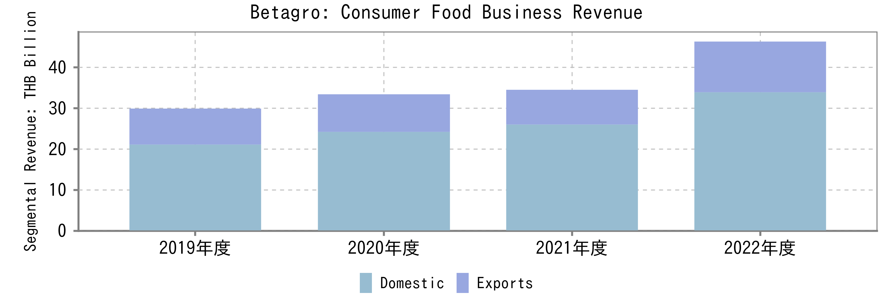

 Source: Company filings

Note 1: The figures also include other kinds of products

Note 2: The segmental operating margin N/A

**Thai Nippon Foods: Thai Subsidiary of Nipponham Group Mainly Caters to Export Market, Particularly to Japan**

NH Foods (JPN), also known as Nipponham Group, established its Thai subsidiary Thai Nippon Foods (THA) in 1989 to operate a variety of businesses, including fresh meat, processed food, logistics, and distribution. The main purpose of setting up the Thai subsidiary is to initially use it as a manufacturing hub and to export its products to Japan. Subsequently, the Thai subsidiary began to sell its products domestically in late 2014, with the first locally launched product being ‘Vienna Sausage.’

The company’s revenue soared 17.0% YoY in FY2022 (FY ends in March) after dropping at a CAGR of 14.7% over FY2018–21. Meanwhile, the operating margin decreased 3.6 percentage points YoY in FY2022 and entered the negative territory due to a fall in the gross margin and a rising SG&A-to-revenue ratio in the same year. Prior to this, the operating margin also dropped 2.0 percentage points YoY in FY2021 as a result of decreasing gross margin and rising SG&A-to-revenue ratio.

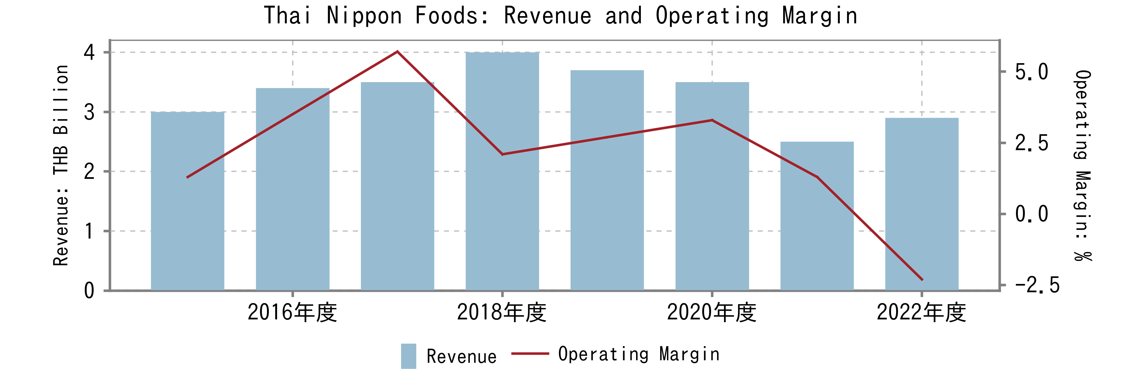

 Source: Company filings

Note: The company’s FY ends in March

# 業界プレイヤー

|  |  |  |  |  |  |  |  |  |  |
| --- | --- | --- | --- | --- | --- | --- | --- | --- | --- |
| （単位：百万円） | 決算期 | 売上高  合計 | 親会社株主に帰属する当期純利益 | 親会社株主に帰属する当期純利益率 | 売上高増加率 | 期末従業員数 | 時価総額 | PER | 企業価値/EBITDA |
| Charoen Pokphand Foods PCL | 2023/12 | 2,368,311 | -23,596 | -1.0％ | -4.6％ | N/A | 780,335 | N/A | 28.9倍 |
| Cargill Meats (Thailand) Ltd （非上場） | 2023/05 | 131,779 | 8,851 | 6.7％ | 34.4％ | N/A | N/A | N/A | N/A |
| BETTER FOODS CO., LTD. （非上場） | 2023/12 | 75,108 | -365 | -0.5％ | -3.5％ | N/A | N/A | N/A | N/A |
| CPF FOOD AND BEVERAGE COMPANY LIMITED （非上場） | 2023/12 | 57,040 | 1,430 | 2.5％ | 6.1％ | N/A | N/A | N/A | N/A |
| SUN FOOD INTERNATIONAL CO.,LTD. （非上場） | 2023/12 | 53,634 | -480 | -0.9％ | -1.4％ | N/A | N/A | N/A | N/A |
| LAEMTHONG AGRI - PRODUCTS CO., LTD. （非上場） | 2023/12 | 46,547 | 73 | 0.2％ | 27.9％ | N/A | N/A | N/A | N/A |
| MCKEY FOOD SERVICES (THIALAND) LIMITED （非上場） | 2023/12 | 44,055 | 3,403 | 7.7％ | -4.4％ | N/A | N/A | N/A | N/A |
| S Khonkaen Foods PCL | 2023/12 | 12,515 | 221 | 1.8％ | -2.7％ | N/A | 5,797 | 25.7倍 | 9.6倍 |
| THAIFOODS FURTHER COMPANY LIMITED （非上場） | 2023/12 | 12,419 | -208 | -1.7％ | -14.3％ | N/A | N/A | N/A | N/A |
| THAI NIPPON FOODS COMPANY LIMITED （非上場） | 2023/03 | 9,955 | 41 | 0.4％ | -11.0％ | N/A | N/A | N/A | N/A |
| SPRING KITCHEN COMPANY LIMITED （非上場） | 2023/12 | 8,995 | 852 | 9.5％ | -12.7％ | N/A | N/A | N/A | N/A |
| PRIMAHAM (THAILAND) COMPANY LIMITED （非上場） | 2023/03 | 7,056 | -162 | -2.3％ | -8.1％ | N/A | N/A | N/A | N/A |
| THAI-GERMAN MEAT PRODUCT COMPANY LIMITED （非上場） | 2023/12 | 6,685 | 156 | 2.3％ | 16.0％ | N/A | N/A | N/A | N/A |
| GF FOODS CO., LTD. （非上場） | 2023/12 | 3,703 | 121 | 3.3％ | -3.4％ | N/A | N/A | N/A | N/A |
| GSB INTERNATIONAL COMPANY LIMITED （非上場） | 2023/12 | 3,047 | 181 | 5.9％ | 9.8％ | N/A | N/A | N/A | N/A |
| 平均値 | N/A | 189,390 | -632 | 2.3％ | 1.9％ | N/A | 393,066 | 25.7倍 | 19.2倍 |
| 中央値 | N/A | 12,515 | 121 | 1.8％ | -3.4％ | N/A | 393,066 | 25.7倍 | 19.2倍 |
| 最小値 | N/A | 3,047 | -23,596 | -2.3％ | -14.3％ | N/A | 5,797 | 25.7倍 | 9.6倍 |
| 最大値 | N/A | 2,368,311 | 8,851 | 9.5％ | 34.4％ | N/A | 780,335 | 25.7倍 | 28.9倍 |