Registration Smart Contract

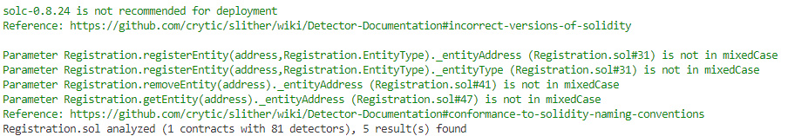

WPV Smart Contract



