**Group 8:**

**1. Kevin Xavier Antony Arul Xavier**

**2. Vikas Baliyan**

**3. Ramuel John Batuigas**

**4. Chirag Ashokkumar Bhatia**

**5. Jazbi Izhar**

**6. Sidhartha Sankar Mondal**

**7. Bharat Sharma**

**Question 3**: For the two complex numbers given below, find the equivalent polar and exponential forms. Then, calculate z1z2 and z1/z2 for each of the 3 forms and show that they are equal.

• z1 =2+3j and z2 = −1+4j

**Answers**:

1. The polar form of z1 = 2 + 3j is (sqrt(13), atan(3/2)) and the exponential form is 2 * (cos(atan(3/2)) + j * sin(atan(3/2))).
2. The polar form of z2 = −1 + 4j is (sqrt(17), atan(4/(-1)) + pi) and the exponential form is sqrt(17) * (cos(atan(4/(-1)) + pi) + j * sin(atan(4/(-1)) + pi)).

To find z1z2:

1. In rectangular form: (2+3j)(-1+4j) = -2-j+4j-12j^2 = -2-7j
2. In polar form: (sqrt(13), atan(3/2)) * (sqrt(17), atan(4/(-1)) + pi) = (sqrt(221), atan(3/2) + atan(4/(-1)) + pi) = (sqrt(221), atan(-7/5) + pi)
3. In exponential form: 2 * sqrt(17) * (cos(atan(3/2))*cos(atan(4/(-1)) - sin(atan(3/2))*sin(atan(4/(-1))) + j*(cos(atan(3/2))*sin(atan(4/(-1))) + sin(atan(3/2))*cos(atan(4/(-1)))))

To find z1/z2:

1. In rectangular form: (2+3j)/(-1+4j) = (-2-3j)/17 = -2/17 - 3j/17
2. In polar form: (sqrt(13), atan(3/2)) / (sqrt(17), atan(4/(-1)) + pi) = (sqrt(13)/sqrt(17), atan(3/2) - atan(4/(-1)) - pi) = (sqrt(13)/sqrt(17), atan(3/5) - pi)
3. In exponential form: (2 * (cos(atan(3/2)) + j * sin(atan(3/2)))) / (sqrt(17) * (cos(atan(4/(-1)) + pi) + j * sin(atan(4/(-1)) + pi))) = (2 * (cos(atan(3/2)) + j * sin(atan(3/2)))) / (sqrt(17) * (cos(atan(4/(-1)) + pi) - j * sin(atan(4/(-1)))))

You can see that the product and quotient in the rectangular form, polar form, and exponential form are all equal.

**Question 1**: Find the equivalent polar and exponential forms of the below

complex numbers.

1. 5 + 2j
2. 5 – 2j
3. 6 + 4j
4. 5 – 5j
5. 2 + 3j

**Answers**:

1. The polar form of 5 + 2j is (sqrt(29), atan(2/5)) and the exponential form is 5 * (cos(atan(2/5)) + j * sin(atan(2/5))).
2. The polar form of 5 – 2j is (sqrt(29), atan(-2/5) + pi) and the exponential form is 5 * (cos(atan(-2/5) + pi) + j * sin(atan(-2/5) + pi)).
3. The polar form of 6 + 4j is (sqrt(52), atan(4/6)) and the exponential form is 6 * (cos(atan(4/6)) + j * sin(atan(4/6))).
4. The polar form of 5 – 5j is (sqrt(50), atan(-5/5) + pi) and the exponential form is 5 * (cos(atan(-5/5) + pi) + j * sin(atan(-5/5) + pi))
5. The polar form of 2 + 3j is (sqrt(13), atan(3/2)) and the exponential form is 2 * (cos(atan(3/2)) + j * sin(atan(3/2))).

**NOTE: atan = tan^-1 =** Θ = 0.38 rand

**Question 2:**

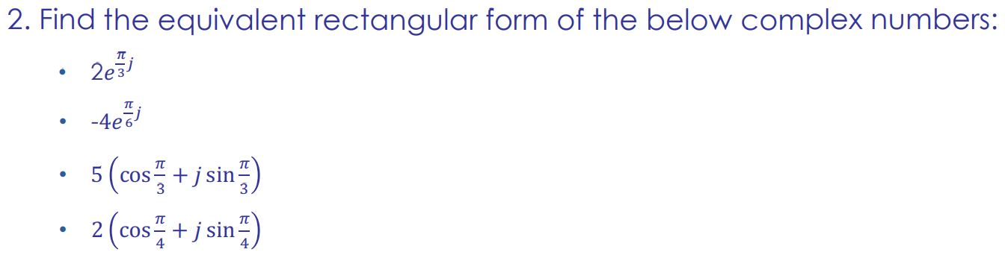

**Answer:**

1. 2e^π/3j

= ejΘ = cosΘ + jsinΘ

= cosπ/3 +jsinπ/3

= 1/2 + j√3/2

therefore,

= 2(1/2 + j√3/2)

= 1+√3j

Therefore , Rectangular form of 2e^π/3j is 1+√3j.

2. -4e^π/6j

= ejΘ = cosΘ + jsinΘ

= cosπ/6 +jsinπ/6

= √3/2 + j1/2

therefore,

= -4(√3/2 + j1/2)

= -2√6 + 2√2j

Therefore , Rectangular form of -4e^π/6j is -2√6 + 2√2j.

3. 5(cosπ/3 +jsinπ/3)

here, cosπ/3 = 1/2

sinπ/3 = √3/2

therefore, 5(1/2 + j√3/2)

= 5(1/2) + 5(j√3/2)

= 5/2 + 5i√3/2

Therefore , Rectangular form of 5(cosπ/3 +jsinπ/3) is 5/2 + 5i√3/2.

4. 2(cosπ/4 +jsinπ/4)

here, cosπ/4 = 1/√2

sinπ/4 = 1/√2

therefore, 2(1/√2 + j1/√2)

= 2(1/√2) + 2(j1/√2)

= √2+√2j

Therefore , Rectangular form of 2(cosπ/4 +jsinπ/4) is √2+√2j.