South Sudan resilience baseline

Demographic profiles

Monitoring and Evaluation Support Project (MESP)

Table of contents

# 1 Jur River (Western Bahr el Gazal)

## 1.1 Age

#include_graphics(here("output/viz/Jur River/age density, Jur River.png"))

include_graphics(here("output/viz/Jur River/age density, Jur River.png"))

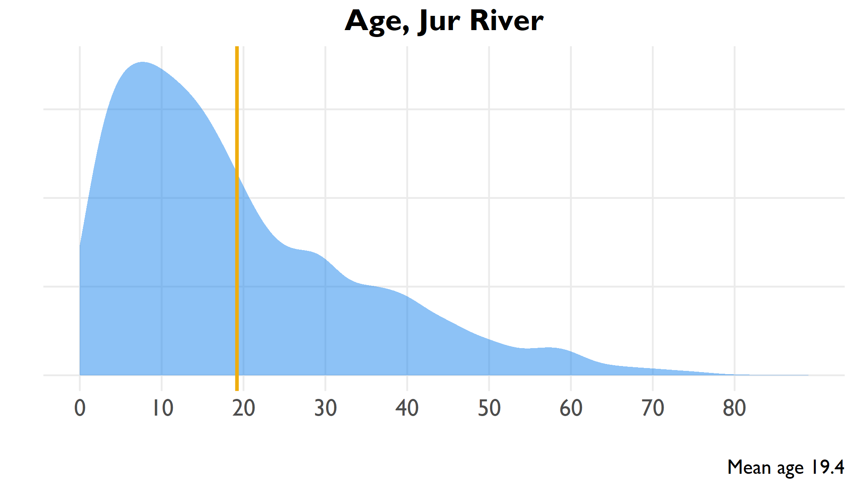

include_graphics(here("output/viz/Jur River/age pyramid, Jur River.png"))

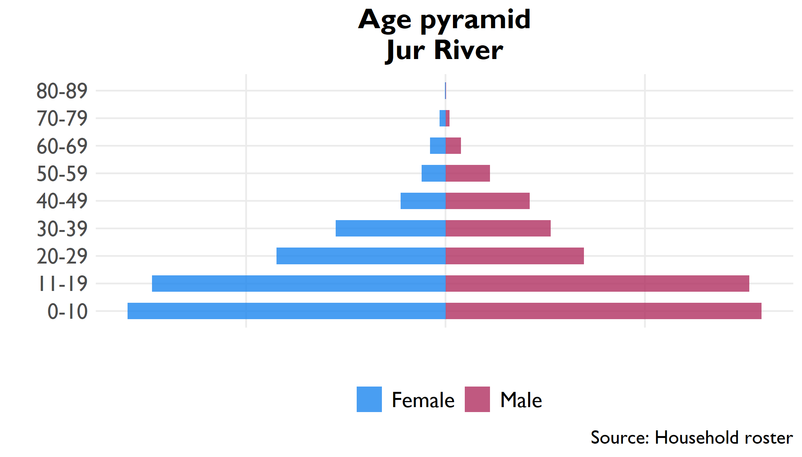

## 1.2 Household

**Table** : Household size, Jur River

| Indicator | Household size | Confidence interval | County rank |
| --- | --- | --- | --- |
| Household size | 6.7 | 6.3 - 7.1 | 3 |

**Table** : Proportion females 12-18 married, Jur River

| Indicator | Percent | Confidence interval | County rank |
| --- | --- | --- | --- |
| Proportion of household 12-18 | 21.7% | 20.4% - 23% | 8 |
| Proportion females 12-18 married | 6.2% | 4% - 8.4% | 10 |

## 1.3 Education

**Table** : Level of education in household

| Education | Number | Percent | Confidence interval |
| --- | --- | --- | --- |
| No education (6+) | 26,868 | 66.3% | 61.8% - 70.7% |
| Literate (6+) | 13,450 | 27.5% | 23.8% - 31.1% |
| Primary education (12+) | 8,022 | 26.4% | 23.4% - 29.5% |
| Secondary education (18+) | 2,266 | 10.7% | 7% - 14.4% |

## 1.4 Livelihoods

### 1.4.1 Economic activity in last 10 years (Q314)

### 1.4.2 Income sources (Q401-Q402)

|  |  |  |  |  |  |  |  |  |  |  |  |  |  |  |  |  |  |  |  |  |  |  |  |  |  |  |  |  |  |  |  |  |  |  |  |  |  |  |  |  |  |  |  |  |  |  |  |  |  |  |  |  |  |  |  |  |  |  |  |  |  |  |  |  |  |  |  |  |  |  |  |  |  |  |  |
| --- | --- | --- | --- | --- | --- | --- | --- | --- | --- | --- | --- | --- | --- | --- | --- | --- | --- | --- | --- | --- | --- | --- | --- | --- | --- | --- | --- | --- | --- | --- | --- | --- | --- | --- | --- | --- | --- | --- | --- | --- | --- | --- | --- | --- | --- | --- | --- | --- | --- | --- | --- | --- | --- | --- | --- | --- | --- | --- | --- | --- | --- | --- | --- | --- | --- | --- | --- | --- | --- | --- | --- | --- | --- | --- | --- |
| **Table** : Economic activity in past ten years | | Activity | Number | Percent | | --- | --- | --- | | Crop farming | 1,841 | 74.3% | | Education | 418 | 16.9% | | Animal husbandry | 69 | 2.8% | | Defense | 55 | 2.2% | | Trade | 35 | 1.4% | | Public administration | 24 | 1.0% | | Health | 17 | 0.7% | | Public servant | 13 | 0.5% | | Construction | 6 | 0.2% | | **Table** : Sources of household income | | Income source | Percent | | --- | --- | | Farm/crop production | 61.9% | | Goat production/sales | 53.2% | | Ag wage labor in village | 45.1% | | Sheep production/sales | 33.7% | | Ag wage labor outside village | 29.6% | | Honey production/sales | 27.5% | | Wage labor in village | 26.2% | | Fishing and sales | 26.0% | | Cattle production/sales | 23.8% | | Petty trade other products | 23.4% | | Salaried work | 18.2% | | Wage labor outside village | 15.6% | | Other self-employment ag | 14.0% | | Petty trade own products | 12.8% | | Wild bush sales | 11.2% | | Other self-employment non-ag | 8.4% | | Remittances | 6.5% | | Gifts/inheritance | 5.5% | | Food / cash safety net | 4.2% | | Rental of land/property | 2.4% | |

## 1.5 Food security

**Table** : Food security indicators

| Indicator | Range | Score | Confidence interval | County rank |
| --- | --- | --- | --- | --- |
| Food Insecurity Experience Scale | 0-9 | 7.2 | 7 - 7.4 | 11 |
| Household Hunger Scale | 0-6 | 2.0 | 1.7 - 2.3 | 13 |
| Household Dietary Diversity Scale | 0-12 | 5.2 | 5 - 5.5 | 11 |
| Food insecurity experience scale divided into moderate (3-5) and severe (6-8) insecurity | | | | |
| Household hunger divided into moderate (2-3) and severe (4-6) hunger | | | | |

**Table** : Severe household hunger

| Indicator | Range | Percent | Confidence interval | County rank |
| --- | --- | --- | --- | --- |
| Severe Household Hunger | 0/1 | 6.0% | 3.2% - 8.9% | 10 |

## 1.6 Health

**Table** : Health indicators

| Indicator | Number | Percent | Confidence interval |
| --- | --- | --- | --- |
| Vaccinated for measles (9+ months) | 3,622 | 54.1% | 48.6% - 59.6% |
| Visited health clinic in past six months | 4,896 | 67.0% | 60.2% - 73.9% |
| Positive rating of health clinic visit | 2,342 | 47.8% | 41.1% - 54.6% |
| Satisfaction with health clinic service | 2,389 | 49.0% | 41.8% - 56.1% |

### 1.6.1 Purpose of visit, with satisfaction rates

**Table** : Health clinic satisfaction by service, Jur River

| Reason for visit | Percent | Confidence interval (visit) | Satisfied | Confidence interval (satisfaction) | Satisfaction rank |
| --- | --- | --- | --- | --- | --- |
| Illness | 85.6% | 79% - 92.3% | 48.6% | 40% - 57.2% | 6 |
| Check-up | 58.6% | 51.3% - 65.8% | 52.8% | 42.9% - 62.7% | 1 |
| Immunization | 56.6% | 47.8% - 65.4% | 51.6% | 40.9% - 62.3% | 2 |
| Postnatal care | 19.7% | 11.4% - 28.1% | 46.0% | 29.3% - 62.7% | 7 |
| Prenatal care | 19.2% | 11.3% - 27.1% | 49.1% | 33.8% - 64.4% | 5 |
| Family planning | 8.3% | 3.9% - 12.7% | 43.8% | 29.6% - 57.9% | 8 |
| Malnutrition | 5.0% | 2.4% - 7.5% | 50.0% | 19.8% - 80.3% | 3 |
| HIV service | 2.4% | 0.7% - 4% | 49.6% | 18.5% - 80.7% | 4 |
| Growth monitoring | 2.2% | 0.8% - 3.6% | 32.6% | 2.8% - 62.3% | 9 |

# 2 Wau (Western Bahr el Gazal)

## 2.1 Age

include_graphics(here("output/viz/Wau/age density, Wau.png"))

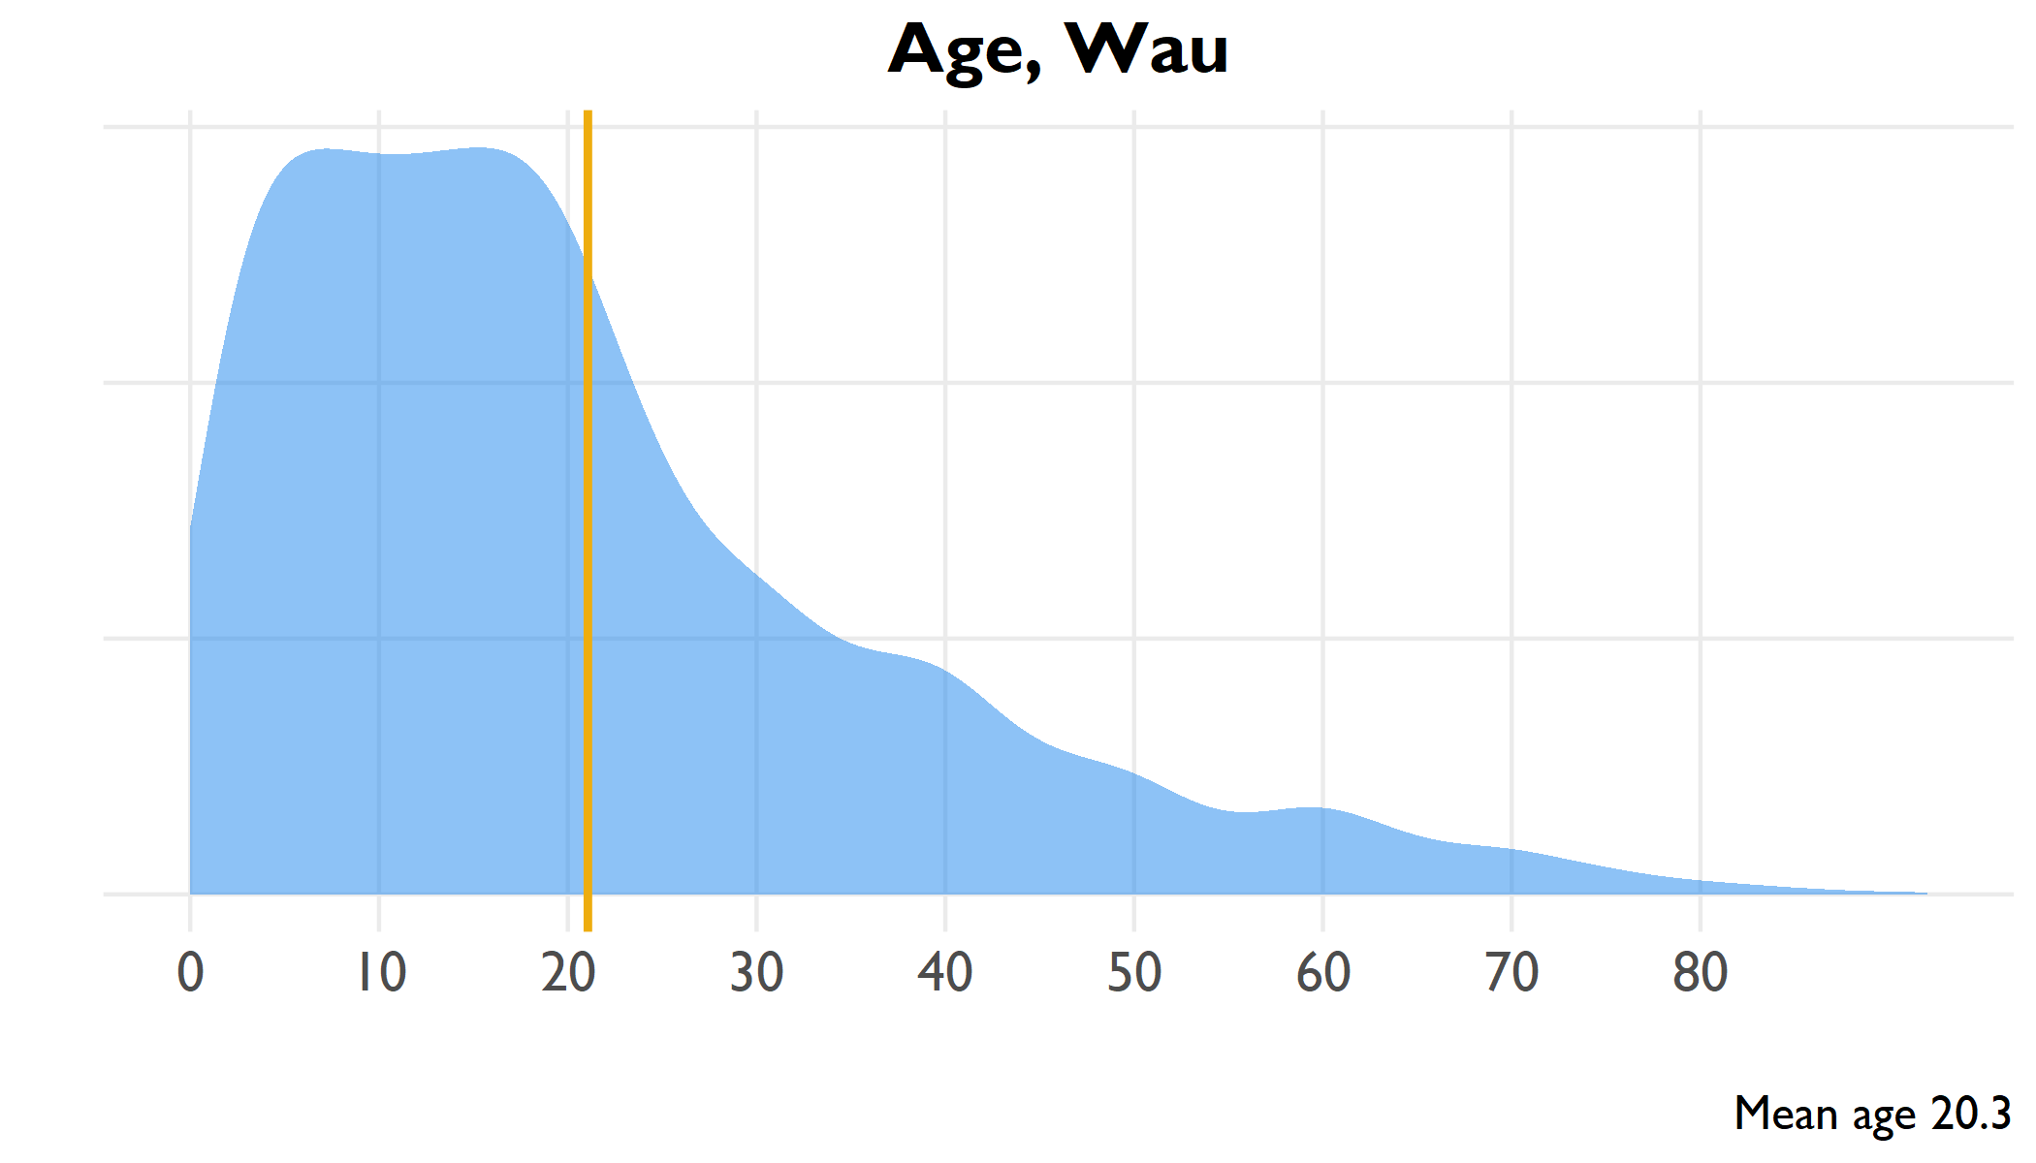

include_graphics(here("output/viz/Wau/age pyramid, Wau.png"))

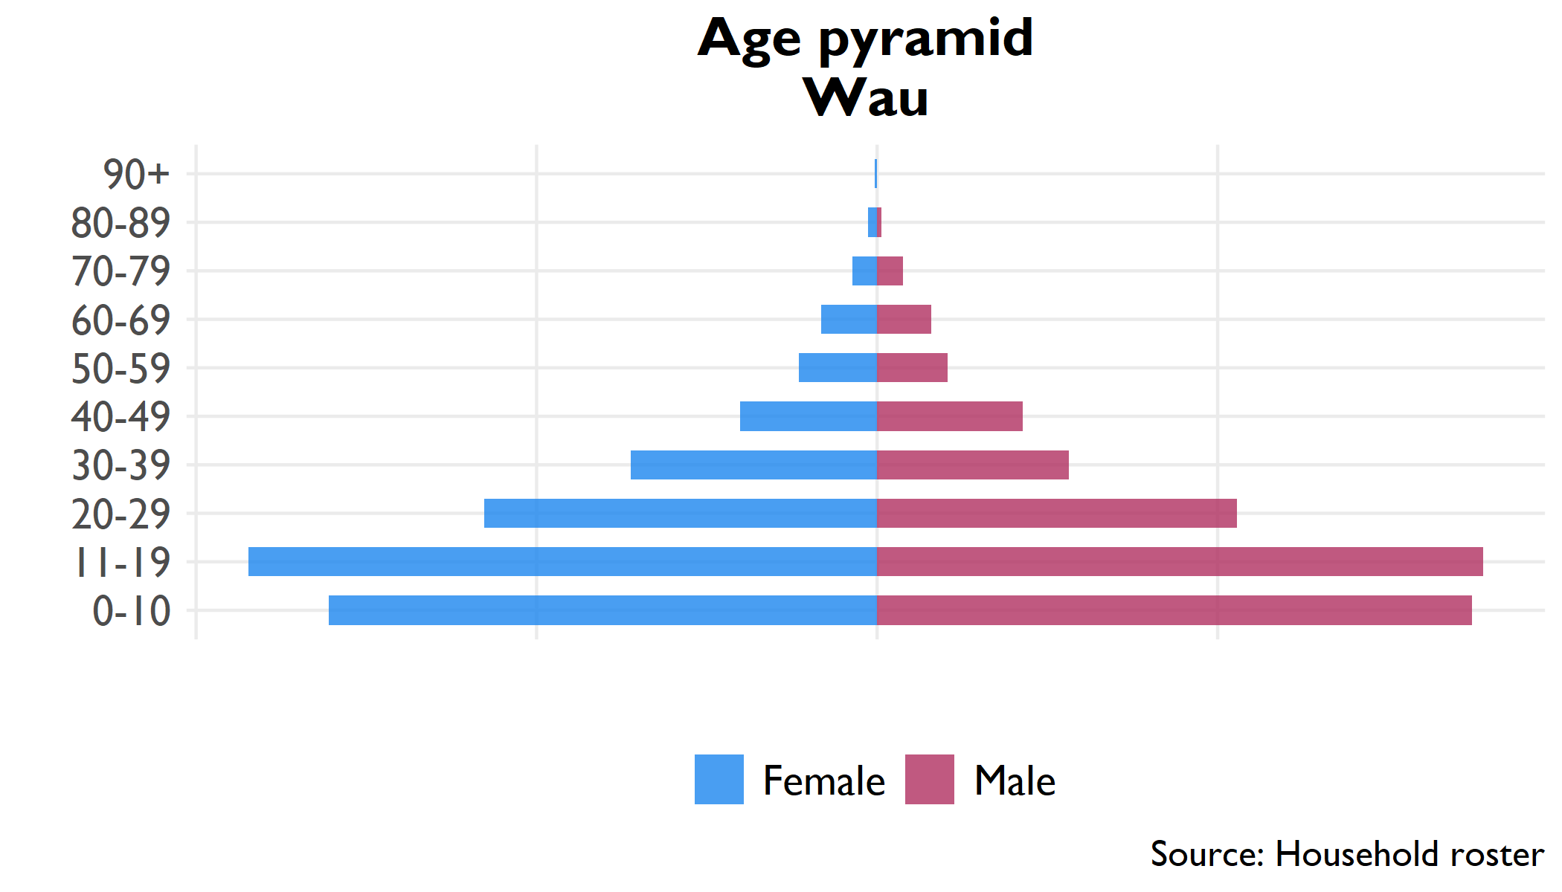

## 2.2 Household

**Table** : Household size, Wau

| Indicator | Household size | Confidence interval | County rank |
| --- | --- | --- | --- |
| Household size | 6.1 | 5.7 - 6.6 | 4 |

**Table** : Proportion females 12-18 married, Wau

| Indicator | Percent | Confidence interval | County rank |
| --- | --- | --- | --- |
| Proportion of household 12-18 | 21.3% | 20% - 22.6% | 9 |
| Proportion females 12-18 married | 13.3% | 7.8% - 18.8% | 4 |

## 2.3 Education

**Table** : Level of education in household

| Education | Number | Percent | Confidence interval |
| --- | --- | --- | --- |
| No education (6+) | 20,783 | 24.8% | 19.8% - 29.8% |
| Literate (6+) | 61,999 | 61.3% | 56.7% - 66% |
| Primary education (12+) | 27,399 | 41.9% | 36.7% - 47% |
| Secondary education (18+) | 19,145 | 39.9% | 32% - 47.9% |

## 2.4 Livelihoods

### 2.4.1 Economic activity in last 10 years (Q314)

### 2.4.2 Income sources (Q401-Q402)

|  |  |  |  |  |  |  |  |  |  |  |  |  |  |  |  |  |  |  |  |  |  |  |  |  |  |  |  |  |  |  |  |  |  |  |  |  |  |  |  |  |  |  |  |  |  |  |  |  |  |  |  |  |  |  |  |  |  |  |  |  |  |  |  |  |  |  |  |  |  |  |  |  |  |  |  |
| --- | --- | --- | --- | --- | --- | --- | --- | --- | --- | --- | --- | --- | --- | --- | --- | --- | --- | --- | --- | --- | --- | --- | --- | --- | --- | --- | --- | --- | --- | --- | --- | --- | --- | --- | --- | --- | --- | --- | --- | --- | --- | --- | --- | --- | --- | --- | --- | --- | --- | --- | --- | --- | --- | --- | --- | --- | --- | --- | --- | --- | --- | --- | --- | --- | --- | --- | --- | --- | --- | --- | --- | --- | --- | --- | --- |
| **Table** : Economic activity in past ten years | | Activity | Number | Percent | | --- | --- | --- | | Education | 748 | 36.0% | | Crop farming | 495 | 23.8% | | Trade | 374 | 18.0% | | Defense | 147 | 7.1% | | Public servant | 96 | 4.6% | | Construction | 81 | 3.9% | | Animal husbandry | 47 | 2.3% | | Public administration | 47 | 2.3% | | Health | 41 | 2.0% | | **Table** : Sources of household income | | Income source | Percent | | --- | --- | | Farm/crop production | 49.7% | | Salaried work | 32.9% | | Food / cash safety net | 25.5% | | Other self-employment non-ag | 22.0% | | Petty trade other products | 21.8% | | Wild bush sales | 21.6% | | Ag wage labor in village | 21.0% | | Rental of land/property | 20.9% | | Wage labor in village | 20.3% | | Wage labor outside village | 16.9% | | Petty trade own products | 16.4% | | Other self-employment ag | 15.4% | | Remittances | 13.5% | | Ag wage labor outside village | 13.4% | | Gifts/inheritance | 12.2% | | Honey production/sales | 10.9% | | Fishing and sales | 10.5% | | Cattle production/sales | 9.4% | | Sheep production/sales | 7.4% | | Goat production/sales | 7.1% | |

## 2.5 Food security

**Table** : Food security indicators

| Indicator | Range | Score | Confidence interval | County rank |
| --- | --- | --- | --- | --- |
| Food Insecurity Experience Scale | 0-9 | 6.4 | 5.9 - 6.9 | 13 |
| Household Hunger Scale | 0-6 | 2.2 | 1.7 - 2.7 | 12 |
| Household Dietary Diversity Scale | 0-12 | 6.1 | 5.3 - 7 | 5 |
| Food insecurity experience scale divided into moderate (3-5) and severe (6-8) insecurity | | | | |
| Household hunger divided into moderate (2-3) and severe (4-6) hunger | | | | |

**Table** : Severe household hunger

| Indicator | Range | Percent | Confidence interval | County rank |
| --- | --- | --- | --- | --- |
| Severe Household Hunger | 0/1 | 13.2% | 5.7% - 20.7% | 8 |

## 2.6 Health

**Table** : Health indicators

| Indicator | Number | Percent | Confidence interval |
| --- | --- | --- | --- |
| Vaccinated for measles (9+ months) | 46,163 | 84.5% | 77.2% - 91.7% |
| Visited health clinic in past six months | 14,622 | 89.4% | 85.2% - 93.7% |
| Positive rating of health clinic visit | 9,867 | 68.5% | 59.2% - 77.8% |
| Satisfaction with health clinic service | 9,349 | 65.3% | 56.3% - 74.4% |

### 2.6.1 Purpose of visit, with satisfaction rates

**Table** : Health clinic satisfaction by service, Wau

| Reason for visit | Percent | Confidence interval (visit) | Satisfied | Confidence interval (satisfaction) | Satisfaction rank |
| --- | --- | --- | --- | --- | --- |
| Check-up | 81.4% | 73.2% - 89.6% | 65.9% | 55.8% - 76% | 2 |
| Illness | 76.9% | 64% - 89.8% | 65.2% | 55.9% - 74.5% | 3 |
| Immunization | 29.3% | 19.2% - 39.4% | 52.2% | 40.9% - 63.5% | 9 |
| Prenatal care | 18.8% | 10.3% - 27.4% | 66.0% | 49.5% - 82.4% | 1 |
| Postnatal care | 14.0% | 7% - 20.9% | 53.3% | 34.8% - 71.7% | 8 |
| Family planning | 12.1% | 5.8% - 18.4% | 57.7% | 40.9% - 74.6% | 6 |
| Growth monitoring | 10.9% | 4.3% - 17.5% | 63.5% | 44.6% - 82.4% | 4 |
| Malnutrition | 10.1% | 2.8% - 17.4% | 60.6% | 38.5% - 82.7% | 5 |
| HIV service | 9.5% | 3.6% - 15.4% | 56.2% | 33.3% - 79.1% | 7 |

# 3 Budi (Eastern Equatoria)

## 3.1 Age

include_graphics(here("output/viz/Budi/age density, Budi.png"))

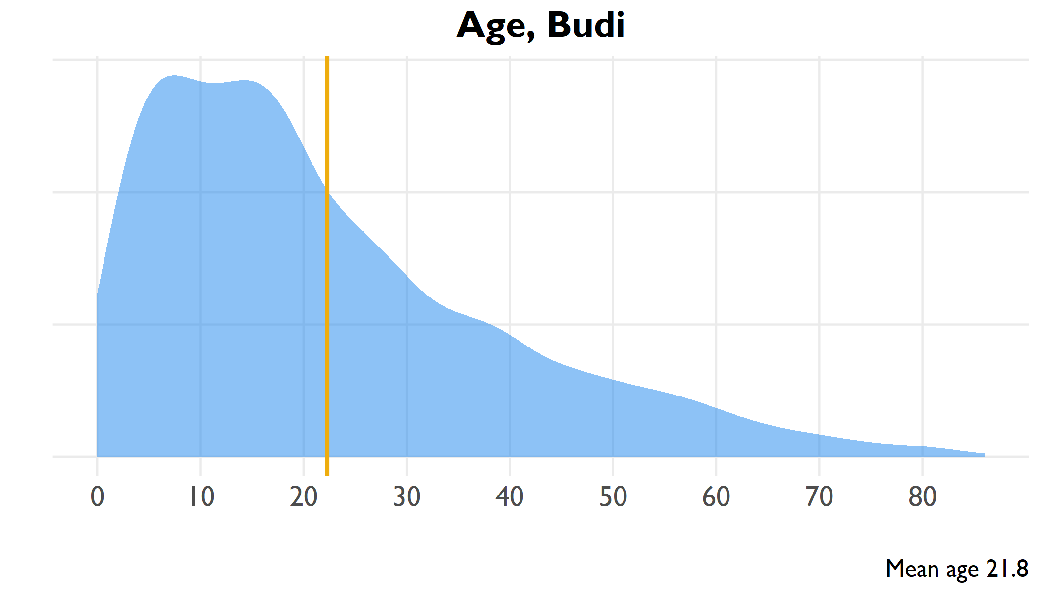

Age distribution of all household members, Budi

include_graphics(here("output/viz/Budi/age pyramid, Budi.png"))

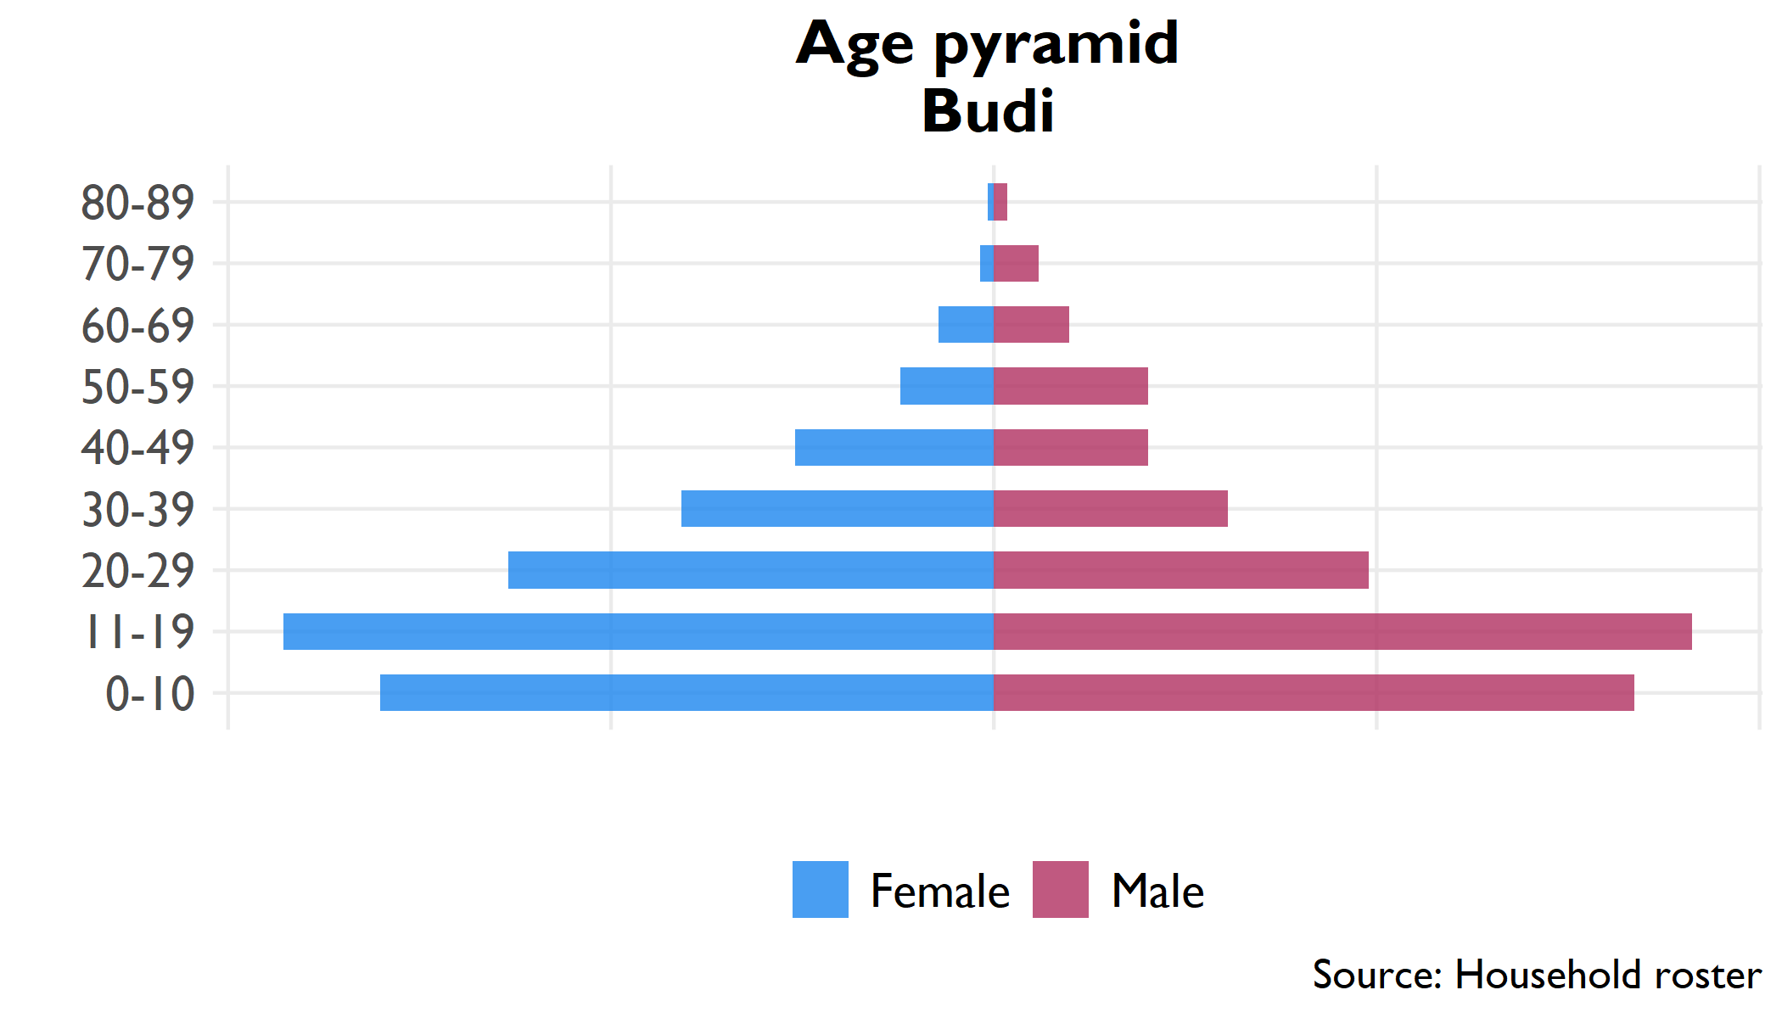

Pyramid plot of age groups by sex, all household members

## 3.2 Household

**Table** : Household size, Budi

| Indicator | Household size | Confidence interval | County rank |
| --- | --- | --- | --- |
| Household size | 5.3 | 4.9 - 5.6 | 9 |

**Table** : Proportion females 12-18 married, Budi

| Indicator | Percent | Confidence interval | County rank |
| --- | --- | --- | --- |
| Proportion of household 12-18 | 21.1% | 18.4% - 23.7% | 10 |
| Proportion females 12-18 married | 8.8% | 4.1% - 13.5% | 8 |

## 3.3 Education

**Table** : Level of education in household

| Education | Number | Percent | Confidence interval |
| --- | --- | --- | --- |
| No education (6+) | 43,085 | 75.5% | 66% - 84.9% |
| Literate (6+) | 11,541 | 16.8% | 9.5% - 24.1% |
| Primary education (12+) | 8,805 | 19.3% | 13.1% - 25.5% |
| Secondary education (18+) | 3,010 | 9.0% | 3.4% - 14.5% |

## 3.4 Livelihoods

### 3.4.1 Economic activity in last 10 years (Q314)

### 3.4.2 Income sources (Q401-Q402)

|  |  |  |  |  |  |  |  |  |  |  |  |  |  |  |  |  |  |  |  |  |  |  |  |  |  |  |  |  |  |  |  |  |  |  |  |  |  |  |  |  |  |  |  |  |  |  |  |  |  |  |  |  |  |  |  |  |  |  |  |  |  |  |  |  |  |  |  |  |  |  |  |  |  |  |  |
| --- | --- | --- | --- | --- | --- | --- | --- | --- | --- | --- | --- | --- | --- | --- | --- | --- | --- | --- | --- | --- | --- | --- | --- | --- | --- | --- | --- | --- | --- | --- | --- | --- | --- | --- | --- | --- | --- | --- | --- | --- | --- | --- | --- | --- | --- | --- | --- | --- | --- | --- | --- | --- | --- | --- | --- | --- | --- | --- | --- | --- | --- | --- | --- | --- | --- | --- | --- | --- | --- | --- | --- | --- | --- | --- | --- |
| **Table** : Economic activity in past ten years | | Activity | Number | Percent | | --- | --- | --- | | Crop farming | 1,509 | 72.3% | | Education | 312 | 14.9% | | Animal husbandry | 101 | 4.8% | | Trade | 73 | 3.5% | | Public servant | 46 | 2.2% | | Defense | 18 | 0.9% | | Health | 16 | 0.8% | | Public administration | 12 | 0.6% | | Construction | 1 | 0.0% | | **Table** : Sources of household income | | Income source | Percent | | --- | --- | | Farm/crop production | 73.1% | | Petty trade own products | 42.0% | | Goat production/sales | 34.7% | | Wild bush sales | 31.5% | | Honey production/sales | 27.2% | | Cattle production/sales | 27.0% | | Sheep production/sales | 24.0% | | Gifts/inheritance | 18.1% | | Food / cash safety net | 12.3% | | Ag wage labor in village | 11.1% | | Petty trade other products | 11.1% | | Other self-employment ag | 10.0% | | Other self-employment non-ag | 8.6% | | Wage labor in village | 7.0% | | Salaried work | 7.0% | | Ag wage labor outside village | 5.5% | | Wage labor outside village | 4.2% | | Remittances | 3.6% | | Fishing and sales | 0.6% | | Rental of land/property | 0.6% | |

## 3.5 Food security

**Table** : Food security indicators

| Indicator | Range | Score | Confidence interval | County rank |
| --- | --- | --- | --- | --- |
| Food Insecurity Experience Scale | 0-9 | 7.1 | 6.6 - 7.6 | 12 |
| Household Hunger Scale | 0-6 | 2.5 | 2.2 - 2.9 | 10 |
| Household Dietary Diversity Scale | 0-12 | 4.0 | 3.6 - 4.3 | 13 |
| Food insecurity experience scale divided into moderate (3-5) and severe (6-8) insecurity | | | | |
| Household hunger divided into moderate (2-3) and severe (4-6) hunger | | | | |

**Table** : Severe household hunger

| Indicator | Range | Percent | Confidence interval | County rank |
| --- | --- | --- | --- | --- |
| Severe Household Hunger | 0/1 | 10.5% | 4.3% - 16.8% | 9 |

## 3.6 Health

**Table** : Health indicators

| Indicator | Number | Percent | Confidence interval |
| --- | --- | --- | --- |
| Vaccinated for measles (9+ months) | 7,472 | 89.6% | 80.7% - 98.5% |
| Visited health clinic in past six months | 8,146 | 62.7% | 48.4% - 76.9% |
| Positive rating of health clinic visit | 6,017 | 74.4% | 62.6% - 86.3% |
| Satisfaction with health clinic service | 5,578 | 69.9% | 56.2% - 83.7% |

### 3.6.1 Purpose of visit, with satisfaction rates

**Table** : Health clinic satisfaction by service, Budi

| Reason for visit | Percent | Confidence interval (visit) | Satisfied | Confidence interval (satisfaction) | Satisfaction rank |
| --- | --- | --- | --- | --- | --- |
| Illness | 96.8% | 94.2% - 99.5% | 69.1% | 55% - 83.1% | 6 |
| Check-up | 44.5% | 33.9% - 55.2% | 65.1% | 44.3% - 85.9% | 8 |
| Immunization | 33.7% | 22.8% - 44.5% | 66.3% | 39.7% - 92.9% | 7 |
| Prenatal care | 15.9% | 10.4% - 21.4% | 92.1% | 84.2% - 100% | 3 |
| Malnutrition | 9.5% | 1.2% - 17.9% | 25.6% | -0.608 | 9 |
| Postnatal care | 8.6% | 4.4% - 12.7% | 94.1% | 85.5% - 102.8% | 2 |
| Family planning | 5.9% | 2.1% - 9.7% | 100.0% | 100% - 100% | 1 |
| HIV service | 4.5% | 1.9% - 7.1% | 83.2% | 59.5% - 106.9% | 5 |
| Growth monitoring | 4.2% | 1.8% - 6.7% | 89.8% | 79.5% - 100.1% | 4 |

# 4 Kapoeta North (Eastern Equatoria)

## 4.1 Age

include_graphics(here("output/viz/Kapoeta North/age density, Kapoeta North.png"))

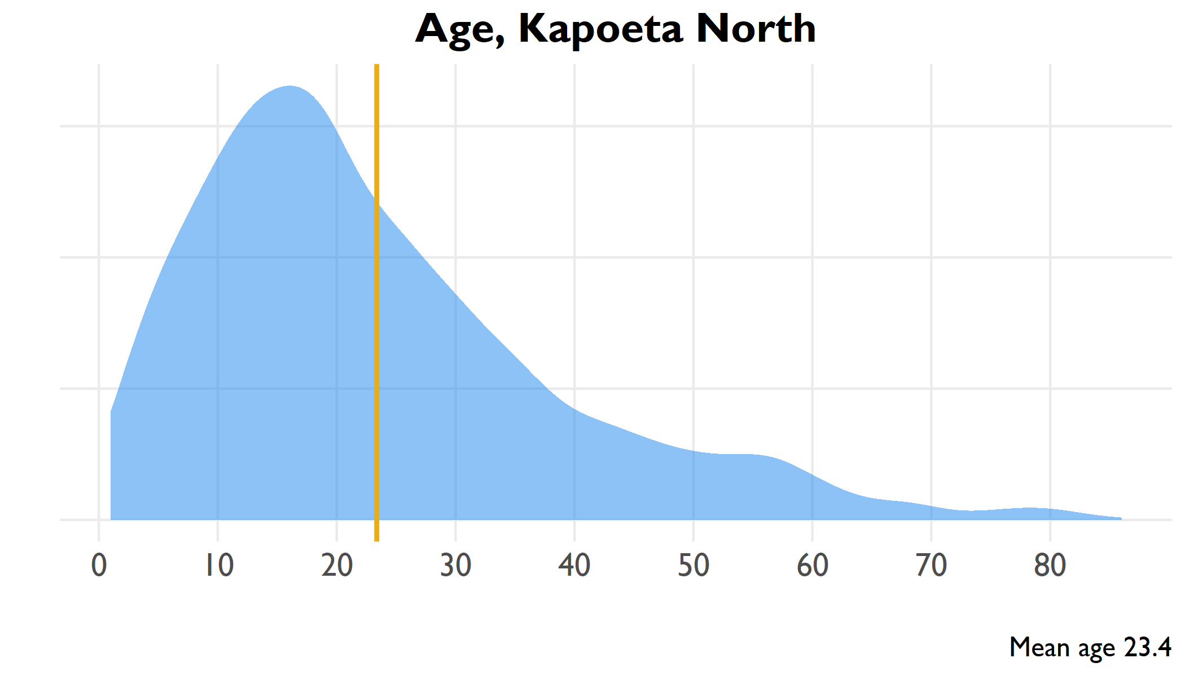

Age distribution of all household members, Kapoeta North

include_graphics(here("output/viz/Kapoeta North/age pyramid, Kapoeta North.png"))

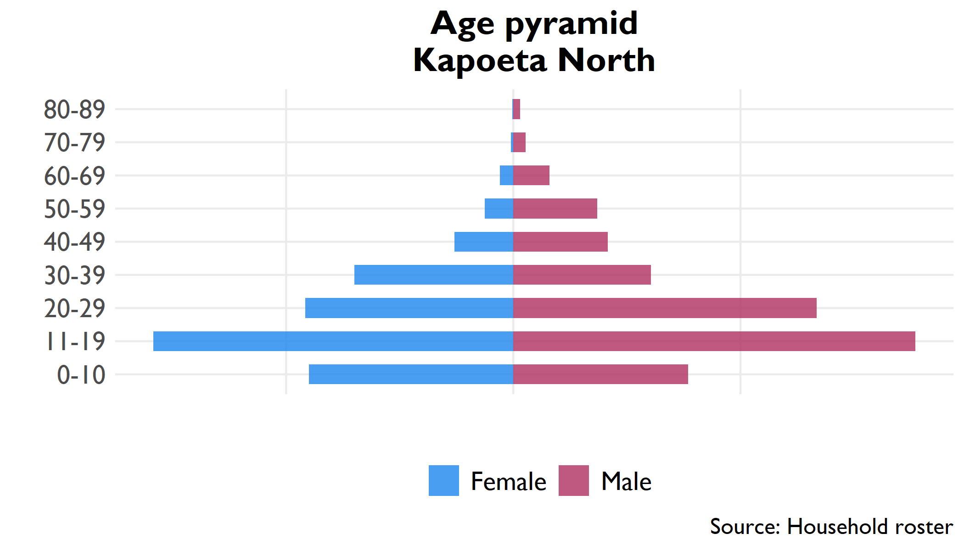

Pyramid plot of age groups by sex, all household members

## 4.2 Household

**Table** : Household size, Kapoeta North

| Indicator | Household size | Confidence interval | County rank |
| --- | --- | --- | --- |
| Household size | 3.2 | 2.3 - 4.1 | 12 |

**Table** : Proportion females 12-18 married, Kapoeta North

| Indicator | Percent | Confidence interval | County rank |
| --- | --- | --- | --- |
| Proportion of household 12-18 | 23.7% | 20.1% - 27.2% | 3 |
| Proportion females 12-18 married | 4.3% | 2.1% - 6.5% | 12 |

## 4.3 Education

**Table** : Level of education in household

| Education | Number | Percent | Confidence interval |
| --- | --- | --- | --- |
| No education (6+) | 32,645.2 | 98.5% | 97.6% - 99.4% |
| Literate (6+) | 354.8 | 1.0% | 0.3% - 1.6% |
| Primary education (12+) | 425.4 | 1.5% | 0.4% - 2.6% |
| Secondary education (18+) | 18.8 | 0.1% | 0% - 0.2% |

## 4.4 Livelihoods

### 4.4.1 Economic activity in last 10 years (Q314)

### 4.4.2 Income sources (Q401-Q402)

|  |  |  |  |  |  |  |  |  |  |  |  |  |  |  |  |  |  |  |  |  |  |  |  |  |  |  |  |  |  |  |  |  |  |  |  |  |  |  |  |  |  |  |  |  |  |  |  |  |  |  |  |  |  |  |  |  |  |  |  |  |  |  |  |  |  |  |  |  |  |
| --- | --- | --- | --- | --- | --- | --- | --- | --- | --- | --- | --- | --- | --- | --- | --- | --- | --- | --- | --- | --- | --- | --- | --- | --- | --- | --- | --- | --- | --- | --- | --- | --- | --- | --- | --- | --- | --- | --- | --- | --- | --- | --- | --- | --- | --- | --- | --- | --- | --- | --- | --- | --- | --- | --- | --- | --- | --- | --- | --- | --- | --- | --- | --- | --- | --- | --- | --- | --- | --- |
| **Table** : Economic activity in past ten years | | Activity | Number | Percent | | --- | --- | --- | | Crop farming | 951 | 60.1% | | Animal husbandry | 592 | 37.4% | | Education | 17 | 1.1% | | Health | 10 | 0.6% | | Trade | 7 | 0.4% | | Defense | 4 | 0.3% | | Public servant | 1 | 0.1% | | **Table** : Sources of household income | | Income source | Percent | | --- | --- | | Goat production/sales | 87.1% | | Farm/crop production | 82.9% | | Cattle production/sales | 82.6% | | Sheep production/sales | 82.4% | | Wild bush sales | 57.2% | | Food / cash safety net | 44.7% | | Ag wage labor in village | 42.8% | | Petty trade other products | 37.0% | | Other self-employment ag | 33.4% | | Other self-employment non-ag | 32.7% | | Wage labor in village | 31.3% | | Gifts/inheritance | 24.6% | | Honey production/sales | 20.5% | | Fishing and sales | 16.3% | | Ag wage labor outside village | 12.0% | | Rental of land/property | 10.9% | | Wage labor outside village | 10.0% | | Petty trade own products | 9.7% | | Remittances | 6.8% | | Salaried work | 6.2% | |

## 4.5 Food security

**Table** : Food security indicators

| Indicator | Range | Score | Confidence interval | County rank |
| --- | --- | --- | --- | --- |
| Food Insecurity Experience Scale | 0-9 | 7.8 | 7.7 - 7.9 | 3 |
| Household Hunger Scale | 0-6 | 2.5 | 2.3 - 2.7 | 11 |
| Household Dietary Diversity Scale | 0-12 | 6.7 | 5.9 - 7.4 | 2 |
| Food insecurity experience scale divided into moderate (3-5) and severe (6-8) insecurity | | | | |
| Household hunger divided into moderate (2-3) and severe (4-6) hunger | | | | |

**Table** : Severe household hunger

| Indicator | Range | Percent | Confidence interval | County rank |
| --- | --- | --- | --- | --- |
| Severe Household Hunger | 0/1 | 5.2% | 2% - 8.4% | 11 |

## 4.6 Health

**Table** : Health indicators

| Indicator | Number | Percent | Confidence interval |
| --- | --- | --- | --- |
| Vaccinated for measles (9+ months) | 1,101 | 51.1% | 38.4% - 63.7% |
| Visited health clinic in past six months | 8,382 | 73.5% | 69.1% - 78% |
| Positive rating of health clinic visit | 3,966 | 48.1% | 39.3% - 57% |
| Satisfaction with health clinic service | 5,768 | 69.9% | 61.1% - 78.7% |

### 4.6.1 Purpose of visit, with satisfaction rates

**Table** : Health clinic satisfaction by service, Kapoeta North

| Reason for visit | Percent | Confidence interval (visit) | Satisfied | Confidence interval (satisfaction) | Satisfaction rank |
| --- | --- | --- | --- | --- | --- |
| Illness | 95.4% | 92.9% - 97.8% | 70.1% | 61% - 79.3% | 3 |
| Growth monitoring | 52.4% | 46% - 58.7% | 76.7% | 65.6% - 87.7% | 2 |
| Check-up | 51.0% | 42.9% - 59% | 77.0% | 67.8% - 86.2% | 1 |
| Prenatal care | 45.1% | 36.7% - 53.4% | 69.8% | 58.4% - 81.3% | 4 |
| Malnutrition | 40.4% | 35.2% - 45.6% | 63.0% | 52.5% - 73.5% | 6 |
| Immunization | 34.3% | 23.1% - 45.4% | 62.8% | 54.1% - 71.6% | 8 |
| Family planning | 23.5% | 17.1% - 29.9% | 63.0% | 47% - 78.9% | 7 |
| Postnatal care | 22.4% | 15.6% - 29.2% | 59.8% | 47.7% - 72% | 9 |
| HIV service | 16.0% | 12.1% - 19.8% | 63.3% | 44.9% - 81.7% | 5 |

# 5 Akobo (Jonglei)

## 5.1 Age

include_graphics(here("output/viz/Akobo/age density, Akobo.png"))

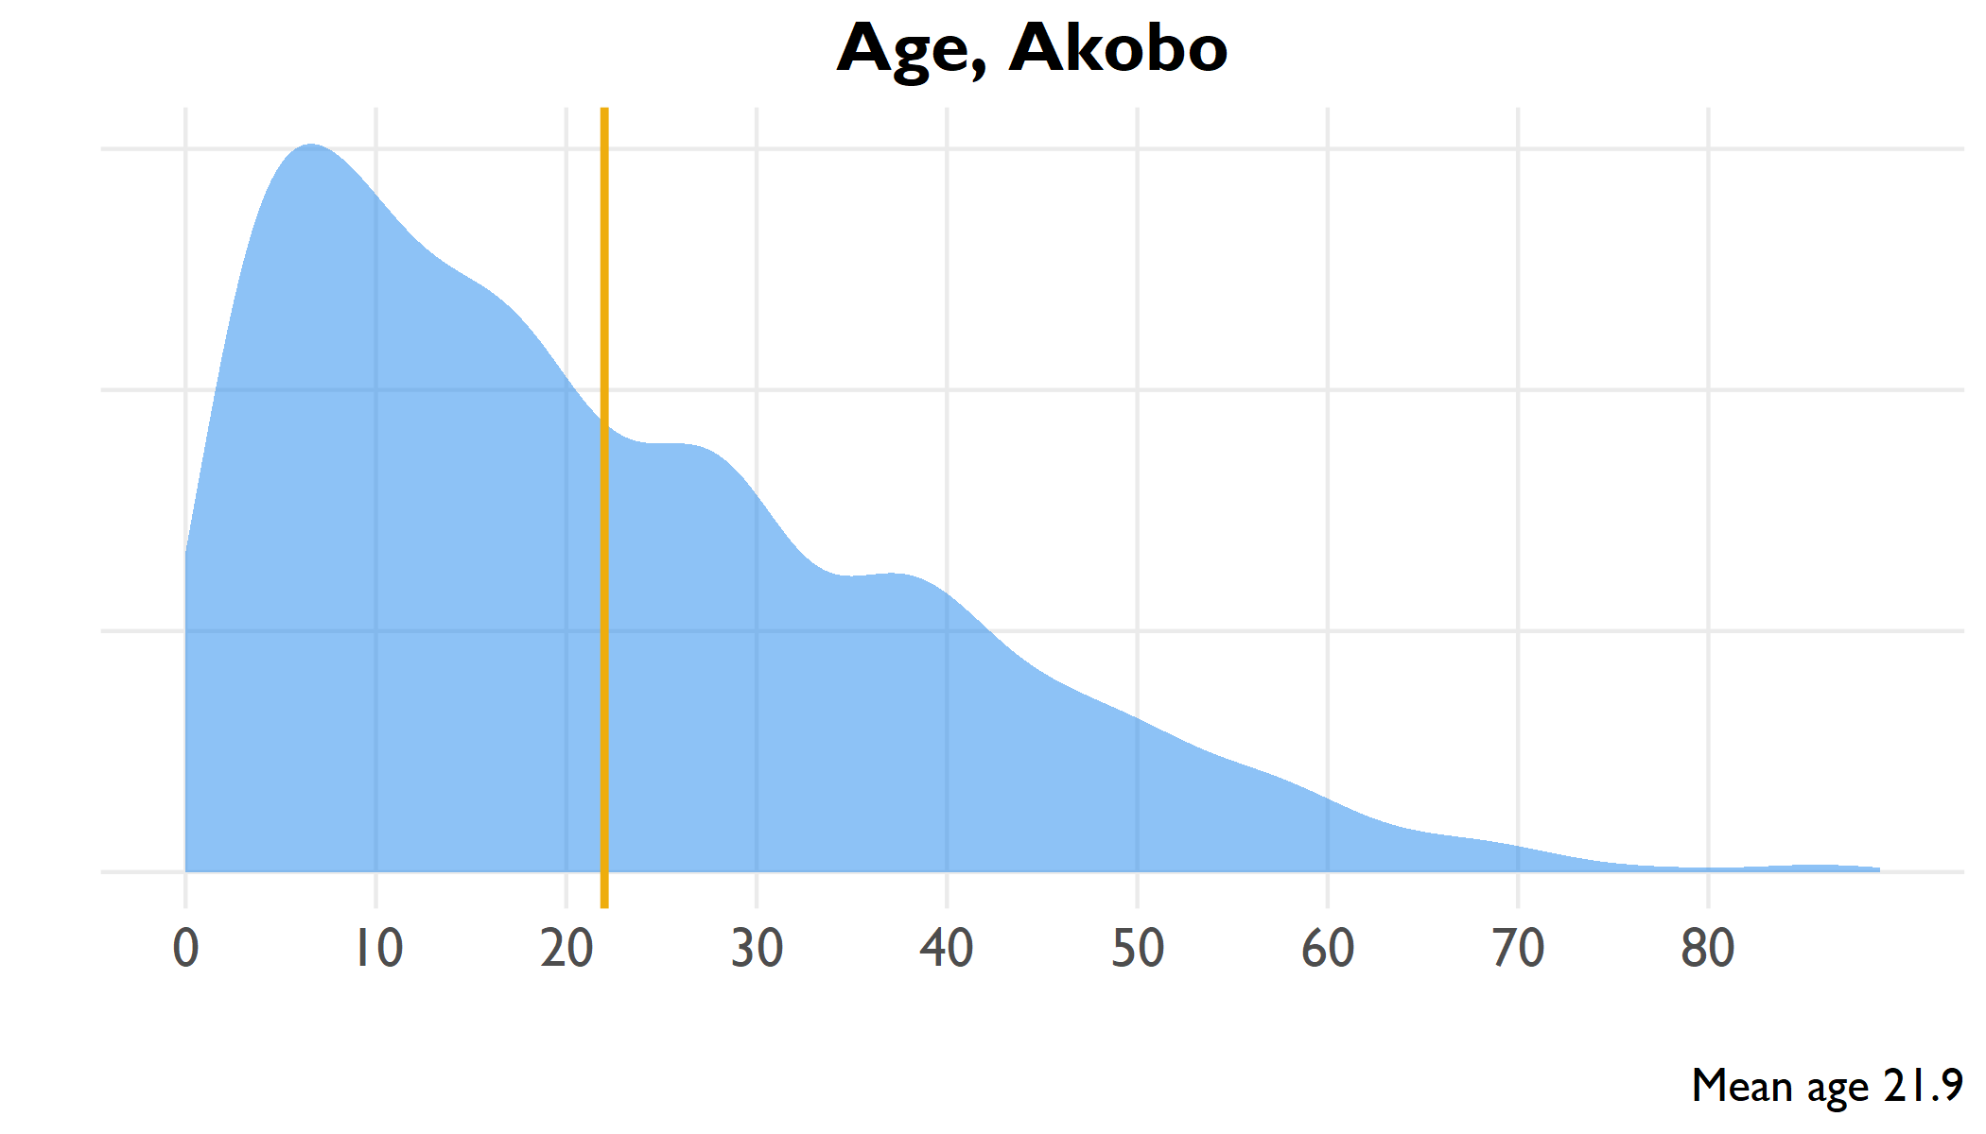

Age distribution of all household members, Akobo

include_graphics(here("output/viz/Akobo/age pyramid, Akobo.png"))

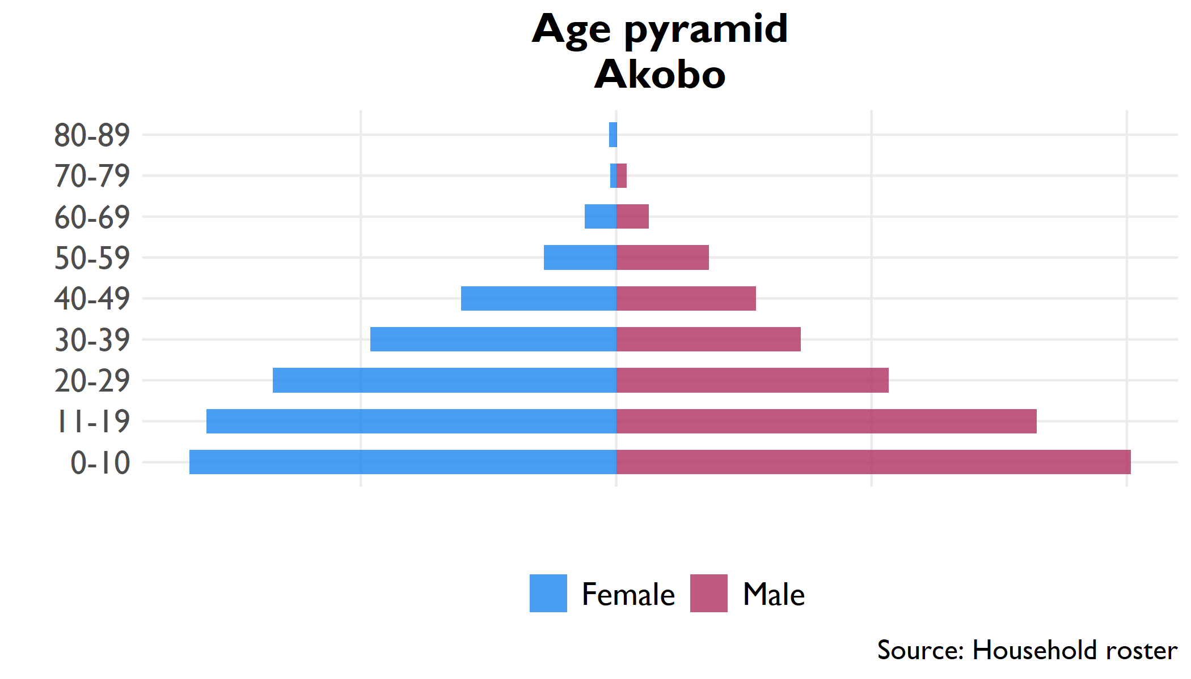

Pyramid plot of age groups by sex, all household members

## 5.2 Household

**Table** : Household size, Akobo

| Indicator | Household size | Confidence interval | County rank |
| --- | --- | --- | --- |
| Household size | 5.3 | 5 - 5.7 | 8 |

**Table** : Proportion females 12-18 married, Akobo

| Indicator | Percent | Confidence interval | County rank |
| --- | --- | --- | --- |
| Proportion of household 12-18 | 18.6% | 17.4% - 19.8% | 11 |
| Proportion females 12-18 married | 20.3% | 9.4% - 31.2% | 1 |

## 5.3 Education

**Table** : Level of education in household

| Education | Number | Percent | Confidence interval |
| --- | --- | --- | --- |
| No education (6+) | 33,624 | 65.5% | 59.1% - 72% |
| Literate (6+) | 17,348 | 28.6% | 22.9% - 34.3% |
| Primary education (12+) | 9,433 | 23.2% | 19.1% - 27.3% |
| Secondary education (18+) | 4,261 | 13.7% | 10.6% - 16.7% |

## 5.4 Livelihoods

### 5.4.1 Economic activity in last 10 years (Q314)

### 5.4.2 Income sources (Q401-Q402)

|  |  |  |  |  |  |  |  |  |  |  |  |  |  |  |  |  |  |  |  |  |  |  |  |  |  |  |  |  |  |  |  |  |  |  |  |  |  |  |  |  |  |  |  |  |  |  |  |  |  |  |  |  |  |  |  |  |  |  |  |  |  |  |  |  |  |  |  |  |  |  |  |  |  |  |  |
| --- | --- | --- | --- | --- | --- | --- | --- | --- | --- | --- | --- | --- | --- | --- | --- | --- | --- | --- | --- | --- | --- | --- | --- | --- | --- | --- | --- | --- | --- | --- | --- | --- | --- | --- | --- | --- | --- | --- | --- | --- | --- | --- | --- | --- | --- | --- | --- | --- | --- | --- | --- | --- | --- | --- | --- | --- | --- | --- | --- | --- | --- | --- | --- | --- | --- | --- | --- | --- | --- | --- | --- | --- | --- | --- | --- |
| **Table** : Economic activity in past ten years | | Activity | Number | Percent | | --- | --- | --- | | Crop farming | 1,629 | 83.6% | | Animal husbandry | 152 | 7.8% | | Trade | 56 | 2.9% | | Public administration | 37 | 1.9% | | Defense | 31 | 1.6% | | Education | 27 | 1.4% | | Public servant | 10 | 0.5% | | Health | 5 | 0.3% | | Construction | 2 | 0.1% | | **Table** : Sources of household income | | Income source | Percent | | --- | --- | | Fishing and sales | 54.5% | | Wild bush sales | 34.3% | | Cattle production/sales | 28.4% | | Wage labor in village | 22.9% | | Food / cash safety net | 21.1% | | Gifts/inheritance | 19.6% | | Farm/crop production | 18.3% | | Honey production/sales | 12.7% | | Goat production/sales | 10.7% | | Salaried work | 6.5% | | Petty trade own products | 4.5% | | Other self-employment non-ag | 4.0% | | Sheep production/sales | 3.0% | | Remittances | 2.9% | | Wage labor outside village | 1.4% | | Other self-employment ag | 1.2% | | Petty trade other products | 0.5% | | Ag wage labor in village | 0.4% | | Rental of land/property | 0.3% | | Ag wage labor outside village | 0.0% | |

## 5.5 Food security

**Table** : Food security indicators

| Indicator | Range | Score | Confidence interval | County rank |
| --- | --- | --- | --- | --- |
| Food Insecurity Experience Scale | 0-9 | 7.7 | 7.5 - 7.9 | 8 |
| Household Hunger Scale | 0-6 | 2.6 | 2.4 - 2.7 | 9 |
| Household Dietary Diversity Scale | 0-12 | 6.1 | 5.5 - 6.7 | 6 |
| Food insecurity experience scale divided into moderate (3-5) and severe (6-8) insecurity | | | | |
| Household hunger divided into moderate (2-3) and severe (4-6) hunger | | | | |

**Table** : Severe household hunger

| Indicator | Range | Percent | Confidence interval | County rank |
| --- | --- | --- | --- | --- |
| Severe Household Hunger | 0/1 | 3.8% | 1.6% - 5.9% | 12 |

## 5.6 Health

**Table** : Health indicators

| Indicator | Number | Percent | Confidence interval |
| --- | --- | --- | --- |
| Vaccinated for measles (9+ months) | 1,101 | 51.1% | 38.4% - 63.7% |
| Visited health clinic in past six months | 8,382 | 73.5% | 69.1% - 78% |
| Positive rating of health clinic visit | 3,966 | 48.1% | 39.3% - 57% |
| Satisfaction with health clinic service | 5,768 | 69.9% | 61.1% - 78.7% |

### 5.6.1 Purpose of visit, with satisfaction rates

**Table** : Health clinic satisfaction by service, Akobo

| Reason for visit | Percent | Confidence interval (visit) | Satisfied | Confidence interval (satisfaction) | Satisfaction rank |
| --- | --- | --- | --- | --- | --- |
| Illness | 84.2% | 79.7% - 88.7% | 36.5% | 24.9% - 48% | 6 |
| Check-up | 40.9% | 31.2% - 50.5% | 36.6% | 20.3% - 53% | 5 |
| Immunization | 31.0% | 22.2% - 39.8% | 35.8% | 21.8% - 49.7% | 7 |
| Prenatal care | 16.2% | 11.1% - 21.4% | 55.1% | 37.9% - 72.3% | 2 |
| Postnatal care | 8.7% | 4.9% - 12.5% | 47.1% | 22.2% - 72% | 3 |
| HIV service | 6.2% | 1.5% - 10.9% | 42.7% | 0.6% - 84.9% | 4 |
| Growth monitoring | 2.0% | 0.7% - 3.4% | 66.3% | 29.6% - 103% | 1 |
| Malnutrition | 2.0% | 0.5% - 3.5% | 25.5% | -0.822 | 9 |
| Family planning | 1.8% | 0.4% - 3.1% | 34.9% | -0.824 | 8 |

# 6 Duk (Jonglei)

## 6.1 Age

include_graphics(here("output/viz/Duk/age density, Duk.png"))

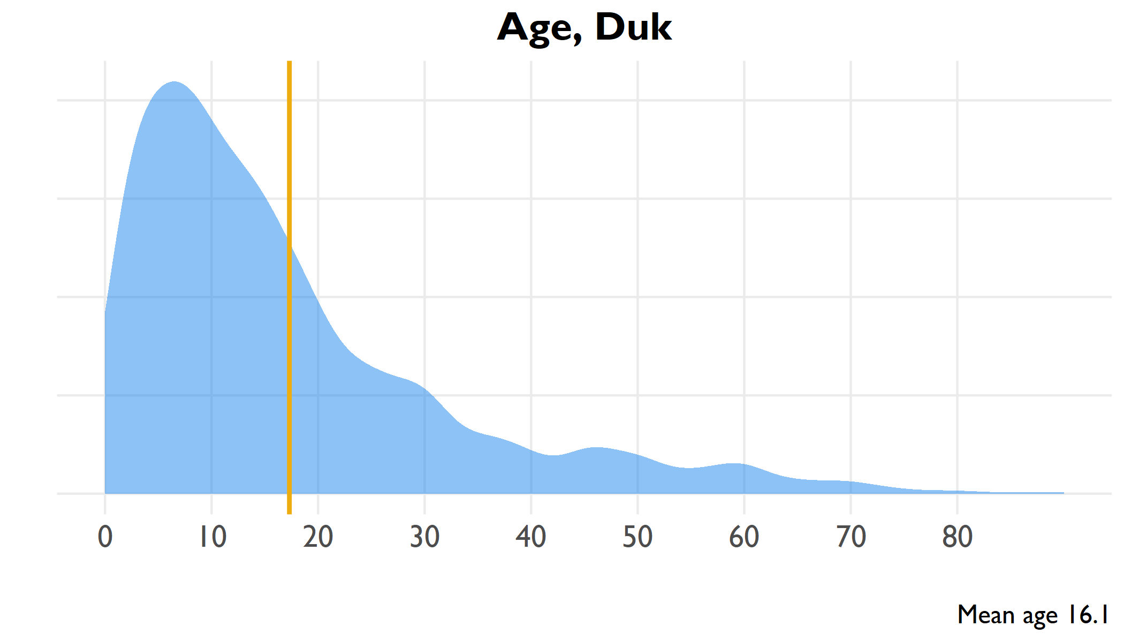

Age distribution of all household members, Duk

include_graphics(here("output/viz/Duk/age pyramid, Duk.png"))

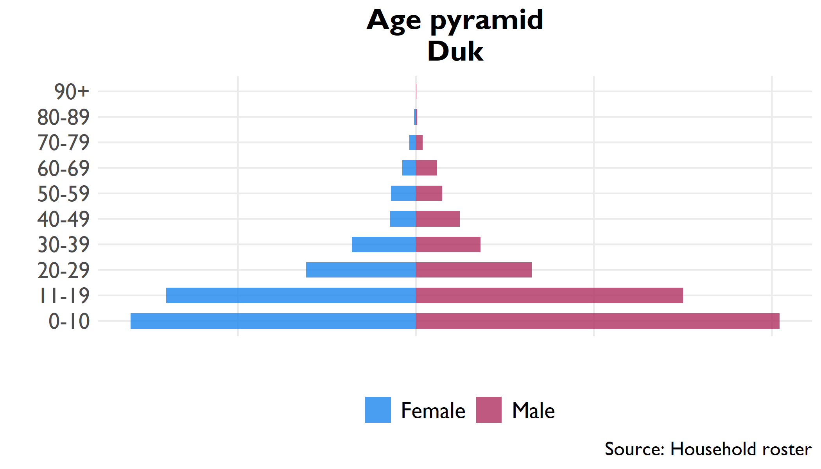

Pyramid plot of age groups by sex, all household members

## 6.2 Household

**Table** : Household size, Duk

| Indicator | Household size | Confidence interval | County rank |
| --- | --- | --- | --- |
| Household size | 5.8 | 5.6 - 6.1 | 5 |

**Table** : Proportion females 12-18 married, Duk

| Indicator | Percent | Confidence interval | County rank |
| --- | --- | --- | --- |
| Proportion of household 12-18 | 22.9% | 20.3% - 25.6% | 5 |
| Proportion females 12-18 married | 17.8% | 11.7% - 23.8% | 2 |

## 6.3 Education

**Table** : Level of education in household

| Education | Number | Percent | Confidence interval |
| --- | --- | --- | --- |
| No education (6+) | 16,147 | 57.5% | 49% - 65.9% |
| Literate (6+) | 12,643 | 35.0% | 26.9% - 43.1% |
| Primary education (12+) | 4,019 | 21.4% | 15.2% - 27.5% |
| Secondary education (18+) | 1,551 | 13.5% | 8.4% - 18.6% |

## 6.4 Livelihoods

### 6.4.1 Economic activity in last 10 years (Q314)

### 6.4.2 Income sources (Q401-Q402)

|  |  |  |  |  |  |  |  |  |  |  |  |  |  |  |  |  |  |  |  |  |  |  |  |  |  |  |  |  |  |  |  |  |  |  |  |  |  |  |  |  |  |  |  |  |  |  |  |  |  |  |  |  |  |  |  |  |  |  |  |  |  |  |  |  |  |  |  |  |  |  |  |  |  |  |  |
| --- | --- | --- | --- | --- | --- | --- | --- | --- | --- | --- | --- | --- | --- | --- | --- | --- | --- | --- | --- | --- | --- | --- | --- | --- | --- | --- | --- | --- | --- | --- | --- | --- | --- | --- | --- | --- | --- | --- | --- | --- | --- | --- | --- | --- | --- | --- | --- | --- | --- | --- | --- | --- | --- | --- | --- | --- | --- | --- | --- | --- | --- | --- | --- | --- | --- | --- | --- | --- | --- | --- | --- | --- | --- | --- | --- |
| **Table** : Economic activity in past ten years | | Activity | Number | Percent | | --- | --- | --- | | Crop farming | 811 | 58.1% | | Education | 217 | 15.6% | | Animal husbandry | 209 | 15.0% | | Defense | 80 | 5.7% | | Trade | 42 | 3.0% | | Construction | 13 | 0.9% | | Public servant | 10 | 0.7% | | Health | 9 | 0.6% | | Public administration | 4 | 0.3% | | **Table** : Sources of household income | | Income source | Percent | | --- | --- | | Farm/crop production | 81.4% | | Cattle production/sales | 57.7% | | Fishing and sales | 56.4% | | Goat production/sales | 49.9% | | Food / cash safety net | 43.1% | | Sheep production/sales | 32.2% | | Wild bush sales | 31.1% | | Petty trade other products | 28.2% | | Petty trade own products | 21.3% | | Salaried work | 12.2% | | Ag wage labor in village | 8.6% | | Gifts/inheritance | 6.5% | | Honey production/sales | 5.2% | | Remittances | 4.0% | | Wage labor in village | 3.7% | | Ag wage labor outside village | 3.6% | | Other self-employment non-ag | 2.1% | | Other self-employment ag | 2.1% | | Wage labor outside village | 1.9% | | Rental of land/property | 0.4% | |

## 6.5 Food security

**Table** : Food security indicators

| Indicator | Range | Score | Confidence interval | County rank |
| --- | --- | --- | --- | --- |
| Food Insecurity Experience Scale | 0-9 | 7.7 | 7.6 - 7.9 | 6 |
| Household Hunger Scale | 0-6 | 3.1 | 2.8 - 3.4 | 4 |
| Household Dietary Diversity Scale | 0-12 | 6.2 | 5.2 - 7.3 | 4 |
| Food insecurity experience scale divided into moderate (3-5) and severe (6-8) insecurity | | | | |
| Household hunger divided into moderate (2-3) and severe (4-6) hunger | | | | |

**Table** : Severe household hunger

| Indicator | Range | Percent | Confidence interval | County rank |
| --- | --- | --- | --- | --- |
| Severe Household Hunger | 0/1 | 21.4% | 9.1% - 33.7% | 4 |

## 6.6 Health

**Table** : Health indicators

| Indicator | Number | Percent | Confidence interval |
| --- | --- | --- | --- |
| Vaccinated for measles (9+ months) | 1,101 | 51.1% | 38.4% - 63.7% |
| Visited health clinic in past six months | 8,382 | 73.5% | 69.1% - 78% |
| Positive rating of health clinic visit | 3,966 | 48.1% | 39.3% - 57% |
| Satisfaction with health clinic service | 5,768 | 69.9% | 61.1% - 78.7% |

### 6.6.1 Purpose of visit, with satisfaction rates

**Table** : Health clinic satisfaction by service, Duk

| Reason for visit | Percent | Confidence interval (visit) | Satisfied | Confidence interval (satisfaction) | Satisfaction rank |
| --- | --- | --- | --- | --- | --- |
| Illness | 96.7% | 94.1% - 99.3% | 51.7% | 34.1% - 69.2% | 9 |
| Check-up | 68.3% | 56.7% - 79.8% | 59.2% | 44.6% - 73.8% | 8 |
| Immunization | 63.9% | 52.4% - 75.4% | 61.3% | 45.2% - 77.5% | 7 |
| Prenatal care | 38.1% | 23.4% - 52.9% | 78.1% | 62.5% - 93.6% | 5 |
| Postnatal care | 35.8% | 20.3% - 51.3% | 83.6% | 69.6% - 97.6% | 4 |
| Malnutrition | 35.7% | 21.7% - 49.8% | 71.1% | 52.7% - 89.6% | 6 |
| Family planning | 32.4% | 16.8% - 48% | 84.9% | 70.3% - 99.4% | 2 |
| Growth monitoring | 24.7% | 10.6% - 38.9% | 84.5% | 68.2% - 100.7% | 3 |
| HIV service | 21.6% | 7.6% - 35.5% | 90.2% | 76.3% - 104.2% | 1 |

# 7 Pibor (Jonglei)

## 7.1 Age

include_graphics(here("output/viz/Pibor/age density, Pibor.png"))

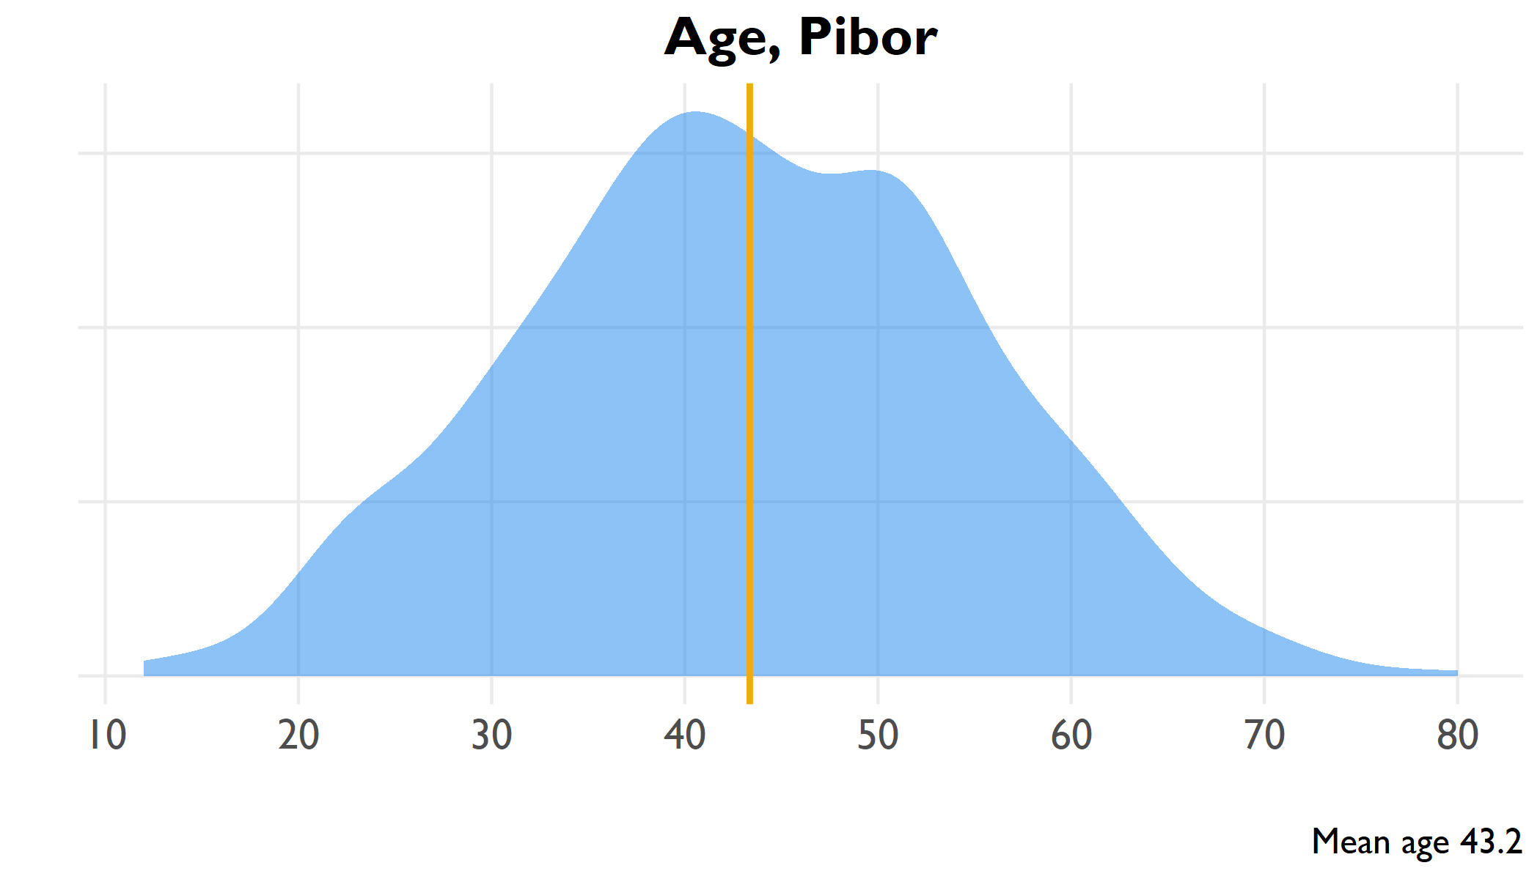

Age distribution of all household members, Pibor

include_graphics(here("output/viz/Pibor/age pyramid, Pibor.png"))

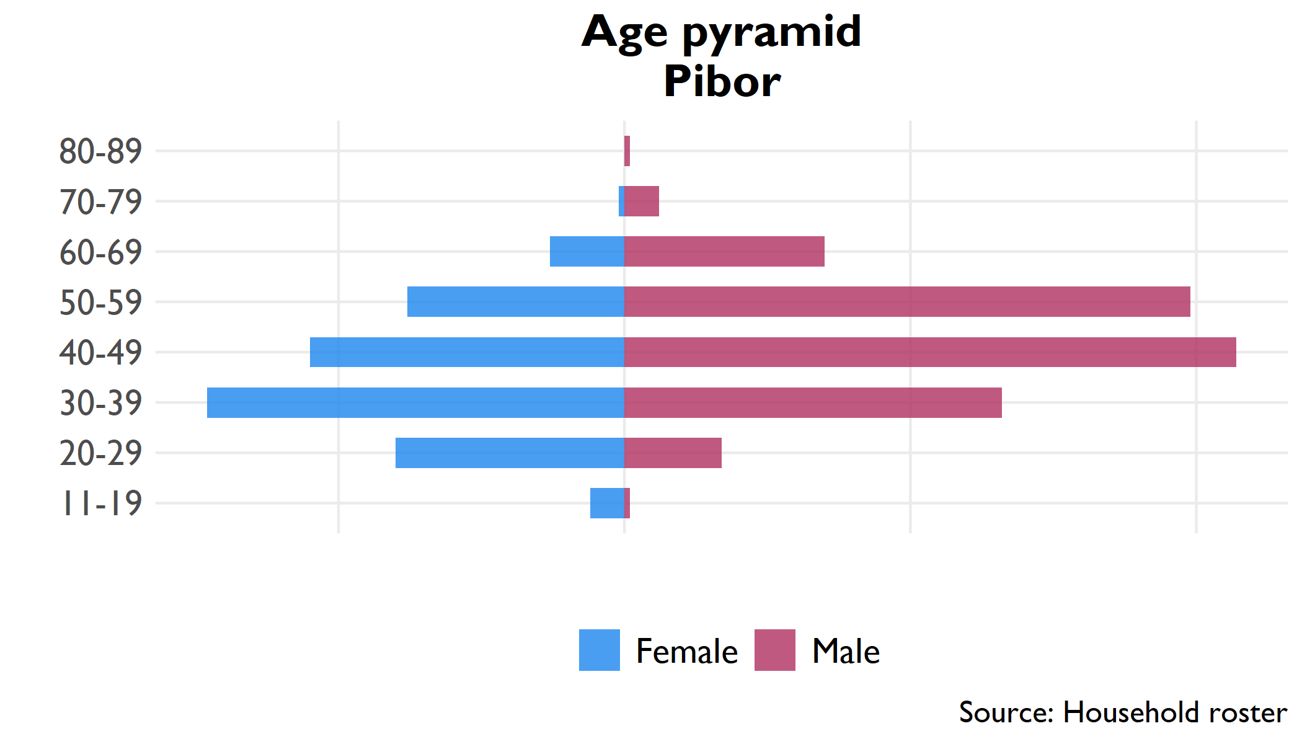

Pyramid plot of age groups by sex, all household members

## 7.2 Education

**Table** : Level of education in household

| Education | Number | Percent | Confidence interval |
| --- | --- | --- | --- |
| No education (6+) | 31,341 | 86.8% | 80.2% - 93.4% |
| Literate (6+) | 1,217 | 3.4% | 1.3% - 5.5% |
| Primary education (12+) | 2,007 | 5.6% | -0.8% - 11.9% |
| Secondary education (18+) | 2,751 | 7.7% | 5.3% - 10.1% |

## 7.3 Livelihoods

### 7.3.1 Economic activity in last 10 years (Q314)

### 7.3.2 Income sources (Q401-Q402)

|  |  |  |  |  |  |  |  |  |  |  |  |  |  |  |  |  |  |  |  |  |  |  |  |  |  |  |  |  |  |  |  |  |  |  |  |  |  |  |  |  |  |  |  |  |  |  |  |  |  |  |  |  |  |  |  |  |  |  |  |  |  |  |  |  |  |  |  |  |  |  |  |  |  |  |  |
| --- | --- | --- | --- | --- | --- | --- | --- | --- | --- | --- | --- | --- | --- | --- | --- | --- | --- | --- | --- | --- | --- | --- | --- | --- | --- | --- | --- | --- | --- | --- | --- | --- | --- | --- | --- | --- | --- | --- | --- | --- | --- | --- | --- | --- | --- | --- | --- | --- | --- | --- | --- | --- | --- | --- | --- | --- | --- | --- | --- | --- | --- | --- | --- | --- | --- | --- | --- | --- | --- | --- | --- | --- | --- | --- | --- |
| **Table** : Economic activity in past ten years | | Activity | Number | Percent | | --- | --- | --- | | Crop farming | 334 | 60.9% | | Animal husbandry | 181 | 33.0% | | Construction | 18 | 3.3% | | Education | 5 | 0.9% | | Public administration | 3 | 0.5% | | Public servant | 3 | 0.5% | | Health | 2 | 0.4% | | Defense | 1 | 0.2% | | Trade | 1 | 0.2% | | **Table** : Sources of household income | | Income source | Percent | | --- | --- | | Farm/crop production | 91.0% | | Cattle production/sales | 82.2% | | Wild bush sales | 77.4% | | Goat production/sales | 74.3% | | Fishing and sales | 72.3% | | Honey production/sales | 66.2% | | Sheep production/sales | 64.0% | | Ag wage labor in village | 58.5% | | Gifts/inheritance | 58.2% | | Food / cash safety net | 56.5% | | Wage labor in village | 53.9% | | Salaried work | 20.3% | | Ag wage labor outside village | 19.7% | | Wage labor outside village | 17.0% | | Other self-employment ag | 14.0% | | Petty trade other products | 13.3% | | Petty trade own products | 13.1% | | Rental of land/property | 13.0% | | Other self-employment non-ag | 11.4% | | Remittances | 6.2% | |

## 7.4 Food security

**Table** : Food security indicators

| Indicator | Range | Score | Confidence interval | County rank |
| --- | --- | --- | --- | --- |
| Food Insecurity Experience Scale | 0-9 | 7.9 | 7.8 - 8 | 2 |
| Household Hunger Scale | 0-6 | 2.9 | 2.8 - 3 | 8 |
| Household Dietary Diversity Scale | 0-12 | 9.4 | 8.8 - 10 | 1 |
| Food insecurity experience scale divided into moderate (3-5) and severe (6-8) insecurity | | | | |
| Household hunger divided into moderate (2-3) and severe (4-6) hunger | | | | |

**Table** : Severe household hunger

| Indicator | Range | Percent | Confidence interval | County rank |
| --- | --- | --- | --- | --- |
| Severe Household Hunger | 0/1 | 3.4% | 0.2% - 6.5% | 13 |

## 7.5 Health

**Table** : Health indicators

| Indicator | Number | Percent | Confidence interval |
| --- | --- | --- | --- |
| Vaccinated for measles (9+ months) | 1,101 | 51.1% | 38.4% - 63.7% |
| Visited health clinic in past six months | 8,382 | 73.5% | 69.1% - 78% |
| Positive rating of health clinic visit | 3,966 | 48.1% | 39.3% - 57% |
| Satisfaction with health clinic service | 5,768 | 69.9% | 61.1% - 78.7% |

### 7.5.1 Purpose of visit, with satisfaction rates

**Table** : Health clinic satisfaction by service, Pibor

| Reason for visit | Percent | Confidence interval (visit) | Satisfied | Confidence interval (satisfaction) | Satisfaction rank |
| --- | --- | --- | --- | --- | --- |
| Illness | 96.7% | 94.9% - 98.5% | 36.1% | 29.5% - 42.8% | 8 |
| Malnutrition | 54.8% | 48.1% - 61.4% | 43.3% | 32.1% - 54.4% | 5 |
| Growth monitoring | 38.9% | 30.7% - 47.1% | 44.6% | 34.2% - 54.9% | 4 |
| Immunization | 38.8% | 33.3% - 44.2% | 65.2% | 54.5% - 75.8% | 1 |
| Family planning | 27.6% | 20.9% - 34.3% | 46.3% | 30.8% - 61.8% | 3 |
| Postnatal care | 24.6% | 18% - 31.3% | 36.2% | 22.1% - 50.4% | 7 |
| Check-up | 24.4% | 18.6% - 30.2% | 56.5% | 40.7% - 72.4% | 2 |
| Prenatal care | 20.9% | 15% - 26.9% | 27.9% | 14.8% - 41.1% | 9 |
| HIV service | 3.4% | 0.8% - 6.1% | 41.5% | -0.848 | 6 |

# 8 Uror (Jonglei)

## 8.1 Age

include_graphics(here("output/viz/Uror/age density, Uror.png"))

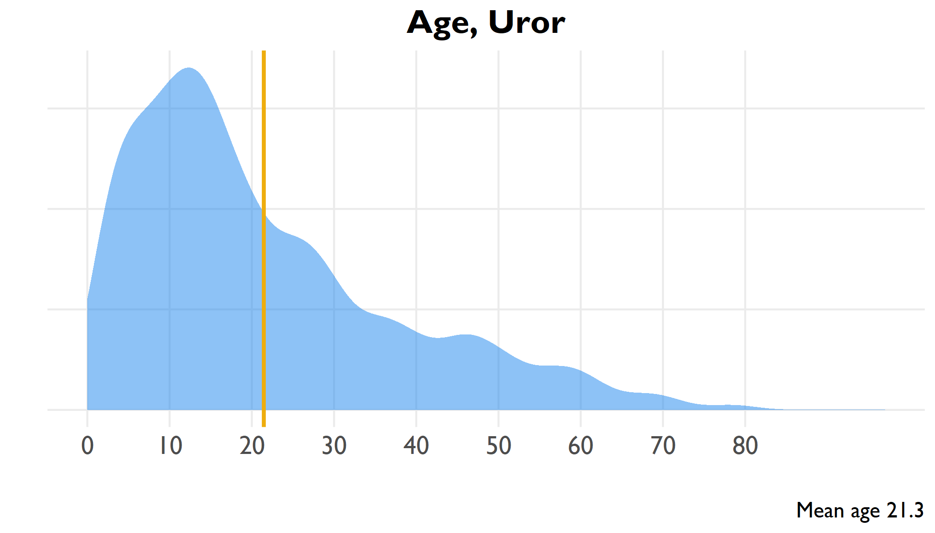

Age distribution of all household members, Uror

include_graphics(here("output/viz/Uror/age pyramid, Uror.png"))

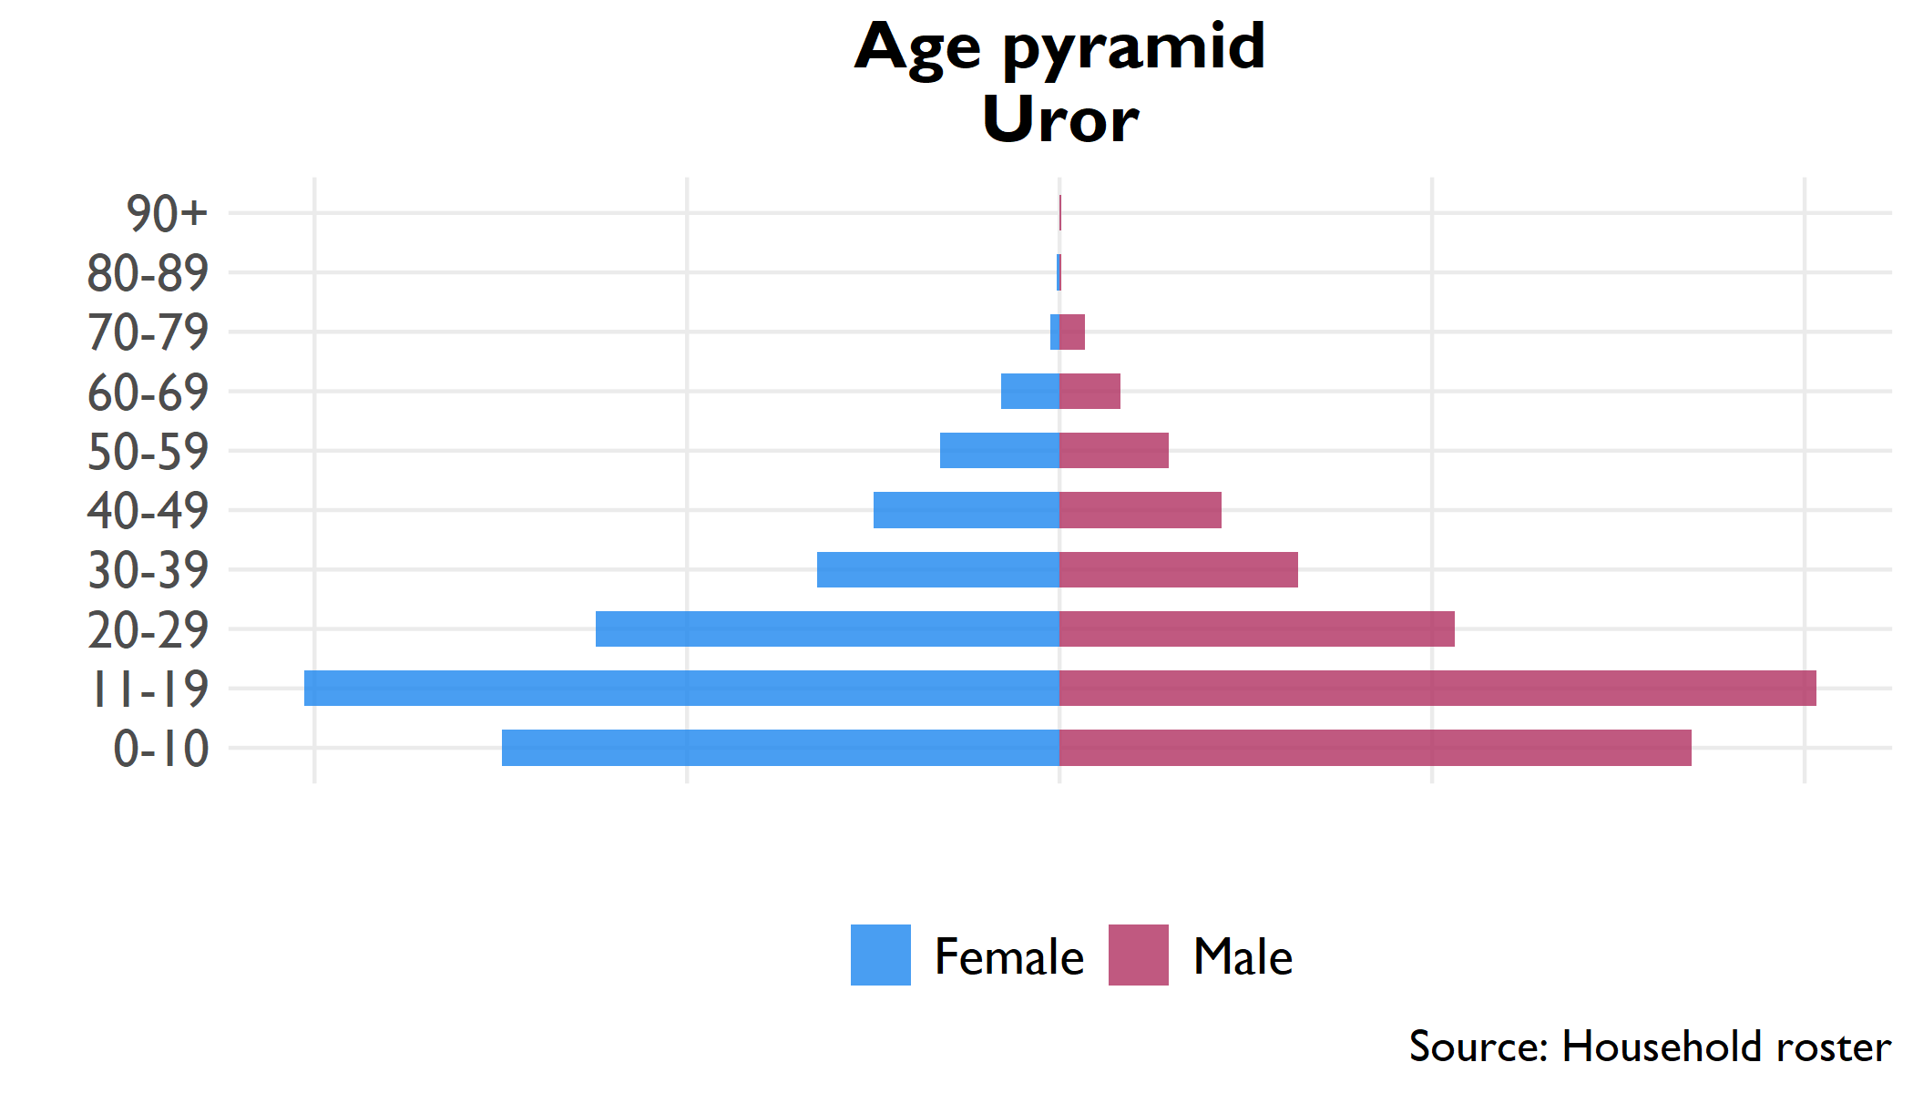

Pyramid plot of age groups by sex, all household members

## 8.2 Household

**Table** : Household size, Uror

| Indicator | Household size | Confidence interval | County rank |
| --- | --- | --- | --- |
| Household size | 5.2 | 4.8 - 5.6 | 10 |

**Table** : Proportion females 12-18 married, Uror

| Indicator | Percent | Confidence interval | County rank |
| --- | --- | --- | --- |
| Proportion of household 12-18 | 23.6% | 21.2% - 25.9% | 4 |
| Proportion females 12-18 married | 9.1% | 5.8% - 12.3% | 7 |

## 8.3 Education

**Table** : Level of education in household

| Education | Number | Percent | Confidence interval |
| --- | --- | --- | --- |
| No education (6+) | 151,043 | 85.7% | 82% - 89.4% |
| Literate (6+) | 22,866 | 11.3% | 8.4% - 14.2% |
| Primary education (12+) | 15,642 | 11.3% | 8.2% - 14.4% |
| Secondary education (18+) | 5,421 | 5.6% | 3.4% - 7.8% |

## 8.4 Livelihoods

### 8.4.1 Economic activity in last 10 years (Q314)

### 8.4.2 Income sources (Q401-Q402)

|  |  |  |  |  |  |  |  |  |  |  |  |  |  |  |  |  |  |  |  |  |  |  |  |  |  |  |  |  |  |  |  |  |  |  |  |  |  |  |  |  |  |  |  |  |  |  |  |  |  |  |  |  |  |  |  |  |  |  |  |  |  |  |  |  |  |  |  |  |  |  |  |  |
| --- | --- | --- | --- | --- | --- | --- | --- | --- | --- | --- | --- | --- | --- | --- | --- | --- | --- | --- | --- | --- | --- | --- | --- | --- | --- | --- | --- | --- | --- | --- | --- | --- | --- | --- | --- | --- | --- | --- | --- | --- | --- | --- | --- | --- | --- | --- | --- | --- | --- | --- | --- | --- | --- | --- | --- | --- | --- | --- | --- | --- | --- | --- | --- | --- | --- | --- | --- | --- | --- | --- | --- | --- |
| **Table** : Economic activity in past ten years | | Activity | Number | Percent | | --- | --- | --- | | Crop farming | 1,953 | 87.7% | | Animal husbandry | 185 | 8.3% | | Education | 39 | 1.8% | | Defense | 17 | 0.8% | | Health | 11 | 0.5% | | Trade | 10 | 0.4% | | Public servant | 8 | 0.4% | | Public administration | 3 | 0.1% | | **Table** : Sources of household income | | Income source | Percent | | --- | --- | | Cattle production/sales | 74.9% | | Goat production/sales | 42.7% | | Farm/crop production | 38.3% | | Fishing and sales | 32.5% | | Wage labor in village | 29.4% | | Wild bush sales | 28.7% | | Sheep production/sales | 17.6% | | Gifts/inheritance | 13.4% | | Food / cash safety net | 9.0% | | Other self-employment non-ag | 8.9% | | Ag wage labor in village | 7.8% | | Other self-employment ag | 7.6% | | Honey production/sales | 4.4% | | Petty trade other products | 3.9% | | Salaried work | 3.5% | | Petty trade own products | 3.2% | | Ag wage labor outside village | 1.7% | | Wage labor outside village | 1.5% | | Remittances | 1.0% | | Rental of land/property | 0.9% | |

## 8.5 Food security

**Table** : Food security indicators

| Indicator | Range | Score | Confidence interval | County rank |
| --- | --- | --- | --- | --- |
| Food Insecurity Experience Scale | 0-9 | 7.8 | 7.7 - 7.9 | 5 |
| Household Hunger Scale | 0-6 | 3.7 | 3.4 - 3.9 | 1 |
| Household Dietary Diversity Scale | 0-12 | 5.0 | 4.3 - 5.6 | 12 |
| Food insecurity experience scale divided into moderate (3-5) and severe (6-8) insecurity | | | | |
| Household hunger divided into moderate (2-3) and severe (4-6) hunger | | | | |

**Table** : Severe household hunger

| Indicator | Range | Percent | Confidence interval | County rank |
| --- | --- | --- | --- | --- |
| Severe Household Hunger | 0/1 | 39.2% | 28.1% - 50.3% | 1 |

## 8.6 Health

**Table** : Health indicators

| Indicator | Number | Percent | Confidence interval |
| --- | --- | --- | --- |
| Vaccinated for measles (9+ months) | 1,101 | 51.1% | 38.4% - 63.7% |
| Visited health clinic in past six months | 8,382 | 73.5% | 69.1% - 78% |
| Positive rating of health clinic visit | 3,966 | 48.1% | 39.3% - 57% |
| Satisfaction with health clinic service | 5,768 | 69.9% | 61.1% - 78.7% |

### 8.6.1 Purpose of visit, with satisfaction rates

**Table** : Health clinic satisfaction by service, Uror

| Reason for visit | Percent | Confidence interval (visit) | Satisfied | Confidence interval (satisfaction) | Satisfaction rank |
| --- | --- | --- | --- | --- | --- |
| Illness | 87.1% | 80.6% - 93.5% | 5.0% | 1.8% - 8.3% | 7.0 |
| Check-up | 26.6% | 16.9% - 36.4% | 6.3% | 1.1% - 11.4% | 5.0 |
| Immunization | 21.9% | 14.5% - 29.3% | 6.0% | 0.8% - 11.1% | 6.0 |
| Malnutrition | 14.7% | 6.9% - 22.5% | 9.4% | 3.4% - 15.4% | 4.0 |
| Prenatal care | 6.7% | 3.6% - 9.9% | 13.4% | 0.1% - 26.7% | 3.0 |
| Postnatal care | 4.9% | 1.4% - 8.5% | 14.7% | -0.301 | 2.0 |
| Growth monitoring | 1.0% | 0.1% - 1.9% | 24.1% | -0.815 | 1.0 |
| HIV service | 0.6% | -.3% - 1.6% | 0.0% | 0% - 0% | 8.5 |
| Family planning | 0.2% | -0.1% - 0.5% | 0.0% | 0% - 0% | 8.5 |

# 9 Leer (Unity)

## 9.1 Age

include_graphics(here("output/viz/Leer/age density, Leer.png"))

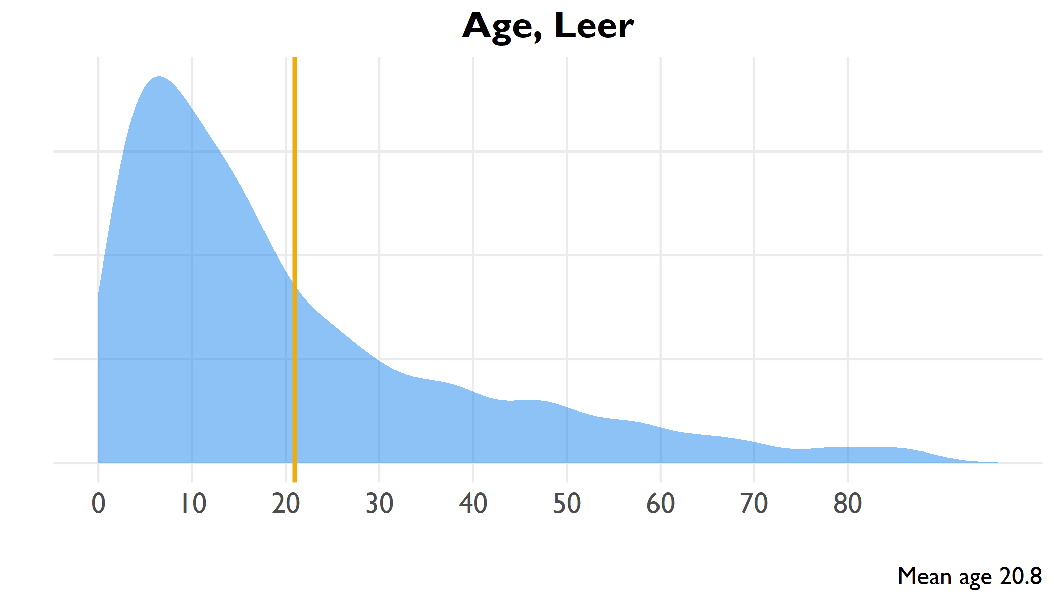

Age distribution of all household members, Leer

include_graphics(here("output/viz/Leer/age pyramid, Leer.png"))

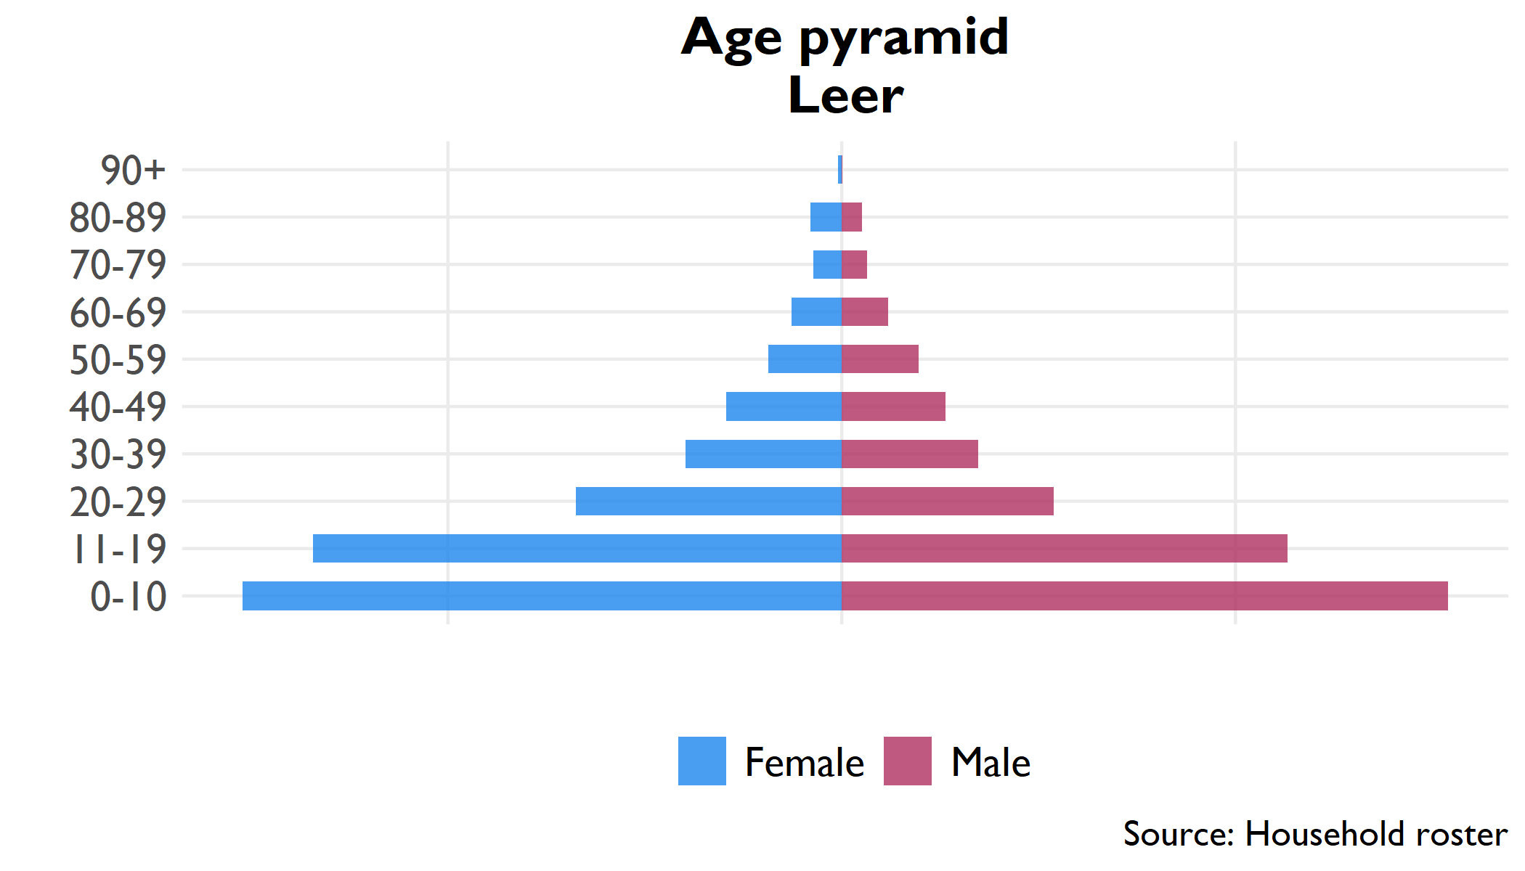

Pyramid plot of age groups by sex, all household members

## 9.2 Household

**Table** : Household size, Leer

| Indicator | Household size | Confidence interval | County rank |
| --- | --- | --- | --- |
| Household size | 7.2 | 6.9 - 7.5 | 1 |

**Table** : Proportion females 12-18 married, Leer

| Indicator | Percent | Confidence interval | County rank |
| --- | --- | --- | --- |
| Proportion of household 12-18 | 18.6% | 16.8% - 20.3% | 12 |
| Proportion females 12-18 married | 14.8% | 12.3% - 17.4% | 3 |

## 9.3 Education

**Table** : Level of education in household

| Education | Number | Percent | Confidence interval |
| --- | --- | --- | --- |
| No education (6+) | 15,582 | 47.0% | 44% - 49.9% |
| Literate (6+) | 17,817 | 43.3% | 40.5% - 46.2% |
| Primary education (12+) | 9,812 | 40.9% | 38.4% - 43.5% |
| Secondary education (18+) | 1,546 | 8.9% | 6.4% - 11.3% |

## 9.4 Livelihoods

### 9.4.1 Economic activity in last 10 years (Q314)

### 9.4.2 Income sources (Q401-Q402)

|  |  |  |  |  |  |  |  |  |  |  |  |  |  |  |  |  |  |  |  |  |  |  |  |  |  |  |  |  |  |  |  |  |  |  |  |  |  |  |  |  |  |  |  |  |  |  |  |  |  |  |  |  |  |  |  |  |  |  |  |  |  |  |  |  |  |  |  |  |  |  |  |  |  |  |  |
| --- | --- | --- | --- | --- | --- | --- | --- | --- | --- | --- | --- | --- | --- | --- | --- | --- | --- | --- | --- | --- | --- | --- | --- | --- | --- | --- | --- | --- | --- | --- | --- | --- | --- | --- | --- | --- | --- | --- | --- | --- | --- | --- | --- | --- | --- | --- | --- | --- | --- | --- | --- | --- | --- | --- | --- | --- | --- | --- | --- | --- | --- | --- | --- | --- | --- | --- | --- | --- | --- | --- | --- | --- | --- | --- | --- |
| **Table** : Economic activity in past ten years | | Activity | Number | Percent | | --- | --- | --- | | Crop farming | 1,660 | 75.6% | | Animal husbandry | 151 | 6.9% | | Trade | 108 | 4.9% | | Education | 103 | 4.7% | | Public administration | 83 | 3.8% | | Defense | 42 | 1.9% | | Public servant | 25 | 1.1% | | Health | 23 | 1.0% | | Construction | 1 | 0.0% | | **Table** : Sources of household income | | Income source | Percent | | --- | --- | | Wage labor in village | 53.2% | | Food / cash safety net | 51.5% | | Fishing and sales | 39.1% | | Gifts/inheritance | 30.0% | | Wild bush sales | 26.5% | | Goat production/sales | 25.3% | | Petty trade own products | 18.2% | | Remittances | 13.1% | | Farm/crop production | 12.6% | | Wage labor outside village | 12.4% | | Other self-employment non-ag | 11.4% | | Sheep production/sales | 10.0% | | Ag wage labor in village | 9.2% | | Ag wage labor outside village | 8.7% | | Petty trade other products | 5.2% | | Cattle production/sales | 4.6% | | Salaried work | 4.5% | | Other self-employment ag | 3.1% | | Honey production/sales | 1.0% | | Rental of land/property | 0.4% | |

## 9.5 Food security

**Table** : Food security indicators

| Indicator | Range | Score | Confidence interval | County rank |
| --- | --- | --- | --- | --- |
| Food Insecurity Experience Scale | 0-9 | 7.9 | 7.8 - 7.9 | 1 |
| Household Hunger Scale | 0-6 | 3.4 | 3.3 - 3.5 | 2 |
| Household Dietary Diversity Scale | 0-12 | 6.3 | 5.9 - 6.6 | 3 |
| Food insecurity experience scale divided into moderate (3-5) and severe (6-8) insecurity | | | | |
| Household hunger divided into moderate (2-3) and severe (4-6) hunger | | | | |

**Table** : Severe household hunger

| Indicator | Range | Percent | Confidence interval | County rank |
| --- | --- | --- | --- | --- |
| Severe Household Hunger | 0/1 | 23.2% | 17.9% - 28.5% | 3 |

## 9.6 Health

**Table** : Health indicators

| Indicator | Number | Percent | Confidence interval |
| --- | --- | --- | --- |
| Vaccinated for measles (9+ months) | 1,101 | 51.1% | 38.4% - 63.7% |
| Visited health clinic in past six months | 8,382 | 73.5% | 69.1% - 78% |
| Positive rating of health clinic visit | 3,966 | 48.1% | 39.3% - 57% |
| Satisfaction with health clinic service | 5,768 | 69.9% | 61.1% - 78.7% |

### 9.6.1 Purpose of visit, with satisfaction rates

**Table** : Health clinic satisfaction by service, Leer

| Reason for visit | Percent | Confidence interval (visit) | Satisfied | Confidence interval (satisfaction) | Satisfaction rank |
| --- | --- | --- | --- | --- | --- |
| Illness | 91.6% | 89.5% - 93.7% | 30.4% | 20.5% - 40.3% | 9 |
| Check-up | 58.2% | 47.7% - 68.7% | 36.3% | 24.1% - 48.6% | 6 |
| Immunization | 46.2% | 38.3% - 54.2% | 36.1% | 24% - 48.2% | 8 |
| Prenatal care | 42.0% | 36.8% - 47.3% | 37.7% | 21.9% - 53.5% | 4 |
| Postnatal care | 32.4% | 27.4% - 37.3% | 37.2% | 23.5% - 51% | 5 |
| Growth monitoring | 23.7% | 16.2% - 31.1% | 36.2% | 22% - 50.5% | 7 |
| HIV service | 21.4% | 15.9% - 26.9% | 39.1% | 26.8% - 51.5% | 3 |
| Family planning | 12.2% | 7.9% - 16.5% | 67.4% | 54.8% - 80.1% | 2 |
| Malnutrition | 9.4% | 5.6% - 13.1% | 76.5% | 59.3% - 93.6% | 1 |

# 10 Mayendit (Unity)

## 10.1 Age

include_graphics(here("output/viz/Mayendit/age density, Mayendit.png"))

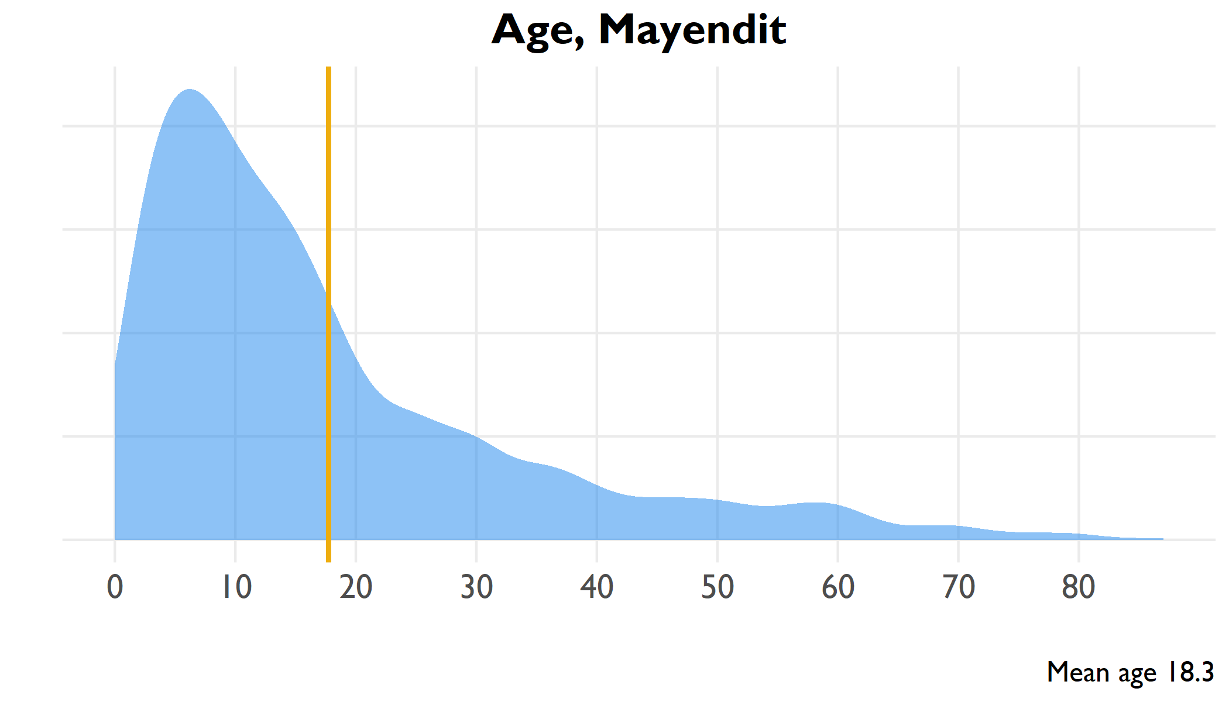

Age distribution of all household members, Mayendit

include_graphics(here("output/viz/Mayendit/age pyramid, Mayendit.png"))

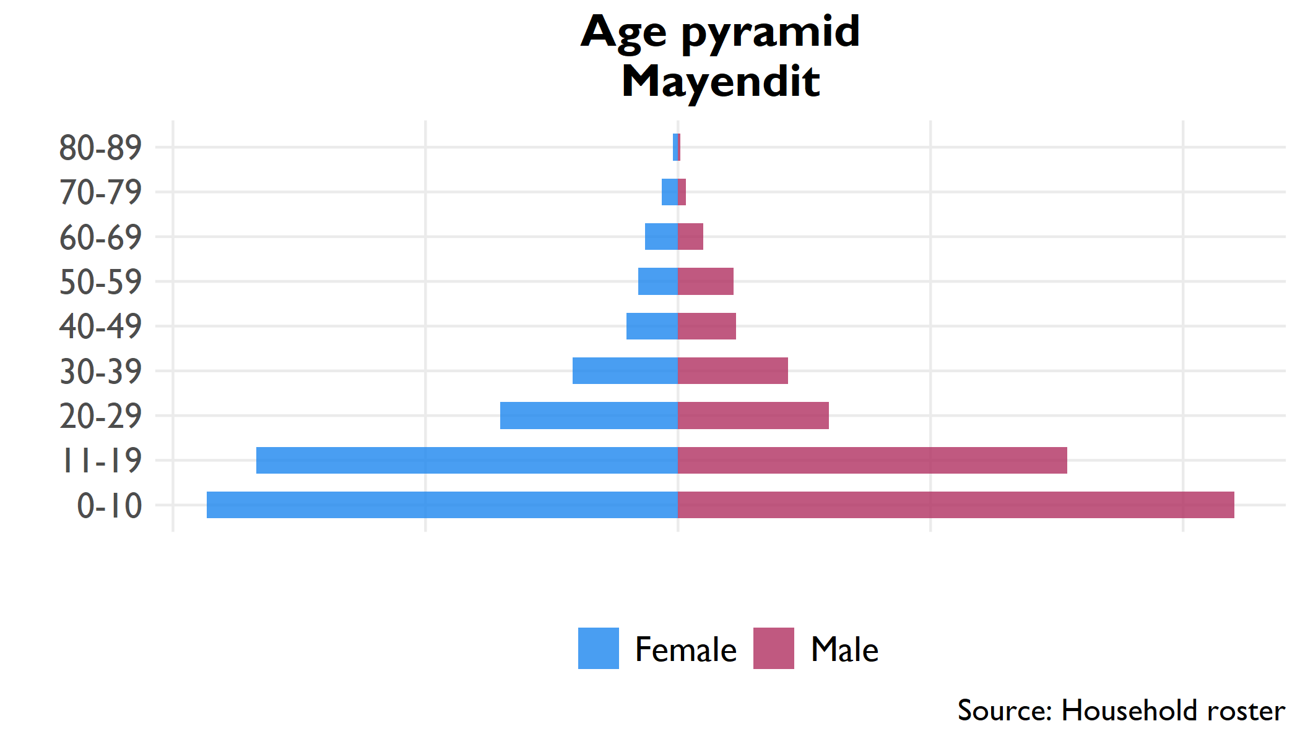

Pyramid plot of age groups by sex, all household members

## 10.2 Household

**Table** : Household size, Mayendit

| Indicator | Household size | Confidence interval | County rank |
| --- | --- | --- | --- |
| Household size | 5.2 | 4.8 - 5.5 | 11 |

**Table** : Proportion females 12-18 married, Mayendit

| Indicator | Percent | Confidence interval | County rank |
| --- | --- | --- | --- |
| Proportion of household 12-18 | 22.8% | 21.1% - 24.5% | 6 |
| Proportion females 12-18 married | 10.9% | 6.9% - 14.8% | 6 |

## 10.3 Education

**Table** : Level of education in household

| Education | Number | Percent | Confidence interval |
| --- | --- | --- | --- |
| No education (6+) | 11,035 | 47.3% | 43.9% - 50.7% |
| Literate (6+) | 12,700 | 43.7% | 41% - 46.5% |
| Primary education (12+) | 6,717 | 40.1% | 37% - 43.3% |
| Secondary education (18+) | 1,318 | 12.0% | 7.7% - 16.3% |

## 10.4 Livelihoods

### 10.4.1 Economic activity in last 10 years (Q314)

### 10.4.2 Income sources (Q401-Q402)

|  |  |  |  |  |  |  |  |  |  |  |  |  |  |  |  |  |  |  |  |  |  |  |  |  |  |  |  |  |  |  |  |  |  |  |  |  |  |  |  |  |  |  |  |  |  |  |  |  |  |  |  |  |  |  |  |  |  |  |  |  |  |  |  |  |  |  |  |  |  |  |  |  |  |  |  |
| --- | --- | --- | --- | --- | --- | --- | --- | --- | --- | --- | --- | --- | --- | --- | --- | --- | --- | --- | --- | --- | --- | --- | --- | --- | --- | --- | --- | --- | --- | --- | --- | --- | --- | --- | --- | --- | --- | --- | --- | --- | --- | --- | --- | --- | --- | --- | --- | --- | --- | --- | --- | --- | --- | --- | --- | --- | --- | --- | --- | --- | --- | --- | --- | --- | --- | --- | --- | --- | --- | --- | --- | --- | --- | --- | --- |
| **Table** : Economic activity in past ten years | | Activity | Number | Percent | | --- | --- | --- | | Crop farming | 1,062 | 65.5% | | Education | 333 | 20.5% | | Animal husbandry | 95 | 5.9% | | Trade | 40 | 2.5% | | Health | 28 | 1.7% | | Defense | 27 | 1.7% | | Public servant | 22 | 1.4% | | Public administration | 14 | 0.9% | | Construction | 1 | 0.1% | | **Table** : Sources of household income | | Income source | Percent | | --- | --- | | Fishing and sales | 59.3% | | Goat production/sales | 32.9% | | Cattle production/sales | 32.0% | | Sheep production/sales | 22.2% | | Farm/crop production | 20.4% | | Gifts/inheritance | 18.0% | | Wage labor in village | 14.0% | | Salaried work | 10.7% | | Food / cash safety net | 10.4% | | Petty trade own products | 10.0% | | Other self-employment non-ag | 8.2% | | Wild bush sales | 6.9% | | Remittances | 5.8% | | Wage labor outside village | 3.7% | | Ag wage labor outside village | 3.7% | | Ag wage labor in village | 3.2% | | Petty trade other products | 1.8% | | Other self-employment ag | 1.5% | | Honey production/sales | 0.5% | | Rental of land/property | 0.1% | |

## 10.5 Food security

**Table** : Food security indicators

| Indicator | Range | Score | Confidence interval | County rank |
| --- | --- | --- | --- | --- |
| Food Insecurity Experience Scale | 0-9 | 7.7 | 7.5 - 7.8 | 7 |
| Household Hunger Scale | 0-6 | 3.0 | 2.9 - 3.1 | 6 |
| Household Dietary Diversity Scale | 0-12 | 6.0 | 5.6 - 6.4 | 7 |
| Food insecurity experience scale divided into moderate (3-5) and severe (6-8) insecurity | | | | |
| Household hunger divided into moderate (2-3) and severe (4-6) hunger | | | | |

**Table** : Severe household hunger

| Indicator | Range | Percent | Confidence interval | County rank |
| --- | --- | --- | --- | --- |
| Severe Household Hunger | 0/1 | 17.4% | 12% - 22.8% | 6 |

## 10.6 Health

**Table** : Health indicators

| Indicator | Number | Percent | Confidence interval |
| --- | --- | --- | --- |
| Vaccinated for measles (9+ months) | 1,101 | 51.1% | 38.4% - 63.7% |
| Visited health clinic in past six months | 8,382 | 73.5% | 69.1% - 78% |
| Positive rating of health clinic visit | 3,966 | 48.1% | 39.3% - 57% |
| Satisfaction with health clinic service | 5,768 | 69.9% | 61.1% - 78.7% |

### 10.6.1 Purpose of visit, with satisfaction rates

**Table** : Health clinic satisfaction by service, Mayendit

| Reason for visit | Percent | Confidence interval (visit) | Satisfied | Confidence interval (satisfaction) | Satisfaction rank |
| --- | --- | --- | --- | --- | --- |
| Illness | 86.3% | 82.6% - 89.9% | 48.5% | 41.3% - 55.7% | 7 |
| Check-up | 33.0% | 26% - 40.1% | 65.8% | 51.7% - 79.8% | 6 |
| Immunization | 27.0% | 20.6% - 33.4% | 65.8% | 51.5% - 80.2% | 5 |
| Prenatal care | 15.9% | 12.5% - 19.4% | 67.0% | 55% - 79% | 4 |
| HIV service | 15.0% | 10.2% - 19.9% | 83.6% | 73.9% - 93.2% | 2 |
| Malnutrition | 12.2% | 6.1% - 18.2% | 26.8% | 12.8% - 40.7% | 9 |
| Postnatal care | 12.0% | 7.8% - 16.2% | 44.4% | 31.2% - 57.6% | 8 |
| Growth monitoring | 9.7% | 4.7% - 14.7% | 70.5% | 56.4% - 84.6% | 3 |
| Family planning | 6.8% | 2.9% - 10.7% | 84.5% | 71.8% - 97.2% | 1 |

# 11 Panyijar (Unity)

## 11.1 Age

include_graphics(here("output/viz/Panyijar/age density, Panyijar.png"))

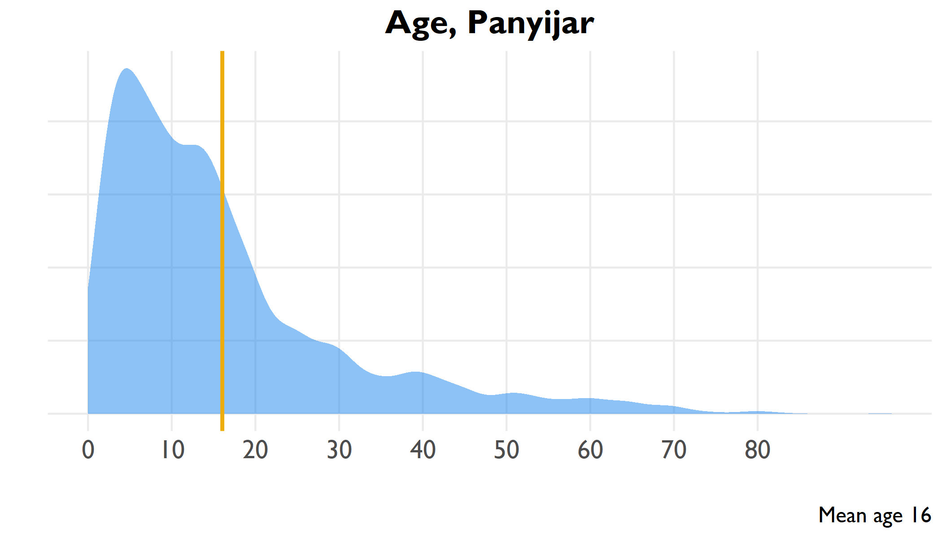

Age distribution of all household members, Panyijar

include_graphics(here("output/viz/Panyijar/age pyramid, Panyijar.png"))

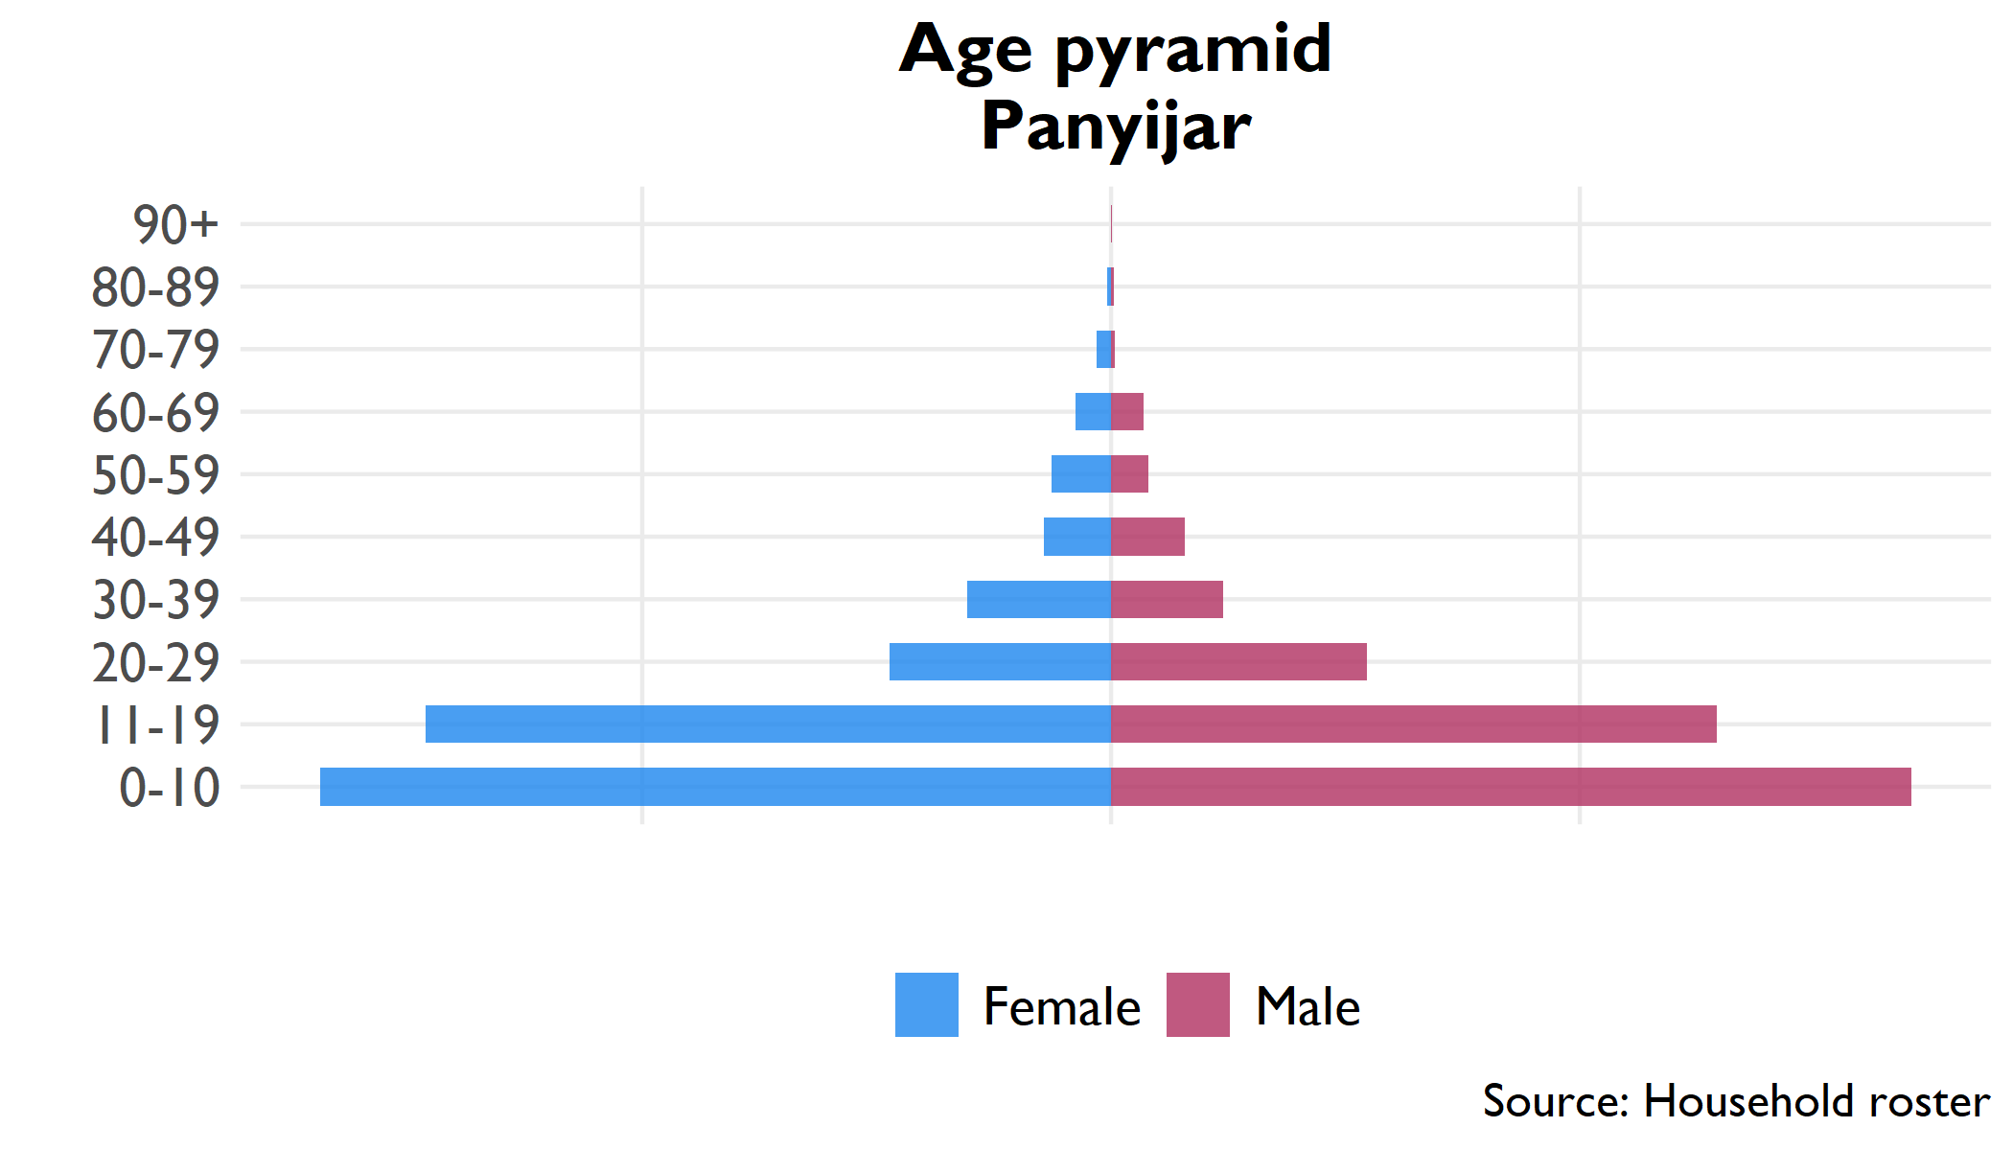

Pyramid plot of age groups by sex, all household members

## 11.2 Household

**Table** : Household size, Panyijar

| Indicator | Household size | Confidence interval | County rank |
| --- | --- | --- | --- |
| Household size | 5.6 | 5.2 - 5.9 | 6 |

**Table** : Proportion females 12-18 married, Panyijar

| Indicator | Percent | Confidence interval | County rank |
| --- | --- | --- | --- |
| Proportion of household 12-18 | 24.0% | 21.8% - 26.2% | 2 |
| Proportion females 12-18 married | 5.8% | 3.4% - 8.3% | 11 |

## 11.3 Education

**Table** : Level of education in household

| Education | Number | Percent | Confidence interval |
| --- | --- | --- | --- |
| No education (6+) | 14,097 | 56.1% | 48.8% - 63.4% |
| Literate (6+) | 10,905 | 32.8% | 27.2% - 38.4% |
| Primary education (12+) | 7,263 | 41.7% | 33.9% - 49.6% |
| Secondary education (18+) | 622 | 6.0% | 3.3% - 8.7% |

## 11.4 Livelihoods

### 11.4.1 Economic activity in last 10 years (Q314)

### 11.4.2 Income sources (Q401-Q402)

|  |  |  |  |  |  |  |  |  |  |  |  |  |  |  |  |  |  |  |  |  |  |  |  |  |  |  |  |  |  |  |  |  |  |  |  |  |  |  |  |  |  |  |  |  |  |  |  |  |  |  |  |  |  |  |  |  |  |  |  |  |  |  |  |  |  |  |  |  |  |  |  |  |
| --- | --- | --- | --- | --- | --- | --- | --- | --- | --- | --- | --- | --- | --- | --- | --- | --- | --- | --- | --- | --- | --- | --- | --- | --- | --- | --- | --- | --- | --- | --- | --- | --- | --- | --- | --- | --- | --- | --- | --- | --- | --- | --- | --- | --- | --- | --- | --- | --- | --- | --- | --- | --- | --- | --- | --- | --- | --- | --- | --- | --- | --- | --- | --- | --- | --- | --- | --- | --- | --- | --- | --- | --- |
| **Table** : Economic activity in past ten years | | Activity | Number | Percent | | --- | --- | --- | | Crop farming | 965 | 62.1% | | Education | 176 | 11.3% | | Animal husbandry | 166 | 10.7% | | Trade | 102 | 6.6% | | Public servant | 45 | 2.9% | | Defense | 42 | 2.7% | | Public administration | 34 | 2.2% | | Health | 25 | 1.6% | | **Table** : Sources of household income | | Income source | Percent | | --- | --- | | Fishing and sales | 56.3% | | Cattle production/sales | 44.2% | | Farm/crop production | 36.3% | | Wild bush sales | 30.6% | | Goat production/sales | 25.0% | | Food / cash safety net | 24.5% | | Wage labor in village | 23.8% | | Petty trade own products | 17.1% | | Sheep production/sales | 17.1% | | Gifts/inheritance | 12.1% | | Other self-employment non-ag | 7.0% | | Other self-employment ag | 5.1% | | Salaried work | 4.0% | | Ag wage labor in village | 3.0% | | Remittances | 2.8% | | Petty trade other products | 2.7% | | Wage labor outside village | 2.3% | | Ag wage labor outside village | 1.0% | | Honey production/sales | 0.5% | | Rental of land/property | 0.3% | |

## 11.5 Food security

**Table** : Food security indicators

| Indicator | Range | Score | Confidence interval | County rank |
| --- | --- | --- | --- | --- |
| Food Insecurity Experience Scale | 0-9 | 7.6 | 7.3 - 7.9 | 10 |
| Household Hunger Scale | 0-6 | 3.0 | 2.8 - 3.2 | 7 |
| Household Dietary Diversity Scale | 0-12 | 5.8 | 4.6 - 7 | 9 |
| Food insecurity experience scale divided into moderate (3-5) and severe (6-8) insecurity | | | | |
| Household hunger divided into moderate (2-3) and severe (4-6) hunger | | | | |

**Table** : Severe household hunger

| Indicator | Range | Percent | Confidence interval | County rank |
| --- | --- | --- | --- | --- |
| Severe Household Hunger | 0/1 | 19.2% | 10.9% - 27.5% | 5 |

## 11.6 Health

**Table** : Health indicators

| Indicator | Number | Percent | Confidence interval |
| --- | --- | --- | --- |
| Vaccinated for measles (9+ months) | 1,101 | 51.1% | 38.4% - 63.7% |
| Visited health clinic in past six months | 8,382 | 73.5% | 69.1% - 78% |
| Positive rating of health clinic visit | 3,966 | 48.1% | 39.3% - 57% |
| Satisfaction with health clinic service | 5,768 | 69.9% | 61.1% - 78.7% |

### 11.6.1 Purpose of visit, with satisfaction rates

**Table** : Health clinic satisfaction by service, Panyijar

| Reason for visit | Percent | Confidence interval (visit) | Satisfied | Confidence interval (satisfaction) | Satisfaction rank |
| --- | --- | --- | --- | --- | --- |
| Illness | 93.6% | 89.2% - 97.9% | 25.6% | 15.3% - 36% | 8 |
| Check-up | 43.5% | 28.8% - 58.3% | 30.3% | 11.8% - 48.8% | 6 |
| Immunization | 33.5% | 22.5% - 44.5% | 31.4% | 10.9% - 51.9% | 5 |
| Prenatal care | 23.9% | 14.5% - 33.3% | 40.9% | 16.7% - 65% | 3 |
| Postnatal care | 19.6% | 10.6% - 28.6% | 41.1% | 14.8% - 67.3% | 2 |
| Malnutrition | 12.4% | 4% - 20.7% | 31.8% | 18.4% - 45.2% | 4 |
| HIV service | 9.6% | 0.4% - 18.8% | 63.9% | 27.7% - 100% | 1 |
| Family planning | 6.0% | 0.4% - 11.6% | 27.6% | 3.5% - 51.8% | 7 |
| Growth monitoring | 3.2% | -1.9% - 8.2% | 17.8% | 14.7% - 20.9% | 9 |

# 12 Baliet (Upper Nile)

## 12.1 Age

include_graphics(here("output/viz/Baliet/age density, Baliet.png"))

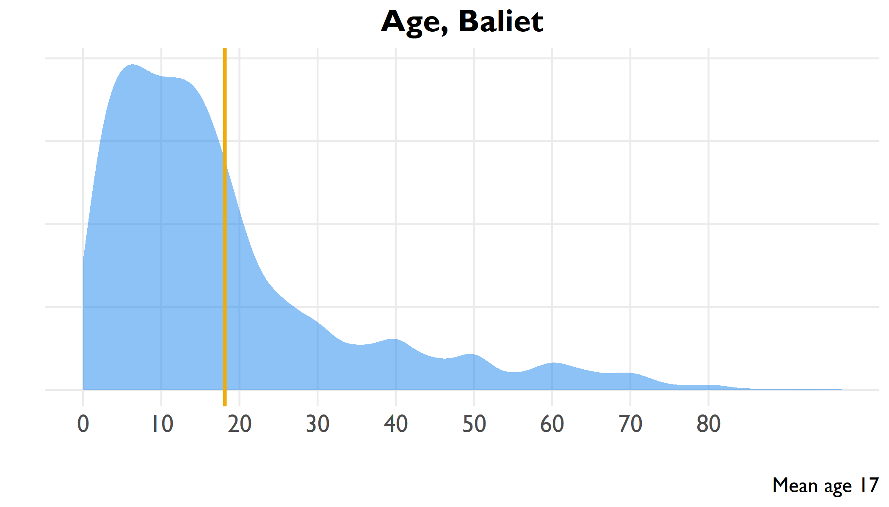

Age distribution of all household members, Baliet

include_graphics(here("output/viz/Baliet/age pyramid, Baliet.png"))

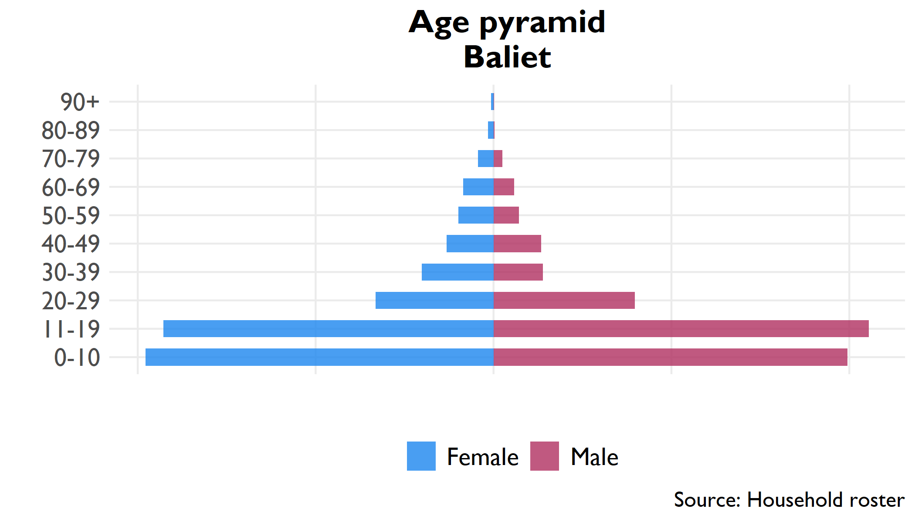

Pyramid plot of age groups by sex, all household members

## 12.2 Household

**Table** : Household size, Baliet

| Indicator | Household size | Confidence interval | County rank |
| --- | --- | --- | --- |
| Household size | 5.5 | 5.2 - 5.9 | 7 |

**Table** : Proportion females 12-18 married, Baliet

| Indicator | Percent | Confidence interval | County rank |
| --- | --- | --- | --- |
| Proportion of household 12-18 | 25.9% | 23.2% - 28.7% | 1 |
| Proportion females 12-18 married | 7.9% | 3.6% - 12.2% | 9 |

## 12.3 Education

**Table** : Level of education in household

| Education | Number | Percent | Confidence interval |
| --- | --- | --- | --- |
| No education (6+) | 8,975 | 36.0% | 26.6% - 45.4% |
| Literate (6+) | 15,389 | 49.3% | 42.4% - 56.1% |
| Primary education (12+) | 5,964 | 34.1% | 23.1% - 45% |
| Secondary education (18+) | 3,071 | 29.0% | 18.3% - 39.8% |

## 12.4 Livelihoods

### 12.4.1 Economic activity in last 10 years (Q314)

### 12.4.2 Income sources (Q401-Q402)

|  |  |  |  |  |  |  |  |  |  |  |  |  |  |  |  |  |  |  |  |  |  |  |  |  |  |  |  |  |  |  |  |  |  |  |  |  |  |  |  |  |  |  |  |  |  |  |  |  |  |  |  |  |  |  |  |  |  |  |  |  |  |  |  |  |  |  |  |  |  |  |  |  |  |  |  |
| --- | --- | --- | --- | --- | --- | --- | --- | --- | --- | --- | --- | --- | --- | --- | --- | --- | --- | --- | --- | --- | --- | --- | --- | --- | --- | --- | --- | --- | --- | --- | --- | --- | --- | --- | --- | --- | --- | --- | --- | --- | --- | --- | --- | --- | --- | --- | --- | --- | --- | --- | --- | --- | --- | --- | --- | --- | --- | --- | --- | --- | --- | --- | --- | --- | --- | --- | --- | --- | --- | --- | --- | --- | --- | --- | --- |
| **Table** : Economic activity in past ten years | | Activity | Number | Percent | | --- | --- | --- | | Crop farming | 781 | 53.7% | | Education | 284 | 19.5% | | Defense | 150 | 10.3% | | Public servant | 86 | 5.9% | | Animal husbandry | 69 | 4.7% | | Trade | 48 | 3.3% | | Construction | 21 | 1.4% | | Public administration | 10 | 0.7% | | Health | 6 | 0.4% | | **Table** : Sources of household income | | Income source | Percent | | --- | --- | | Ag wage labor in village | 52.1% | | Fishing and sales | 49.3% | | Farm/crop production | 43.2% | | Wild bush sales | 36.7% | | Food / cash safety net | 29.8% | | Ag wage labor outside village | 29.0% | | Goat production/sales | 29.0% | | Cattle production/sales | 26.8% | | Wage labor in village | 20.2% | | Sheep production/sales | 20.1% | | Petty trade other products | 17.2% | | Petty trade own products | 15.4% | | Remittances | 15.3% | | Salaried work | 12.3% | | Wage labor outside village | 12.1% | | Honey production/sales | 11.2% | | Other self-employment ag | 8.7% | | Gifts/inheritance | 7.5% | | Other self-employment non-ag | 5.7% | | Rental of land/property | 2.0% | |

## 12.5 Food security

**Table** : Food security indicators

| Indicator | Range | Score | Confidence interval | County rank |
| --- | --- | --- | --- | --- |
| Food Insecurity Experience Scale | 0-9 | 7.6 | 7.4 - 7.9 | 9 |
| Household Hunger Scale | 0-6 | 3.0 | 2.9 - 3.2 | 5 |
| Household Dietary Diversity Scale | 0-12 | 5.6 | 4.5 - 6.7 | 10 |
| Food insecurity experience scale divided into moderate (3-5) and severe (6-8) insecurity | | | | |
| Household hunger divided into moderate (2-3) and severe (4-6) hunger | | | | |

**Table** : Severe household hunger

| Indicator | Range | Percent | Confidence interval | County rank |
| --- | --- | --- | --- | --- |
| Severe Household Hunger | 0/1 | 15.9% | 6.5% - 25.3% | 7 |

## 12.6 Health

**Table** : Health indicators

| Indicator | Number | Percent | Confidence interval |
| --- | --- | --- | --- |
| Vaccinated for measles (9+ months) | 1,101 | 51.1% | 38.4% - 63.7% |
| Visited health clinic in past six months | 8,382 | 73.5% | 69.1% - 78% |
| Positive rating of health clinic visit | 3,966 | 48.1% | 39.3% - 57% |
| Satisfaction with health clinic service | 5,768 | 69.9% | 61.1% - 78.7% |

### 12.6.1 Purpose of visit, with satisfaction rates

**Table** : Health clinic satisfaction by service, Baliet

| Reason for visit | Percent | Confidence interval (visit) | Satisfied | Confidence interval (satisfaction) | Satisfaction rank |
| --- | --- | --- | --- | --- | --- |
| Illness | 93.1% | 88.6% - 97.6% | 46.8% | 31.9% - 61.7% | 9 |
| Immunization | 65.2% | 48.6% - 81.9% | 51.1% | 34.2% - 67.9% | 8 |
| Check-up | 44.0% | 25.4% - 62.5% | 61.9% | 46.6% - 77.2% | 5 |
| Malnutrition | 34.4% | 20.3% - 48.5% | 54.8% | 32.5% - 77% | 7 |
| Prenatal care | 26.5% | 19% - 34% | 59.1% | 44.5% - 73.6% | 6 |
| Postnatal care | 23.3% | 15.2% - 31.4% | 62.2% | 44.9% - 79.5% | 3 |
| Growth monitoring | 4.8% | -.1% - 9.8% | 76.6% | 54.8% - 98.3% | 1 |
| Family planning | 3.4% | 1.1% - 5.6% | 62.0% | 28.9% - 95.2% | 4 |
| HIV service | 0.9% | -.2% - 2% | 64.4% | 11.9% - 116.9% | 2 |

# 13 Ulang (Upper Nile)

## 13.1 Age

include_graphics(here("output/viz/Ulang/age density, Ulang.png"))

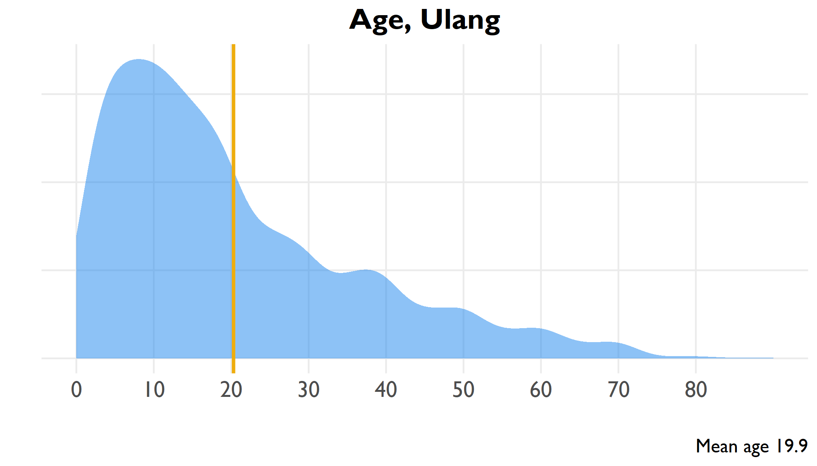

Age distribution of all household members, Ulang

include_graphics(here("output/viz/Ulang/age pyramid, Ulang.png"))

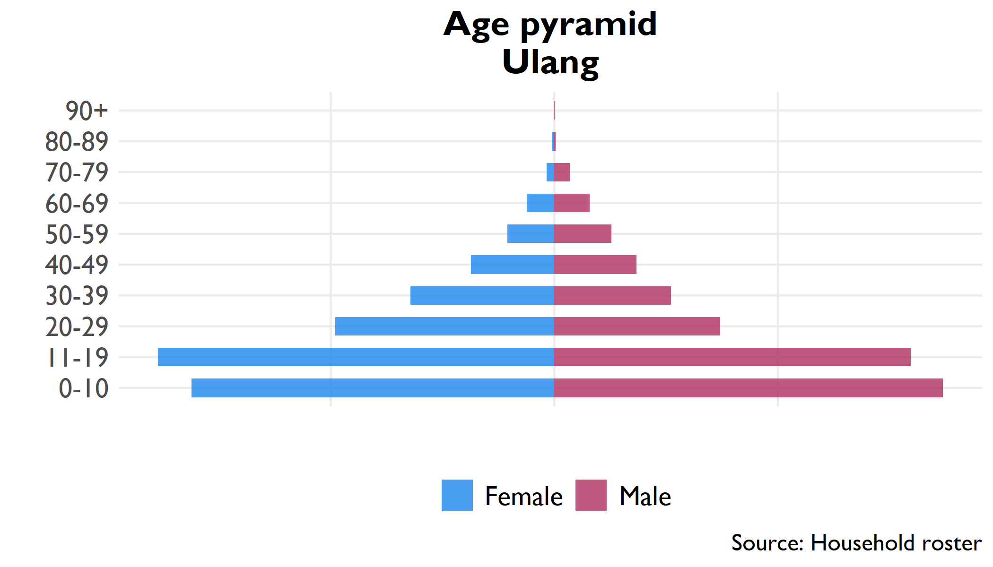

Pyramid plot of age groups by sex, all household members

## 13.2 Household

**Table** : Household size, Ulang

| Indicator | Household size | Confidence interval | County rank |
| --- | --- | --- | --- |
| Household size | 7.2 | 6.3 - 8 | 2 |

**Table** : Proportion females 12-18 married, Ulang

| Indicator | Percent | Confidence interval | County rank |
| --- | --- | --- | --- |
| Proportion of household 12-18 | 22.3% | 19.4% - 25.2% | 7 |
| Proportion females 12-18 married | 12.7% | 7.9% - 17.6% | 5 |

## 13.3 Education

**Table** : Level of education in household

| Education | Number | Percent | Confidence interval |
| --- | --- | --- | --- |
| No education (6+) | 21,152 | 58.7% | 50% - 67.3% |
| Literate (6+) | 15,143 | 34.9% | 27.4% - 42.4% |
| Primary education (12+) | 8,002 | 29.3% | 21.1% - 37.5% |
| Secondary education (18+) | 2,630 | 13.6% | 10% - 17.2% |

## 13.4 Livelihoods

### 13.4.1 Economic activity in last 10 years (Q314)

### 13.4.2 Income sources (Q401-Q402)

|  |  |  |  |  |  |  |  |  |  |  |  |  |  |  |  |  |  |  |  |  |  |  |  |  |  |  |  |  |  |  |  |  |  |  |  |  |  |  |  |  |  |  |  |  |  |  |  |  |  |  |  |  |  |  |  |  |  |  |  |  |  |  |  |  |  |  |  |  |  |  |  |  |  |  |  |
| --- | --- | --- | --- | --- | --- | --- | --- | --- | --- | --- | --- | --- | --- | --- | --- | --- | --- | --- | --- | --- | --- | --- | --- | --- | --- | --- | --- | --- | --- | --- | --- | --- | --- | --- | --- | --- | --- | --- | --- | --- | --- | --- | --- | --- | --- | --- | --- | --- | --- | --- | --- | --- | --- | --- | --- | --- | --- | --- | --- | --- | --- | --- | --- | --- | --- | --- | --- | --- | --- | --- | --- | --- | --- | --- | --- |
| **Table** : Economic activity in past ten years | | Activity | Number | Percent | | --- | --- | --- | | Crop farming | 2,322 | 84.7% | | Education | 164 | 6.0% | | Trade | 101 | 3.7% | | Public administration | 70 | 2.6% | | Animal husbandry | 32 | 1.2% | | Defense | 28 | 1.0% | | Health | 17 | 0.6% | | Construction | 5 | 0.2% | | Public servant | 2 | 0.1% | | **Table** : Sources of household income | | Income source | Percent | | --- | --- | | Fishing and sales | 78.7% | | Cattle production/sales | 57.3% | | Goat production/sales | 52.5% | | Farm/crop production | 47.8% | | Sheep production/sales | 33.7% | | Wage labor in village | 32.0% | | Wild bush sales | 26.8% | | Honey production/sales | 26.5% | | Petty trade own products | 25.3% | | Food / cash safety net | 24.9% | | Other self-employment non-ag | 24.0% | | Gifts/inheritance | 16.6% | | Other self-employment ag | 16.4% | | Wage labor outside village | 12.1% | | Petty trade other products | 8.7% | | Ag wage labor in village | 8.6% | | Ag wage labor outside village | 8.0% | | Remittances | 5.6% | | Salaried work | 4.6% | | Rental of land/property | 4.3% | |

## 13.5 Food security

**Table** : Food security indicators

| Indicator | Range | Score | Confidence interval | County rank |
| --- | --- | --- | --- | --- |
| Food Insecurity Experience Scale | 0-9 | 7.8 | 7.7 - 8 | 4 |
| Household Hunger Scale | 0-6 | 3.3 | 2.9 - 3.7 | 3 |
| Household Dietary Diversity Scale | 0-12 | 5.8 | 4.6 - 7.1 | 8 |
| Food insecurity experience scale divided into moderate (3-5) and severe (6-8) insecurity | | | | |
| Household hunger divided into moderate (2-3) and severe (4-6) hunger | | | | |

**Table** : Severe household hunger

| Indicator | Range | Percent | Confidence interval | County rank |
| --- | --- | --- | --- | --- |
| Severe Household Hunger | 0/1 | 28.2% | 13.7% - 42.7% | 2 |

## 13.6 Health

**Table** : Health indicators

| Indicator | Number | Percent | Confidence interval |
| --- | --- | --- | --- |
| Vaccinated for measles (9+ months) | 1,101 | 51.1% | 38.4% - 63.7% |
| Visited health clinic in past six months | 8,382 | 73.5% | 69.1% - 78% |
| Positive rating of health clinic visit | 3,966 | 48.1% | 39.3% - 57% |
| Satisfaction with health clinic service | 5,768 | 69.9% | 61.1% - 78.7% |

### 13.6.1 Purpose of visit, with satisfaction rates

**Table** : Health clinic satisfaction by service, Ulang

| Reason for visit | Percent | Confidence interval (visit) | Satisfied | Confidence interval (satisfaction) | Satisfaction rank |
| --- | --- | --- | --- | --- | --- |
| Illness | 85.2% | 70% - 100.5% | 30.8% | 11.6% - 50% | 9 |
| Check-up | 51.6% | 29.1% - 74.1% | 44.4% | 26.6% - 62.2% | 7 |
| Immunization | 38.7% | 21.5% - 55.9% | 47.3% | 24.8% - 69.8% | 6 |
| Growth monitoring | 34.1% | 15.2% - 53% | 49.4% | 24.4% - 74.3% | 5 |
| Malnutrition | 32.7% | 16% - 49.5% | 34.0% | 14.3% - 53.6% | 8 |
| Prenatal care | 27.3% | 11.8% - 42.9% | 50.0% | 21.6% - 78.5% | 4 |
| Family planning | 26.6% | 11.1% - 42% | 52.9% | 26% - 79.8% | 3 |
| Postnatal care | 25.8% | 9.6% - 42.1% | 57.9% | 32.8% - 82.9% | 2 |
| HIV service | 24.3% | 6.8% - 41.8% | 61.2% | 37.7% - 84.6% | 1 |