IBM HR Analytics

Employee Attrition and Performance

Manahil Aamir (24441)

Hritika Rai (24513)

Table of Contents

**PROBLEM STATEMENT:** 3

**REPORTING:** 3

***Age and Gender:*** 4

**Charts:** 4

**Dashboard:** 7

***Demographic:*** 8

**Charts:** 8

**Dashboard:** 9

***Job Factors affecting Attrition:*** 10

**Charts:** 10

**Dashboard:** 12

***Factors related to Job Analysis:*** 13

**Charts:** 13

**Dashboard:** 15

***Yearly Analysis 1:*** 16

**Charts:** 16

**Dashboard:** 18

***Yearly Analysis 2:*** 19

**Charts:** 19

**Dashboard:** 21

***Rate Analysis on Attrition:*** 22

**Charts:** 22

**Dashboard:** 24

***Rate Analysis On No Of Employees:*** 25

**Charts:** 25

**Dashboard:** 27

***Drill Through:*** 28

**FINAL INSIGHTS:** 28

**RECOMMENDATIONS:** 28

**CONTRIBUTION:** 28

# **PROBLEM STATEMENT:**

In the realm of HR analytics, understanding employee attrition is crucial, especially when it's marked as "Yes." Our investigation utilizes a dataset rich in demographic, job-related, and satisfaction metrics like age, tenure, job roles, and satisfaction levels. By delving deep into these factors, we aim to uncover the root causes of attrition. Our goal is to empower HR decision-makers with actionable insights derived from a robust analytical framework. These insights will help in crafting targeted retention strategies to nurture a supportive work environment that enhances employee engagement and fosters organizational sustainability.

# **REPORTING:**

Our investigation in HR analytics focuses on comprehending employee attrition, particularly when labeled as "Yes." Leveraging a dataset abundant in demographic and job-related metrics such as age, tenure, job roles, and satisfaction levels, we delve into the underlying causes of attrition. By examining these factors thoroughly, our aim is to equip HR decision-makers with actionable insights from a robust analytical framework. These insights are instrumental in formulating targeted retention strategies aimed at cultivating a supportive work environment, fostering employee engagement, and ensuring organizational sustainability.

Our analytical approach entails a multifaceted examination of various aspects of employee attrition. We meticulously analyze dimensions such as age, job roles, and satisfaction levels to uncover patterns and trends. By linking observed attrition rates to key metrics such as tenure and job satisfaction, we seek to provide comprehensive insights into the factors influencing attrition. This holistic understanding empowers HR professionals to devise effective strategies for talent retention and organizational growth.

Throughout our analysis, we integrate advanced visualization techniques and drill-through capabilities to offer a nuanced understanding of attrition dynamics. Our multi-page report incorporates hierarchies of employee demographics and job-related factors, facilitating in-depth exploration of attrition drivers. By enabling users to drill down and drill through to specific options, we provide granular insights into the underlying causes of attrition.

The insights of each page are provided in the following pages:

## ***Age and Gender:***

### **Charts:**

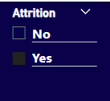  
Slicer to select Attrition ‘Yes’ or ’No’.

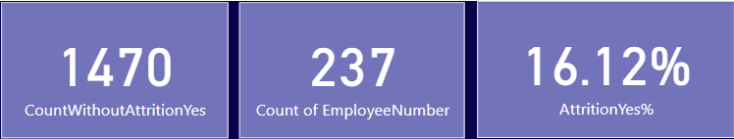  
These are KPIs. They show the total number of employees, employees whose attrition = ‘Yes’ and the percentage of employees whose Attrition = ‘Yes’ over the total number of employees.

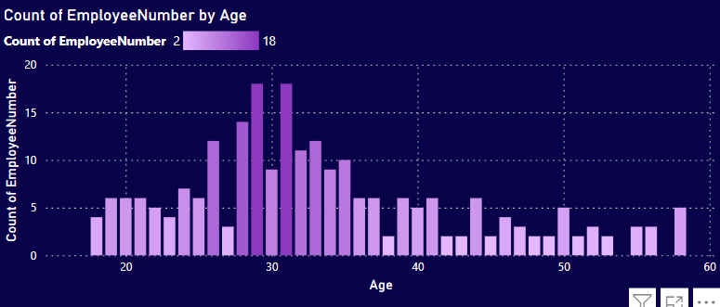  
The graph displays the count of employees by age, with the highest count (18 employees) falling in the age group of 30-35. Overall, the employee distribution is more concentrated between ages 25 and 40.

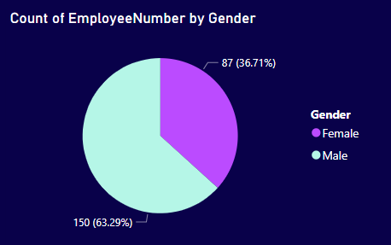  
The pie chart displays the count of employees by gender, with a larger portion (63.29%) being male.

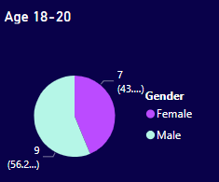  
Age 18-20: More males are represented than females in this age group.

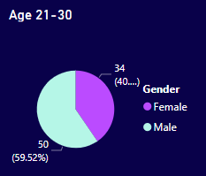  
Age 21-30: Males are represented more than females.

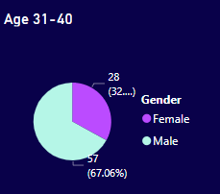  
Age 31-40: A significant majority of males are represented.

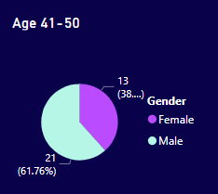  
Age 41-50: Males are again the majority by a significant margin.

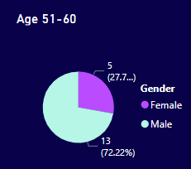  
Age 51-60: A significant majority of males, similar to the age group 31-40.

### **Dashboard:**

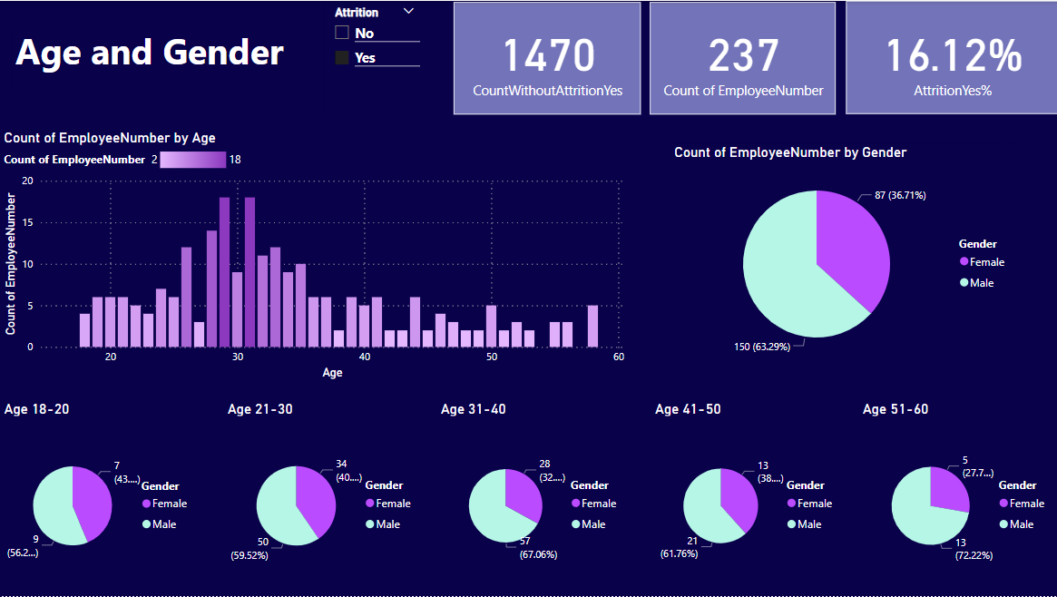  
The dashboard shows analysis on basis of age and gender. It mainly focuses on when attrition equals to ‘Yes’. It depicts an attrition rate of 16.12% with a majority of employees aged between 30-40. Males constitute 63.29% of the workforce and dominate in all age groups.

## ***Demographic:***

This dashboard has filter of Attrition ‘Yes’.

### **Charts:**

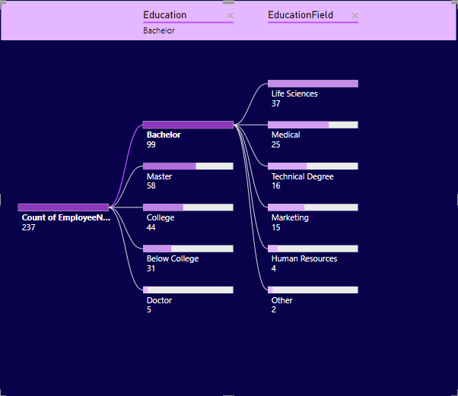  
The graph represents the distribution of 237 employees based on their education level and field. Most employees have a Bachelor’s degree, with Life Sciences being the most common education field.

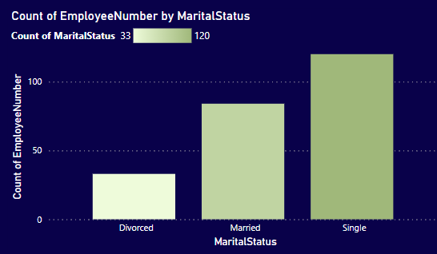  
The column chart represents the count of employees by their marital status. It shows that there are more single employees who are leaving job compared to married and divorced employees.

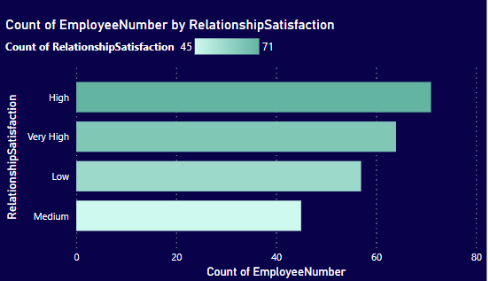  
The bar graph represents the count of employees by their relationship satisfaction levels. It shows that the highest count is for “High” satisfaction, followed by “Very High”, “Medium”, and “Low”.

### **Dashboard:**

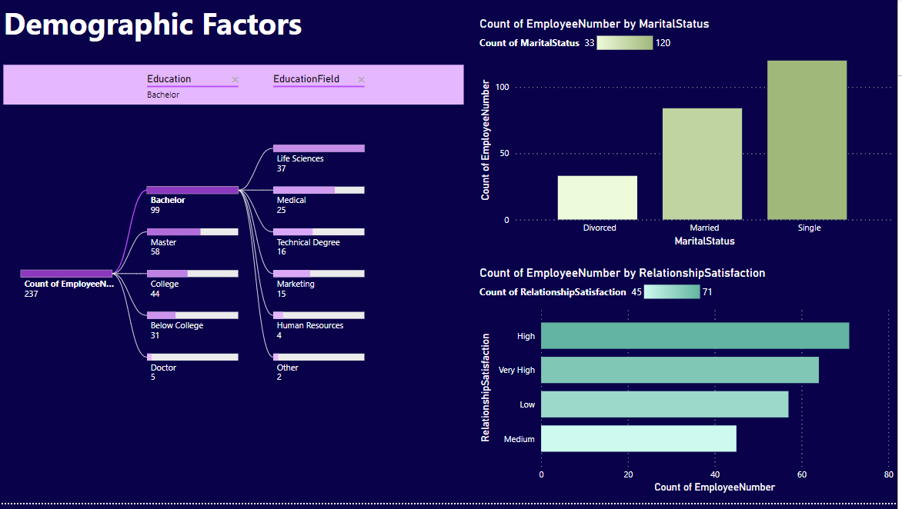This dashboard provides insights into the demographic factors associated with employee attrition. Furter, it demonstrates that most employees have a Bachelor’s degree in Life Sciences, are single, and have high relationship satisfaction.

## ***Job Factors affecting Attrition:***

This dashboard has filter of Attrition ‘Yes’.

### **Charts:**

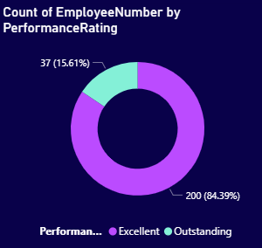  
The donut chart represents the distribution of employee performance ratings. It shows that a significant majority received an “Excellent” rating, while only 37 employees (15.61%) were rated as “Outstanding”.

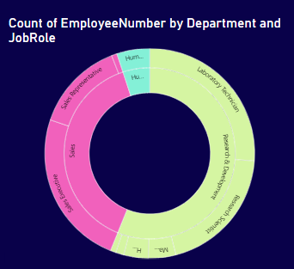  
The sunburst chart visualizes the count of employees by Department and JobRole. Th etwo prominent departments are Sales and Research and Development, and the prominent job roles within them are Sales Executive, Sales Representative, Laboratory Technician, and Research Scientist.

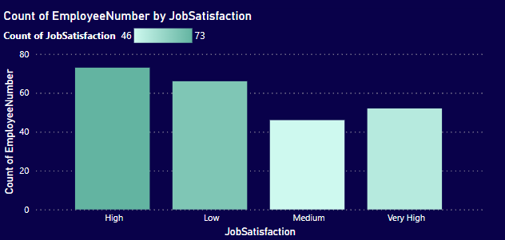  
The column chart represents the count of employees by their level of job satisfaction. It shows that a higher number of employees have high job satisfaction.

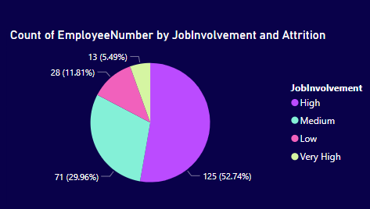  
The pie chart represents the count of employees by their level of job involvement and attrition. It shows that a significant majority, 125 employees (52.74%), have very high job involvement.

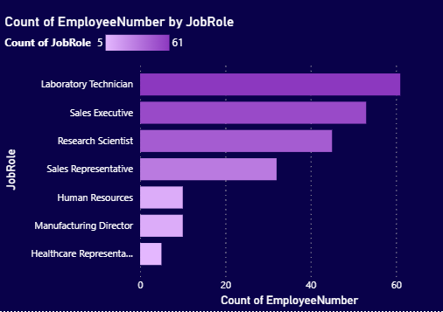  
The bar chart represents the count of employees in various job roles. It shows that Laboratory Technician has the highest count, with Job Level 1 in it being highest.

### **Dashboard:**

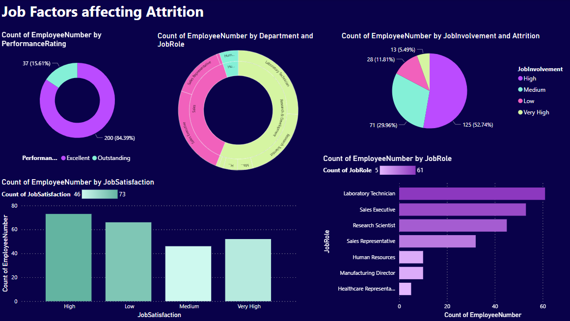  
This dashboard, filtered for attrition ‘Yes’, provides a comprehensive view of job factors. It reveals that a majority of employees have excellent performance ratings, high job involvement, and are mostly in the Sales and R&D departments. Moreover, attrition is observed predominantly among Laboratory Technicians at Job Level 1.

## ***Factors related to Job Analysis:***

This dashboard has filter of Attrition ‘Yes’.

### **Charts:**

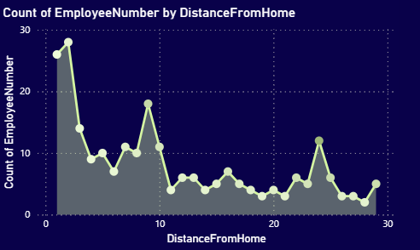  
The area chart represents the count of employees in relation to their distance from home. It shows a notable peak of employees living close to the workplace, with general trend of number of employees decreasing as distance increases.

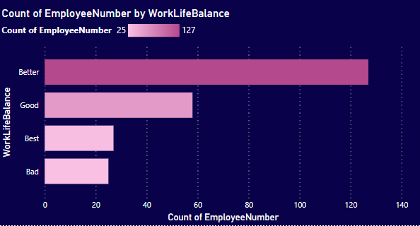  
The bar chart represents the count of employees by their rated work-life balance. It shows that a majority of employees (127) rate their work-life balance as “Better”, while the fewest (25) rate it as “Bad”.

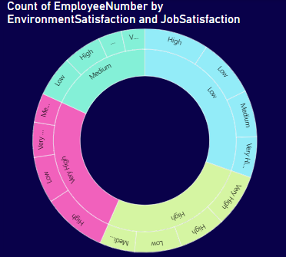  
The sunburst chart represents the count of employees by their levels of environment and job satisfaction. It shows a distribution across various levels, providing insights into employee satisfaction metrics in the workplace with number of employees having ‘Low’ environment satisfaction being highest.

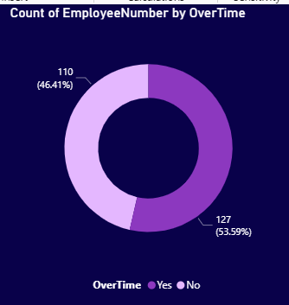  
The donut chart represents the count of employees who have worked overtime versus those who haven’t. A larger portion of employees, 127 (53.59%), have not worked overtime compared to 110 (46.41%) who have. When drilled down for overtime equals ‘Yes’, it shows that the R&D department has the highest count, with Research Scientist being the most common job role.

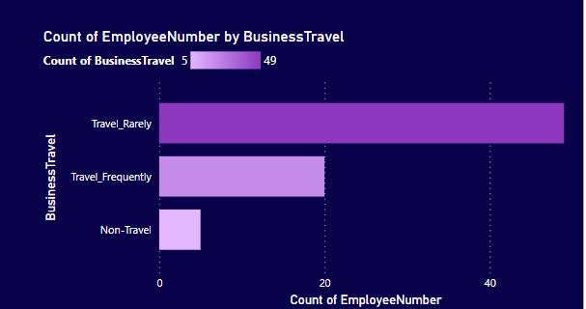  
The bar chart represents the count of employees categorized by their frequency of business travel. It shows that a significant majority, 49 employees, travel rarely, a smaller number that do not travel at all.

### **Dashboard:**

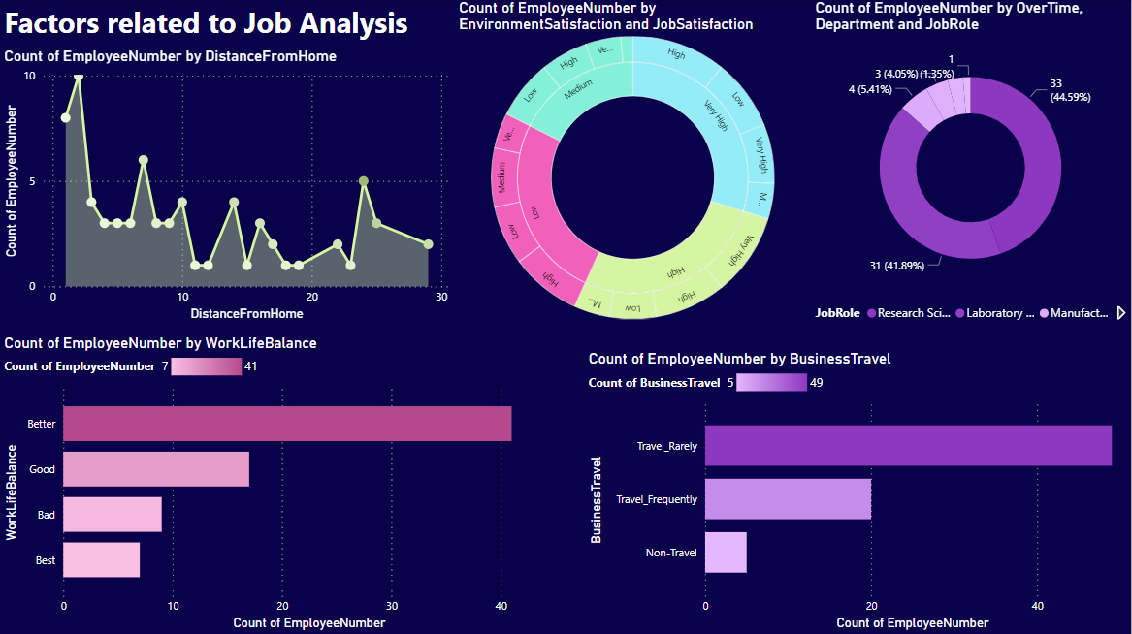  
The dashboard, filtered for attrition ‘Yes’, provides valuable insights into job factors that may influence employee attrition. It reveals that a majority of these employees live close to the workplace, have a “Better” work-life balance, and rarely travel for business. Also, a significant number of employees have worked overtime, particularly in the R&D department, with Research Scientist being the most common job role.

## ***Yearly Analysis 1:***

This dashboard has filter of Attrition ‘Yes’.

### **Charts:**

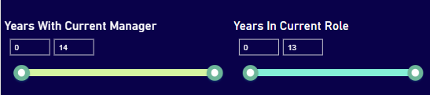  
These are two sliders to apply filter to values of ‘Years With Current Manager’ and ‘Years In Current Role’.

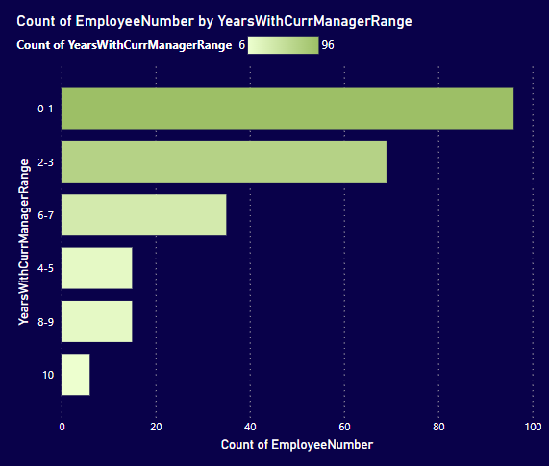  
The bar chart represents the count of employees grouped by the number of years they have been with their current manager. It shows that a significant number of employees (96) have been with their current manager for 0-1 years, while fewer employees fall into the other year ranges.

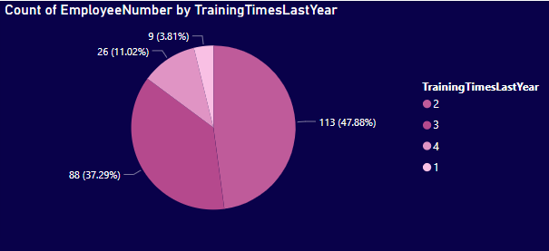  
The pie chart represents the distribution of employees based on the number of training times they had last year. It shows that a significant portion, 47.88%, had 2 training sessions, while only a small fraction, 3.81%, had 1 sessions.

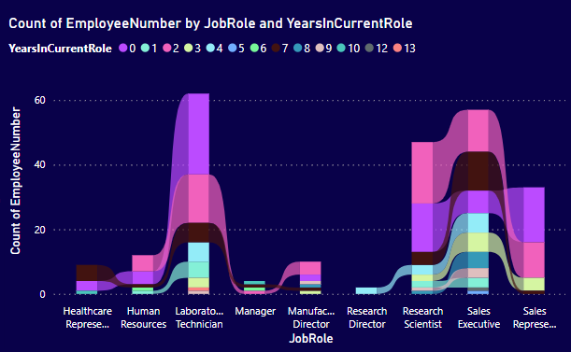  
The ribbon chart represents the count of employees in various job roles over the years in their current role. It shows that Laboratory Technician and Sales Representative roles have the highest employee counts, particularly within their first year.

### **Dashboard:**

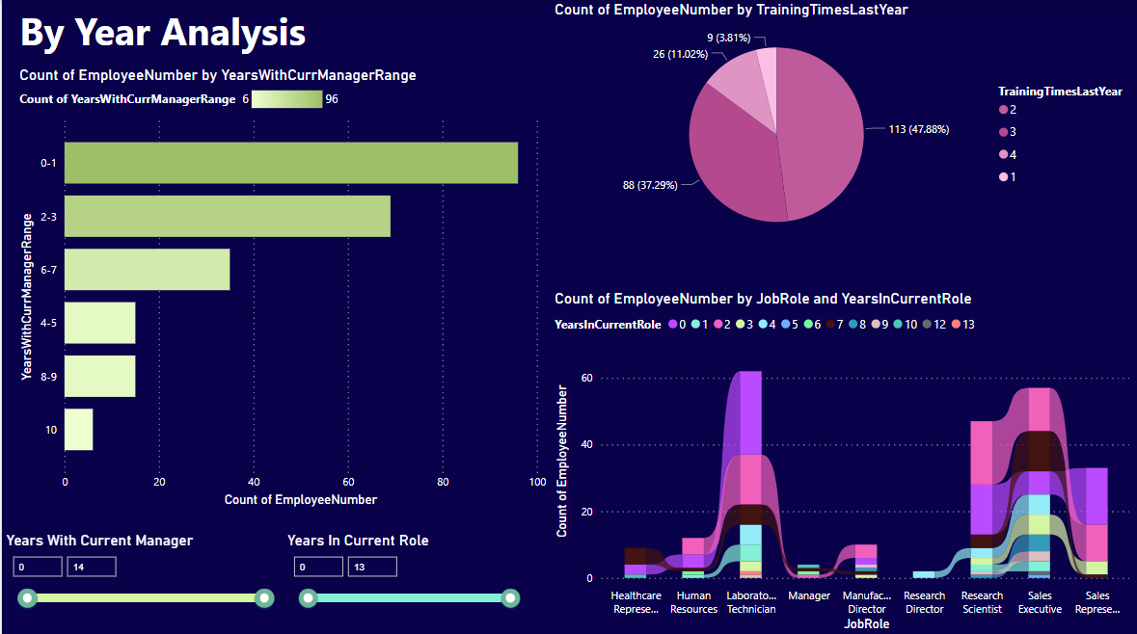  
The dashboard, filtered for attrition ‘Yes’, provides a comprehensive view of by year analysis. It reveals that a majority of employees have been with their current manager for 0-1 years, have had 2 training sessions last year, and are in the roles of Laboratory Technician or Sales Representative, particularly within their first year.

## ***Yearly Analysis 2:***

This dashboard has filter of Attrition ‘Yes’.

### **Charts:**

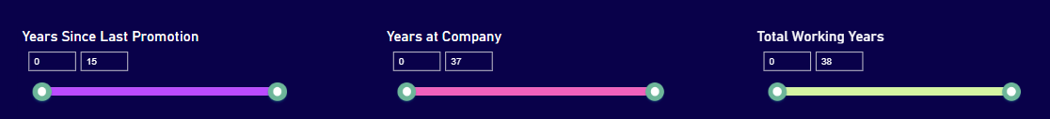  
These are three sliders to filter the values of ‘Years Since Last Promotion’, ‘Years At Company’, and ‘Total Working Years’.

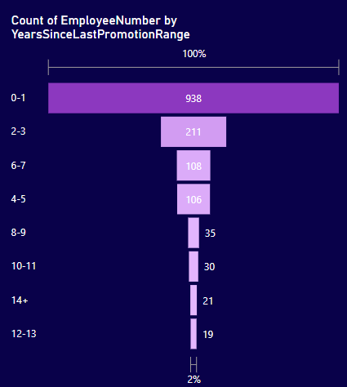  
The funnel chart represents the count of employees by years since their last promotion. It highlights that significant number, received a promotion within the last year. The number of employees decreases significantly with an increase in the years since their last promotion.

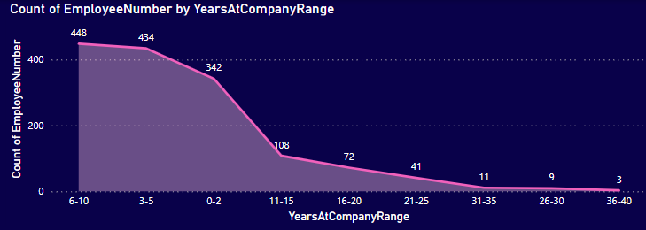  
The line graph represents the count of employees by their years at the company. It shows a significant decrease in employee count who are leaving job as the years at the company increase.

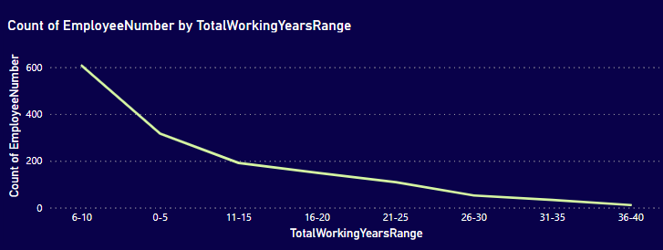  
The line graph represents the count of employees by their total working years. It shows a sharp decline in the number of employees leaving job as the total working years increase.

### **Dashboard:**

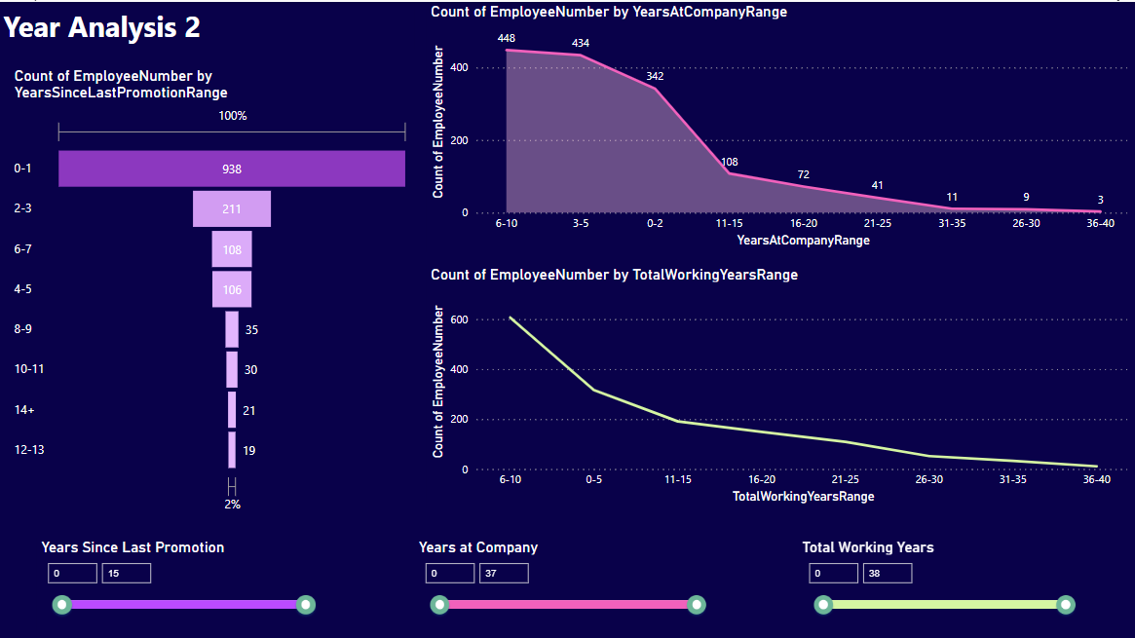  
The dashboard, filtered for attrition ‘Yes’, provides a comprehensive view of by year analysis. It depicts that employees leaving job have fewer total working years and fewer working years at this company. Also, most of them have received a promotion within a year.

### ***Rate Analysis on Attrition:***

### **Charts:**

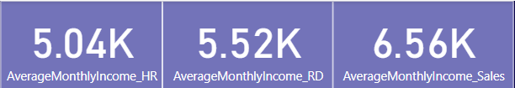  
These are three KPIs indicating average monthly income for three different departments.

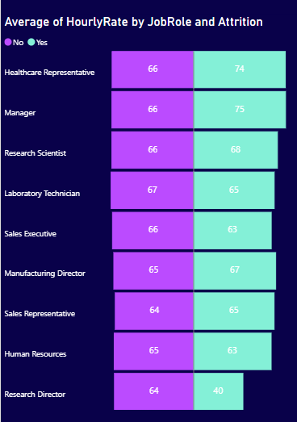  
The tornado chart represents the average hourly rate by job role and attrition status. It highlights that, in most roles, employees who left the company had a higher or slightly lower average hourly rate, with Research Director being a notable exception.

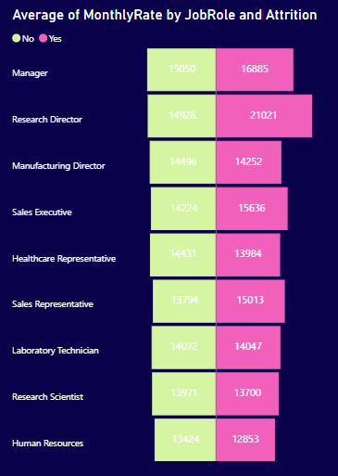  
The tornado chart represents the average monthly rate by job role and attrition. It highlights that for every job role, those who left the company (Yes) had a similar average monthly rate than those who stayed (No), except at job role ‘Research Director’ where monthly rate is noticeably high for employees who left the company.

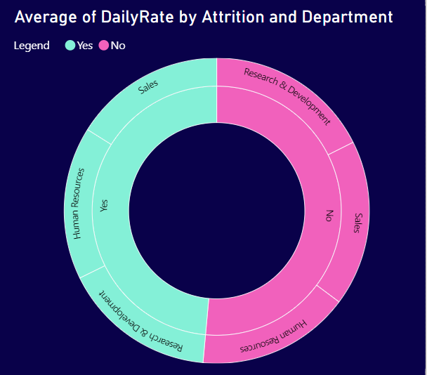  
The donut chart represents the average daily rate by attrition and department. It highlights that the average daily rate for attrition both ‘Yes’ or ‘No’ has no such major difference across various departments.

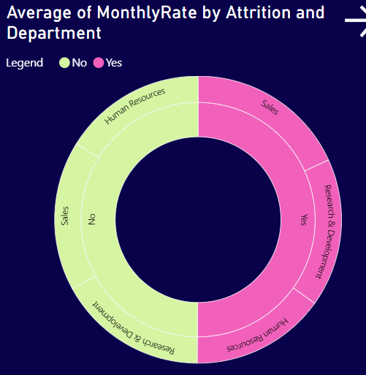  
The donut chart represents the average monthly rate by attrition and department. It highlights that the average monthly rate for attrition both ‘Yes’ or ‘No’ has no such major difference across various departments.

### **Dashboard:**

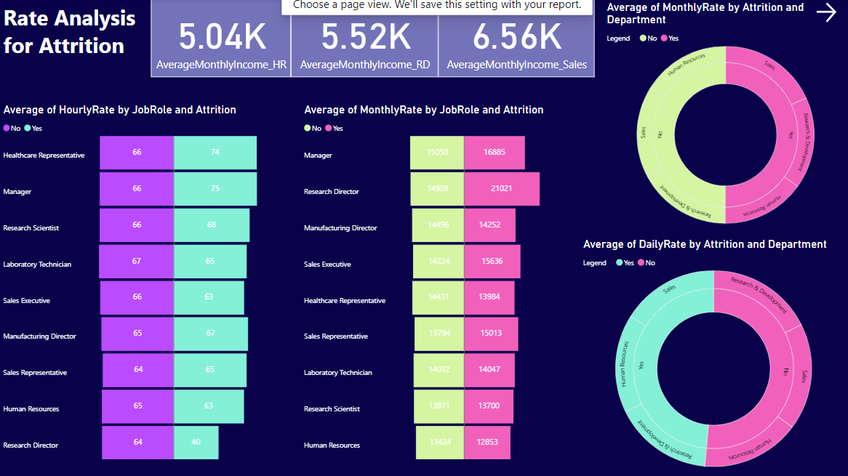  
The dashboard provides a comprehensive view of attrition in relation to average hourly, daily, and monthly rates across different job roles and departments. It suggests that attrition is not significantly influenced by these rates, with some exceptions noted for specific job roles like ‘Research Director’.

## ***Rate Analysis On No Of Employees:***

This dashboard has filter of Attrition ‘Yes’.

### **Charts:**

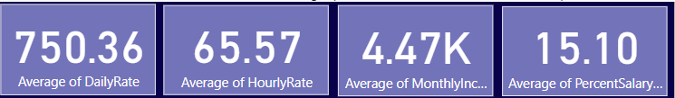  
These cards indicate average values of: hourly rate, daily rate, month rate, and percentage by which there was hike in salary.

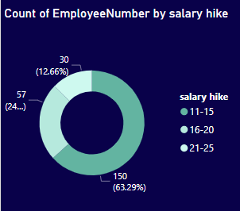  
The donut chart represents the count of employees by different salary hike percentages. It highlights that a majority, 63.29%, received a 21-25% hike, while smaller portions received 11-15% and 16-20% hikes.

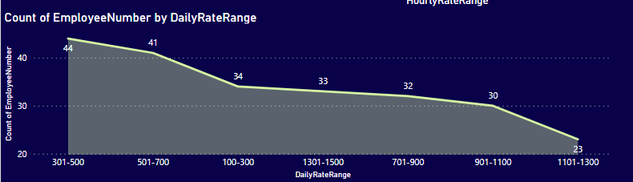  
The area chart represents the count of employees across various daily rate ranges. It highlights a decline in the count of employees from the 301-500 range to the 1101-1300 range, suggesting that fewer employees receive higher daily rates.

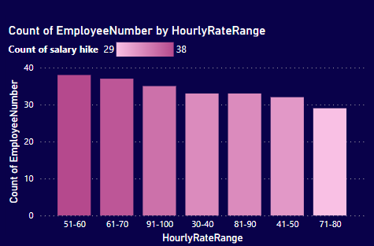  
The column chart represents the count of employees across various hourly rate ranges. It highlights that the 51-60 range has the highest count of employees, while the 71-80 range has the lowest count.

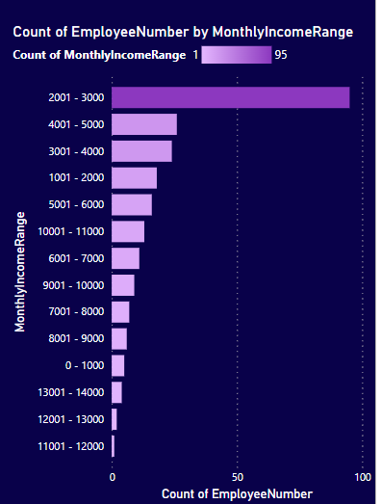  
The bar chart represents the count of employees across various monthly income ranges. It highlights that the majority of employees earn between 2001 - 3000 as per monthly rate (quite low), indicating a concentration of employees in this income range.

### **Dashboard:**

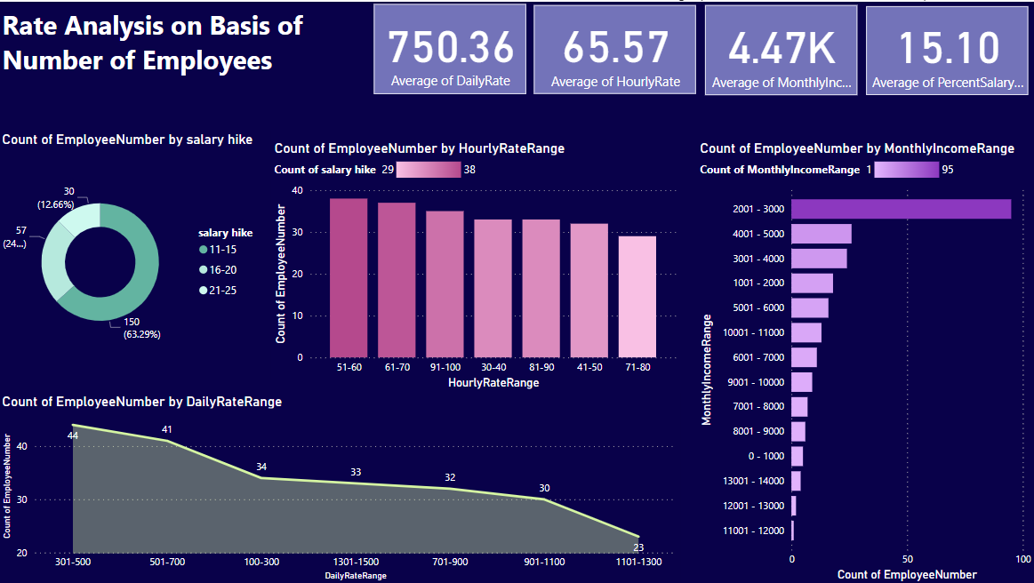The dashboard provides a comprehensive view of employees with ‘Yes’ for attrition, highlighting their salary hikes, daily rates, hourly rates, and monthly income ranges. It suggests that most of these employees received a 21-25% salary hike, earn between 2001 - 3000 in monthly rate, and fewer of them receive higher daily rates.

### ***Drill Through:***

* By selecting the gender one can drill through to view the demographics that include, education and relationship dimensions. Further, by selecting gender one can drill through to view various job factors that are spread over two of our dashboards.
* One can select the education and education field and can drill through different job elements that are laid out on two of our dashboards. Also, on the basis of education (how much educated an employee is), user can drill through to analyze the hourly, daily and monthly rates. This can also be viewed on two of our dashboards.
* By selecting job department and/or job role, user can drill through to inspect the hourly, daily and monthly rates. Moreover, user can drill through the yearly analysis of the following factors; years with current manager, training times last year, years in current role, years since last promotion, years at company and total working years.
* By selecting years at company one can drill through to analyze the hourly, daily and monthly rates. This information is also spread over two of our dashboards.

# **FINAL INSIGHTS:**

Across multiple dashboards and charts, it becomes apparent that attrition rates are influenced by a complex interplay of variables.

Demographically, the majority of employees are male, predominantly within the age range of 25 to 40, with a significant portion holding Bachelor's degrees, particularly in Life Sciences. Interestingly, single individuals tend to exhibit higher attrition rates compared to their married or divorced counterparts. Moreover, employees generally report high levels of relationship satisfaction, indicating that personal factors may not be the primary driver of attrition.

Job-related factors paint a nuanced picture of attrition drivers. While employees generally express high job satisfaction and involvement, certain roles within departments like Sales and Research & Development, particularly Laboratory Technicians at Job Level 1, experience higher attrition rates. Performance ratings skew towards the "Excellent" category, suggesting that job performance might not be a significant contributor to attrition.

Yearly analyses reveal that employees tend to leave within their initial years with their current manager and company, with Laboratory Technicians and Sales Representatives being prevalent roles among attrition cases. Training sessions, while common, don't seem to significantly impact attrition rates.

Rate analyses provide mixed insights, indicating that average rates don't substantially differ between employees who leave and those who stay, except for outliers like Research Directors. Salary hikes, daily rates, and monthly incomes fall within predictable ranges, with the majority of employees earning moderate incomes and receiving standard salary increments.

# **RECOMMENDATIONS:**

* Implement targeted retention strategies for employees within high-attrition roles, such as Laboratory Technicians and Sales Representatives.
* Conduct regular surveys to gauge employee satisfaction and identify areas for improvement, particularly focusing on factors like work-life balance and career advancement opportunities.
* Offer personalized development plans and training opportunities to enhance employee skill sets and job satisfaction.
* Foster a culture of open communication and feedback to address concerns proactively and maintain high levels of employee engagement.
* Continuously monitor attrition trends and adapt retention strategies accordingly to stay responsive to evolving workforce dynamics.

# **CONTRIBUTION:**

Both partners made significant contributions to the project, collaborating closely throughout various stages. They both dedicated time and effort to data cleaning, exploratory data analysis (EDA), and the creation of paperwork and business intelligence dashboards, demonstrating a shared commitment to the project's success. While Manahil took the lead in crafting the report, leveraging her analytical skills to derive insights from the data, Hritika played a vital role in enhancing the project's foundation by delving deep into the background data knowledge through Excel sheets.