Project 2: Exploratory Data Analysis
E-Commerce Orders Dataset DecodeLabs Industrial Training Kit, Batch 2026

Prepared by: Manahil
Dataset: Dataset_for_Data_Analytics.xlsx (1,200 orders, cleaned in Project 1)

Problem Statement
What patterns, trends, and anomalies exist in the e-commerce orders dataset, and what do they reveal about order value distribution, fulfillment performance, and customer purchasing behavior?

Methodology
The cleaned dataset from Project 1 was analyzed using Python (pandas, NumPy, matplotlib, seaborn). The analysis covered descriptive statistics (mean, median, five-number summary), outlier detection using the IQR method (1.5 × IQR rule), categorical distribution analysis, time-based trend analysis, and Pearson correlation between numeric variables.

Key Findings

Descriptive Statistics

Metric | Quantity | Unit Price ($) | Total Price ($)
Mean | 3.01 | 350.92 | 1,053.97
Median | 3.00 | 297.65 | 823.62
Std Dev | 1.42 | 229.61 | 823.45
Min | 1 | 10.05 | 10.12
Max | 5 | 999.82 | 3,464.10
Note: Mean Total Price ($1,053.97) is notably higher than the Median ($823.62), confirming a right-skewed distribution. The Median is the more representative figure for a 'typical' order.
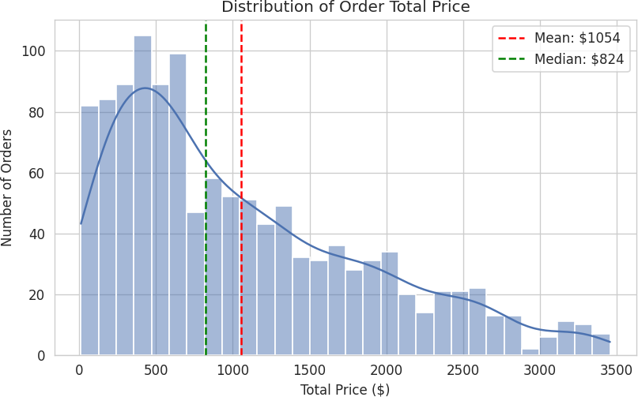
Figure 1: Distribution of order total price, showing right-skew.

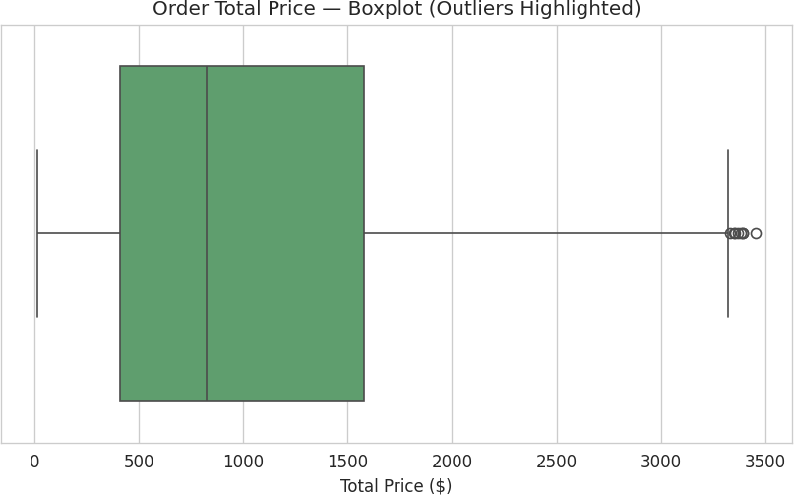
Figure 2: Boxplot highlighting 8 high-value outlier orders beyond the IQR upper bound.

Outliers
Using the IQR method (Outlier > Q3 + 1.5×IQR), 8 orders were flagged as high-value outliers, all with Quantity = 5 (the dataset maximum) and Unit Price above $665. These appear to be genuine bulk or premium purchases rather than data entry errors signal, not noise and are worth highlighting to the sales team as a high-value customer segment.

Order Status & Fulfillment

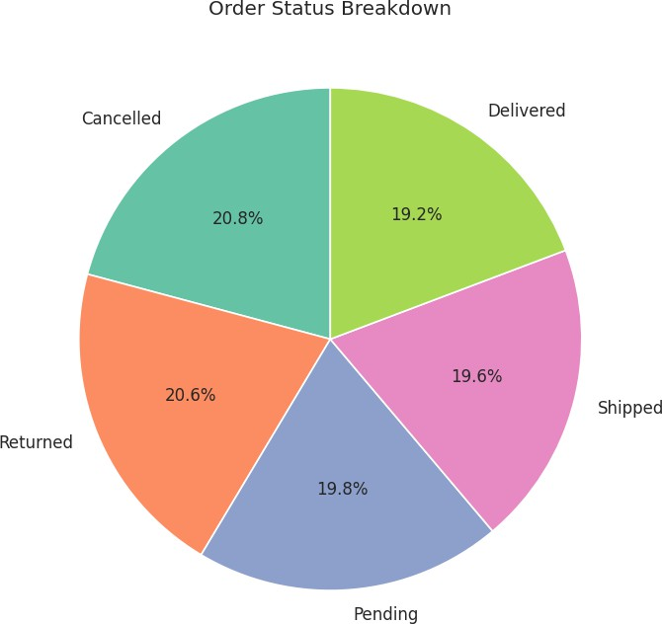

Figure 3: Order status breakdown across all 1,200 orders.

41.4% of all orders are either Cancelled or Returned the single most actionable finding in this dataset. This represents nearly half of all transactions failing to complete successfully and warrants direct investigation into checkout and fulfillment processes.

Revenue Trend Over Time
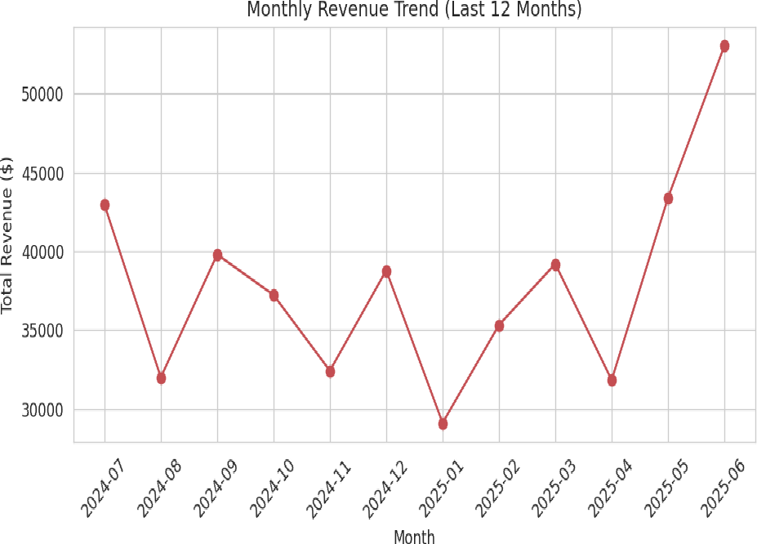
Figure 4: Monthly revenue over the most recent 12 months.

Monthly revenue fluctuates between roughly $29,000 and $53,000 with no single sustained directional trend. Year-level totals appear to decline from 2023 to 2025, but the 2025 figure reflects a partial year and should not yet be read as a real decline without confirming the full date range covered.

Correlation Between Variables
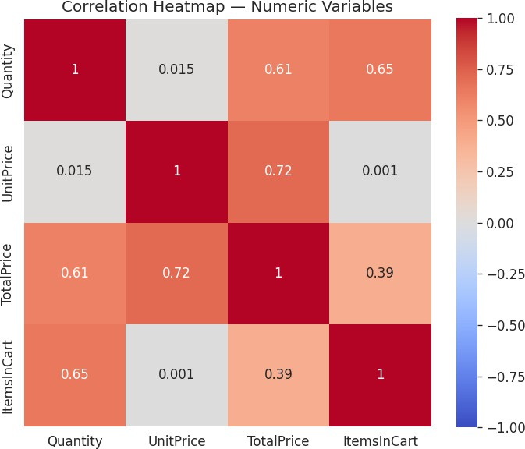
Figure 5: Correlation heatmap of numeric order variables.

Quantity and Unit Price are essentially uncorrelated (r = 0.015) customers are not trading off buying more of cheaper items. Total Price is driven independently by both Unit Price (r = 0.717) and Quantity (r = 0.615), confirming both factors matter separately rather than one dominating.

Product Performance

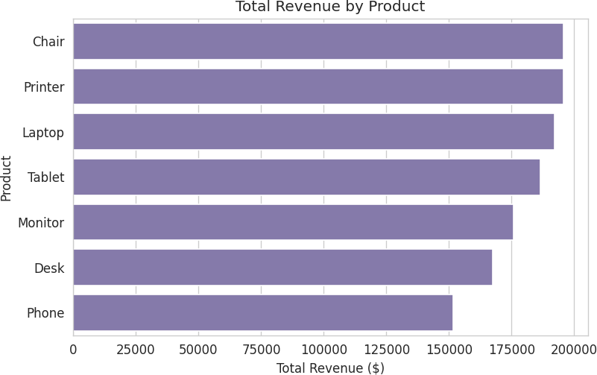
Figure 6: Total revenue generated by each product category.

Revenue is unusually evenly distributed across products (each contributing roughly 14-15% of total revenue), unlike typical real-world e-commerce data which often shows a few products dominating sales. This evenness is worth noting when presenting findings, as it differs from a typical Pareto pattern and may reflect how the dataset was generated.

