Sentinel-AI

Working:

SentinelAI is a hybrid security dashboard designed to provide a centralized view of system health and network vulnerabilities. It operates on two primary modules:
- Log Analysis (AI-Driven): This module processes Windows Security logs (CSV). The AI model analyzes event patterns and flags activities that deviate from normal behavior—such as brute-force login attempts or unauthorized access—as "Suspicious".
- Network Monitoring (Cyber Reconnaissance): Utilizing the Nmap engine, this module scans target IPs or network ranges. It detects open ports, active services, and version numbers to help administrators identify potential entry points for attackers.
- Integrated Visualization: Both data streams are visualized on a single Streamlit dashboard, allowing security professionals to monitor internal logs and external network exposure simultaneously.

Environment and Tools

The following technologies were used to develop and deploy the project:
- Programming Language: Python 3.10+
- Frontend Framework: Streamlit (For the web-based UI)
- Security Engine: Nmap (Network Mapper)
- Data Processing: Pandas and NumPy
- Visuals: Plotly Express (For interactive charts)
- Machine Learning: Scikit-learn (Isolation Forest implementation)
- Operating System: Windows (Note: Nmap must be installed in the system path)

AI Algorithm Used: Isolation Forest
The core AI component of this project is the Isolation Forest algorithm.
- Why Isolation Forest?: It is an Unsupervised Learning algorithm specifically designed for Anomaly Detection. Unlike other algorithms that learn "normal" behavior, Isolation Forest explicitly isolates anomalies.
- How it Works: It functions by randomly selecting a feature and then randomly selecting a split value. Since anomalies are few and different, they are partitioned (isolated) much faster than normal points. Points that have shorter path lengths in the "trees" are marked as suspicious.
- Configuration: The code uses a contamination=0.05 parameter, which tells the model that we expect roughly 5% of the log data to be potentially malicious or anomalous.

4. Complete Source Code:
import streamlit as st
import pandas as pd
import plotly.express as px
import numpy as np
import nmap
import os
from sklearn.ensemble import IsolationForest

# ---------------- CONFIG ----------------
st.set_page_config(page_title="SentinelAI: Log and Network Monitoring", layout="wide")
st.title("🛡️ SentinelAI: Log and Network Monitoring")

# ---------------- HELPERS ----------------
def get_nmap_path():
possible_paths = [
r"C:\Program Files (x86)\Nmap\nmap.exe",
r"C:\Program Files\Nmap\nmap.exe",
"/usr/bin/nmap"
]
for path in possible_paths:
if os.path.exists(path):
return path
return None

# ---------------- SIDEBAR ----------------
st.sidebar.header("Controls")
uploaded_file = st.sidebar.file_uploader("Upload Windows Security Logs (CSV)", type=["csv"])

# ---------------- LOG ANALYSIS (AI) ----------------
if uploaded_file is not None:
df = pd.read_csv(uploaded_file)
if len(df) > 5:
df_numeric = df.select_dtypes(include=[np.number])
if df_numeric.shape[1] < 2:
for col in df.columns:
if df[col].dtype == 'object':
df[f'{col}_code'] = df[col].astype('category').cat.codes
df_numeric = df.select_dtypes(include=[np.number])

if st.sidebar.button("Analyze Logs"):
# AI Algorithm: Isolation Forest
model = IsolationForest(contamination=0.05, random_state=42)
df['anomaly'] = model.fit_predict(df_numeric)
df['Result'] = df['anomaly'].map({1: 'Safe', -1: 'Suspicious'})

st.subheader("📊 Log Analysis Results")
fig = px.histogram(df, x="Result", color="Result", color_discrete_map={"Safe": "green", "Suspicious": "red"})
st.plotly_chart(fig)
st.dataframe(df[df['Result'] == 'Suspicious'], use_container_width=True)
else:
st.error("Insufficient data in file!")

# ---------------- NETWORK SCANNER (NMAP) ----------------
st.sidebar.markdown("---")
st.sidebar.subheader("🌐 Universal Network Scanner")
scan_ip = st.sidebar.text_input("Enter Target IP", placeholder="e.g. 192.168.1.1")
scan_depth = st.sidebar.selectbox("Scan Depth", ["Standard Scan", "Comprehensive", "Aggressive"])

if st.sidebar.button("🚀 Start Scanning"):
nmap_exe = get_nmap_path()
if nmap_exe:
try:
nm = nmap.PortScanner(nmap_search_path=(nmap_exe,))
args = "-T4 -F -Pn" if scan_depth == "Standard Scan" else "-A -T4 -Pn"

with st.spinner("Scanning network..."):
nm.scan(hosts=scan_ip, arguments=args)
data = []
for host in nm.all_hosts():
for proto in nm[host].all_protocols():
for port in nm[host][proto]:
service = nm[host][proto][port]
data.append({
"Host": host, "Port": port, "Service": service.get('name'),
"State": service.get('state'), "Version": service.get('version')
})

df_scan = pd.DataFrame(data)
if not df_scan.empty:
st.subheader(f"📡 Results for {scan_ip}")
st.dataframe(df_scan, use_container_width=True)
fig = px.pie(df_scan, names='Service', title='Services Distribution')
st.plotly_chart(fig)
except Exception as e:
st.error(f"Error during scan: {e}")

DASHBOARD:
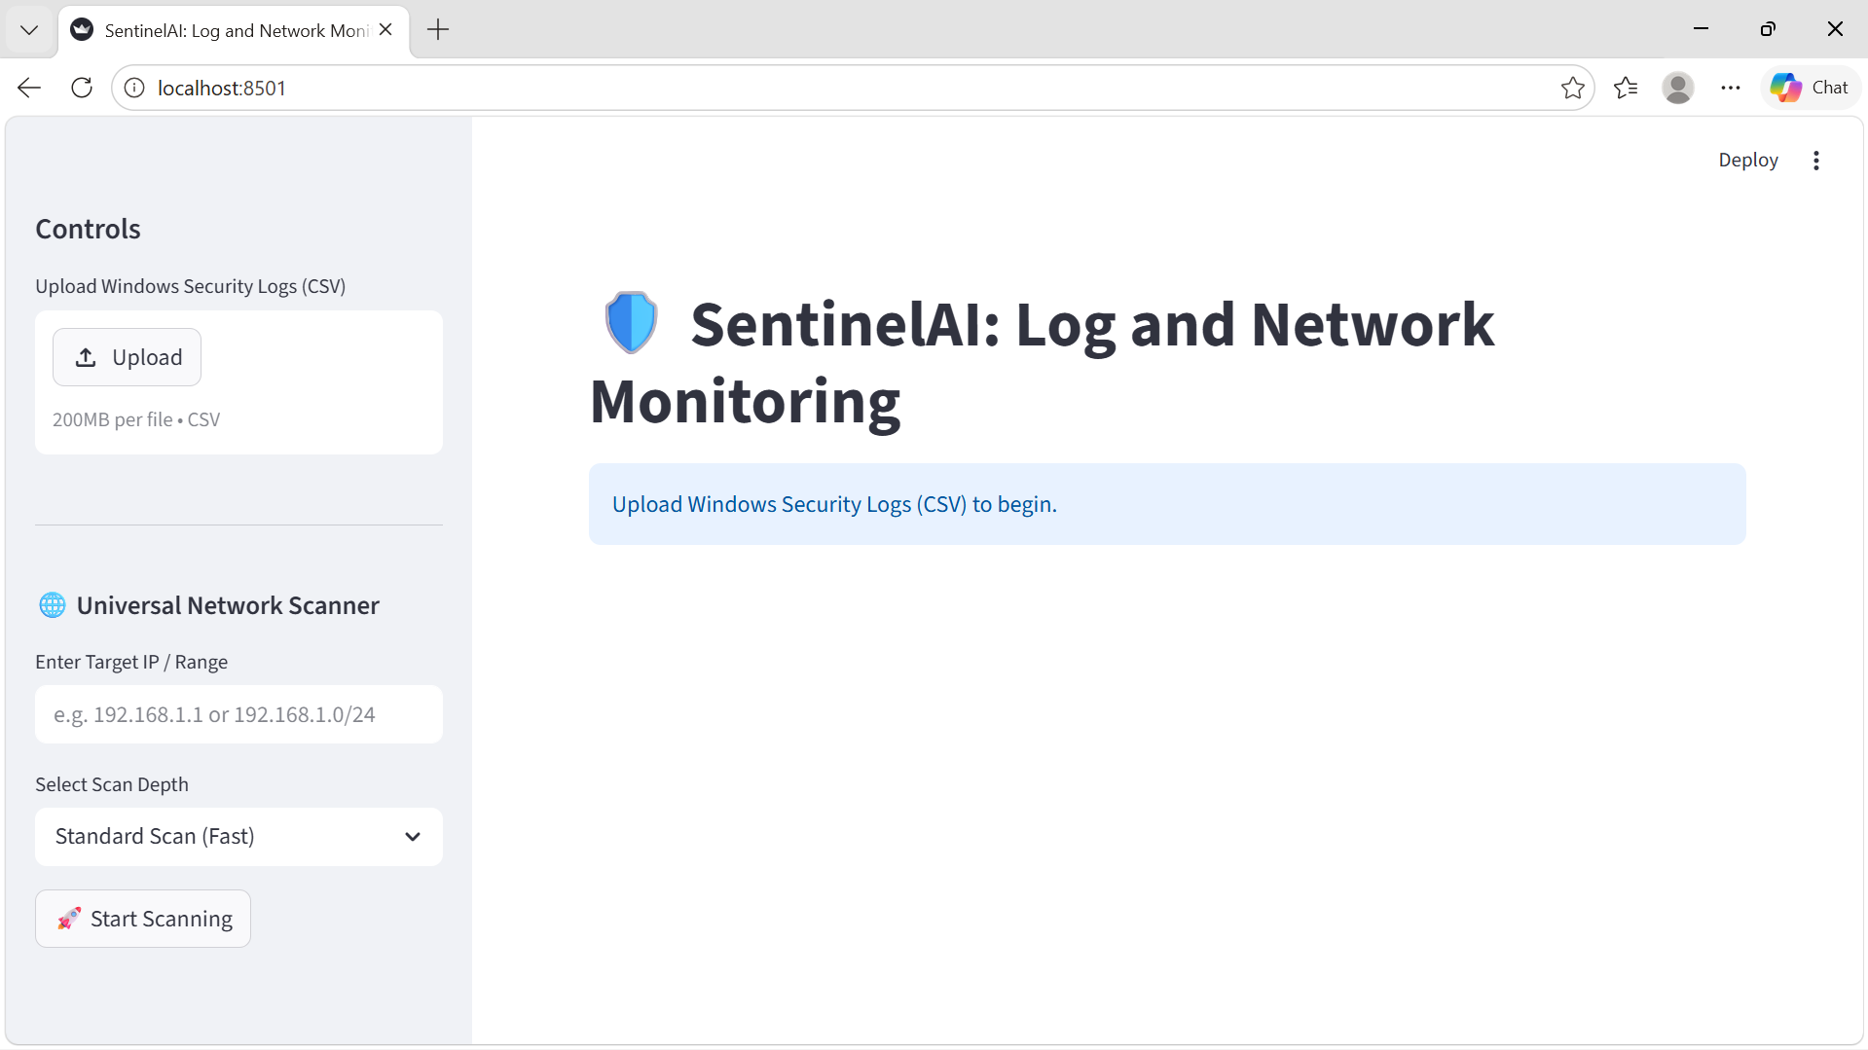
Nmap Scanning:
Using windows ip that is 192.168.100.9:
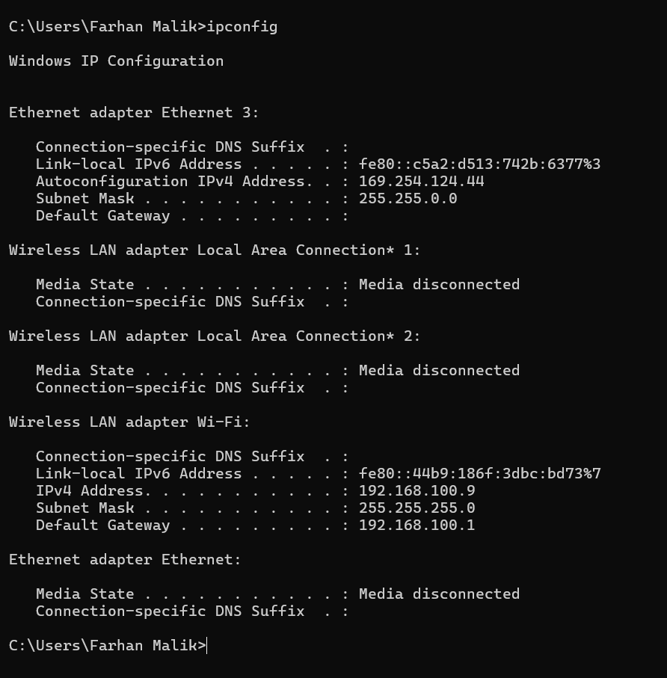
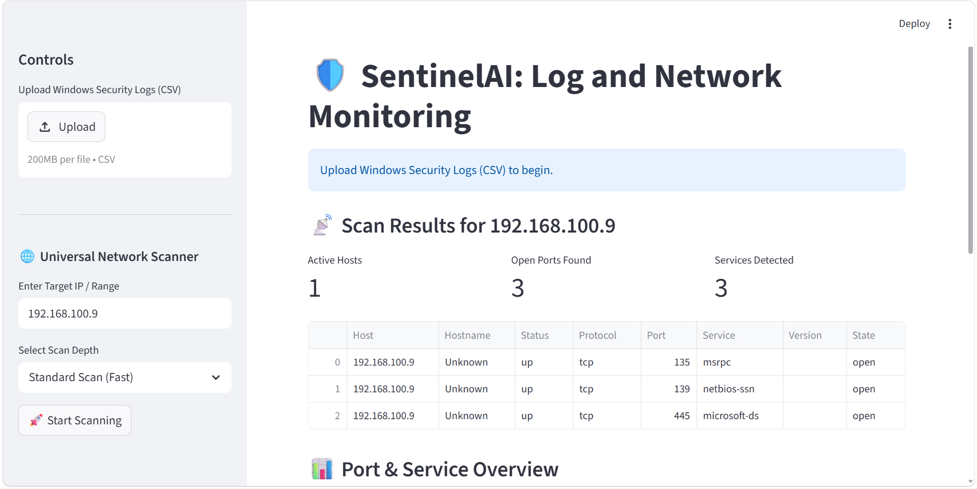
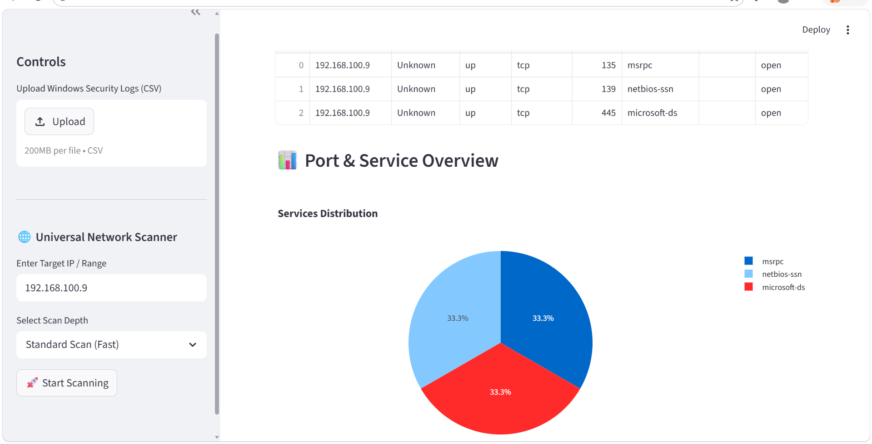
Log Auditing:
Upload .CVS file on dashboard to track the logs:
Event Viewer > windows logs > security > Save all Event as(on right side bar)
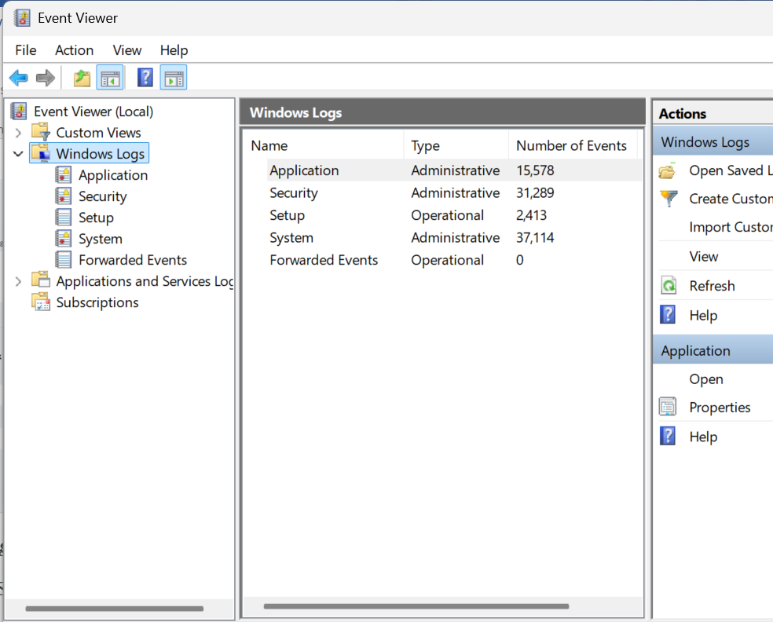
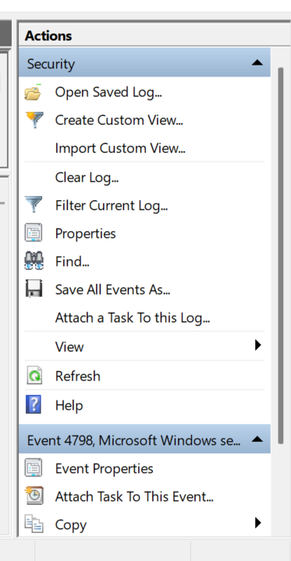
Save with .cvs extension.
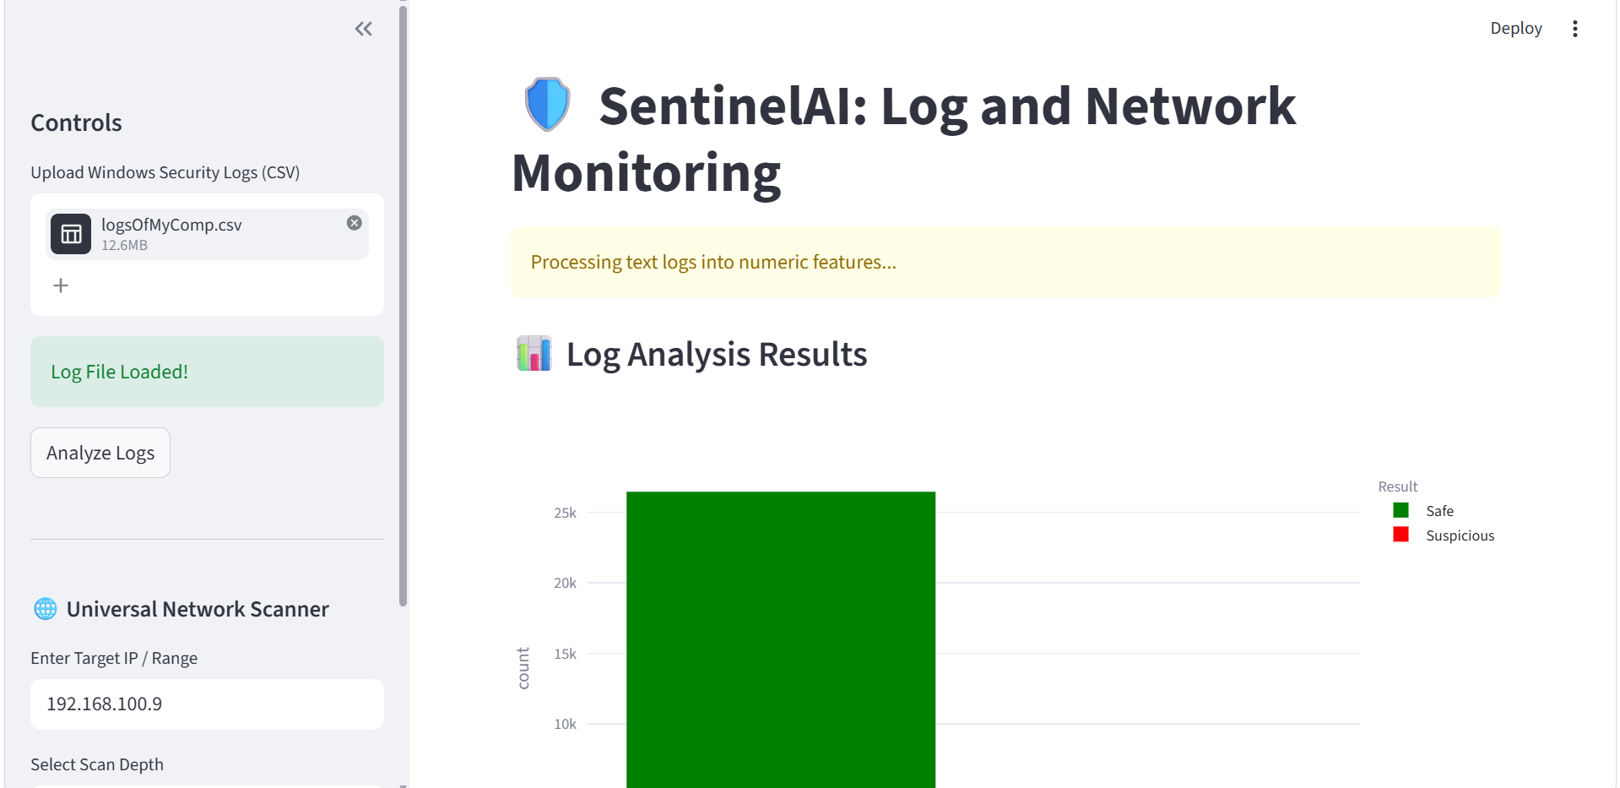
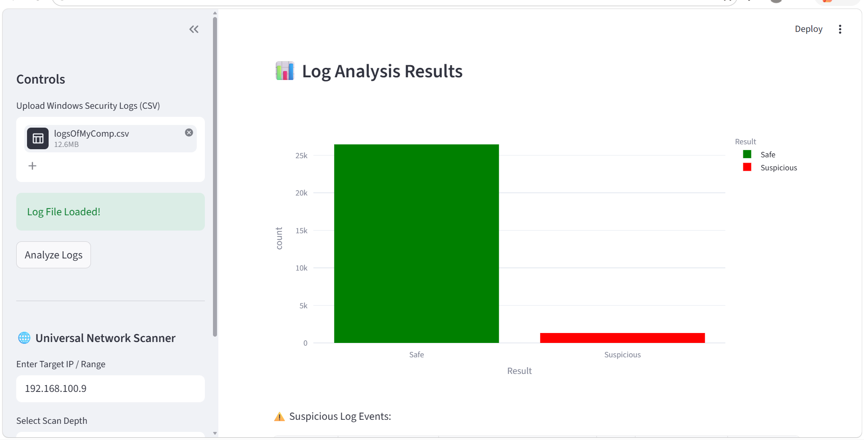
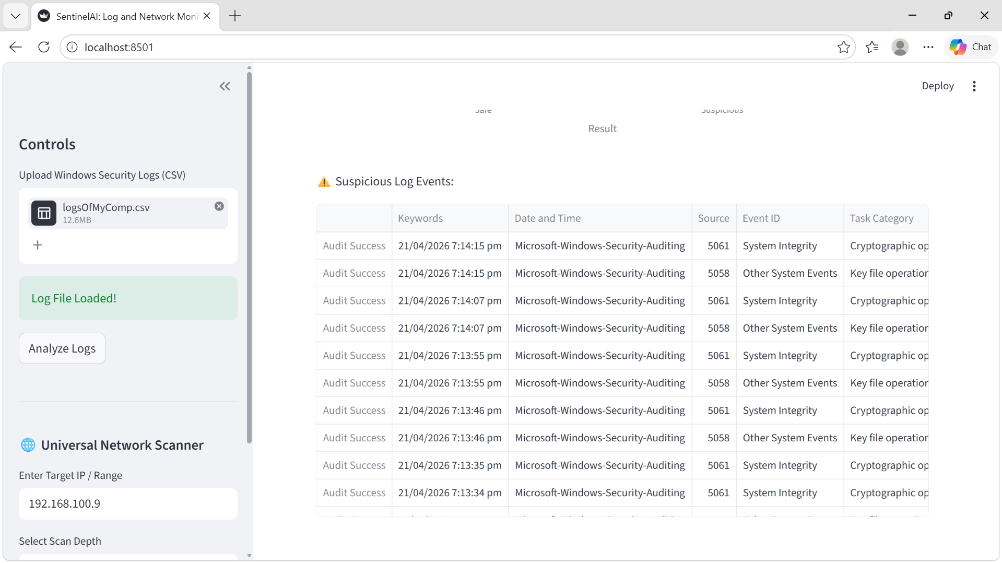
Algorithms Used:
- The AI algorithm used is Isolation Forest.
- It uses A* while searching on dashboard.

