MultiShield: Multimodal Threat Detection System

Phase 2 Progress Report

1. Cover Page & Repository Link
Team: Team MultiShield
Course: Deep Learning (Semester Project)
Date: May 5, 2026
GitHub URL: [Pending Upload]
Commit Hash: [Pending Final Commit]

2. Roadmap Updates
What changed since Phase 1? The core scope of creating a multimodal threat detection system remains unchanged. However, we encountered an obstacle with the dataset acquisition for the deepfake modality. The FaceForensics++ dataset requires submitting an access request form to the authors, which is currently pending approval. As a result, Phase 2 EDA and Baseline testing were conducted exclusively on the Fake News, Phishing Email, and UNSW-NB15 datasets. If access is not granted soon, we will pivot to our identified backup (DFDC Kaggle Dataset) to maintain schedule.

3. EDA Summary
Top findings from our Exploratory Data Analysis.
- Temporal Bias Discovered (Fake News): Fake and real articles peak in entirely different years/months. A random train/test split will leak temporal context, causing the model to learn publication dates instead of semantics.
- Severe Outliers & Heavy Tails (UNSW): Network byte counts (sbytes, dbytes) span extreme logarithmic ranges, making standard StandardScaler ineffective and requiring robust log transformations.
- Variable Sequence Lengths (Text): Word counts range from 10 to over 2000. This dictates a hard truncation threshold (e.g., max_length=512) for future BERT embeddings to balance context retention with memory limits.
- Extreme Multi-Class Imbalance (UNSW): Certain attack classes (e.g., Worms) have fewer than 200 samples, while normal traffic has over 100,000. Accuracy is a useless metric here.
- High Duplication Rate (Fake News): Significant exact string duplication exists, likely from cross-posting. These must be removed prior to splitting to prevent validation leakage.
- Feature Collinearity (UNSW): High collinearity between features like sbytes and sload implies that dropping highly correlated features will reduce dimensionality without losing information.
- Missing Categorical Labels (UNSW): Missing values in the attack_cat column perfectly correspond to label 0 (Normal traffic).
- Massive Vocabulary Size (Text): The raw vocabulary across the text datasets exceeds 150,000 unique tokens, confirming that a subword tokenizer (WordPiece) is strictly required to handle out-of-vocabulary (OOV) terms.

4. Preprocessing Decisions
EDA Finding | Preprocessing Step Implemented | Expected Effect
Temporal Bias in Fake News | Use a stratified temporal split instead of a random split. | Prevents data leakage; forces model to learn linguistics, not dates.
Extreme heavy-tailed network bytes | Apply np.log1p() followed by RobustScaler. | Normalizes distributions, preventing gradients from exploding on large outliers.
Extreme class imbalance (UNSW) | Apply SMOTE oversampling to the minority classes. | Balances the decision boundary so the MLP doesn’t just predict “Normal” every time.
Massive Vocabulary / OOV terms | Truncate sequences to 512; prepare for WordPiece subword tokenization. | Ensures memory efficiency and prevents crashes on unseen words during inference.
Missing Categorical Values | Impute missing attack_cat values with the string “Normal”. | Preserves data integrity without dropping thousands of valid negative samples.

5. Baseline Architecture
We implemented a PyTorch Multi-Layer Perceptron (MLP) as our baseline model. While the final architecture will utilize Transformers, this baseline ensures our training loop, preprocessing pipelines, and evaluation metrics are fully functional end-to-end.
graph TD
A[Input: TF-IDF / Normalized Numeric] --> B[Linear Layer 1: 256 Neurons]
B --> C[GELU Activation]
C --> D[Dropout: p=0.4]
D --> E[Linear Layer 2: 128 Neurons]
E --> F[GELU Activation]
F --> G[Dropout: p=0.4]
G --> H[Output Layer: 1 or N Classes]
H --> I[BCEWithLogitsLoss / CrossEntropyLoss]
Hyperparameters & Design Choices:
Component | Choice | Justification
Hidden Layers | 2 layers (256 → 128) | Sufficient capacity for baseline tabular/TF-IDF data without severe overfitting.
Activation | GELU | Gaussian Error Linear Unit smooths the thresholding of standard ReLU, preventing the “dying ReLU” problem. It is the modern standard used in Transformers (like BERT), aligning the baseline with our final goal.
Weight Init. | He/Kaiming Normal | Mathematically derived to preserve variance across layers when using ReLU/GELU activations, preventing vanishing/exploding gradients.
Loss Function | BCEWithLogitsLoss | Chosen for binary tasks (Phishing/Fake News). It combines a Sigmoid layer and BCELoss into a single class, which is vastly more numerically stable.
Optimizer | AdamW | Adam with decoupled weight decay ensures robust regularization.

6. Training Setup & Results
To validate the pipeline, we trained the Baseline MLP on a 10% subset of the Phishing Emails dataset.
- Epochs: 8
- Learning Rate: 1e-3 (with ReduceLROnPlateau scheduling)
- Patience: 3 (Early Stopping)
- Final Test Accuracy: 97.90%

Learning Curves & Confusion Matrix
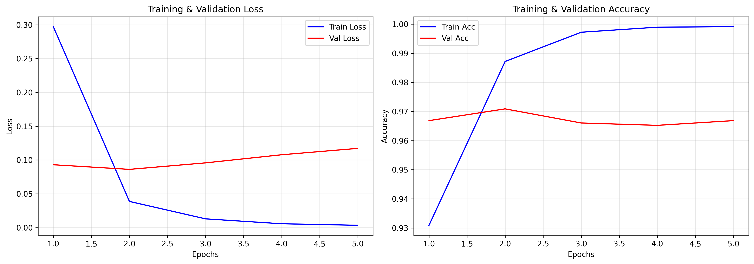 (Left: Training vs Validation Loss. Right: Training vs Validation Accuracy. The model converges rapidly due to the TF-IDF representation.)
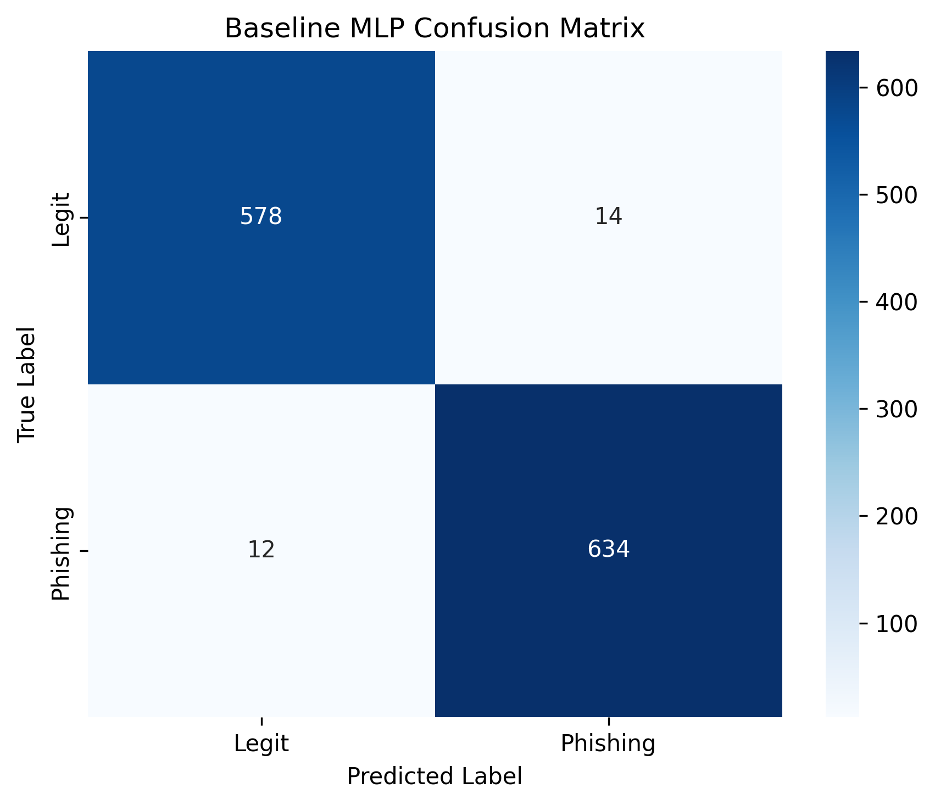 (The model successfully identifies the vast majority of Phishing and Legitimate emails, with a slight tendency toward False Positives on this subset.)

7. Error Analysis (Light)
We extracted misclassified samples from the test set to analyze failure modes.
Observations from Wrong Predictions: 1. Phishing classified as Legit (False Negatives): - Example: “wetransfer postmaster… hello received file 1 item…” - Example: “apple support ticket… review case reference…” - Pattern: These emails perfectly mimic legitimate transactional/support emails. A simple TF-IDF + MLP struggles here because the vocabulary is identical to real emails. A Transformer (BERT) is required to understand the contextual threat (e.g., urgency combined with a suspicious link). 2. Legit classified as Phishing (False Positives): - Example: “borsheim web site http www borsheims com corporate gifts shopping…” - Pattern: Legitimate emails that contain multiple URLs and transactional keywords (“shopping”, “discount”) are incorrectly flagged. The model over-indexes on the presence of links.
Implication for Phase 5: Context-aware embeddings will be critical to separating transactional spam from malicious phishing.

8. Reproducibility Statement
To reproduce the baseline model exactly as shown above, run the following commands in the project directory:
# 1. Install dependencies
pip install torch torchvision torchaudio --index-url https://download.pytorch.org/whl/cpu
pip install scikit-learn pandas numpy matplotlib seaborn imbalanced-learn nltk tensorboard
# 2. Execute the Baseline Report Script
python run_report_baseline.py
Note: The script automatically handles preprocessing, train/val/test splits, training, evaluation, and saves the plots to the assets/ directory.

9. Risks Encountered & Plan for Phase 3
Risks Encountered: - Dataset Access: As mentioned, FaceForensics++ is gated. We risk falling behind on the vision modality if approval takes too long. - PyTorch Installation: Transitioning from Jupyter to modular Python scripts required careful environment management and debugging PyTorch CPU vs CUDA dependencies.
Plan for Phase 3: 1. Secure the deepfake dataset (or switch to DFDC). 2. Migrate from TF-IDF to advanced embeddings (Word2Vec/GloVe or direct BERT embeddings) to solve the contextual errors found in section 7. 3. Build the CNN baseline for the image modality. 4. Scale up the training loop from the 10% subset to the full 100% datasets using cloud/GPU resources.

